

PES UNIVERSITY
Department of Computer Science & Engineering

Database Management System

UE23CS351A

Miniproject Report

Name of the Student | Pranav Hemanth
SRN | PES1UG23CS433
Section | G
Department | CSE
Campus | RR

Name of the Student | Nishant K Holla
SRN | PES1UG23CS401
Section | G
Department | CSE
Campus | RR

Topic: Geocab - A geo-distributed ride-hailing application

Department of Computer Science & Engineering
Database Management System

UE23CS351A

Geocab - A geo-distributed ride-hailing application

Overview:

Problem statement:

Solution architecture:

User requirement specification:

Types of users:
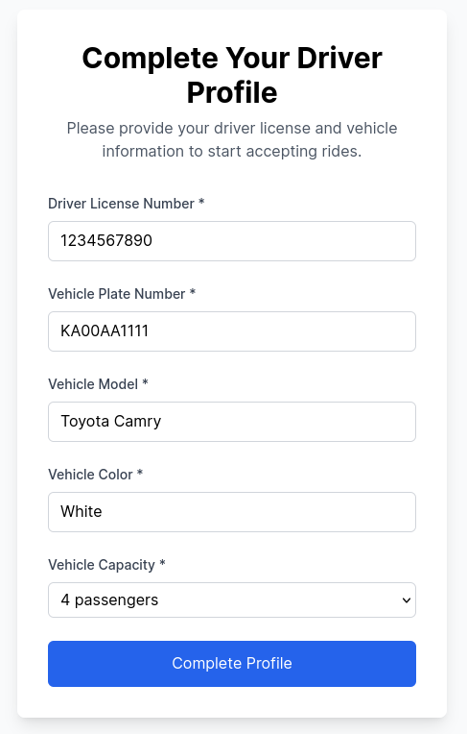
Driver
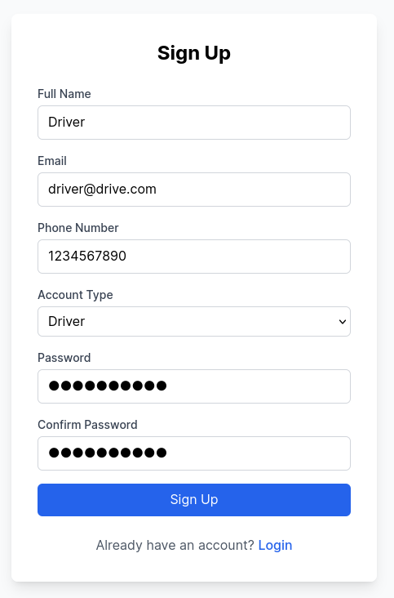

Rider

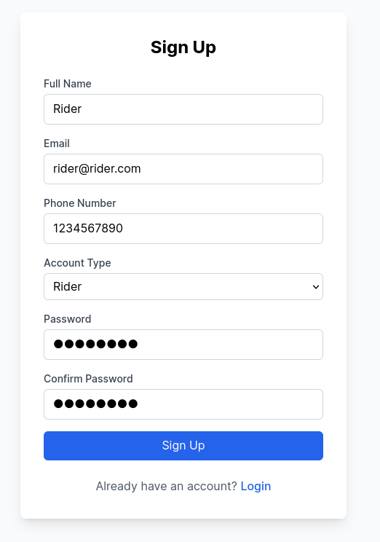

ER diagram:
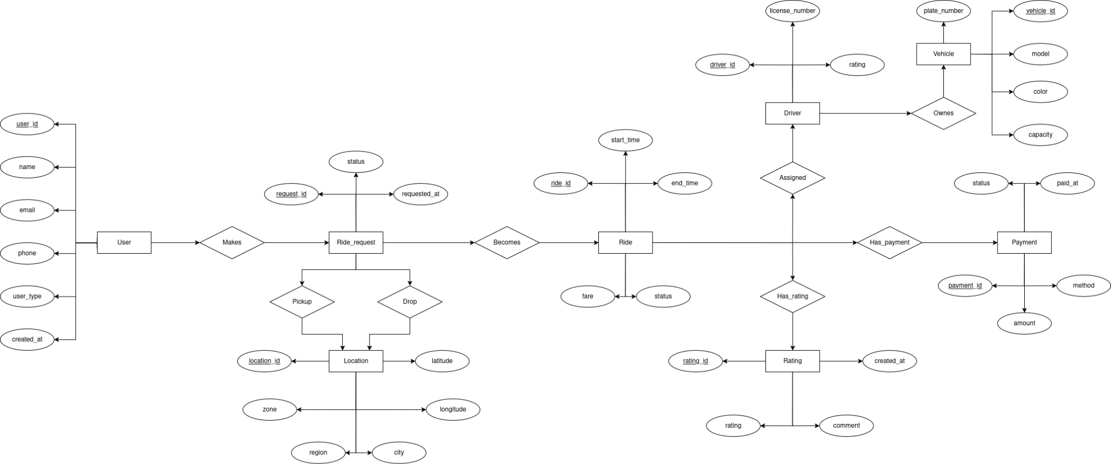

Relational Schema:
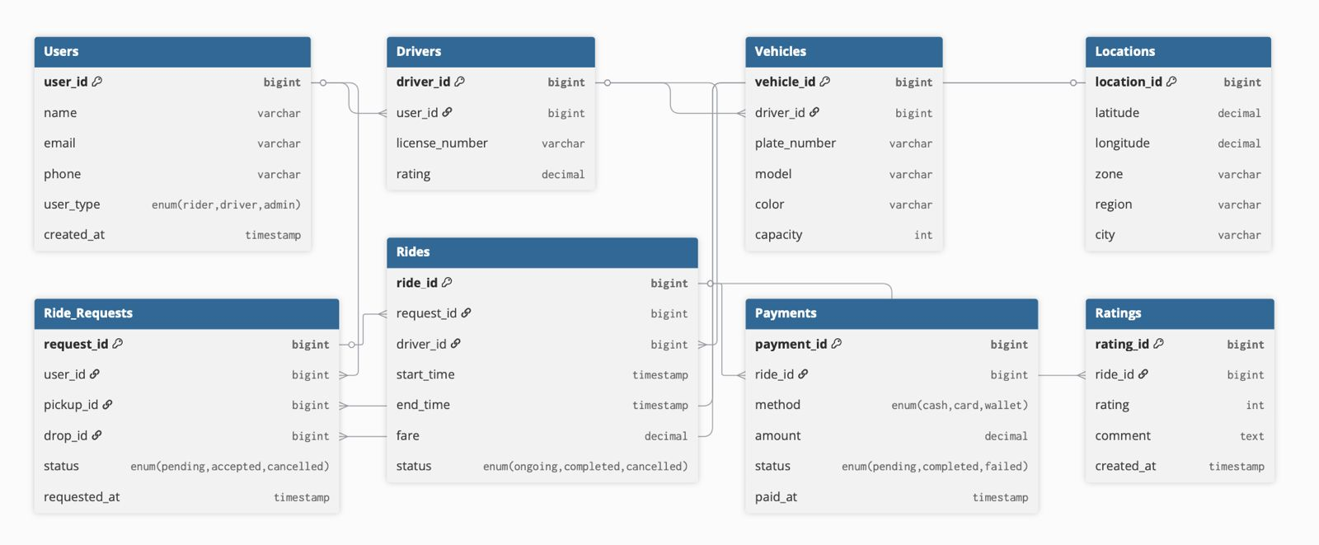

DDL commands:
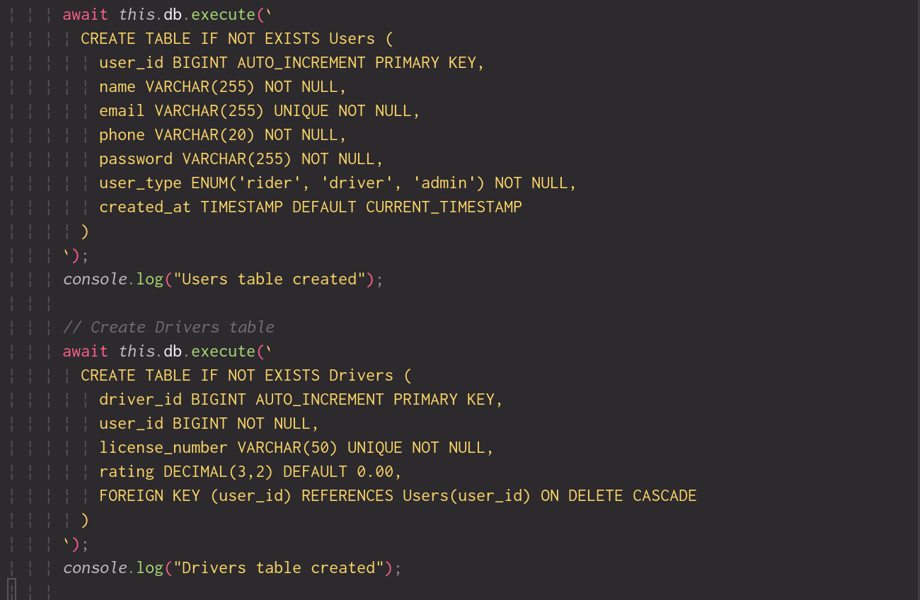

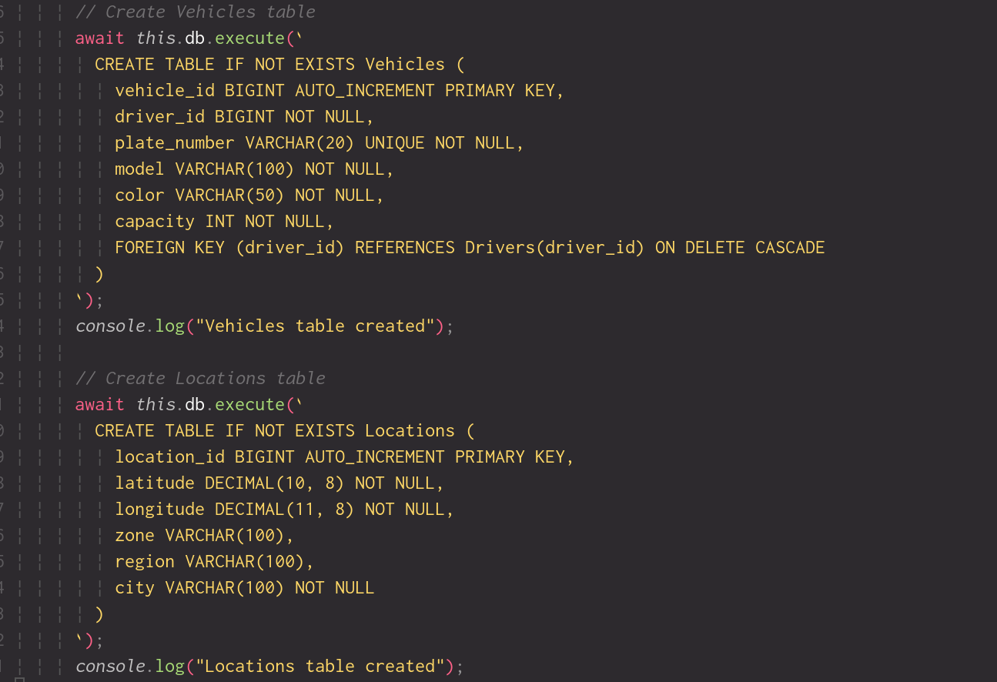

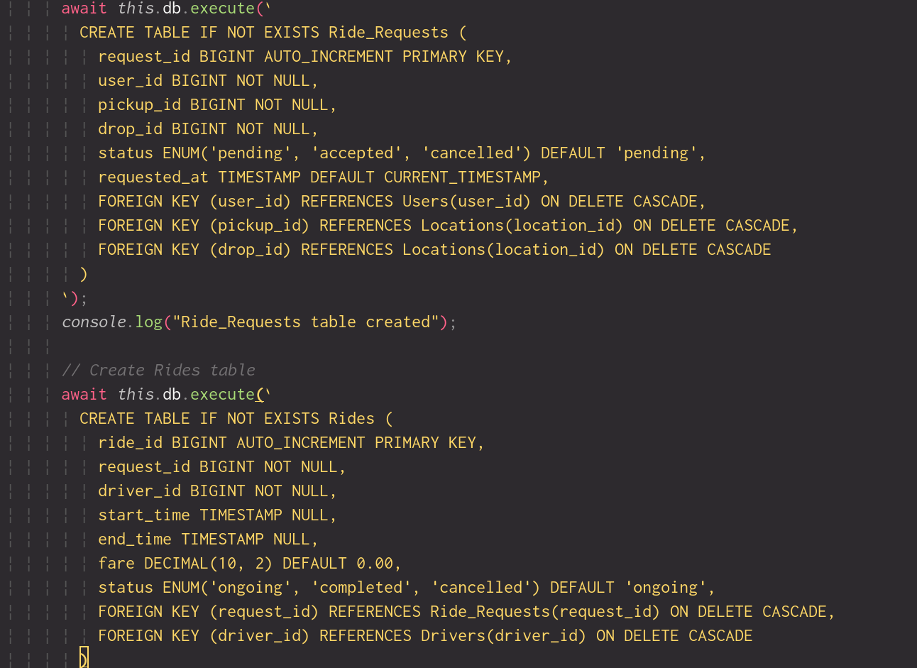

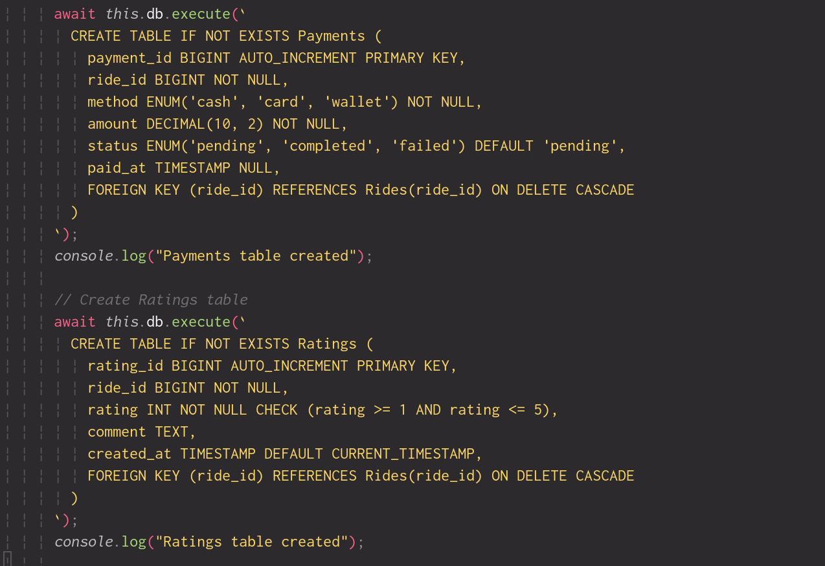

CRUD operations:
Creating new user
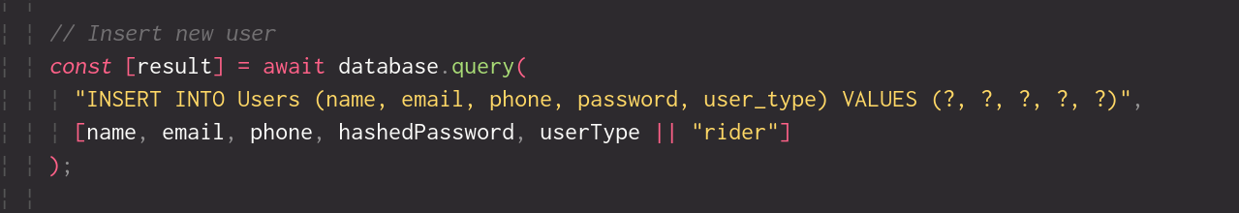

Reading user data
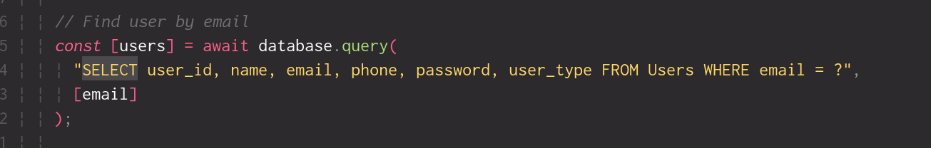

Updating ride status
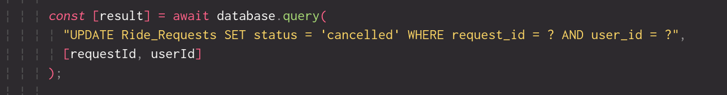

Deleting user:


List of functionalities/features of the application and its associated screenshots using front end

Functions:
Creating fare_for_request function that computes fare for a request using configured base and per-km rates
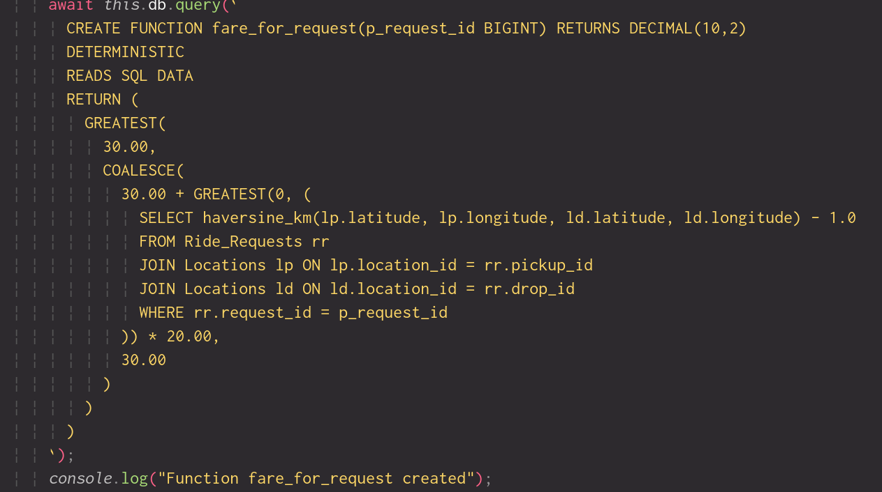

Procedures:
Procedure to accept a ride request
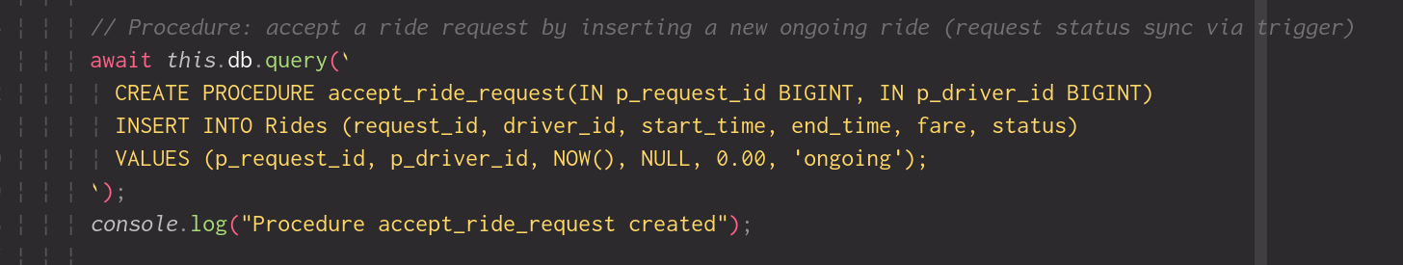

Procedure to complete a ride
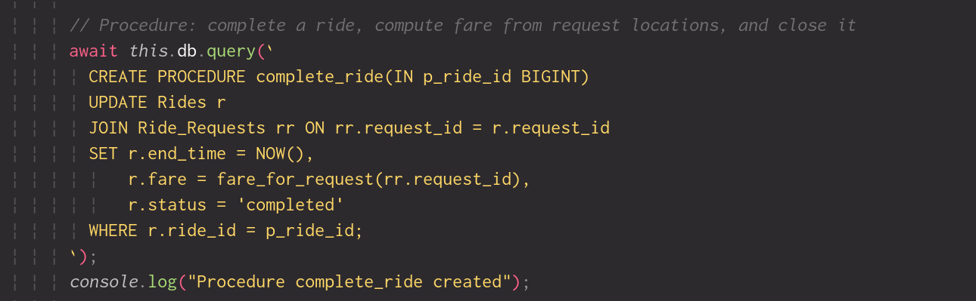

Triggers:
Creating a trigger to mark request as "accepted" when a ride entry is created
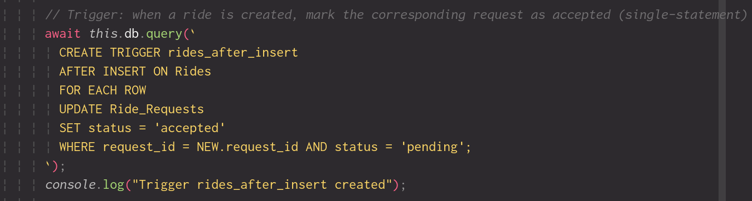

Creating a trigger to auto-manage paid_at timestamp for completed payments
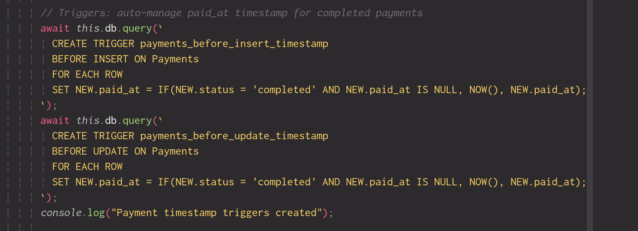

Creating trigger to auto-complete payment when the required amount is paid
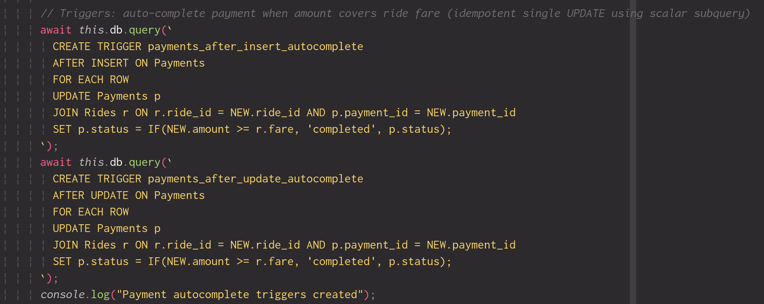

Nested/ aggregate queries:

Github repository link:
https://github.com/nishantHolla/GeoCab

