

PES UNIVERSITY
Department of Computer Science & Engineering

Object Oriented Analysis and Design

UE23CS352B

Assignment 8 Submission

Name of the Student | Pranav Hemanth
SRN | PES1UG23CS433
Section | G
Department | CSE
Campus | RR

Object Oriented Analysis and Design (UE23CS352B) - Lab 8

Student Management System

Department of Computer Science & Engineering
Object Oriented Analysis and Design

UE23CS352B

Problem Statement - Student Management System

1. Problem Statement
The objective of this lab is to build a web-based Student Management System that performs basic CRUD operations. The application is required to implement the Model-View-Controller (MVC) architectural pattern using Spring Boot, Hibernate (JPA), and an H2 relational database.

2. Technologies Used
Backend Framework: Java Spring Boot
Architecture Pattern: Model-View-Controller (MVC)
Persistence: Spring Data JPA / Hibernate
Database: H2 (In-Memory Database)
Frontend: HTML, CSS, Thymeleaf

3. Architecture Overview
The application follows a standard three-tier architecture:
- Model (Data Layer): The Student entity represents the database schema. It is mapped to the default STUDENT table using JPA annotations.
- View (Presentation Layer): The HTML/Thymeleaf template (index.html) provides the user interface for registration and viewing records.
- Controller (Application Logic): The StudentController intercepts incoming HTTP requests (GET, POST), communicates with the StudentService to apply business rules, and returns the appropriate HTTP responses or UI templates.

4. Implementation Details
4.1. The Model (Student.java)
The Student class serves as the JPA Entity. It uses @Entity to map it to a database table. The primary key (id) is auto-generated using @GeneratedValue(strategy = GenerationType.IDENTITY). The fields include name, email, and course.

4.2. The Repository (StudentRepository.java)
This interface extends JpaRepository<Student, Long>, providing built-in CRUD functionalities without writing SQL queries. We defined custom query methods such as existsByEmail(String email) to check for data duplication, and findByCourse(String course) to retrieve students by course.

4.3. The Service (StudentService.java)
The service layer acts as a bridge between the Controller and the Repository. It houses the core business logic.
Duplicate Validation: Before adding a student, addStudent() checks if the email already exists using the repository's existsByEmail() method. If it does, it throws a RuntimeException.

4.4. The Controller (StudentController.java)
- The controller serves both MVC web endpoints and REST API endpoints:
- GET / : Serves the main HTML interface with the student form and list.
- POST /add : Accepts form submissions to add a new student, using redirect attributes for success/error messages.
- GET /delete/{id} : Deletes a student by ID and redirects to the home page.
- POST /api/students : Accepts JSON payload and calls the service to save the student, returning a ResponseEntity.
- GET /api/students : Fetches all registered students as a JSON array.

5. System Output & Verification (Screenshots)
5.0. Run the Project

The project was generated as a Maven-based Spring Boot application with the required dependencies: Spring Web, Spring Data JPA, H2 Database, and Thymeleaf, declared in pom.xml.
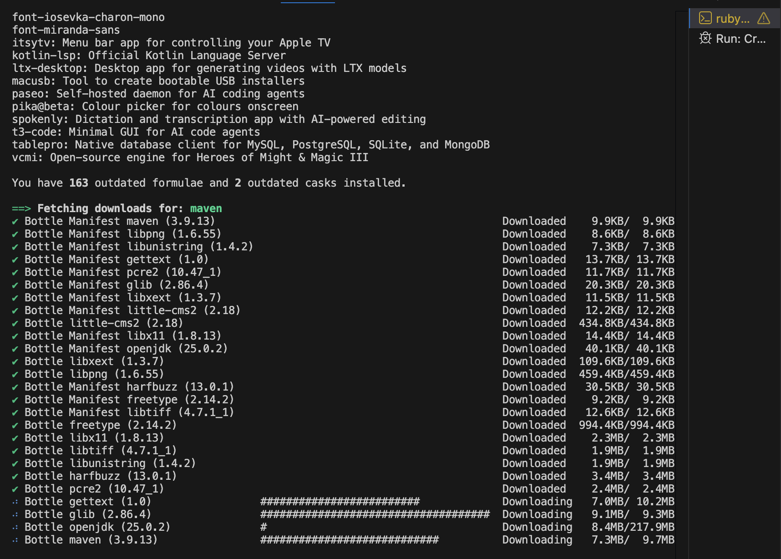
The H2 in-memory database is configured with spring.datasource.url=jdbc:h2:mem:studentdb. Hibernate’s ddl-auto=updatesetting allows automatic table creation from entity definitions at startup. SQL logging is enabled for debugging purposes, and the H2 web console is made accessible at /h2-console.
