Live Meeting Summarizer Application

Project Statement:
The objective is to develop a real-time Meeting Summarizer that leverages speech-to-text (STT) models and open source LLMs or hugging face transformers to generate structured summaries from live meeting recordings. The solution will be delivered as a fully integrated Streamlit application with backend support for transcription, speech diarization, summarization, user interaction and endpoint services like sending email or downloading the summary by 1 click.

Outcomes:
- Capture live audio and convert it to text using offline STT models.
- Identify and segment the audio by speaker using diarization models like pyannote
- Integrate transformer-based summarization using LLMs and transformers from Groq API or Hugging Face.
- Deliver structured summaries only after the Stop button is pressed and the complete transcript is available.
- Build an interactive UI using Streamlit with real-time control and result rendering.
- One-click export as Markdown/PDF and send via email.

Modules to be implemented:
- Audio Recording and STT using Vosk/Whisper with PyAudio or SoundDevice
- Integrates diarization models like pyannote-audio for speaker separation.
- Prompt updates for diarized transcript to perfom text wummarization via LLM or transformer models (Groq or Hugging Face etc)
- Streamlit Frontend with recording controls
- Backend Pipeline (multi-threaded capture, queuing, async summarization)
- Testing, Evaluation & Optimization
- Final Presentation & Documentation
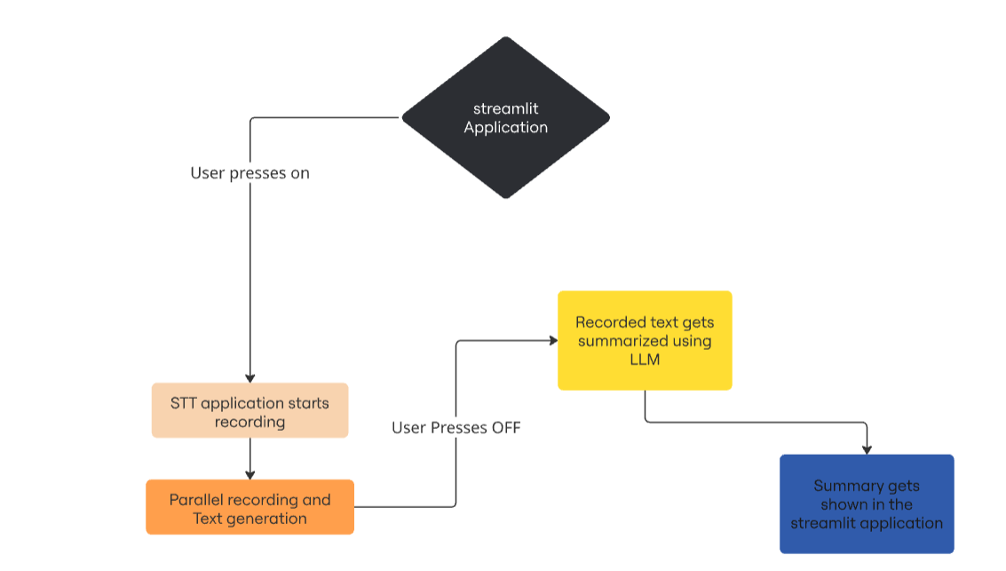

Milestone 1: Speech-to-Text System (Weeks 1–2)
Module 1: Project Kickoff and Audio Dataset Setup
Tasks:
- Define technical architecture (multi-threaded STT → diarization → summarization).
- Explore and compare STT models: Vosk and Whisper.
- Set up Python environment with pyaudio, sounddevice, vosk, or whisper.
- Download evaluation datasets like AMI Meeting Corpus or create synthetic datasets for testing and benchmarking.
- Use the dataset to evaluate baseline WER across models and to assist in model selection.
Deliverables:
- Architecture diagram and documentation
- Audio data samples for testing.
- WER benchmark report using AMI dataset.
Evaluation:
- Completion of architecture and setup
- Data readiness for transcription experiments

Module 2: Real-Time Speech-to-Text Engine Implementation
Tasks:
- Implement threaded audio capture from the microphone.
- Connect STT engine (Vosk/Whisper) to transcribe in real time.
- Display transcription updates in a terminal/console.
- Evaluate performance using jiwer to calculate WER.
Deliverables:
- Python module for real-time STT
- Sample transcription logs
- Evaluation report using WER
Evaluation:
- WER below 15%
- Real-time transcription accuracy and stability

Milestone 2: Speech diarization and summarization Engine (Weeks 3–4)
Module 3: Speaker Diarization Engine
Tasks:
- Integrate pyannote.audio to tag different speakers in audio.
- Process the .wav file after recording ends.
- Convert speaker segments into readable transcript like:
[Speaker 1]: Let's discuss next quarter goals.
[Speaker 2]: We should increase sales by 20%.
- Sync segments with STT output.
Deliverables:
- Diarized transcript
- Python function for diarization
- Sample AMI corpus results
Evaluation:
- Diarization Error Rate (DER) < 20%
- Accurate segmentation of turns
Module 4: LLM-Based Summarization Logic
Tasks:
- Choose summarizer model (Groq LLaMA 3.1, T5, BART via HuggingFace).
- Design prompts for diarized transcripts
- Write API wrapper for summarization
- Evaluate summary quality with ROUGE, BLEU, human review.
Deliverables:
- Prompt templates for various meeting types .
- Summarizer module
- Sample summary outputs
Evaluation:
- ROUGE > 0.4.
- Speaker-based structure preserved in summary

Milestone 3: Frontend and Backend Fusion (Weeks 5–6)
Module 5: STT + Diarization + Summarization Integration
Tasks:
- Ensure summarization only triggers after Stop button.
- Build backend queue for transcript → diarization → summary.
- Merge diarized text with transcription output before summarization.
Deliverables:
- Fully integrated processing pipeline
- End-to-end transcript → summary demo.
Evaluation:
- Consistent structure & no race conditions
Module 6: Streamlit UI Development
Tasks:
- Design real-time frontend with Start/Stop buttons
- Add transcription log and summary viewer
- Status bar: “Recording”, “Transcribing”, “Summarizing”
- There need to be real time stt on UI and after end of recording there need to be summary along with diarized transcript
Deliverables:
- Fully functional Streamlit application
- Robust integration between all backend components.
- Live feedback components.
Evaluation:
- Smooth end-to-end functionality from Streamlit UI
- No backend/API delays or blocking

Milestone 4: Finalization and Delivery (Weeks 7–8)
Module 7: Testing, Evaluation, and Optimization
Tasks:
- Add download options: Export summaries as .md and .pdf
- Integrate email system using smtplib to send: Subject: “Meeting Summary – [Date/Title]”
- Implement structured logging:Save each meeting session with timestamp, transcript, summary, speaker info in .json/.parquet
Deliverables:
- Working export and email modules
- Updated UI with export/email option
- Final bugfixes
Evaluation:
- Fully functional Streamlit application.
Module 8: Documentation and Demo Prep
Tasks:
- Finalize documentation covering architecture, APIs, models, and UI.
- Prepare a demo script with sample recordings.
- Package entire solution for GitHub release.
- Create a presentation deck and rehearse walkthrough.
Deliverables:
- Documented codebase with README
- Slide deck and/or recorded walkthrough
- GitHub repo with tagged release
Evaluation:
- Comprehensive documentation
- Demo-ready solution
- Presentation delivery quality

Evaluation Criteria:

Milestone | Focus Area | Metric / Evaluation Method | Target/Goal
Milestone 1 | STT System | WER (Word Error Rate) via jiwer | < 15%
Milestone 2 | Diarization & Summarization | ROUGE Score, DER | ROUGE > 0.4, DER < 20%
Milestone 3 | UI Integration | Control Responsiveness | No lag/errors
Milestone 4 | Full System + Output Features | Full Pipeline Flow | Fully Working with Export/Email
Overall | Delivery & Presentation | Docs + GitHub + Demo | Clear, complete, and professional

Tech Stack:

Area | Tools / Libraries
STT | Vosk, Whisper, pyaudio, sounddevice
Diarization | pyannote.audio, torchaudio
Summarizer | LLaMA 3.1 (Groq API), T5, BART (Hugging Face)
Frontend | Streamlit
Backend | Python threading, asyncio, queue
Evaluation | jiwer (WER), rouge_score, BLEU
Logging/Export | JSON, Markdown, Pandas, Parquet, smtplib

