
Intelligent QR Code Risk Analysis & Malicious QR Detection System
COURSE: CRYPTANALYSIS AND CYBER DEFENCE (24CSB3101) | A.Y. 2026 – 2027
S. No. | University ID | Name
1 | 2420030410 | P. Sreehitha
2 | 2420090110 | M. Pranavi
Name of the Guide | VINISHA VELTHURU

Abstract
QR codes are widely used for payments, websites, authentication, and information sharing, but attackers can misuse them to redirect users to phishing and malicious websites. This project proposes an Intelligent QR Code Risk Analysis & Malicious QR Detection System that analyzes the content embedded within QR codes and identifies potential security threats. The system first decodes the QR code and extracts the associated URL or data. For URLs, it analyzes security-related features such as URL structure, domain characteristics, suspicious keywords, and other phishing indicators. A machine learning model then classifies the QR-linked URL as benign or malicious, and the system combines these results to generate an understandable risk score along with the reasons behind it. Based on this analysis, the QR code is categorized as Safe, Suspicious, or Malicious, helping users avoid potentially harmful links. The proposed system aims to provide a practical and intelligent security layer for QR-code-based interactions while improving user awareness of QR-related cyber threats.

Objectives
- To develop a system that can scan or upload QR codes and extract their embedded information, such as URLs or text.
- To analyze QR-linked URLs using security features such as URL structure, domain characteristics, suspicious keywords, and phishing indicators.
- To develop a machine learning model capable of classifying QR-linked URLs as benign or malicious.
- To calculate a risk score based on the results of URL analysis and machine learning prediction.
- To categorize QR codes as Safe, Suspicious, or Malicious based on their calculated risk level.
- To provide explainable security results by identifying the factors that contributed to the detected risk.
- To provide users with an early warning before they access potentially harmful QR-linked content.

System Architecture
The diagram below illustrates the end-to-end workflow of the proposed system, from QR code upload or scanning and decoding, through URL feature extraction and machine-learning-based classification, to risk scoring and explainable security output.
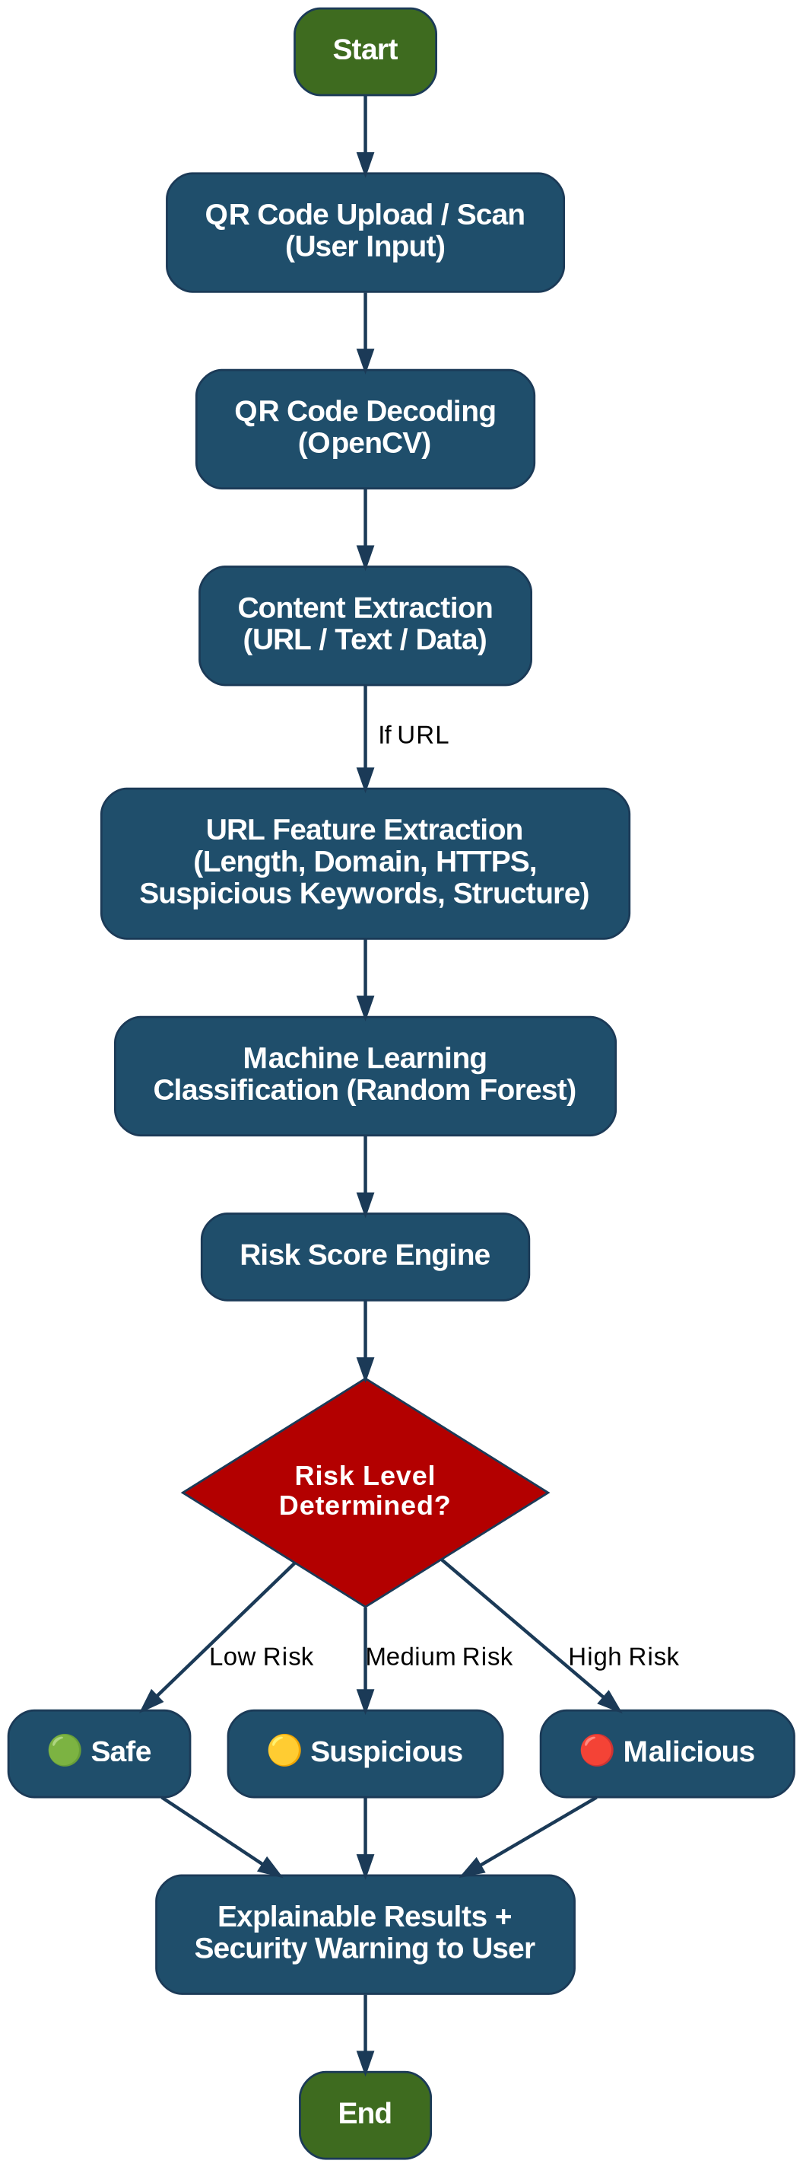
Dataset: Phishing URL Websites Dataset (PhiUSIIL) — Kaggle

Methodology Overview

1. QR Code Data Collection & Preprocessing
Benign, phishing, and malicious URL datasets are collected from publicly available cybersecurity sources. The URLs are cleaned, duplicates are removed, and the data is labeled according to security category. Selected URLs are also converted into QR codes to create a QR-specific dataset for testing and evaluation.

2. QR Code Decoding & Content Extraction
The system accepts a QR code through image upload or live scanning. The QR code is decoded to extract its embedded content, such as URLs, plain text, email addresses, or other data. For URL-based QR codes, the extracted URL is forwarded to the security analysis module.

3. Security Feature Extraction
Relevant features are extracted from the decoded URL, including URL length, number of special characters, domain characteristics, HTTPS usage, suspicious keywords, IP-based URLs, subdomain patterns, and URL shortening, among other phishing-related indicators. These features are used to identify potentially malicious characteristics.

4. Feature Selection & Preprocessing
The extracted features are cleaned, encoded, and normalized where required, then analyzed to remove irrelevant or redundant attributes. Feature selection techniques are applied to retain the most significant indicators while improving the efficiency and performance of the detection model.

5. Intelligent Malicious QR Classification
A machine learning classifier such as Random Forest, Gradient Boosting, or XGBoost is trained on the processed feature set. The model classifies QR-linked URLs as benign or malicious based on learned patterns, and the classification results are combined with rule-based security checks to improve detection reliability.

6. Risk Scoring & Threat Analysis
The system generates an overall QR Risk Score based on the detected security indicators and the machine learning prediction. Based on the score, the QR code is categorized as Safe, Suspicious, or Malicious, and the system provides an explanation of the factors contributing to the detected risk.

7. Evaluation & Performance Analysis
The proposed system is evaluated using unseen test data and QR samples. Performance is measured using accuracy, precision, recall, F1-score, false-positive rate, and detection time. The results are analyzed to determine the effectiveness of the proposed malicious QR detection approach.

8. Warning & Continuous Improvement
When a high-risk QR code is detected, the system generates an appropriate security warning and advises the user not to access the associated content. Detection results and any incorrectly classified samples are recorded for further analysis and future model improvement.

