***AI GENERATED IMAGES AND ANALYSIS***

**DELL-AI**

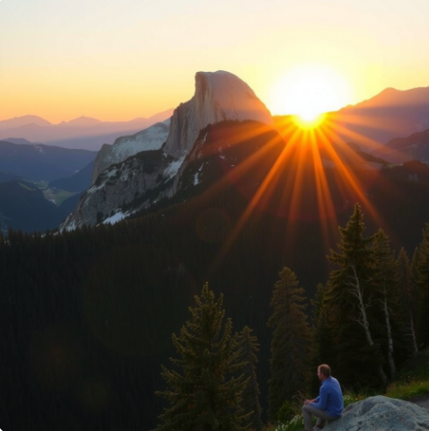

**ADOBE FIREFLY**

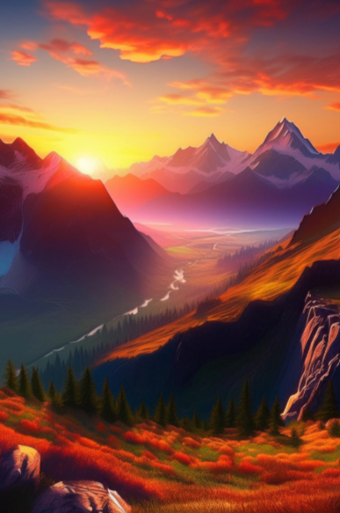

**DEEP DREAM GENERATOR**

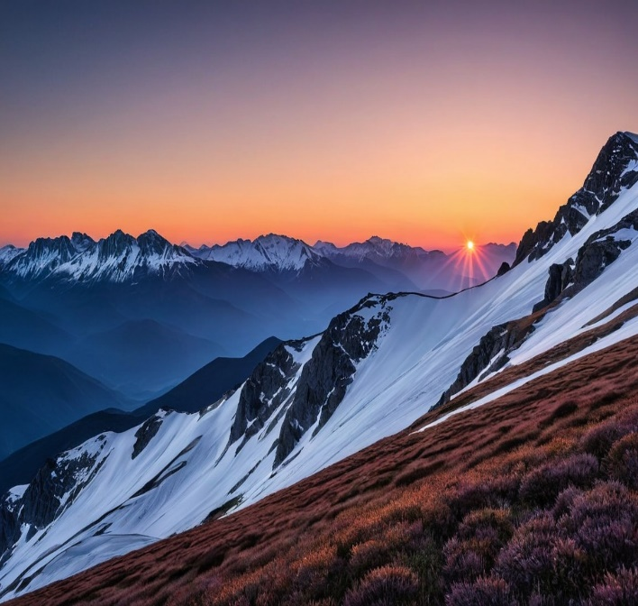

**ANALYSIS**

I've noticed that each AI tool creates mountains in its own unique way, with some looking very real, while others appear more artistic or even dreamlike.

For example, when asked to generate a snowy mountain at sunrise, DALL-E produces an image that looks like a real photograph. The sunlight gently touches the peaks, creating natural shadows and highlights. The texture of the snow appears soft, while the rocks look detailed and rugged. It captures depth very well, making the mountain feel lifelike. This is the best choice for realistic and natural-looking mountains.

Adobe Firefly, on the other hand, focuses on making the mountain look more artistic and visually appealing. The sky might have rich, dramatic colors like deep purples and oranges, while the snow reflects a warm golden glow. The details are still sharp, but the image has a slightly stylized look, almost like a beautifully edited landscape painting. This is the best choice for bright, colorful, and artistic mountains.

Deep Dream Generator creates something entirely different. Instead of making the mountain look real, it adds surreal effects, making the scene look like something from a dream. The rocks might have swirling patterns, the snow might glow in unusual colors, or the sky might have textures that don’t exist in reality. Sometimes, the shapes of the mountain even change in strange ways. This is the best choice for abstract and creative mountains that look like fantasy art.

Overall, if user needs a mountain that looks like it was taken by a camera, DALL-E is the best choice. If you want a mountain that looks like a stunning piece of digital art with bold colors, Adobe Firefly is better. But if you prefer something completely unique, almost like a dream or a painting from another world, Deep Dream Generator is the way to go. Each tool has its strengths, depending on what kind of image you need.