**Apex**

Apex is a huge-scoped programming language of Salesforce that lets developers create new business applications. The architecture of Apex is designed in such a way that it can be used by multiple users simultaneously in a distributed workspace.

The concept behind it is OOPS, so that it is very close to Java. It allows developers work with control statements on servers of Salesforce alongside with the API calls. Apex also behaves like a database which contains functions that lets users to perform CRUD actions on the data.

**Features of Apex:**

* Integrated
* Easy to use
* Data focused
* Rigorous
* Hosted
* Multi-tenancy
* Easy to test
* Works for different API versions

As Apex is a programming language, it contains elements like:

* **Variable Declaration –**

It is the beginning part of the code where objects are created using specific data types.

**Syntax:** Integer numberOfEssays = 3;

here the variable numberOfEssays is declared with integer as a datatype.

* **SOQL Query –**

Salesforce Object Query Language is a language using which developers write commands of operations to perform on the data.

**Syntax:** Contact con = [select c, number from Contact Limit 1];

the above query fetches a contact record from salesforce database.

* **Control Structure –**

It is similar to the looping statements as in every other programming language, where the action will be executed if the mentioned condition is satisfied.

**Syntax:** for(Contact con : listOfContacts){

//your logic

}

In the above query, the logic is executed for every contact in the database.

* **Arrays/ Lists –**

Arrays are collections of elements of same data type, whose memory is in sequential order. Lists are collections of elements of different data types.

**Syntax:** list<Contact>listOfContacts = [select c, number from Contact limit 100];

// execute the logic if the size of the account list is greater than zero

if(listOfContacts.size() >0){

//your logic

}

The above snippet of code is querying Contact records from the database and checking the list size.

* **Data Operations –**

The DML operations like Insert, Update, Delete, Upsert, Undelete, and Merge can be performed on the variables.

**Syntax**: Contact contact = new Contact(Number = 999999999);

Insert contact;

The above code is DML statement to insert contact record.

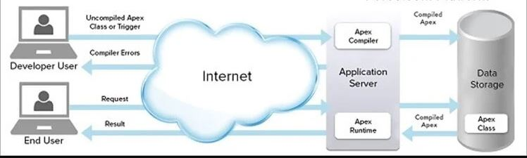

**Figure-1: Working of Apex [1]**

From Figure-1, the working flow of Apex is

End User sends a request over the Internet to the Application Server. The Apex Runtime compiles the request, stores the data in Apex Class. This will be returned as a result to the End User by the Apex Runtime over the cloud.

Whereas, the Developer User writes the code as instructions which can be understood by the Apex Runtime.

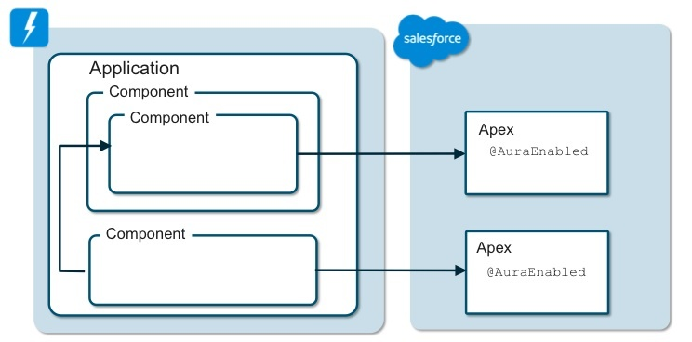

**Figure-2: Component-based structure of Apex**

Figure-2 describes the structure of Apex in a detailed form. It shows how the components are integrated inside the Application, those components are based on Apex.

**Code for generating an integer array:**

public class IntegerArrayTest{

public static List<String> generateIntegerArray(Integer n)

{

List<String> myIntArray = new List<Integer>();

for(Integer i=0;i<n;i++)

{

myIntArray.add('Test '+i);

System.debug(myIntArray[i]);

}

return myIntArray;

}

}

**Sample Input:**

IntegerArrayTest.generateIntegerArray(5);

**Sample Output:**

{0,1, 2, 3, 4}

**Analysis:**

myIntArray variable of Integer data type which is a list is created inside the generateIntegerArray method of IntegerArrayTest class.It is updated based on the user input and returned at the last on the console.

As our input is 5, starting from 0 to 4, that is the last number less than 5, are stored in the array and outputted on the console.

**Conclusion:**

In conclusion, customers prefer using Salesforce Apex as it is user-friendly and secure. But at present, the Apex code can be used only inside the salesforce.com.

Using Apex, developers of various businesses can create SAAS applications.

**References:**

1. <https://www.tutorialspoint.com/apex/apex_overview.htm> - Tutorialspoint overview of Apex
2. <https://developer.salesforce.com/blogs/developer-relations/2015/05/creating-lightning-components-component-based-architecture> - Salesforce Developers

**Please leave the query and comments in the comment section.**