PRANAVI DHIRAJ JOSHI
12622426991
TY ECE AIML C G3
DBMS
FA 1 and FA3

Problem statement :- A computer institute offers programming, networking, cybersecurity, and database courses. Students enrol in batches, faculty members conduct classes, practical laboratories are allocated, examinations are conducted, and certificates are issued after course completion.

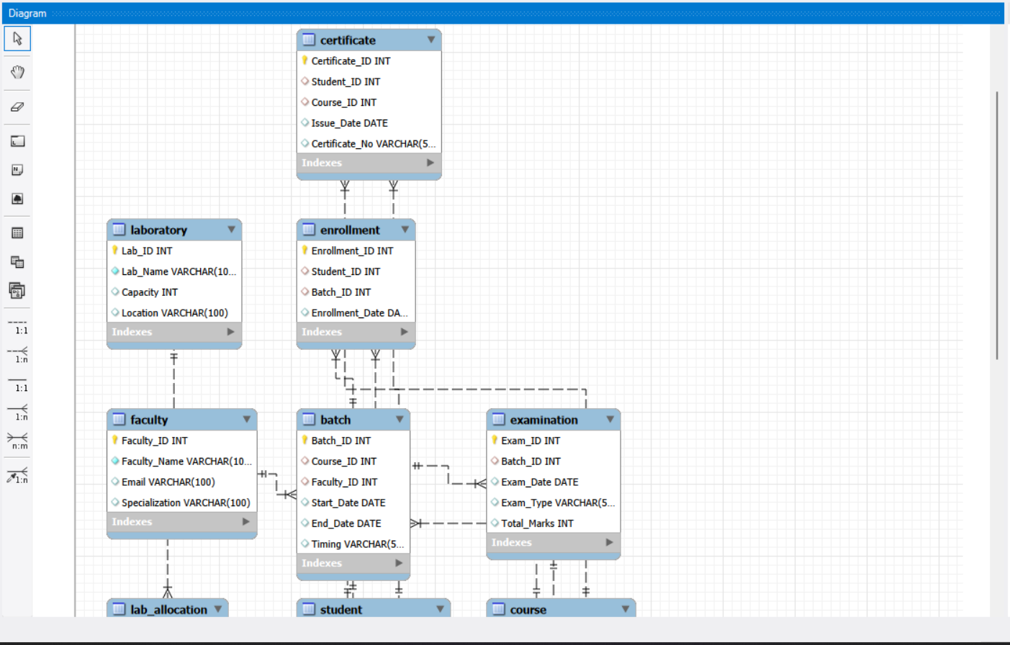
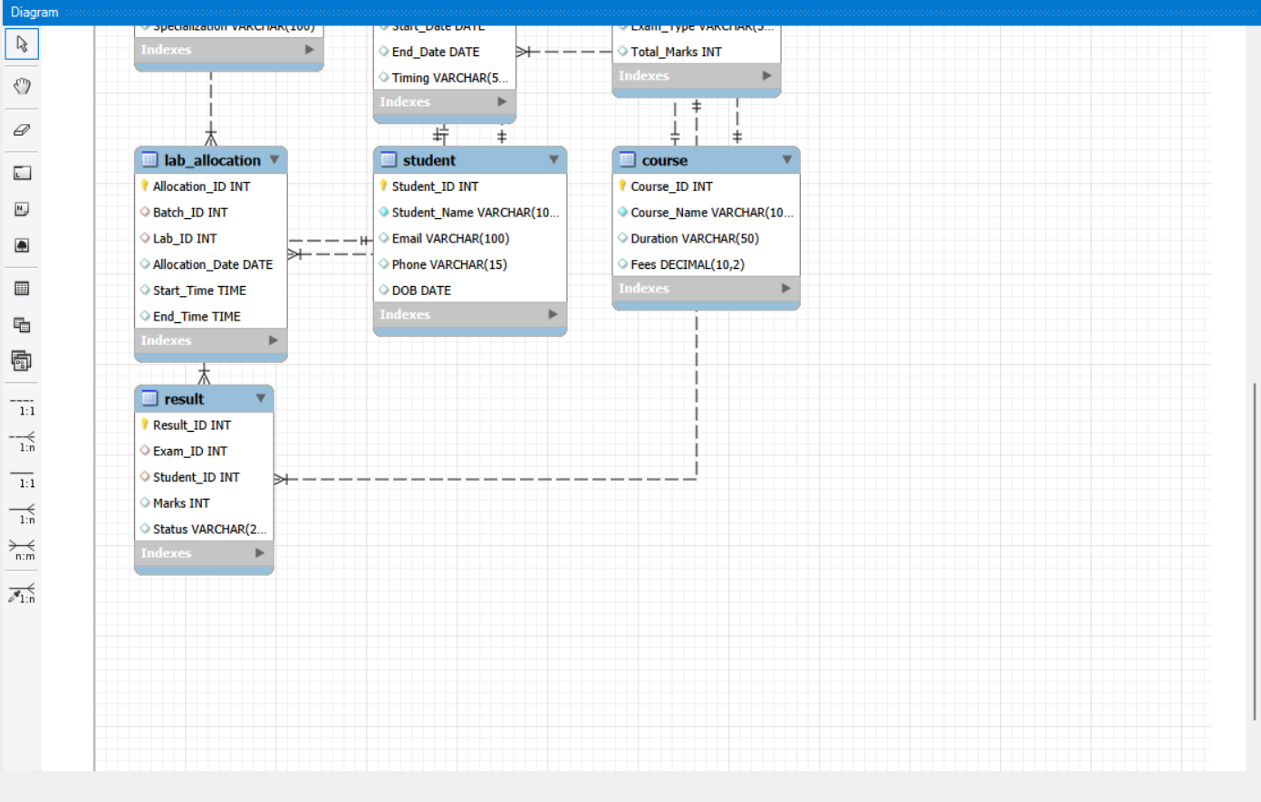

FA 3 :

Qs1. Task
- Write a query to find out the percentage of users having >= 2200 rating ( rounded to 2 decimal places ) , rename that column as percentage
SELECT
ROUND(
100.0 * SUM(CASE WHEN rating >= 2200 THEN 1 ELSE 0 END)
/ COUNT(*),
2
) AS percentage
FROM users;

Qs2Task
- Write a query to print the team name ( as team_name ) along with count of users ( rename that column as user_count ) in that team. Only print the rows with non-zero number of team members.
- Order it by team_name in ascending order

SELECT
T.name AS team_name,
COUNT(U.email) AS user_count
FROM Users U
JOIN Teams T
ON U.team_id = T.team_id
GROUP BY T.team_id, T.name
ORDER BY T.name ASC;

Qs 3 Task
Write a query to find the names of the top 3 distinct players by highest score who have won matches, including their scores.
Table 1: Players
player_id | player_name | score | rank
1 | Alice | 1200 | 5
2 | Bob | 1500 | 2
3 | Charlie | 1300 | 4
4 | David | 1600 | 1
5 | Eve | 1100 | 6
Table 2: Matches
match_id | player1 | player2 | winner | match_date
101 | Alice | Bob | Bob | 2024-01-15
102 | Charlie | David | David | 2024-01-16
103 | Eve | Bob | Bob | 2024-01-17
104 | Alice | David | David | 2024-01-18
105 | Charlie | Eve | Charlie | 2024-01-19

Expected Output Columns:
┌─────────────┬───────┐
│ player_name │ score │
├─────────────┼───────┤
│ David │ 1600 │
│ Bob │ 1500 │
│ Charlie │ 1300 │
└─────────────┴───────┘

SELECT
p.player_name,
p.score
FROM Players p
WHERE EXISTS (
SELECT 1
FROM Matches m
WHERE m.winner = p.player_name
)
ORDER BY p.score DESC
LIMIT 3;

Qs4Task
Write a query to retrieve the details of the last five matches played, including the match ID, the names of the players who participated, the name of the winning player, match date, and the final score of the winner.
There are two tables named Players and Matches.
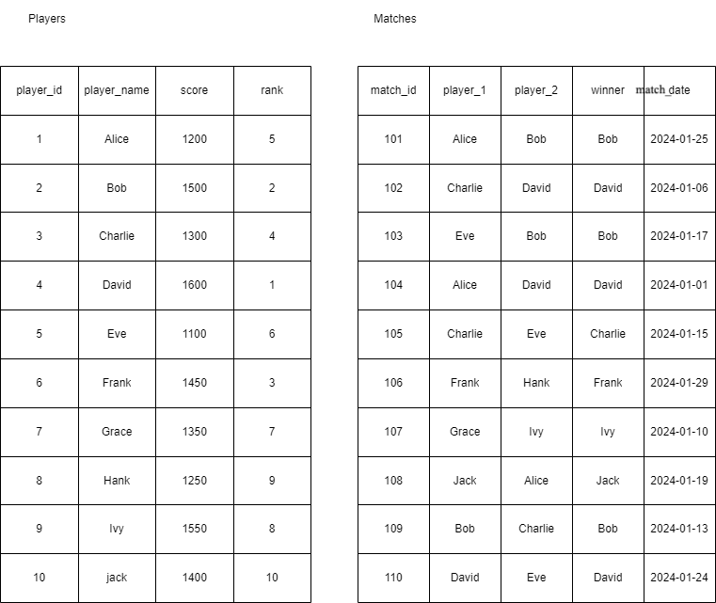

Expected Output Columns:
- match_id
- player_1
- player_2
- winner
- match_date
- score

Expected Output:
┌──────────┬──────────┬──────────┬────────┬────────────┬───────┐
│ match_id │ player_1 │ player_2 │ winner │ match_date │ score │
├──────────┼──────────┼──────────┼────────┼────────────┼───────┤
│ 106 │ Frank │ Hank │ Frank │ 2024-01-29 │ 1450 │
│ 101 │ Alice │ Bob │ Bob │ 2024-01-25 │ 1500 │
│ 110 │ David │ Eve │ David │ 2024-01-24 │ 1600 │
│ 108 │ Jack │ Alice │ Jack │ 2024-01-19 │ 1400 │
│ 103 │ Eve │ Bob │ Bob │ 2024-01-17 │ 1500 │
└──────────┴──────────┴──────────┴────────┴────────────┴───────┘
SELECT
m.match_id,
m.player_1,
m.player_2,
m.winner,
m.match_date,
p.score
FROM Matches m
JOIN Players p
ON m.winner = p.player_name
ORDER BY m.match_date DESC
LIMIT 5;

Qs5Task
- Write a query to find out the user_name of user with highest rating grouped by college
- If a college has multiple users with same max rating then print all of them

SELECT
u.college,
u.user_name
FROM Users u
JOIN (
SELECT
college,
MAX(rating) AS max_rating
FROM Users
GROUP BY college
) m
ON u.college = m.college
AND u.rating = m.max_rating;

Qs6Task
- Write a query to display the name of each college ( NOT NULL Values only ) along with the count of users from that college (rename it as "user_count"), and sort the result based on the "user_count" in ascending order.

SELECT
college,
COUNT(*) AS user_count
FROM Users
WHERE college IS NOT NULL
GROUP BY college
ORDER BY user_count ASC;

Qs7. Task
- Find the team(s) with the highest average rating among all teams and the corresponding number of users in that team.
Print the team_name , Count of users in that team as user_count & highest rating ( rounded to 2 decimal places ) as highest avg_rating
SELECT
t.name AS team_name,
COUNT(u.email) AS user_count,
ROUND(AVG(u.rating), 2) AS highest_avg_rating
FROM Users u
JOIN Teams t
ON u.team_id = t.team_id
GROUP BY t.team_id, t.name
HAVING AVG(u.rating) = (
SELECT MAX(avg_rating)
FROM (
SELECT AVG(rating) AS avg_rating
FROM Users
WHERE team_id IS NOT NULL
GROUP BY team_id
) x
)
ORDER BY t.name ASC;

Qs8Library Management System
Case Study: A Library Management System is a software application that helps manage the various activities and operations of a library. The primary goal of this system is to efficiently organize and track books, members, loans, and reservations within the library. The library contains books from different genres, and members can borrow and reserve books.
- Dataset for a Library Management System, consisting of five tables: Books Table, Authors Table, Members Table, Loans Table and Reservations Table.

What is the purpose of a CASE WHEN expression in SQL?

ANS:- To conditionally assign values or perform transformations based on specified conditions.

Qs9Purpose of ELSE in Case When
Case Study: A Library Management System is a software application that helps manage the various activities and operations of a library. The primary goal of this system is to efficiently organize and track books, members, loans, and reservations within the library. The library contains books from different genres, and members can borrow and reserve books.
- Data-set for a Library Management System, consisting of five tables: Books Table, Authors Table, Members Table, Loans Table and Reservations Table.

What is the purpose of the ELSE statement in a CASE WHEN expression?

ANS : It provides the default value or action when none of the previous conditions are met.

Qs 10Case Study: A Library Management System is a software application that helps manage the various activities and operations of a library. The primary goal of this system is to efficiently organize and track books, members, loans, and reservations within the library. The library contains books from different genres, and members can borrow and reserve books.
- Data-set for a Library Management System, consisting of five tables: Books Table, Authors Table, Members Table, Loans Table and Reservations Table.

Which option represents the correct syntax for using CASE WHEN in SQL?

ANS : CASE WHEN column_name = value THEN result ELSE other_result END

