UNIT 1 – INTRODUCTION TO NETWORKING
AND DATA COMMUNICATION
PRN:2125UCSM1061
MINI-PROJECT REPORT
Building a LAN in Cisco Packet Tracer

Student Name | Pranav Kotame
Project | Local Area Network (LAN) Simulation
Software | Cisco Packet Tracer
Network Devices | 1 Router, 2 Switches, 4 PCs
Verification | PC-to-PC and Cross-Switch Ping

Submitted as part of Unit 1 practical / mini-project

1. Objective
To design and configure a Local Area Network (LAN) in Cisco Packet Tracer using one router, two switches, and four PCs. Static IPv4 addresses are assigned to all PCs and network connectivity is verified using the ping command, including communication between PCs connected to different switches.

2. Requirements
Device / Software | Quantity | Purpose
Cisco Packet Tracer | 1 | Network simulation
Cisco 2911 Router | 1 | Network gateway / Layer-3 device
Cisco 2960 Switch | 2 | LAN switching
PC-PT | 4 | End devices
Copper Ethernet cables | 6 | Device interconnection

3. Network Topology
The network consists of Router R1 connected to Switch SW1. SW1 is connected to SW2, while two PCs are connected to each switch.
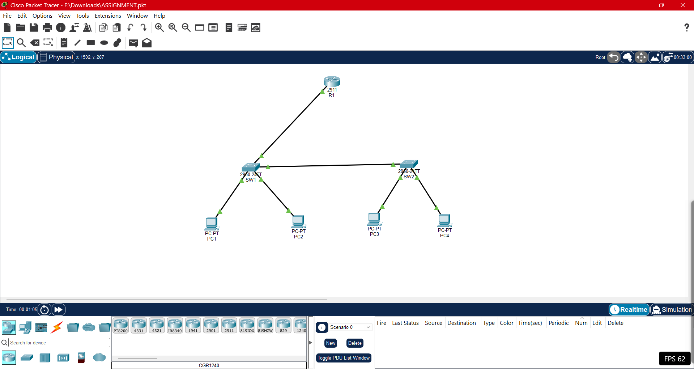
Figure 1: Cisco Packet Tracer LAN topology

4. IP Addressing Plan
Device | Interface | IP Address | Subnet Mask | Default Gateway
R1 | G0/0 | 192.168.10.1 | 255.255.255.0 | —
PC1 | FastEthernet0 | 192.168.10.11 | 255.255.255.0 | 192.168.10.1
PC2 | FastEthernet0 | 192.168.10.12 | 255.255.255.0 | 192.168.10.1
PC3 | FastEthernet0 | 192.168.10.13 | 255.255.255.0 | 192.168.10.1
PC4 | FastEthernet0 | 192.168.10.14 | 255.255.255.0 | 192.168.10.1

5. Configuration Procedure
- Placed one Cisco 2911 router (R1), two Cisco 2960 switches (SW1 and SW2), and four PCs (PC1–PC4) in the Packet Tracer workspace.
- Connected R1 G0/0 to SW1 and connected SW1 to SW2 using Ethernet cables.
- Connected PC1 and PC2 to SW1, and PC3 and PC4 to SW2.
- Configured R1 G0/0 with IP address 192.168.10.1/24 and enabled the interface using the no shutdown command.
- Configured static IPv4 addresses on PC1–PC4 using the addressing plan shown above.
- Used the ping command from PC1 to verify communication with PCs on the same and different switches.

6. Router Configuration Commands
enable
configure terminal
interface gigabitEthernet 0/0
ip address 192.168.10.1 255.255.255.0
no shutdown
exit
end
show ip interface brief

7. Connectivity Verification
The connectivity test was performed from PC1 using the Command Prompt. PC1 successfully reached PC3 and PC4, which are connected through the second switch.
Test commands:
- ping 192.168.10.13
- ping 192.168.10.14
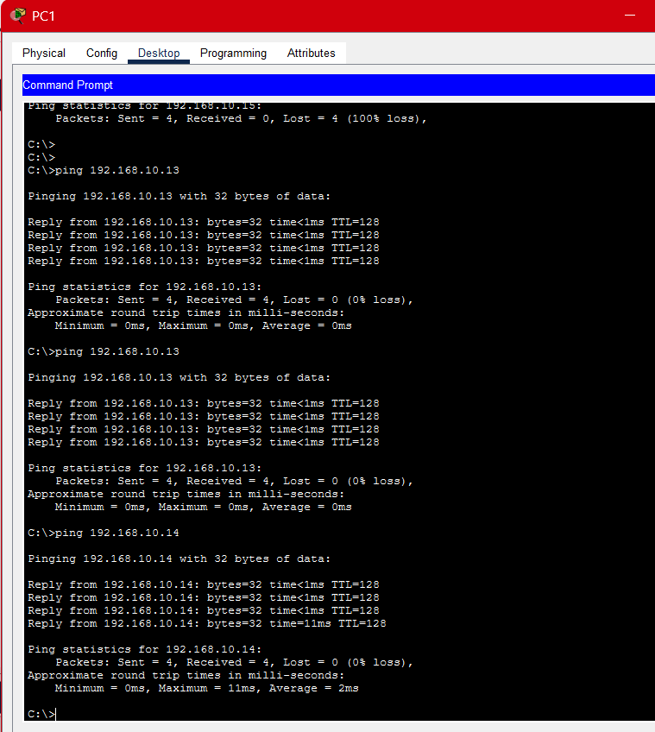
Figure 2: Successful PC1 ping responses

8. Test Results
Source | Destination | Packets | Result
PC1 | PC3 (192.168.10.13) | 4 sent / 4 received | 0% loss – SUCCESS
PC1 | PC4 (192.168.10.14) | 4 sent / 4 received | 0% loss – SUCCESS

9. Result
The LAN was successfully designed and configured in Cisco Packet Tracer. All four PCs were assigned static IPv4 addresses. The router interface was enabled successfully, all network links were operational, and PC-to-PC communication was verified. Cross-switch communication between PC1 and PC3 was successful with 0% packet loss.

10. Conclusion
This mini-project demonstrated the basic principles of networking and data communication, including LAN topology, Ethernet switching, IPv4 addressing, subnet masks, default gateways, router interface configuration, and connectivity testing with ICMP ping. The successful cross-switch ping confirmed that the configured LAN was functioning correctly.

11. Submission Evidence Checklist
- ✓ Cisco Packet Tracer project file: ASSIGNMENT.pkt
- ✓ Topology screenshot showing R1, SW1, SW2, PC1, PC2, PC3 and PC4
- ✓ Successful ping screenshot showing PC1 → PC3 and PC1 → PC4 with 0% packet loss

