



SCOPING SHEET

For

APPLICATION SECURITY AUDIT

Prepared by
Innovador Infotech Pvt. Ltd.

- Innovador Infotech- A Brief Introduction:
Innovador Infotech Pvt Limited is an Information Security Service company which is based in India and provides Information Security related services to the government and private enterprises in India another country.
The company is also a certified Information Security auditor, empaneled by CERT-IN (Computer Emergency Response Team), & STQC Empaneled Test Lab (SETL) which is India’s premier body tasked with preparing the policies and undertaking activities for safeguarding the critical computer infrastructure of the country. These auditing companies are appointed after a stringent 4-step qualification process by CERT-IN, the nodal agency for designing and implementing cyber policy in India. As on date, there are less than 100 CERT-IN empanelled information security auditing companies.
As the world goes digital, the threat of cyber-attacks, malware, unauthorized intrusion, and incidents of data theft are on the rise, securing the digital infrastructure is critical to financial as well as reputational well-being of the organization such a scenario, a qualified cyber-security expert like us can help and guide an organization during the process of preparing an effective defense of their digital assets.

With us, you are in safe hands.

- Key Components of Cyber Security Process:

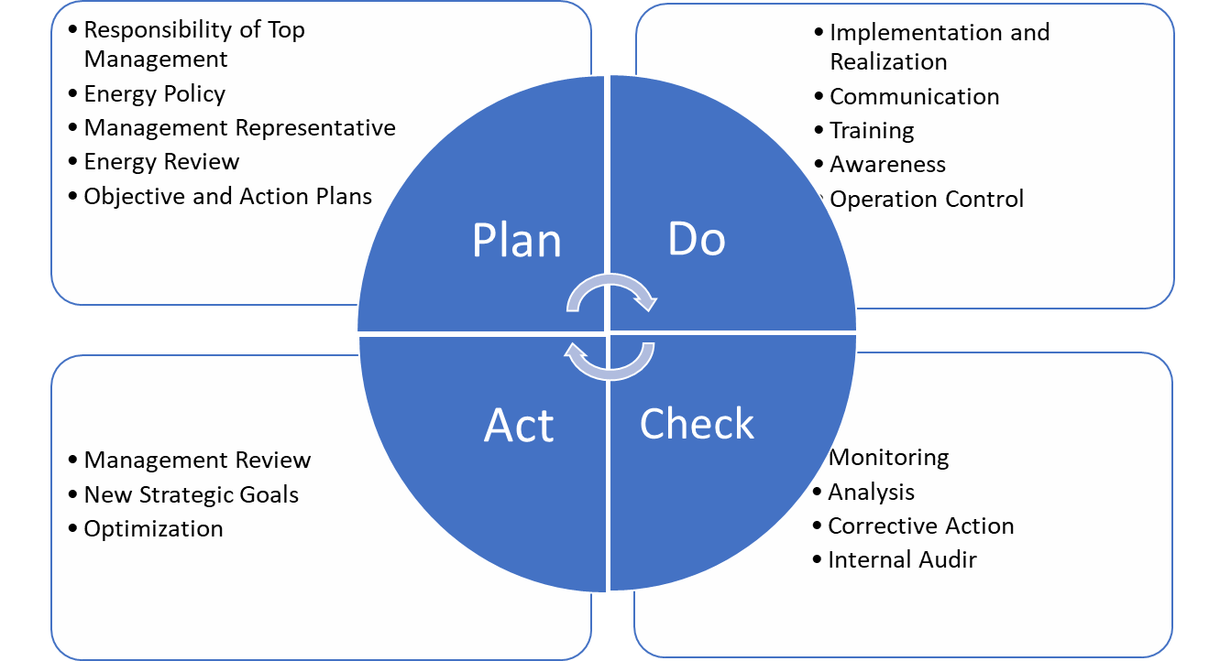

- Process Followed for Preparing Comprehensive Cyber Security Audit Report:
Innovador Infotech follows a 12-step process while undertaking a Comprehensive Cyber Security Audit and preparing the report. This process starts with defining the scope and purpose of the audit and ends with the audit observation and suggestions for continual improvement in the cyber security policies and practices at the organization.


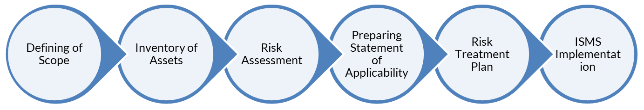

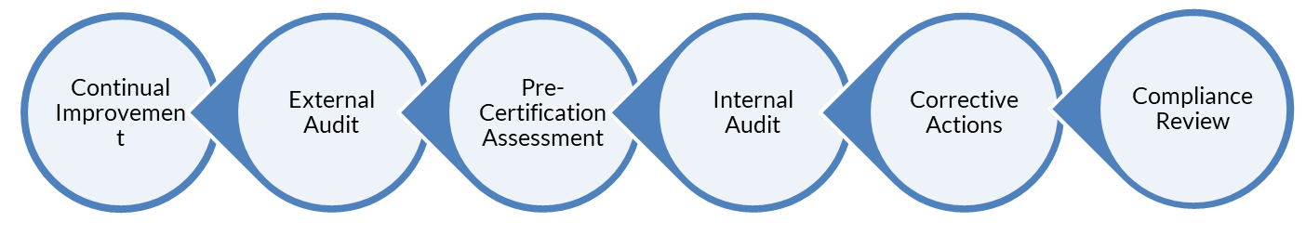
- Vulnerability Assessment & Risk Assessment (VAPT) Scoping Sheet for Applications.

S.N. | Technical Details of Scope(s)
1 | Number of Applications
2 | Application Name (to be mentioned on the Report and Certificate)
3 | Client Name (to be mentioned on the Report and Certificate)
4 | Application URL(s) – Host URL(s)  (To be mentioned on the Certificate)
5 | Application URL(s) – Test URL(s)  (To be used by our Team for VAPT)
6 | Application Descriptions  (Please share the application details with major module names)
7 | Please mention the email IDs for reports sharing.
8 | Please mention SPOC Name, Phone Number and Designation.  **Please mention the contact details of the technical person who will be available to assist in case of any issues during testing.
9 | Detailed Scope including Applications, APIs, Ips or others.

S. N. | Information About the Application | Version and Count
1 | Database
2 | Development platform for application
3 | Technologies Used for by the application (Front-End)
4 | Technologies Used for by the application (Back-End)
5 | How many application roles/privilege levels of users? <Please share the application credentials i.e. minimum 2 credentials per user role for example if a web application has student role and admin role users, we need credentials of min 2 students and 2 admin>
6 | Does the application provide a file download feature (Yes / No)?
7 | Does the application use a client-side certificate (Yes / No)?
8 | Is there a CMS (Content Management System) present to maintain the public portal/login module?
9 | Tentative Testing environment (Development / Staging / Production Box)?
10 | Does the application have SMS integration (Yes/No)?
11 | Does the application have E-Mail integration (Yes/No)?
12 | Does the application have Payment Gateway integration (Yes/No)?
13 | Does the application provide a file upload feature (Yes / No)?
14 | Does the application have any API integration (Provide the location) (Yes / No)?
15 | Provide all the API endpoints.

S.N. | Detail of Total Number of Pages | Folder Wise Count
1 | Dynamic
2 | Static
3 | Any Other pages
4 | Total Pages

- Note:

  - The details asked are required to give a techno-commercial proposal for Gap analysis, Implementation Consulting, Audit, and Certification, as per ISO 27001:2013 standards.
  - All the details will remain confidential and be used by the Internal Team of Innovador Infotech only.
  - Please get in touch in case of any input or clarifications.

Module names

Please mention the module names inside the application.

List of Web API’s

Kindly provide the complete list of API endpoints in the application.

