React.js – Components, State & Forms
These are three important concepts in React.js. Let's understand each with definitions, features, syntax and practical examples.

1. React Components

Definition
A React Component is a reusable and independent piece of code that is used to create a part of the user interface (UI) of a web application.
Components help divide a large application into smaller and manageable parts.
Example: A website can have separate components for:
- Header
- Navigation bar
- Login form
- Footer
- Sidebar

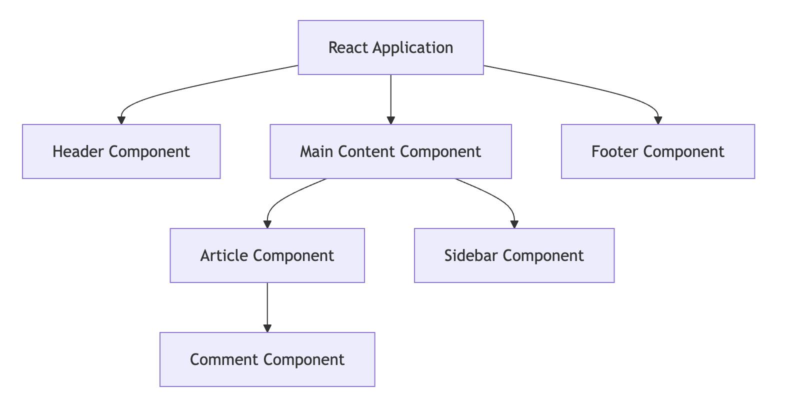

Types of React Components
There are two commonly discussed types:

A. Functional Components
- Functional components are JavaScript functions.
- They return JSX to display UI.
- They can use React Hooks such as useState and useEffect.
- They are commonly used in modern React applications.
Example:
function Welcome() {
return <h1>Welcome to React!</h1>;
}

export default Welcome;

B. Class Components
- Class components are created using JavaScript classes.
- They extend the React.Component class.
- They use a render() method to return JSX.
- They can manage state using this.state.
Example:
import React from "react";

class Welcome extends React.Component {
render() {
return <h1>Welcome to React!</h1>;
}
}

export default Welcome;

Advantages of Components
- Code reusability.
- Easy maintenance.
- Better code organization.
- Simplifies application development.
- Makes testing easier.

2. State in React.js

Definition
State is an object or data maintained inside a React component that stores information which can change over time.
When the state changes, React automatically updates the user interface wherever that state is used.
Examples:
- Counter value.
- Login status.
- Username.
- Selected theme.
- Shopping cart items.

useState Hook
useState() is a React Hook used to create and manage state in functional components.
Syntax:
const [state, setState] = useState(initialValue);
Where:
- state – Stores the current value.
- setState – Updates the state value.
- initialValue – Initial value of the state.

Example: Counter Application
import { useState } from "react";

function Counter() {
const [count, setCount] = useState(0);

return (
<div>
<h2>Counter: {count}</h2>

<button onClick={() => setCount(count + 1)}>
Increase
</button>

<button onClick={() => setCount(count - 1)}>
Decrease
</button>
</div>
);
}

export default Counter;

3. Forms in React.js

Definition
A Form in React.js is used to collect information from users through input fields such as text boxes, checkboxes, radio buttons and dropdown menus.
React forms commonly use state to manage and control input values.
Examples:
- Student registration form.
- Login form.
- Contact form.
- Feedback form.

Types of Forms in React

A. Controlled Components
- Input values are controlled by React state.
- The value attribute is connected to state.
- The onChange event updates the state.
- Provides better control over form data.
Example:
import { useState } from "react";

function StudentForm() {
const [name, setName] = useState("");

return (
<div>
<h2>Student Form</h2>

<input
type="text"
value={name}
onChange={(e) => setName(e.target.value)}
placeholder="Enter Name"
/>

<p>Your Name: {name}</p>
</div>
);
}

export default StudentForm;

B. Uncontrolled Components
- Input values are managed by the DOM itself.
- React does not control every input update through state.
- The useRef() Hook is commonly used to access input values.
- Useful for simple forms.
Example:
import { useRef } from "react";

function StudentForm() {
const nameRef = useRef();

function handleSubmit(e) {
e.preventDefault();
alert(nameRef.current.value);
}

return (
<form onSubmit={handleSubmit}>
<input
type="text"
ref={nameRef}
placeholder="Enter Name"
/>

<button type="submit">Submit</button>
</form>
);
}

export default StudentForm;

Practical Example: Student Registration Form
The following is an interactive demonstration of a React-style controlled form.
Student Registration
Top of Form
Full Name
Email Address
Select CourseComputer Engineering
Gender
Male
Female
Other
Submit Registration

Bottom of Form

4. Difference Between Components, State and Forms
Components | State | Forms
Building blocks of UI | Stores changing data | Collects user information
Creates reusable UI | Manages dynamic values | Accepts user input
Uses functions or classes | Uses Hooks like useState | Uses input elements
Example: Header | Example: Counter | Example: Registration

5. Important React.js Events
Event | Description
onClick | When a user clicks a button
onChange | When input value changes
onSubmit | When a form is submitted
onFocus | When an input gets focus
onBlur | When an input loses focus

1. Functional Components
Definition:
A Functional Component is a JavaScript function that returns JSX to display the user interface (UI) in a React application.
Features:
- It is created using a JavaScript function.
- It returns JSX elements.
- It is reusable and easy to maintain.
- It supports React Hooks.
- It makes code simple and readable.
Example:
function Welcome() {
return <h1>Welcome to React</h1>;
}

export default Welcome;

2. Props (Properties)
Definition:
Props are special arguments used to pass data from a parent component to a child component in React.
Features:
- Props are used for data sharing between components.
- They are passed from parent to child.
- Props are read-only.
- They help create reusable components.
- They can contain strings, numbers, arrays and objects.
Example:
function Student(props) {
return <h2>Hello, {props.name}</h2>;
}

function App() {
return <Student name="Pranav" />;
}
Output: Hello, Pranav

3. State
Definition:
State is a built-in React feature used to store and manage data inside a component. When state changes, React updates the user interface automatically.
Features:
- State stores dynamic data.
- It can change during application execution.
- State is managed inside a component.
- Updating state causes the component to re-render.
- State makes applications interactive.
Example:
import { useState } from "react";

function App() {
const [name, setName] = useState("Pranav");

return <h2>{name}</h2>;
}

4. useState Hook
Definition:
The useState Hook is a React Hook used to add and manage state in functional components.
Syntax:
const [state, setState] = useState(initialValue);
Features:
- It manages component state.
- It stores the initial value.
- It provides a function to update state.
- It automatically re-renders the component when state changes.
- It can store strings, numbers, arrays and objects.
Example:
import { useState } from "react";

function Counter() {
const [count, setCount] = useState(0);

return (
<div>
<h2>{count}</h2>
<button onClick={() => setCount(count + 1)}>
Increase
</button>
</div>
);
}

5. Event Handling
Definition:
Event Handling in React is the process of responding to user actions such as clicking buttons, typing text, submitting forms and moving the mouse.
Features:
- Events make applications interactive.
- Event names are written in camelCase.
- Event handlers are passed as functions.
- React supports different types of events.
- Events can update the component state.
Common Events:
Event | Description
onClick | Button click
onChange | Input value change
onSubmit | Form submission
onMouseOver | Mouse moves over an element
onKeyDown | Keyboard key is pressed
Example:
function App() {
function showMessage() {
alert("Button Clicked!");
}

return (
<button onClick={showMessage}>
Click Me
</button>
);
}

6. Controlled Components
Definition:
Controlled Components are form elements whose values are controlled by React state. The input value is updated using the onChange event.
Features:
- Input values are managed by React state.
- The value attribute is connected to state.
- The onChange event updates the state.
- They provide better control over user input.
- They are useful for form validation.
Example:
import { useState } from "react";

function App() {
const [name, setName] = useState("");

return (
<input
value={name}
onChange={(e) => setName(e.target.value)}
placeholder="Enter Name"
/>
);
}

7. Form Handling
Definition:
Form Handling in React is the process of collecting, managing and processing user information through form elements such as text fields, checkboxes, radio buttons and dropdown menus.
Features:
- It collects information from users.
- It manages input values using state.
- It uses the onChange event to update values.
- It uses the onSubmit event to submit forms.
- It helps validate user information.
- It prevents unwanted page reloading using preventDefault().
Example:
import { useState } from "react";

function StudentForm() {
const [name, setName] = useState("");

function handleSubmit(e) {
e.preventDefault();
alert("Welcome " + name);
}

return (
<form onSubmit={handleSubmit}>
<input
value={name}
onChange={(e) => setName(e.target.value)}
placeholder="Enter Name"
/>

<button type="submit">Submit</button>
</form>
);
}

8. Conditional Rendering
Definition:
Conditional Rendering is a technique in React used to display different UI elements based on a particular condition.
Features:
- It displays UI based on conditions.
- It uses JavaScript conditional statements.
- It supports if-else statements.
- It uses the ternary operator (? :).
- It helps show or hide elements dynamically.
Example:
function App() {
const isLoggedIn = true;

return (
<div>
{isLoggedIn ? (
<h2>Welcome User</h2>
) : (
<h2>Please Login</h2>
)}
</div>
);
}
Output: Welcome User

9. Basic Form Validation
Definition:
Form Validation is the process of checking user-entered information to ensure that it is correct, complete and follows the required format before submitting the form.
Features:
- It checks whether required fields are empty.
- It validates email addresses.
- It checks password length.
- It verifies input formats.
- It displays error messages for invalid inputs.
- It prevents submission of incorrect data.
Example:
import { useState } from "react";

function App() {
const [email, setEmail] = useState("");
const [error, setError] = useState("");

function handleSubmit(e) {
e.preventDefault();

if (!email.includes("@")) {
setError("Enter a valid email");
} else {
setError("");
alert("Form Submitted Successfully");
}
}

return (
<form onSubmit={handleSubmit}>
<input
type="text"
placeholder="Enter Email"
value={email}
onChange={(e) => setEmail(e.target.value)}
/>

<p>{error}</p>

<button type="submit">Submit</button>
</form>
);
}

