***Lab 04: Ping Utility Analysis Report:***

***1. Ping Basics:***

1.1 **Purpose of Ping Utility:** The ping command is a network utility used to test the reachability of a host on an Internet Protocol (IP) network. It works by sending ICMP (Internet Control Message Protocol) Echo Request packets to the target host and waiting for an Echo Reply. The primary use of ping is to check network connectivity and to measure the round-trip time for messages sent from the source to the destination.

The basic syntax for the ping command is as follows:

***ping [options] destination***

* destination: The IP address or hostname of the target to ping.
* options: Various options that can modify the behaviour of the ping command.

**1.3 Examples:**

**2. Ping Output Analysis:**

***Breakdown of the Output:***

* PING Header: Indicates the IP address of the target and the packet size.
* ICMP Sequence: Each line shows the response from the target, including:
* icmp_seq=0: The sequence number of the packet.
* ttl=56 : Time-To-Live value, which indicates the remaining lifespan of the packet in the network.
* time=68.0 ms: The round-trip time in milliseconds.
* Ping Statistics Summary: Provides the overall statistics:
* 4 packets transmitted, 4 packets received, 0.0% packet loss: Indicates that all packets were successfully received, with no packet loss.
* round-trip min/avg/max/stddev: Shows the minimum, average, maximum, and standard deviation of the round-trip times.

**3. Ping Options**

**3.1 -c (count)**

This option specifies the number of echo requests to send.

* **Example**: Send 4 ping requests to 127.0.0.1

**3.2 -s (size)**

This option allows you to specify the size of the packet to send.

* **Example**: Send ping requests with a packet size of 100 bytes

**3.3 -t (ttl)**

This option sets the TTL (Time-To-Live) value, which limits the number of hops a packet can take.

* **Example**: Send ping requests with a TTL value of 10

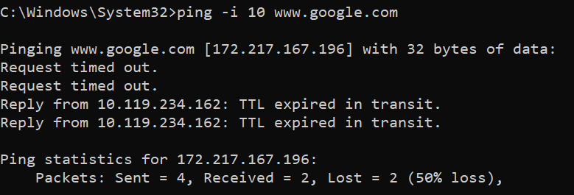

**3.4 -w (Timeout)**

To set the timeout in milliseconds for each reply:

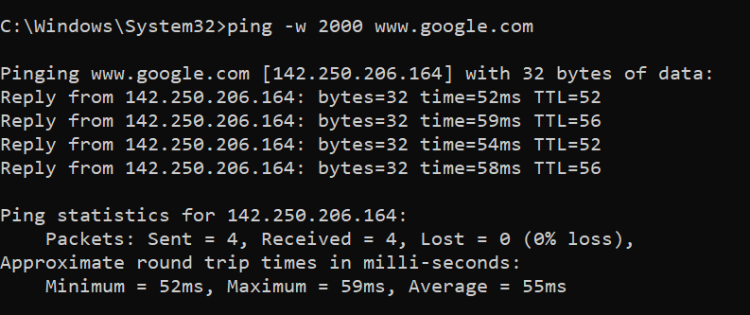

**4. Troubleshooting with Ping**

**4.1 Diagnosing Connectivity Issues**

To diagnose connectivity issues by sending 10 pings with a TTL value of 5:

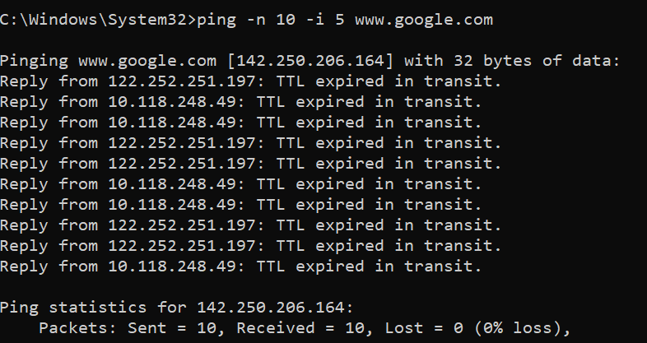

**4.2 Testing with Larger Packets**

To test with a larger packet size (e.g., 1000 bytes):

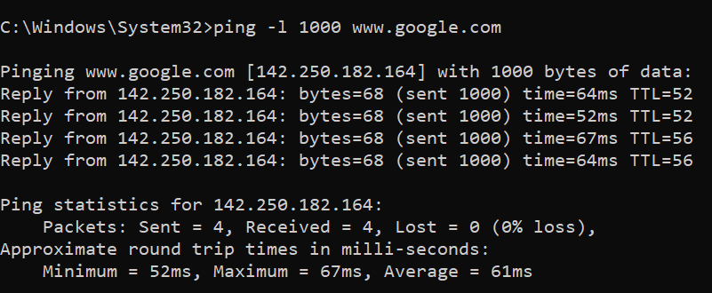

**4.3 Testing for Packet Loss and Latency**

To test for packet loss and analyze round-trip times, run the following command and manually review the output:

**5. SCAPY Code:**

**Explanation of the Script**

1. Imports:
   * from scapy.all import *: Imports all necessary Scapy modules.
   * import time: Used for calculating the round-trip time and controlling the delay between packets.
2. custom_ping Function:
   * Parameters:
     + destination: IP address or hostname of the target.
     + count: Number of ICMP requests to send.
     + ttl: Time-To-Live value for each packet.
     + size: Size of the ICMP packet payload.
     + timeout: Timeout in seconds for each reply.
   * Packet Creation:
     + Uses the IP() and ICMP() classes from Scapy to create an IP packet with an ICMP Echo Request.
     + The Raw() class is used to generate a payload of the specified size.
   * Sending and Receiving:
     + sr1() sends the packet and waits for a reply within the specified timeout.
     + RTT (Round-Trip Time) is calculated by measuring the time difference between sending the packet and receiving a reply.
   * Output:
     + Displays the reply details including source IP, round-trip time, and TTL.
     + If no reply is received within the timeout, it prints "Request timed out."
   * Statistics:
     + After all pings, the script calculates and prints packet loss and round-trip time statistics (min, max, average).
3. Main Execution Block:
   * Prompts the user to input the destination, count, TTL, packet size, and timeout.
   * Calls the custom_ping() function with these values.
   * Error handling is implemented using a try-except block to catch and report any exceptions.
   * 