***NAME: PRANAV SAKUNDE***

***URN:2023-B-20012005C***

***COURSE: BCA (AIML)***

***SEMISTER:4***

***SUBJECT:AIML***  
  
  
***Data Visualization Report***

**Step 1: Load Dataset**  
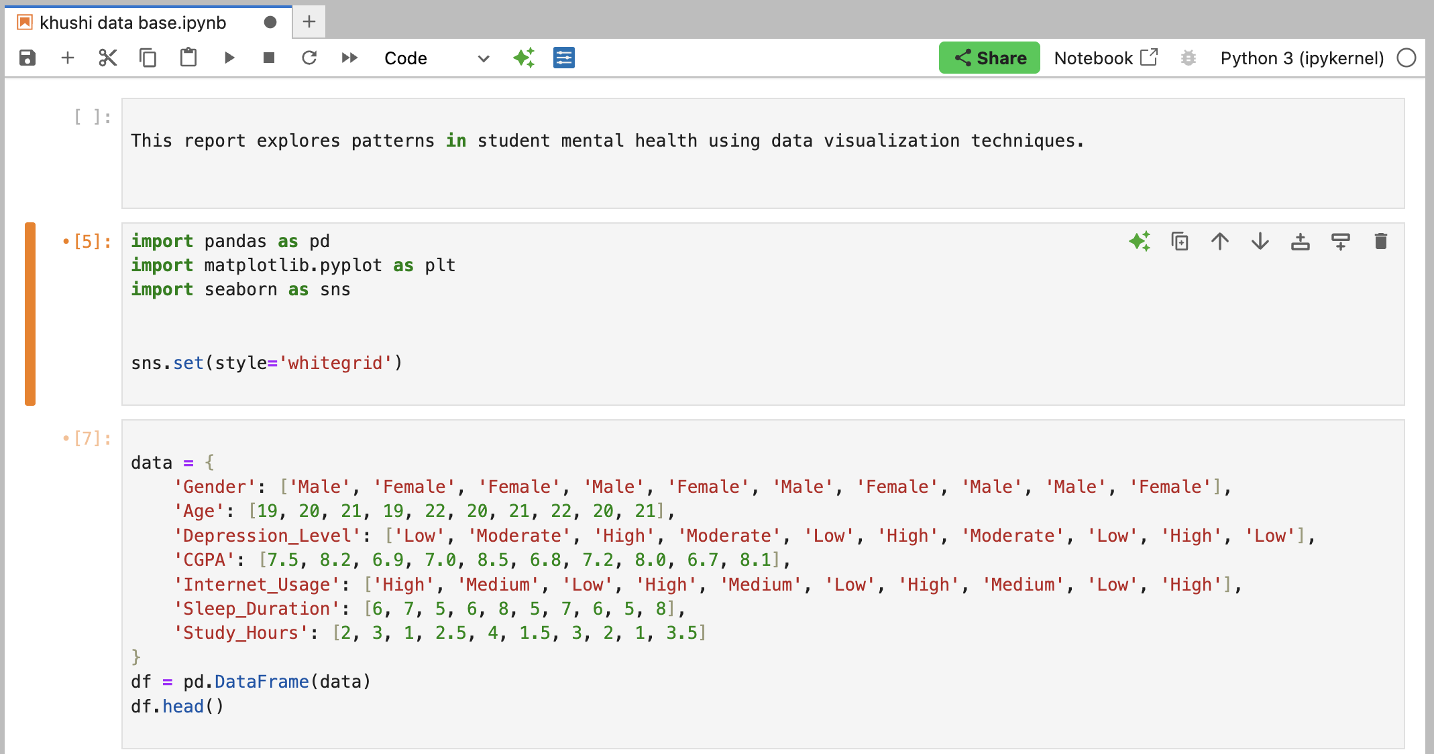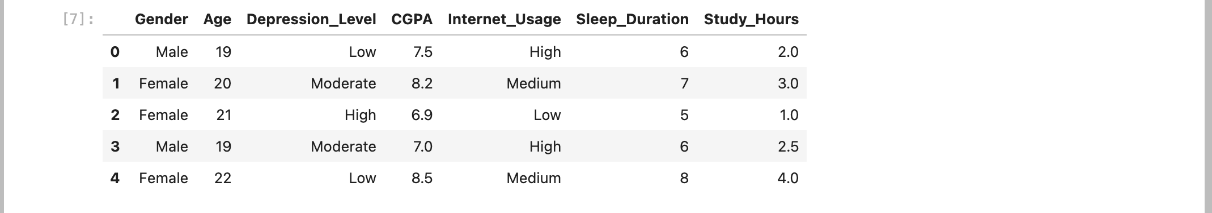

1. **Pie Chart** – Gender distribution  
   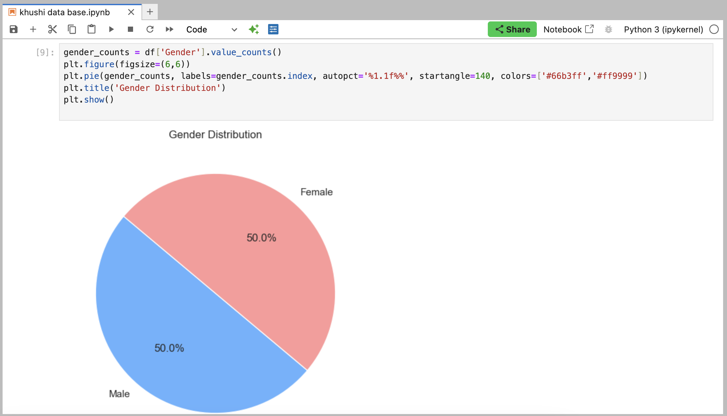
2. **Bar Chart** – Count by Depression Level  
   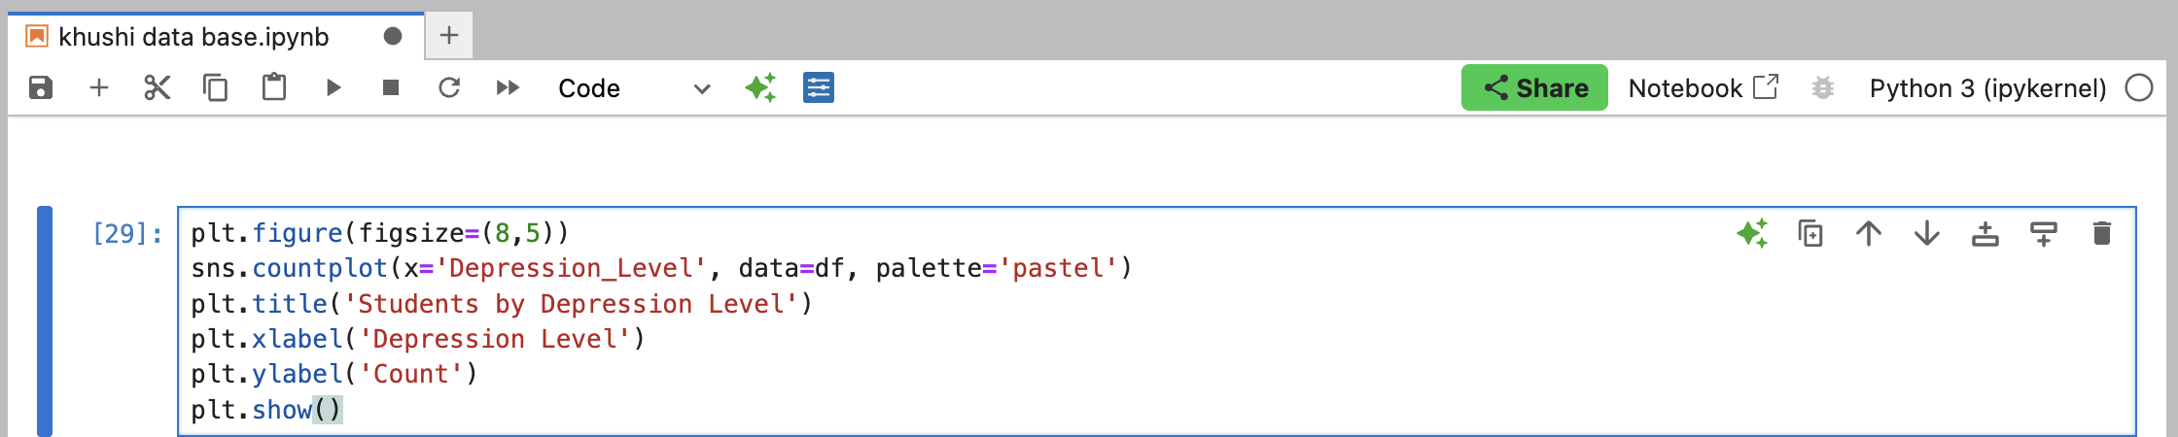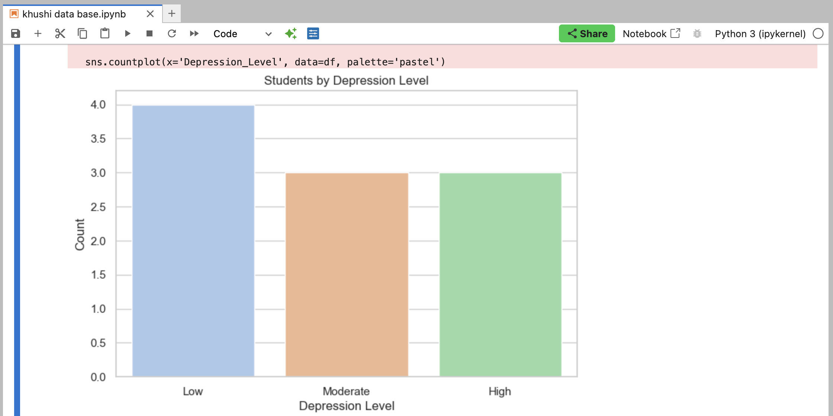
3. **Histogram** – Age Distribution  
   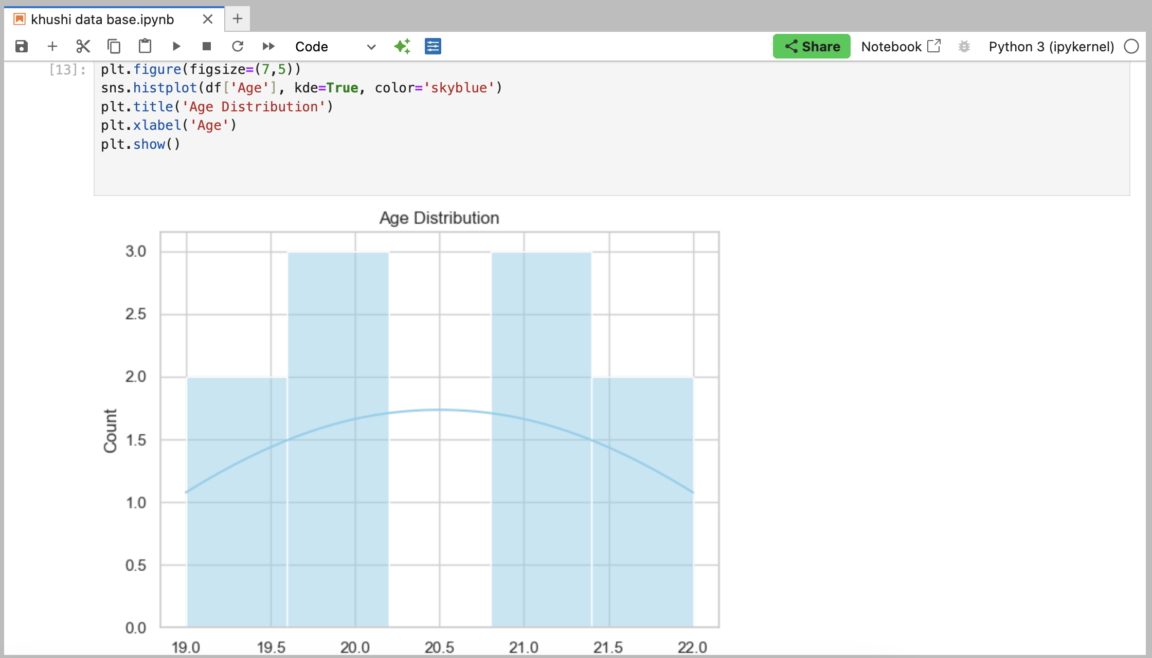
4. **Box Plot** – Age vs Depression Level  
   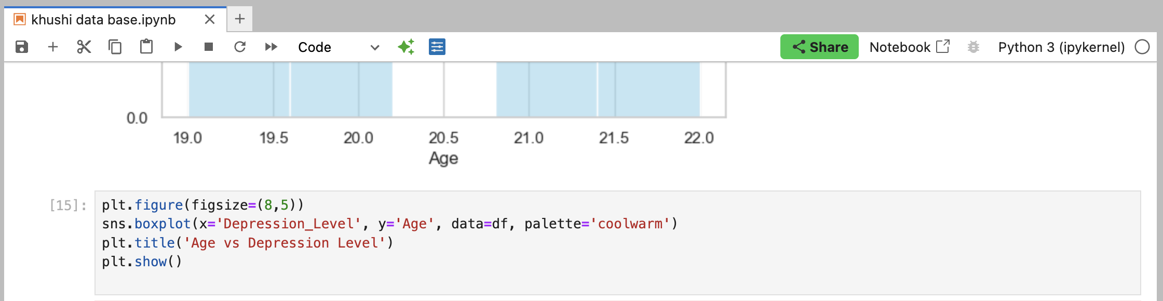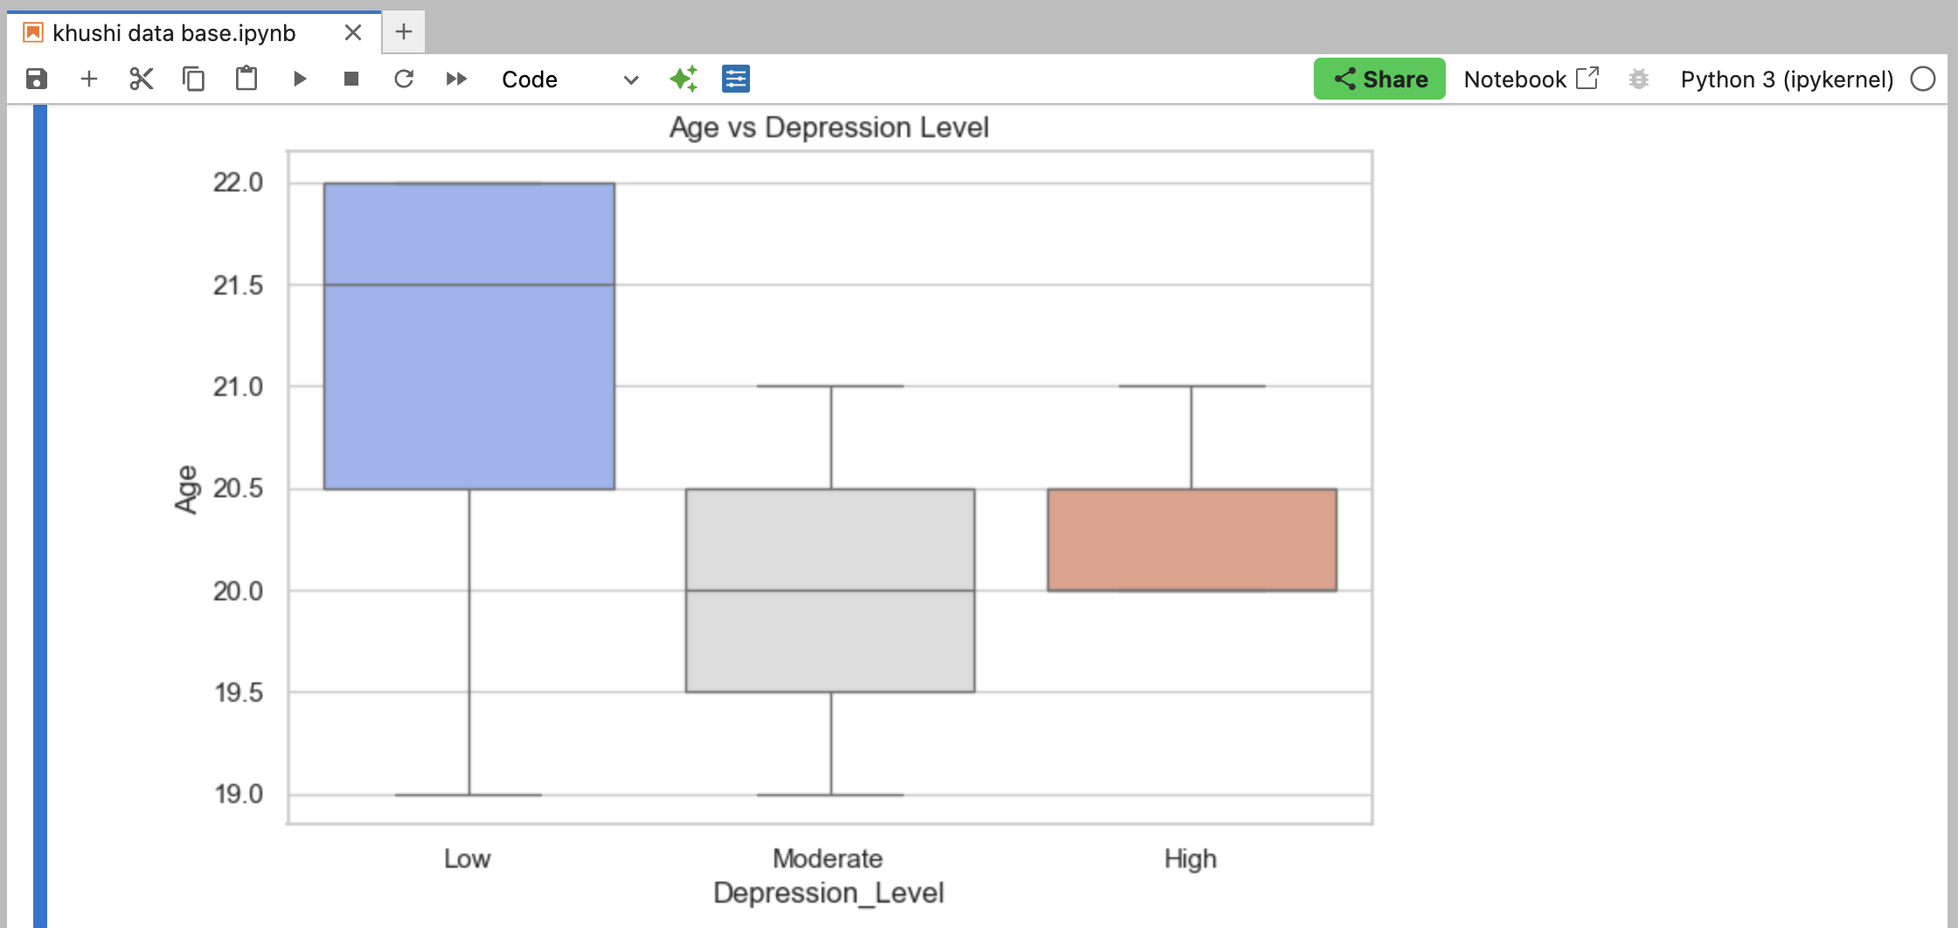
5. **Count Plot** – Internet Usage  
   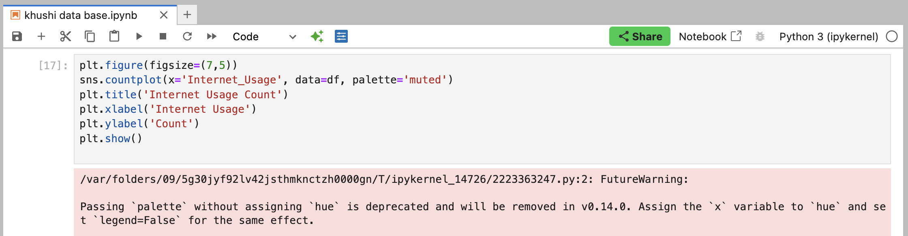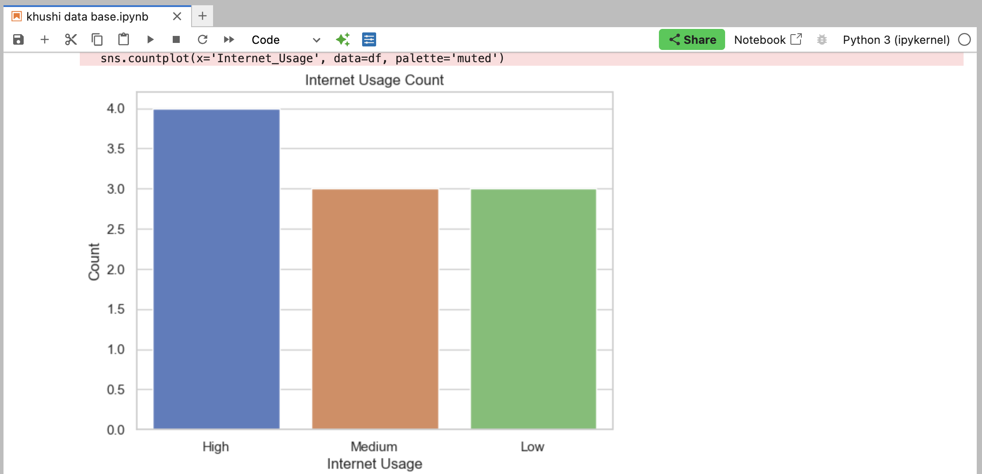
6. **Box Plot** – CGPA by Gender  
     
   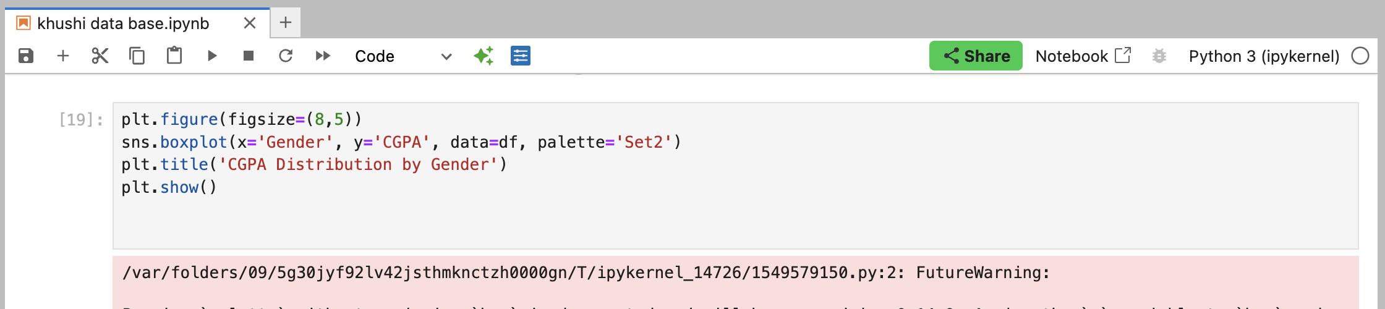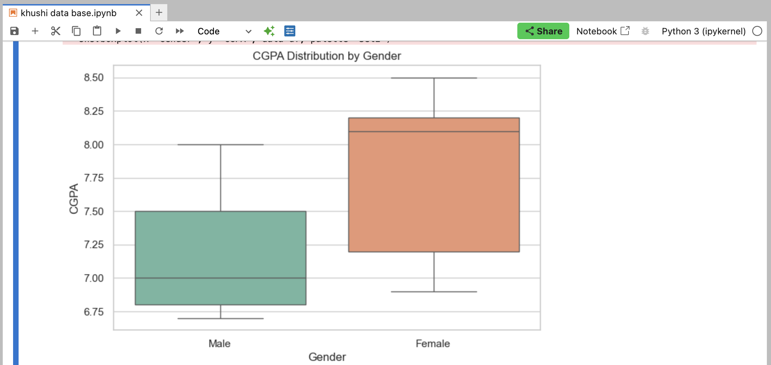
7. Histogram: Sleep Duration

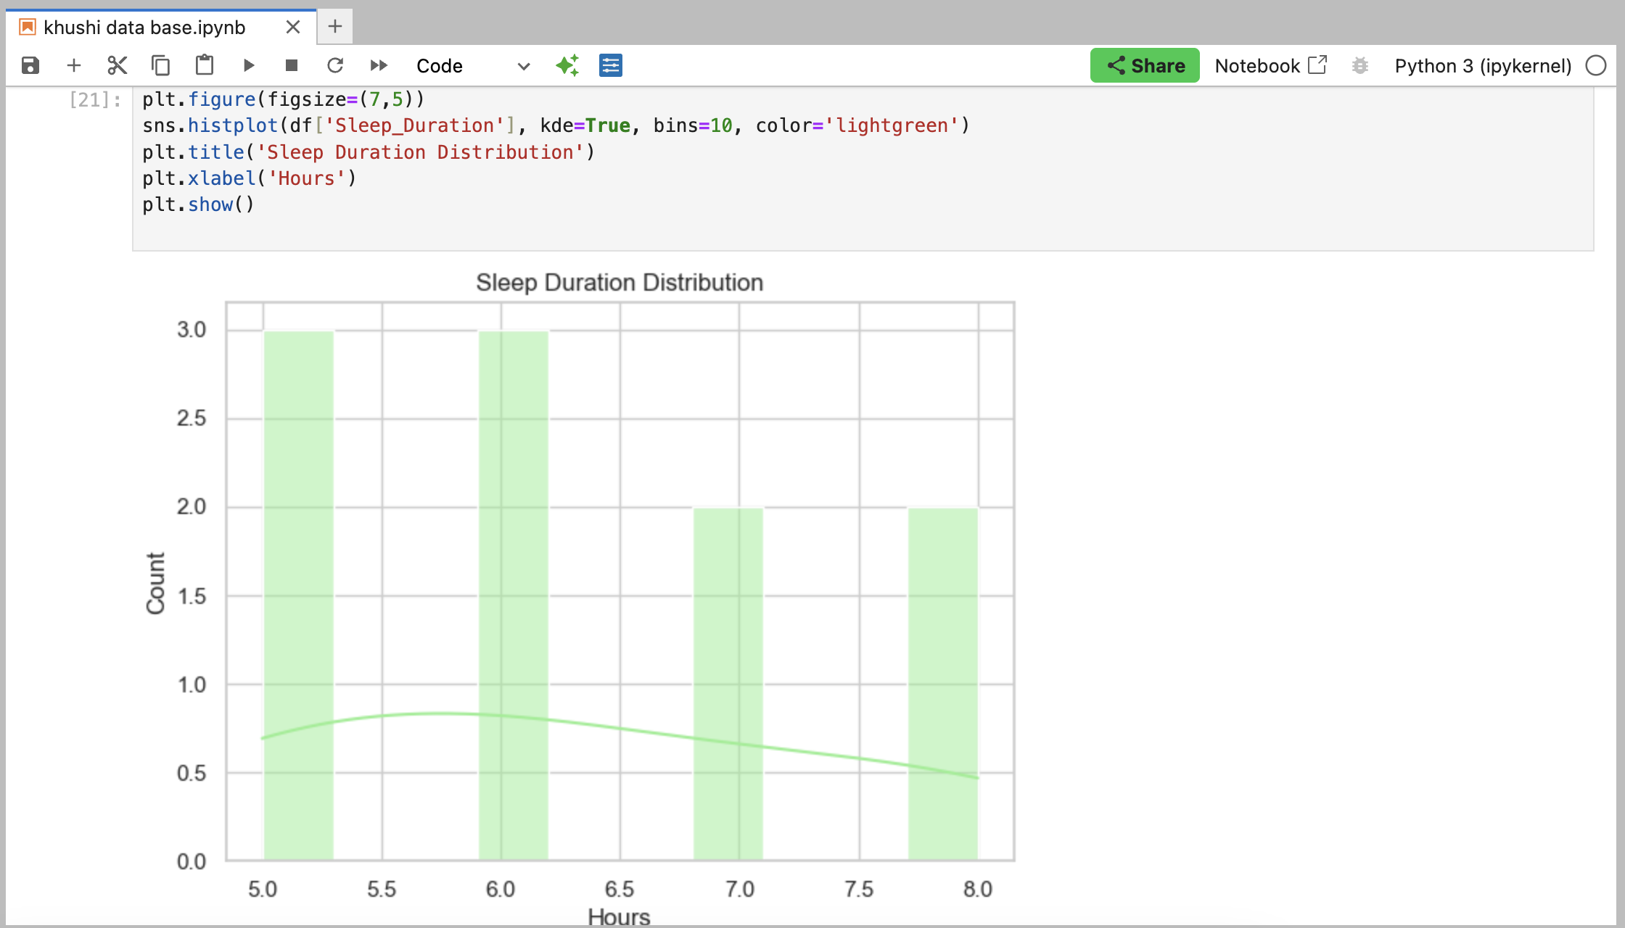

1. **Scatter Plot** – Study Hours vs CGPA  
   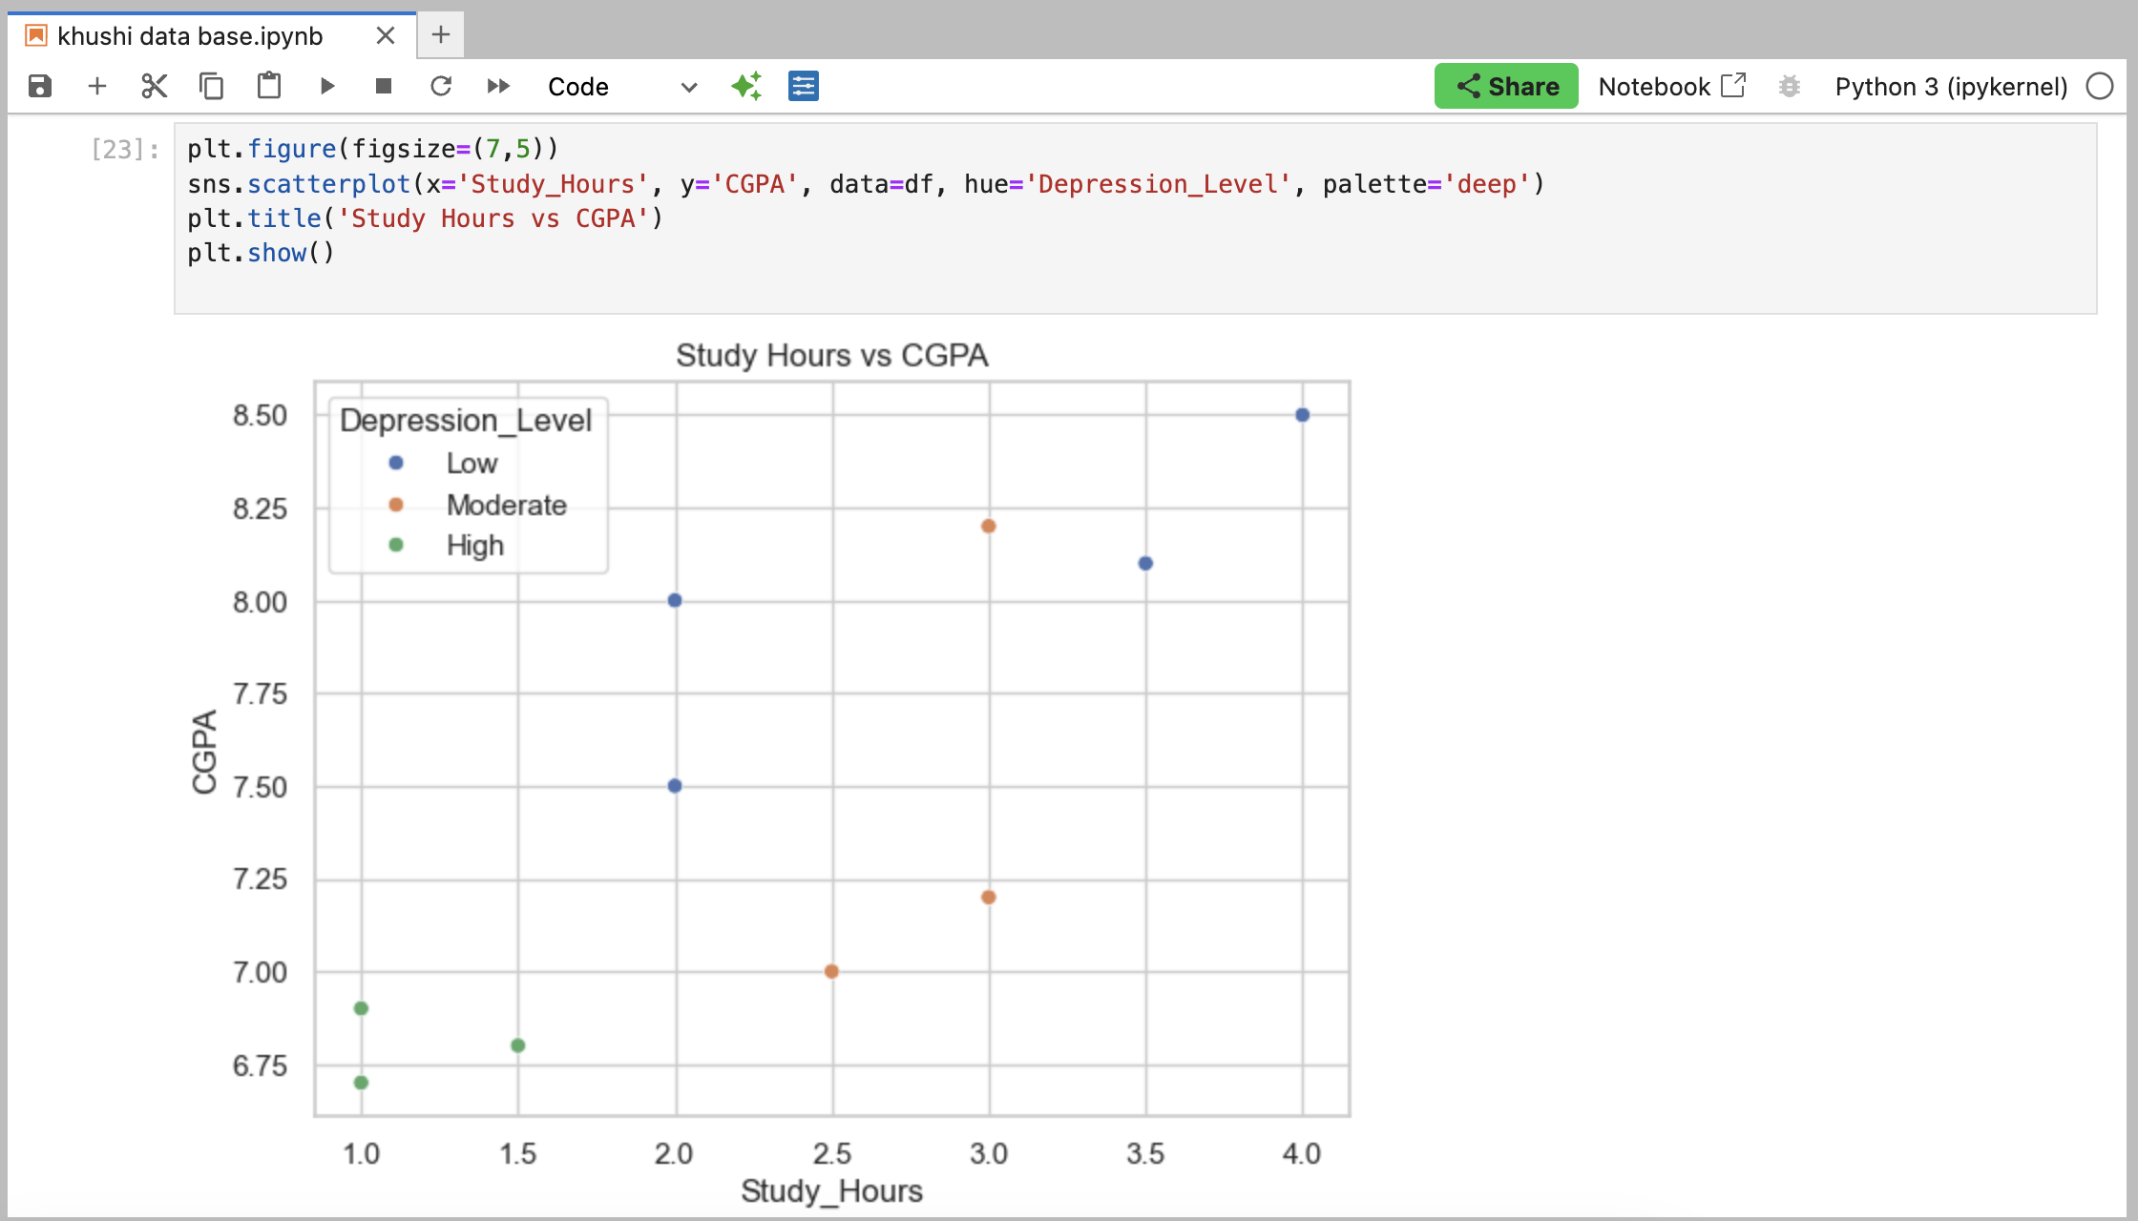

### **✅ Conclusion**

* Gender was almost evenly distributed.
* Age and sleep duration showed visible impact on depression.
* Students with more study hours often had better CGPA.
* Depression levels showed patterns with academic and lifestyle factors.