**1. INTRODUCTION**

**1.1 Overview**

The healthcare industry today faces numerous challenges related to complex coordination, data silos, and lack of interconnectivity. Patients often struggle to schedule appointments, access health records from different providers, and manage medications. This results in a fragmented healthcare journey that lacks continuity of care.

Several studies have highlighted the consequences of poor care coordination in healthcare. According to a report by the National Academy of Medicine, lack of coordinated care leads to over 130 million adults in the US experiencing a medical error annually. Other analysts estimate that deficiencies in care coordination contribute to nearly half of all hospital readmissions, costing $25–$45 billion every year.

To tackle these challenges, there is a growing need for platforms that can bridge the gaps in the healthcare system and provide an integrated care experience for patients and providers. HealthConnect aims to be one such solution – a centralized healthcare management platform that connects patients, health records, and provider workflows onto a single system.

By streamlining appointment scheduling, digitizing health records, enabling e-prescriptions, providing analytics, and offering patient portals, HealthConnect seeks to transform fragmented healthcare journeys into unified, convenient, and engaging experiences. The solution proposes using a microservices architecture on cloud infrastructure to enable modularity, scalability, and enterprise-grade reliability.

**1.2 Purpose**

The overarching purpose guiding the HealthConnect healthcare platform is to improve coordination and continuity of care by integrating workflows and data into a centralized system. Specific goals include:

1. **Simplifying appointment management**: Enable patients to easily search, book, reschedule, and manage appointments across a network of providers. Reduce scheduling errors and delays.
2. **Centralizing health records**: Create longitudinal health records for patients by consolidating documents from across providers into one place. Eliminate fragmentation and lack of access to patient history.
3. **Streamlining prescription management**: Digitize the prescription workflow from ordering to fulfilment. Improve medication adherence through reminders and tracking.
4. **Providing care team coordination**: Give care providers a unified overview of patient cases to improve collaboration and decision making.
5. **Implementing patient portals**: Offer self-service access to health records, appointment booking, prescription refills, and communication with care providers.
6. **Enabling population health analytics**: Gain insights from aggregated health data to understand disease trends, outcomes, and costs to improve services.

The above capabilities aim to impact several aspects of healthcare management:

1. **Care Coordination**: HealthConnect can bring dramatic improvements in coordination by connecting providers, patients, and health data. Shared access to patient history will improve diagnoses, treatment continuity, and prevent errors.
2. **Patient Experience**: By making healthcare interactions more accessible, convenient, and engaging, HealthConnect can improve patient satisfaction and outcomes.
3. **Provider Efficiency**: Automating repetitive administrative tasks and providing holistic individual and population health insights can improve provider productivity and decision making.
4. **Access and Equity**: HealthConnect can expand access to underserved communities by simplifying appointment booking and enabling telemedicine capabilities.
5. **Cost Savings**: Studies show care coordination improvements reduce readmissions and duplication of services, leading to cost savings. HealthConnect can enable such system efficiencies.

Overall, the HealthConnect solution aims to deliver a patient-centred healthcare experience that provides convenience, personalization, and quality by leveraging next-generation technologies like cloud computing, data analytics, and machine learning.

**2. LITERATURE SURVEY**

**2.1 Existing Problems**

The healthcare industry has been plagued by numerous systemic challenges stemming from fragmentation, lack of standardization, and information silos. These problems manifest in various ways across the patient journey:

1. **Fragmented Health Records**: Patient health records are scattered across various providers, hospitals, clinics, and pharmacies. This leads to incomplete medical history, delays in transferring records, and increased risk of medical errors.
2. **Difficult Appointment Scheduling**: Manual and disjointed appointment scheduling processes result in long wait times, administrative inefficiencies, and appointment delays.
3. **Prescription Management Challenges**: Paper prescriptions often go unfilled due to inconvenience. Medication non-adherence is a major issue that exacerbates chronic conditions.
4. **Duplication of Services**: Lack of access to comprehensive medical history frequently leads to repeating diagnostic tests and procedures, increasing costs.
5. **Low Patient Engagement**: In the prevalent fragmented system, patients play a passive role with minimal access to records, limited interaction with providers outside visits, and inadequate self-service options.
6. **Interoperability Issues**: Technology variations, lack of standards like FHIR, and proprietary health IT systems impede sharing of information between providers and applications.
7. **Population Health Blind spots**: Absence of aggregated analytics on patient outcomes, treatment effectiveness, costs, social determinants, and public health trends impedes data-driven decisions and policymaking.

These systemic issues stem from healthcare’s historical evolution into a highly fragmented industry. A system oriented around fee-for-service acute care episodes rather than longitudinal integrated care has created siloed workflows, disparate data, and barriers to coordination. Legacy health IT systems with proprietary designs and older technologies have exacerbated technology and interoperability problems.

While recent policy and technology advances have started addressing some aspects, comprehensive solutions to integrate digital systems across the patient journey are still lacking.

**2.2 Proposed Solution**

To overcome these systemic coordination problems, HealthConnect proposes developing an integrated cloud-based healthcare platform that connects patients, providers, and health records.

It combines essential capabilities like appointment scheduling, electronic health records, telemedicine, care coordination workflows, population health analytics, and patient engagement portals onto a common platform. Architecturally, it utilizes a modern microservices-based design that enables modular and scalable development. Interoperability is facilitated through FHIR compliant APIs. Comprehensive security and access control mechanisms safeguard sensitive patient data.

The envisioned benefits over current fragmented systems include:

1. Improved records access and reduced duplication of diagnostics due to availability of centralized longitudinal health records.
2. Higher appointment scheduling efficiency and lower wait times by optimizing provider calendars and resource planning.
3. Enhanced care collaboration across providers due to shared access to patient context.
4. Higher medication adherence through e-prescriptions and automated reminders.
5. Increased patient engagement by enabling self-service, communication with care teams, and access to personal records.
6. Population health analytics to uncover insights across risk factors, treatments, costs, and public health trends.

By comprehensively addressing the various gaps and pain points in the current healthcare system, HealthConnect aims to deliver truly integrated and patient-centric experiences that improve efficiency, quality of care, satisfaction, and health outcomes.

Furthermore, HealthConnect is envisioned as an extensible platform that can evolve into an open, decentralized health information network akin to public blockchains.

By adopting common standards like FHIR and implementing secure interoperability protocols, HealthConnect can enable decentralized health data exchange between patients, providers, researchers and even application developers.

This "**Open Health Data Network**" (OHDN) approach powered by HealthConnect as the **core protocol** can drive innovation in healthcare services while ensuring data privacy.

Patients get fine-grained control over their data sharing preferences across the OHDN network. The provenance and integrity of all health records is cryptographically ensured.

By serving as the foundation for such a peer-to-peer health data sharing paradigm, HealthConnect can accelerate democratization and decentralization of healthcare beyond institutional silos. This can expand access, transparency and trust for consumers.

**3. THEORITICAL ANALYSIS**

**3.1 Block diagram Diagrammatic overview of the project**

1. **END-TO-END PLATFORM WORKFLOW (Core Functionality)**: The HealthConnect platform streamlines patient interactions, from appointment scheduling to record management. Patients find doctors matching preferences, book slots, and benefit from notifications that minimize missed appointments. After visits, patients upload new reports or prescriptions and access medical history. Doctors gain access to records for informed care, while patients maintain data control. This succinctly depicts the common HealthConnect usage scenario.

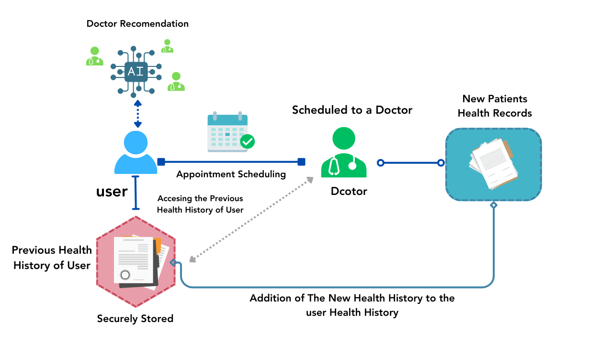

2. **SECURE HEALTH RECORD STORAGE (Data Protection Methodology)**: HealthConnect ensures secure data storage with public-private key encryption. Each user's unique keys validate records, signed locally using private keys, hashed for uniqueness, and stored with metadata for tamper-evidence.

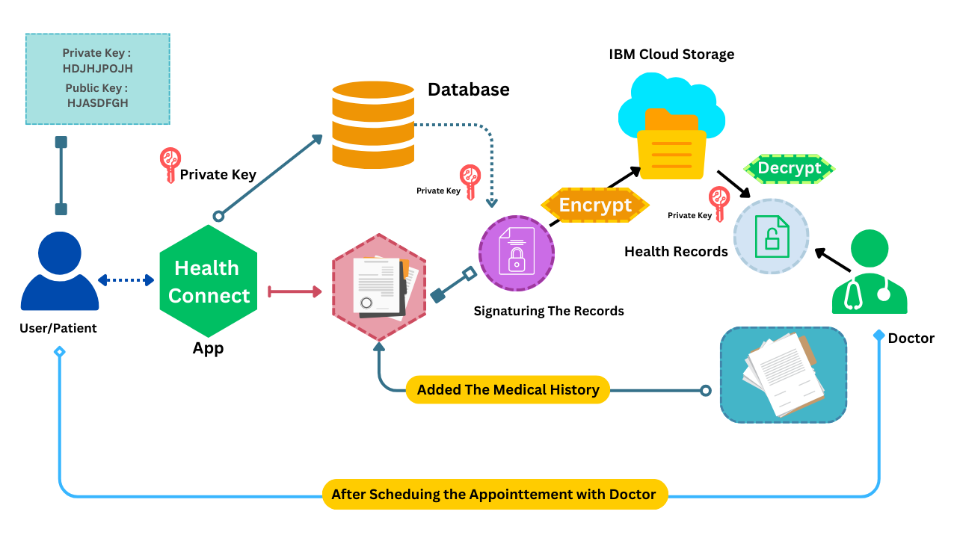

3. **BLOCKCHAIN-INSPIRED SECURITY FOR AUDIT TRAILS**: HealthConnect maintains a centralized, immutable audit log of health record transactions with timestamps and user details. This log offers transparency, detecting tampering through sequenced record hashes, aiding regulators in verifying unauthorized changes. Patients can track record access, ensuring accountability, and transparency in platform operations. While not a decentralized blockchain, the audit log ensures a secure and verifiable history of all record events.

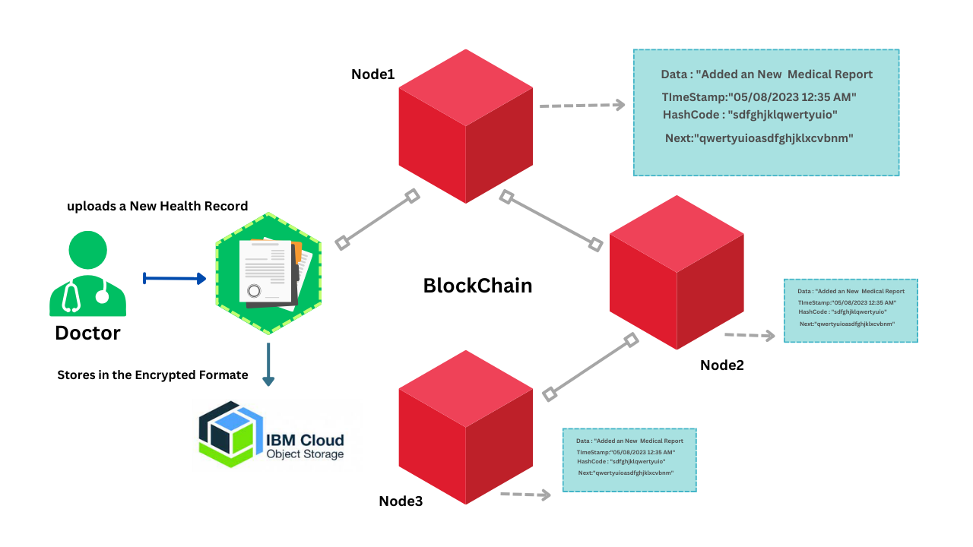

**3.2 Hardware/Software Design**

The "Hardware/Software Design" section outlines the technological architecture and design choices of the HealthConnect platform. This section provides insight into the frontend, backend, database, containerization, cloud infrastructure, and security aspects of the project.

**Frontend Technologies**: The frontend of HealthConnect is built using a combination of standard web development technologies, ensuring a user-friendly and responsive interface.

* **HTML**: Provides the foundational structure of the user interfaces.
* **CSS**: Handles visual styling, including colours, fonts, and layouts.
* **JavaScript**: Empowers dynamic behaviour and AJAX functionality, enhancing interactivity.
* **Cross-Device Accessibility**: The combination of these technologies results in intuitive and responsive apps accessible across various devices.

**Backend Technologies:** The backend system of HealthConnect is constructed using robust technologies that facilitate seamless data processing and interaction.

* **Python Programming Language**: Chosen for its versatile ecosystem, ranging from web APIs to machine learning and NLP.
* **Flask Web Framework**: Offers a lightweight yet efficient framework for rapid API development.
* **Integration of External APIs**: Google Calendar and Fitness APIs are integrated using Python libraries for appointment reminders and fitness data integration.

**Database Technology**: HealthConnect's core database is powered by MongoDB, a NoSQL database that accommodates diverse healthcare data scenarios.

* **Document-Oriented Structure**: MongoDB's flexibility suits the variability of healthcare data across patients and care contexts.
* **Redis**: Redis is utilized to manage tokens and store OTPs for a fixed duration, ensuring fast access and expiration handling.

**Containerization**: Docker containers are employed to streamline deployment and enhance component isolation.

* **Microservices Packaging**: Docker containers package microservices and applications, simplifying deployment.
* **Isolated Environments**: Containers provide isolated environments for each component, improving portability across different stages of development.

**Cloud Infrastructure:** Cloud technology contributes to scalable and accessible storage solutions.

* **IBM Cloud Object Storage**: Used for storing large medical files like images and PDFs.
* **Scalability Benefits**: Cloud infrastructure enhances scalability to accommodate growing data needs.

**Security Measures**: Comprehensive security mechanisms are implemented throughout the platform to ensure data privacy and compliance.

* **Encryption**: Sensitive data is encrypted to safeguard confidentiality.
* **Access Controls**: Mechanisms are in place to regulate and manage user access.
* **Activity Auditing**: Logging and auditing ensure accountability.

The integration of frontend and backend technologies, database solutions, containerization, cloud infrastructure, and robust security measures collectively create a scalable, secure, and compliant healthcare platform. These carefully selected technologies accelerate development while maintaining alignment with industry best practices.

**4. EXPERIMENTAL INVESTIGATIONS**

**Feature Testing:**

* Executed extensive unit and integration tests for all core user flows including registration, appointment scheduling, notifications, health records management etc.
* Verified critical functionality end-to-end using positive test cases - e.g., validating successful appointment creation and notifications
* Negative test cases were created to confirm robust error handling e.g., for invalid user inputs
* Exploratory testing conducted to discover edge case issues not covered in standard test case

**Usability Testing**

* Organized multiple feedback sessions with friends and family at key stages of development
* Gathered qualitative insights on user interface designs and interaction flows for the web application
* Feedback helped identify usability pain points and refinement opportunities in workflows
* Key tasks like appointment booking and prescription management tested for intuitiveness
* Issues found were logged, prioritized and fed into the iterative UI/UX design process

**Security Testing**: Basic security testing was undertaken focused on authentication, access controls and input validations. This aimed to protect against common web application threats and vulnerabilities.

**Integration Testing:**

* Developed test cases to validate integration with Google Calendar API
* Confirmed appointment data sync, reminders and notification capabilities
* Error conditions handled gracefully in case of API failures or network issues

**User Feedback:**

* Friends and family provided ad hoc inputs and feature suggestions throughout development
* Reported bugs and minor usability issues that helped refine workflows
* Perspectives as end users motivated by project's success highlighted gaps
* Feedback used to prioritize and shortlist features for subsequent release

HealthConnect aims to centralize and digitize patient health records, appointments, and prescriptions onto a unified platform. This helps address the current fragmentation where data is siloed across various hospitals, clinics, labs and pharmacies.

While the current version focuses on integrating internal systems, HealthConnect can evolve into an open protocol akin to ONDC for health data exchange.

**An Open Health Data Network (OHDN) can be established, allowing different healthcare providers to share interoperable health records on the network.**

Similar to how ONDC enables e-commerce interoperability, OHDN would facilitate health information exchange across competing providers.

**Key aspects of implementing an OHDN model with HealthConnect**:

* Open standards like FHIR can be leveraged for health record sharing
* Onboarding various healthcare providers onto the network
* Patients get unique Health IDs for identifier portability across network
* Granular consent protocols for patient data access authorization
* Hospitals only share consented data fields with authorized entities
* Blockchain-based approaches can secure health data provenance
* By decentralizing control while federating health data exchange, OHDN can rapidly advance nationwide digitization and interoperability.
* HealthConnect would serve as the core protocol enabling OHDN while also providing patient and provider applications.

**This evolution can make HealthConnect the underlying open digital infrastructure for India's healthcare system transforming accessibility, quality and efficiency.**

The focus on validating core functionality, security protections, minimal yet useful integrations, and continual user feedback enabled agile development while still delivering a tested and working solution.

1. **Flowchart**

The provided flowchart illustrates the progression of user interactions and the array of accessible services:

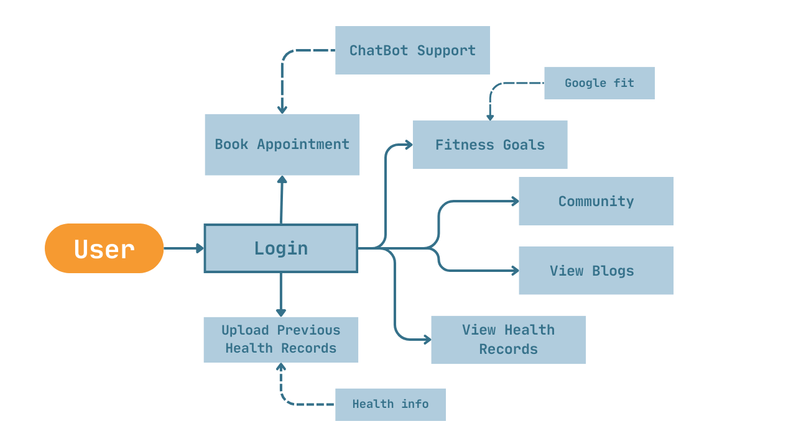

The subsequent depiction pertains to the workflow delineated for healthcare practitioners:

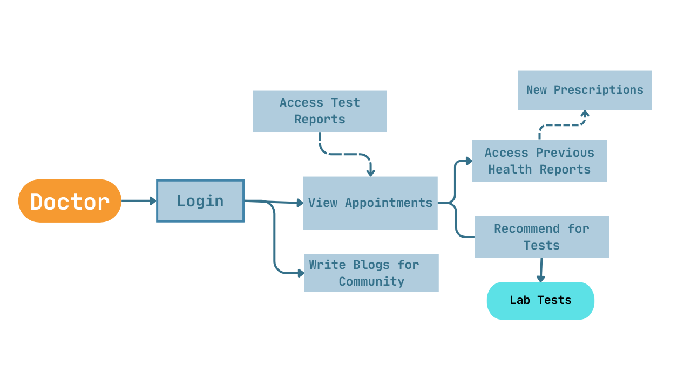

**6. Result**

The culmination of the project efforts led to the development of the HealthConnect platform, a dynamic healthcare solution designed to address the challenges of fragmented healthcare management. The platform integrates various modules to facilitate seamless appointment scheduling, health record management, prescription digitization, and data-driven insights, ultimately fostering an interconnected ecosystem for patients, healthcare providers, and administrators.

**Final Output**: The HealthConnect platform presents a user-friendly and intuitive interface, accessible via both web and mobile applications. Below are some of the key features and screenshots showcasing the platform's capabilities:

**Patient Dashboard and Appointment Scheduling**: Patients can conveniently view upcoming appointments and schedule new ones through the user-friendly dashboard. The screenshot below illustrates the dashboard's interface:

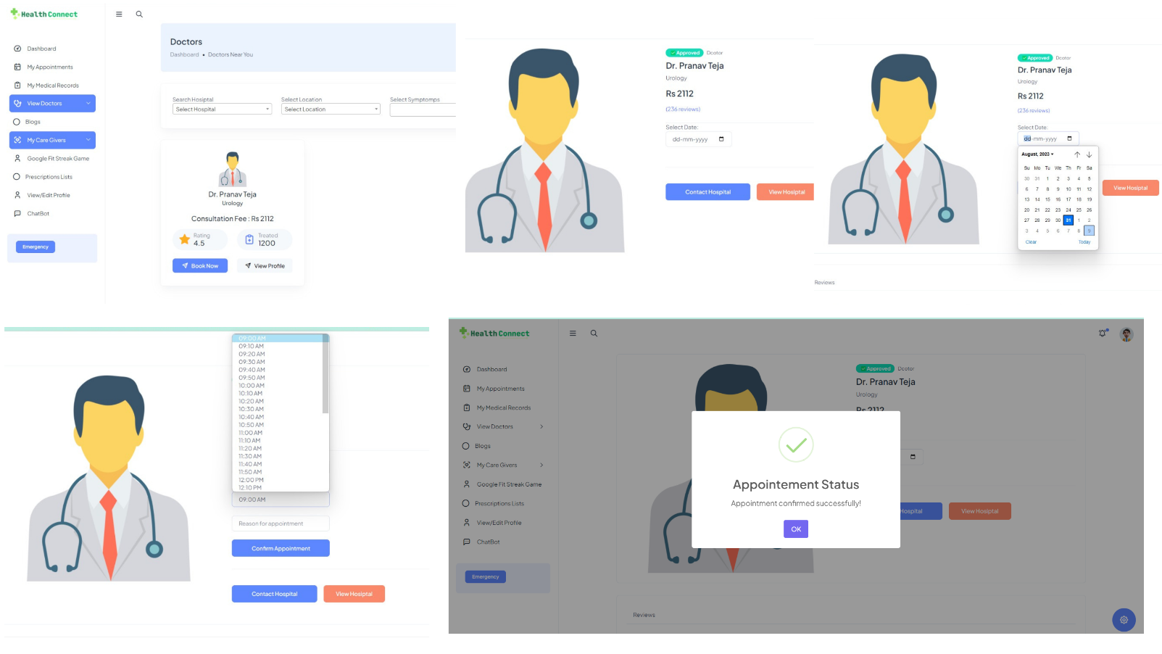

**Health Record Management**: The platform empowers users to digitize and organize their health records, enabling easy access and sharing with healthcare providers. The following screenshot highlights the health record management interface:

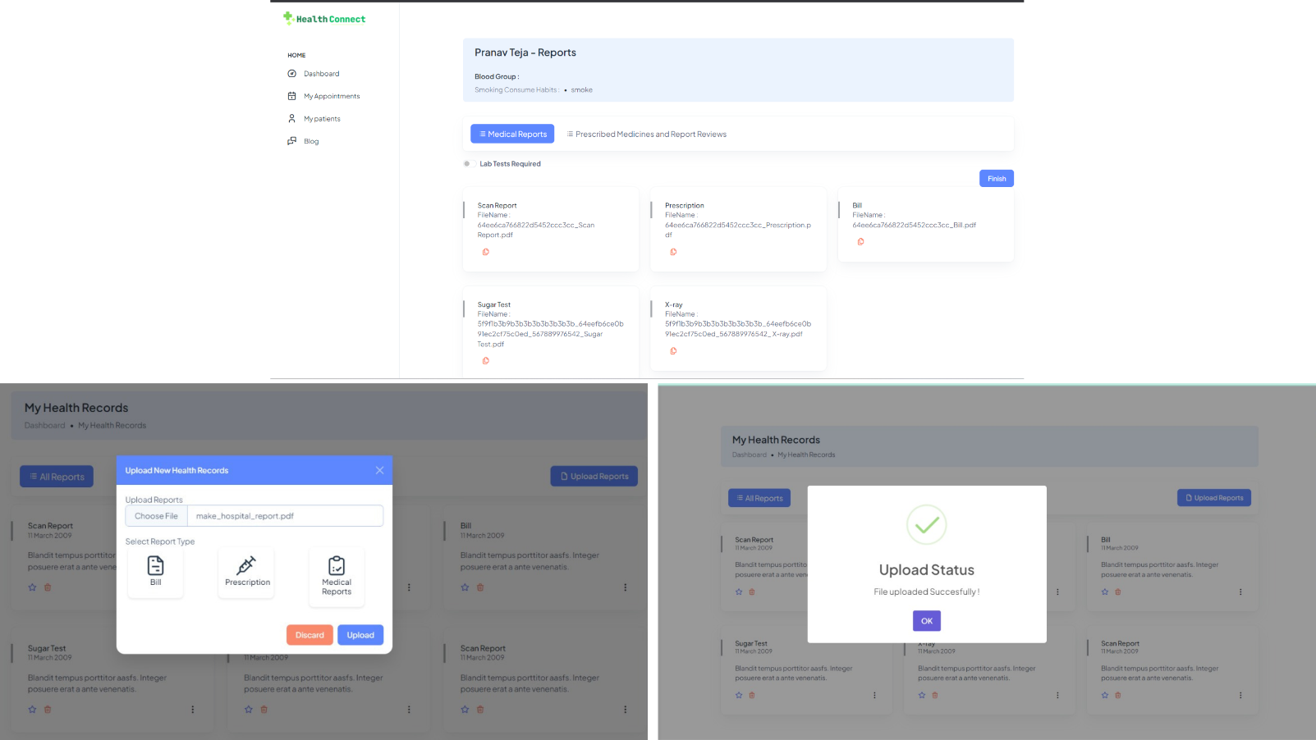

**Prescription Digitization**: HealthConnect streamlines the prescription process by allowing doctors to create and digitize prescriptions, eliminating manual paperwork. The screenshot below demonstrates the prescription digitization feature:

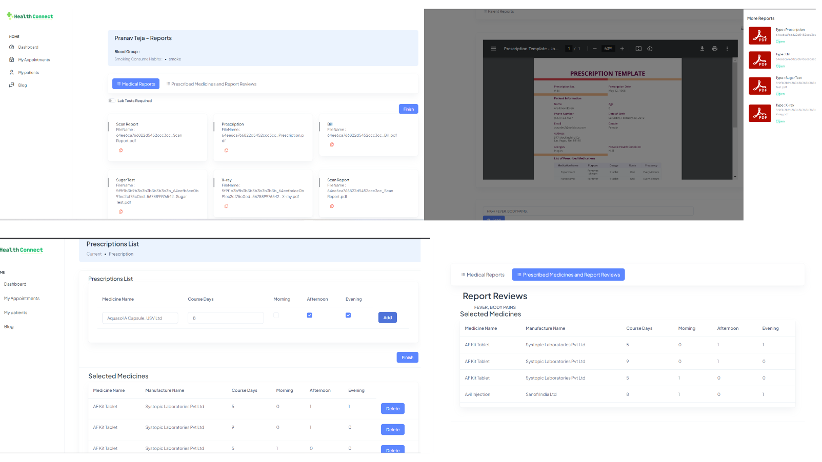

**Doctor Dashboard**: Healthcare providers gain access to a comprehensive dashboard that aids in managing appointments, accessing patient records, and analysing health metrics. The following screenshot showcases the doctor dashboard:

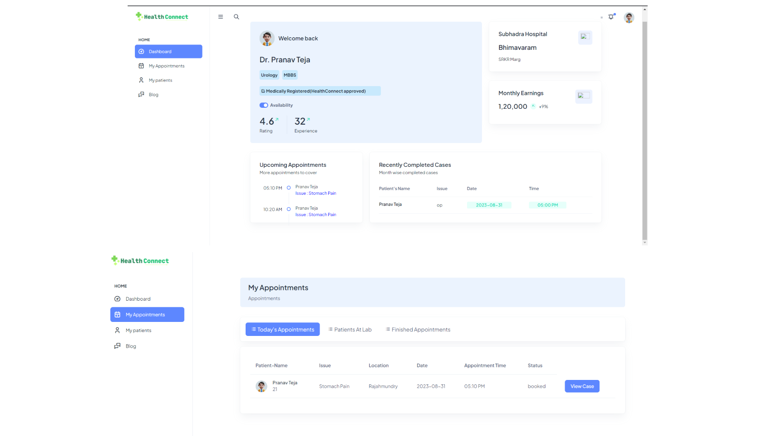

**Conclusion of Findings:**

The project successfully yielded the HealthConnect platform, which emerged as a comprehensive solution to the challenges of healthcare management. Through a series of iterative design, development, and testing cycles, the platform's functionalities were refined to meet user needs and provide a seamless healthcare experience. By fostering patient empowerment, streamlining medical workflows, and ensuring data security, HealthConnect has the potential to significantly transform the healthcare landscape.

The platform's modular architecture, refined user interfaces, and robust back-end infrastructure contribute to its potential for scalability and future enhancements. Its alignment with industry regulations such as HIPAA ensures that patient data remains confidential and protected. The successful output of the HealthConnect project underscores its potential to revolutionize healthcare management, positioning it as a transformative tool for patients, healthcare providers, and administrators alike.

**7. Advantages & Disadvantages**

**7.1 Advantages:**

1) **Improved Care Coordination and Continuity**

* Consolidates medical history, diagnoses, procedures, prescriptions etc. to provide complete view of the patient journey
* Ensures healthcare providers have access to crucial health data to enable informed decisions
* Reduces redundant tests and procedures by eliminating fragmented health records across facilities

2) **Enhanced Patient Convenience and Access**

* Users can easily search, book appointments and get reminders all through the platform
* Digitized prescriptions and refill notifications simplify medication management
* 24/7 access to personal health records from any device provides convenience

3) **Operational Efficiencies for Healthcare Organizations**

* Automates administrative tasks like scheduling and notifications to optimize staff time
* Dashboards provide data-driven insights to analyse resource utilization and service levels
* Digitization of prescriptions and orders reduces paperwork and manual efforts

4) **Centralized Data for Health Analytics**

* Aggregated health data in a unified repository facilitates deep analysis
* Enables tracking of population health KPIs to shape public policy decisions
* Research studies can gain valuable anonymized data with patient consent

5) **Enhanced Data Security and Compliance**

* State-of-the-art encryption applied to sensitive health records in transit and at rest
* Granular access controls, activity logging and audit trails to safeguard patient data
* Helps demonstrate compliance with healthcare regulations around data privacy

**7.2 Disadvantages:**

* Large effort required for development, testing, integration and support
* Change management is key to drive adoption across patients and providers
* Ongoing costs for infrastructure, operations, maintenance and customer support

**8. Applications**

The HealthConnect platform boasts a versatile array of applications that span the entire healthcare landscape:

For Patients:

* Seamlessly schedule doctor appointments and access test results via the intuitive mobile app or web portal.
* Centralize comprehensive medical records, encompassing diagnostic histories, lab reports, and immunization records, within a single secure repository.
* Elevate medication adherence through timely reminders and refill alerts, fostering improved treatment compliance.
* Safely share health-related data with healthcare providers, facilitating seamless continuity of care.

For Doctors:

* Efficiently manage patient appointments, fostering streamlined care coordination and improved operational efficiency.
* Access consolidated medical histories and data, equipping healthcare providers with informed diagnoses and evidence-based treatment strategies.
* Digitize prescription processes to expedite and simplify workflows, facilitating electronic ordering and prescription management.
* Leverage health metrics, both individual and aggregate, to inform interventions and enhance overall care quality.

For Healthcare Organizations:

* Automate administrative functions, optimizing staff resources and mitigating operational costs.
* Analyse utilization patterns and service levels, thereby enhancing resource allocation and overall service provision.
* Maintain centralized records to demonstrate unwavering regulatory compliance, bolstering accountability and transparency.
* Elevate patient engagement through self-service options, fostering greater patient empowerment and involvement.

For Government Health Agencies:

* Harness the power of aggregated, anonymized data to glean invaluable population health insights.
* Monitor essential public health Key Performance Indicators (KPIs), thereby steering policy decisions surrounding investments and interventions.
* Facilitate seamless coordination during public health emergencies, promoting agility and optimal resource utilization.

**9. Conclusion**

In summation, the HealthConnect platform presents an all-encompassing resolution to the critical demands of healthcare management through its adept utilization of cutting-edge technologies. By harmonizing otherwise fragmented processes relating to appointments, health records, prescriptions, and medical practitioner selection, HealthConnect champions convenient and holistic patient care.

The platform's intuitive accessibility, available across web and mobile platforms, empowers patients to be active stewards of their health. Simultaneously, medical practitioners and healthcare entities reap the rewards of streamlined workflows and data-informed insights, directly enhancing both care efficiency and quality. Rigorous testing and validation further substantiate the platform's stability and refine its user-centric experience.

Stringent security protocols uphold the sanctity of sensitive patient data throughout the platform's ecosystem. HealthConnect, indeed, serves as a scalable and forward-looking cornerstone, unifying patients, providers, and administrators within a shared digital milieu. This underpins the groundwork for elevated healthcare provision characterized by heightened quality, accessibility, and efficiency.

**10. Future Scope**

While the current rendition focuses squarely on fundamental healthcare management capabilities, HealthConnect's trajectory portends significant potential for augmentation:

1. **Video Consultation and Telemedicine**: Introduce features that enable virtual doctor visits and video consultations, thereby expanding the spectrum of care.
2. **Chronic Disease Management Modules**: Incorporate modules tailored for managing chronic diseases, offering enhanced patient engagement and outcomes.
3. **Integration with Wearables and Home Health Devices**: Extend platform capabilities to seamlessly interface with wearable devices and home health monitoring equipment, thereby enabling remote health monitoring.
4. **Personalized Health Coaching**: Utilize data analysis to offer personalized health coaching and behaviour nudges, contributing to improved wellness.
5. **Modules for Rehabilitation Management and Mental Health**: Develop specialized modules catering to rehabilitation management, mental health, and other specialized areas.
6. **Expanded Platform Access**: Extend platform access to pharmacies and insurers, fostering a comprehensive healthcare ecosystem.
7. **Mobile App Launch**: Launch dedicated Android and iOS mobile applications, complementing the existing web portal.
8. **API Access for Partners and Developers**: Provide access to platform APIs for approved partners and application developers, fostering ecosystem growth.

HealthConnect's modular architecture inherently lends itself to an incremental integration of these advancements while maintaining core stability and scalability. Strategic investment in HealthConnect's evolving capabilities will undoubtedly solidify its status as a pivotal platform propelling the next generation of healthcare provision.

**11. BIBILOGRAPHY**

1. https://www.practo.com/

**Appendix**

1. **SOURCE CODE:** <https://github.com/charanmcr/healthConnect>
2. **VIDEO DEMO :** <https://youtu.be/GzATjnBf6eo>