# Output Document

Following two are the outputs for the given Search Engine Project:

**Command**

./bin/Hadoop jar lib/cglHBaseMooc.jar iu.pti.hbaseapp.clueweb09.SearchEngineTester search-keyword snapshot

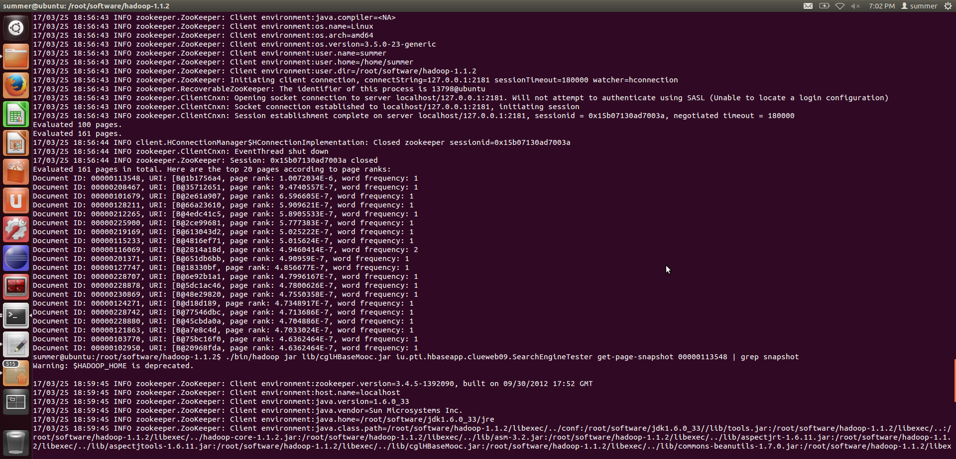

Command-2

./bin/Hadoop jar lib/cglHBaseMooc.jar iu.pti.hbaseapp.clueweb09.SearchEngineTester get-page-snapshot 00000113548 | grep snapshot

