Machine Learning Case Study: Chronic Kidney Disease Classification

1. Problem Statement & Objectives
A healthcare organization wants to develop a Machine Learning system that classifies patients based on available clinical measurements and identifies whether they belong to a kidney-disease-related class (Chronic Kidney Disease or Not CKD).
Objectives:
1. Understand and clean the clinical dataset.
2. Handle missing values appropriately.
3. Perform Exploratory Data Analysis (EDA).
4. Identify important predictors (Feature Engineering).
5. Develop and compare ML models (Logistic Regression, KNN, Decision Tree, Random Forest, Gradient Boosting).
6. Deploy a web application for real-time prediction.

2. Dataset Overview & Preprocessing
The UCI Chronic Kidney Disease Dataset contains 400 patient records with 24 clinical features and 1 target variable. The dataset exhibited significant missing values (up to 38% in some features like Red Blood Cell count). To handle this, a two-pass imputation strategy was implemented: K-Nearest Neighbors (KNN) Imputation for numerical features and Mode Imputation for categorical features. This allowed us to retain all 400 patient records without data loss.

3. Exploratory Data Analysis (EDA)
Several visualizations were generated to understand feature distributions and class separation.
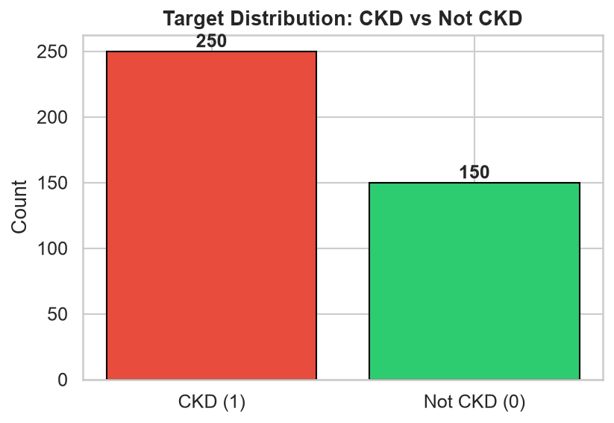
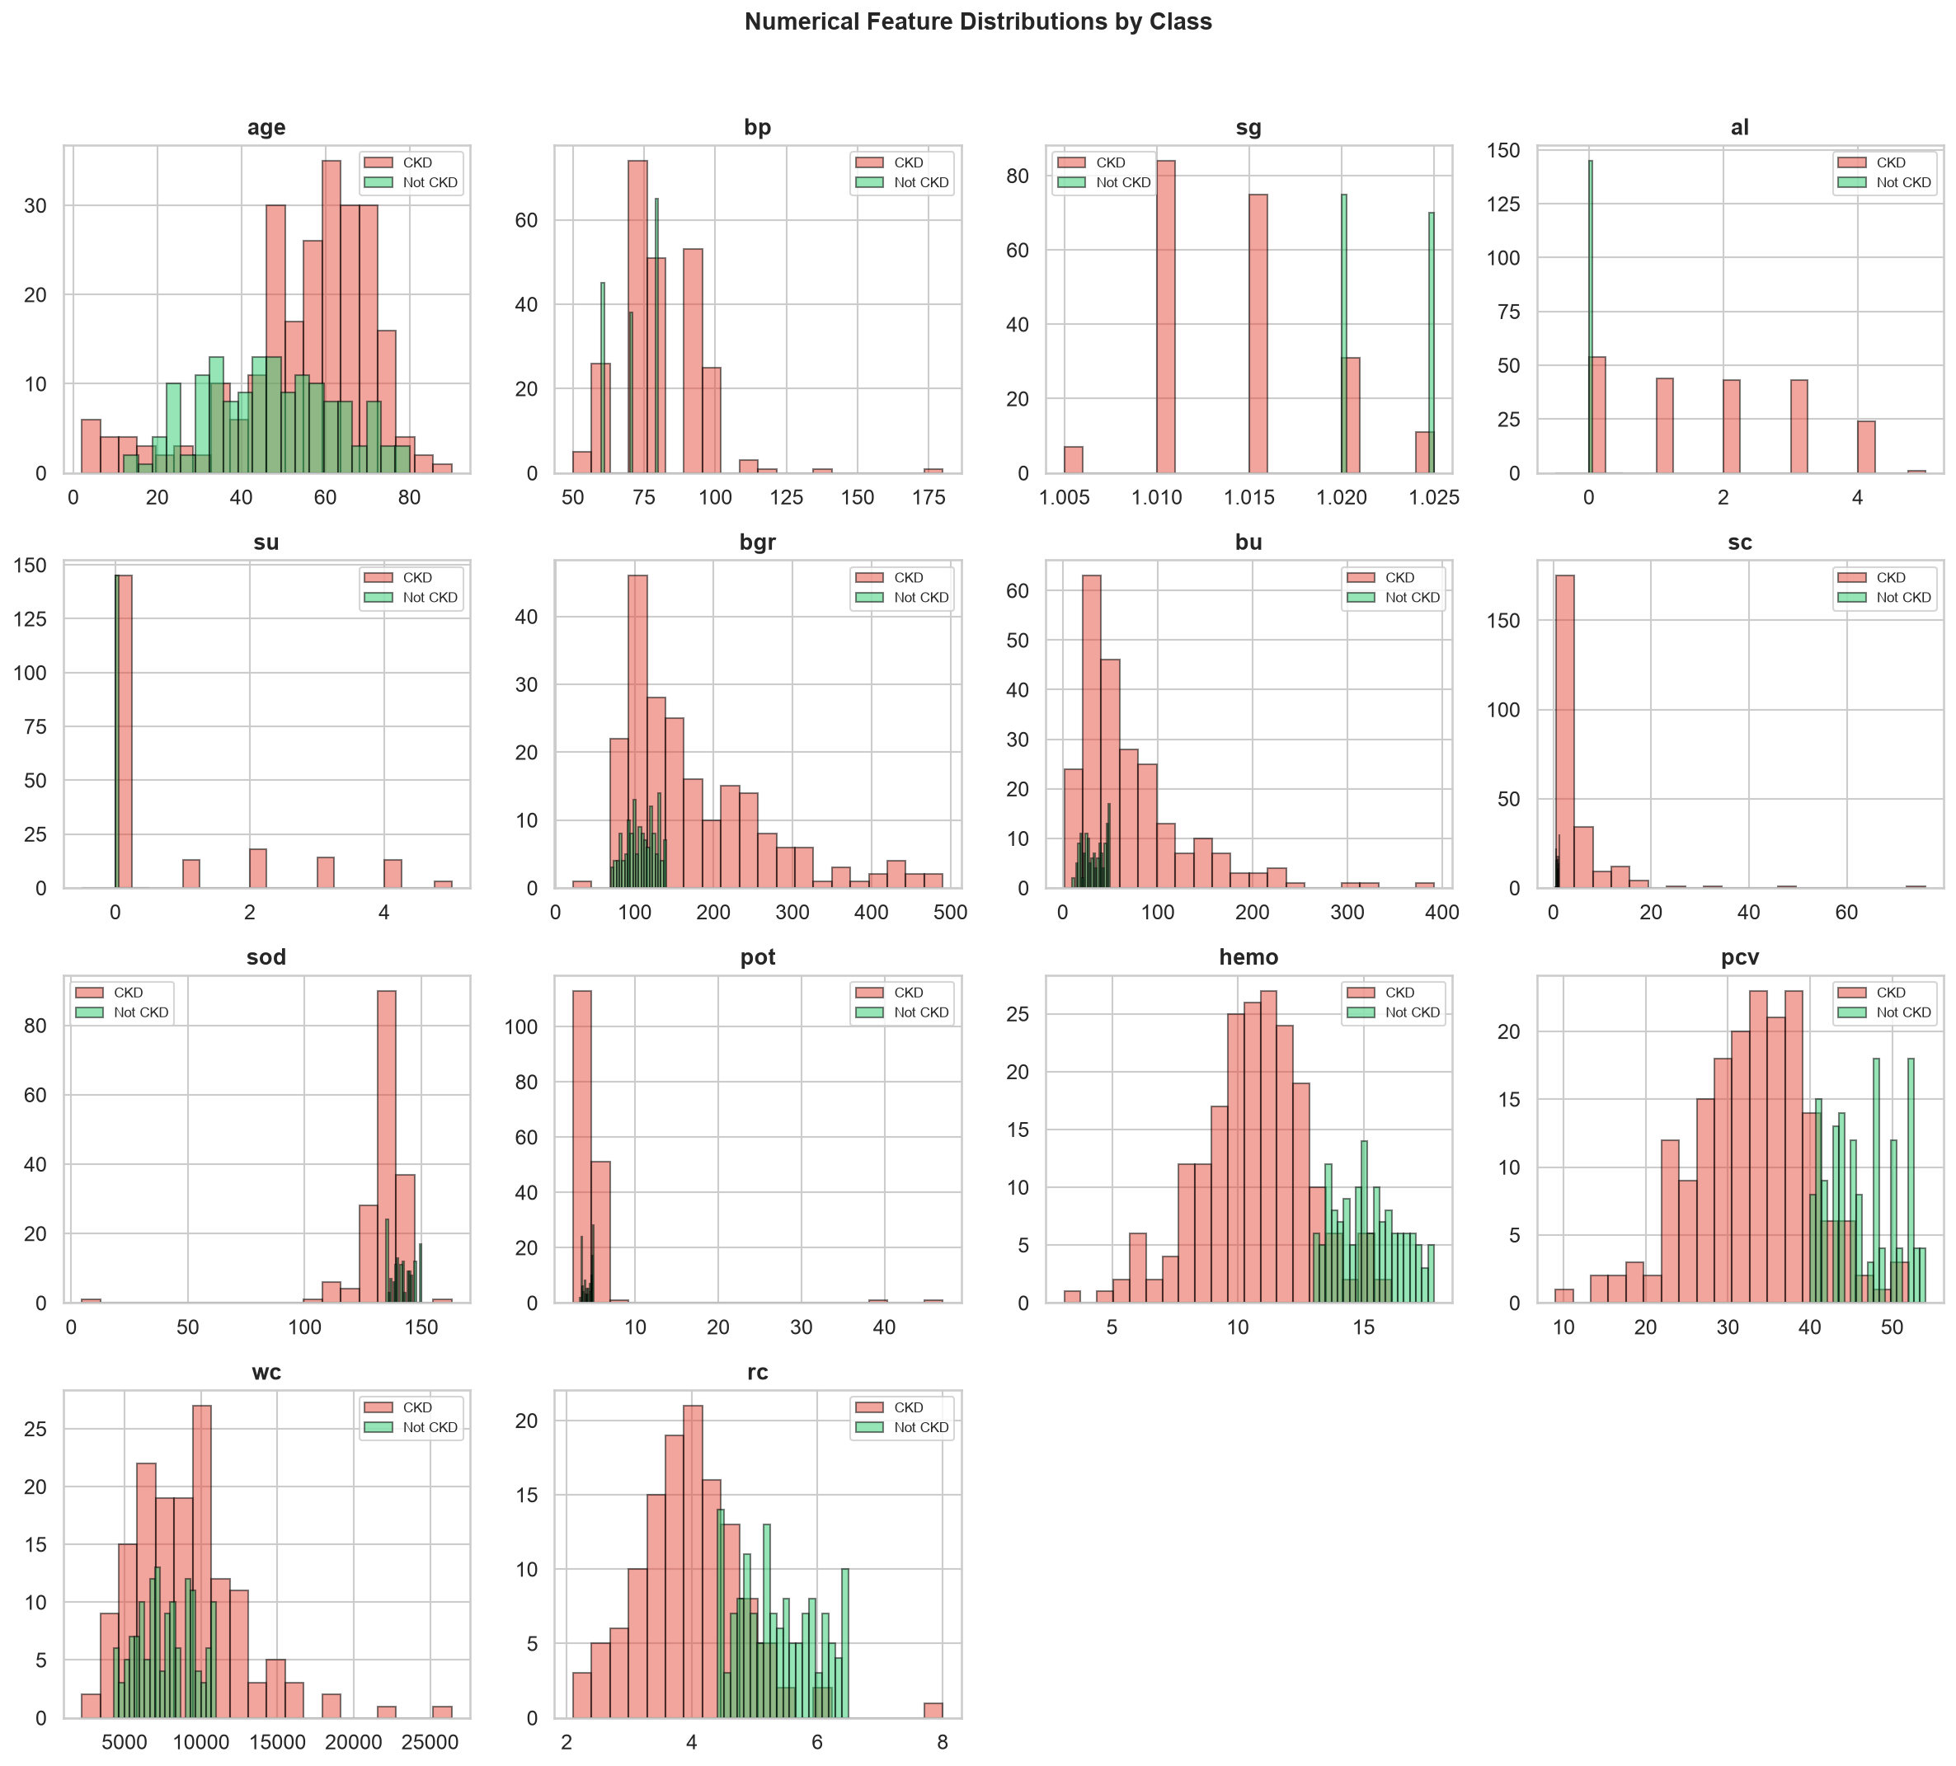
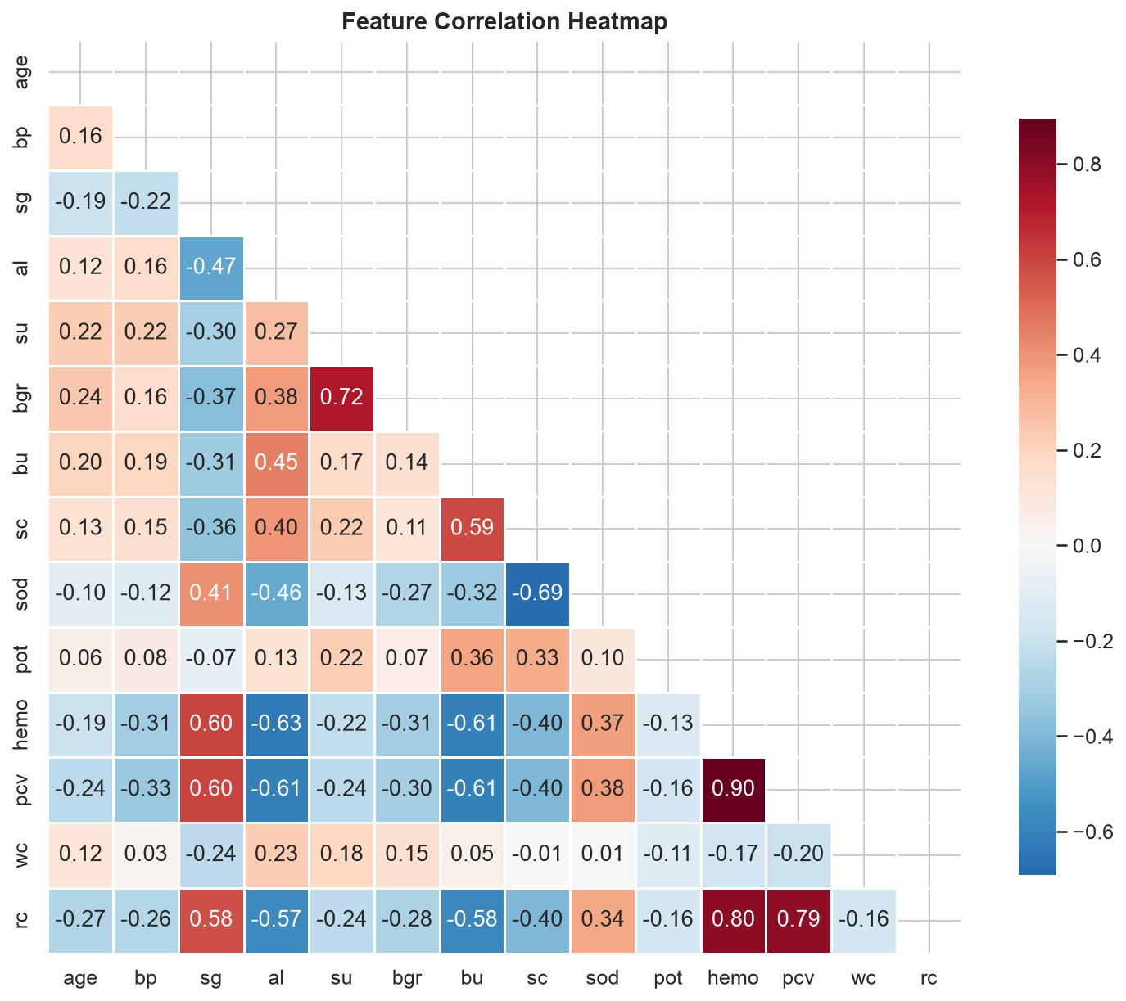

4. Feature Importance
Using Random Forest Feature Importances and Mutual Information scores, the most critical indicators for CKD were identified as:
1. Hemoglobin (hemo)
2. Packed Cell Volume (pcv)
3. Specific Gravity (sg)
4. Serum Creatinine (sc)
5. Albumin (al)
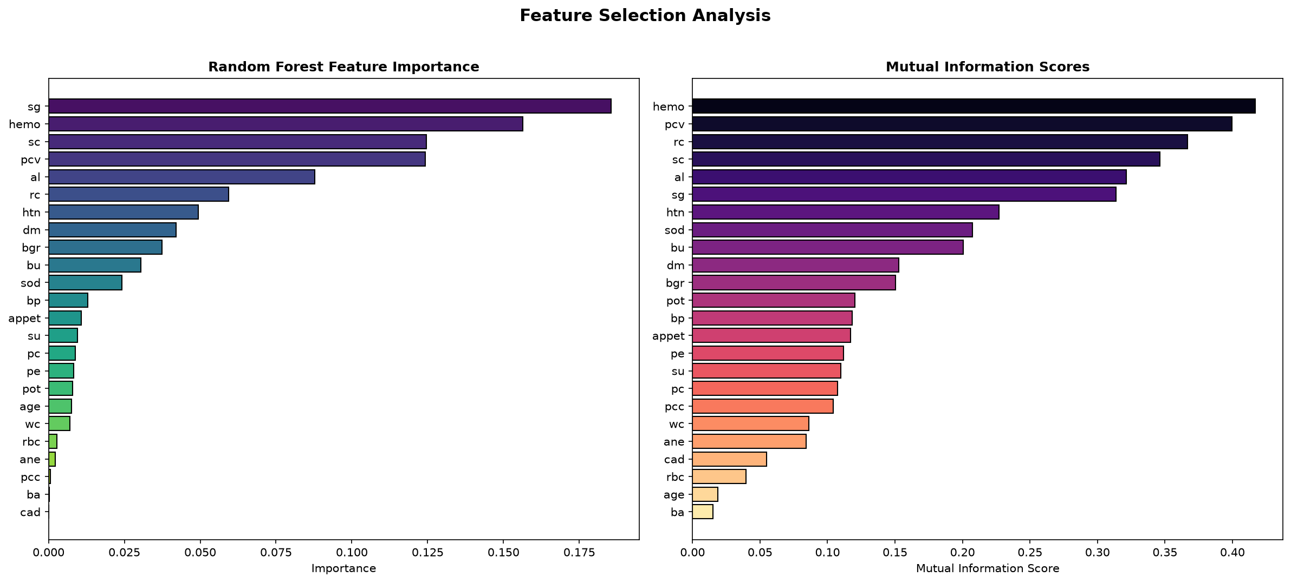

5. Model Development & Comparison
Five algorithms were trained using 5-fold Stratified Cross-Validation and hyperparameter tuning via GridSearchCV. The models were evaluated on an unseen 20% test set.
Model | Accuracy | Precision | Recall | F1-Score
Logistic Regression | 97.50% | 100.0% | 96.00% | 97.96%
KNN | 97.50% | 100.0% | 96.00% | 97.96%
Decision Tree | 91.25% | 93.88% | 92.00% | 92.93%
Random Forest | 98.75% | 100.0% | 98.00% | 98.99%
Gradient Boosting | 96.25% | 97.96% | 96.00% | 96.97%
Comparative Visualizations:
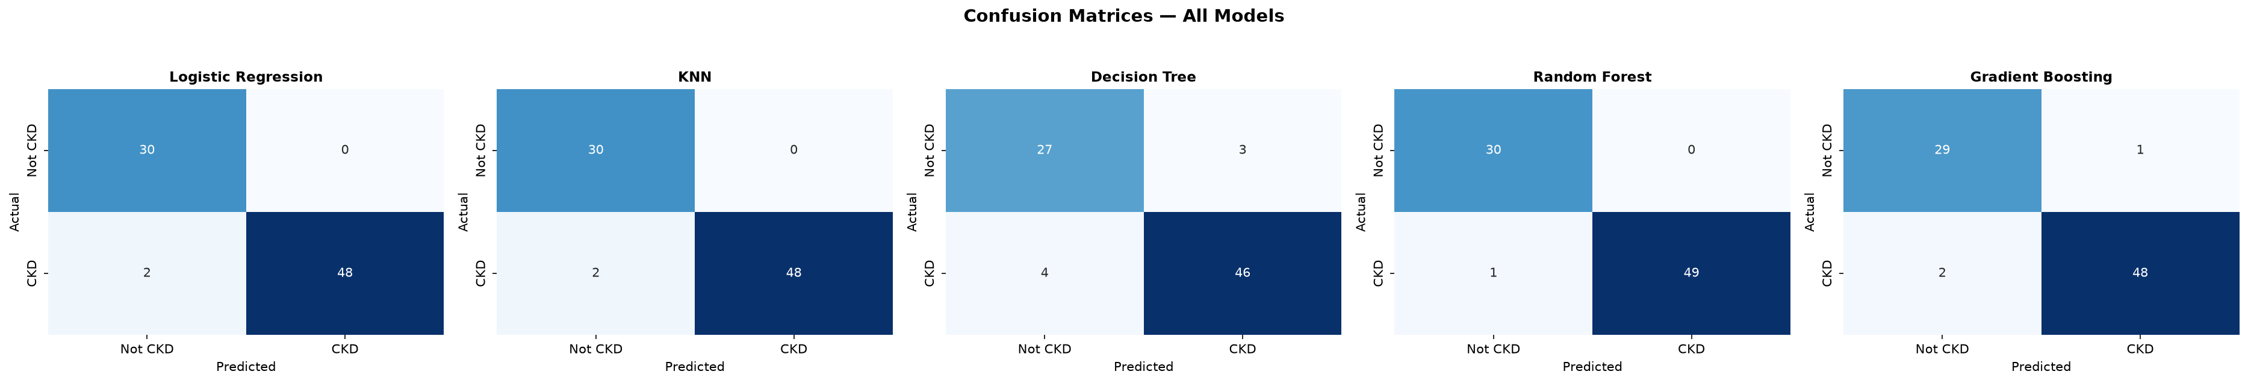
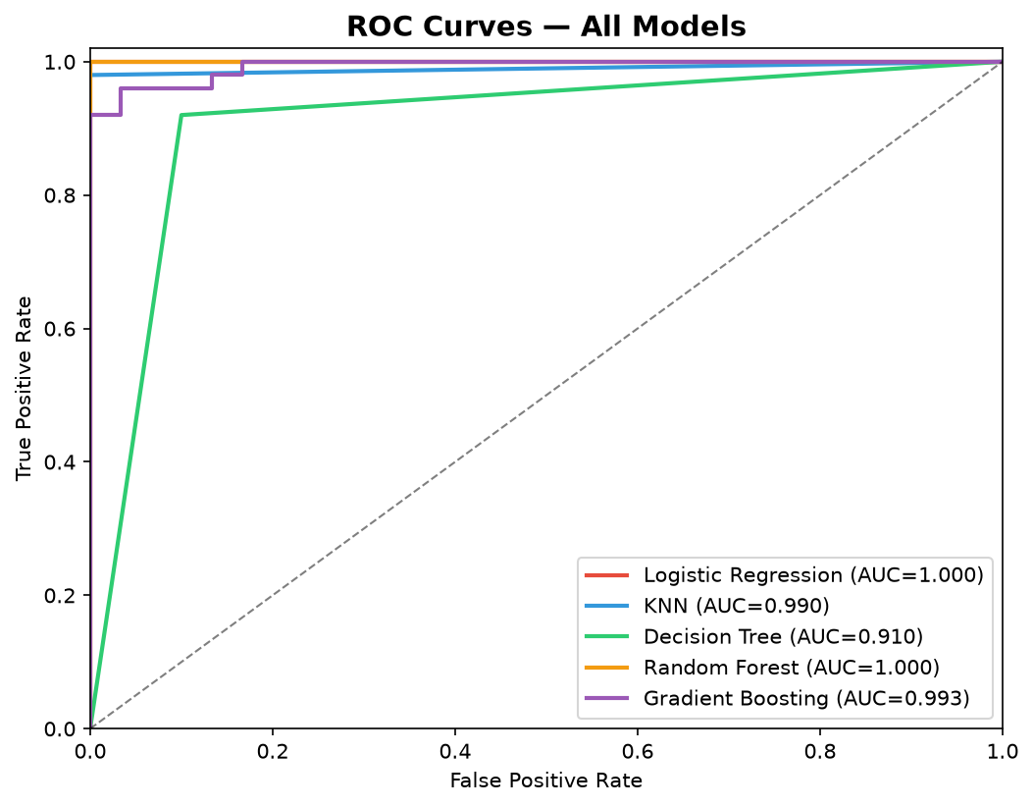

6. Final Analysis & Answers
Q1: Can kidney-disease-related classification be performed using ML?
Yes. The models demonstrated high discriminative power, all scoring above 91% accuracy.
Q2: Which features are most important?
Hemoglobin, Packed Cell Volume, Specific Gravity, and Serum Creatinine.
Q3: Which algorithm performs best?
Random Forest outperformed others with 98.75% accuracy and an F1-score of 98.99%.
Q4: How does missing-value treatment affect the model?
Proper imputation (KNN & Mode) allowed retention of 100% of the data without bias, enabling robust model training.
Q5: Which model has the best recall?
Random Forest achieved the best recall (98.00%), which is crucial in healthcare to minimize false negatives (missed diagnoses).
Q6: Can the model be deployed successfully?
Yes, the Random Forest model was successfully serialized and deployed via a Streamlit web application.

