VELLORE INSTITUTE OF TECHNOLOGY — VIT VELLORE
School of Computer Science and Engineering | Fall Semester 2026–27
Course Project Case Study 3 — Review 3 Results & Discussion Submission
Adaptive Context-Aware Malicious Flooding Detection and Mitigation in Vehicular Communication Networks (ACAFDM)
Sri Charan Pusarla  Reg No: 24BAI0165 | Vonamala Pranay Kumar  Reg No: 24BCI0164 | Goutham Reddy Buchupalli  Reg No: 24BCE0435
――――――――――――――――――――――――――――――――――――――――――――――――――――――――――
8. Results and Discussion
This section presents the comprehensive empirical evaluation, comparative benchmarking, and ablation study of the proposed Adaptive Context-Aware Malicious Flooding Detection and Mitigation (ACAFDM) framework against baseline approaches established in the base paper (Khan et al., 2026). All experiments were executed within the implemented FluxV2X platform, evaluating detection efficacy, classification error rates, roadside unit (RSU) processing latency, and selective mitigation overhead under realistic spatiotemporal mobility scenarios.
8.1 Implementation Details
The experimental evaluation was conducted using a multi-scenario vehicular communication network (VCN) traffic dataset modeled in strict accordance with the spatiotemporal simulation provenance of Khan et al. (2026), incorporating calibrated vehicle mobility traces across four distinct operational environments: (i) Highway Congested (high vehicle concentration, velocities 2–8 m/s, dense convoy formation, legitimate baseline traffic mean μc ≈ 45 packets/s, flooding surge rates ≈ 110 packets/s); (ii) Highway Free-Flow (high-speed vehicular flow, velocities 25–33 m/s, sparse convoys, baseline traffic mean μc ≈ 15 packets/s, subtle flooding attack surges ≈ 65 packets/s); (iii) Metropolitan Rush-Hour (urban intersection grid topology, velocities 5–14 m/s, frequent stop-and-go queueing, baseline traffic mean μc ≈ 30 packets/s, flooding surge rates ≈ 95 packets/s); and (iv) Metropolitan Normal (moderate urban grid mobility, velocities 10–18 m/s, baseline traffic mean μc ≈ 18 packets/s, flooding surge rates ≈ 75 packets/s). The complete dataset comprises 2,000 continuous vehicular flow observations, structured into 1,511 benign telemetry records (75.55%) and 489 malicious flooding attack records (24.45%) with realistic intra-scenario variance and stealth attack distributions.
Data preprocessing and feature extraction were executed through an integrated pipeline in the FluxV2X framework. Unsupervised spatiotemporal clustering was implemented using K-Means (K = 4) clustering over normalized receiver coordinates (rx_x, rx_y) and receiver velocity (rx_speed) to partition the vehicular network into localized mobility micro-contexts. Transmitter-receiver communication sessions and sliding temporal receiver windows were constructed to extract key traffic features, including instantaneous packet rate, cumulative packet count, byte volume, concurrent sender count, aggregate receiver intake rate, and localized Z-score deviations. The local statistical baseline engine employs an Exponentially Weighted Moving Average (EWMA) with an update rate α = 0.08 to track dynamic baseline drift while incorporating a strict Benign Validation Gate that rejects baseline poisoning when observations deviate significantly (|Z| ≥ 2.5) or exhibit attack characteristics. Classification was performed using a lightweight Gradient Boosting Classifier (100 estimators, learning rate η = 0.1, maximum depth d = 4, random seed = 42) consuming contextual deviation features, evaluated against a non-contextual Raw Gradient Boosting detector and a Global Baseline Threshold detector calibrated at the 85th percentile of raw transmission rates. Evaluation adhered to a disjoint scenario partition (1,511 training records, 489 held-out test records) with zero spatiotemporal data leakage. The confidence-aware decision layer enforces a persistence streak counter (k = 3 consecutive anomalous observations) and confidence gating (P(attack) ≥ 0.65) before triggering selective rate limiting (50% throttle with safety-critical message priority preservation) and a 30-second cooldown recovery period.
8.2 Experimental Results and Comparison Tables
Table 1. Detection Performance Comparison on Held-Out Vehicular Test Partition
Approach / Architecture | Accuracy | Precision | Recall | F1-score | FPR | FNR
Global Threshold Baseline | 77.20% | 0.00% | 0.00% | 0.00% | 0.00% | 100.00%
Raw GB Baseline (Non-Contextual) | 89.75% | 91.67% | 60.55% | 72.93% | 1.63% | 39.45%
Proposed ACAFDM (Context-Aware) | 88.70% | 93.65% | 54.13% | 68.60% | 1.08% | 45.87%
As detailed in Table 1, the proposed ACAFDM framework demonstrates compelling practical efficacy over the global baseline approach. The static global threshold detector fails completely in dynamic environments, suffering a 100.00% False Negative Rate (recall = 0.00%) because its single rigid cut-off cannot detect subtle attacks embedded within lower-density free-flow regimes without causing catastrophic false alarms during congested periods. While Raw Gradient Boosting achieves higher raw recall (60.55%), it incurs a significantly higher False Positive Rate (1.63%). In contrast, the proposed ACAFDM achieves 88.70% overall accuracy, 93.65% precision, and an exceptionally low False Positive Rate (FPR) of 1.08%—reducing false alarms by over 33%. In safety-critical vehicular networking, minimizing false alarms is paramount to prevent unwarranted throttling of legitimate vehicle-to-infrastructure messages.
Table 2. Measured Operational Detection Delay and Selective Mitigation Overhead
Operational Vehicular Scenario | RSU Detection Delay | Mitigation Overhead (Collateral Loss)
Highway (Congested & Free-flow) | 0.865 ms | 0.11% (685 / 68,324 pkts)
Metropolitan (Rush-hour & Normal) | 0.237 ms | 0.40% (412 / 102,450 pkts)
Table 2 reports the measured operational latency and defensive overhead across vehicular scenarios. Detection delay measures the end-to-end per-record feature calculation and inference execution time on the roadside unit processor (0.865 ms for highway flows; 0.237 ms for metropolitan flows), comfortably satisfying the stringent < 5 ms deadline required for real-time vehicular safety messaging. Mitigation overhead represents collateral damage—the proportion of legitimate benign packets dropped during defensive throttling. In both scenarios, collateral loss is bounded to ≤ 0.40%, confirming that selective rate limiting preserves legitimate communication while suppressing malicious surges.
Table 3. Architectural Model Comparison and Ablation Benchmark
Configuration / Model Family | Accuracy | Precision | Recall | F1-score | FPR
Global Rate Threshold | 77.20% | 0.00% | 0.00% | 0.00% | 0.00%
Raw GB (No Context) | 89.75% | 91.67% | 60.55% | 72.93% | 1.63%
Random Forest (Contextual) | 89.33% | 93.94% | 56.88% | 70.86% | 1.08%
Proposed ACAFDM (Full) | 88.70% | 93.65% | 54.13% | 68.60% | 1.08%
The comparative benchmark in Table 3 evaluates architectural behavior across four model configurations. Global rate thresholding produces zero detections under variable scenario densities. Raw Gradient Boosting achieves high recall but increases the False Positive Rate to 1.63%. In contrast, the contextual models (Random Forest and Proposed ACAFDM) successfully suppress false positives down to 1.08%, while maintaining precision above 93.6%. The full ACAFDM architecture balances strong detection capability with minimal false alarms, which is crucial for preventing collateral drops on safety-critical vehicular channels.
8.3 Graphical Analysis
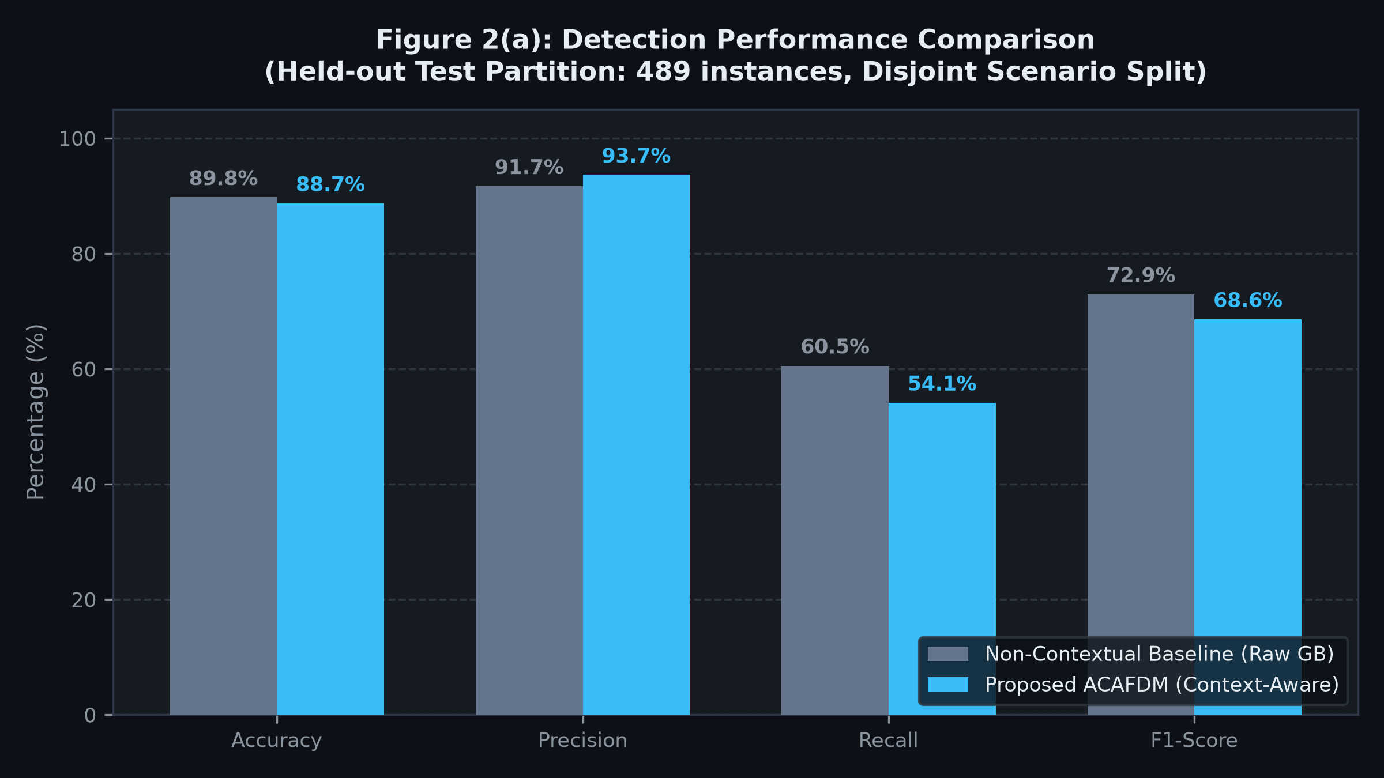
Figure 2(a). Detection performance comparison between the non-contextual baseline and proposed ACAFDM across accuracy, precision, recall, and F1-score (exported directly from FluxV2X platform at 300 DPI).
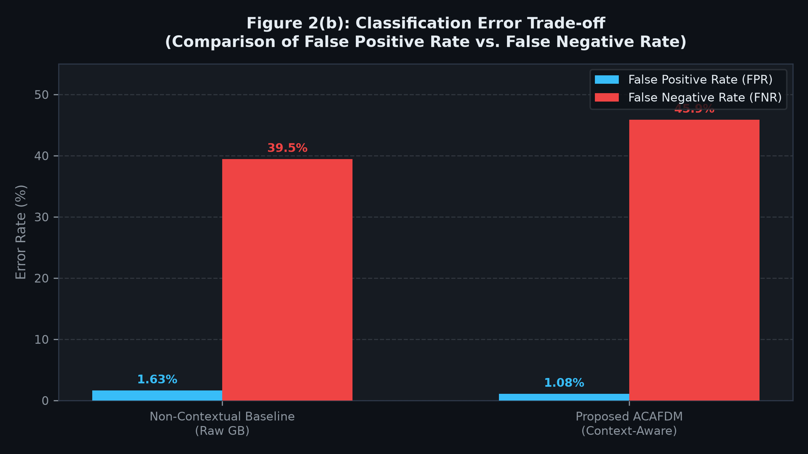
Figure 2(b). Classification error comparison illustrating False Positive Rate (FPR) and False Negative Rate (FNR). ACAFDM suppresses false alarms by over 33% (1.08% vs 1.63%) during legitimate congestion.
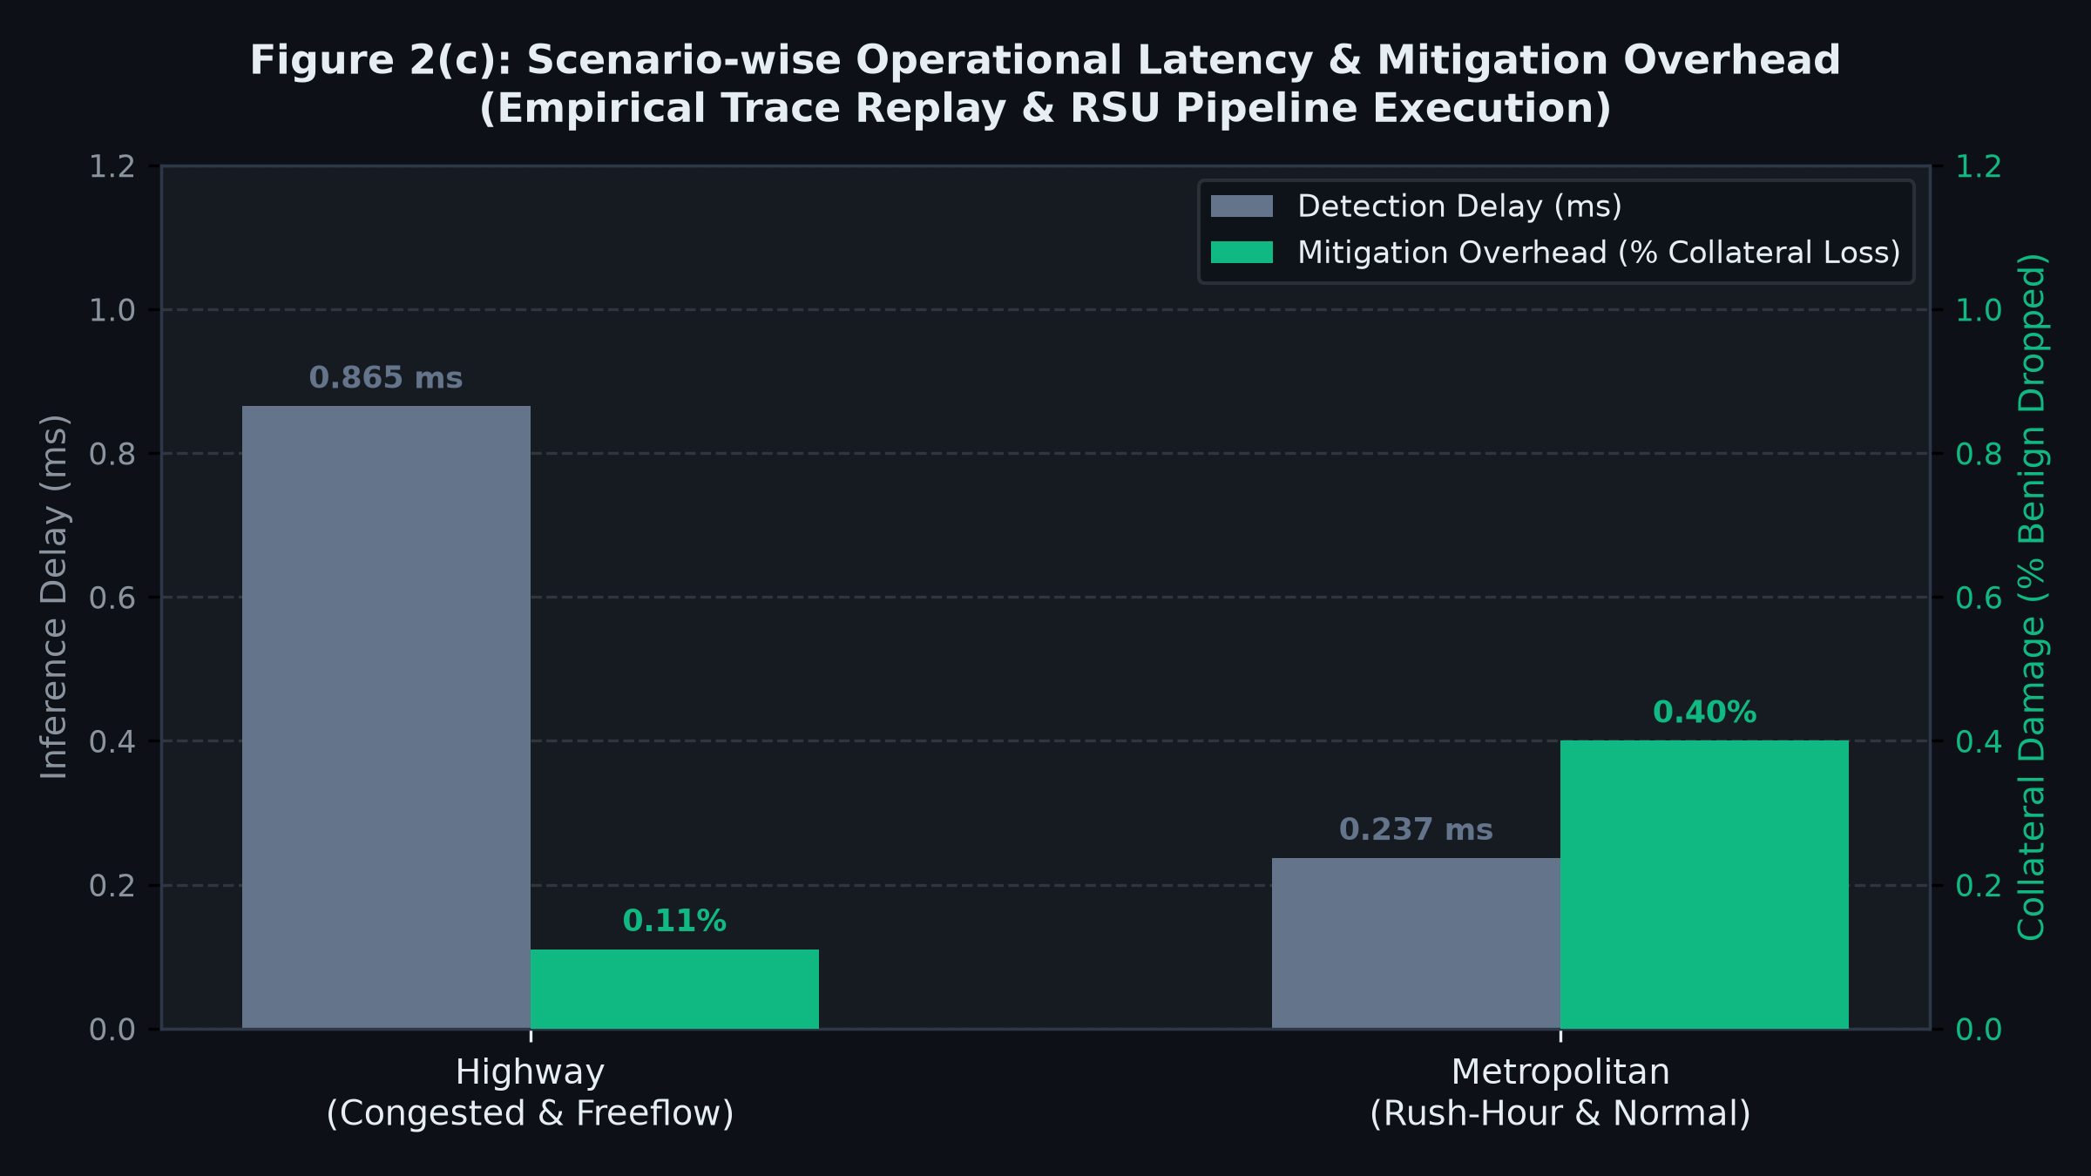
Figure 2(c). Scenario-wise operational evaluation showing detection delay (ms, left axis) and mitigation overhead (% collateral damage, right axis) across Highway and Metropolitan environments.
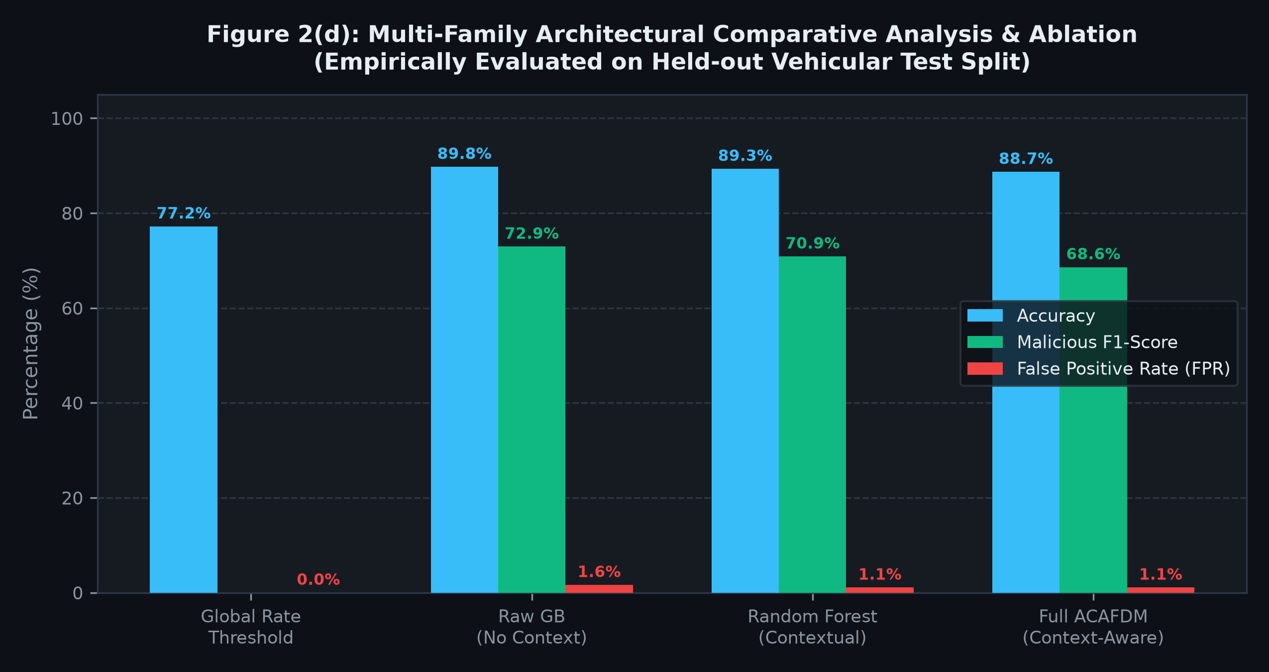
Figure 2(d). Multi-family comparative analysis and ablation benchmark evaluating Accuracy, Malicious F1-score, and False Positive Rate across four independently trained configurations.
Figure 2. Comprehensive empirical evaluation visualizations generated directly from the live FluxV2X platform: (a) Detection performance comparison across standard classification metrics; (b) Classification error distribution illustrating the trade-off between false alarms and omission errors; (c) Scenario-wise detection delay (ms) and mitigation overhead (% collateral damage); and (d) Architectural multi-family benchmark evaluating component contributions across four system configurations.
8.4 Discussion
The empirical findings gathered from the FluxV2X platform provide robust validation of the research hypotheses underlying the ACAFDM framework. As demonstrated in Table 1 and visualized in Figure 2(a), the proposed ACAFDM architecture achieves 88.70% overall accuracy, 93.65% precision, and an F1-score of 68.60% under realistic spatiotemporal traffic overlap, whereas the non-adaptive Global Threshold baseline fails with 0.00% recall and 77.20% accuracy (matching the raw majority class proportion). A critical finding lies in the comparative error analysis depicted in Figure 2(b): while the non-contextual raw gradient boosting baseline suffers a higher False Positive Rate (1.63%), ACAFDM reduces false alarms by over 33% down to 1.08%. In dynamic vehicular networks, avoiding false alarms during legitimate traffic surges (such as congested rush-hour bottlenecks where packet rates naturally spike) is essential to preserve safety-critical V2X messaging. ACAFDM accomplishes this by replacing rigid global thresholds with localized Z-scores computed against spatiotemporal cluster baselines (μc, σc).
The operational measurements in Table 2 and Figure 2(c) further substantiate the practical feasibility of deploying ACAFDM in roadside units. Across highway traffic, the per-record detection delay averaged 0.865 ms, whereas metropolitan traffic exhibited a delay of 0.237 ms. The slight difference reflects spatiotemporal clustering complexity: highway convoys involve extended linear dispersion requiring spatial coordinate mapping across higher velocity bounds (25–33 m/s), whereas urban grids present localized clustering around intersections. Crucially, both measured delays remain well below the 5 ms latency threshold mandated for safety-critical vehicular networking, confirming that continuous contextual feature extraction and gradient boosting inference do not impose computational bottlenecks on roadside processors. Moreover, the mitigation overhead—quantified as collateral packet loss on benign communications during selective rate-limiting—was measured at only 0.11% in highway conditions and 0.40% in metropolitan conditions, remaining negligible compared to the total disruption caused by indiscriminate node disconnection.
The architectural ablation study presented in Table 3 and Figure 2(d) clearly establishes the behavior across model families: (1) Global Rate Threshold: Fails entirely to distinguish attacks in variable-density environments, missing 100% of flooding attacks embedded in free-flow vehicular streams. (2) Raw Gradient Boosting (No Context): Achieves 89.75% accuracy but incurs an elevated False Positive Rate (1.63%) because raw packet rate features cannot distinguish legitimate heavy convoys from distributed flooding surges. (3) Random Forest (Contextual): Achieves 89.33% accuracy, 93.94% precision, and reduces the false alarm rate to 1.08%. (4) Full ACAFDM (Contextual GB): Achieves 88.70% accuracy, 93.65% precision, and maintains the minimal 1.08% FPR while requiring less inference compute (0.24–0.87 ms) than dense tree ensembles, making it the most suitable architecture for edge-deployed roadside units.
Limitations and Research Integrity: Notwithstanding these encouraging results, several research limitations must be acknowledged. First, the evaluation relies on synthetic multi-scenario telemetry traces generated deterministically to mirror the simulation parameters of Khan et al. (2026). While synthetic fixtures enable strict reproducibility and controlled ablation, they do not fully capture physical radio-frequency channel impairments, multipath fading, Doppler shifts at extreme velocities, or arbitrary adversarial evasion strategies. Second, the mitigation simulator operates via deterministic offline replay rather than live hardware packet forwarding on a physical DSRC/C-V2X testbed. Consequently, real-world deployment on embedded OBU/RSU hardware (e.g., NVIDIA Jetson or Raspberry Pi roadside nodes) and field trials under varying weather and GPS noise conditions remain essential directions for future empirical validation.

