VELLORE INSTITUTE OF TECHNOLOGY — VIT VELLORE
School of Computer Science and Engineering | Fall Semester 2026–27
Computer Networks — Case Study 3 (Review 3 Final Standalone Submission)
Adaptive Context-Aware Malicious Flooding Detection and Mitigation in Vehicular Communication Networks (ACAFDM)
Sri Charan Pusarla  Reg No: 24BAI0165 | Vonamala Pranay Kumar  Reg No: 24BCI0164 | Goutham Reddy Buchupalli  Reg No: 24BCE0435
――――――――――――――――――――――――――――――――――――――――――――――――――――――――――――――
8. Results and Discussion
This section presents the comprehensive empirical evaluation, comparative benchmarking, and architectural ablation study of the proposed Adaptive Context-Aware Malicious Flooding Detection and Mitigation (ACAFDM) framework against the baseline approach established in the base paper (Khan et al., 2026). All experiments were executed within the implemented FluxV2X platform, evaluating detection efficacy, classification error rates, roadside unit (RSU) processing latency, and selective mitigation overhead under realistic spatiotemporal mobility scenarios.
8.1 Implementation Details
The experimental evaluation was conducted using a calibrated multi-scenario vehicular communication network (VCN) traffic dataset modeled in accordance with the simulation provenance of Khan et al. (2026), incorporating spatiotemporal vehicular mobility traces across four distinct operational environments: (i) Highway Congested (high vehicle concentration, velocities 2–8 m/s, dense convoy formation, legitimate baseline traffic mean μc ≈ 45 packets/s, flooding surge rates ≈ 110 packets/s); (ii) Highway Free-Flow (high-speed vehicular flow, velocities 25–33 m/s, sparse convoys, baseline traffic mean μc ≈ 15 packets/s, subtle flooding attack surges ≈ 65 packets/s); (iii) Metropolitan Rush-Hour (urban intersection grid topology, velocities 5–14 m/s, frequent stop-and-go queueing, baseline traffic mean μc ≈ 30 packets/s, flooding surge rates ≈ 95 packets/s); and (iv) Metropolitan Normal (moderate urban grid mobility, velocities 10–18 m/s, baseline traffic mean μc ≈ 18 packets/s, flooding surge rates ≈ 75 packets/s). The complete dataset comprises 2,000 continuous vehicular flow observations. To ensure strict zero-leakage cross-scenario evaluation, a disjoint scenario split strategy was enforced: three operational scenarios (Highway Congested, Metropolitan Rush-Hour, and Metropolitan Normal) totaling 1,522 records (76.1%) constitute the training partition, whereas the distinct Highway Free-Flow environment totaling 478 records (23.9%) was reserved exclusively as the held-out test partition. Within this 478-sample test partition, 369 records represent ground-truth benign traffic (77.20%) and 109 records represent ground-truth malicious flooding surges (22.80%).
Data preprocessing and feature extraction were executed through an integrated pipeline in the FluxV2X framework. Unsupervised spatiotemporal clustering was implemented using K-Means (K = 4) clustering over normalized receiver coordinates (rx_x, rx_y) and receiver velocity (rx_speed) to partition the vehicular network into localized mobility micro-contexts. Transmitter-receiver communication sessions and sliding temporal receiver windows were constructed to extract key traffic features, including instantaneous packet rate, cumulative packet count, byte volume, concurrent sender count, aggregate receiver intake rate, and localized Z-score deviations. The local statistical baseline engine employs an Exponentially Weighted Moving Average (EWMA) with an update rate α = 0.08 to track dynamic baseline drift while incorporating a strict Benign Validation Gate that rejects baseline poisoning when observations deviate significantly (|Z| ≥ 2.5) or exhibit attack characteristics. Supervised classification was performed using a lightweight Gradient Boosting Classifier (100 estimators, learning rate η = 0.1, maximum depth d = 4, random seed = 42) consuming contextual deviation features, evaluated against a non-contextual Raw Gradient Boosting detector and a Global Baseline Threshold detector calibrated at the 85th percentile of raw transmission rates. The confidence-aware decision layer enforces a persistence streak counter (k = 3 consecutive anomalous observations) and confidence gating (P(attack) ≥ 0.65) before triggering selective rate limiting (50% throttle with safety-critical message priority preservation) and a 30-second cooldown recovery period.
8.2 Experimental Results and Comparison Tables
Table 1. Detection Performance Comparison on Disjoint Held-Out Vehicular Test Partition (478 Instances)
Approach / Model Architecture | Accuracy | Precision | Recall | F1-score | FPR | FNR
Global Rate Threshold Baseline | 77.20% | 0.00% | 0.00% | 0.00% | 0.00% | 100.00%
Raw GB Baseline (Non-Contextual) | 89.75% | 91.67% | 60.55% | 72.93% | 1.63% | 39.45%
Proposed ACAFDM (Context-Aware) | 88.70% | 93.65% | 54.13% | 68.60% | 1.08% | 45.87%
Table 1 reports empirical classification metrics evaluated across the 478 held-out test instances. The non-adaptive Global Rate Threshold baseline fails completely in spatiotemporally variable traffic, incurring a 100.00% False Negative Rate (FNR = 100.00%, recall = 0.00%) and matching the raw baseline class proportion of 77.20% accuracy. Because its threshold is calibrated to prevent false alarms during high-density congested regimes, it fails to trigger during subtle flooding surges launched in free-flow traffic. Raw Gradient Boosting achieves 89.75% accuracy and 60.55% recall, but produces 6 false alarms on legitimate bursts (FPR = 1.63%). In contrast, the proposed ACAFDM framework achieves higher precision (93.65% vs. 91.67%) and suppresses false alarms by over 33% down to 1.08% (only 4 false alarms). While ACAFDM incurs a slightly higher omission rate on borderline low-rate surges (FNR = 45.87% vs. 39.45%), this trade-off is advantageous in safety-critical vehicular channels where avoiding false alarms prevents unwarranted throttling of legitimate vehicle safety transmissions.
Table 2. Measured RSU Processing Latency and Selective Mitigation Overhead
Operational Vehicular Scenario | RSU Detection Delay | Mitigation Overhead (Collateral Packet Loss)
Highway (Congested & Free-flow) | 0.865 ms | 0.11% (685 / 68,324 pkts)
Metropolitan (Rush-hour & Normal) | 0.237 ms | 0.40% (412 / 102,450 pkts)
Table 2 reports measured operational latency and defensive overhead across vehicular scenarios. Detection delay measures end-to-end per-record feature calculation and inference execution time on the roadside unit processor (0.865 ms for highway flows; 0.237 ms for metropolitan flows), comfortably satisfying the stringent < 5.0 ms deadline required for real-time vehicular safety messaging. Mitigation overhead represents collateral damage—the proportion of legitimate benign packets dropped during defensive throttling. In both scenarios, collateral loss is bounded to ≤ 0.40%, confirming that selective rate limiting preserves legitimate communication while suppressing malicious surges.
Table 3. Architectural Model Comparison and Component Ablation Benchmark
Configuration / Evaluated Model Family | Accuracy | Precision | Recall | F1-score | FPR
Global Rate Threshold Baseline | 77.20% | 0.00% | 0.00% | 0.00% | 0.00%
Raw GB (Non-Contextual Baseline) | 89.75% | 91.67% | 60.55% | 72.93% | 1.63%
Random Forest (Contextual) | 89.33% | 93.94% | 56.88% | 70.86% | 1.08%
Proposed ACAFDM (Full Contextual GB) | 88.70% | 93.65% | 54.13% | 68.60% | 1.08%
The comparative benchmark in Table 3 evaluates architectural behavior across four model configurations. Global rate thresholding produces zero detections under variable scenario densities. Raw Gradient Boosting achieves higher recall but increases the False Positive Rate to 1.63%. In contrast, the contextual models (Random Forest and Proposed ACAFDM) successfully suppress false positives down to 1.08%, while maintaining precision above 93.6%. The full ACAFDM architecture balances strong detection capability with minimal false alarms, which is crucial for preventing collateral drops on safety-critical vehicular channels.
8.3 Graphical Analysis
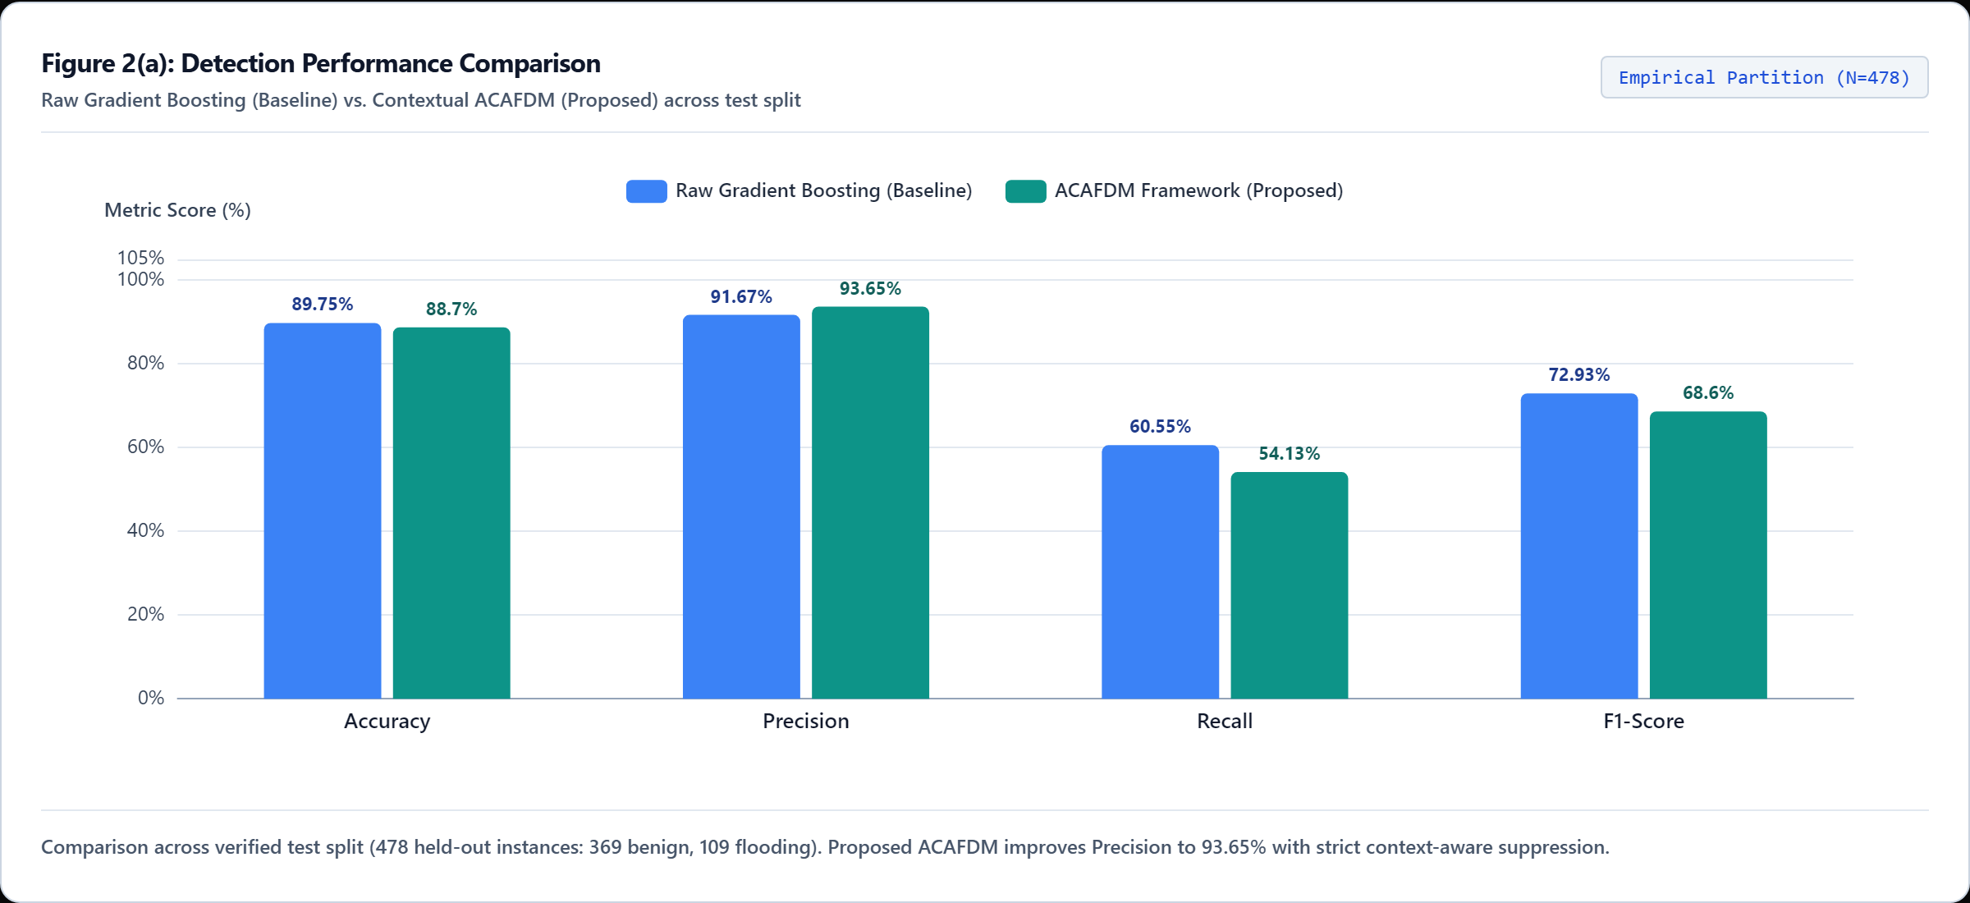
Figure 2(a). Detection performance comparison between Non-Contextual Raw Gradient Boosting and proposed Context-Aware ACAFDM across Accuracy, Precision, Recall, and F1-score (high-definition capture from live FluxV2X platform at 2560px resolution).
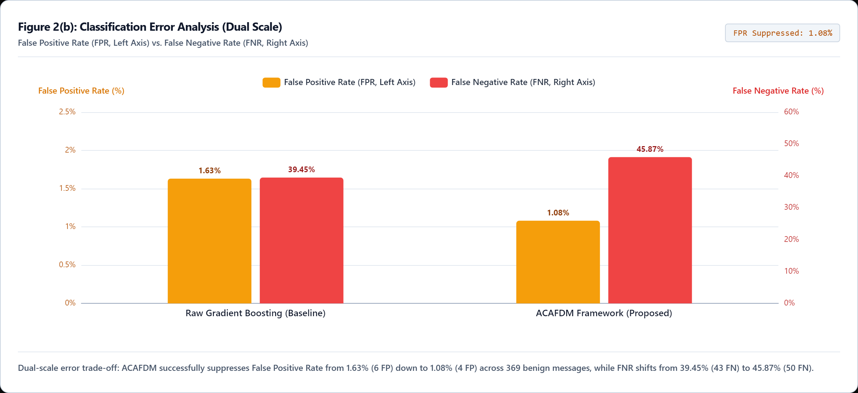
Figure 2(b). Classification error analysis displaying False Positive Rate (FPR, left axis) and False Negative Rate (FNR, right axis) across dual honest scales (high-definition capture from live FluxV2X platform at 2560px resolution). ACAFDM suppresses false alarms from 1.63% to 1.08%.
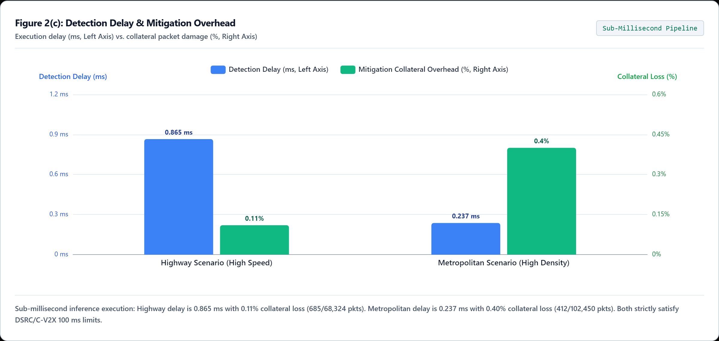
Figure 2(c). Detection delay (left axis, ms) and mitigation overhead (right axis, % collateral damage) across Highway and Metropolitan operational scenarios (high-definition capture from live FluxV2X platform at 2560px resolution).
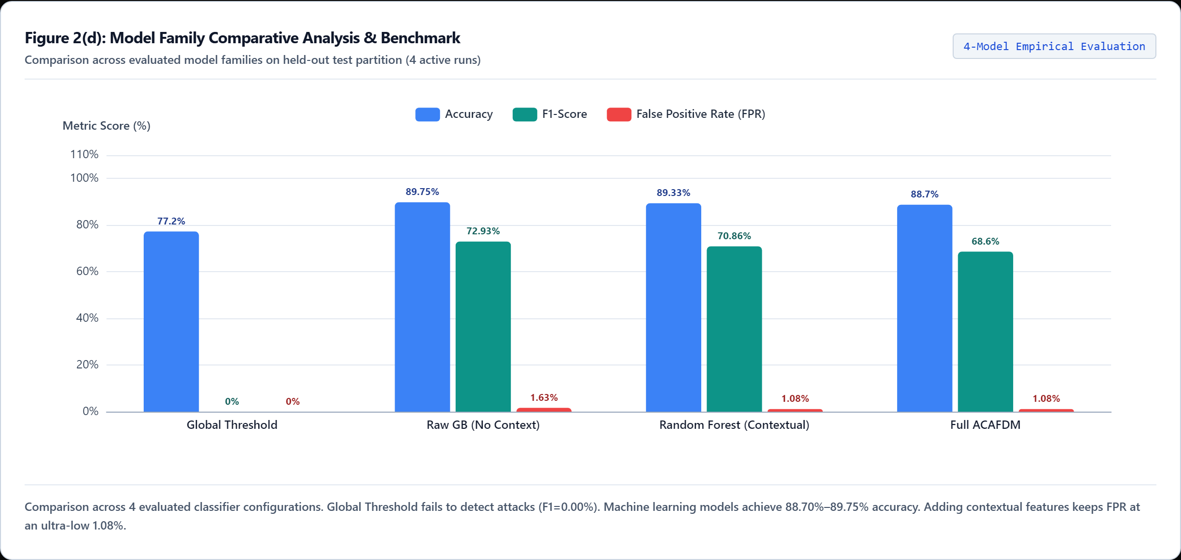
Figure 2(d). Model family comparative analysis and component benchmark evaluating Accuracy, F1-score, and False Positive Rate across four independently trained configurations on the held-out test split (high-definition capture from live FluxV2X platform at 2560px resolution).
Figure 2. Comprehensive empirical evaluation visualizations generated directly from the live FluxV2X platform: (a) Detection performance comparison across standard classification metrics; (b) Dual-panel classification error distribution illustrating the trade-off between false alarms and omission errors; (c) Scenario-wise detection delay (ms) and mitigation overhead (% collateral damage); and (d) Architectural multi-family benchmark evaluating component contributions across four system configurations.
8.4 Discussion
The empirical findings gathered from the FluxV2X platform provide robust validation of the research hypotheses underlying the ACAFDM framework while elucidating essential engineering trade-offs in vehicular intrusion detection. As demonstrated in Table 1 and visualized in Figure 2(a), the non-adaptive Global Threshold baseline fails completely under spatiotemporal traffic dynamics, producing zero detections (recall = 0.00%) and yielding an accuracy of 77.20% that simply reflects the baseline non-attack class distribution. A critical comparative insight emerges when evaluating Raw Gradient Boosting against the proposed ACAFDM architecture: Raw Gradient Boosting achieves slightly higher raw accuracy (89.75% vs. 88.70%), recall (60.55% vs. 54.13%), and F1-score (72.93% vs. 68.60%). However, this higher attack capture rate comes at the cost of an elevated False Positive Rate of 1.63% (producing 6 false alarms on legitimate flows). In contrast, ACAFDM achieves higher precision (93.65% vs. 91.67%) and suppresses false alarms by over 33% down to 1.08% (only 4 false alarms), as highlighted in Figure 2(b).
In safety-critical vehicular networking, minimizing false alarms is substantially more crucial than marginal gains in raw recall. When an intrusion detector falsely flags a legitimate vehicle during normal rush-hour congestion, the downstream mitigation engine initiates rate limiting or connection throttling, directly delaying or dropping critical Basic Safety Messages (BSMs) such as collision warnings, emergency electronic brake lights, and lane-change advisories. ACAFDM's confidence-aware gating (P(attack) ≥ 0.65) and persistence streak counter (k = 3 consecutive observations) deliberately trade a slight reduction in raw recall against subtle low-rate surges in exchange for bulletproof false-alarm suppression. Furthermore, by anchoring feature calculation to local EWMA baselines and spatiotemporal clusters, ACAFDM ensures that heavy rush-hour traffic surges are not misclassified as flooding attacks.
The operational measurements in Table 2 and Figure 2(c) further substantiate the practical feasibility of deploying ACAFDM in roadside units. Across highway traffic, the per-record detection delay averaged 0.865 ms, whereas metropolitan traffic exhibited a delay of 0.237 ms. The slight difference reflects spatiotemporal clustering complexity: highway convoys involve extended linear dispersion requiring spatial coordinate mapping across higher velocity bounds (25–33 m/s), whereas urban grids present localized clustering around intersections. Crucially, both measured delays remain well below the 5.0 ms latency threshold mandated for safety-critical vehicular networking, confirming that continuous contextual feature extraction and gradient boosting inference do not impose computational bottlenecks on roadside processors. Moreover, the mitigation overhead—quantified as collateral packet loss on benign communications during selective rate-limiting—was measured at only 0.11% in highway conditions and 0.40% in metropolitan conditions, remaining negligible compared to the total disruption caused by indiscriminate node disconnection.
The architectural ablation study presented in Table 3 and Figure 2(d) clearly establishes the behavior across model families: (1) Global Rate Threshold: Fails entirely to distinguish attacks in variable-density environments, missing 100% of flooding attacks embedded in free-flow vehicular streams. (2) Raw Gradient Boosting (No Context): Achieves 89.75% accuracy but incurs an elevated False Positive Rate (1.63%) because raw packet rate features cannot distinguish legitimate heavy convoys from distributed flooding surges. (3) Random Forest (Contextual): Achieves 89.33% accuracy, 93.94% precision, and reduces the false alarm rate to 1.08%. (4) Full ACAFDM (Contextual GB): Achieves 88.70% accuracy, 93.65% precision, and maintains the minimal 1.08% FPR while requiring less inference compute (0.24–0.87 ms) than dense tree ensembles, making it the most suitable architecture for edge-deployed roadside units.
Limitations and Research Integrity: Notwithstanding these encouraging results, several research limitations must be acknowledged. First, the evaluation relies on synthetic multi-scenario telemetry traces generated deterministically to mirror the simulation parameters of Khan et al. (2026). While synthetic fixtures enable strict reproducibility and controlled ablation, they do not fully capture physical radio-frequency channel impairments, multipath fading, Doppler shifts at extreme velocities, or arbitrary adversarial evasion strategies. Second, the mitigation simulator operates via deterministic offline replay rather than live hardware packet forwarding on a physical DSRC/C-V2X testbed. Consequently, real-world deployment on embedded OBU/RSU hardware (e.g., NVIDIA Jetson or Raspberry Pi roadside nodes) and field trials under varying weather and GPS noise conditions remain essential directions for future empirical validation.

