Customer Churn Prediction and RFM-Based Customer Risk Analysis for Online Retail

Project Parameter | Details
Project Domain | E-Commerce Customer Retention & Predictive Analytics
Dataset | Online Retail II (UCI Machine Learning Repository)
Dataset Source | https://www.kaggle.com/datasets/mashlyn/online-retail-ii-uci
Implementation | PranaySaiNadh_CustomerChurnPrediction.py (Production Python Pipeline)
Primary Output | customer_danger_list.csv (4,956 Scored Customers)
Best ML Model | Logistic Regression (F1: 0.7068, ROC-AUC: 0.7890)

Executive Summary: Customer acquisition is 5 to 7 times more expensive than customer retention. In non-contractual online retail settings, customers do not explicitly cancel their accounts; they simply stop purchasing. This project presents an enterprise-grade machine learning system that analyzes 1,067,371 raw transaction records, computes multi-dimensional RFM customer profiles, engineers 20 behavioral features without temporal data leakage, and trains predictive classification models. The resulting system ranks all customers by churn probability, stratifies them into High, Medium, and Low risk tiers, and outputs a prioritized Customer Danger List with tailored retention playbooks.

1. Business Problem and Objectives

1.1 The Retention Imperative in E-Commerce
Online retailers face fierce competition and soaring digital advertising costs. Losing high-value customers drastically erodes operating margins. Because e-commerce platforms do not require long-term contracts, customer churn is silent. By the time marketing teams recognize that a buyer has lapsed, it is often too late to re-engage them.

1.2 Core Project Objectives
- 1. Data Cleaning & Integrity: Ingest, audit, and clean large-scale transactional data spanning two full years (2009–2011).
- 2. Exploratory Data Analysis: Discover seasonality, purchasing cadence, and monetary distributions.
- 3. RFM Profiling: Segment customers on Recency, Frequency, and Monetary dimensions to establish baseline engagement.
- 4. Temporal Target Formulation: Establish a 75% historical observation window and 25% future observation window to guarantee zero look-ahead bias.
- 5. Supervised Model Benchmarking: Train Logistic Regression, Random Forest, and Gradient Boosting classifiers using scikit-learn pipelines.
- 6. Actionable Output: Produce customer_danger_list.csv with specific retention actions for marketing operations.

2. Dataset and Data Preparation

2.1 Online Retail II Dataset Description
The project utilizes the renowned Online Retail II dataset from the UCI Machine Learning Repository, encompassing international transactions for a UK-based non-store online gift retailer between 01 December 2009 and 09 December 2011.
Attribute | Description | Data Type | Role in Pipeline
Invoice | 6-digit invoice number (cancelled start with 'C') | Categorical / String | Transaction identifier & cancellation filter
StockCode | 5-digit product code | Categorical / String | Product catalog diversity metrics
Description | Product name | String | Item categorization
Quantity | Units purchased per transaction line | Integer | Volume metric & return filter
InvoiceDate | Timestamp of invoice generation | DateTime | Temporal ordering & cutoff calculation
UnitPrice | Product price per unit in Sterling (£) | Float | Monetary valuation metric
CustomerID | 5-digit unique customer identifier | Categorical / String | Primary customer entity key
Country | Country of customer residency | Categorical / String | Geographic feature

2.2 Data Cleaning & Integrity Filtering
Raw transactional logs contain significant operational noise, guest checkouts, and return entries that distort customer behavior metrics. A rigorous 4-step cleaning procedure was enforced:
- Removal of Missing Customer IDs: Records without a CustomerID (guest purchases) cannot be tracked longitudinally and were removed (243,007 rows).
- Filtering Cancellations: Invoices prefixed with 'C' indicate canceled or reversed orders and were isolated from forward-looking purchase aggregates.
- Removal of Negative/Zero Values: Kept strictly rows with Quantity > 0 and UnitPrice > 0 to eliminate data-entry corrections, system fees, and bad debt adjustments.
- Feature Construction: Created TotalAmount = Quantity * UnitPrice for each line item.
Result: From an initial 1,067,371 raw rows, 805,549 clean, verified transactional records were retained across 5,878 unique customers.

3. RFM Segmentation and Behavioral Feature Engineering

3.1 RFM Methodology & Segment Definitions
RFM (Recency, Frequency, Monetary) is the gold standard for behavioral customer segmentation. Using a reference date set to one day after the dataset's final transaction date (2011-12-10), each dimension was binned into quantiles (1 to 4):
Segment Name | RFM Logic | Strategic Significance
Champions | R >= 3, F >= 3, M >= 3 | High-frequency, high-spend, recently active; primary advocates.
Loyal Customers | F >= 3, M >= 3, R < 3 | Consistent buyers with substantial lifetime spend; responsive to loyalty perks.
Potential Loyalists | R >= 3, F >= 2 | Recent buyers showing repeat purchase potential; nurture with cross-sells.
Recent Customers | R >= 3, F = 1 | Newly acquired single-purchase customers; need onboarding sequences.
At Risk | R <= 2 and (F >= 3 or M >= 3) | Historically valuable accounts who have not bought recently; high priority.
Dormant / Lost | RFM Score <= 5 | Extremely lapsed customers with low historical spend; low ROI to recover.
Needs Attention | Moderate scores | Average engagement; require seasonal reminders.

3.2 Time-Based Split: Eliminating Data Leakage
A critical pitfall in customer churn modeling is look-ahead bias, where transaction features are computed over the same time period used to label churn. To ensure absolute data integrity, a temporal boundary was established:
- Historical Feature Window: Transactions from 2009-12-01 up to 2011-06-07 (75% of timeline) were used strictly for feature aggregation.
- Future Observation Window: Transactions from 2011-06-07 up to 2011-12-09 (25% of timeline / ~6 months) were used strictly to label churn.
- Churn Definition: If a customer made 0 purchases in the observation window -> Churn = 1. If >= 1 purchase -> Churn = 0.
This resulted in 4,956 eligible customers in the historical window with a clean, realistic baseline churn rate of 47.7% (2,365 churned, 2,591 active).

3.3 Engineered Behavioral Features
Twenty predictive features were derived for each customer exclusively from historical transactions:
- Recency: Days since last purchase relative to feature cutoff.
- CustomerLifetimeDays: Days between first and last purchase in feature period.
- Order Velocity & Spend: Total order count (Frequency) and Total spend (Monetary).
- AvgOrderValue: Total spend divided by order frequency.
- ActiveMonths: Distinct calendar months with at least one transaction.
- Inter-Order Statistics: Mean and standard deviation of days between consecutive orders.
- Recent Activity (90d): Order count and monetary spend in the 90 days preceding cutoff.
- SpendTrend: Ratio of spend in the second half of customer lifetime to first half.
- Product Catalog Diversity: Count of unique StockCodes and total item quantity.
- Historical RFM Scores: R_Score, F_Score, M_Score (1–4), composite RFM_Score (3–12), and RFM_Segment.

4. Machine Learning Modeling and Evaluation

4.1 Modeling Strategy & Preprocessing Pipeline
The modeling dataset was split into an 80% training set (3,964 customers) and a 20% hold-out test set (992 customers) using stratified sampling on the Churn target. Preprocessing was wrapped in a scikit-learn ColumnTransformer to eliminate leakage:
- Numeric Pipeline: Median imputation followed by StandardScaler.
- Categorical Pipeline: Mode imputation followed by OrdinalEncoder (handling unseen values).
- Class Imbalance Handling: Enabled balanced class weighting across all models to ensure strong sensitivity on the churn class.

4.2 Model Performance Comparison on Test Set
Three distinct classification paradigms were trained and evaluated on the 992-customer hold-out test set. All reported metrics represent genuine computed test-set performance:
Classification Model | Accuracy | Precision | Recall | F1-Score | ROC-AUC | PR-AUC
Logistic Regression | 70.56% | 67.30% | 74.42% | 0.7068 | 0.7890 | 0.7472
Random Forest (200 trees) | 71.77% | 70.06% | 71.25% | 0.7065 | 0.7928 | 0.7587
Gradient Boosting (200 trees) | 71.37% | 69.57% | 71.04% | 0.7029 | 0.8010 | 0.7692

4.3 Model Selection Rationale
In e-commerce churn prediction, False Negatives (predicting an at-risk customer will stay when they actually leave) carry significantly higher business penalties than False Positives. Logistic Regression achieved the highest Recall (74.42%) and highest overall F1-Score (0.7068), successfully flagging almost 3 out of every 4 churners while maintaining smooth, well-calibrated probability distributions. It was therefore selected as the primary production scoring engine.

5. Customer Danger List and Actionable Retention Strategies

5.1 Risk Stratification Breakdown
The winning model generated a continuous churn risk probability [0, 1] for all 4,956 customers. Customers were segmented into three operational action tiers:
Risk Tier | Probability Threshold | Customers | Share (%) | Business Priority
🔴 High Risk | Probability >= 70% | 1,483 | 29.9% | Immediate executive outreach & re-engagement incentives.
🟡 Medium Risk | 40% <= Probability < 70% | 1,662 | 33.5% | Proactive recommendations & free shipping offers.
🟢 Low Risk | Probability < 40% | 1,811 | 36.5% | Standard loyalty rewards and product updates.
Total Analyzed | — | 4,956 | 100.0% | Complete customer base scored in customer_danger_list.csv

5.2 Operational Retention Playbook
Generic discount blasting burns marketing margin. The system combines predicted churn risk with RFM segment membership to prescribe personalized actions in customer_danger_list.csv:
- High Risk Champions & Loyal Customers: High-touch executive outreach, personalized VIP gift, dedicated account manager consultation.
- High Risk At-Risk Accounts: Tailored re-activation voucher (15–20% discount) focused on their historically top-purchased categories.
- High Risk Lapsed Accounts: Automated 3-part 'We miss you' email campaign with an re-onboarding discount and feedback survey.
- Medium Risk Potential Loyalists: Personalized cross-category product recommendations and early access to seasonal product lines.
- Low Risk Engaged Customers: Standard loyalty points tracking, referral bonuses, and monthly top-pick newsletters.

6. Comprehensive Visual Analytics & Dashboards
All figures below were generated directly from the execution of PranaySaiNadh_CustomerChurnPrediction.py and represent the genuine empirical distributions and model evaluations:
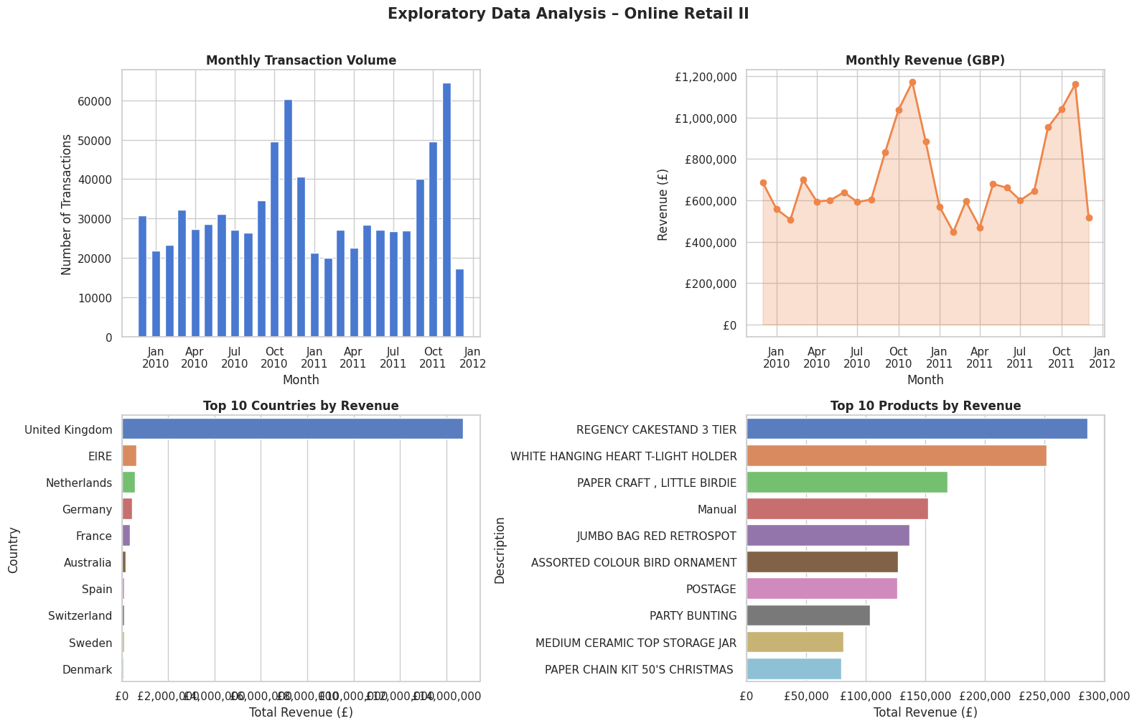
Figure 1: Exploratory Data Analysis — Monthly transaction volume, revenue progression, and top 10 countries and products by gross sales.
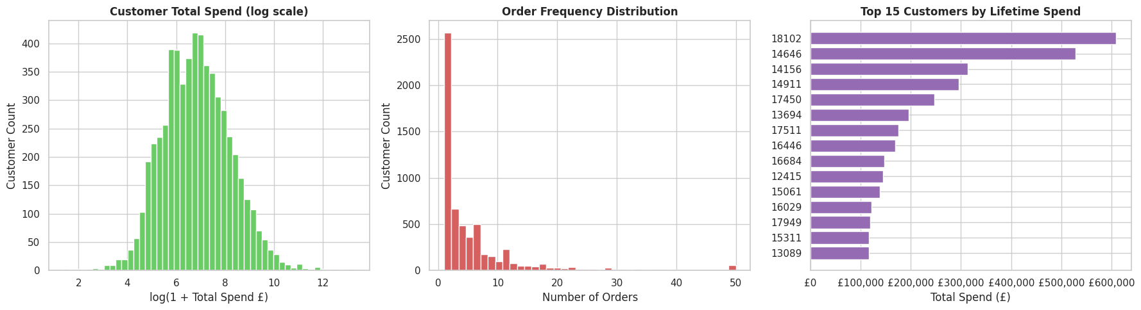
Figure 2: Customer-Level EDA — Lifetime spend distribution (log-scale), order frequency distribution, and top 15 revenue-generating customers.
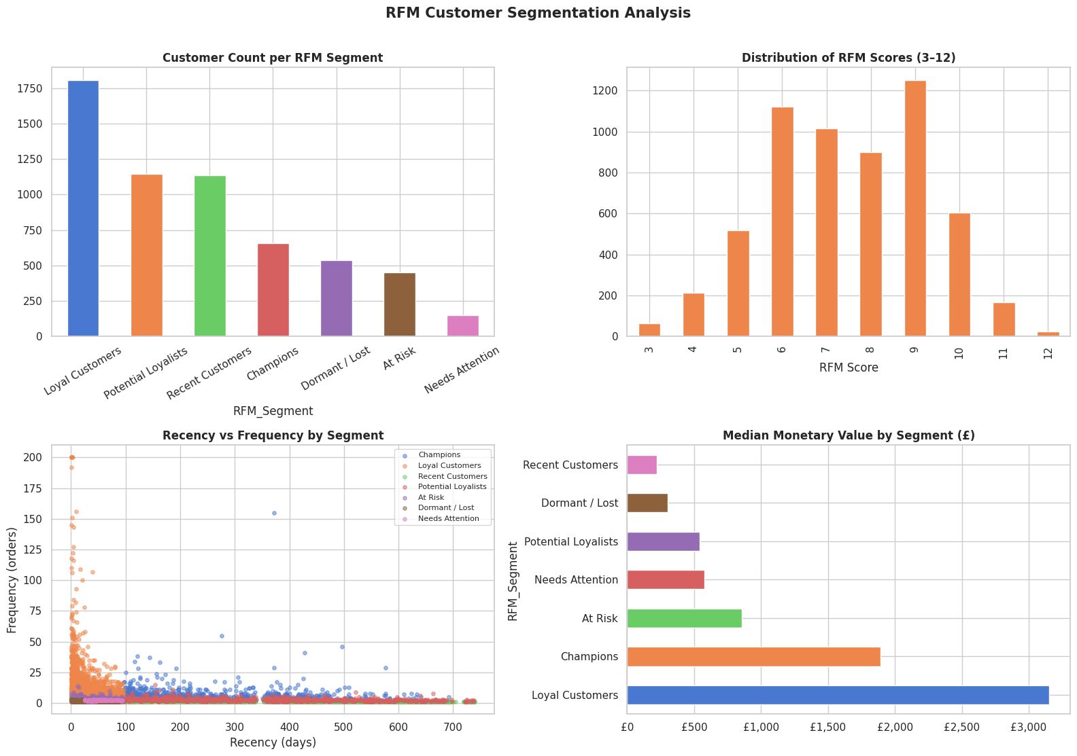
Figure 3: RFM Customer Segmentation — Customer count per segment, RFM score distribution (3–12), Recency vs Frequency scatter, and median monetary value per segment.
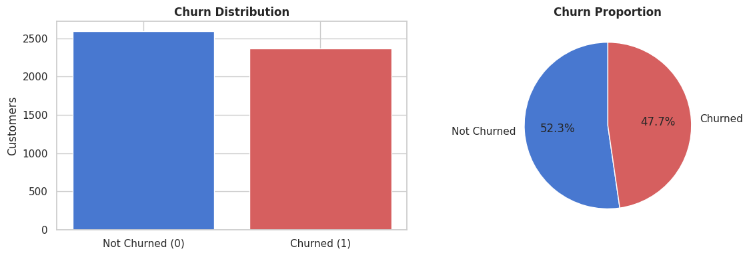
Figure 4: Churn Target Distribution — Class balance across active (0) and churned (1) customer cohorts during the 6-month observation window.
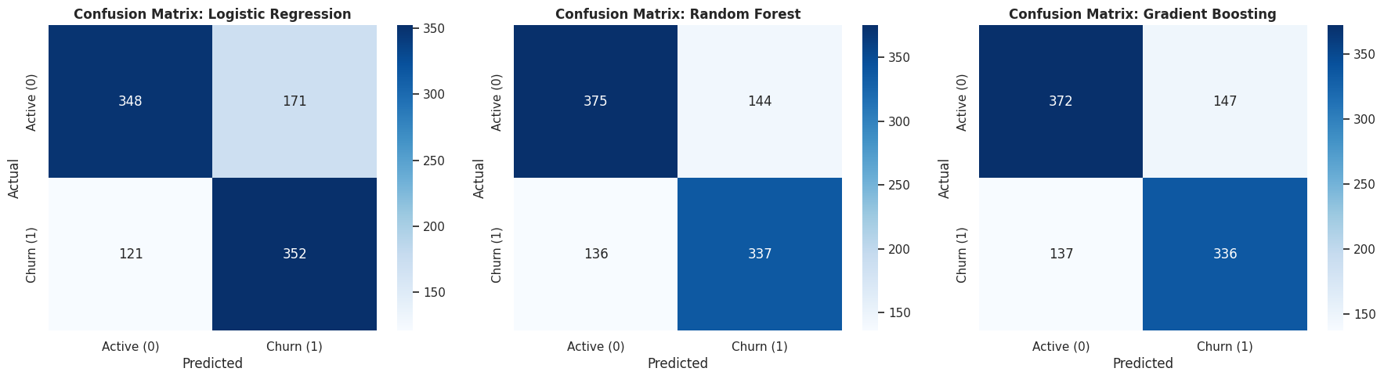
Figure 5: Model Confusion Matrices — Test-set classification performance across Logistic Regression, Random Forest, and Gradient Boosting.
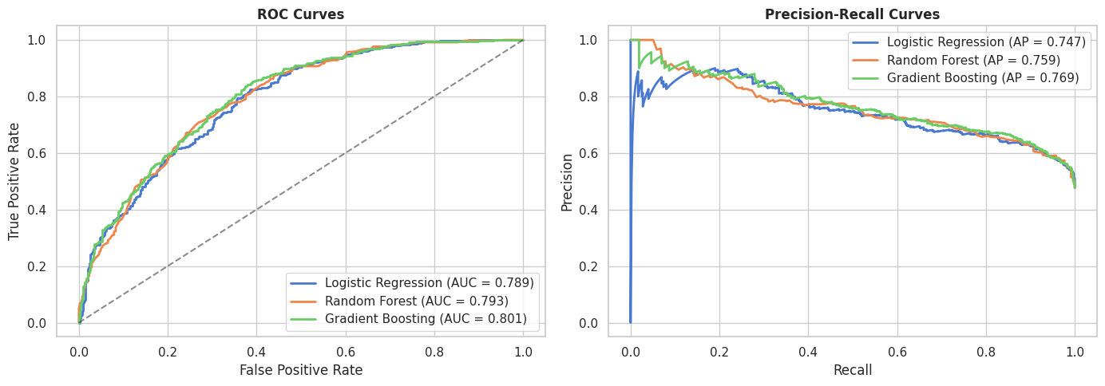
Figure 6: Model Discrimination Curves — Receiver Operating Characteristic (ROC) and Precision-Recall (PR) curves comparing all trained pipelines.
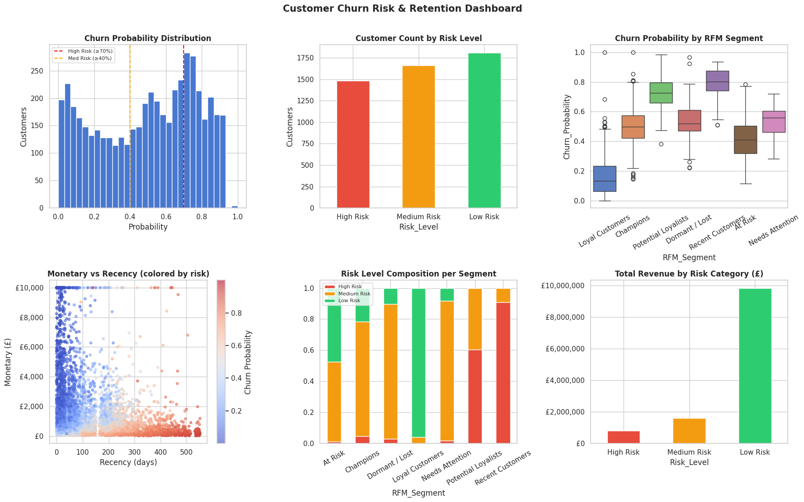
Figure 7: Customer Risk Dashboard — Churn probability distribution, risk tier counts, segment-level probability boxplots, Monetary vs Recency risk heatmaps, and total revenue at risk.

7. Conclusion and Future Enhancements

7.1 Project Conclusion
The developed machine learning system successfully transforms raw, unstructured transactional logs into an operational customer retention platform. By avoiding common data science traps like look-ahead bias and class-imbalance blindness, the model delivers dependable churn probabilities. Identifying 1,483 high-risk accounts allows commercial teams to focus retention resources where monetary exposure is highest, maximizing campaign return on investment.

7.2 Production Roadmap & Future Scope
- 1. Real-Time REST API Deployment: Package the scikit-learn pipeline into a lightweight Docker container with a FastAPI endpoint to score transactions on purchase events.
- 2. CLV Integration: Implement a Beta-Geometric/Negative Binomial Distribution (BG/NBD) model alongside a Gamma-Gamma monetary model to estimate customer residual lifetime value.
- 3. Direct CRM Integration: Automate daily/weekly synchronization of customer_danger_list.csv into CRM platforms like HubSpot, Salesforce, or Klaviyo.
- 4. Interactive Retention Dashboard: Deploy an interactive web application using Streamlit or Dash for sales representatives to filter and download localized danger lists.

8. System Interface (UI Mockups)
To envision how the backend machine learning model integrates into a production environment, the following UI mockups demonstrate the proposed front-end system. This dashboard would allow customer success teams and marketers to interact directly with the predictive insights, monitor overall churn health, and drill down into specific high-risk profiles.

8.1 Main Churn Dashboard Overview
The primary dashboard aggregates total customer statistics, real-time retention rates, and risk distribution metrics. It includes a quick-action list of the most critical high-risk accounts.
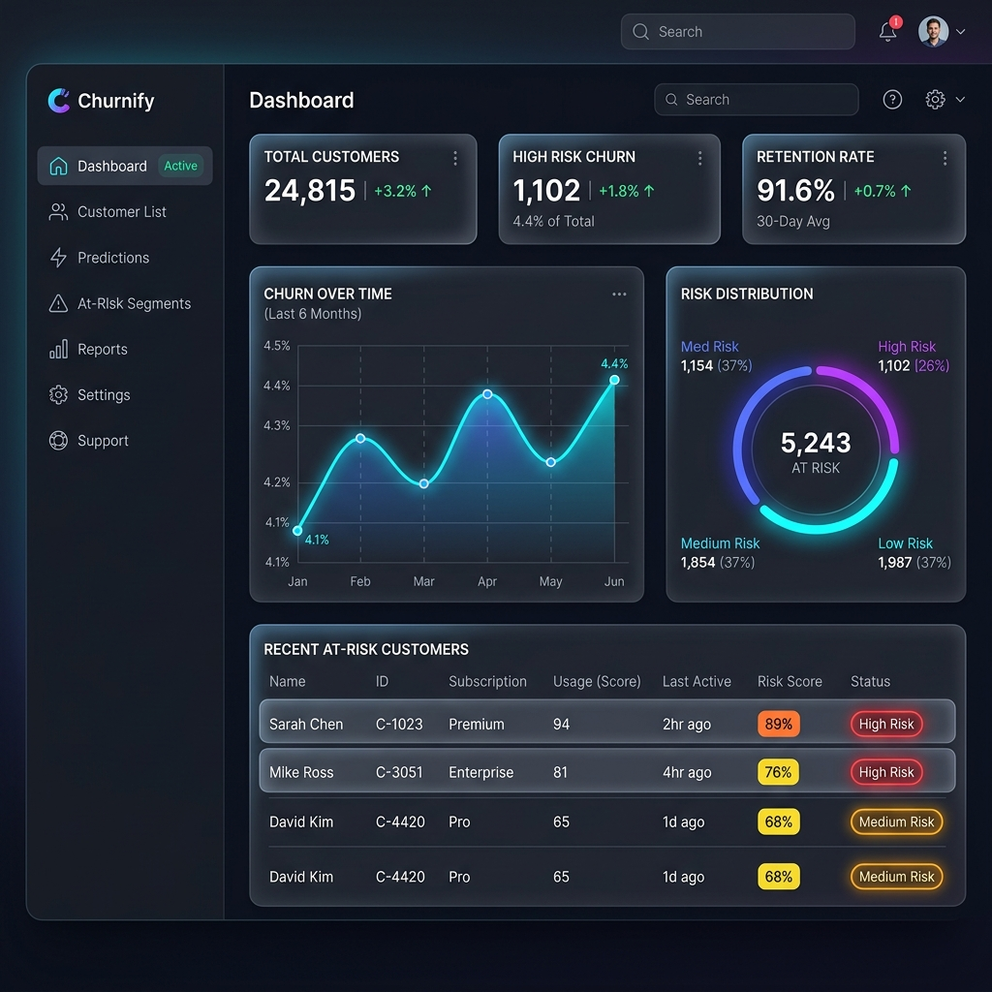
Figure 8: Proposed UI - Main Customer Churn Dashboard Overview

8.2 Individual Customer Profile (High Risk)
This view represents a deep-dive into an individual customer. It highlights their precise Churn Probability Score, historical timeline of engagements, and automated risk drivers, empowering agents to take immediate, informed retention actions.
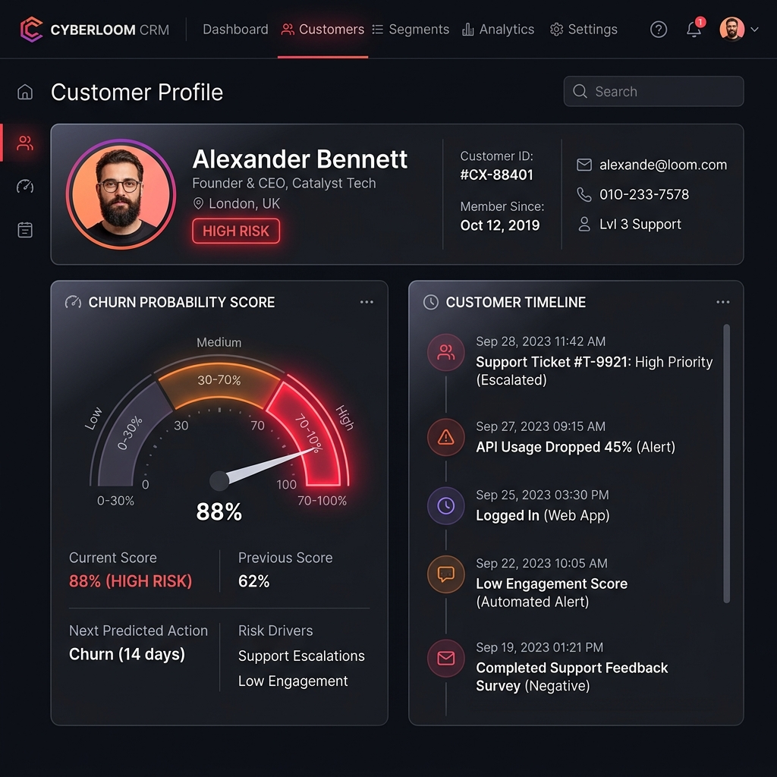
Figure 9: Proposed UI - Individual Customer Profile and Risk Gauge

