**Bank Loan Report Query Document**

1. **Bank Loan Report | Summary**

**KPI’s:**

**Total Loan Applications**

**Select count(id) AS Total_Loan_Applications from finance;**

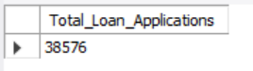

**MTD Loan Applications**

**SELECT COUNT(id)**

**FROM finance**

**WHERE STR_TO_DATE(issue_date, '%Y-%m-%d') IS NOT NULL**

**AND MONTH(STR_TO_DATE(issue_date, '%Y-%m-%d')) = 12;**

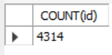

**PMTD Loan Applications**

**SELECT COUNT(id)**

**FROM finance**

**WHERE STR_TO_DATE(issue_date, '%Y-%m-%d') IS NOT NULL**

**AND MONTH(STR_TO_DATE(issue_date, '%Y-%m-%d')) = 11;**

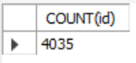

**Total Funded Amount**

**SELECT SUM(loan_amount) AS Total_Funded_Amount FROM finance;**

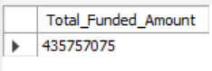

**MTD Total Funded Amount**

**SELECT SUM(loan_amount) AS MTD_Total_Funded_Amount FROM finance**

**WHERE STR_TO_DATE(issue_date, '%Y-%m-%d') IS NOT NULL**

**AND MONTH(STR_TO_DATE(issue_date, '%Y-%m-%d')) = 12;**

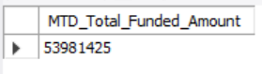

**PMTD Total Funded Amount**

**SELECT SUM(loan_amount) AS PMTD_Total_Funded_Amount FROM finance**

**WHERE STR_TO_DATE(issue_date, '%Y-%m-%d') IS NOT NULL**

**AND MONTH(STR_TO_DATE(issue_date, '%Y-%m-%d')) = 11;**

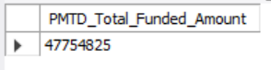

**Total Amount Received**

**SELECT SUM(total_payment) AS Total_Amount_Recevived FROM finance;**

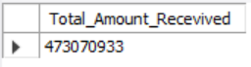

**MTD Total Amount Received**

**SELECT SUM(total_payment) AS MTD_Total_Amount_Recevived FROM finance**

**WHERE STR_TO_DATE(issue_date, '%Y-%m-%d') IS NOT NULL**

**AND MONTH(STR_TO_DATE(issue_date, '%Y-%m-%d')) = 12;**

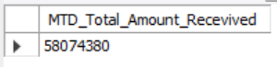

**PMTD Total Amount Received**

**SELECT SUM(total_payment) AS PMTD_Total_Amount_Recevived FROM finance**

**WHERE STR_TO_DATE(issue_date, '%Y-%m-%d') IS NOT NULL**

**AND MONTH(STR_TO_DATE(issue_date, '%Y-%m-%d')) = 11;**

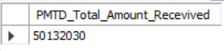

**Average Interest Rate**

**SELECT ROUND(AVG(int_rate), 5) * 100 AS Avg_Interest_Rate FROM finance;**

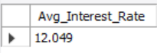

**MTD Average Interest Rate**

**SELECT ROUND(AVG(int_rate), 5) * 100 AS MTD_Avg_Interest_Rate FROM finance**

**WHERE STR_TO_DATE(issue_date, '%Y-%m-%d') IS NOT NULL**

**AND MONTH(STR_TO_DATE(issue_date, '%Y-%m-%d')) = 12;**

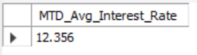

**PMTD Average Interest Rate**

**SELECT ROUND(AVG(int_rate), 5) * 100 AS PMTD_Avg_Interest_Rate FROM finance**

**WHERE STR_TO_DATE(issue_date, '%Y-%m-%d') IS NOT NULL**

**AND MONTH(STR_TO_DATE(issue_date, '%Y-%m-%d')) = 11;**

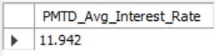

**Average DTI**

**SELECT ROUND(AVG(dti), 5) * 100 AS Avg_DTI FROM finance;**

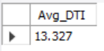

**MTD Average DTI**

**SELECT ROUND(AVG(dti), 5) * 100 AS MTD_Avg_DTI FROM finance**

**WHERE STR_TO_DATE(issue_date, '%Y-%m-%d') IS NOT NULL**

**AND MONTH(STR_TO_DATE(issue_date, '%Y-%m-%d')) = 12;**

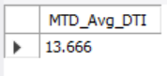

**PMTD Average DTI**

**SELECT ROUND(AVG(dti), 5) * 100 AS PMTD_Avg_DTI FROM finance**

**WHERE STR_TO_DATE(issue_date, '%Y-%m-%d') IS NOT NULL**

**AND MONTH(STR_TO_DATE(issue_date, '%Y-%m-%d')) = 11;**

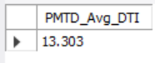

**Good Loan Issued:**

**Good Loan Applications Percentage**

**SELECT**

**(COUNT(CASE WHEN loan_status = 'FULLY Paid' OR loan_status = 'Current' THEN id END) * 100)**

**/**

**COUNT(id) AS Good_Loan_Percentage FROM finance;**

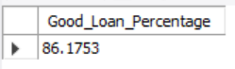

**Good Loan Applications**

**SELECT COUNT(id) AS Good_Loan_Applications FROM finance**

**WHERE loan_status = 'Fully Paid' OR loan_status = 'Current';**

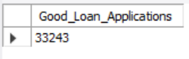

**Good Loan Funded Amount**

**SELECT SUM(loan_amount) AS Good_Loan_Funded_Amount FROM finance**

**WHERE loan_status = 'Fully Paid' OR loan_status = 'Current';**

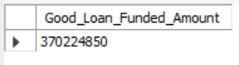

**Good Loan Total Received Amount**

**SELECT SUM(total_payment) AS Good_Loan_Total_Received_Amount FROM finance**

**WHERE loan_status = 'Fully Paid' OR loan_status = 'Current’;**

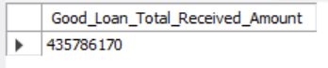

**Bad Loan Issued:**

**Bad Loan Applications Percentage**

**SELECT**

**(COUNT(CASE WHEN loan_status = 'Charged Off' THEN id END) * 100)**

**/**

**COUNT(id) AS Bad_Loan_Percentage FROM finance;**

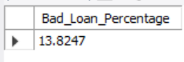

**Bad Loan Applications**

**SELECT COUNT(id) AS Bad_Loan_Applications FROM finance**

**WHERE loan_status = 'Charged Off';**

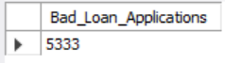

**Bad Loan Funded Amount**

**SELECT SUM(loan_amount) AS Bad_Loan_Funded_Amount FROM finance**

**WHERE loan_status = 'Charged Off';**

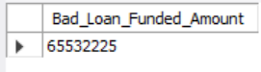

**Bad Loan Total Received Amount**

**SELECT SUM(total_payment) AS Bad_Loan_Total_Received_Amount FROM finance**

**WHERE loan_status = 'Charged Off';**

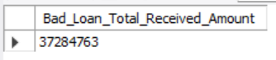

**Loan Status:**

**Loan Status**

**SELECT**

**loan_status,**

**COUNT(id) AS Loan_Count,**

**SUM(total_payment) AS Total_Amount_Received,**

**SUM(loan_amount) AS Total_Funded_Amount,**

**AVG(int_rate * 100) AS Interest_Rate,**

**AVG(dti * 100) AS Average_DTI**

**FROM finance**

**GROUP BY loan_status;**

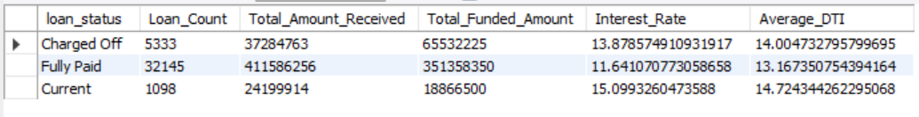

**MTD Loan Status**

**SELECT**

**loan_status,**

**SUM(total_payment) AS MTD_Total_Amount_Received,**

**SUM(loan_amount) AS MTD_Total_Funded_Amount**

**FROM finance**

**WHERE STR_TO_DATE(issue_date, '%Y-%m-%d') IS NOT NULL**

**AND MONTH(STR_TO_DATE(issue_date, '%Y-%m-%d')) = 12**

**GROUP BY loan_status;**

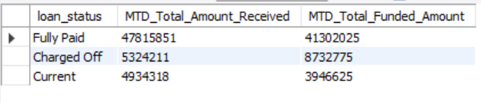

1. **Bank Loan Report | Overview**

**Monthly Trend**

**SELECT**

**MONTHNAME(STR_TO_DATE(issue_date, '%Y-%m-%d')) AS Month_Name,**

**COUNT(id) AS Total_Loan_Applications,**

**SUM(loan_amount) AS Total_Funded_Amount,**

**SUM(total_payment) AS Total_Received_Amount**

**FROM finance**

**GROUP BY MONTH(STR_TO_DATE(issue_date, '%Y-%m-%d')),**

**MONTHNAME(STR_TO_DATE(issue_date, '%Y-%m-%d'))**

**ORDER BY MONTH(STR_TO_DATE(issue_date, '%Y-%m-%d'));**

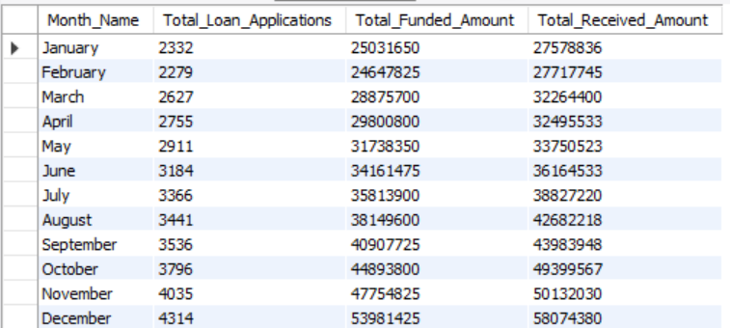

**Regional Trend**

**SELECT**

**address_state,**

**COUNT(id) AS Total_Loan_Applications,**

**SUM(loan_amount) AS Total_Funded_Amount,**

**SUM(total_payment) AS Total_Received_Amount**

**FROM finance**

**GROUP BY address_state**

**ORDER BY COUNT(id) DESC;**

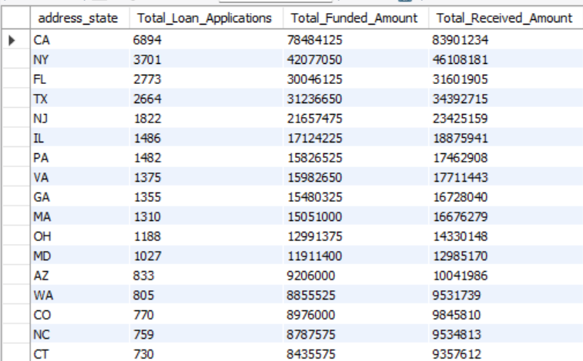

**Loan Term**

**SELECT**

**term,**

**COUNT(id) AS Total_Loan_Applications,**

**SUM(loan_amount) AS Total_Funded_Amount,**

**SUM(total_payment) AS Total_Received_Amount**

**FROM finance**

**GROUP BY term**

**ORDER BY term;**

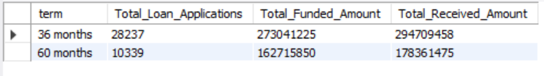

**Employee Length**

**SELECT**

**emp_length,**

**COUNT(id) AS Total_Loan_Applications,**

**SUM(loan_amount) AS Total_Funded_Amount,**

**SUM(total_payment) AS Total_Received_Amount**

**FROM finance**

**GROUP BY emp_length**

**ORDER BY emp_length;**

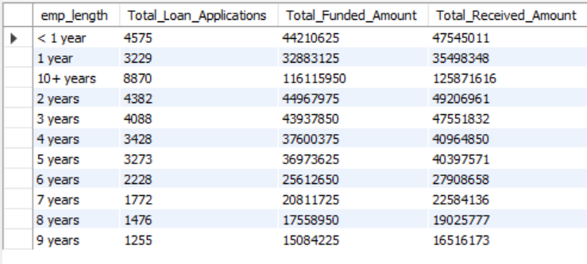

**Loan Purpose**

**SELECT**

**purpose,**

**COUNT(id) AS Total_Loan_Applications,**

**SUM(loan_amount) AS Total_Funded_Amount,**

**SUM(total_payment) AS Total_Received_Amount**

**FROM finance**

**GROUP BY purpose**

**ORDER BY purpose;**

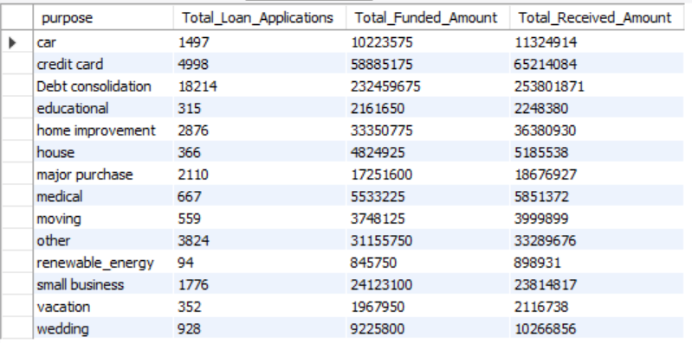

**Home Ownership**

**SELECT**

**home_ownership,**

**COUNT(id) AS Total_Loan_Applications,**

**SUM(loan_amount) AS Total_Funded_Amount,**

**SUM(total_payment) AS Total_Received_Amount**

**FROM finance**

**GROUP BY home_ownership**

**ORDER BY home_ownership;**

