SKILL WEEK-4 : TRIGGERS AND PROCEDURES

2520080061
E.Pranay Reddy
------------------------------------------------------------
- PROCEDURE TO DISPLAY ALL CUSTOMERS
------------------------------------------------------------
DELIMITER //
CREATE PROCEDURE GetAllCustomers()
BEGIN
SELECT * FROM Customer;
END //
DELIMITER ;

CALL GetAllCustomers();
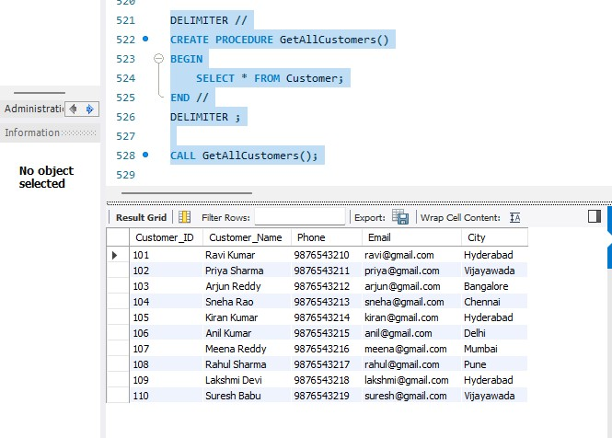

------------------------------------------------------------
- PROCEDURE TO DISPLAY ACCOUNT DETAILS FOR A GIVEN ACCOUNT
NUMBER
------------------------------------------------------------
DELIMITER //
CREATE PROCEDURE GetAccountDetails(
IN p_Account_No INT
)
BEGIN
SELECT *
FROM Account
WHERE Account_No = p_Account_No;
END //
DELIMITER ;

CALL GetAccountDetails(10001);
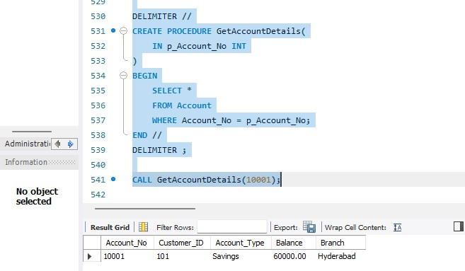
------------------------------------------------------------
13. PROCEDURE TO FIND CUSTOMER ACCOUNTS
------------------------------------------------------------
DELIMITER //
CREATE PROCEDURE GetCustomerAccounts(
IN p_Customer_ID INT
)
BEGIN

SELECT
C.Customer_ID,
C.Customer_Name,
A.Account_No,
A.Account_Type,
A.Balance,
A.Branch
FROM Customer C
JOIN Account A
ON C.Customer_ID = A.Customer_ID
WHERE C.Customer_ID = p_Customer_ID;
END //
DELIMITER ;

CALL GetCustomerAccounts(101);
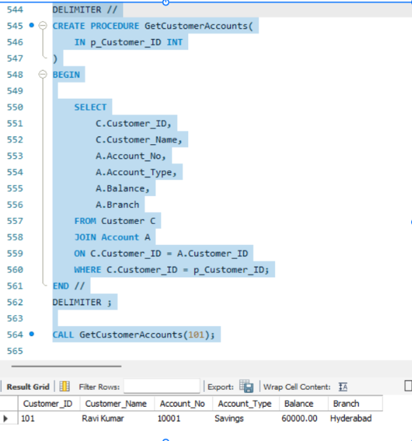
------------------------------------------------------------
14. PROCEDURE TO DEPOSIT MONEY
------------------------------------------------------------
DELIMITER //
CREATE PROCEDURE DepositMoney(
IN p_Account_No INT,
IN p_Amount DECIMAL(12,2)
)
BEGIN
UPDATE Account
SET Balance = Balance + p_Amount
WHERE Account_No = p_Account_No;
END //
DELIMITER ;

CALL DepositMoney(10001, 5000);
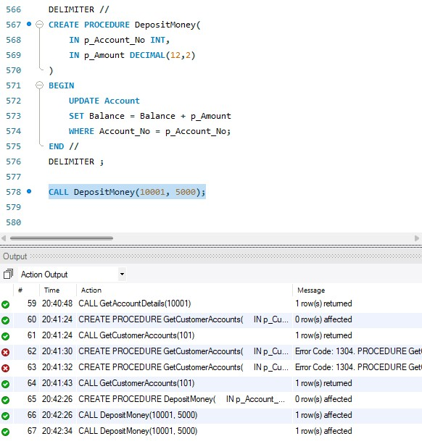

------------------------------------------------------------
15. PROCEDURE TO WITHDRAW MONEY
------------------------------------------------------------
DELIMITER //
CREATE PROCEDURE WithdrawMoney(
IN p_Account_No INT,
IN p_Amount DECIMAL(12,2)
)
BEGIN
UPDATE Account
SET Balance = Balance - p_Amount
WHERE Account_No = p_Account_No;
END //
DELIMITER ;

CALL WithdrawMoney(10001, 3000);
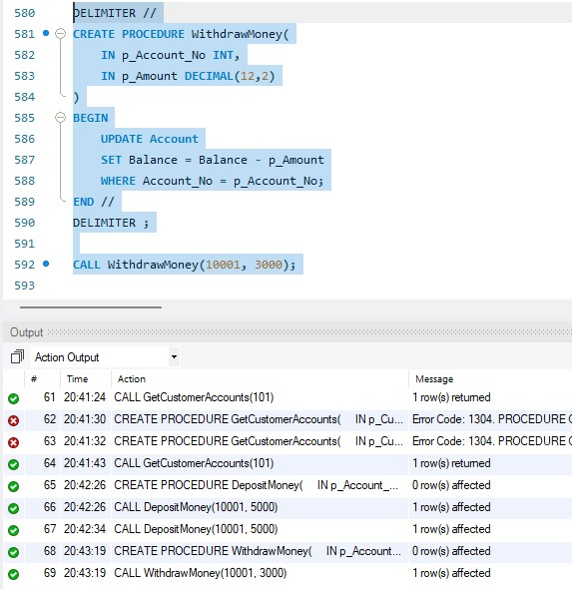

===========================
TRIGGERS
===========================
------------------------------------------------------------
16. TRIGGER – PREVENT NEGATIVE BALANCE
------------------------------------------------------------
DELIMITER //
CREATE TRIGGER CheckBalance
BEFORE UPDATE ON Account
FOR EACH ROW
BEGIN
IF NEW.Balance < 0 THEN

SIGNAL SQLSTATE '45000'
SET MESSAGE_TEXT =
'Transaction failed: Insufficient balance';
END IF;
END //
DELIMITER ;

UPDATE Account
SET Balance = Balance - 60000
WHERE Account_No = 10001;
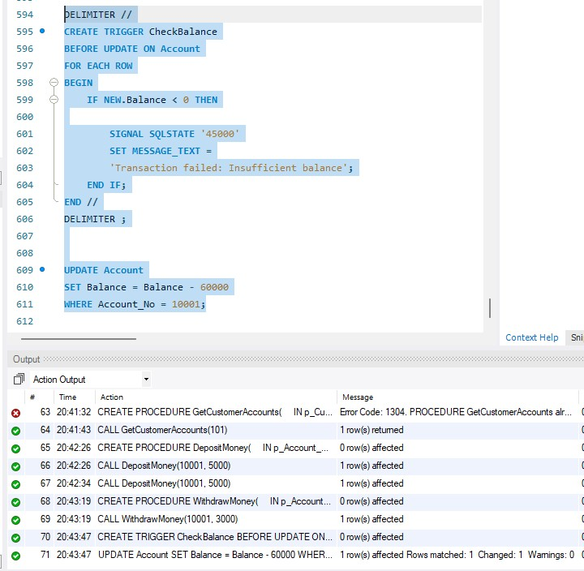

----------------------------------------------------------
17. TRIGGER – PREVENT NEGATIVE DEPOSIT
------------------------------------------------------------
DELIMITER //
CREATE TRIGGER CheckTransactionAmount
BEFORE INSERT ON Bank_Transaction
FOR EACH ROW
BEGIN
IF NEW.Amount <= 0 THEN

SIGNAL SQLSTATE '45000'
SET MESSAGE_TEXT =
'Transaction amount must be greater than zero';

END IF;
END //
DELIMITER ;

INSERT INTO Bank_Transaction
(Account_No, Transaction_Type, Amount)
VALUES
(10001, 'DEPOSIT', -5000);
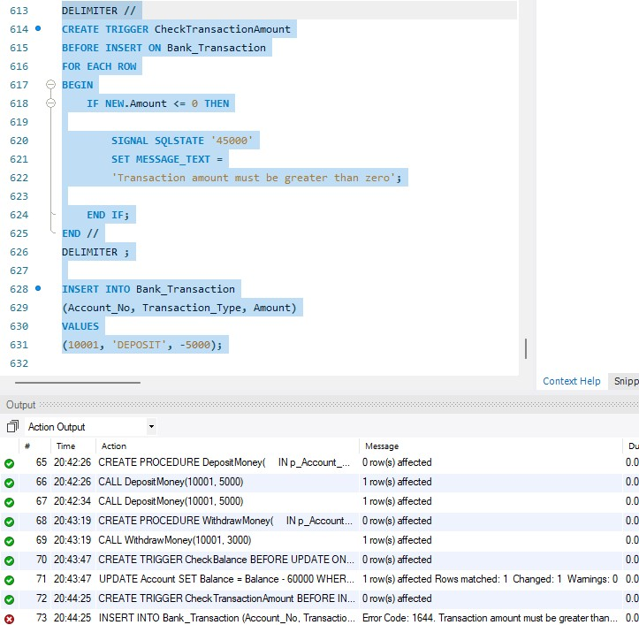

------------------------------------------------------------
- CREATE TRANSACTION AUDIT TABLE
------------------------------------------------------------
CREATE TABLE Transaction_Audit (
Audit_ID INT PRIMARY KEY AUTO_INCREMENT,
Transaction_ID INT,
Account_No INT,
Transaction_Type VARCHAR(20),
Amount DECIMAL(12,2),
Audit_Date DATETIME DEFAULT CURRENT_TIMESTAMP
);

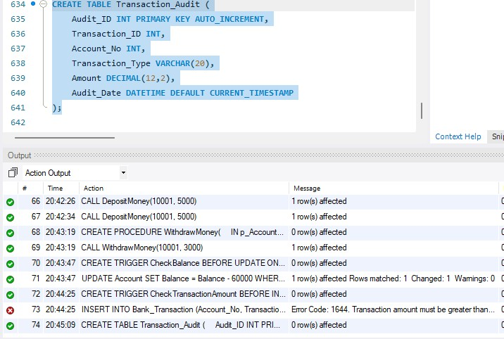

------------------------------------------------------------
- TRIGGER – TRANSACTION AUDIT
------------------------------------------------------------
DELIMITER //
CREATE TRIGGER TransactionAudit
AFTER INSERT ON Bank_Transaction
FOR EACH ROW
BEGIN

INSERT INTO Transaction_Audit
(
Transaction_ID,
Account_No,
Transaction_Type,
Amount
)
VALUES
(
NEW.Transaction_ID,
NEW.Account_No,
NEW.Transaction_Type,
NEW.Amount
);

END //
DELIMITER ;

INSERT INTO Bank_Transaction
(Account_No, Transaction_Type, Amount)
VALUES
(10001, 'DEPOSIT', 2500);

SELECT * FROM Transaction_Audit;

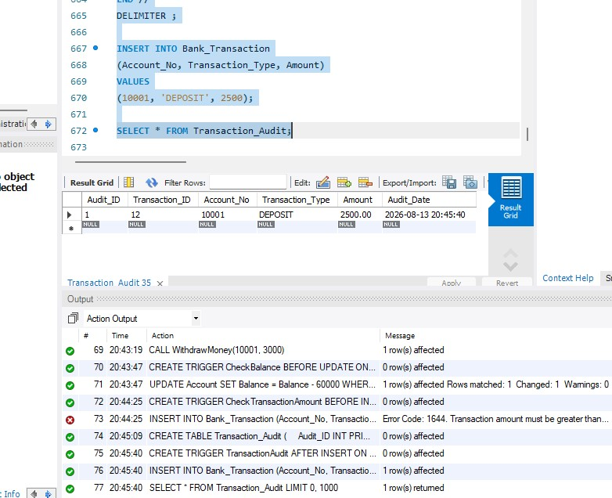

------------------------------------------------------------
20. TRIGGER – AUTOMATICALLY UPDATE ACCOUNT BALANCE
------------------------------------------------------------
DELIMITER //
CREATE TRIGGER UpdateBalanceAfterTransaction
AFTER INSERT ON Bank_Transaction
FOR EACH ROW
BEGIN
IF NEW.Transaction_Type = 'DEPOSIT' THEN
UPDATE Account
SET Balance = Balance + NEW.Amount
WHERE Account_No = NEW.Account_No;
ELSEIF NEW.Transaction_Type = 'WITHDRAW' THEN
UPDATE Account
SET Balance = Balance - NEW.Amount
WHERE Account_No = NEW.Account_No;

END IF;
END //
DELIMITER ;

INSERT INTO Bank_Transaction
(Account_No, Transaction_Type, Amount)
VALUES
(10001, 'DEPOSIT', 5000);

SELECT *
FROM Account
WHERE Account_No = 10001;
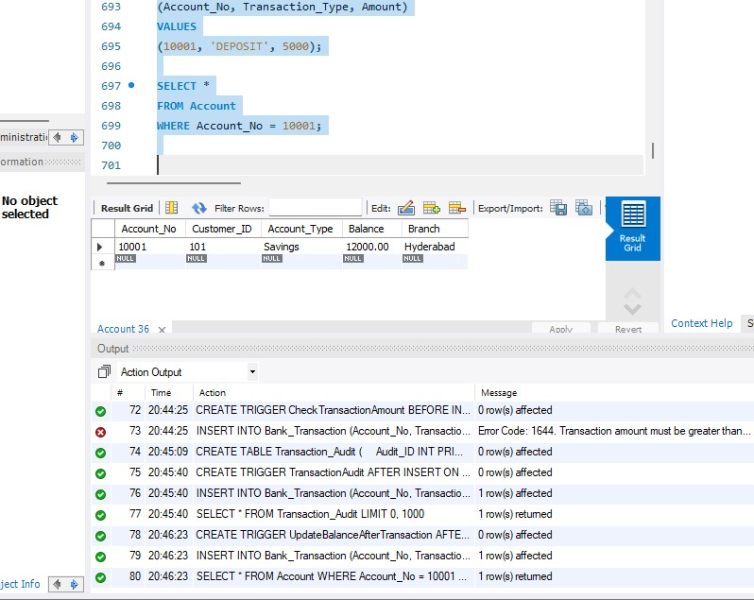

------------------------------------------------------------
21. TRIGGER – PREVENT WITHDRAWAL ABOVE BALANCE
------------------------------------------------------------
DELIMITER //
CREATE TRIGGER PreventInsufficientWithdrawal
BEFORE INSERT ON Bank_Transaction
FOR EACH ROW
BEGIN

DECLARE CurrentBalance DECIMAL(12,2);

SELECT Balance
INTO CurrentBalance
FROM Account
WHERE Account_No = NEW.Account_No;

IF NEW.Transaction_Type = 'WITHDRAW'
AND NEW.Amount > CurrentBalance THEN

SIGNAL SQLSTATE '45000'
SET MESSAGE_TEXT =
'Withdrawal failed: Insufficient balance';

END IF;

END //
DELIMITER ;

INSERT INTO Bank_Transaction
(Account_No, Transaction_Type, Amount)
VALUES
(10001, 'WITHDRAW', 1000000);
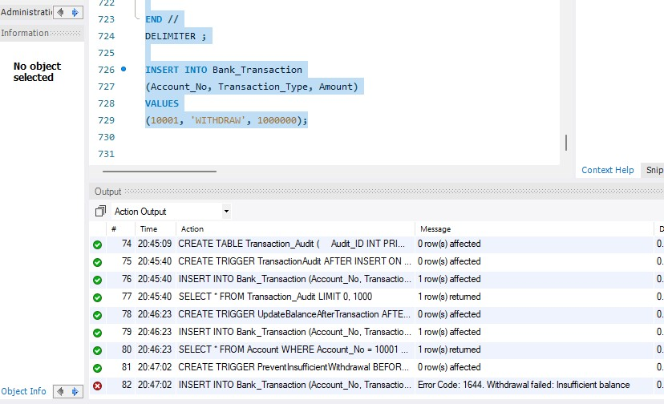
============================================================
ADVANCED STORED PROCEDURES
============================================================
------------------------------------------------------------
22. PROCEDURE – ACCOUNT TRANSFER
------------------------------------------------------------
DELIMITER //
CREATE PROCEDURE TransferMoney(
IN SenderAccount INT,
IN ReceiverAccount INT,
IN TransferAmount DECIMAL(12,2)
)
BEGIN

DECLARE SenderBalance DECIMAL(12,2);

SELECT Balance
INTO SenderBalance
FROM Account
WHERE Account_No = SenderAccount;

IF SenderBalance < TransferAmount THEN

SIGNAL SQLSTATE '45000'
SET MESSAGE_TEXT =
'Transfer failed: Insufficient balance';

ELSE

UPDATE Account
SET Balance = Balance - TransferAmount
WHERE Account_No = SenderAccount;

UPDATE Account
SET Balance = Balance + TransferAmount
WHERE Account_No = ReceiverAccount;

END IF;

END //
DELIMITER ;

CALL TransferMoney(10001, 10002, 5000);

SELECT *
FROM Account
WHERE Account_No IN (10001,10002);
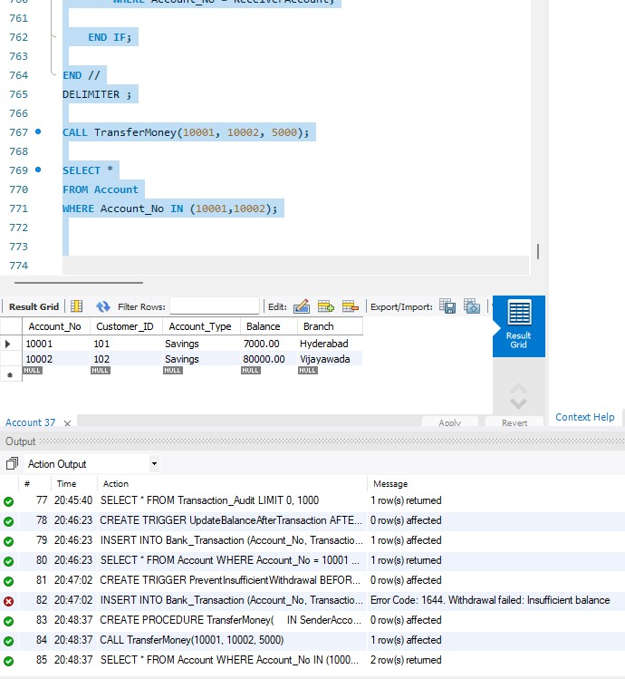

------------------------------------------------------------
23. PROCEDURE – CUSTOMER LOAN DETAILS
------------------------------------------------------------
DELIMITER //

CREATE PROCEDURE GetCustomerLoans(
IN p_Customer_ID INT
)
BEGIN

SELECT
C.Customer_Name,
L.Loan_ID,
L.Loan_Type,
L.Loan_Amount,
L.Interest_Rate
FROM Customer C
JOIN Loan L
ON C.Customer_ID = L.Customer_ID
WHERE C.Customer_ID = p_Customer_ID;

END //
DELIMITER ;

CALL GetCustomerLoans(101);
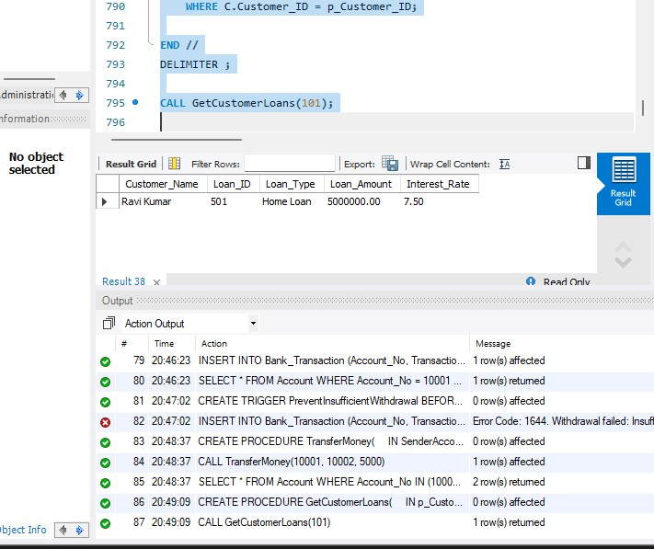

------------------------------------------------------------
24. PROCEDURE – HIGH BALANCE ACCOUNTS
------------------------------------------------------------
DELIMITER //
CREATE PROCEDURE HighBalanceAccounts(
IN MinimumBalance DECIMAL(12,2)
)
BEGIN

SELECT *
FROM Account
WHERE Balance >= MinimumBalance
ORDER BY Balance DESC;

END //

DELIMITER ;

CALL HighBalanceAccounts(50000);
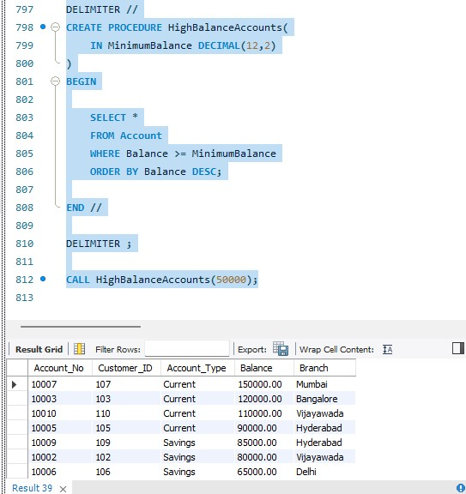

------------------------------------------------------------
25. PROCEDURE WITH IN, OUT PARAMETERS
------------------------------------------------------------
DELIMITER //

CREATE PROCEDURE GetBalance(
IN p_Account_No INT,
OUT p_Balance DECIMAL(12,2)
)
BEGIN

SELECT Balance
INTO p_Balance
FROM Account
WHERE Account_No = p_Account_No;

END //

DELIMITER ;

CALL GetBalance(10001, @CurrentBalance);

SELECT @CurrentBalance;
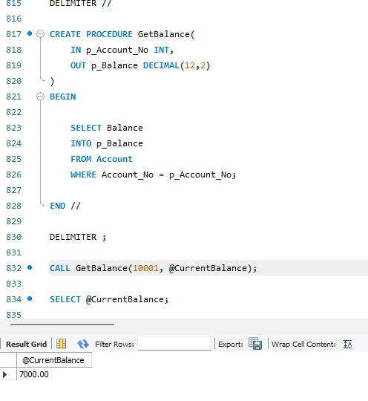

============================================================
TRIGGER MANAGEMENT COMMANDS
============================================================
SHOW TRIGGERS;
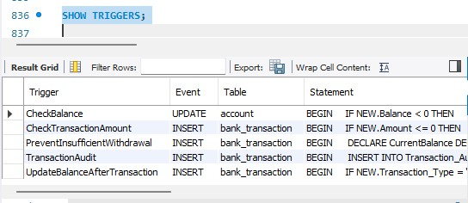

SHOW CREATE TRIGGER CheckBalance;
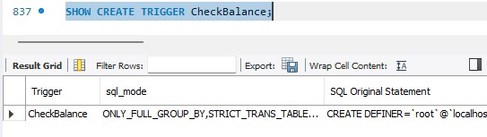

DROP TRIGGER CheckBalance;
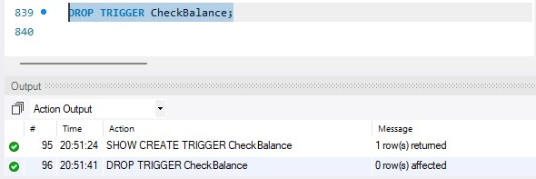

============================================================
PROCEDURE MANAGEMENT COMMANDS
============================================================ SHOW PROCEDURE STATUS
WHERE Db = 'BankDB';
