https://www.mdpi.com/2076-3417/11/1/68#Ground_Microgravity_Simulators
This paper states :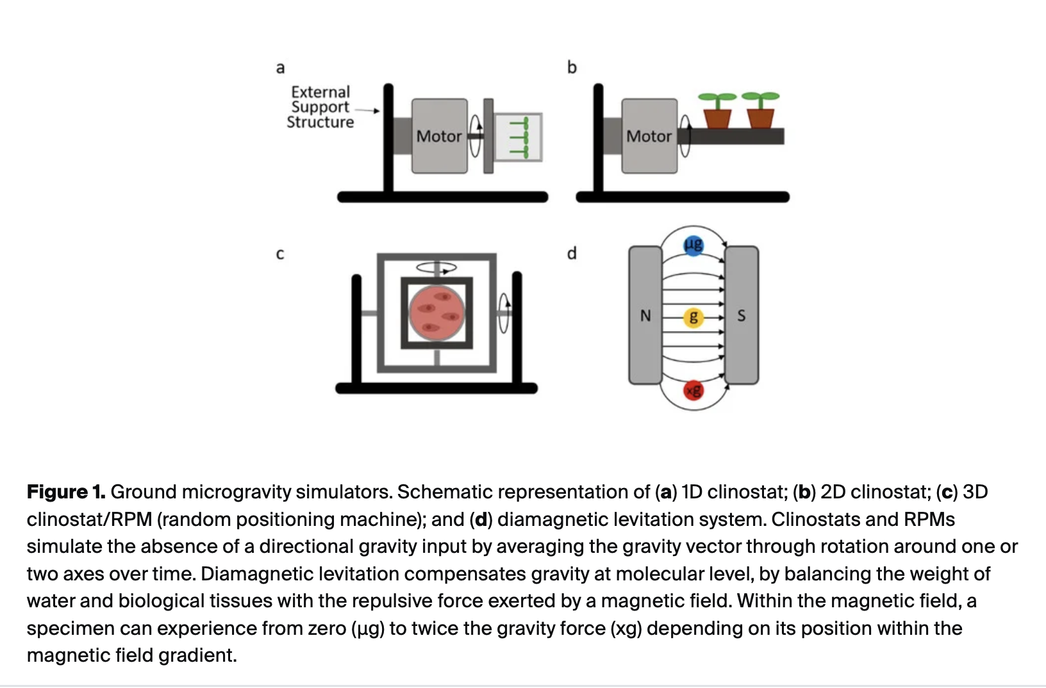

2)
https://www.frontiersin.org/journals/space-technologies/articles/10.3389/frspt.2022.1032610/full
Refer this for data and code

