**Data Mining**

Assignment 3

Name: Pranaya Bhat (1001408965)

**Energy Efficiency Data Set**

This data set is based on the study that assess the heating and cooling load requirements of buildings (that is, energy efficiency) as a function of building parameter. The energy analysis was performed using 12 different building shapes.

The aim is to use the eight features to predict each of the two responses.

The data set contains 8 attributes denoted by X1 till X8 and two responses (or outcomes) denoted by y1 and y2

**Binning:**

Bin size: 25

Column Used: X3

**OUTPUT:**

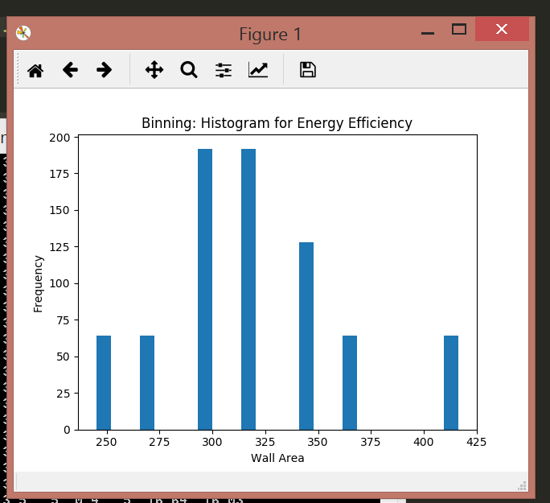

**Normalization:**

I have used min-max normalization to plot a histogram for the data set. The min-max range is from 0 to 1.

Normalization is performed on column X3

**Output:**

