SESSION -2

Book Database

-- creating a database book_shop;

CREATE DATABASE book_shop;

-- use database

USE book_shop;

CREATE TABLE books
(
book_id INT NOT NULL AUTO_INCREMENT,
title VARCHAR(100),
author_fname VARCHAR(100),
author_lname VARCHAR(100),
released_year INT,
stock_quantity INT,
pages INT,
PRIMARY KEY(book_id)
);

INSERT INTO books (title, author_fname, author_lname, released_year, stock_quantity, pages)
VALUES
('The Namesake', 'Jhumpa', 'Lahiri', 2003, 32, 291),
('Norse Mythology', 'Neil', 'Gaiman',2016, 43, 304),
('American Gods', 'Neil', 'Gaiman', 2001, 12, 465),
('Interpreter of Maladies', 'Jhumpa', 'Lahiri', 1996, 97, 198),
('A Hologram for the King: A Novel', 'Dave', 'Eggers', 2012, 154, 352),
('The Circle', 'Dave', 'Eggers', 2013, 26, 504),
('The Amazing Adventures of Kavalier & Clay', 'Michael', 'Chabon', 2000, 68, 634),
('Just Kids', 'Patti', 'Smith', 2010, 55, 304),
('A Heartbreaking Work of Staggering Genius', 'Dave', 'Eggers', 2001, 104, 437),
('Coraline', 'Neil', 'Gaiman', 2003, 100, 208),
('What We Talk About When We Talk About Love: Stories', 'Raymond', 'Carver', 1981, 23, 176),
("Where I'm Calling From: Selected Stories", 'Raymond', 'Carver', 1989, 12, 526),
('White Noise', 'Don', 'DeLillo', 1985, 49, 320),
('Cannery Row', 'John', 'Steinbeck', 1945, 95, 181),
('Oblivion: Stories', 'David', 'Foster Wallace', 2004, 172, 329),
('Consider the Lobster', 'David', 'Foster Wallace', 2005, 92, 343);

-- filter realease year 2012

select
*
FROM
books
WHERE
released_Year = 2012;

book_id | title | author_fname | author_lname | released_year | stock_quantity | pages
6 | A Hologram for the King: A Novel | Dave | Eggers | 2012 | 154 | 352

-- filter pages > 420

select
*
FROM
books
WHERE
pages > 420;

book_id | title | author_fname | author_lname | released_year | stock_quantity | pages
4 | American Gods | Neil | Gaiman | 2001 | 12 | 465
7 | The Circle | Dave | Eggers | 2013 | 26 | 504
8 | The Amazing Adventures of Kavalier & Clay | Michael | Chabon | 2000 | 68 | 634
10 | A Heartbreaking Work of Staggering Genius | Dave | Eggers | 2001 | 104 | 437
13 | Where I'm Calling From: Selected Stories | Raymond | Carver | 1989 | 12 | 526

-- filter rel.year >=2004 AND pages<500

select
*
FROM
books
WHERE
(released_year>=2004) AND (pages<500);

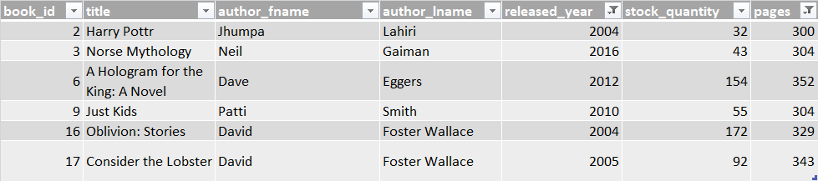

Cars Table :

car_id | model | color | car_size | last_driven
1 | fiat 500 | white | S | 10
2 | lamborgini | green | L | 200
3 | ferrari | black | M | 10
4 | ford GT | blue | S | 50
5 | VW Polo | pink | S | 0
6 | Maruti Brezza | red | M | 5
7 | Mercedes C class | white | XL | 200
8 | BMW i8 | blue | M | 15

CREATE DATABASE cars_db;

USE cars_db;

CREATE TABLE cars (
car_id INT NOT NULL PRIMARY KEY AUTO_INCREMENT,
model VARCHAR(20) NOT NULL,
color VARCHAR(20) NOT NULL,
car_size VARCHAR(2) NOT NULL,
last_driven INT NOT NULL
);

INSERT INTO
cars (model, color, car_size, last_driven)
VALUES
('fiat 500', 'white', 'S', 10),
('lamborgini', 'green', 'L', 200),
('ferrari', 'black', 'M', 10),
('ford GT', 'blue', 'S', 50),
('VW Polo', 'pink', 'S', 0),
('Maruti Brezza', 'red', 'M', 5),
('Mercedes C class', 'white', 'XS', 200),
('BMW i8', 'blue', 'M', 15);

INSERT INTO
cars (color, model, car_size, last_driven)
VALUES
('purple', 'fiat 500X', 'M', 50);

SELECT model, color
FROM cars;

SELECT
model,
color,
car_size,
last_driven
FROM
cars
WHERE
car_size = 'M';

UPDATE cars
SET car_size = 'L'
WHERE model = 'lamborgini';

UPDATE cars
SET last_driven = 0
WHERE last_driven = 15;

UPDATE cars
SET
car_size = 'XL',
color = 'off white'
WHERE color = 'white';

DELETE FROM cars
WHERE last_driven = 200;

DELETE FROM cars
WHERE model = 'VW Polo';

DELETE FROM cars;

DROP TABLE cars;

SESSION - 3

SELECT * FROM books;

-- LIMIT and OFFSETS

SELECT * FROM books LIMIT 12;

-- IF WE WANT A TABLE FROM 6-10 THEN?

SELECT * FROM books LIMIT 5 OFFSET 5;

-- Update query

SELECT * FROM books WHERE title = 'White Noise';

UPDATE books
SET stock_quantity = 100
WHERE title = 'White Noise';

-- Update author_lname to 'Smith' WHERE author_fname is 'Raymond'

UPDATE books
SET author_lname = 'Smith'
WHERE author_fname = 'Raymond';

SELECT * FROM books ORDER BY pages, stock_quantity DESC;

-- Update query

SELECT * FROM books WHERE title = 'White Noise';

UPDATE books
SET stock_quantity = 100
WHERE title = 'White Noise';

-- Update author_lname to 'Smith' WHERE author_fname is 'Raymond'

UPDATE books
SET author_lname = 'Smith'
WHERE author_fname = 'Raymond';

-- set stock_quantity to 60

UPDATE books
SET stock_quantity = 60
WHERE title = 'White Noise';

-- lname to Carver

UPDATE books
SET author_lname = 'Carver'
WHERE stock_quantity = 23;

Session- 4

GROUP BY

-- GROUP BY

SELECT released_year, AVG(stock_quantity) FROM books
GROUP BY released_year;

USE book_shop;

SELECT * FROM books;

SELECT AVG(stock_quantity)
FROM books;

SELECT MIN(stock_quantity)
FROM books;

SELECT MAX(stock_quantity)
FROM books;

SELECT MIN(stock_quantity) as min_value, AVG(stock_quantity) as avg_quantity, MAX(stock_quantity) as max_value
FROM books;

SELECT DISTINCT(author_lname), author_fname FROM books;

-- GROUP BY

SELECT released_year, AVG(stock_quantity) FROM books
GROUP BY released_year;

SELECT author_lname, COUNT(title) as num_of_books
FROM books
GROUP BY author_lname;

SELECT author_fname, author_lname, CONCAT(author_fname, " ", author_lname) as author_name, COUNT(*) as num_of_books
FROM books
GROUP BY author_name
ORDER BY num_of_books DESC;

SELECT
author_fname,
author_lname,
CONCAT(author_fname, ' ', author_lname) AS author_name,
CONCAT(CONCAT(author_fname, ' ', author_lname),
' released ',
', ',
COUNT(title),
' book(s)') AS num_of_books
FROM books
GROUP BY author_name
ORDER BY num_of_books DESC;

JOINS

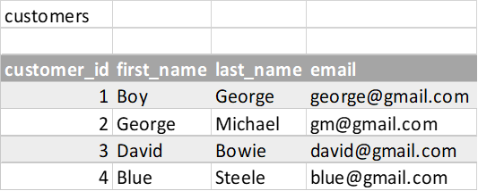

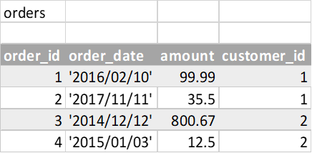

CREATE DATABASE customers_and_orders;
-- DROP DATABASE customers_and_orders;
USE customers_and_orders;

CREATE TABLE customers (
id INT PRIMARY KEY AUTO_INCREMENT,
first_name VARCHAR(100),
last_name VARCHAR(100),
email VARCHAR(100)
);

CREATE TABLE orders
(
id INT PRIMARY KEY AUTO_INCREMENT,
order_date DATE,
amount DECIMAL(8,2),
customer_id INT,
FOREIGN KEY(customer_id) REFERENCES customers(id)
);

SELECT * FROM customers;
SELECT * FROM orders;

INSERT INTO customers (first_name, last_name, email)
VALUES ('Boy', 'George', 'george@gmail.com'),
('George', 'Michael', 'gm@gmail.com'),
('David', 'Bowie', 'david@gmail.com'),
('Blue', 'Steele', 'blue@gmail.com'),
('Bette', 'Davis', 'bette@aol.com');

INSERT INTO orders (order_date, amount, customer_id)
VALUES ('2016/02/10', 99.99, 1),
('2017/11/11', 35.50, 1),
('2014/12/12', 800.67, 2),
('2015/01/03', 12.50, 2),
('1999/04/11', 450.25, 5);

INSERT INTO orders (order_date, amount, customer_id)
VALUES ('2014/12/12', 800.67, 3);

-- JOIN

SELECT * FROM customers, orders;

-- implicit
SELECT first_name, last_name, order_date, amount, customer_id
FROM customers, orders
WHERE customers.id = orders.customer_id;

-- explicit
SELECT first_name, last_name, customer_id
FROM customers
INNER JOIN orders
ON customers.id = orders.customer_id;

-- LEFT JOIN

SELECT first_name, last_name, order_date, amount
FROM customers
LEFT JOIN orders
ON customers.id = orders.customer_id;

-- RIGHT JOIN

SELECT first_name, last_name, order_date, amount
FROM customers
RIGHT JOIN orders
ON customers.id = orders.customer_id;

SELECT
first_name,
last_name,
IFNULL(SUM(amount), 0) AS total_spent
FROM customers
LEFT JOIN orders
ON customers.id = orders.customer_id
GROUP BY customers.id
ORDER BY total_spent;

Resources :

https://dataschool.com/how-to-teach-people-sql/
https://webdev.slides.com/coltsteele search for MySQL content in this link

SESSION 6 -

Not nomalized table - tb_not_normalize
Columns - full_name, physical_address, movies_rented, salutation

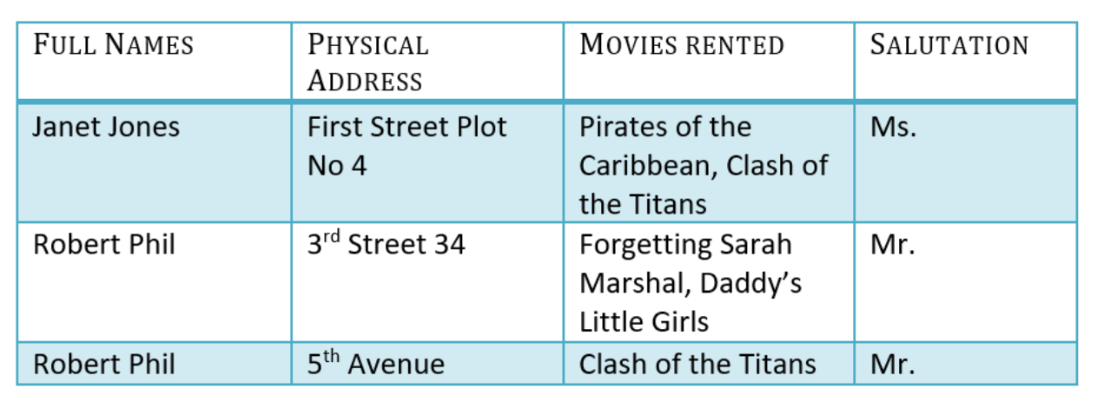

1NF - tb_1NF_normalized
Columns - full_name, physical_address, movies_rented, salutation
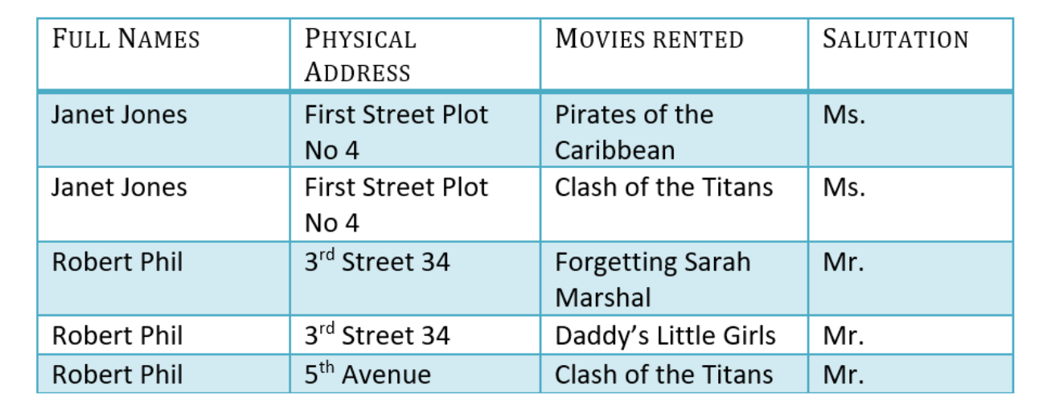

Task -

- Create database db_normalization
- Use database;
- Create a table tb_not_normalize
- Create a tb_1NF_normalized

Rule 1- Be in 1NF
Rule 2- Single Column Primary Key that does not functionally dependant on any subset of candidate key relation

tb_2NF_normalized_tb_1 membership_id
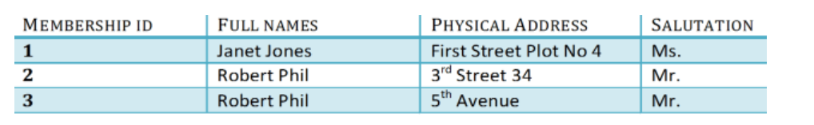

tb_2NF_normalized_tb_2
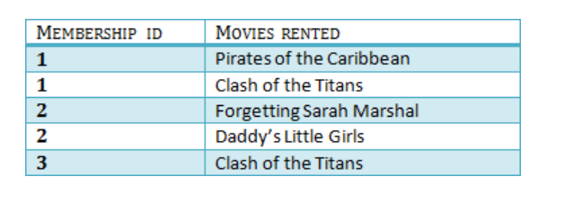

3NF
- Rule 1- Be in 2NF
- Rule 2- Has no transitive functional dependencies

Transitive functional dependency
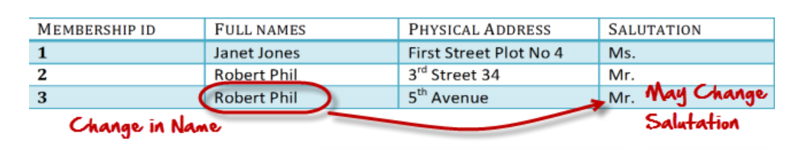

3NF Table

