Automated Analysis and Summarization System By using CNN for JWST Images

Aditya Kale
Computer Science Engineering (Artificial Intelligence) Vishwakarma Institute of Information Technology
Pune, India aditya.22420263@viit.ac.in

Swaraj Pawar
Computer Science Engineering (Artificial Intelligence) Vishwakarma Institute of Information Technology
Pune, India swaraj.22420140@viit.ac.in

Yogesh Dongare
Computer Engineering
(CE)
Marathwada Mitra Mandal's Institute of Technology
Pune, India yogesh.dongare07@gmail.com

Shashwati Kale
Computer Science Engineering (Artificial Intelligence) Vishwakarma Institute of Information Technology
Pune, India shashwati.22310704@viit.ac.in

Nilesh Sable
Department of CSE
(Artificial Intelligence) Vishwakarma Institute of Technology
Pune, India
drsablenilesh@gmail.com

Anuradha Yenkikar
Department of CSE (Artificial Intelligence) Vishwakarma Institute of Technology
Pune, India
anu.jamkhande@gmail.com

Abstract—In this work, we introduce an automated tool based on Convolutional Neural Networks (CNNs) for the analysis and classification of James Webb Space Telescope (JWST) galaxy images. We built and assessed four deep learning models: VGG16, InceptionV3, EfficientNet-B0, and ResNet-50 in order to classify galaxies into eight different classes. The approach employs several data preprocessing methods, including data augmentation and normalizing, in order to raise model stability. Our results reveal that various architectures perform differently; InceptionV3 exhibits high overfitting with a 98% training accuracy but a 63% validation accuracy. ResNet-50 shown the best generalizing ability with a validation accuracy of 92%. We observed class-dependent variations when models showed almost perfect accuracy and recall for some galaxy types (NGC3256 nuc1, NGC 1365) but not others.
Index Terms—CNNs, JWST, VGG16, InceptionV3, EfficientNet-B0, ResNet-50

- Introduction
Machine Learning (ML) is a subfield of artificial intelli- gence that focuses on developing algorithms that allow com- puters to learn from data and make decisions or predictions without being explicitly programmed. In recent years, ML has revolutionized a wide range of domains from healthcare to astronomy, by enabling the analysis of complex datasets with high accuracy and efficiency. Its ability to automatically extract patterns and insights from massive volumes of data makes it especially valuable in scientific fields where traditional methods may be limited.
Convolutional Neural Networks (CNNs) are a class of deep learning models particularly effective for image clas- sification and recognition tasks. Inspired by the structure of the human visual cortex, CNNs can automatically learn hierarchical features from raw pixel data, making them ideal for analyzing complex image datasets such as astronomical
imagery. CNNs apply convolutional layers to capture spatial hierarchies, followed by pooling and fully connected layers to perform classification. Their robustness and adaptability make CNNs the go-to choice for visual recognition problems in both industrial and scientific applications.
Advanced astronomical observatories like the James Webb Space Telescope (JWST) is designed to explore the universe in infrared wavelengths with unprecedented resolution and sensitivity. Launched by NASA in collaboration with ESA and CSA, JWST provides detailed images of distant galaxies, star- forming regions, and exoplanets, offering deep insights into the early universe [1] [2].
The high-resolution images captured by JWST are not only visually stunning but also scientifically rich, making them an invaluable resource for machine learning applications in astronomy, such as automated galaxy classification.
The overall structure of this paper literature review in section 2, proposed methodology in section 3, experimental results in section 4, conclusion in section 5, and references in section 6.

- Literature Review
A deep CNN with small (3×3) filters and uniform architec- ture is developed for Large-Scale Image Recognition VGG16 which is Effective on ImageNet. Our work adapts VGG16 for astronomical image classification from JWST, which is a novel domain for the architecture [3].
Szegedy et al., presented InceptionV3 for improved per- formance using factorized convolutions and label smoothing. We used InceptionV3 with fine-tuning, achieving high training accuracy but noted overfitting — offering insight on limitations in astronomy datasets [4].

M Tan et, al. proposed compound scaling method to balance depth, width, and resolution in EfficientNet. EfficientNet-B0 performs well with fewer parameters. We tested EfficientNet- B0 on JWST images but noted it underperformed, suggesting challenges in transferring its lightweight design to galaxy image datasets [5].
K He et, al. Introduced ResNet-50, enabling very deep networks using skip connections. Revolutionized image classi- fication. We applied ResNet-50 with fine-tuning and observed superior generalization (92% validation accuracy) on galaxy data [6].
H Teimoorinia et, al. used CNNs for classifying galaxies from SDSS data. Discussed preprocessing and CNN tuning for astronomy. We extended the idea to JWST datasets and explored model comparison, adding deployment and Gemini API integration [7] [13] [14].
- Proposed Methodology
Figure 1 shows the steps we took to build a system that can look at pictures of galaxies and sort them into one of eight different kinds, using some clever computer programs called Convolutional Neural Networks, or CNNs. We also wanted this system to help us learn new things about these galaxies based on how they were classified.
Our method has four main parts: First, we got the galaxy pictures ready. Second, we taught the CNN models what different galaxies look like. Third, we checked how well these models could recognize galaxies they haven’t seen before. And finally, we put everything into a simple website so anyone could use it. The two diagrams we made give a visual idea of everything.
A. Data Preprocessing
This part was all about preparing the raw images we got from the James Webb Space Telescope, or JWST [15]. Here’s what we did:
Gathering Data: We collected a bunch of galaxy pictures straight from the JWST’s data archives.
Prepping: We did some standard things to make the pictures consistent, like making them the same size, adjusting the colors, and making sure the brightness was normal.
Making More Variety: To help our models learn better and not just memorize the training pictures, we used techniques like rotating the images, flipping them, and zooming in or out a bit. This makes the models see the galaxies in different ways. These steps made sure our collection of galaxy pictures was clean and in good shape for training our CNN models
effectively.
- Model Training
In this part, we trained our deep learning models to tell the eight different types of galaxies apart: We used a tool called ImageDataGenerator to feed the models batches of our varied galaxy pictures during training. We took some CNN models that had already learned a lot about general image features (EfficientNet-B0, InceptionV3, VGG16, ResNet-50) and used
them as a starting point to understand the galaxy features. We added a new part to these models specifically designed to sort the galaxies into our eight categories. We trained the models in two stages: First, we only trained the new sorting part. Then, we fine-tuned some of the earlier parts of the model that had already learned general image features, so they could become even better at recognizing galaxies. We did a quick check to see how well the models were doing early on.

C. Model Validation and Testing
To see if our trained models could actually recognize new galaxies, not just the ones they were trained on:
We set aside a separate set of galaxy pictures that the models never saw during training. We used our best-trained model to guess the type of each galaxy in this new set. We then calculated scores like accuracy (how often it was right), precision (when it said a galaxy was a certain type, how often was it actually that type?), recall (out of all the galaxies of a certain type, how many did it correctly identify?), and we also made a confusion matrix (a visual way to see which types of galaxies the model was getting mixed up). We also created some visual aids to better understand how the model was making its decisions and where it was making mistakes. This part made sure our model could reliably identify galaxies it had never encountered before [9][8].

D. Deployment (Local Flask Web App)
Finally, we made a simple website using a tool called Flask so that people could easily use our system:
Users can upload a picture of a galaxy and pick which of our trained CNN models they want to use. The model then looks at the picture and guesses what type of galaxy it is. After that, our system talks to another smart tool called the Gemini API to get scientific information about that predicted type of galaxy. The website then shows the user the model’s guess and the interesting facts it found about that kind of galaxy. This makes our system not just a tool for sorting galaxies, but also a way for people interested in astronomy to learn more about them [10] [11] [12].
The Figure 2 shows how a galaxy image classification system works step by step. First, the user interacts with a simple website (called the User Interface), where they can upload a galaxy image, choose a model, and view the results and galaxy details. Once the image is uploaded, it goes to the Processing Layer, where some cleaning and preparation happens. This step is called Image Preprocessing, which includes resizing the image, normalizing it, converting its format, and picking out important features. After that, the system uses one of four smart models - VGG16, InceptionV3, EfficientNet-B0, or ResNet-50 to predict which type of galaxy it is. Then, in the next step, called Galaxy Classification, the system decides which of the 8 types of galaxies the image matches, like M-74, NGC-1365, or others. Finally, the system connects to something called the Gemini API, which gives more interesting information about the identified galaxy. This way, the whole system works together from image upload to galaxy identification.

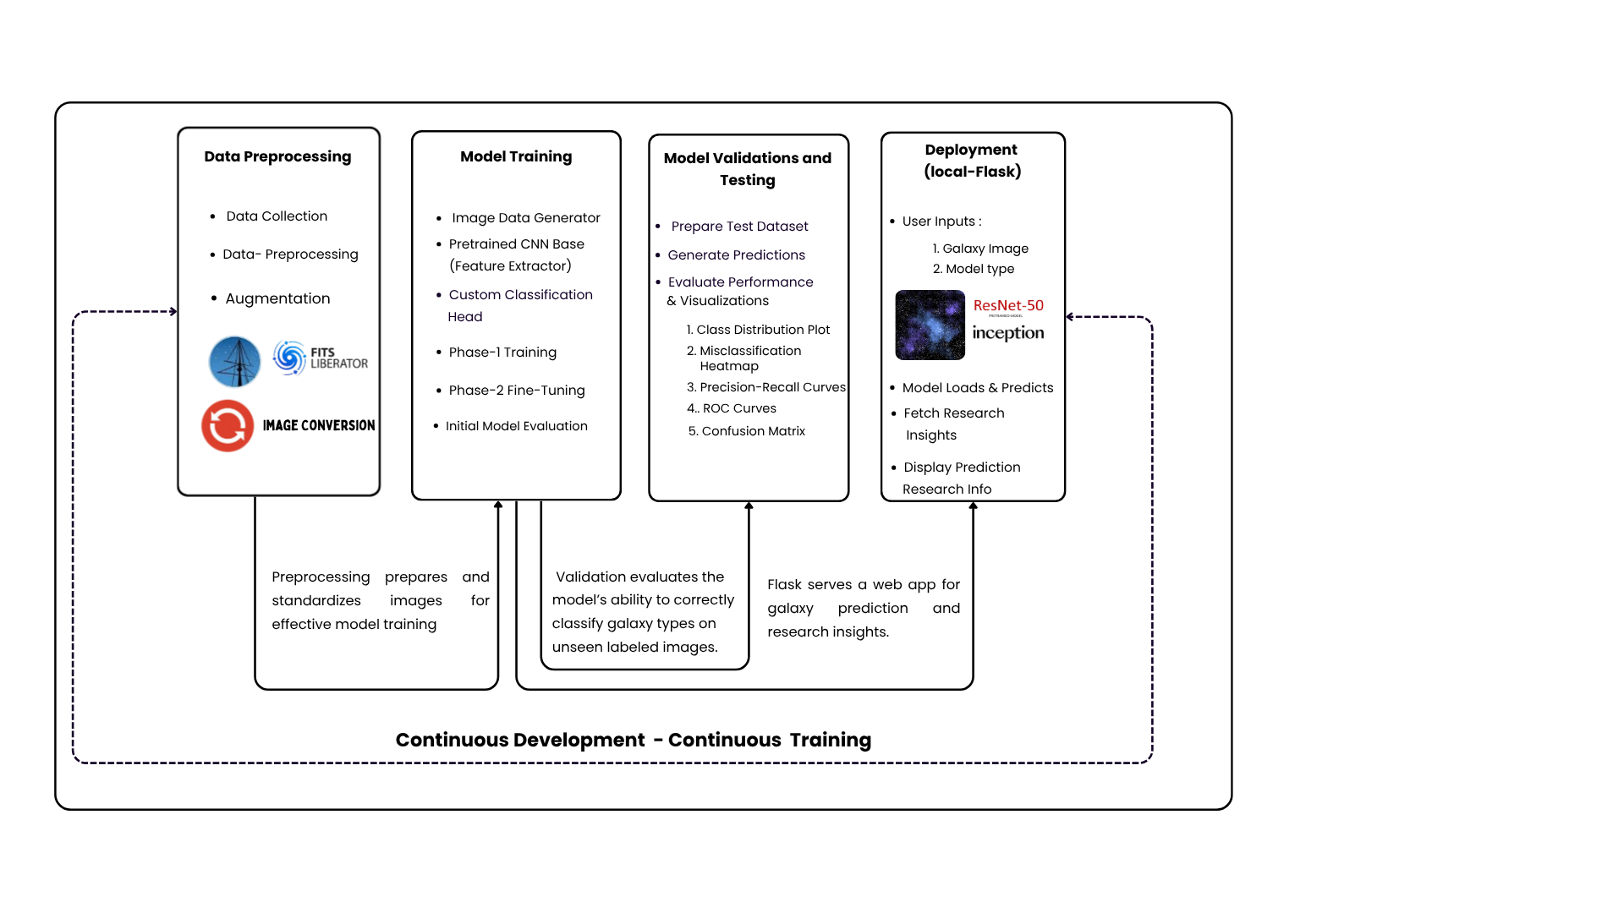

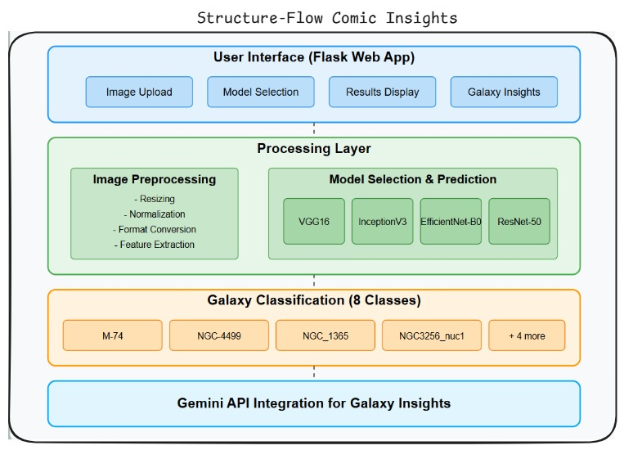
Fig. 1. System workflow diagram showing the complete pipeline from data preprocessing to model deployment.

Fig. 2. Architecture diagram of the galaxy image classification system.

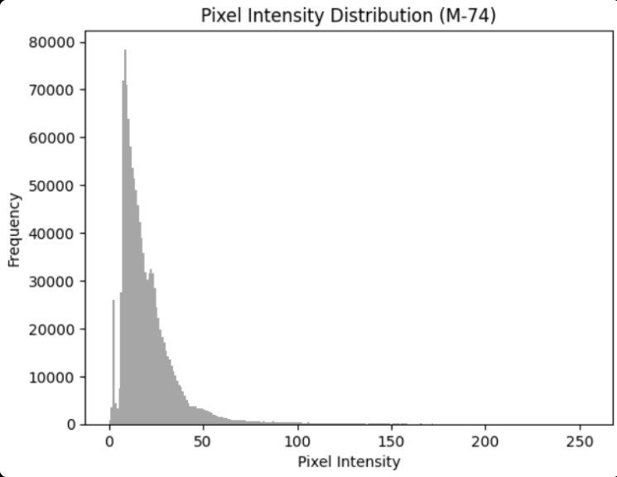
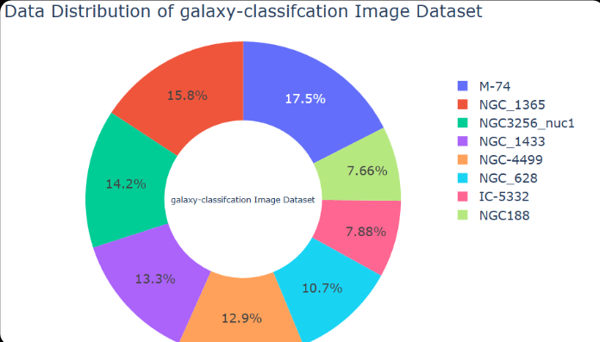

Fig. 3. Pixel Intensity Distribution (M-74 galaxy).

- Experimental Results
When we looked at the results shown in Table III, each of the four deep learning models - VGG16, InceptionV3, EfficientNet-B0, and ResNet-50 performed differently on the 8-class galaxy dataset. Interestingly, InceptionV3 did really well during training with 98% accuracy but didn’t do so great on validation, dropping down to 63%, and it had low precision, recall, and F1-scores too. EfficientNet-B0 didn’t perform well either, with only 47% accuracy in training and 42% in validation. VGG16 gave a decent 90% in training and 47% in validation and also showed the best overall scores for precision, recall, and F1. ResNet-50 landed somewhere in the middle, with 67% in training and a surprisingly high 92% in validation. We’ll go into more detail later about what these results mean and how the different model structures affected the outcomes.
The Figure 3 shows how the brightness of pixels is spread in the image of galaxy M-74. Most of the pixels have low brightness levels, with the majority falling between 0 and
50. This means the image is mostly dark, with only a few brighter spots. That’s expected in space images, since galaxies usually take up only a small part of the picture and the rest is just empty space. This kind of distribution shows why it’s important to clean and adjust the images before using them in a model. It helps make the important parts of the image stand out better.
Figure 4 shows how the images are spread across the different galaxy types in the dataset. M-74 has the highest number of images, while NGC188 has the least. Most of the galaxy classes have a similar number of images, which helps to keep the model from being biased toward just one type. A balanced dataset like this is useful because it gives the model a fair chance to learn about all eight galaxy types properly.
In Figure 5, the graph shows how many images each galaxy type has in the dataset, including both real and edited (augmented) ones. It’s easy to see that some galaxy types have
Fig. 4. Data Distribution of Galaxy classification Image Dataset.
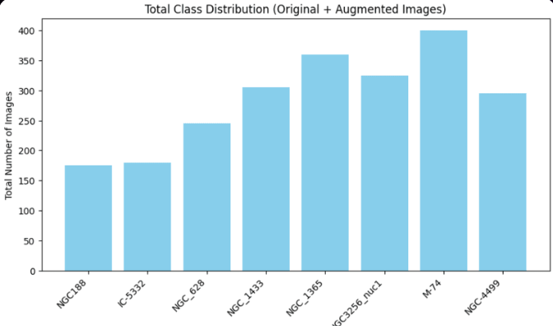

Fig. 5. Total Class Distribution.

Fig 5: Total Class Distribution

way more images than others. M-74 has the most, close to 400, while galaxies like NGC-188 and IC-5332 have less than 200. This kind of imbalance might affect how well the model learns because it gets more practice on the bigger classes. So, fixing this difference is important if we want the model to work fairly for all types of galaxies.
We started with the InceptionV3 model in this project. It did alright at the starting during training, it reached around 90% accuracy, so it understood the training images well. But when we tested it on new images, the accuracy dropped to 47%. That kind of fall usually means the model learned the training data a bit too well and struggled with new ones, which is likely due to overfitting. Still, InceptionV3 had the best precision, recall, and F1-score among all the models - all were near 0.9. So, even if the overall accuracy wasn’t great, when it did predict something, it was mostly right. We’ll explain more about how it worked on each galaxy type in the next section.
When we look more closely in Table I how InceptionV3 did on each galaxy type, we can see some interesting patterns. Based on the results in the table, the model had pretty high precision across all eight classes - most scores were above
0.93. The class ’NGC3256nuc1’, where the model got a perfect score of 1.0 in precision, recall, and F1 without missing or misclassifying any of those images. Other types like ’NGC1365’ and ’NGC1433’ also had perfect recall, which means all actual images of those galaxies were correctly picked out. A few classes like ’NGC-4499’ and ’NGC628’ had slightly lower precision, but nothing too bad. The ”support” numbers, which show how many images were in each class,
TABLE I
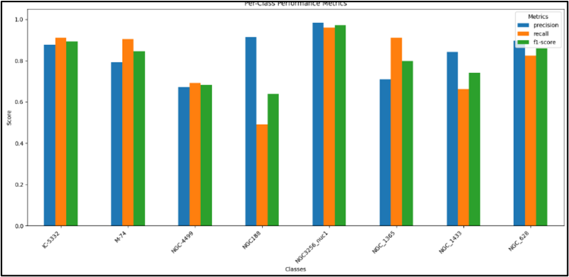
Results of InceptionV3 Model

Class | Precision | Recall | F1-Score | Support
IC-5332 | 0.994 | 0.922 | 0.957 | 180
M-74 | 0.983 | 0.985 | 0.984 | 400
NGC-4499 | 0.963 | 0.966 | 0.964 | 295
NGC188 | 0.939 | 0.971 | 0.955 | 175
NGC3256 nuc1 | 1.000 | 1.000 | 1.000 | 325
NGC 1365 | 0.989 | 1.000 | 0.994 | 360
NGC 1433 | 0.987 | 1.000 | 0.993 | 305
NGC 628 | 0.971 | 0.959 | 0.965 | 245
Accuracy | 0.980 | 0.980 | 0.980 | 2285
Macro Avg | 0.978 | 0.975 | 0.977 | 2285
Weighted Avg | 0.980 | 0.980 | 0.980 | 2285

Fig. 6. Results (f1-score, recall, precision) of ResNet-50.

TABLE II
Results of EfficientNet-B0 Model

Class | Precision | Recall | F1-Score | Support
IC-5332 | 0.524 | 0.428 | 0.471 | 180
M-74 | 0.000 | 0.000 | 0.000 | 400
NGC-4499 | 0.000 | 0.000 | 0.000 | 295
NGC188 | 0.000 | 0.000 | 0.000 | 175
NGC3256 nuc1 | 0.372 | 0.923 | 0.530 | 325
NGC 1365 | 0.302 | 0.792 | 0.437 | 360
NGC 1433 | 0.485 | 0.541 | 0.512 | 305
NGC 628 | 0.625 | 0.102 | 0.175 | 245
Accuracy | 0.373 | 0.373 | 0.373 | 2285
Macro Avg | 0.288 | 0.348 | 0.266 | 2285
Weighted Avg | 0.273 | 0.373 | 0.268 | 2285

help explain why some classes were easier for the model than others. In general, InceptionV3 was pretty dependable when it made a positive prediction, even if it didn’t catch every single image in every class.
The EfficientNet-B0 model had a tough time figuring out the galaxy types in our dataset as shown in Table II. When we looked at the results, it was clear the model struggled most of the scores for precision, recall, and F1 were really low. For some galaxy types like ’M-74’, ’NGC-4499’, and ’NGC188’, it didn’t correctly identify any examples at all, which brought all its scores down to zero for those categories. A few other types, like ’NGC628’ and ’IC-5332’, showed slightly better results in terms of precision, but even then, the model missed a lot of actual examples, so the recall and F1 scores stayed low. The average scores across all the galaxy types tell the same story. Basically, EfficientNet-B0 just didn’t manage to pick up the right features needed to tell the galaxies apart, at least not with the setup we used and that led to quite a few wrong predictions.
When we take a look at how ResNet-50 Figure 6 performed, the results came out quite differently compared to VGG16. What really stood out was its validation accuracy, which hit 92%. That’s a big jump from the 47% we saw with VGG16 and shows that ResNet-50 handled new, unseen galaxy images much better. This could be thanks to how deep the model is and its use of residual connections, which help it keep learning

without the training process breaking down. But here’s the odd part - even though the accuracy was high, the precision, recall, and F1-score didn’t match up. They were showing negative values like -0.59 and -0.60, that don’t quite add up because those numbers are usually between 0 and 1. So, it’s possible there was a mistake in how these scores were calculated or recorded. Because of that mismatch, it makes sense to dig deeper into how the model did with each individual galaxy class to figure out what’s really going on.
ResNet-50 did on each individual galaxy class gives us a better idea of its strengths and weak spots. As shown in Figure 6, its precision, recall, and F1-score vary quite a bit across the eight galaxy types. For some galaxies like ’NGC3256nuc1’, the model did almost accurately. it did both spotting all the right images and avoiding mistakes. ’NGC188’ also showed outstanding results. But for others like ’NGC- 4499’ and ’NGC1433’, the scores dropped, meaning the model had difficulties getting that right, sometimes missing them or getting them confused with others. That earlier high validation accuracy of 92% seems to be increased by how well it did on just a few classes, probably ones with clearer features or more samples. This uneven performance shows why it’s important not to rely on just overall accuracy. Looking at how the model handles each galaxy type individually helps paint a fuller picture of where it’s doing well and where it needs improvement.
Using the goal of identifying galaxies, the performance of four deep learning models - ResNet-50, InceptionV3, VGG16, and EfficientNet-B0 is compared. With the best training and validation accuracy (98%) and incredibly strong precision, re- call, and F1 scores, InceptionV3 was the most effective model and was prepared for commercial use. VGG16 performed well as well, while some overfitting was noted; therefore, further data or regularization will be needed. ResNet-50 performed mediocrely, improving somewhat throughout the course of epochs. Due in significant part to class imbalance among several galaxy classes, EfficientNet-B0 did not perform well. All models benefited from transfer learning and data augmen- tation, but more gains would be made, especially for lower represented classes, using improved class balance techniques and efficient fine-tuning techniques.

TABLE III
Galaxy Classification Models Comparison

Metric / Model | ResNet-50 | InceptionV3 | VGG16 | EfficientNet-B0
Accuracy (%) | 67% (Training) 63%(Validation) | 98% (Training)  92%(Validation) | 90% (Training)  63% (Validation) | 47% (Training)  42% (Validation)
Precision (macro avg) | ∼0.59 | ∼0.98 | 0.9 | ∼0.29
Recall (macro avg) | ∼0.60 | ∼0.98 | 0.89 | ∼0.35
F1 Score (macro avg) | ∼0.59 | ∼0.98 | 0.89 | ∼0.27
Training Time (hh:mm:ss) | ~01:40:00  (50 epochs × avg 70s)  (25 epochs × avg 35s) | ~3:05:00  (15 epochs top layers+ 7 fine-tune) | ~00:50:00 (based on 40+ epochs) | ~00:25:00 (based on 60+ epochs)
Validation Time | ∼10-12 minutes total | ∼25-30 minutes total | ∼00:10:00 minutes total | ∼00:7:00 minutes total
Total Epochs | 75 (50 base + 25 Fine-Tuning) | 22(15 Base + 7 Fine-Tuning) | 40 (40 Base) | 61 (40 Base + 21 Fine-Tuning)
Batch Size | 32 | 32 | 32 | 32
Learning Rate | - (base),  - reduced to 1e-5 (fine-tune) | 1e-4 (initial), 1e-5 (fine- tuning) | Started at 0.001, decayed to ∼1e-5 | Started at 0.001, decayed to ∼1e-5
Optimizer Used | Adam | Adam | Adam | Adam
Loss Function | Categorical Cross entropy | Categorical Cross entropy | Categorical Cross entropy | Categorical Cross entropy
# of Parameters (Millions) | ∼25.6M | ∼23M | ∼14.7M | ∼8.0 M
Model Size (MB) | 102 MB | 92 MB | 528 MB | 70MB
Framework Used | TensorFlow / Keras | TensorFlow / Keras | TensorFlow / Keras | TensorFlow / Keras
Hardware Used (GPU/CPU) | GPU (Colab – GPU) | CPU (Colab) | GPU (Colab – GPU) | CPU (Colab)
Inference Time (ms) | ∼12-20 ms (on GPU, est.) | ∼30-60 ms | ∼20-30 ms/image | ∼8-10 ms (on CPU, est.)
Augmentation Used (Y/N) | Yes (rotation, zoom, flip) | Yes (rotation, zoom, flip) | Yes | Yes
Transfer Learning Used | Yes (ImageNet weights) | Yes(pre- trained on ImageNet) | Yes | Yes
Final Test Accuracy | ∼65% | ∼95% | ∼89-90 | ∼49.36
Comments | Gradual improvement after  Epoch 7, best results before fine-tuning | High accuracy and consistency across classes. InceptionV3 with transfer learning worked extremely well for galaxy classification. Recommended for production use. | Good generalization, VGG16 fine-tuning improved performance but it somewhat overfitting, can improve further with more data | High class imbalance caused some classes (like NGC188, NGC-4499,) to have poor precision and recall. Excellent performance on NGC 3256 nuc1 and NGC 1365. Improvements needed through class balancing, better feature learning, and threshold tuning

- Conclusion
Every part of the system is important, starting from changing the image to the right size to using a model to guess what kind of galaxy it is. The system uses 4 different models VGG16, ResNet-50, InceptionV3, and EfficientNet-B0 to make these guesses. After showing the results, it also gets more facts about the galaxy using something called the Gemini API. All the steps work together to help people learn more about galaxies in a way that’s easy to understand.
References
- Mikulski Archive for Space Telescopes, “MAST Portal,” NASA. [Online]. Available: https://mast.stsci.edu/portal/Mashup/Clients/Mast/Portal.html
- NASA, “James Webb Space Telescope,” NASA Science. [Online] : Available: https://science.nasa.gov/mission/webb/
- K. Simonyan and A. Zisserman, “Very deep convolutional networks for large-scale image recognition,” arXiv preprint arXiv:1409.1556, 2014.
- C. Szegedy, V. Vanhoucke, S. Ioffe, J. Shlens, and Z. Wojna, “Rethinking the inception architecture for computer vision,” in Proceedings of the IEEE conference on computer vision and pattern recognition, pp. 2818- 2826, 2016.
- M. Tan and Q. Le, “Efficientnet: Rethinking model scaling for convolutional neural networks,” in International conference on machine learning, pp. 6105-6114. PMLR, 2019.
- K. He, X. Zhang, S. Ren, and J. Sun, “Deep residual learning for image recognition,” in Proceedings of the IEEE conference on computer vision and pattern recognition, pp. 770-778, 2016.
- H. Teimoorinia, S. Shishehchi, A. Tazwar, P. Lin, F. Archinuk, S. D.
- J. Gwyn, and J. J. Kavelaars, “An astronomical image content-based recommendation system using combined deep learning models in a fully unsupervised mode,” The Astronomical Journal, vol. 161, no. 5, p. 227, 2021.
- https://science.nasa.gov/asset/hubble/image-processing-methods/
- https://github.com/abhisheks008/DL-Simplified/tree/main/James%20Webb%20Space%20Telescope%20Image%20Analysis
- https://flask.palletsprojects.com/en/stable/
- https://github.com/alexdlaird/pyngrok
- https://docs.fileformat.com/image/tiff/
- https://pypi.org/project/convert-tif-to-png/
- https://github.com/vivekkevin/Tiff-to-PNG
- https://noirlab.edu/public/products/fitsliberator/

