- Full name, nationality and address of applicant(s):

Full Name | Nationality | Address
Vishwakarma Institute of Technology | Indian | 666, Upper Indiranagar, Bibwewadi, Pune, Maharashtra, India – 411 037

- Full name, nationality, address, mail id, and phone number of inventors:

Full Name (Including middle name) | Nation ality | VIT/VIIT Address (Start with full dept. name followed by full institute name) | Mail ID | Phone No. | Gender
Rushiraj Suwarnkar | IN | Department of Computer Science & Engineering (Artificial Intelligence), Vishwakarma Institute of Information  Technology, Pune | rushiraj.22310315@viit.ac.in | 8830414908 | Male
Pranay Harne | IN | Department of Computer Science & Engineering (Artificial Intelligence), Vishwakarma Institute of Information  Technology, Pune | pranay.22310103@viit.ac.in | 8261086182 | Male
Naman Mishra | IN | Department of Computer Science & Engineering (Artificial Intelligence), Vishwakarma Institute of Information  Technology, Pune | naman.22310154@viit.ac.in | 9152554944 | Male
Ayush Gupta | IN | Department of Computer Science & Engineering (Artificial Intelligence), Vishwakarma Institute of Information Technology, Pune | ayush.22311637@viit.ac.in | 7021066359 | Male

Dr. Anuradha Yenkikar | IN | Department of Computer Science & Engineering (Artificial Intelligence), Vishwakarma Institute of Information  Technology, Pune | anuradha.yenkikar@viit.ac.in | 9970364113 | Female
Dr. Nilesh Popat Sable | IN | Department of Computer Science & Engineering (Artificial Intelligence), Vishwakarma Institute of Information  Technology, Pune | nilesh.sable@viit.ac.in | 7588019070 | Male

Copy and paste clear soft copy of signatures of all inventors in the following table: (Insert or delete the cells as per number of inventers)

Name 1 | Name 2 | Name 3 | Name 4
Name 5 | Name 6 | Name 7 | Name 8

Title of the invention:
Brainwave-Synchronized AI System for Context-Aware Creative Assistance

4. Technical field of the invention:
The present invention is in the interdisciplinary field that combines Artificial Intelligence (AI), specifically generative and adaptive models. It also includes Brain-Computer Interfaces (BCI), focusing on non-invasive ways to acquire neural signals. Human-Computer Interaction (HCI) plays a role, particularly in designing smooth and non-disruptive user interfaces. Cognitive Neuroscience is involved, as it seeks to understand and identify the neural correlates of creativity and peak mental states. Finally, Neural Engineering deals with the practical use of systems that interpret and respond to neural signals.
More specifically, the invention relates to a new human-AI co-invention ecosystem. This system is designed to use real-time brainwave detection, primarily through Electroencephalography (EEG) or functional Near-Infrared Spectroscopy (fNIRS), to interpret a user's cognitive state. By identifying moments of peak creative thought, it activates a context-aware artificial intelligence to provide relevant, synchronized ideation prompts. This helps improve and support the invention generation process.

Prior art:
The current landscape of AI-assisted invention and creativity tools is limited. Traditional processes are mostly task-driven and reactive. Systems like OpenAI's ChatGPT, Google's Gemini, and Anthropic's Claude need explicit, user-initiated text prompts. Image generators such as MidJourney and Stable Diffusion rely on detailed textual descriptions for output. Similarly, AI-powered Computer-Aided Design (CAD) tools act as advanced assistants that respond to direct commands. A major drawback of these models is their inability to adjust to the user's changing cognitive or emotional state; they do not recognize when a user is most open to creative input.

While Brain-Computer Interface (BCI) technologies have developed, their use is mostly outside of creative idea generation. They mainly focus on control commands for neuroprosthetics, navigational input in assistive tech and gaming, and biofeedback for meditation or focus tracking. Existing patents and academic literature describe EEG-based systems for monitoring attention, neurofeedback devices for relaxation training, and machine learning models that classify broad emotional states like happiness or stress.

However, a significant gap exists in the prior art. These systems do not connect the complex process of generating ideas with neural feedback. They do not trigger specific, context-aware AI actions when detecting cognitive peaks, such as the short bursts of high-frequency gamma wave activity (~30-100 Hz) linked to moments of insight and increased creativity (the "Aha!" moment). Moreover, the AI models used in creativity-support tools lack real-time, closed-loop interaction with the user's brain state. No current system creates a synchronized connection between identifying a user's peak neural receptivity and delivering context-aware AI-generated suggestions tailored for invention or complex problem-solving. The present invention directly addresses this technological gap.

Object of the invention:
The main aim of this invention is to change the role of artificial intelligence in the creative process. It shifts from being a passive tool that follows commands to an active partner that works alongside humans. The goal is to develop a system where the AI works intelligently with the user. It should anticipate and enhance their creative abilities during their most productive moments.

To achieve this, the invention focuses on detecting specific brain patterns that indicate peak creativity. This includes identifying gamma wave bursts and other clear markers using non-invasive EEG or fNIRS sensors. By catching these key moments of heightened brain activity, the system can provide AI-generated suggestions at just the right time. This timing ensures that the suggestions come when the user is most ready to take in and use new ideas, making them more effective.

Another goal is to make sure these timely suggestions are relevant. The system can figure out what the user is currently working on by watching their digital workspace. It analyzes things like open applications, document titles, code repositories, or spoken keywords. By combining precise timing with an understanding of context, it creates a strong collaboration system between humans and AI. The ultimate aim is to significantly improve the quality, novelty, and effectiveness of the idea generation process, leading to faster and deeper innovation.

Synopsis:
This invention presents a real-time, closed-loop human-AI collaboration framework that uses brainwave signals to intelligently time and trigger relevant, context-aware AI-generated creative suggestions. It consists of five main, connected components:
i. Neural Interface Layer: This layer includes the hardware, such as a multi-channel EEG headset or an fNIRS sensor band. Its function is to non-invasively capture the user's raw brainwave activity with enough temporal and spatial resolution for later analysis.
ii. Cognitive State Detection Module: This is a powerful real-time signal analysis engine. It processes the incoming raw neural data, applies filters to remove noise, and uses trained machine learning models to identify and classify specific brain states. Its main task is to find the neural markers of peak creativity, like a significant rise in gamma band power, which signals a moment of high receptivity.
iii. Contextual Inference Engine: This software module runs alongside the others and monitors the user’s digital environment. It accesses metadata from active applications through APIs and other methods, extracts keywords from open documents or web pages, and can use a microphone to capture voice commands or spoken thoughts to establish a clear, dynamic understanding of the user's current project or train of thought.
iv. Symbiotic Suggestion Engine: This is the main AI ideation module. It is powered by generative models, like fine-tuned Large Language Models or diffusion models, that have been trained on large, specific datasets, including patent databases, technical and scientific literature, and creative design pattern libraries. Once it receives a trigger from the Cognitive State Detection Module and a context vector from the Inference Engine, it generates new and relevant suggestions.
v. Human-AI Interaction Interface: This component connects to the user. It presents the suggestions in a non-intrusive way, like a subtle pop-up or a dedicated panel. It also gathers explicit and implicit user feedback, such as accepting, rejecting, or modifying a suggestion, which is essential for the system's learning.

Brief description of drawings:
Figure 1 provides a clear overview of the complete architecture of the proposed Symbiotic Human-AI Invention Amplification System. It shows how data and control signals flow between its main components.

- The process begins with the EEG/fNIRS Headset (100), which the user wears to capture neural signals.

- These raw signals are sent to the Real-time Signal Capture Module (101). This module digitizes and preprocesses the data.

- The processed data goes to the Cognitive Peak Detector (102), where machine learning algorithms analyze the signals to find moments of high creativity. At the same time, the Contextual Inference Engine (103) observes the user's digital workspace to identify the subject matter.

- When a cognitive peak is detected, a trigger is sent to the AI Suggestion Generator (104). This generator also gets the topic context from (103) to produce a relevant idea.

- The generated idea is presented to the user through the Human-AI Interaction Interface (105). The user's response to the suggestion is recorded and sent to the Feedback & Learning Module (106). This module improves the models in both the Peak Detector (102) and the Suggestion Generator (104).

- Accepted or modified ideas are saved in the Invention Output Workspace (107), creating a lasting record of the collaborative session.

Detailed description of the invention:
The invention functions as a closed-loop co-creation framework that combines a neuroadaptive interface with a context-aware AI suggestion engine. The workflow is as follows:

Neural Signal Acquisition and Processing: The user wears a comfortable, non-invasive EEG or fNIRS headset, such as a multi-channel dry-electrode device. This headset continuously captures raw neural signals across different frequency bands: Delta, Theta, Alpha, Beta, and Gamma. These signals are transmitted wirelessly to the host computer. There, the signals are processed to remove common artifacts like eye blinks, muscle movements, and electrical noise. This ensures a clean signal for analysis.

Cognitive State Classification: After cleaning, the Cognitive State Detection Module processes the signals in real-time. This module uses machine learning algorithms, such as Support Vector Machines, Random Forests, or a recurrent neural network like an LSTM. These algorithms are trained to identify specific neural markers of a peak creative state. The primary feature for detection is a transient, high-amplitude burst in the gamma wave frequency band, typically defined as 30-100 Hz. Research links this burst to insight and the connection of different ideas. The module continually analyzes the power spectral density of the EEG signal. When the gamma power crosses a threshold adjusted to the user's baseline, it issues a "peak state" trigger.

Contextual Inference Mechanism: Simultaneously, the Contextual Inference Engine gathers data from the user's digital workspace. It uses system-level APIs to identify active window titles, read file names and paths, and employ Natural Language Processing techniques to extract key terms and meaning from open documents in text editors, web browsers, and PDF readers. For better accuracy, the user can optionally provide a spoken intent, such as "I am now working on a new bicycle suspension system." This spoken input is transcribed to enhance context. The gathered data is converted into a semantic vector embedding that represents the user's current focus area.

AI-Powered Suggestion Generation and Interaction: When the Cognitive State Detection Module sends a trigger, it indicates that the user is in an ideal state to receive creative input.

This trigger, along with the context vector from the Inference Engine, goes to the AI Suggestion Generator. This engine uses a transformer-based large language model or a multi-modal generative model trained on extensive datasets of patents, research papers, design methods, and technical manuals. The model applies the context vector to generate a concise and relevant suggestion. This suggestion might be a new technical approach, a metaphor from a different field, a possible improvement, or a visual concept. The suggestion is presented non-intrusively on the Human-AI Interaction Interface, such as a small toast notification or a sidebar. The user can accept the suggestion, refine it, or reject it with a single click.

Adaptive Feedback and Learning Loop: The Feedback & Learning Module captures every user interaction. This feedback serves as a reward in a reinforcement learning framework, specifically Reinforcement Learning with Human Feedback (RLHF). An 'accept' action positively reinforces the type of suggestion generated, while a 'reject' action penalizes it. This feedback loop allows the system to gradually adjust and personalize its performance. It improves the AI's understanding of the user’s interests and preferences and helps calibrate the sensitivity of the cognitive timing logic. This makes the entire system more attuned to the individual’s unique cognitive and creative patterns over time.

Best method of performance of the invention:
  - The invention is best realized by using the system as an integrated desktop and wearable solution. It is designed to fit smoothly into a professional's daily workflow. The ideal setup includes:

  - 1. Hardware: A commercially available, high-quality, multi-channel dry-electrode EEG headset is preferred. Options like the OpenBCI Galea or an Emotiv model work well due to their signal quality, comfort, and ease of use. The headset connects via low-latency Bluetooth to a desktop or laptop computer.

  - 2. Software Stack: The system operates on a desktop application built with a modular software stack.
  - - Signal Processing Backend: It uses reliable libraries such as MNE-Python or Brainflow for real-time EEG signal acquisition, filtering (band-pass, notch), artifact removal, and feature extraction (such as Fast Fourier Transform for power spectral density).
  - - Cognitive Detection: A machine learning model, such as a pre-trained convolutional neural network (CNN) or a lightweight support vector machine (SVM), is implemented in Python using frameworks like Scikit-learn or TensorFlow Lite for efficient real-time classification of cognitive states.
  - - Context Capture: The application uses platform-specific APIs (such as Windows UI Automation and macOS Accessibility API) to track window titles and application metadata locally and securely.
  - - AI Suggestion Engine: This can be set up with a local instance of an open-source language model like LLaMA or Mixtral, fine-tuned on relevant material. Alternatively, it can use API calls to a powerful proprietary model like GPT-4 or Claude 3, ensuring top generative capabilities.

  - 3. User Workflow:
  - - Calibration: When first using the system, the user goes through a brief calibration phase lasting 5 to 10 minutes. They perform a series of guided tasks (such as reading technical text, brainstorming freely, or solving a puzzle) to establish personal neural baselines for different cognitive states. This helps tailor the Cognitive Peak Detector.
  - - Operation: During regular use, the application runs quietly in the background. When it detects a cognitive peak during a work session, the Human-AI Interaction Interface panel appears discreetly in a corner of the screen, offering a single, clear suggestion. The UI includes "Accept," "Refine," and "Reject" buttons. An accepted suggestion can be automatically copied to the user's clipboard or added to a dedicated log file in their project directory, creating a smooth workflow. All interactions are logged locally to be used for periodic offline retraining of the preference model, ensuring ongoing improvement and personalization.

CLAIMS:
What is claimed is:
1. A system for synchronized human-AI co-invention, the system comprising:
- a neural interface that acquires real-time brainwave signals from a human user;
- a cognitive peak detection module connected to the neural interface, which analyzes the brainwave signals to identify a temporary neural state that shows increased creative receptivity;
- a contextual inference engine that determines a user's current topic of focus by analyzing data from the user's digital workspace; and
- an AI suggestion generator connected to the cognitive peak detection module and the contextual inference engine, which creates a relevant creative suggestion when it detects the temporary neural state.
2. The system of claim 1, where the cognitive peak detection module is designed to detect gamma wave bursts. These bursts are marked by a significant rise in signal power in the 30-100 Hz frequency range, serving as an indicator of peak creative receptivity.
3. The system of claim 1, where the contextual inference engine derives the user's topic of focus from at least one of the following: active application metadata, window titles, open document filenames, voice input, or keywords taken from on-screen text using natural language processing.
4. The system of claim 1, where the AI suggestion generator includes a transformer-based large language model trained on a specific set of invention databases, scientific literature, and design principles.
5. The system of claim 1, which also includes a feedback module that collects user input about a generated suggestion and uses that input to improve the AI suggestion generator's performance for future interactions.
6. The system of claim 5, where the feedback module uses reinforcement learning with human feedback to change the AI suggestion generator's output based on the user's preferences.
7. The system of claim 1, where the invention produces workspace logs that allow suggestions to be accepted or modified in a collaborative document or digital notebook for long-term storage.
8. A method for synchronized human-AI co-invention, the method including the steps of:
- continuously acquiring brainwave signals from a user through a neural interface;
- analyzing these brainwave signals in real time to detect a cognitive peak state;
- determining a context related to the user's current task;
- when the cognitive peak state is detected, triggering an AI engine to create a creative suggestion based on the determined context;
- presenting that suggestion to the user through an interface.

Inventive step of your invention:
The innovative aspect of this invention lies in the unique and non-obvious combination of three different technological areas: real-time cognitive state detection, contextual computing, and generative artificial intelligence. This creates a truly cooperative system. Previous work shows the use of these components separately. AI models are tools driven by user prompts, and BCI systems are used for direct control or basic biofeedback.

A person skilled in AI would typically try to make inventions better by developing more powerful generative models. Someone experienced in BCI would focus on improving signal clarity for neuroprosthetics. The breakthrough here is recognizing that the timing of AI intervention, aligned with the user's natural rhythm of creativity, is a vital, unexplored factor. The system does not just deliver information; it provides it at the peak moments of neural receptivity.

This timing-based, context-aware collaboration changes human-AI interaction from a reactive "pull" model—where the user has to stop their thought process to ask the AI—to a proactive, cooperative "push" model. In this model, the system predicts the user's moment of insight and offers relevant stimuli. This creates a combined effect that exceeds the individual contributions, tackling the main issues of mental fatigue and creative blocks in a way that differs fundamentally from existing technology. This novel combination sets a new standard for human-AI collaboration, significantly improving the quality of ideas and creative output.

Industrial application:
The invention has wide and important use in any industry that relies on innovation, creativity, and solving complex problems.

• Research & Development (R&D): In pharmaceutical, materials science, and biotechnology R&D departments, the system can speed up discovery. A scientist writing a research grant or analyzing experimental data could get timely suggestions for new hypotheses, different experimental designs, or links to related research in other fields.

• Industrial Design and Engineering: An engineer or designer using CAD software, such as SolidWorks or Autodesk Fusion, could receive real-time suggestions for different materials, more efficient mechanical links, or new aesthetic ideas that fit their design goals while they are working through a design challenge.

• Intellectual Property (IP) and Legal Services: Patent attorneys and IP creation teams can use the system to explore new claims, find possible workarounds for existing patents, and brainstorm new inventions for a client's portfolio. This dramatically boosts both the quantity and quality of ideas that can be protected.

• Software Engineering and Architecture: A software developer working in an Integrated Development Environment (IDE) could receive tips for better algorithms, alternative software design patterns, or solutions to complex bugs when they are focused on writing code.

• Creative Industries: Professionals in architecture, marketing, and media can use it to get past creative blocks. An architect might get new structural or spatial ideas, while a marketing professional could receive unique campaign slogans or strategies during a brainstorming session.

• Education and Academia: The system can serve as a useful learning tool to help students and researchers build critical thinking and problem-solving skills. It prompts them with new perspectives and information at just the right moments in their study process.

Abstract
A system and method for human-AI co-invention is presented. The system improves human creativity by syncing AI-generated suggestions with the user's peak cognitive states. It includes a neural interface, like an EEG headset, to capture real-time brainwave signals. A cognitive state detection module analyzes these signals to find signs of increased creativity, such as gamma wave bursts. A contextual inference engine identifies the user's current focus from their digital workspace. Additionally, a symbiotic suggestion engine generates contextually relevant creative ideas.

When the system detects a peak creative state, the AI generates a relevant suggestion and shows it to the user. A feedback mechanism helps the system learn and personalize its responses based on user interaction. This creates a closed-loop learning framework. This new approach turns the AI from a passive tool into an active cognitive partner. It allows for a collaborative effort that significantly improves the novelty and efficiency of the invention process.
- Drawing

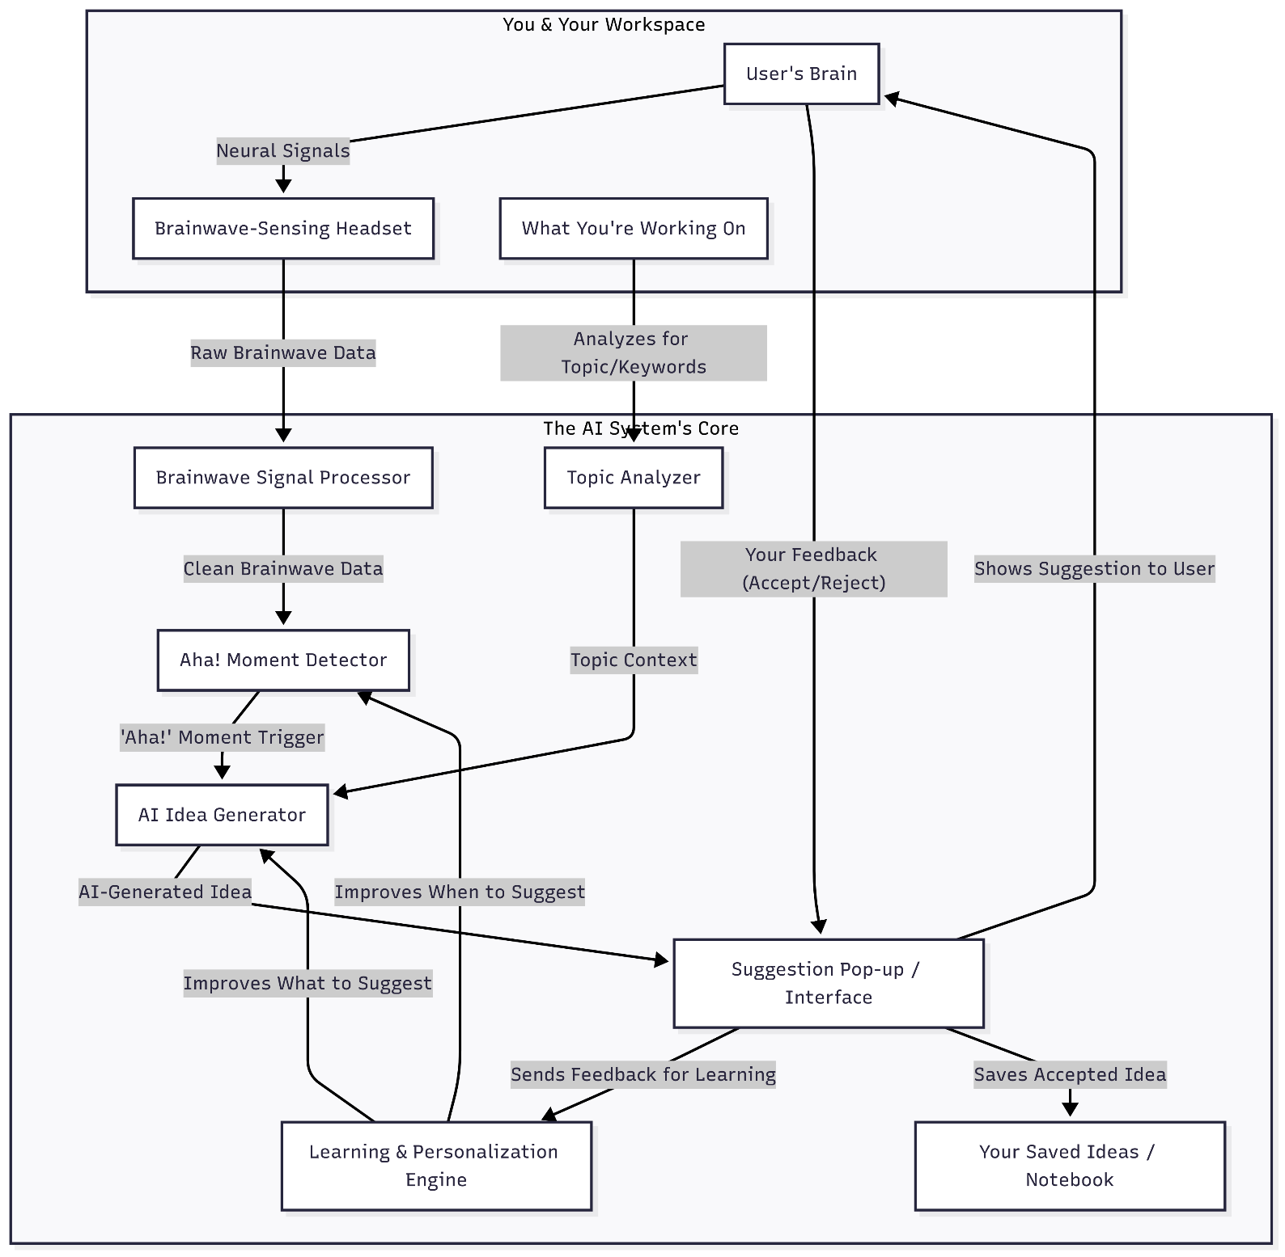

- Student Information
Name | Phone no | Prn | Branch
Pranay Harne | 5689784556 | 22310103 | CSE-AI
Pranay Harne | 1058968747 | 22310103 | CSE-AI
Om | 5254589656 | 55669 | IT
Rohit | 1425368596 | 5641 | CS

