**iLibrary**

Library at Fingertips

SUBMITTED IN PARTIAL FULFILMENT OF THE REQIREMENTS FOR THE

AWARD

OF

**DIPLOMA**

**IN**

**COMPUTER ENGINEERING**

Submitted by:

Pranay Chavhan-1913007

Atharva Gotmare-1913003 Gunjan Ghuguskar-1913018

Aditya Dandare-1913009 Shwetank Gopnarayan-1913016

Under the supervision of

**MR. S.A. Khatri**

**Lecturer**

**Department of Computer Engineering**



**DEPARTMENT OF COMPUTER ENGINEERING**

**GOVERNMENT POLYTECHNIC, NAGPUR**

(An Autonomous Institute of Govt. of Maharashtra)

(Mangalwari Bazaar, Nagpur-440001)

JUNE, 2022

**CERTIFICATE**

**GOVERNMENT POLYTECHNIC, NAGPUR**

 (An Autonomous Institute of Government of Maharashtra)

**This is to certify that,**

**1. Pranay Chavhan-1913007**

**2. Atharva Gotmare-1913003**

**3. Shwetank Gopnarayan-1913016**

**4. Aditya Dandare-1913009**

**5. Gunjan Ghuguskar-1913018**

**Of term** EVEN 2021 of Computer Engineering department students have submitted their Project report on **“iLibrary”** during academic session 2021-2022 as a part of project work prescribed by Government Polytechnic, Nagpur for the partial fulfillment of the requirement of diploma in Computer Engineering, Sixth Semester. The project work is the record of students’ own work and is completely satisfactory.

**Mr. S. A. Khatri Dr. M. V. Sarode**

**(Project Guide) (HOD)**

**Dr. Manoj B. Daigavane**

**(Principal)**

(Mangalwari Bazaar, Nagpur - 4400001)

**GOVERNMENT POLYTECHNIC, NAGPUR**

**DEPARTMENT OF COMPUTER ENGINEERING**

**CANDIDATES’ DECLARATION**

We, student of Diploma (Computer Engineering Department), hereby declare that the project titled **“iLibrary”** which is submitted by us to the **Department of Computer Science & Engineering, Government Polytechnic, Nagpur** in partial fulfillment of the requirement for the award of the Diploma is original and not copied from any source without proper citation. This work has not previously formed the basis for the award of and Degree, Diploma Associateship, Fellowship or other similar title or recognition.

Place: Nagpur Date:

**Name and Signature of students**

Pranay Chavhan-1913007

Atharva Gotmare-1913003 Gunjan Ghuguskar-1913018

Aditya Dandare-1913009 Shwetank Gopnarayan-1913016

This is to certify that the above statement made by the candidate is correct to best of our knowledge.

**MR. S.A. Khatri**

**(Project Guide)**

**ACKNOWLEDGEMENT**

The success of this project requires the assistance and input of numerous people and the organization. We are grateful to everyone who helped in shaping the result of the project.

We express my sincere thanks to Mr. Sumit Khatri, our project guide, for providing me with the opportunity to undertake this project under his guidance. We were always supported and encouraged by him to realize that the learning process is more important than the final outcome. We are very indebted to the faculties for their guidance, continuous monitoring and motivation during all the progress evaluations to complete my work. They helped me throughout with new ideas, provided information necessary and pushed me to complete the work.

We express my sincere gratitude to Dr. M. V. Sarode Sir, Head of Computer Engineering, for his stimulating guidance, continuous encouragement and supervision throughout the course of present work.

**ABSTRACT**

In traditional libraries, the students/user has to search for books which are hassle process and there is no proper maintenance of database about issues/fines. The librarians have to work hard for arranging, sorting books in the book shelves. At the same time, they have to check and monitor the lend/borrow book details with its fine.

With the advancement of technology, the library should also become the part of the computerization era. Online Library Management System is designed to operate all the working of the library on the Librarian’s screen. The Librarian will act as the admin and will monitor all the activities like user logins, entering new users, their payment if they are buying or prebooking the book for reading. Users will have their own GUI where they can check the availability of the book and reserve the book for reading. Users can also download the pdf file version of the e-books available in the Online Library. Resource management is also done by the project. Resources like the Projector availability, AV(Audio-Visual) Room availability. The possession of these resource can be obtained by booking the resource for the particular time slot.

**INDEX**

*Title Page i*

*Certificate ii*

*Candidates’ Declaration iii*

*Acknowledgement iv*

*Abstract v*

**Chapter 1: Introduction**

* 1. Introduction 10

1.1.1 Pre-computerization (Traditional Workings and Developments)

1.1.2 1960s: the influence of computer technologies

1.1.3 1970s–1980s: the early integrated library system

1.1.4 1990s–2000s: the growth of the Internet

1.1.5 Mid 2000s–present: increasing costs and customer dissatisfaction

1.1.6 2010s–present: the rise of cloud-based solutions

1.2 Motivation 13

1.3 Objectives and Characteristics 14

1.3.1 Objectives

1.3.2 Characteristics

1.4 Brief Description of the System 15

**Chapter 2: Literature Survey**

2.1 Literature Survey 17

**Chapter 3: System Analysis and Design**

3.1 Analysis 21

3.1.1 Problem Definition

3.1.2 Objectives

3.1.3 Feasibility Study

3.1.4 Software (Website) Requirement Specification

3.2 Design 29

3.2.1 Existing System

3.2.2 Proposed System

3.3 Diagrams 32

**Chapter 4: System Implementation**

4.1 Setting Environment 41

4.1.1 Laravel

4.1.2 React Js

4.1.3 XAMPP Server

4.1.4 Tailwind CSS

4.2 Implementation Details 46

4.3 System Execution Details 46

4.4 Snapshots 49

**Chapter 5: Future Scope and Conclusion 52**

**References 55**

**Annexure 57**

**List of Figures**

|  |  |  |
| --- | --- | --- |
| **S.NO.** | **Figure Name** | **Page No**. |
| 1. | Zero level DFD | 32 |
| 2. | First level DFD | 33 |
| 3. | Second Level DFD | 34 |
| 4. | Use Case Diagram | 35 |
| 5. | Activity Diagram | 36 |
| 6. | Entity Relationship Diagram | 37 |
| 7. | Sequence Diagram Book Request/Issue | 38 |
| 8. | Sequence Diagram for Resource Request | 39 |

Chapter 1 Introduction

* 1. **Introduction**

*What is Integrated Library System?*

An **integrated library system** (**ILS**), also known as a **Library Management System** owned, orders made, bills paid, and patrons who have borrowed. An ILS usually is constituted of a [relational database](https://en.m.wikipedia.org/wiki/Relational_database), software to interact with that database, and two [graphical user interfaces](https://en.m.wikipedia.org/wiki/Graphical_user_interface) (one for patrons, one for staff). Most ILSes separate software functions into discrete programs called modules, each of them integrated with a unified interface. Examples of modules might include:

* acquisitions (ordering, receiving, and invoicing materials)
* [cataloguing](https://en.m.wikipedia.org/wiki/Library_catalog) (classifying and indexing materials)
* circulation (lending materials to patrons and receiving them back)
* [serials](https://en.m.wikipedia.org/wiki/Serial_(literature)) (tracking magazine, journals, and newspaper holdings)
* [online public access catalogue](https://en.m.wikipedia.org/wiki/Online_public_access_catalog) or OPAC (public user interface)
* Resource management (reserving projector and A-V room)

Each patron and item have a unique ID in the database that allows the ILS to track its activity. To bring a complete library on your, you will require a system which will work as a library for you. This is where the **iLibrary** project comes into action which provides you the complete library on your screens and the selection on your fingertips.

**iLibrary**

iLibrary is website best support on chrome which provides an interface of an offline library onto your screens and within the reaches of your fingertips. The interface just like an online shopping website, a login page for the user, the home page filled with the categories the user can go through, an admin operation page, resource management section, etc.

***Note****: Here after the term “****website****” will be referred as “****system****” or “****software****” to avoid the confusion between conceptual terminologies e.g.,* ***Software Requirements*** *is**equivalent**to* ***Website Requirements.***

* + 1. **Pre-computerization (Traditional Workings and Developments)**

Prior to computerization, library tasks were performed manually and independently from one another. Selectors ordered materials with ordering slips, cataloguers manually catalogued sources and indexed them with the card catalog system (in which all bibliographic data was kept on a single index card), fines were collected by local bailiffs, and users signed books out manually, indicating their name on cue cards which were then kept at the circulation desk. Early mechanization came in 1936, when the University of Texas began using a punch card system to manage library circulation. While the punch card system allowed for more efficient tracking of loans, library services were far from being integrated, and no other library task was affected by this change.

**1.1.2 1960s: the influence of computer technologies**

The next big innovation came with the advent of MARC standards in the 1960s, which coincided with the growth of computer technologies – library automation was born. From this point onwards, libraries began experimenting with computers, and, starting in the late 1960s and continuing into the 1970s, bibliographic services utilizing new online technology and the shared MARC vocabulary entered the market; these included OCLC (1967), Research Libraries Group (which has since merged with OCLC), and the Washington Library Network (which became Western Library Network and is also now part of OCLC).

**1.1.3 1970s–1980s: the early integrated library system**

The 1970s can be characterized by improvements in computer storage, as well as in telecommunications. As a result of these advances, "turnkey systems on microcomputers", known more commonly as integrated library management systems (ILS) finally appeared. These systems included necessary hardware and software which allowed the connection of major circulation tasks, including circulation control and overdue notices. As the technology developed, other library tasks could be accomplished through ILS as well, including acquisition, cataloguing, reservation of titles, and monitoring of serials.

**1.1.4 1990s–2000s: the growth of the Internet**

With the evolution of the Internet throughout the 1990s and into the 2000s, ILSs began allowing users to more actively engage with their libraries through an OPACs and online web-based portals. Users could log into their library accounts to reserve or renew books, as well as authenticate themselves for access to library-subscribed online databases. Inevitably, during this time, the ILS market grew exponentially. By 2002, the ILS industry averaged sales of approximately US$500 million annually, compared to just US$50 million in 1982.

**1.1.5 Mid 2000s–present: increasing costs and customer dissatisfaction**

By the mid to late 2000s, ILS vendors had increased not only the number of services offered but also their prices, leading to some dissatisfaction among many smaller libraries. At the same time, open-source ILS was in its early stages of testing. Some libraries began turning to such open-source ILSs as Koha and Evergreen. Common reasons noted were to avoid vendor lock in, avoid license fees, and participate in software development. Freedom from vendors also allowed libraries to prioritize needs according to urgency, as opposed to what their vendor can offer. Libraries which have moved to open-source ILS have found that vendors are now more likely to provide quality service in order to continue a partnership since they no longer have the power of owning the ILS software and tying down libraries to strict contracts.

**1.1.6 2010s–present: the rise of cloud-based solutions**

The use of cloud-based library management systems has increased drastically since the rise of cloud technology started. According to NIST, cloud computing can include a variety of "characteristics (e.g., self-service, resource pooling, and elasticity), management models (e.g., service, platform, or infrastructure focus), and deployment models (e.g., public, private)”, and this is also true of cloud-based library systems.

* 1. **Motivation**

The purpose of a library management system is to operate a library with efficiency and at reduced costs. The system being entirely automated streamlines all the tasks involved in operations of the library. The activities of book purchasing, cataloging, indexing, circulation recording and stock checking are done by the software. Such software eliminates the need for repetitive manual work and minimizes the chances of errors.

The library management system software helps in reducing operational costs. Managing a library manually is labour intensive and an immense amount of paperwork is involved. An automated system reduces the need for manpower and stationery. This leads to lower operational costs.

The system saves time for both the user and the librarian. With just a click the user can search for the books available in the library. The librarian can answer queries with ease regarding the availability of books. Adding, removing or editing the database is a simple process.

Stock checking and verification of books in the library can be done within a few hours. The automated system saves a considerable amount of time as opposed to the manual system.  
The library management system software makes the library a smart one by organizing the books systematically by author, title and subject. This enables users to search for books quickly and effortlessly.  
Students need access to authentic information. An advanced organized library is an integral part of any educational institution. In this digital age a web-based library management system would be ideal for students who can access the library’s database on their smartphones.

* 1. **Objectives and Characteristics**

**1.3.1 Objectives**

The Interface has to be simple to use, as the target end-users for the system are non-technical persons. Our system also aims to provide a complete IT solution in managing a library. This system aims to automate the functions performed by the librarian.

* Library Management System is website used to provide information regarding the books and e-books in a library to the user.
* It can be accessed by unlimited number of users.
* Each user will be assigned a different set of permissions for each module of the library including basic searching, permissions, advance booking etc.
* The user can take of use his required books up to the time limit extended to him. User can also e-books in pdf file.
* At the cross of his time limit he may face the fine.
* Fine session is under the control of administration.
* The administrator has to generate daily/weekly/Monthly reports, which include the details of books, issued, returned, collection of fine etc.
* Pre-reserving of the resources like projector and audio-visual room.

**1.3.2 CHARACTERISTICS OF THE SYSTEM**

1. User login/logout, user Administration.
2. Add, edit and delete the books/e-books information.
3. Search and view the books information.
4. Define Student.
5. Faculty members can check the availability of projector and av room.
6. Add, edit and delete Student information.
7. Search and view the student, and return book from Student to Library.
8. Issue a book to Student, and return book from Member to Library.
9. Reports based on existing records.
   1. **Brief Description of the System**

As the library and information services community seeks to cope with new patterns of information provision, new technology and changing financial circumstances, it is critical to gain new thinking across the profession. Library Management System website which is used to supply the books to the user. This is done through React JS technologies. This has various technical areas. It includes WINDOWS as the operating System, LARAVEL as Database. The front-end deals with GUI and source code deals with LARAVEL (Backend). Library Management System provides knowledge and practical perspectives for all aspects of management of libraries and information services, which will prove invaluable to managing a library or information services cost effectively, while meeting the needs of its users. Library Management System is one of the most tedious processes, which involves the regular updating of many files and records. As new members enroll for membership the management has to issue a unique membership code for that member. For this they have to keep a track of many records such as student details, book details and maintain a number of registers. Doing this manually involves a lot of time and labor. Hence this can be made easy through automation.

Chapter 2

LITERATURE SURVEY

**2.1 Literature Survey**

1. Akazue Maureen and Ojeme Blessing “Design of Automated Library Management System for States Universities in Nigeria” [1] proposed Library automation has to do with the act of computerizing user’s registration and library materials, borrowing and returning, locating of material and calculating overdue fines in the library system. The status of automated library management systems in Nigerian state universities were assessed through site visits and interview surveys of the views of academic/non-academic staff, students and researchers in the universities. This study designed an automated library system that will help university libraries to keep accurate track of the transaction done via storing information about library users, accurately locating library materials effectively with ease and tracking of all borrowing and returning of books. Also, where fine is applicable, the system can calculate overdue of library defaulters and provide useful information that can help the management of the library in decision making. The findings were used to design an automated library management system for Delta State University in Nigeria.

(Paper: Design of Automated Library Management System for States Universities in Nigeria)

1. Shanmugam A.P, Ramalakshmi, A, Sasthri, G, Baalachandran, S [2]

The authors have proposed the idea that how LMS will assist the librarians to work easily. In traditional libraries, the students/user has to search for books which are hassle process and there is no proper maintenance of database about issues/fines. The overall progress of work is slow and it is impossible to generate a fast report. The librarians have to work allotted for arranging, sorting books in the book sells. At the same time, they have to check and monitor the lend/borrow book details with its fine. It is a tedious process to work simultaneously in different sectors. But now with the help of LMS the users need not stand in a queue for a long period to return/borrow a book from the library. The single PC contains all the data in it. The librarians have to assess the system and provide an entry in it. Through LMS the librarian can find the book in the bookshelves. The LMS is designed with the basic features such as librarian can add/view/update/delete books and students' details in it

(Paper: Library Management System)

1. Nicola Aloia, Cesare Concordia, Carlo Meghini [3] ; proposed how Digital Libraries (DLs) play a central role in the way information is produced, accessed and used in the Internet era. While the Web provides a universal access to uncontrolled information resources, DLs allow large,distributed repositories of multimedia content, annotated with possibly richsemantic structures and regulated by digital rights, to be created and managed to satisfy the needs of vast user communities. This paper describes the main features of BRICKS, an open-source DL management system based on an innovative peer-to-peer architecture and integrating advanced information management techniques, ranging from model-agnostic content and metadata management to distributed query processing.

(Paper: Implementing BRICKS, a Digital Library Management System)

1. NAMBURI SAI NAGA LAKSHMI PRASANNA,B.N. SRINIVASA GUPTA [4]; stated that the Interface of ILS has to be simple to use, as the target end-users for the system are non-technical persons. The system must aim to provide a complete IT solution in managing a library. The system should automate the functions performed by the librarian. Operations such as cataloguing the books, Managing Member Information, searching books, issuing books, collecting fines etc are included in this system. The system must provide powerful functionalities to the user by making use of simple easy-to-easy interface.

(Paper: ONLINE LIBRARY MANAGEMENT SYSTEM)

1. Chunchao Liu, Sheng Ma [5]; proposed the basic structure and design elements needed to develop a Library Management System. The paper also states the history of Library Management System right from early 1960s, methodologies and working techniques of librarian, challenges faced, evolution of the Library Management System, the influence of Computer Technologies and Internet. The testing phase is also mentioned in paper.

(Paper: Design of Library Management System)

1. Ayooluwa Aregbesola, Toluwani Eyiolorunshe,Jerome Idiegbeyan-ose, Sola Owolabi, Foluke Okocha [6]; The purpose of their paper was to discuss adoption of library management system, motivation and challenges in developing countries. It started with the introduction of the concept; it further discussed the trend in the adoption of library management system in the developing countries. The paper also highlighted the factors influencing the adoption of library management system in developing countries, it also discussed the motivating factors in adopting library management system to library services. The paper further pointed out the challenges in adopting LMS in developing countries, such as prolonged adverse economic conditions, limitations in budgetary provision, infrastructural and political challenges facing these countries as well as inadequate technical-know required for the deployment and usage of modern working tools and technologies involved within LMS. Based on these, the paper concluded and recommended that there should be adequate planning, preparation and consultations before embarking on the adoption of a software for LMS, regular training and retraining should be conducted for library personnel on the use of the software, institutional support and the reputation of the company that developed the software should also be considered among others.

(Paper: Adoption of Library Management System: Motivation and Challenges in Developing Countries)

Chapter 3

SYSTEM ANALYSIS

AND

DESIGN

**3.1 Analysis**

**3.1.1 Problem Definition**

With the improvement of people’s level of knowledge, the library has become an indispensable part of daily life. But the library storage and the business volume are huge, the traditional accounts’ management is merely not feasible. At the time, library management system comes into being and becomes an important part of information construction gradually. In order to develop, build and adapt to the modern information society, establishing a management information system becomes the main trend, and also, we can’t avoid the problem. The implementation of electronic book management can help human resource officials free themselves from the heavy deskwork to complete some more important work. Library management system is to reduce and solve the cumbersome manual management, so that the library can rise to a perfect electronic management.

**3.1.2 Objectives**

The main objective of the Project on Library Management System is to manage the details of Student, Books, Issues, Librarian, Member. It manages all the information about Student, Address, Member, Student. The project is totally built at administrative end and thus only the administrator is guaranteed the access. The purpose of the project is to build an application program to reduce the manual work for managing the Student, Books, E-Books, Address, Issues. It tracks all the details about the Issues, Librarian, Member.

Functionalities provided by Library Management System are as follows Provides the searching facilities based on various factors. Such as Student, Issues, Librarian, Member Library Management System also manage the Address details online for Librarian details, Member details, Student. It tracks all the information of Books, Address, Librarian etc. Manage the information of Books Shows the information and description of the Student, Issues To increase efficiency of managing the Student, Books and Resources like projector and audio-visual room availability.

It deals with monitoring the information and transactions of Librarian. Manage the information of Student, editing, adding and updating of Records is improved which results in proper resource management of Student data. Manage the information of Librarian Integration of all records of Member.

**3.1.3 Feasibility Study**

A feasibility study assesses the operational, technical and economic merits of the proposed project. The feasibility study is intended to be a preliminary review of the facts to see if it is worthy of proceeding to the analysis phase. From the systems analyst perspective, the feasibility analysis is the primary tool for recommending whether to proceed to the next phase or to discontinue the project.

The feasibility study is a management-oriented activity. The objective of a feasibility study is to find out if an information system project can be done and

to suggest possible alternative solutions.

Projects are initiated for two broad reasons:

* Problems that lend themselves to systems solutions
* Opportunities for improving through:

(a) upgrading systems

(b) altering systems

(c) installing new systems

A feasibility study should provide management with enough information to decide:

* Whether the project can be done?
* Whether the final product will benefit its intended users and organization
* What are the alternatives among which a solution will be chosen?
* Is there a preferred alternative?
* How beneficial or practical the development of an information system would be to an organization?

And for the System to be act as worth-while it should pass through some test that examine that it should proceed further or not. This series of test is commonly known as feasibility study on the system and it plays a very vital role for every system projects. Feasibility studies undergo four major analyses to predict the system to be success and they are as follows: -

1. Operational Feasibility
2. Technical Feasibility
3. Economic Feasibility
4. Operational Feasibility:

Operational feasibility is a measure of how well a proposed system solves the problems, and takes advantage of the opportunities identified during scope definition and how it satisfies the requirements identified in the requirements analysis phase of system development. Operational feasibility reviews the willingness of the organization to support the proposed system. This is probably the most difficult of the feasibilities to gauge. In order to determine this feasibility, it is important to understand the management commitment to the proposed project. If the request was initiated by management, it is likely that there is management support and the system will be accepted and used.

Following questions can be asked to observe the operational feasibility of the system:

* Can admin create user and manipulate other entities?
* Can the user login in the system and order a book?
* Can the user pay the fine using online/offline methods?
* Can the user download pdf of the e-books?
* Can the admin control the complete system without any problems?
* Are the web pages responsive enough to work on all devices?
* Does current mode of operation provide reliable service? Is it flexible and expandable?
* Does current mode of operation make maximum use of available resources, including people, time, and flow of forms?
* Can faculty members check availability and pre-register the resources?

1. Technical Feasibility:

A large part of determining resources has to do with assessing technical feasibility. It considers the technical requirements of the proposed project. The technical requirements are then compared to the technical capability of the organization. The systems project is considered technically feasible if the internal technical capability is sufficient to support the project requirements.   
The analyst must find out whether current technical resources can be upgraded or added to in a manner that fulfils the request under consideration.  This is where the expertise of system analysts is beneficial, since using their own experience and their contact with vendors they will be able to answer the question of technical feasibility.  
The essential questions that help in testing the operational feasibility of a system include the following:

* Is the project feasible within the limits of current technology?
* Does the technology exist at all?
* Is it available within given resource constraints?
* Is it a practical proposition?
* Manpower- programmers, testers & debuggers
* Software and hardware
* Are the current technical resources sufficient for the new system?
* Can they be upgraded to provide to provide the level of technology necessary for the new system?
* Do we possess the necessary technical expertise, and is the schedule reasonable?
* Can the technology be easily applied to current problems?
* Does the technology have the capacity to handle the solution?
* Do we currently possess the necessary technology?

Automated library system deals with the modern technology system that needs the well efficient technical system to run this project. All the resource constrains must be in the favor of the better influence of the system. Technical Feasibility collects its data from the system requirements that the end user provides. The data is in the textual form(documented) which is collected from the end user. This data requires to be converted into such data the so that system analyst can configure the process flow of the data. Once the process flow is acquired the system is sent to development and once completed, it is handed over to the end user.

Economic Feasibility:

Economic analysis could also be referred to as cost/benefit analysis. It is the most frequently used method for evaluating the effectiveness of a new system. In economic analysis the procedure is to determine the benefits and savings that are expected from a candidate system and compare them with costs. If benefits outweigh costs, then the decision is made to design and implement the system. An entrepreneur must accurately weigh the cost versus benefits before taking an action.

Possible questions raised in general economic analysis are:

* Is the system cost effective?
* Do benefits outweigh costs?
* The cost of doing full system study
* The cost of business employee time
* Estimated cost of hardware
* Estimated cost of software/software development
* Is the project possible, given the resource constraints?
* What are the savings that will result from the system?
* Cost of employees' time for study
* Cost of packaged software/software development
* Selection among alternative financing arrangements (rent/lease/purchase)

Questions raised regarding economic analysis for iLibrary are:

* What is cost for implementing the system (website)?

All the resources used for development are either open-source, freely available and no specific requirements are required as it a website. It can run on almost every device.

* Does the system require external cost for filling up an inventory of books?

Probably Yes. Sometimes the library will have to purchase the books while sometimes books are also donated to the library.

* Does the system require maintenance and upgradation cost?

If the business perspective is considered then, YES.

* Does the project require external expenses other than main stream expenses?

Maintenance of the A-V ROOM and the projector might be considered external expenses.

**3.1.4 Software (Website) Requirement Specification:**

The Software Requirements Specification is produced at the culmination of the analysis task. The function and performance allocated to software as part of system engineering are refined by establishing a complete information description, a detailed functional and behavioral description, an indication of performance requirements and design constraints, appropriate validation criteria, and other data pertinent to requirements.

The proposed system has the following requirements:

**Physical Requirements:**

* Firstly, we will need an offline library (Departmental Library) which will act the inventory for our online library. It will also act as the Head Controlling Office of the Librarian (Admin).
* The library must have at two Desktop Systems on the website will be hosted. One will be the main operational system and other will act as the backup.
* Currently the online library system is working on the book id instead of barcode scanning technology. So, Librarian will have to manually enter the entries. But in further upgrades the barcode entry system can be implemented and for that the barcode scanner will be requirement.
* The desktop system must have a software that supports spreadsheets.
* It should have an internet card as internet connection will be required to host the website.
* The Departmental Library should have the projector.

**Desktop System Requirements:**

As the system is a website, a desktop system with minimum of requirements will works. Some of them are;

* + - Windows 7 Operating System
    - 32-bits/64-bit Operating System
    - 4GB RAM 500GB ROM
    - Web Browser: Google Chrome RECOMMENDED
    - XAMPP Server, Laravel, React js

**iLibrary Requirements:**

* System needs to have a user-friendly GUI,
* Responsive and provide the complete Library Experience.
* System needs store information about new entry of Student.
* System needs to help the internal staff to keep information of Books and find them as per various queries.
* System needs to maintain quantity record. System needs to keep the record of Issues.
* System needs to update and delete the record.
* System also needs a search area. It also needs a security system to prevent data.
* System must able to add and download pdf file for e-books.
* System should be able to do the resource management.

**3.2 Design**

**3.2.1 Existing System**

A library is an ideal candidate for an IT solution, given the huge amounts of data it has to deal with on a day-to-day basis. Library is a place that enters to the needs of book lovers. In the current system all the details of the books in the library are maintained in the books. If the management want to search a record of the book, they have to search all the records. If the management wants to add a new book in to the database, they have to search to which category the book belongs to. User has to know the availability of the book before issuing to the student. Student must come to the library to know the status of the book. If the book is not available the student will make it as advance booking. In the current system there is a malfunctioning of that feature, because one student can use advance booking option one or more times for the same book, and the person who had the book can also use the advance booking feature for the same book. If the students want to know the status of the book they have to come to the library and they will know the status. The whole process is now manually controlled. This requires maintaining the records of the queries coming from the students in the paper.

Limitations in Existing System:

* Maintaining the data in excel sheets and files is very hard to remember the file names in which the required data is feed.
* No easy access to the required queries.
* Data redundancy, inconsistency, lot of human work need to be done in order analyze the details present in the excel sheets.
* It leads to wastage of time. No timely response to the end users.

**3.2.2 Proposed System**

Proposed system is the one that is going to be automated, so that it is easy to retrieve the responses from the system with hast and updating the details once the response or services are provided to the end-users upon their request without any difficulty and saves time. Library is a place that caters to the needs of book lovers. Managing a library is no easy task due to advent of digital and web libraries it has become indispensable to use computers in management of a library.

**Advantages over Existing System**

The proposed system is automated that is faster than the existing manually maintained system and can handle data easily.

* Computerization of the details of the members and books.
* The System allow administrator to control roles and accessibility of other users.
* Maintenance time and cost are greatly reduced.
* Accurate information can be generated easily and quickly at different levels.
* Report can be generated easily and quickly.
* Pdf file for e-books can be easily downloaded.
* As an additional feature, considering it’s a project for the departmental library, resources like projector and availability of the audio-visual room can be monitored. This will help the faculty members as they can check the availability and reserve the resource for the time its required.

**3.3 Diagrams**

**3.3.1 Detailed Design Diagrams**

**0-Level DFD**

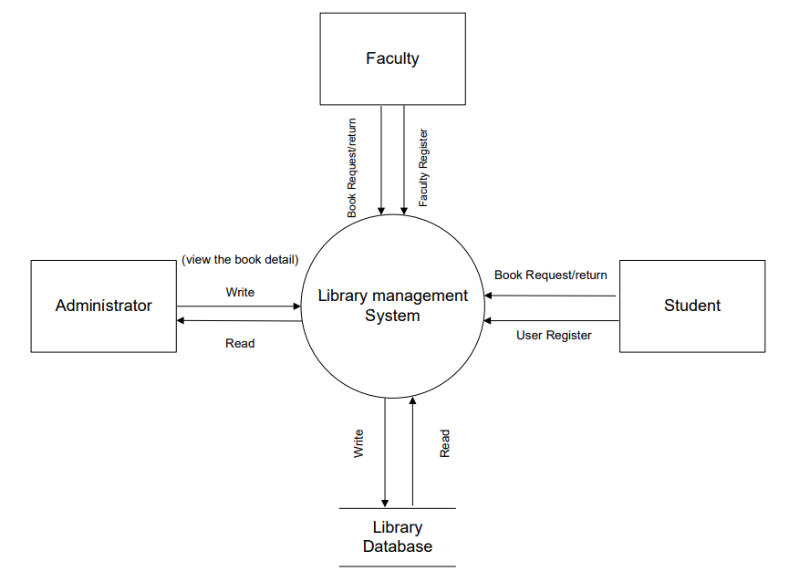

Faculty Register

Book/Resource request and return

**1-Level DFD**

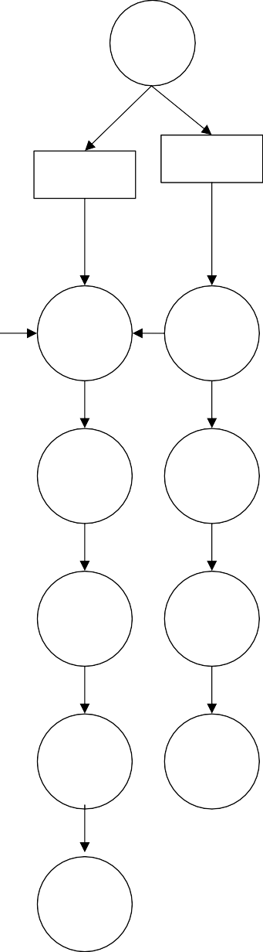

Login

Create New Account

Faculty

Student

All book/ resource details

Search Book Search Book/ r Resource

Update book info

Add book Search

info book info

Request Book

Request Book/ Resource

Library data base

Book return date

Due to Date

Due to Date

Return Book

Return Book

Fine Calculation

Logout

Administrator

Student

Faculty

User

Update resource info

**2- Level DFD**

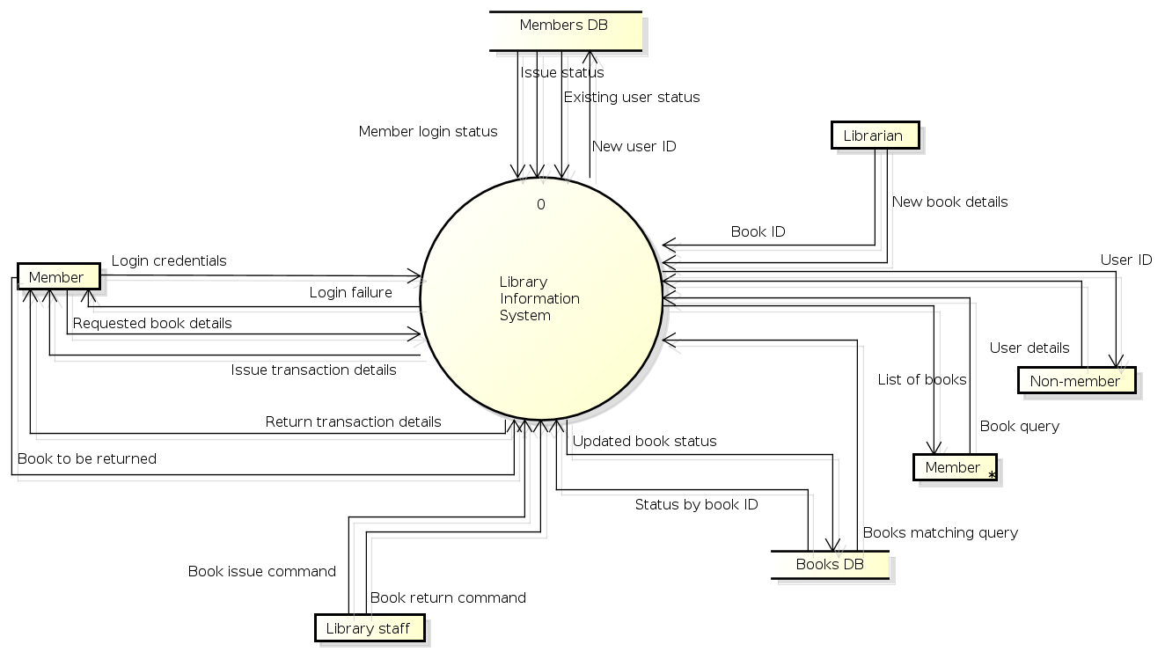

Resource info

Resource request

Resource ID

Pdf downloads for e-books

**Use Case Diagram**



**Online Library Management System**

Sign up

Login

Issue Book/ e-book

Search Book/e-book check resource

Check Status/ availability

Return Book

Administrator

Student OR Faculty

Fine Calculation

Check Book Stock

Book Availability Resource Availability

Add new Book

Profile

Logout

**Activity** **Diagram**



START

Sign up

Login

Invalid Id

Valid User

Home

Search Engine

Profile

Check availability of Book/Resource

Search Book resource

Logout

Book/Resource Not available

### 

**ER -Diagram for Online Library System**

User id

Price

Book author

Availability

Renew The Book

password

Title

Fine Collection

Manage Student or faculty Profile

Manage

B_ID

Administrator

Books

e-books

Reserve

Request

Resource

Projector

Return Date

Faculty Id

Request Book

Faculty Name

Password

Search The Book

Contact no

Book Status

Address

Faculty

A-V Room

e-book pdf

Return Date

Student Id

Request Book

Student Name

Password

Search The Book

Contact no

Book Status

Address

Student

**Sequence Diagram for Book Request/Issue**



**Sequence Diagram for Resource Request**



allotment date

update resource record

allot resource with time slot

check time slot

Search resource

Request for resource

Chapter 4

System Implementation

System implementation is the important stage of project when the theoretical design is tuned into practical system. The main stages in the implementation are as follows:

* Planning
* Training
* System testing and
* Changeover Planning is the first task in the system implementation

**4.1 Setting Environment**

**4.1.1 Laravel**

Laravel is an open-source PHP framework, which is robust and easy to understand. It follows a model-view-controller design pattern. Laravel reuses the existing components of different frameworks which helps in creating a web application. The web application thus designed is more structured and pragmatic.

**Features of Laravel**

Laravel offers the following key features which makes it an ideal choice for designing web applications −

Modularity

Laravel provides 20 built in libraries and modules which helps in enhancement of the application. Every module is integrated with Composer dependency manager which eases updates.

Testability

Laravel includes features and helpers which helps in testing through various test cases. This feature helps in maintaining the code as per the requirements.

Routing

Laravel provides a flexible approach to the user to define routes in the web application. Routing helps to scale the application in a better way and increases its performance.

Configuration Management

A web application designed in Laravel will be running on different environments, which means that there will be a constant change in its configuration. Laravel provides a consistent approach to handle the configuration in an efficient way.

Query Builder and ORM

Laravel incorporates a query builder which helps in querying databases using various simple chain methods. It provides **ORM** (Object Relational Mapper) and **Active Record** implementation called Eloquent.

Schema Builder

Schema Builder maintains the database definitions and schema in PHP code. It also maintains a track of changes with respect to database migrations.

Template Engine

Laravel uses the **Blade Template** engine, a lightweight template language used to design hierarchical blocks and layouts with predefined blocks that include dynamic content.

E-mail

Laravel includes a **mail** class which helps in sending mail with rich content and attachments from the web application.

Authentication

User authentication is a common feature in web applications. Laravel eases designing authentication as it includes features such as **register, forgot password** and **send password reminders**.

Redis

Laravel uses **Redis** to connect to an existing session and general-purpose cache. Redis interacts with session directly.

Queues

Laravel includes queue services like emailing large number of users or a specified **Cron** job. These queues help in completing tasks in an easier manner without waiting for the previous task to be completed.

**4.1.2 React Js**

ReactJS is a declarative, efficient, and flexible JavaScript library for building reusable UI components. It is an open-source, component-based front-end library responsible only for the view layer of the application.

A ReactJS application is made up of multiple components, each component responsible for outputting a small, reusable piece of HTML code. The components are the heart of all React applications. These Components can be nested with other components to allow complex applications to be built of simple building blocks. ReactJS uses virtual DOM based mechanism to fill data in HTML DOM. The virtual DOM works fast as it only changes individual DOM elements instead of reloading complete DOM every time.

**Features:**

### JSX

JSX stands for JavaScript XML. It is a JavaScript syntax extension. Its an XML or HTML like syntax used by ReactJS.

### Components

ReactJS is all about components. ReactJS application is made up of multiple components, and each component has its own logic and controls. These components can be reusable which help you to maintain the code when working on larger scale projects.

### One-way Data Binding

ReactJS is designed in such a manner that follows unidirectional data flow or one-way data binding. The benefits of one-way data binding give you better control throughout the application. If the data flow is in another direction, then it requires additional features

Virtual DOM

A virtual DOM object is a representation of the original DOM object. It works like a one-way data binding. Whenever any modifications happen in the web application, the entire UI is re-rendered in virtual DOM representation. Then it checks the difference between the previous DOM representation and new DOM. Once it has done, the real DOM will update only the things that have actually changed. This makes the application faster, and there is no wastage of memory.

Simplicity

ReactJS uses JSX file which makes the application simple and to code as well as understand. We know that ReactJS is a component-based approach which makes the code reusable as your need. This makes it simple to use and learn.

Performance

ReactJS is known to be a great performer. This feature makes it much better than other frameworks out there today. The reason behind this is that it manages a virtual DOM. The DOM is a cross-platform and programming API which deals with HTML, XML or XHTML. The DOM exists entirely in memory. Due to this, when we create a component, we did not write directly to the DOM. Instead, we are writing virtual components that will turn into the DOM leading to smoother and faster performance.

**4.1.3 XAMPP Server**

XAMPP is one of the widely used cross-platform web servers, which helps developers to create and test their programs on a local webserver. It was developed by the Apache Friends, and its native source code can be revised or modified by the audience. It consists of Apache HTTP Server, MariaDB, and interpreter for the different programming languages like PHP and Perl. It is available in 11 languages and supported by different platforms such as the IA-32 package of Windows & x64 package of macOS and Linux.

XAMPP is an abbreviation where ***X stands for Cross-Platform, A stands for Apache, M stands for MYSQL, and the Ps stand for PHP and Perl***, respectively. It is an open-source package of web solutions that includes Apache distribution for many servers and command-line executables along with modules such as Apache server, MariaDB, PHP, and Perl.

XAMPP helps a local host or server to test its website and clients via computers and laptops before releasing it to the main server. It is a platform that furnishes a suitable environment to test and verify the working of projects based on Apache, Perl, MySQL database, and PHP through the system of the host itself. Among these technologies, Perl is a programming language used for web development, PHP is a backend scripting language, and MariaDB is the most vividly used database developed by MySQL.

**4.1.4 Tailwind CSS**

Tailwind CSS is a utility first CSS framework that allows developers to design custom web components without switching to a CSS file. In this tutorial, you will learn how to install Tailwind CSS in React and how you can use it to build a simple React page.

There are already a lot of CSS frameworks that simplify how developers design web pages. So why should you use Tailwind CSS?

CSS frameworks such as Bootstrap and Foundation are opinionated frameworks, meaning they provide developers with pre-defined components that have default styles. This limits both customization and creativity, and you end up with websites that look rather generic.

Tailwind CSS, however, is a utility-first framework that gives you the creative control to create dynamic components. And unlike Bootstrap, you can easily customize designs as you please.

Another advantage of using Tailwind CSS is that you end up with a small CSS bundle size since it removes all of the unused CSS during the build process (which is different from Bootstrap, since it includes all CSS files in the build).

**Advantages:**

1. Control Over Styling

Tailwind is a unique CSS framework when it comes to styling web applications, meaning that Tailwind does not have a default theme that you have to use like other CSS frameworks.

2. Faster CSS Styling Process

There is no faster framework than Tailwind when it comes to styling HTML. As a result, you can easily create good-looking layouts by styling elements directly. This is possible because Tailwind offers thousands of built-in classes that do not require you to create designs from scratch.

3. Responsiveness and Security

With Tailwind’s pre-built classes, you can design the layout directly in an HTML file. This makes it a very responsive, mobile-friendly CSS framework. Apart from that, Tailwind has proven to be a stable framework since its initial release.

4. Additional Features

Tailwind CSS works in the front end of a website. For this reason, it is reasonable for developers to demand ultimate responsiveness.

**4.2 Implementation Details**

While implementation of project we need to make sure certain requirements:

* Make sure the system has the above softwares installed and running completely fine.
* Make sure data from the database can be accessed and fed-in without any issue.
* Make sure the system has network connection.
* Assure that admin and user are able to access all the functions.
* Assure that the pdf file can be downloaded on both PC and mobile.

**4.3 System Execution Details**

System execution is the stage where the system is ready to be deployed for the general users. This can be done by two ways; one is, you can host the system publicly or you can host it on a particular network.

In our case of the iLibrary project we have hosted this website on the Departmental Network. This will limit the access of users to the website. Only the users having Departmental Id, Faculty Members can access the website.

The Server used to host the website is the XAMPP server.

Following are the steps for deploying the system in the Departmental Server:

Step 1. Download XAMPP

Go to this website https://www.apachefriends.org/download.html and Download XAMPP PHP version 8.

Step 2. Install XAMPP to your PC.

Double click on the XAMPP installer that was downloaded and it should launch a wizard.

Step 3. Install Laravel to XAMPP.

Once the download is successful, there should be a XAMPP folder in your C drive.

Please be sure to have composer installed globally on your PC for this step. Here is a tutorial on how to install Composer "https://wecode101.com/install-composer-on-windows-10". Otherwise, if you already have a Laravel project on your PC, copy and paste the project in "C:\xampp\htdocs".

Open your command prompt terminal and cd to the "xampp/htdocs" folder. Run this command "composer create-project laravel/laravel example-app".

**iLibrary** is the name on the project so you can change that to whatever name you desire.

Step 4. Start the Xampp servers

Launch the Xampp Control Panel via the Xampp app icon.

Step 5. Create database on server.

Once Apache and MySQL as started successfully open a browser such as chrome, copy and paste the url "http://localhost/dashboard/" then click on the phpMyAdmin tab. You should see the phpMyAdmin panel, click on the database tab in order to create a new database.

Step 6. Configure .env file to connect with XAMPP database.

Go to your .env file and edit the database section as below:

DB_CONNECTION=mysql

DB_HOST=127.0.0.1 DB_PORT=3306

DB_DATABASE=thexamppdatabasename

DB_USERNAME=root

DB_PASSWORD=

Step 7. Launch project

Once all the steps are completed successfully launch the Laravel project in a browser "http://localhost/yourlaravelprojectname/public/". If you created the project from command line as in step 3 then your project name would be "iLibrary”.

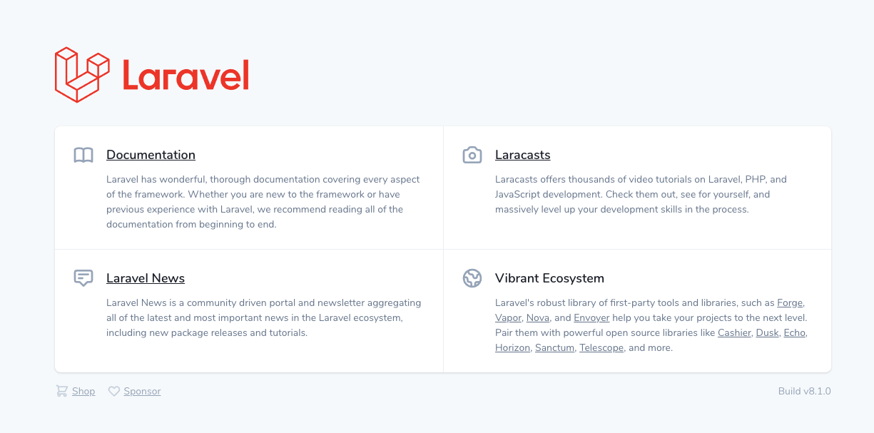

**4.4 Snapshots**

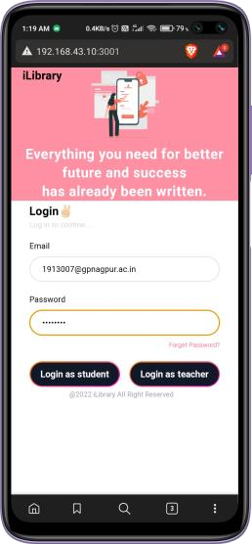**Authentication Page**

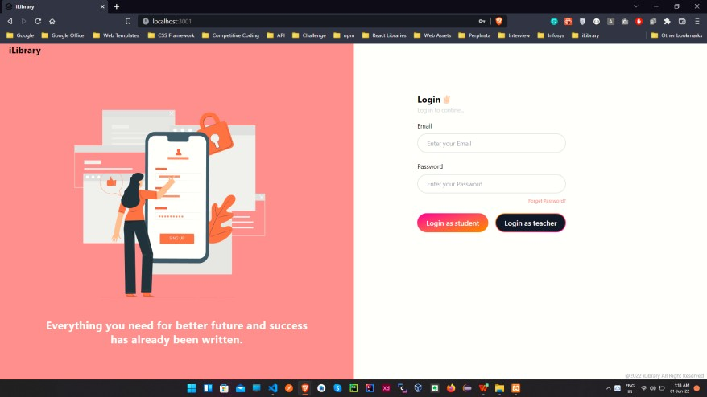

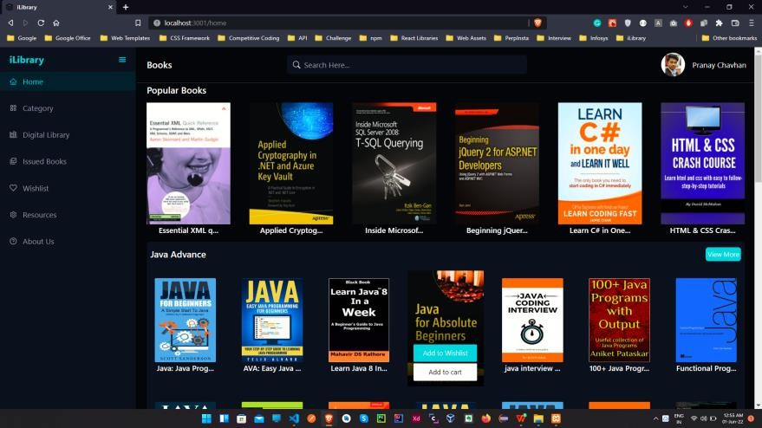**Home Page**

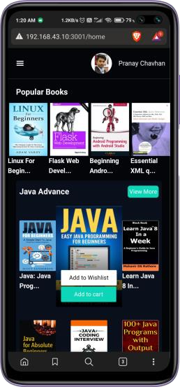

**Details Page**

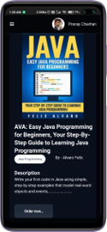

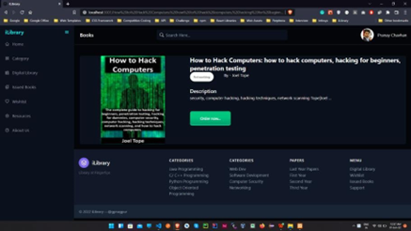

**Dashboard**

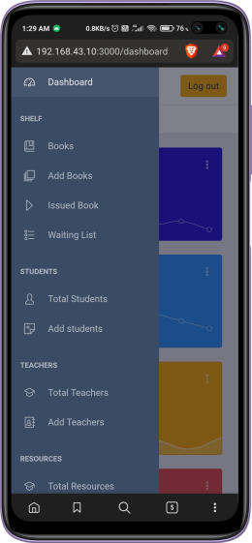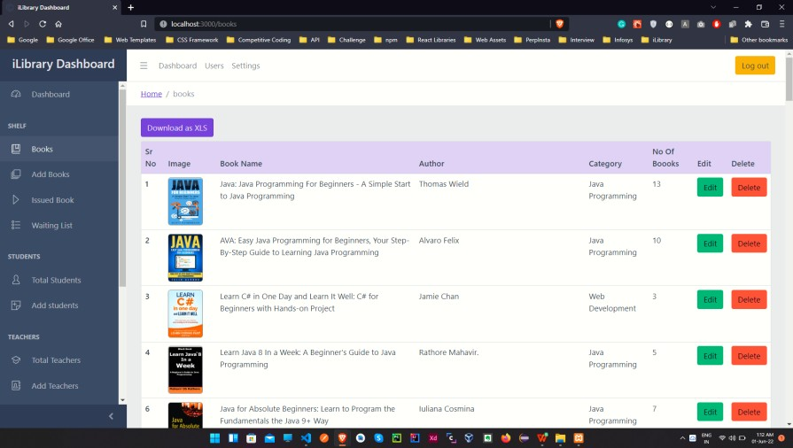

**About Dashboard Success Message**

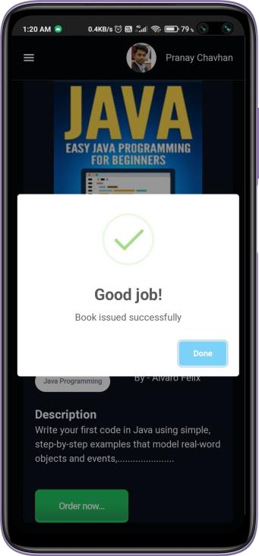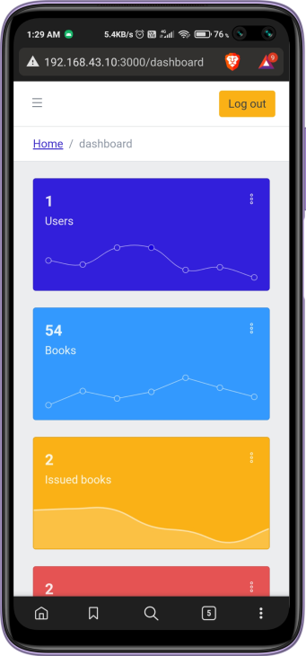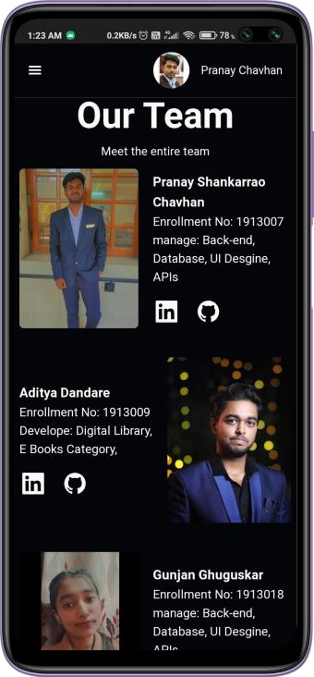

**Resources Page**

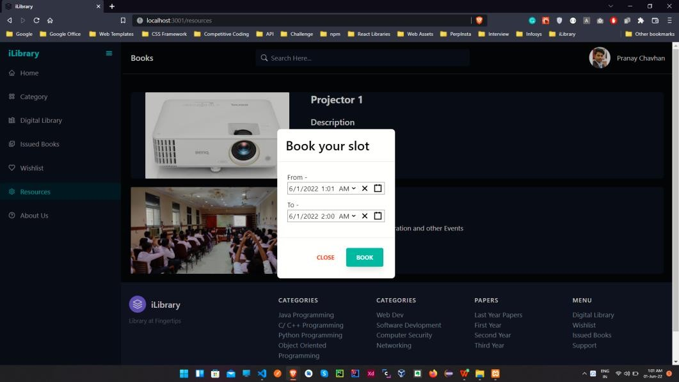

Chapter 5

Future Scope and Conclusion

**Future Scope of the Project:**

In a nutshell, it can be summarized that the future scope of the project circles around maintaining information regarding: We can add printer in future. We can also add the barcode system for the entry purposes. We can give more advance software for Library Management System including more facilities. We will host the platform on online servers to make it accessible worldwide. Integrate multiple load balancers to distribute the loads of the system. Create the master and slave database structure to reduce the overload of the database queries. Implement the backup mechanism for taking backup of codebase and database on regular basis on different servers.

The above-mentioned points are the enhancements which can be done to increase the applicability and usage of this project. Here we can maintain the records of Student and Books. Also, as it can be seen that now-a-days the players are versatile, i.e., so there is a scope for introducing a method to maintain the Library Management System. Enhancements can be done to maintain all the Student, Books, Issues, Librarian, Member.

We have left all the options open so that if there is any other future requirement in the system by the user for the enhancement of the system then it is possible to implement them. In the last we would like to thanks all the persons involved in the development of the system directly or indirectly. We hope that the project will serve its purpose for which it is develop there by underlining success of process.

**Conclusion:**

The library Management System has been computed successfully and was also tested successfully by taking “test cases”. It is user friendly, and has required options, which can be utilized by the user to perform the desired operations.

The software is developed using React coding as front end and Laravel coding as back end in Windows environment. The goals that are achieved by the software are:

• Optimum utilization of resources.

• Efficient management of records.

• Simplification of the operations.

• Less processing time and getting required information.

• User friendly.

• Portable and flexible for further enhancement.

REFERENCES

[1] Akazue Maureen and Ojeme Blessing, “*Design of Automated Library Management System for States Universities in Nigeria*” Asian Journal of Information Technology, 2011. Delta State University, Abraka, Nigeria.

[2] Shanmugam A.P, Ramalakshmi, A, Sasthri, G, Baalachandran, S, *“Library Management System*” Thiruvalluvar University, Journal of Xi’an University of Architecture and Technology, Published December 2020.

[3] Nicola Aloia, Cesare Concordia, Carlo Meghini, “*Implementing BRICKS, a Digital Library Management System*” 2007, Institute of Information Science and Technologies, Italy.

[4] Namburi Sai Naga Lakshmi Prasanna, B.N. Srinivasa Gupta, “*Online Library Management System*” Journal of Emerging Technologies and Innovative Research (JETIR) 2020, *vol 7, issue 5.*

[5] Chunchao Liu, Sheng Ma, “*Design of Library Management System*” Huanggang Normal University Open Access Library Journal 2018, vol.5: e4974, Published: Dec 25, 2018.

[6] Ayooluwa Aregbesola, Toluwani Eyiolorunshe, Jerome Idiegbeyan-ose, Sola Owolabi, Foluke Okocha, “*Adoption of Library Management System: Motivation and Challenges in Developing Countries*” 5th International Conference of Information Management 2019, Centre for Learning Resource Landmark University, Nigeria.

ANNEXURE









