THEBOX SYNC
Detailed Subscriptions Plans and Panel Interfaces Report

Plan 1: QSR Plan
Plan Price (Promo): ₹8,000 / month | Actual Price: ₹10,000 / month (Strikethrough in catalog)

Included Features & Functional Points Explained:
- Inventory Management (BILLING & CORE): Tracks raw material stock, recipe ingredients, purchase orders, and supplier bills in real-time, helping reduce food waste and optimize costs.
- Statistics Management (BILLING & CORE): Provides analytical dashboards showing top-performing dishes, sales volumes, hourly peaks, and revenue margins to support data-driven decisions.
- Third-party Integrations (BILLING & CORE): Seamlessly syncs orders from food delivery platforms (such as Swiggy and Zomato) directly into the POS system, avoiding manual double-entry.
- In-built CRM (BILLING & CORE): Saves guest order history, contact details, and dietary preferences to deliver a personalized dining experience.
- Menu Management (BILLING & CORE): Allows instant updates to categories, pricing, item availability, and modifiers across all POS registers and online menus.
- Staff Management (BILLING & CORE): Tracks employee attendance, shift schedules, check-in/out stamps, and sets granular user roles and system access permissions.
- Unlimited Users & Terminals (BILLING & CORE): Enables the software to run on multiple devices (mobiles, tablets, PCs) without charging extra licensing fees per device/user.
- Unlimited Cash Register (BILLING & CORE): Allows the creation of multiple digital tills to manage separate cashier drawers, making shift handovers and reconciliations easy.
- Multi-terminal Billing (BILLING & CORE): Supports simultaneous order entering and payment processing on different registers, minimizing queue times during rush hours.
- QSR Panel (ADD-ONS): A highly-optimized cashier screen built specifically for Quick Service Restaurants to input take-away orders, choose modifiers, and bill quickly.
- Kitchen Display System (ADD-ONS): A digital screen in the kitchen that organizes active orders chronologically, replacing paper slips and tracking preparation times.
- Token Management (ADD-ONS): A front-facing queue screen that notifies customer-pickup numbers ('Preparing' or 'Ready') to streamline order retrieval.
- Scan & QR Order (ADD-ONS): Allows customers to scan a dining-table QR code, view the menu, and place orders directly from their personal smartphones.
- QR-based Feedback (ADD-ONS): Appends feedback QR codes on bills so customers can rate their dining experience online, feeding data into the CRM.
- Dynamic Reports (ADD-ONS): Generates custom reports detailing payment method distributions, discount audits, and taxation compliance summaries.
- WhatsApp Invoice (ADD-ONS): Saves paper by sending official, digital invoices directly to the customer's WhatsApp number immediately upon settlement.
- Customer Profiles (LOYALTY & CRM ENGINE): Builds rich customer portfolios including transaction histories, milestone dates, and lifetime values.
- Points Earn/Redeem at POS (LOYALTY & CRM ENGINE): An automated reward points engine that accumulates loyalty credits at checkout and allows easy redemption on future visits.
- 24/7 Support (SUPPORT): Access to round-the-clock technical support for server issues, billing discrepancies, or hardware troubleshooting.
- Free Training (SUPPORT): Initial comprehensive onboarding classes to train managers and system administrators.
- Free Staff Re-training (SUPPORT): Regular refresher training sessions for new restaurant workers at no additional charge.

Excluded Features (Upgrade Required):
- Manager Panel: Not included. Requires subscription upgrade.
- Create Cashier: Not included. Requires subscription upgrade.
- Captain Panel: Not included. Requires subscription upgrade.
- Reservation Management: Not included. Requires subscription upgrade.
- Table Management: Not included. Requires subscription upgrade.
- Waiter Calling System: Not included. Requires subscription upgrade.
- Restaurant Website: Not included. Requires subscription upgrade.
- Automated Retention Campaigns: Not included. Requires subscription upgrade.
- Gamified Loyalty — Food Quests: Not included. Requires subscription upgrade.
- TheBoxSync Payroll: Not included. Requires subscription upgrade.
- Dedicated Account Manager: Not included. Requires subscription upgrade.

Panel Interfaces Deployed & Verified under the QSR Plan:
Interface 1.1: QSR Panel
A fast checkout console customized for Quick Service Restaurants (QSR). It optimizes table-less ordering, direct payment collection, counter orders, and prompt delivery handovers.
Deployment URL: https://manager.theboxsync.com/dashboard/qsr
Verified Login Credentials:
- Restaurant Code: GJ0005IN
- Username: sardarji_londonwaley_manager
- Password: Rushi@123
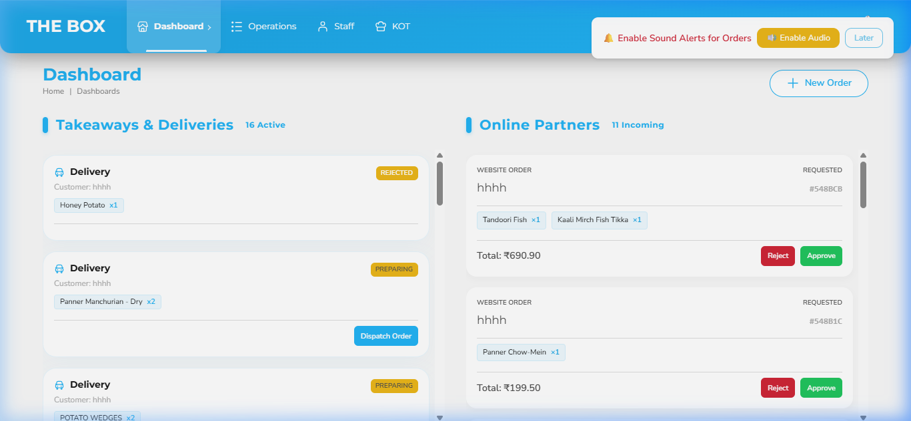
Figure 1.1: QSR Panel Active Interface Screenshot
Interface 1.2: KOT Panel
Kitchen Order Ticket display panel placed in the kitchen. Chefs and line cooks use this real-time dashboard to view incoming orders from the QSR or Captain terminals, update cooking states, and signal when food is prepared.
Deployment URL: https://kot.theboxsync.com/dashboard
Verified Login Credentials:
- Restaurant Code: GJ0005IN
- Username: sardarji_londonwaley_kot
- Password: Rushi@123
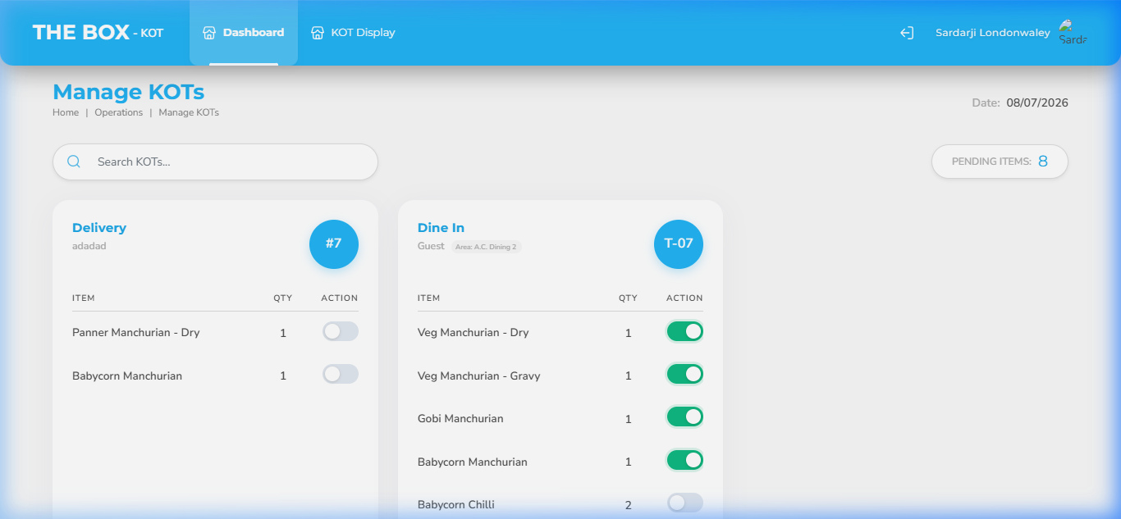
Figure 1.2: KOT Panel Active Interface Screenshot
Interface 1.3: Token Management
A customer-facing screen showing the preparation status of active tokens. Customers can look at this screen in the waiting lobby to see if their token is 'Preparing' or 'Ready for Pickup'.
Deployment URL: https://kot.theboxsync.com/kot-display
Verified Login Credentials:
- Restaurant Code: GJ0005IN
- Username: sardarji_londonwaley_kot
- Password: Rushi@123
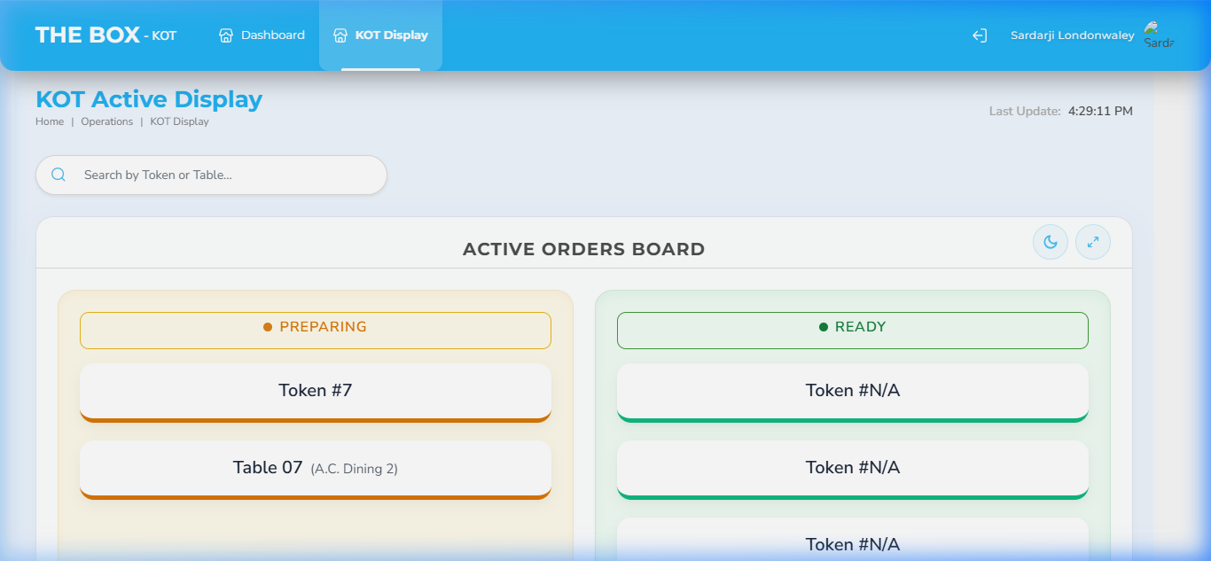
Figure 1.3: Token Management Active Interface Screenshot

Plan 2: CAFÉ Plan
Plan Price (Promo): ₹10,000 / month | Actual Price: ₹12,500 / month (Strikethrough in catalog)

Included Features & Functional Points Explained:
- Inventory Management (BILLING & CORE): Tracks raw material stock, recipe ingredients, purchase orders, and supplier bills in real-time, helping reduce food waste and optimize costs.
- Statistics Management (BILLING & CORE): Provides analytical dashboards showing top-performing dishes, sales volumes, hourly peaks, and revenue margins to support data-driven decisions.
- Third-party Integrations (BILLING & CORE): Seamlessly syncs orders from food delivery platforms (such as Swiggy and Zomato) directly into the POS system, avoiding manual double-entry.
- In-built CRM (BILLING & CORE): Saves guest order history, contact details, and dietary preferences to deliver a personalized dining experience.
- Menu Management (BILLING & CORE): Allows instant updates to categories, pricing, item availability, and modifiers across all POS registers and online menus.
- Staff Management (BILLING & CORE): Tracks employee attendance, shift schedules, check-in/out stamps, and sets granular user roles and system access permissions.
- Unlimited Users & Terminals (BILLING & CORE): Enables the software to run on multiple devices (mobiles, tablets, PCs) without charging extra licensing fees per device/user.
- Unlimited Cash Register (BILLING & CORE): Allows the creation of multiple digital tills to manage separate cashier drawers, making shift handovers and reconciliations easy.
- Multi-terminal Billing (BILLING & CORE): Supports simultaneous order entering and payment processing on different registers, minimizing queue times during rush hours.
- QSR Panel (ADD-ONS): A highly-optimized cashier screen built specifically for Quick Service Restaurants to input take-away orders, choose modifiers, and bill quickly.
- Kitchen Display System (ADD-ONS): A digital screen in the kitchen that organizes active orders chronologically, replacing paper slips and tracking preparation times.
- Token Management (ADD-ONS): A front-facing queue screen that notifies customer-pickup numbers ('Preparing' or 'Ready') to streamline order retrieval.
- Scan & QR Order (ADD-ONS): Allows customers to scan a dining-table QR code, view the menu, and place orders directly from their personal smartphones.
- QR-based Feedback (ADD-ONS): Appends feedback QR codes on bills so customers can rate their dining experience online, feeding data into the CRM.
- Dynamic Reports (ADD-ONS): Generates custom reports detailing payment method distributions, discount audits, and taxation compliance summaries.
- WhatsApp Invoice (ADD-ONS): Saves paper by sending official, digital invoices directly to the customer's WhatsApp number immediately upon settlement.
- Restaurant Website (ADD-ONS): An SEO-friendly promotional website containing the restaurant's location, story, digital menu, and direct online ordering links.
- Customer Profiles (LOYALTY & CRM ENGINE): Builds rich customer portfolios including transaction histories, milestone dates, and lifetime values.
- Points Earn/Redeem at POS (LOYALTY & CRM ENGINE): An automated reward points engine that accumulates loyalty credits at checkout and allows easy redemption on future visits.
- Automated Retention Campaigns (LOYALTY & CRM ENGINE): Trigger-based SMS or email notifications sent to inactive customers to invite them back with custom discount vouchers.
- 24/7 Support (SUPPORT): Access to round-the-clock technical support for server issues, billing discrepancies, or hardware troubleshooting.
- Free Training (SUPPORT): Initial comprehensive onboarding classes to train managers and system administrators.
- Free Staff Re-training (SUPPORT): Regular refresher training sessions for new restaurant workers at no additional charge.

Excluded Features (Upgrade Required):
- Manager Panel: Not included. Requires subscription upgrade.
- Create Cashier: Not included. Requires subscription upgrade.
- Captain Panel: Not included. Requires subscription upgrade.
- Reservation Management: Not included. Requires subscription upgrade.
- Table Management: Not included. Requires subscription upgrade.
- Waiter Calling System: Not included. Requires subscription upgrade.
- Gamified Loyalty — Food Quests: Not included. Requires subscription upgrade.
- TheBoxSync Payroll: Not included. Requires subscription upgrade.
- Dedicated Account Manager: Not included. Requires subscription upgrade.

Panel Interfaces Deployed & Verified under the CAFÉ Plan:
Interface 2.1: QSR Panel
A fast checkout console customized for Quick Service Restaurants (QSR). It optimizes table-less ordering, direct payment collection, counter orders, and prompt delivery handovers.
Deployment URL: https://manager.theboxsync.com/dashboard/qsr
Verified Login Credentials:
- Restaurant Code: GJ0005IN
- Username: sardarji_londonwaley_manager
- Password: Rushi@123

Figure 2.1: QSR Panel Active Interface Screenshot
Interface 2.2: KOT Panel
Kitchen Order Ticket display panel placed in the kitchen. Chefs and line cooks use this real-time dashboard to view incoming orders from the QSR or Captain terminals, update cooking states, and signal when food is prepared.
Deployment URL: https://kot.theboxsync.com/dashboard
Verified Login Credentials:
- Restaurant Code: GJ0005IN
- Username: sardarji_londonwaley_kot
- Password: Rushi@123

Figure 2.2: KOT Panel Active Interface Screenshot
Interface 2.3: Token Management
A customer-facing screen showing the preparation status of active tokens. Customers can look at this screen in the waiting lobby to see if their token is 'Preparing' or 'Ready for Pickup'.
Deployment URL: https://kot.theboxsync.com/kot-display
Verified Login Credentials:
- Restaurant Code: GJ0005IN
- Username: sardarji_londonwaley_kot
- Password: Rushi@123

Figure 2.3: Token Management Active Interface Screenshot

Plan 3: FINE DINE Plan
Plan Price (Promo): ₹16,000 / month | Actual Price: ₹20,000 / month (Strikethrough in catalog)

Included Features & Functional Points Explained:
- Inventory Management (BILLING & CORE): Tracks raw material stock, recipe ingredients, purchase orders, and supplier bills in real-time, helping reduce food waste and optimize costs.
- Statistics Management (BILLING & CORE): Provides analytical dashboards showing top-performing dishes, sales volumes, hourly peaks, and revenue margins to support data-driven decisions.
- Third-party Integrations (BILLING & CORE): Seamlessly syncs orders from food delivery platforms (such as Swiggy and Zomato) directly into the POS system, avoiding manual double-entry.
- In-built CRM (BILLING & CORE): Saves guest order history, contact details, and dietary preferences to deliver a personalized dining experience.
- Menu Management (BILLING & CORE): Allows instant updates to categories, pricing, item availability, and modifiers across all POS registers and online menus.
- Staff Management (BILLING & CORE): Tracks employee attendance, shift schedules, check-in/out stamps, and sets granular user roles and system access permissions.
- Unlimited Users & Terminals (BILLING & CORE): Enables the software to run on multiple devices (mobiles, tablets, PCs) without charging extra licensing fees per device/user.
- Unlimited Cash Register (BILLING & CORE): Allows the creation of multiple digital tills to manage separate cashier drawers, making shift handovers and reconciliations easy.
- Multi-terminal Billing (BILLING & CORE): Supports simultaneous order entering and payment processing on different registers, minimizing queue times during rush hours.
- Manager Panel (ADD-ONS): A back-office control panel that managers use to view real-time sales, adjust system settings, manage configurations, and edit staff rosters.
- Create Cashier (ADD-ONS): Gives the ability to onboard cashiers, trace active till sessions, and audit open/closed register balances.
- Captain Panel (ADD-ONS): A tableside ordering interface designed for waiters to enter customer selections, customize order notes, and send KOTs instantly to the kitchen.
- Kitchen Display System (ADD-ONS): A digital screen in the kitchen that organizes active orders chronologically, replacing paper slips and tracking preparation times.
- Reservation Management (ADD-ONS): An advanced tool to book guest tables, schedule dining slots, and manage waiting lists during busy periods.
- Table Management (ADD-ONS): A live interactive map of the dining floor showing table status (occupied, vacant, billed, cleaning) to optimize guest seating.
- Scan & QR Order (ADD-ONS): Allows customers to scan a dining-table QR code, view the menu, and place orders directly from their personal smartphones.
- QR-based Feedback (ADD-ONS): Appends feedback QR codes on bills so customers can rate their dining experience online, feeding data into the CRM.
- Waiter Calling System (ADD-ONS): A digital tableside alert system allowing customers to call a server or request their bill with a single button press.
- Dynamic Reports (ADD-ONS): Generates custom reports detailing payment method distributions, discount audits, and taxation compliance summaries.
- WhatsApp Invoice (ADD-ONS): Saves paper by sending official, digital invoices directly to the customer's WhatsApp number immediately upon settlement.
- Restaurant Website (ADD-ONS): An SEO-friendly promotional website containing the restaurant's location, story, digital menu, and direct online ordering links.
- Customer Profiles (LOYALTY & CRM ENGINE): Builds rich customer portfolios including transaction histories, milestone dates, and lifetime values.
- Points Earn/Redeem at POS (LOYALTY & CRM ENGINE): An automated reward points engine that accumulates loyalty credits at checkout and allows easy redemption on future visits.
- Automated Retention Campaigns (LOYALTY & CRM ENGINE): Trigger-based SMS or email notifications sent to inactive customers to invite them back with custom discount vouchers.
- Gamified Loyalty — Food Quests (LOYALTY & CRM ENGINE): Creates fun challenges (e.g. 'try 5 different dishes to unlock a discount') to boost repeat visits and customer engagement.
- 24/7 Support (SUPPORT): Access to round-the-clock technical support for server issues, billing discrepancies, or hardware troubleshooting.
- Free Training (SUPPORT): Initial comprehensive onboarding classes to train managers and system administrators.
- Free Staff Re-training (SUPPORT): Regular refresher training sessions for new restaurant workers at no additional charge.

Excluded Features (Upgrade Required):
- QSR Panel: Not included. Requires subscription upgrade.
- Token Management: Not included. Requires subscription upgrade.
- TheBoxSync Payroll: Not included. Requires subscription upgrade.
- Dedicated Account Manager: Not included. Requires subscription upgrade.

Panel Interfaces Deployed & Verified under the FINE DINE Plan:

Plan 4: CLOUD Plan
Plan Price (Promo): ₹10,000 / month | Actual Price: ₹12,500 / month (Strikethrough in catalog)

Included Features & Functional Points Explained:
- Inventory Management (BILLING & CORE): Tracks raw material stock, recipe ingredients, purchase orders, and supplier bills in real-time, helping reduce food waste and optimize costs.
- Statistics Management (BILLING & CORE): Provides analytical dashboards showing top-performing dishes, sales volumes, hourly peaks, and revenue margins to support data-driven decisions.
- Third-party Integrations (BILLING & CORE): Seamlessly syncs orders from food delivery platforms (such as Swiggy and Zomato) directly into the POS system, avoiding manual double-entry.
- In-built CRM (BILLING & CORE): Saves guest order history, contact details, and dietary preferences to deliver a personalized dining experience.
- Menu Management (BILLING & CORE): Allows instant updates to categories, pricing, item availability, and modifiers across all POS registers and online menus.
- Staff Management (BILLING & CORE): Tracks employee attendance, shift schedules, check-in/out stamps, and sets granular user roles and system access permissions.
- Unlimited Users & Terminals (BILLING & CORE): Enables the software to run on multiple devices (mobiles, tablets, PCs) without charging extra licensing fees per device/user.
- Unlimited Cash Register (BILLING & CORE): Allows the creation of multiple digital tills to manage separate cashier drawers, making shift handovers and reconciliations easy.
- Multi-terminal Billing (BILLING & CORE): Supports simultaneous order entering and payment processing on different registers, minimizing queue times during rush hours.
- Kitchen Display System (ADD-ONS): A digital screen in the kitchen that organizes active orders chronologically, replacing paper slips and tracking preparation times.
- QR-based Feedback (ADD-ONS): Appends feedback QR codes on bills so customers can rate their dining experience online, feeding data into the CRM.
- Dynamic Reports (ADD-ONS): Generates custom reports detailing payment method distributions, discount audits, and taxation compliance summaries.
- WhatsApp Invoice (ADD-ONS): Saves paper by sending official, digital invoices directly to the customer's WhatsApp number immediately upon settlement.
- Customer Profiles (LOYALTY & CRM ENGINE): Builds rich customer portfolios including transaction histories, milestone dates, and lifetime values.
- Points Earn/Redeem at POS (LOYALTY & CRM ENGINE): An automated reward points engine that accumulates loyalty credits at checkout and allows easy redemption on future visits.
- Automated Retention Campaigns (LOYALTY & CRM ENGINE): Trigger-based SMS or email notifications sent to inactive customers to invite them back with custom discount vouchers.
- 24/7 Support (SUPPORT): Access to round-the-clock technical support for server issues, billing discrepancies, or hardware troubleshooting.
- Free Training (SUPPORT): Initial comprehensive onboarding classes to train managers and system administrators.
- Free Staff Re-training (SUPPORT): Regular refresher training sessions for new restaurant workers at no additional charge.

Excluded Features (Upgrade Required):
- QSR Panel: Not included. Requires subscription upgrade.
- Manager Panel: Not included. Requires subscription upgrade.
- Create Cashier: Not included. Requires subscription upgrade.
- Captain Panel: Not included. Requires subscription upgrade.
- Reservation Management: Not included. Requires subscription upgrade.
- Table Management: Not included. Requires subscription upgrade.
- Token Management: Not included. Requires subscription upgrade.
- Scan & QR Order: Not included. Requires subscription upgrade.
- Waiter Calling System: Not included. Requires subscription upgrade.
- Restaurant Website: Not included. Requires subscription upgrade.
- Gamified Loyalty — Food Quests: Not included. Requires subscription upgrade.
- TheBoxSync Payroll: Not included. Requires subscription upgrade.
- Dedicated Account Manager: Not included. Requires subscription upgrade.

Panel Interfaces Deployed & Verified under the CLOUD Plan:
Interface 4.1: KOT Panel
Kitchen Order Ticket display panel placed in the kitchen. Chefs and line cooks use this real-time dashboard to view incoming orders from the QSR or Captain terminals, update cooking states, and signal when food is prepared.
Deployment URL: https://kot.theboxsync.com/dashboard
Verified Login Credentials:
- Restaurant Code: GJ0005IN
- Username: sardarji_londonwaley_kot
- Password: Rushi@123

Figure 4.1: KOT Panel Active Interface Screenshot

Plan 5: CHAIN Plan
Plan Price (Promo): ₹24,000 / month | Actual Price: ₹30,000 / month (Strikethrough in catalog)

Included Features & Functional Points Explained:
- Inventory Management (BILLING & CORE): Tracks raw material stock, recipe ingredients, purchase orders, and supplier bills in real-time, helping reduce food waste and optimize costs.
- Statistics Management (BILLING & CORE): Provides analytical dashboards showing top-performing dishes, sales volumes, hourly peaks, and revenue margins to support data-driven decisions.
- Third-party Integrations (BILLING & CORE): Seamlessly syncs orders from food delivery platforms (such as Swiggy and Zomato) directly into the POS system, avoiding manual double-entry.
- In-built CRM (BILLING & CORE): Saves guest order history, contact details, and dietary preferences to deliver a personalized dining experience.
- Menu Management (BILLING & CORE): Allows instant updates to categories, pricing, item availability, and modifiers across all POS registers and online menus.
- Staff Management (BILLING & CORE): Tracks employee attendance, shift schedules, check-in/out stamps, and sets granular user roles and system access permissions.
- Unlimited Users & Terminals (BILLING & CORE): Enables the software to run on multiple devices (mobiles, tablets, PCs) without charging extra licensing fees per device/user.
- Unlimited Cash Register (BILLING & CORE): Allows the creation of multiple digital tills to manage separate cashier drawers, making shift handovers and reconciliations easy.
- Multi-terminal Billing (BILLING & CORE): Supports simultaneous order entering and payment processing on different registers, minimizing queue times during rush hours.
- QSR Panel (ADD-ONS): A highly-optimized cashier screen built specifically for Quick Service Restaurants to input take-away orders, choose modifiers, and bill quickly.
- Manager Panel (ADD-ONS): A back-office control panel that managers use to view real-time sales, adjust system settings, manage configurations, and edit staff rosters.
- Create Cashier (ADD-ONS): Gives the ability to onboard cashiers, trace active till sessions, and audit open/closed register balances.
- Captain Panel (ADD-ONS): A tableside ordering interface designed for waiters to enter customer selections, customize order notes, and send KOTs instantly to the kitchen.
- Kitchen Display System (ADD-ONS): A digital screen in the kitchen that organizes active orders chronologically, replacing paper slips and tracking preparation times.
- Reservation Management (ADD-ONS): An advanced tool to book guest tables, schedule dining slots, and manage waiting lists during busy periods.
- Table Management (ADD-ONS): A live interactive map of the dining floor showing table status (occupied, vacant, billed, cleaning) to optimize guest seating.
- Token Management (ADD-ONS): A front-facing queue screen that notifies customer-pickup numbers ('Preparing' or 'Ready') to streamline order retrieval.
- Scan & QR Order (ADD-ONS): Allows customers to scan a dining-table QR code, view the menu, and place orders directly from their personal smartphones.
- QR-based Feedback (ADD-ONS): Appends feedback QR codes on bills so customers can rate their dining experience online, feeding data into the CRM.
- Waiter Calling System (ADD-ONS): A digital tableside alert system allowing customers to call a server or request their bill with a single button press.
- Dynamic Reports (ADD-ONS): Generates custom reports detailing payment method distributions, discount audits, and taxation compliance summaries.
- WhatsApp Invoice (ADD-ONS): Saves paper by sending official, digital invoices directly to the customer's WhatsApp number immediately upon settlement.
- Restaurant Website (ADD-ONS): An SEO-friendly promotional website containing the restaurant's location, story, digital menu, and direct online ordering links.
- Customer Profiles (LOYALTY & CRM ENGINE): Builds rich customer portfolios including transaction histories, milestone dates, and lifetime values.
- Points Earn/Redeem at POS (LOYALTY & CRM ENGINE): An automated reward points engine that accumulates loyalty credits at checkout and allows easy redemption on future visits.
- Automated Retention Campaigns (LOYALTY & CRM ENGINE): Trigger-based SMS or email notifications sent to inactive customers to invite them back with custom discount vouchers.
- Gamified Loyalty — Food Quests (LOYALTY & CRM ENGINE): Creates fun challenges (e.g. 'try 5 different dishes to unlock a discount') to boost repeat visits and customer engagement.
- TheBoxSync Payroll (ADVANCED): An advanced payroll manager that automatically calculates basic wages, overtime, attendance deductions, and prepares salary slips.
- 24/7 Support (SUPPORT): Access to round-the-clock technical support for server issues, billing discrepancies, or hardware troubleshooting.
- Free Training (SUPPORT): Initial comprehensive onboarding classes to train managers and system administrators.
- Free Staff Re-training (SUPPORT): Regular refresher training sessions for new restaurant workers at no additional charge.
- Dedicated Account Manager (SUPPORT): A single point-of-contact from TheBox Sync team who reviews performance, optimizes configurations, and priority handles requests.

Excluded Features (Upgrade Required):
None. This plan includes all available features of the platform.

Panel Interfaces Deployed & Verified under the CHAIN Plan:
Interface 5.1: Admin Panel
The Master Administrator portal of the platform. Used by platform owners to manage all onboarded restaurants, verify subscription states, review financial stats, configure Global Settings, and supervise other restaurant modules.
Deployment URL: https://admin.theboxsync.com
Verified Login Credentials:
- Username: rushimaru96@gmail.com
- Password: Rushi@123
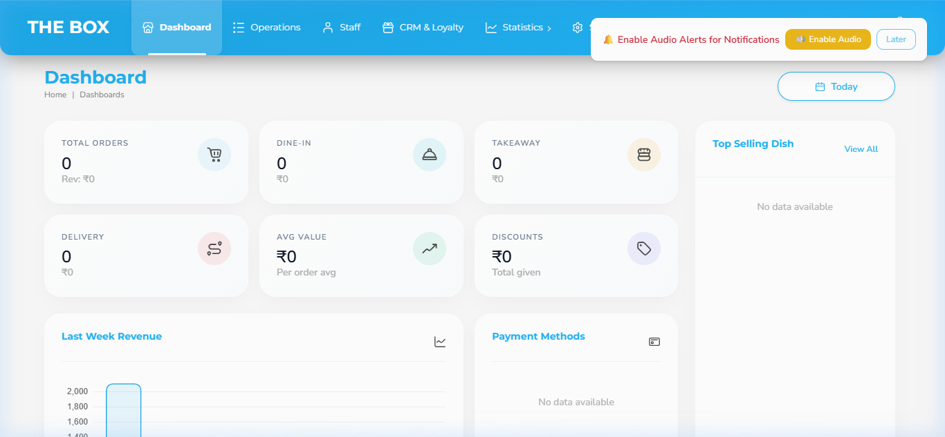
Figure 5.1: Admin Panel Active Interface Screenshot
Interface 5.2: Manager Panel
The dedicated administrative console for individual restaurant outlets. In this workspace, the manager supervises tables, schedules staff, configures item ingredients/menus, handles general inventory tracking, and analyzes daily sales reporting.
Deployment URL: https://manager.theboxsync.com/dashboard/manager
Verified Login Credentials:
- Restaurant Code: GJ0005IN
- Username: sardarji_londonwaley_manager
- Password: Rushi@123
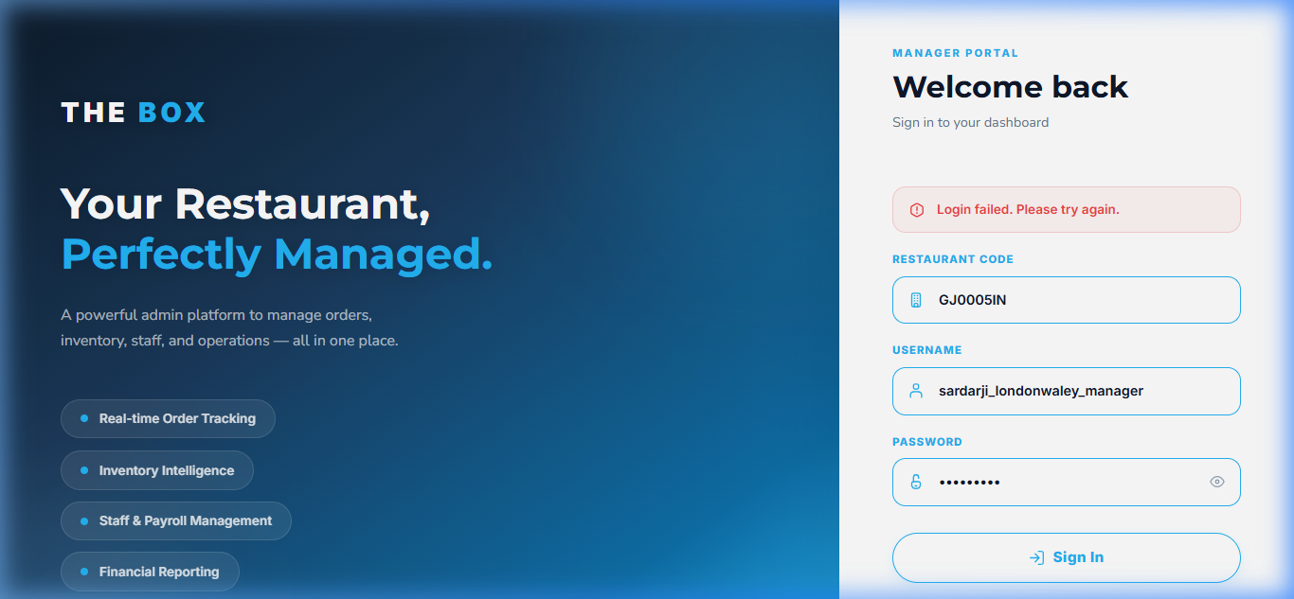
Figure 5.2: Manager Panel Active Interface Screenshot
Interface 5.3: QSR Panel
A fast checkout console customized for Quick Service Restaurants (QSR). It optimizes table-less ordering, direct payment collection, counter orders, and prompt delivery handovers.
Deployment URL: https://manager.theboxsync.com/dashboard/qsr
Verified Login Credentials:
- Restaurant Code: GJ0005IN
- Username: sardarji_londonwaley_manager
- Password: Rushi@123

Figure 5.3: QSR Panel Active Interface Screenshot
Interface 5.4: Captain Panel
Designed specifically for waiters and table captains in Fine Dine restaurants. Allows taking orders directly at customer tables, linking orders to specific table IDs, modifying order notes, and instantly printing KOTs remotely to the kitchen.
Deployment URL: https://captain.theboxsync.com/dashboard
Verified Login Credentials:
- Restaurant Code: GJ0005IN
- Username: sardarji_londonwaley_captain
- Password: Rushi@123
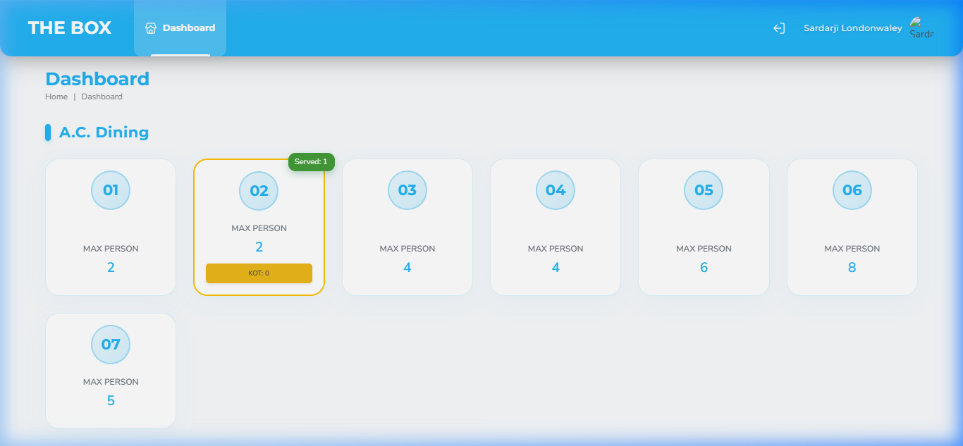
Figure 5.4: Captain Panel Active Interface Screenshot
Interface 5.5: Cashier Panel
The central cashier point of the restaurant. Designed for managing customer billing, issuing physical receipts, processing electronic/cash payments, and auditing the register till balances.
Deployment URL: https://cashier.theboxsync.com/dashboard/manager
Verified Login Credentials:
- Restaurant Code: GJ0005IN
- Username: sardarji_londonwaley_cashier
- Password: Rushi@123
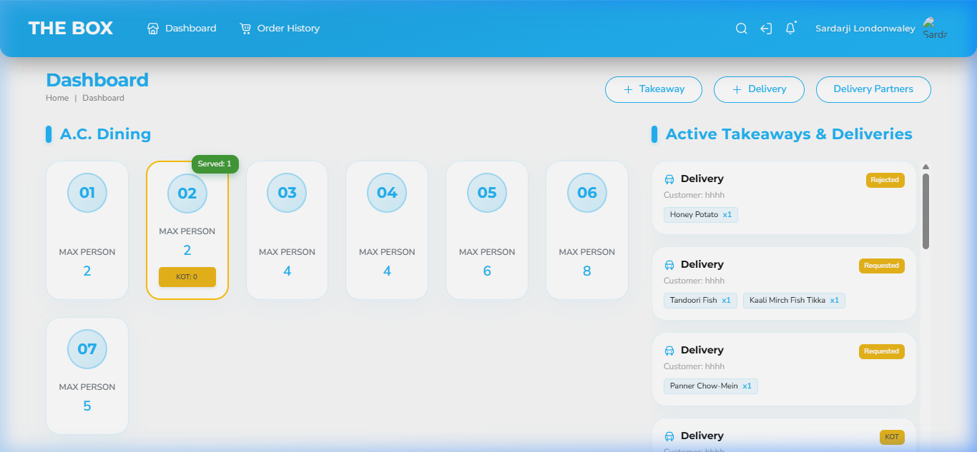
Figure 5.5: Cashier Panel Active Interface Screenshot
Interface 5.6: KOT Panel
Kitchen Order Ticket display panel placed in the kitchen. Chefs and line cooks use this real-time dashboard to view incoming orders from the QSR or Captain terminals, update cooking states, and signal when food is prepared.
Deployment URL: https://kot.theboxsync.com/dashboard
Verified Login Credentials:
- Restaurant Code: GJ0005IN
- Username: sardarji_londonwaley_kot
- Password: Rushi@123

Figure 5.6: KOT Panel Active Interface Screenshot
Interface 5.7: Token Management
A customer-facing screen showing the preparation status of active tokens. Customers can look at this screen in the waiting lobby to see if their token is 'Preparing' or 'Ready for Pickup'.
Deployment URL: https://kot.theboxsync.com/kot-display
Verified Login Credentials:
- Restaurant Code: GJ0005IN
- Username: sardarji_londonwaley_kot
- Password: Rushi@123

Figure 5.7: Token Management Active Interface Screenshot

