RM-201 CO2 Ventilation Control
Control Sequence and Modeling Notes
Document CDS-IAQ-02 / MOD-NT-03 - Rev B
Issued 2026-03-01

1. Purpose and model boundary
This note defines the functional control interpretation for the single-zone room CO2 demonstration. The room is represented as one perfectly mixed 100 m3 air volume. Outdoor air enters through a controlled mass-flow source and supply duct. Room air leaves through an exhaust duct to an ideal pressure boundary. Occupants are represented as a separate trace-substance mass source.
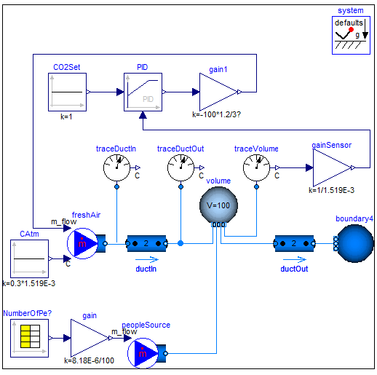
Figure 1 - Legacy graphical simulation model used as topology evidence.

2. Concentration conventions
- The owner compliance limit is 1000 ppm absolute room CO2. Under the project molecular-weight convention this is represented by the rounded trace-substance mass fraction C_nominal = 1.519E-3 kg/kg.
- Outdoor air is 300 ppm and is implemented as C_out = 0.3*C_nominal = 4.557E-4 kg/kg.
- The room sensor output is a trace-substance mass fraction in kg/kg. gainSensor multiplies it by 1/C_nominal so that 1000 ppm becomes the normalized value 1.0.
- CO2Set therefore has value 1.0. This is a normalized controller signal, not 1 ppm and not 1 kg/kg.

3. Occupant source implementation
At the design activity level, one person emits approximately 8.18E-6 kg/s of CO2. Directly adding this as a carrier-fluid source would also add carrier mass to the room energy and mass balances. The simulation therefore uses an intentionally high trace concentration at the people source and a proportionally reduced carrier flow:
m_peopleSource = (8.18E-6 / 100) * nPeo kg/s
with peopleSource.C = 100 kg/kg. The trace-substance injection is m_peopleSource * C = nPeo * 8.18E-6 kg/s. The 100 kg/kg value is a numerical device only and must not be interpreted as a physical room concentration.

4. Ventilation control path
- Measure room CO2 mass fraction at traceVolume.
- Normalize the measurement using gainSensor = 1/1.519E-3.
- Compare normalized feedback with CO2Set = 1.0.
- Generate an ACH command. Effective reference-run tuning after CR-IAQ-007 is Kp=6.0, bias=3.5 ACH, integral disabled, output limited to 0.2..6.0 ACH.
- Convert ACH to mass-flow magnitude using V*rho/3600 = 100*1.2/3600 = 0.033333 kg/s per ACH.
- Apply a negative sign to the Modelica source command because negative source m_flow denotes flow from the source into the connected duct. Report physical outdoor-air flow as a positive quantity.

5. State / mode interpretation
Mode | Entry condition | Control output | Exit condition | Notes
AUTO_MIN | CO2 sufficiently below setpoint | 0.2 ACH lower limit | P-law requests >0.2 ACH | Common while unoccupied.
AUTO_CO2 | 0.2 < requested ACH < 6.0 | Bias + Kp*(C/Cnom-1) | Saturation or operating condition changes | Baseline occupied regulation.
AUTO_MAX | Requested ACH >= 6.0 | 6.0 ACH | Requested value falls below maximum | Not expected in baseline run.
SENSOR_FAULT | Sensor invalid >60 s | 4.0 ACH | Valid signal restored and reset logic satisfied | Raise fault indication. Not exercised in baseline run.

6. Known evidence conflicts and precedence
CO2 limit wording: 10-Feb email suggests 1000 ppm above outdoor; DR-IAQ-05 rejects this. Use 1000 ppm absolute.
Outdoor CO2: Archived model uses 350 ppm; URS and approved review use 300 ppm.
Peak occupancy: Archived model peaks at 12 people; OCC-SCH-04 Rev C peaks at 15.
Controller tuning: CDS Rev A / archived model use Kp=4; CR-IAQ-007 uses Kp=6 and 3.5 ACH bias with integral disabled.
Sensor units: Legacy architecture drawing labels sensor output as ppm; ICD-IAQ-03 defines the internal feedback signal in kg/kg before normalization.

7. Modeling constraints suitable for system-model capture
- C_room <= 1.519E-3 kg/kg during the approved design occupancy schedule.
- C_out = 0.3*C_nominal.
- G_CO2 = nPeo*8.18E-6 kg/s.
- m_peopleCarrier = G_CO2/100.
- m_supply_physical = ACH*V*rho/3600.
- m_supply_sourceCommand = -m_supply_physical.
- 0.2 <= ACH <= 6.0.
- normalized_CO2 = C_room/C_nominal.

8. Revision note
This Rev B note incorporates DR-IAQ-05, OCC-SCH-04 Rev C, and CR-IAQ-007. The archived Modelica file is retained as evidence of the existing implementation structure and of realistic revision inconsistency.

