**REPORT:   
 - Pranay V**

**QUESTION:**  
**I have a device(sensor) that collects data, but I'm facing a challenge because I have no Wi-Fi or cellular network available for transmitting the information. What alternative technologies or methods can I use to transmit this data?**   
  
**SOLUTION: IR COMMUNICATION  
  
Infrared Radiation:**

Infrared (IR) radiation is invisible light, making it suitable for communication. Common sources include the sun and light bulbs. For example, a TV remote uses an IR LED to send signals to the television.  
  
The IR receiver in your TV can filter out ambient light to pick up signals from the remote. This is possible because the IR signal is modulated, which means it follows a specific pattern. This helps the receiver know when to listen for data.  
  
**Infrared:**

Infrared radiation is a form of light similar to the light we see all around us. The only difference between IR light and visible light is the frequency and wavelength. Infrared radiation lies outside the range of visible light, so humans can’t see it:

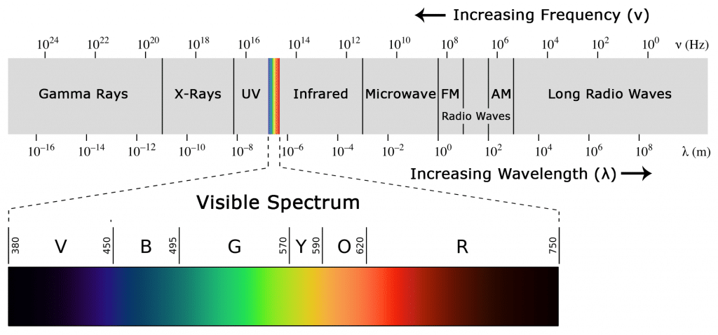

**Why IR? (explained with an example)**

A common method of modulation in IR communication is 38kHz modulation. This frequency is chosen because there are few natural sources emitting signals at this rate, allowing the transmitted data to stand out. Although 38kHz is the most popular, other frequencies can also be used.

When you press a button on your remote, the IR LED quickly blinks to send encoded data to the device. This rapid blinking allows the appliance to interpret the signal and perform the desired action.

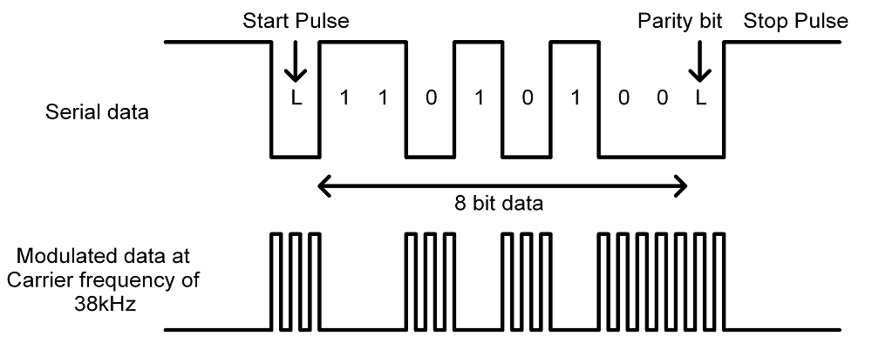

When you hit a key on your remote, the transmitting IR LED will blink very quickly for a fraction of a second, transmitting encoded data to your appliance.



**CIRCUIT DAIGRAM:  
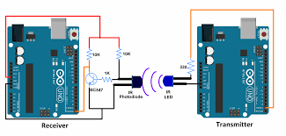**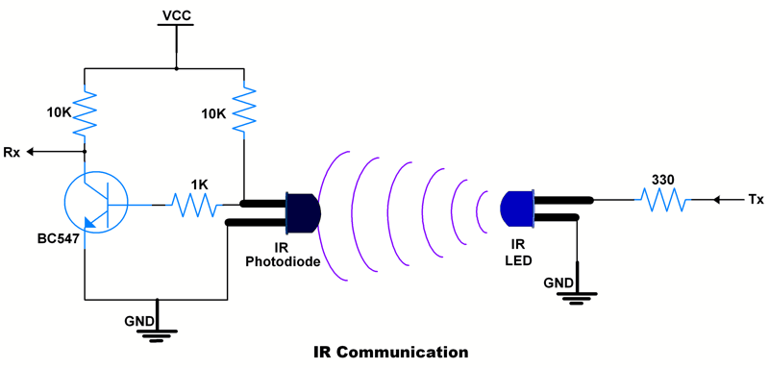

**Components List:**

1. Arduino Boards (2): One for the transmitter and one for the receiver.
2. IR LED: Used as the transmitter to send infrared signals.
3. IR Photodiode/Receiver: Used as the receiver to detect the infrared signals.
4. Resistors:
   * 330Ω resistor: Connected in series with the IR LED.
   * 10kΩ resistor: Connected to the photodiode for biasing.
   * 10kΩ resistor: Used in the circuit for the receiver setup.
5. Breadboard: For connecting the components.
6. Jumper Wires: For making the necessary connections between components.

**Code for IR Communication between IR LED And IR Photodiode Using Arduino Uno**

**Sketch for Transmitter**

void setup() {

Serial.begin(9600);

}

void loop() {

int count;

for(count = 0; count<100; count++)

{

Serial.println(count);

delay(1000);

}

}

**Sketch for Receiver**

void setup() {

Serial.begin(9600);

}

void loop() {

if(Serial.available())

{

Serial.print(char(Serial.read()));

}

}

**Reference:**[**https://learn.sparkfun.com/tutorials/ir-communication/all**](https://learn.sparkfun.com/tutorials/ir-communication/all)[**https://forum.arduino.cc/t/using-ir-sensor-and-ir-transmitter-not-remote/1042532**](https://forum.arduino.cc/t/using-ir-sensor-and-ir-transmitter-not-remote/1042532)[**https://www.electronicwings.com/sensors-modules/ir-communication**](https://www.electronicwings.com/sensors-modules/ir-communication)