HCP Targeting Case Study Solution Report
Sambodhu Pranay Raj | 5 November 2026

1 Solution overview
A specialty pharma client has a weekly targeting model with strong reported discrimination, yet reps contact fewer than 5% of flagged HCPs and say the list largely confirms their existing plans. I built a reproducible 4000 HCP simulation, predictive baselines, a two model logistic regression uplift approach, grounded explanation records and a static rep dashboard. On 800 test HCPs, uplift ranking produced a 28.75 percentage point visited versus control prescribing rate difference in the top 20%, compared with 5.25 points for an unweighted pooled LR ranking. These findings support a prospective pilot in the simulated setting; they do not establish real client impact, and live LLM explanation generation remains incomplete.

Problem framing
The operational decision is which HCP should receive an additional rep visit when visit capacity is limited. Predicting that an HCP will prescribe is useful for forecasting, but does not identify whether visiting that HCP changes prescribing. The proposed decision target is incremental response over a 28 day outcome window, supported by rep usable explanations and activity measurement.
Exhibit evidence | Interpretation
AUC 0.86 | Discrimination on the reported validation population; not evidence of causal visit impact.
Validation limited to at least 3 annual visits | Reported performance may exclude rarely visited and unvisited HCPs.
Top decile outcome rate 71% | A response rate among highly scored HCPs; no control comparison establishes incrementality.
Contacts 14/340, 11/335, 16/352 | Contact rates 4.12%, 3.28% and 4.55%; the list was opened, so opening alone is not adoption.

Primary hypotheses are overlap with existing plans, a predictive objective misaligned with incremental growth, limited evaluation coverage and workflow timing or usability. The exhibit supports investigation of these hypotheses, not a definitive causal explanation of rep behaviour.

2 Approach and methodology

Historical features and leakage controls
Each HCP has one historical snapshot at 1 November 2026. Features include category and brand prescribing, annual visits, recent calls, specialty, territory, stage and historical sample acceptance. The binary outcome records any client brand prescribing during the following 28 days. Future visit assignment, future outcome, identifiers, free text and simulation truth are excluded from classifier inputs.
Missing historical values use structural zero placeholders with explicit flags for prior visits. Timestamp and review blanks remain metadata. Categories are one hot encoded using a fixed schema. Three engineered features are retained: time since the latest visit, brand share in the recent 90 days and brand prescription change between consecutive 90 day periods. Each scaler is fitted only inside its training pipeline.

Predictive baselines
The original classifier workflow compares logistic regression, random forest, decision tree, XGBoost and gradient boosting using a limited grid search and three fold training cross validation. A 60/20/20 HCP split uses joint stratification on outcome and assigned visit. Following model choice, the selected LR and random forest settings are refitted on training plus validation, with the 800 test HCPs excluded from fitting. LR is retained for the simple uplift demonstration, although random forest has slightly higher predictive test AUC.

Two model uplift approach
An unweighted LR pipeline is trained on 1623 HCPs assigned the additional visit; another is trained on 1577 controls. Both use C equal to 0.1 with no new hyperparameter search. Every HCP is scored by both models. Estimated uplift equals the additional visit probability minus the control probability. Negative estimates are retained, rather than clipped to manufacture beneficial visits.
No class balancing is used for uplift because the two probability estimates must represent the observed arm distributions. The simulation randomises the additional visit and assumes complete adherence; the models estimate conditional average effects, not observed individual causal outcomes.

Decision and interface
The top 400 uplift scores become the demonstration recommendation list. The interface exposes territory and stage filters, evidence, the separate dated rep review and suggested follow up. Tier 1 is an illustrative top 100 uplift score display filter for senior view, not a validated business segment or authenticated permission role.

3 How the solution was developed

Alternatives and decisions
Option | Decision and reason
One prescribing classifier | Retained as a diagnostic baseline; cannot separate spontaneous prescribing from visit response.
Restrict all data to at least 3 visits | Rejected for the improved approach because it removes the under visited population we need to assess.
Two logistic regression models | Chosen for simplicity, probability outputs and traceable explanations. Flexible causal forests remain a future alternative.
Rep review as a training feature | Excluded by design. Reviews remain visible as historical context; unique wording is not evidence of predictive value.
Class balanced uplift probabilities | Avoided because reweighted outcome probabilities can distort the difference between treatment arms.
Static dashboard for reviewers | Chosen for submission access without Python. Browser action storage is a demonstration, not central telemetry.

Key assumptions
Additional visit assignment is random with probability 0.5. The assigned visit is completed and occurs before the outcome window matures. There is no interference between HCPs, and the control group receives no additional assigned visit. Historical visits can exist in both groups. Prescribing means at least one client brand prescription, not an HCP buying a box or a patient outcome.

Changes during development
The modelling objective changed from general prescribing classification to incremental additional visit response. Unnecessary engineered variables were removed, rep reviews were kept outside training, and final refitting was clarified to mean training plus validation. The delivery changed from a local dashboard to a static GitHub Pages version for interviewer access. No formal clarification desk answer or mid session client update was supplied for this rebuild; none is assumed.

Validation universe distinction
A restricted validation universe changes where reported metrics apply. It changes model learning only if training data or model selection are also restricted. Our current models use the broader training population. We created the at least 3 visit subsets, but have not fitted and compared a restricted training reconstruction. This remains an explicit incomplete element of the original brief.

4 Data generation and ground truth
Property | Generated value
Universe and history | 4000 HCPs and 8057 historical visit records
Outcome balance | 1734 prescribing and 2266 non prescribing HCPs
Additional visit assignment | 2029 assigned and 1971 controls
Stage | 2830 already prescribing; 405 testing; 765 never accepted a sample
Coverage | 1170 without historical visits; 1028 with at least 3 annual visits
Restricted subsets | 213 from the original validation split; 204 from the test split

The seeded generator creates daily category and brand prescription counts with heterogeneous, skewed volumes, and preferential historical visits among high brand prescribers. Historical brand use takes precedence when assigning stage. The category count includes the client brand, and brand counts do not exceed category counts. Historical review observations are separated from cutoff based numeric interpretation by their timestamps.

Synthetic incremental response
The generator builds a no additional visit probability from recent brand activity and assigns a heterogeneous visit effect related to category potential, brand share and historical attention, with random heterogeneity. A subset has zero effect. Additional visit assignment is random and the binary prescribing outcome is sampled from the assigned scenario. The hidden probability and effect records are saved in simulation_truth_DO_NOT_TRAIN.csv; they are not model inputs, reason evidence or UI records.
The effect functions make incrementality genuinely present by construction. Success on this simulation demonstrates the workflow and its assumptions, not that the same effect patterns hold for real dermatology prescribers. Oracle effect recovery has not been reported; current evaluation uses observed randomised outcomes.

Public data status and limitations
CMS Medicare Part D prescribing data were suggested by the brief as a possible distributional reference. No CMS provider records were downloaded or fitted into this rebuild. The generated count distributions are illustrative and must not be described as empirically calibrated to CMS. Medicare coverage, aggregation, lag and suppression would also limit direct transfer to a recent brand launch.
The single snapshot supports an HCP holdout demonstration, not a temporal test of weekly refreshes. Synthetic future labels cover 2 to 29 November 2026; they are generated outcomes, not observations already collected at report time. The 213 original validation subset rows were included in final refitting and are no longer held out.

5 Predictive evaluation results
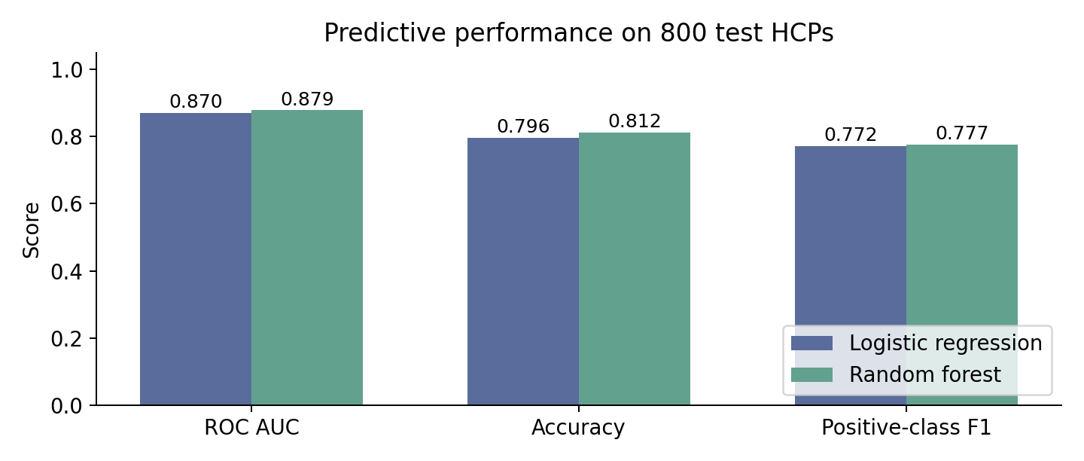
Figure 1 Predictive metrics after final refitting on 3200 HCPs and scoring 800 test HCPs.
Metric | Logistic regression | Random forest
ROC AUC | 0.8699 | 0.8785
Average precision | 0.8305 | 0.8372
Accuracy at 0.5 | 79.63% | 81.25%
Positive precision | 74.80% | 80.06%
Positive recall | 79.77% | 75.43%
Positive F1 | 0.7720 | 0.7768
Brier score | 0.1476 | 0.1358

ROC AUC measures whether prescribing HCPs tend to receive higher scores than non prescribing HCPs. It does not measure the effect of visits. Average precision summarises precision and recall across thresholds; Brier score measures probability error and is lower when probabilities better match binary outcomes.
The LR classification threshold remains 0.5. Recommendation rankings use continuous probabilities rather than the binary prediction. The positive class is any prescribing in the following 28 days. Random forest is slightly stronger on these predictive measures; LR is selected for interpretability and a simple paired model demonstration, not claimed to be the numerical winner.
The test set was inspected during earlier iterations. Later comparisons therefore provide exploratory evidence rather than a pristine final assessment. The final refit uses training plus validation only; there is no test fitting.

6 Uplift evaluation results
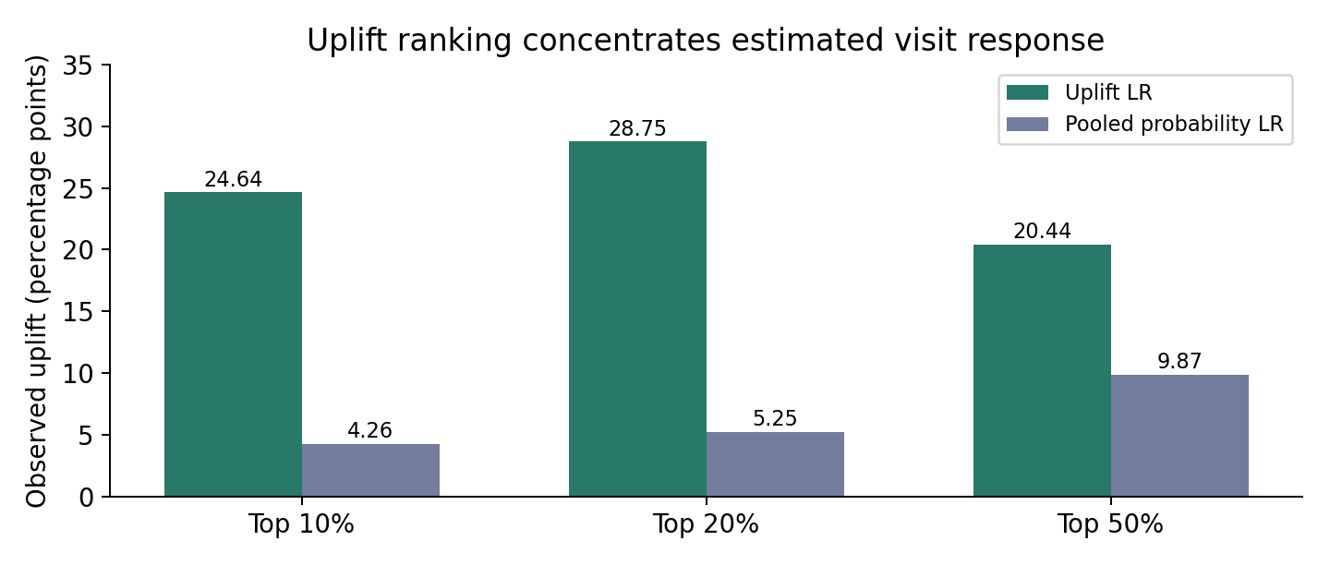
Figure 2 Observed visit minus control prescribing rate differences within each selected fraction. Values are percentage points.
Metric | Uplift LR | Pooled probability LR
Normalised Qini AUC | 0.0389 | -0.0199
Normalised uplift AUC | 0.0491 | -0.0285
Uplift in top 10% | 24.64 pp | 4.26 pp
Uplift in top 20% | 28.75 pp | 5.25 pp
Uplift in top 50% | 20.44 pp | 9.87 pp

The controlled comparison uses a new unweighted pooled LR with C equal to 0.1, fitted on the same 3200 HCPs. It differs from the earlier balanced current model used in the UI. Keeping these baselines distinct avoids attributing all comparison differences to uplift alone.
The top 20% contains 160 test HCPs, including 80 visited and 80 controls. Its observed difference is 28.75 percentage points, or 0.2875 in probability units. On the visited size scale, this corresponds to 23 estimated additional prescribers relative to the control rate. It does not mean 23 additional prescriptions or a 28.75% relative increase.
The approximate 95% bootstrap interval for uplift at 20% is 11.79 to 43.39 percentage points. The paired top 20% difference versus pooled probability ranking has an interval of 3.54 to 39.56 points. The 500 bootstrap samples hold fitted models fixed and reflect test sample variation only, not training uncertainty or a prospective client result.
The test wide observed treatment effect is 15.71 points and mean predicted uplift is 14.62 points. The normalised Qini score is modest and quintile outcomes are not strictly monotone, so the result should support further validation rather than an immediate broad rollout.

7 Reading the curves and the new list
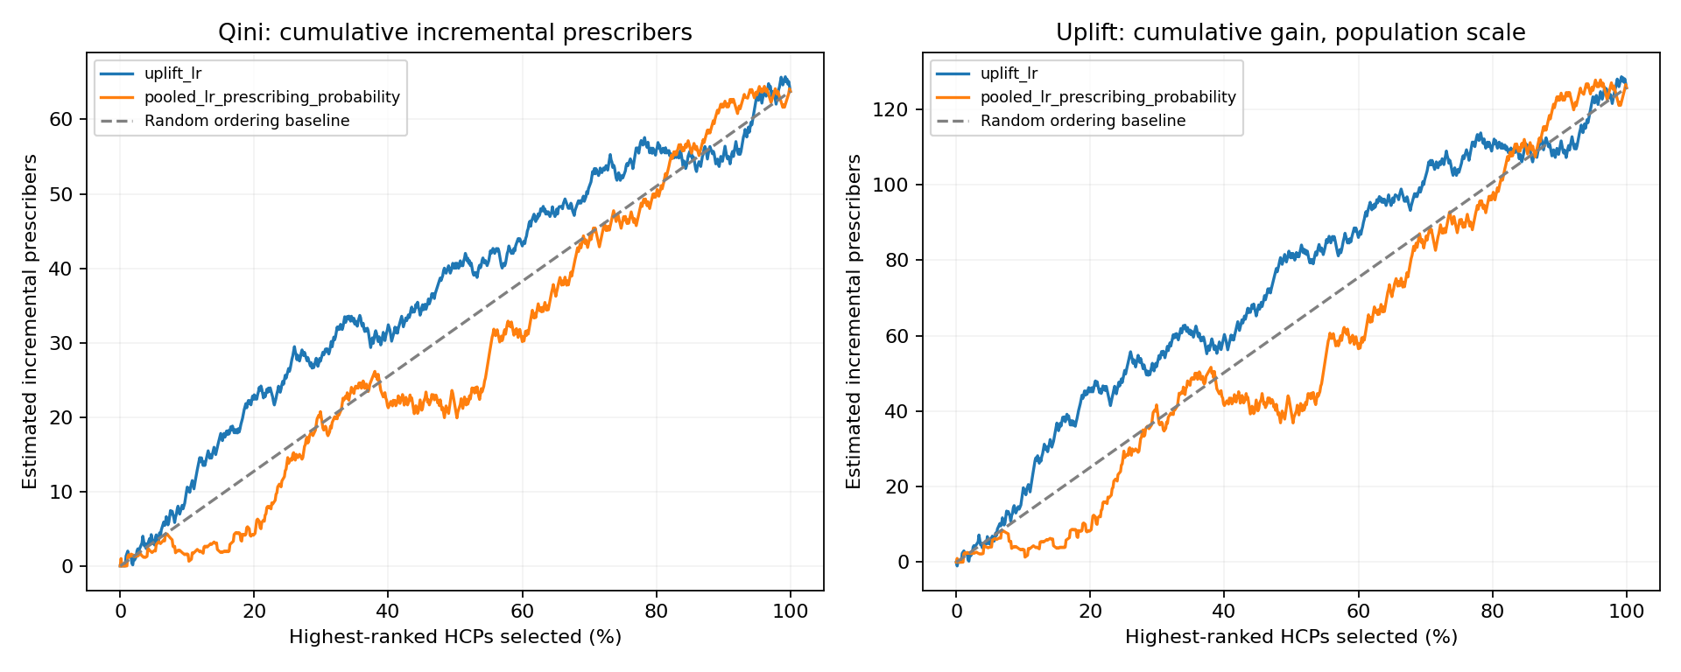
Figure 3 Actual synthetic test Qini and cumulative uplift gain curves. The dashed line represents random ordering. These are not ROC curves.
Both horizontal axes show the proportion of the uplift ranked population selected. Qini counts visited responders minus control responders rescaled to the number visited. The cumulative uplift gain curve multiplies the visited minus control rate difference by the entire selected population. The second curve therefore uses a different scale; it is not a rate curve. Area above the random line indicates concentration of gain near the top. The package normalises AUC against its reference ranking, so Qini AUC must not be read as classification accuracy.
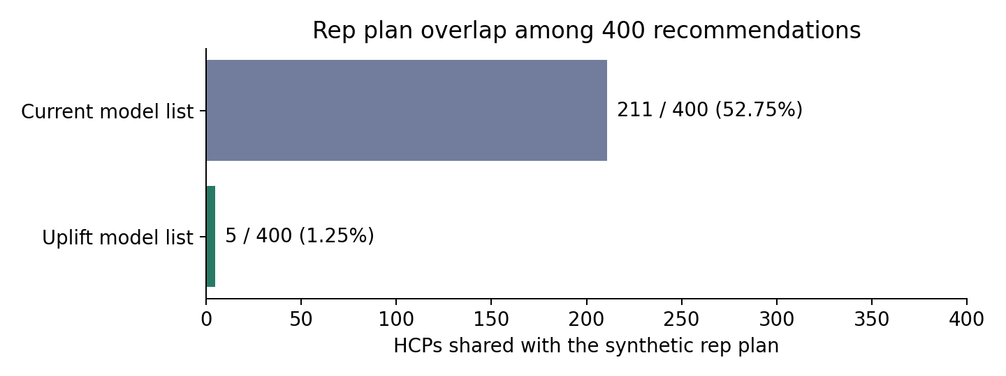
Figure 4 Overlap with the simulated rep plan. Plan selection itself favours historical contact and brand volume.
The current and uplift top 400 lists share 7 HCPs, or 1.75%, leaving 393 uplift names outside the current list. Current list overlap with the synthetic rep plan is 211 of 400; uplift overlap is 5 of 400. The rep plan selects 80 HCPs per territory by recent calls, annual visits and brand volume. The resulting novelty partly reflects that construction. Actual frozen call plans are required to establish whether recommendations change real rep choices.

8 Explanations and technology

Grounded reasons and use of LLMs
For every flagged HCP, the paired LR explanation identifies the strongest absolute probability contributions relative to one actual training reference HCP, grouping categorical columns. The contributions reconstruct estimated uplift when combined with the reference uplift. Each displayed fact is linked to that HCP record; missing visit placeholders are suppressed. Large contributions may raise or lower the estimate and are not independent causal feature effects.
For HCP2331, the reason reports an estimated additional visit benefit of 38.9 percentage points, a 20 prescription increase between the two 90 day brand periods and 48 brand prescriptions in the recent period. The follow up suggestion asks the rep to review contact suitability. This separates the model estimate, recorded evidence and suggested action without asserting guaranteed response or clinical benefit.
ChatGPT assisted with problem framing, code development, debugging, explanation design and documentation. Inside the application, current reasons are deterministic grounded templates, not live LLM generations. One grounded prompt per flagged HCP is exported for later rewriting. The original brief requires actual LLM generated reasons; that integration and a measured grounding evaluation remain pending.
A completed LLM stage should receive only evidence facts, driver directions and an explicitly labelled estimate. Require the output to identify its evidence fields; verify numbers, units, HCP identity, time windows and unsupported claims. Review a sample semantically and fall back to a verified template on failure. Do not permit invented preferences, access barriers, clinical recommendations or outcome guarantees.

Technology stack
Layer | Implementation
Data and features | Python, pandas and NumPy; CSV snapshots and metadata
Models | scikit learn pipelines, StandardScaler and LR; other classifiers for comparison
Uplift metrics | scikit uplift 0.5.1 normalised Qini and uplift AUC; overall top k rate differences
Persistence and plots | joblib model pipelines; matplotlib figures
Submission UI | Static HTML, CSS and JavaScript; bundled precomputed JSON; browser localStorage
Local dashboard | Flask plus SQLite, delivered separately from GitHub Pages

GitHub Pages does not execute Python models. Exported scores and evidence drive the static dashboard. Browser actions are isolated per reviewer and are not shared telemetry. Tier 1 is a display choice, not an authentication control.

9 Limitations and next steps

Complete the analytical gaps
First obtain the original model target, training population, validation construction and frozen rep call plans. Compare a model trained only on HCPs with at least 3 visits against a broader model, evaluate both on the same held out population and report rare visit coverage, calibration and top list overlap. Add temporal holdouts for repeated weekly snapshots. Calibrate probabilities and assess stability across territories and stages.
Calibrate the synthetic distributions to an appropriate permitted source, document applicability to a new topical therapy and report recovery against the hidden simulation effect without using it in fitting or selection. Integrate and evaluate the LLM reason stage. Compare simpler reference based explanations with alternatives and review correlated driver redundancy with field stakeholders.

Measure adoption separately from impact
Instrument snapshot and model version, recommendation publication time, authenticated rep identity, HCP identity, existing plan membership and action timestamps. Measure lists available before planning, unique rep open and review rates, accepted and completed visits, new contacts outside the frozen plan, deferral reasons and explanation usefulness. Use distinct HCP and rep denominators rather than raw clicks.
For impact, randomise comparable reps or territories to current versus uplift lists while holding list size, timing, UI, training and visit capacity constant. Predefine a primary 28 day prescribing outcome, minimum worthwhile effect and sample size accounting for cluster dependence. Analyse assignment to the new policy on an intention to treat basis, including ignored recommendations, and report confidence intervals. Allow complete outcome follow up before drawing conclusions.
Track prescription volume, contribution net of visit cost and workload separately because our binary label cannot quantify those outcomes. Policy randomisation estimates the value of the list; validating individual visit effect estimates needs randomised additional visits or another credible causal design.

Production data and security
Use approved prescribing and CRM data with documented access and retention. Add authenticated rep roles, server enforced territory permissions, encrypted transport and storage, managed secrets and audit logs. Minimise sensitive notes. Real client data must not be embedded in a public static website. Monitor data freshness, missingness, score drift, repeated recommendations, delayed outcomes, calibration, grounding defects and operational burden. Version models, source features, prompts and reason validation results.

10 Submission index and reproducibility
The submission is organised into scripts, data, results, reports and docs. The uploaded local project supplies the canonical source scripts and latest result files; duplicate downloaded packages, the Python environment, caches and local activity database are excluded. The existing repository URL remains the submission entry point; publishing the website is separate from uploading source.
Artifact | Purpose
scripts/generate_hcp_data.py | Seeded 4000 HCP universe, historical visit log and hidden simulation truth
scripts/preprocess_hcp.py | Structural missing value handling and fixed categorical encoding
scripts/feature_engineering_split.py | Three engineered variables, feature allowlist and stratified splits
scripts/train_classifiers.py | Limited grids and predictive classifier validation
scripts/refit_lr_rfc.py | Refit selected LR and RFC on training plus validation; test reports
scripts/build_ranking_datasets.py | Predictive rankings, synthetic plan and at least 3 visit subsets
scripts/train_uplift_lr.py | Paired LR fitting, test rankings, Qini, uplift and bootstrap results
scripts/explain_hcp.py | Grounded template reasons, driver audit and LLM prompt exports
docs/index.html and assets | Static rep dashboard for GitHub Pages
reports and result folders | This report, charts and uploaded canonical evaluation artifacts

Reproduction sequence
Generate data, preprocess, engineer and split, train predictive baselines, refit selected classifiers, create diagnostic rankings, train uplift LR, create grounded reasons and export dashboard records. Preserve HCP alignment across X, y, treatment and ID files. Never fit preprocessing on test rows or use simulation truth as a model feature.
Run commands from the repository root using README.md. Scripts use project relative defaults. The analytical environment needs pandas, NumPy, scikit learn, joblib, matplotlib, scikit uplift and XGBoost for the five model comparison. The static UI has no Python dependencies. Regenerate uploaded model files before reuse in a different scikit learn version.

Methods references
scikit uplift two model approach: https://www.uplift-modeling.com/en/latest/user_guide/models/two_models.html
Metric definitions and implementation: https://www.uplift-modeling.com/en/latest/_modules/sklift/metrics/metrics.html

