Challenge 1 questions

1. SELECT s.customer_id, sum(m.price) as total_amount

FROM sales s

JOIN menu m

ON s.product_id = m.product_id

GROUP BY s.customer_id;

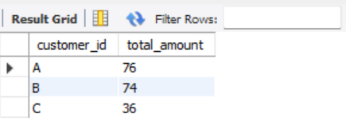

1. SELECT customer_id, count(distinct(order_date)) as days_visited

FROM sales

GROUP BY customer_id;

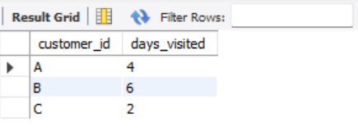

1. SELECT *

FROM (

SELECT s.customer_id, m.product_name,

ROW_NUMBER() OVER (PARTITION BY s.customer_id ORDER BY s.order_date ASC) as row_num

FROM sales s

JOIN menu m

ON s.product_id = m.product_id

) t

where t.row_num = 1;

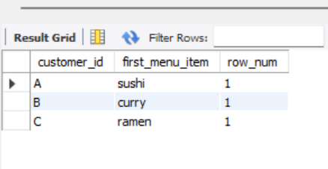

1. SELECT m.product_name, count(s.product_id) as frequent_item_count

FROM sales s

JOIN menu m

ON s.product_id = m.product_id

GROUP BY m.product_name

ORDER BY frequent_item_count DESC

LIMIT 1;

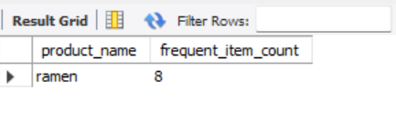

1. WITH RankedProducts AS (

SELECT

customer_id,

product_id,

COUNT(*) AS order_count,

ROW_NUMBER() OVER (PARTITION BY customer_id ORDER BY COUNT(*) DESC) AS row_rank

FROM sales

GROUP BY customer_id, product_id

)

SELECT customer_id, product_id, order_count, row_rank

FROM RankedProducts

WHERE row_rank = 1;

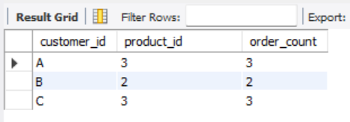

6. SELECT *

FROM (

SELECT s.customer_id, m.product_name,

ROW_NUMBER() OVER (PARTITION BY s.customer_id ORDER BY s.order_date ASC) as row_num

FROM sales s

JOIN menu m

ON s.product_id = m.product_id

JOIN members mb

ON s.customer_id = mb.customer_id

WHERE s.order_date > mb.join_date

) t

where t.row_num = 1;

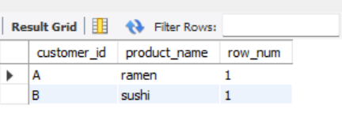

7. SELECT *

FROM (

SELECT s.customer_id, m.product_name,

ROW_NUMBER() OVER (PARTITION BY s.customer_id ORDER BY s.order_date DESC, m.product_name) as row_num

FROM sales s

JOIN menu m

ON s.product_id = m.product_id

JOIN members mb

ON s.customer_id = mb.customer_id

WHERE s.order_date < mb.join_date

) t

WHERE t.row_num = 1;

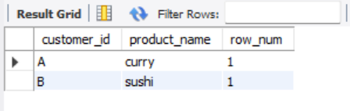

8. SELECT s.customer_id, COUNT(*) as total_items, SUM(m.price) as total_amount

FROM sales s

JOIN menu m

ON s.product_id = m.product_id

JOIN members mb

ON s.customer_id = mb.customer_id

WHERE s.order_date < mb.join_date

GROUP BY s.customer_id;

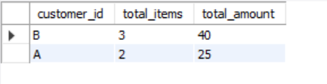

9. SELECT s.customer_id, SUM(2 * m.price * 10) AS total_points, m.product_name

FROM sales s

JOIN menu m

ON s.product_id = m.product_id

WHERE m.product_name = 'sushi'

GROUP BY s.customer_id;

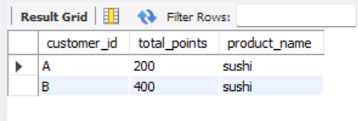

10. SELECT s.customer_id, SUM(2 * m.price * 10) AS total_points

FROM sales s

JOIN menu m

ON s.product_id = m.product_id

JOIN members mb

ON s.customer_id = mb.customer_id

WHERE s.order_date >= mb.join_date

GROUP BY s.customer_id;

