

SRM Institute of Science and Technology School of Computing
Department of Computing Technologies

21DCS201P DESIGN THINKING & METHODOLOGY

REPORT

Name of the Student : D Bhanu prasad
Register Number : RA2411003011339
Section : A2

Class : II B.Tech CSE (CORE) Academic Year / Sem : 2025-2026 (EVEN) / IV SEM

S.No | Activity
1 | Visualization
2 | Brainstorming
3 | Mind Mapping
4 | 30 Circles
5 | Problem Sizing
6 | Persona
7 | Convergent & Divergent Thinking
8 | Business Model Canvas

Faculty In-charge Dr. M.Kandan, Assistant Professor/CTECH

VISUALIZATION

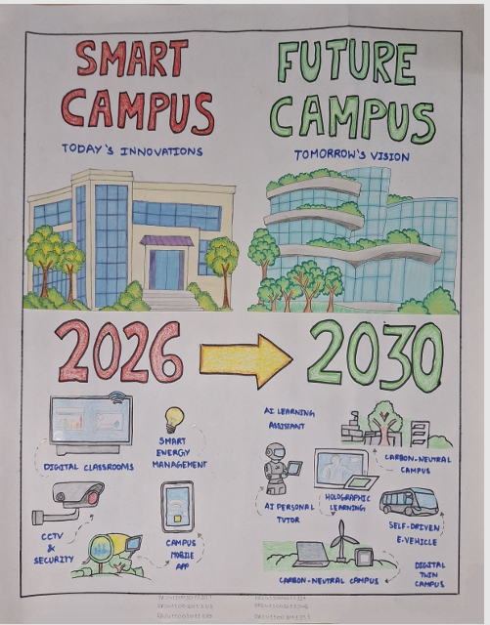
BRAINSTROMING

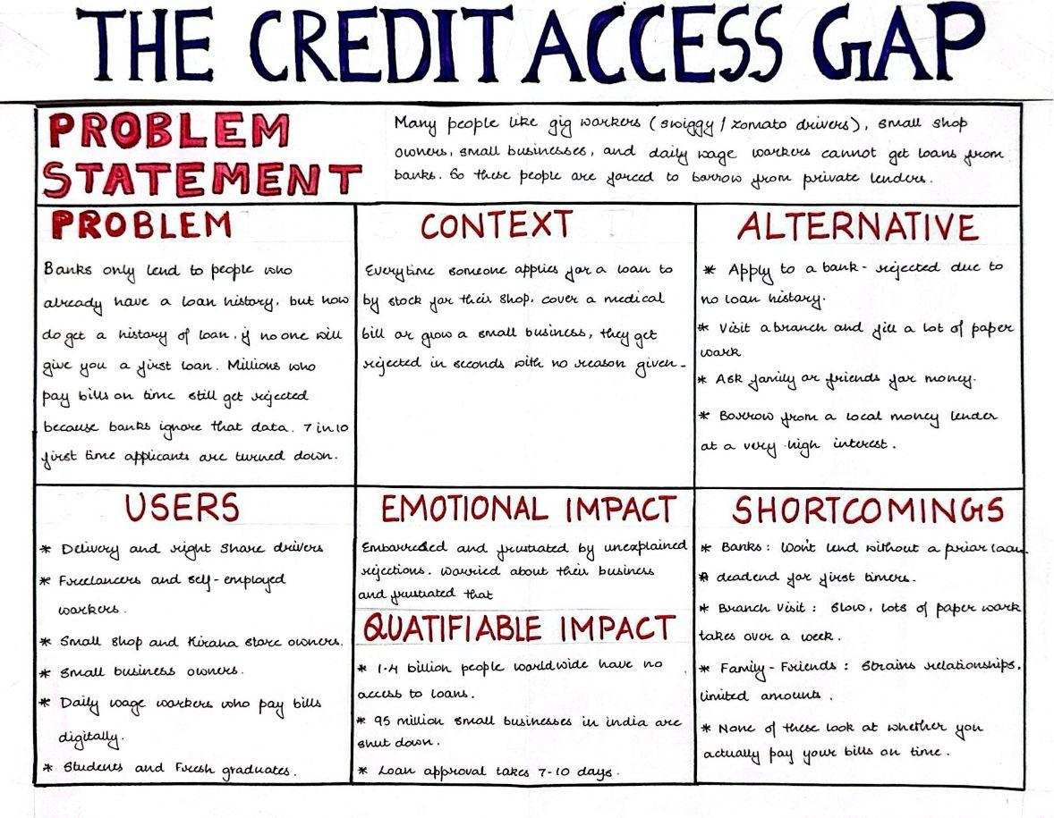

MIND MAPPING

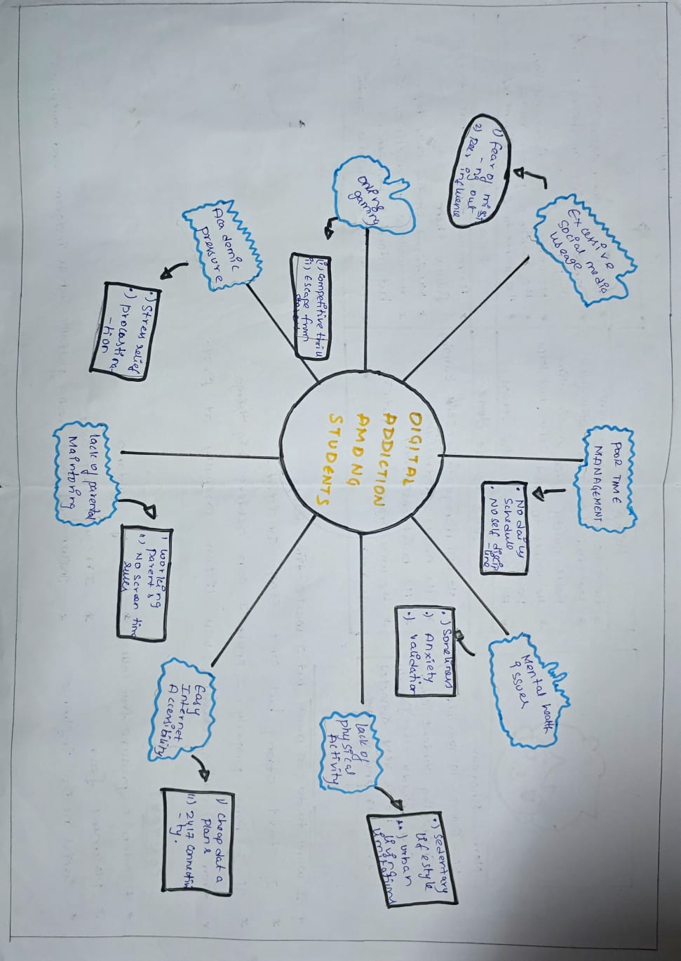

30 CIRCLES

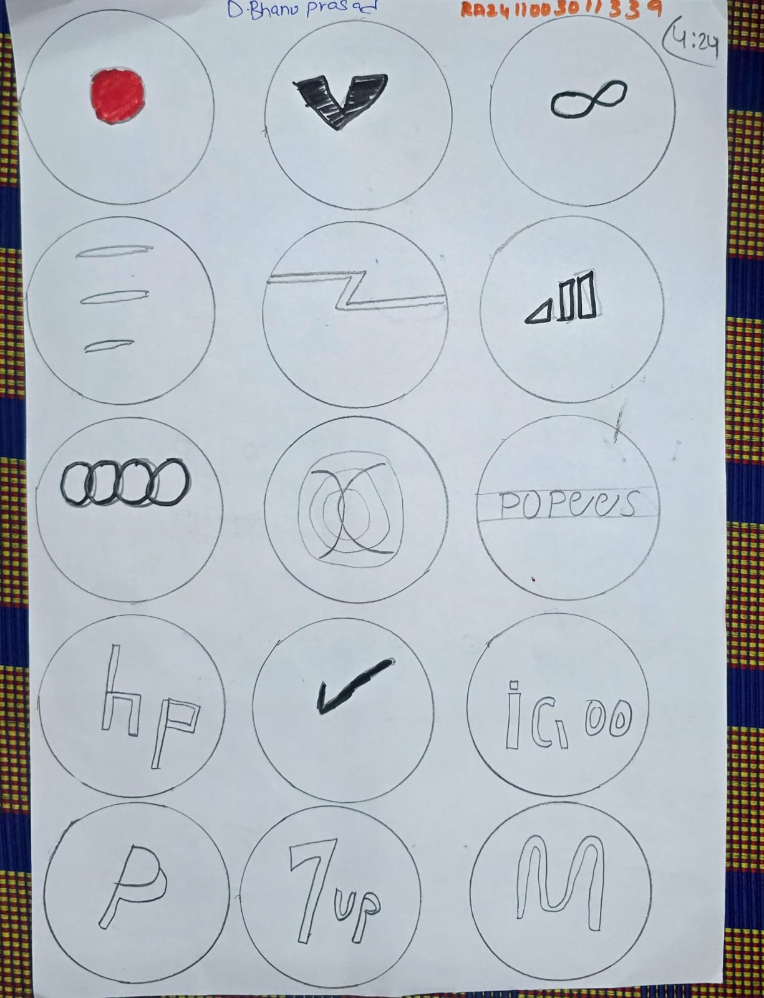

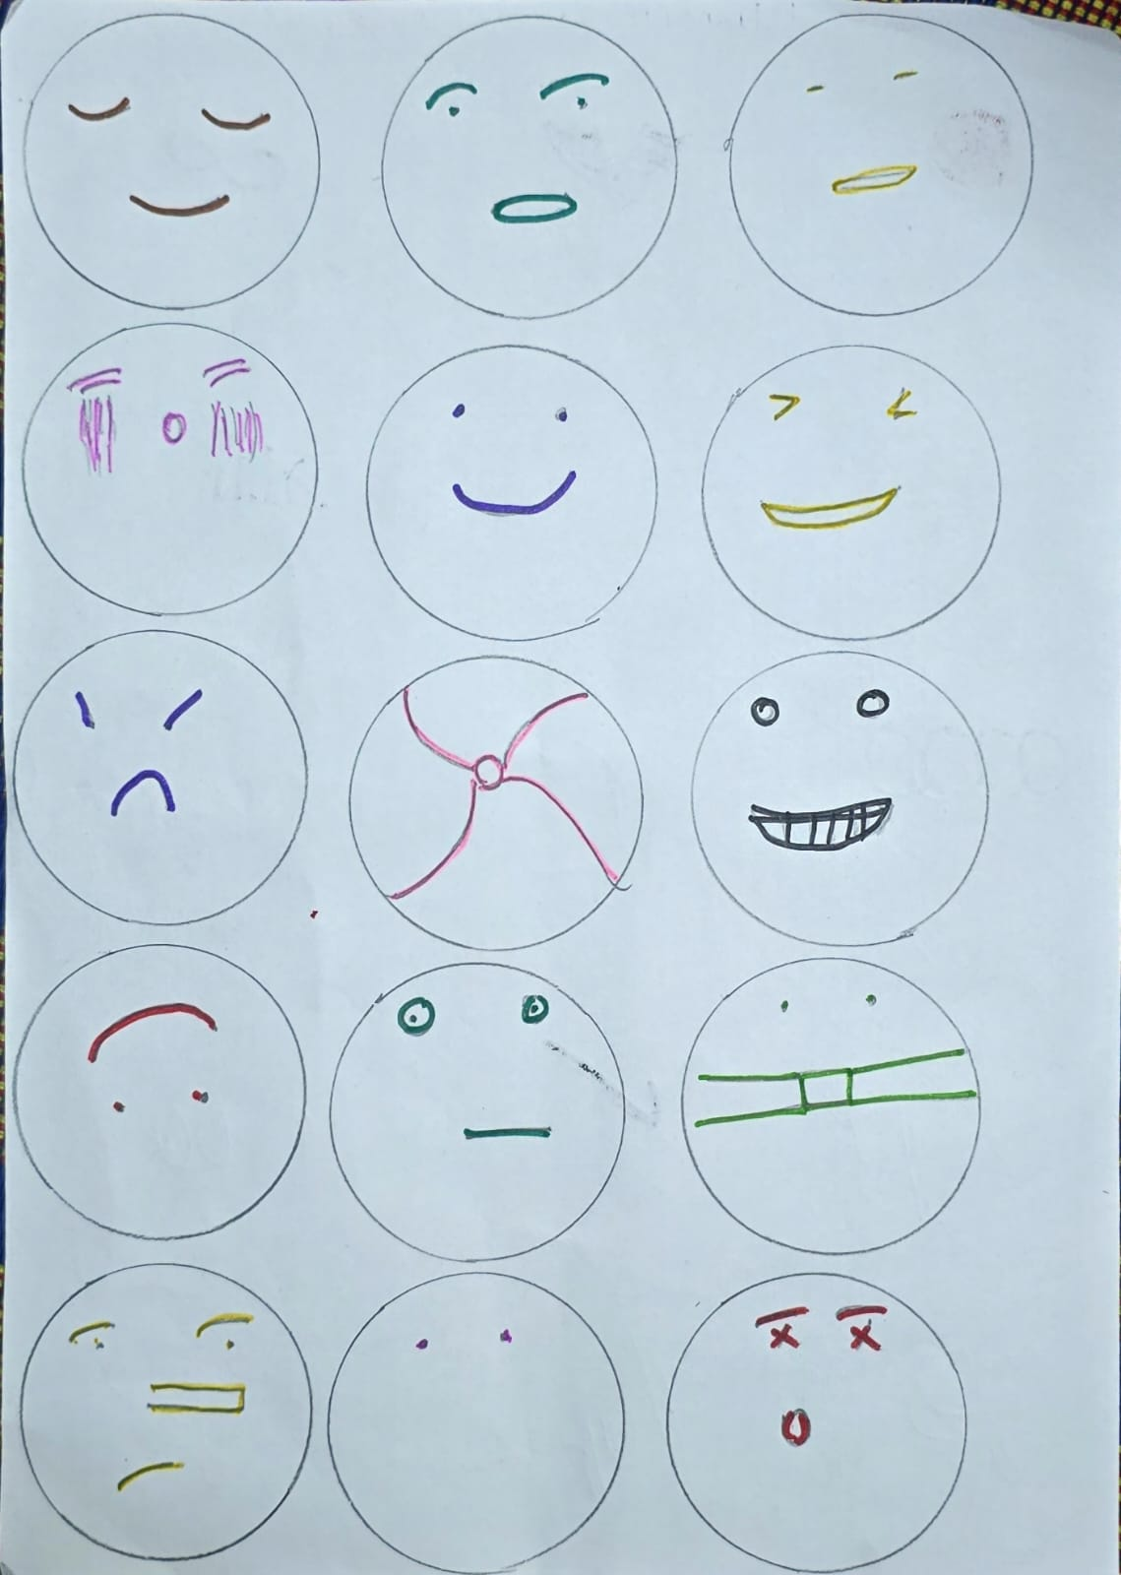
PROBLEM SIZING

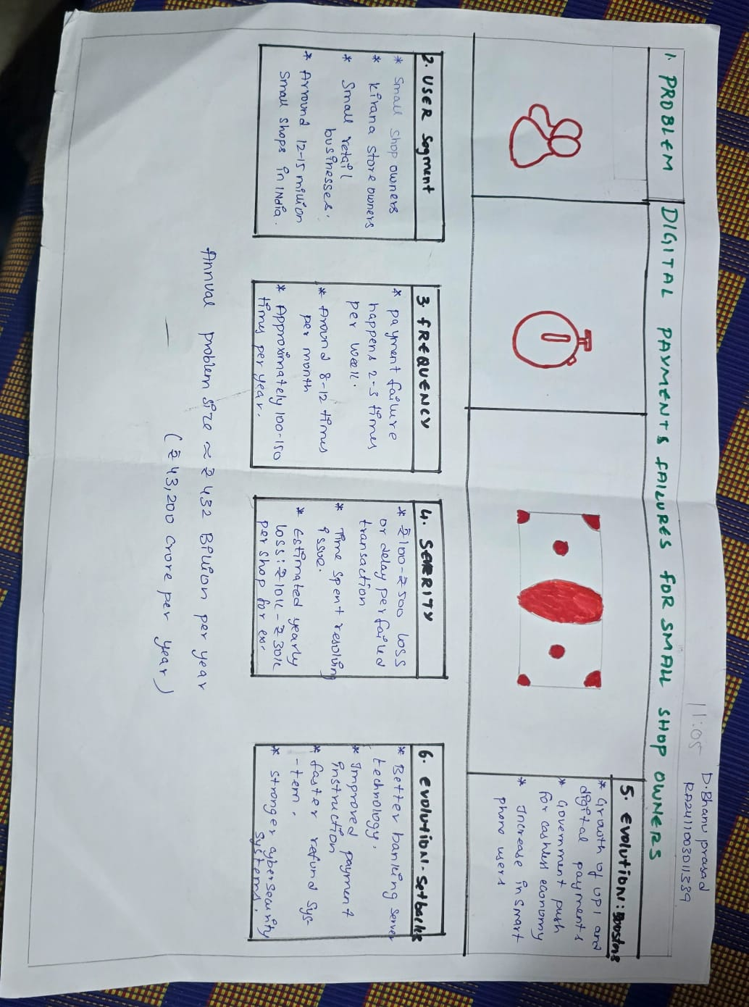

PERSONA
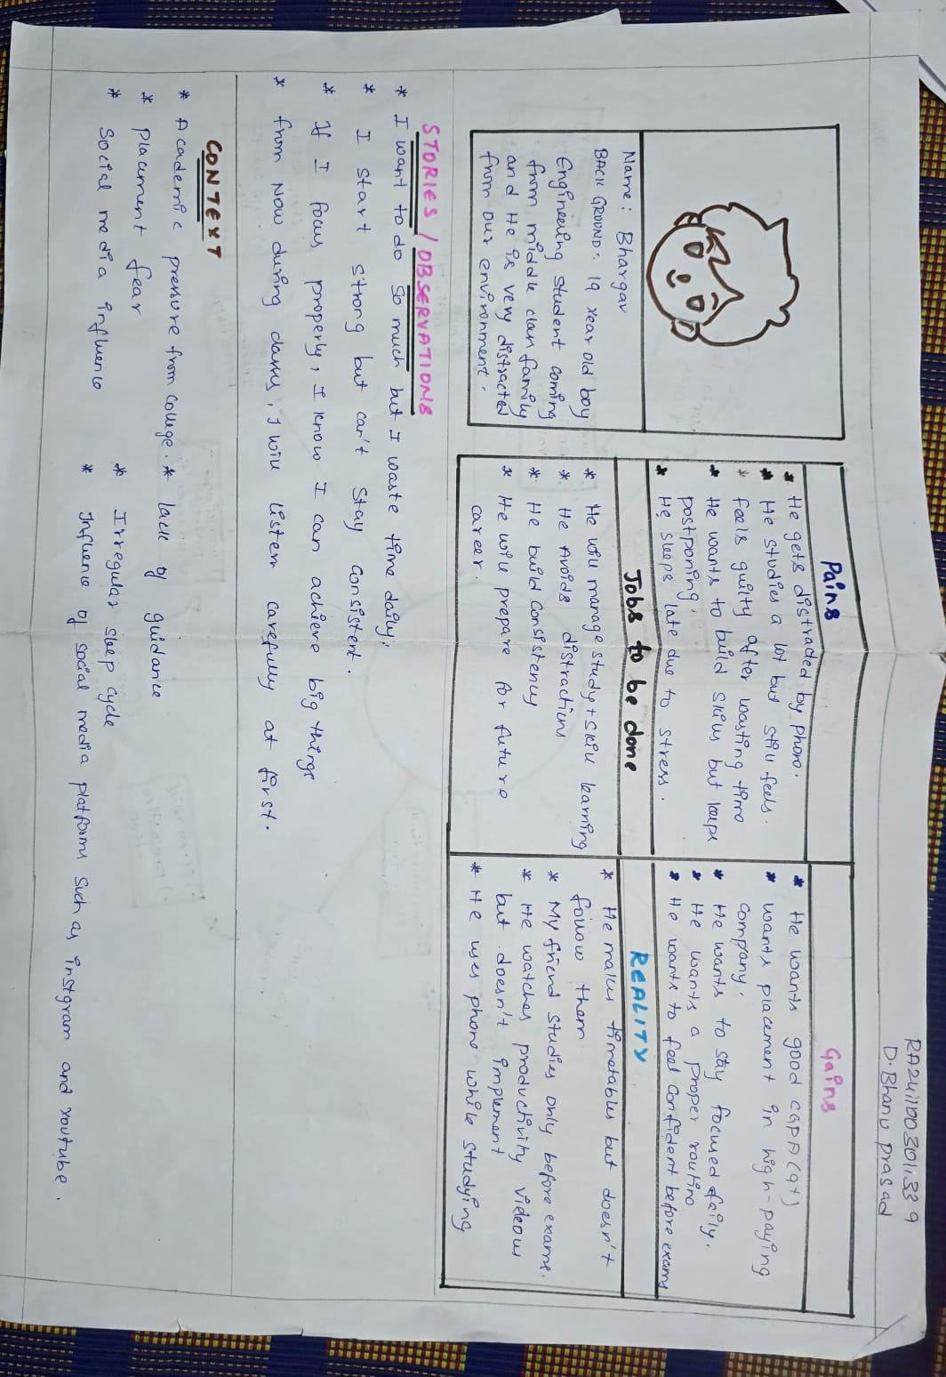

Convergent & Divergent Thinking

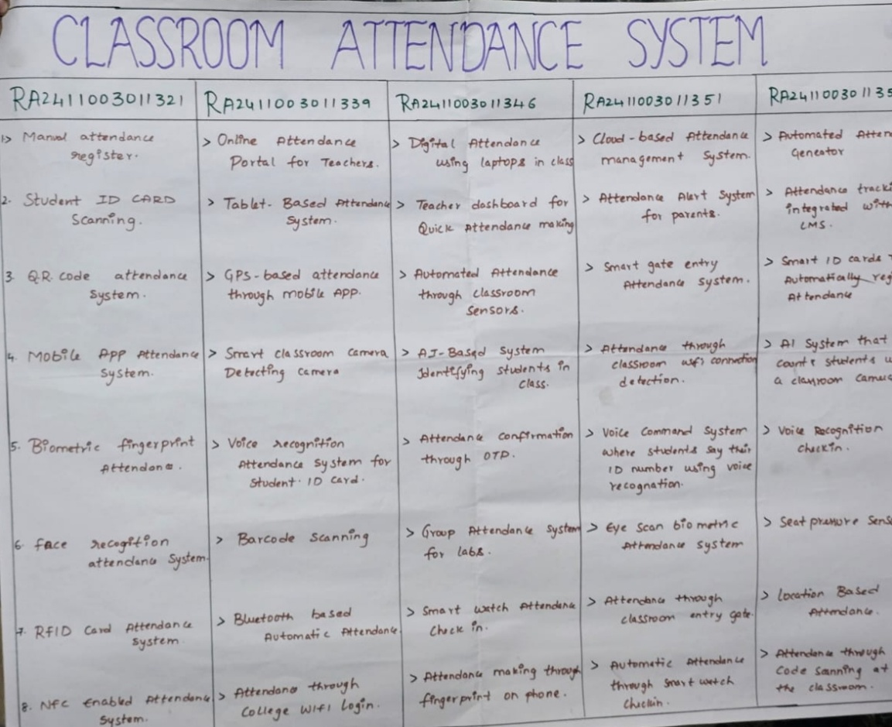

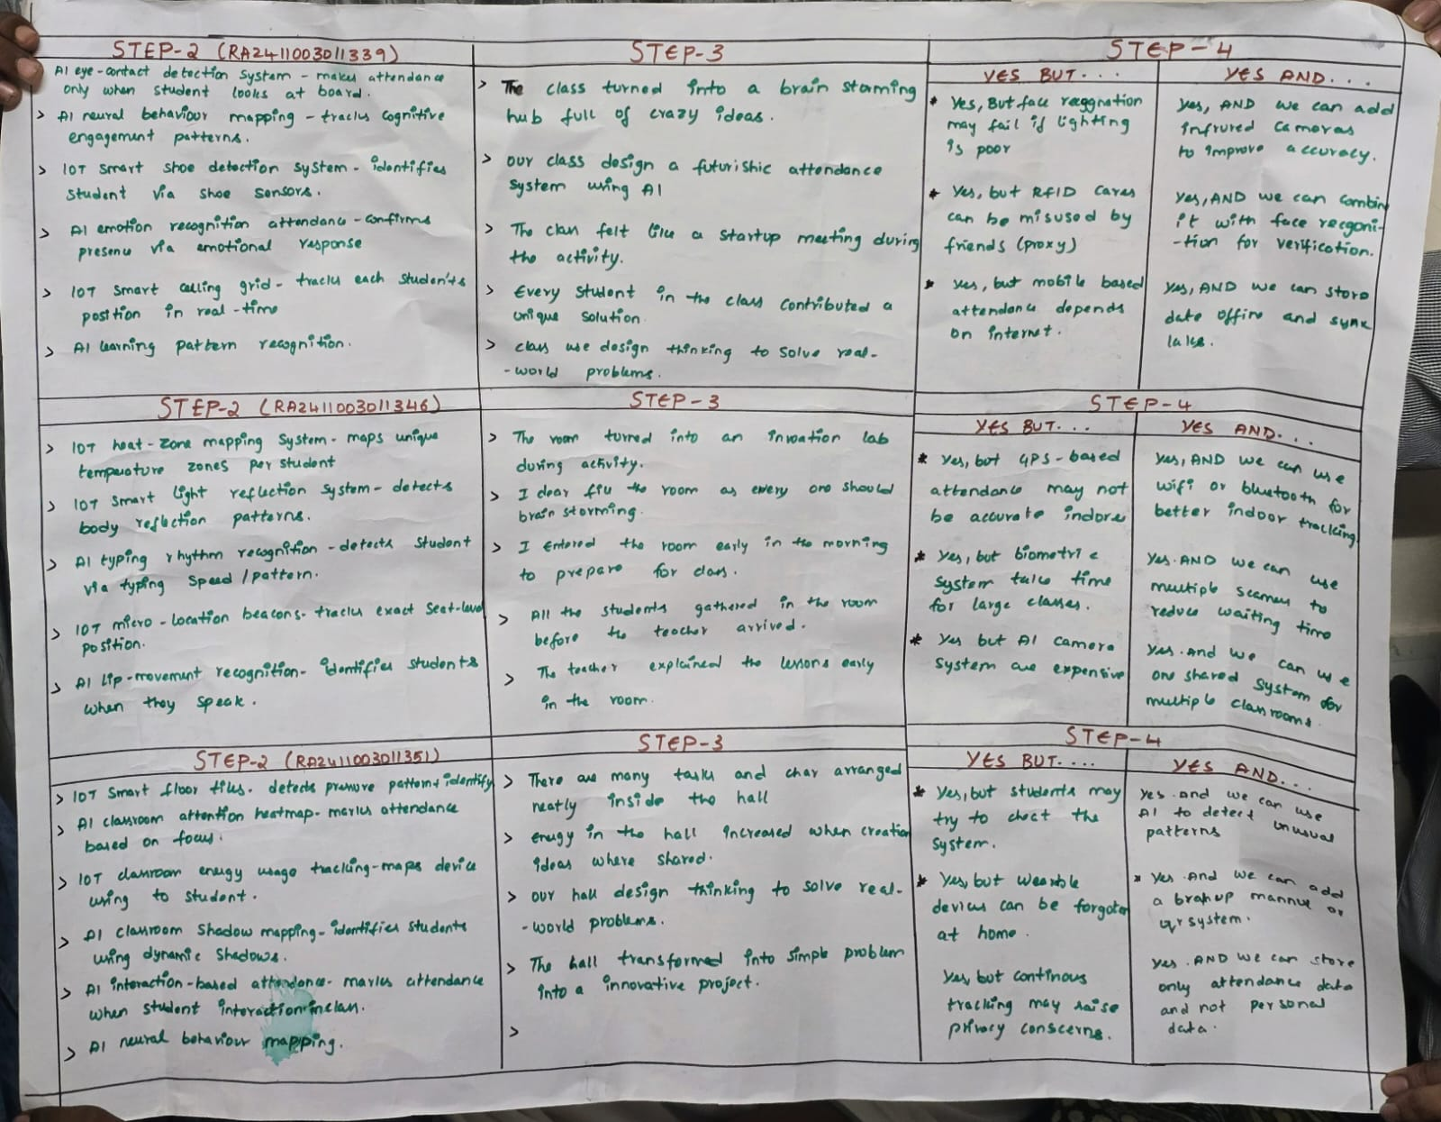

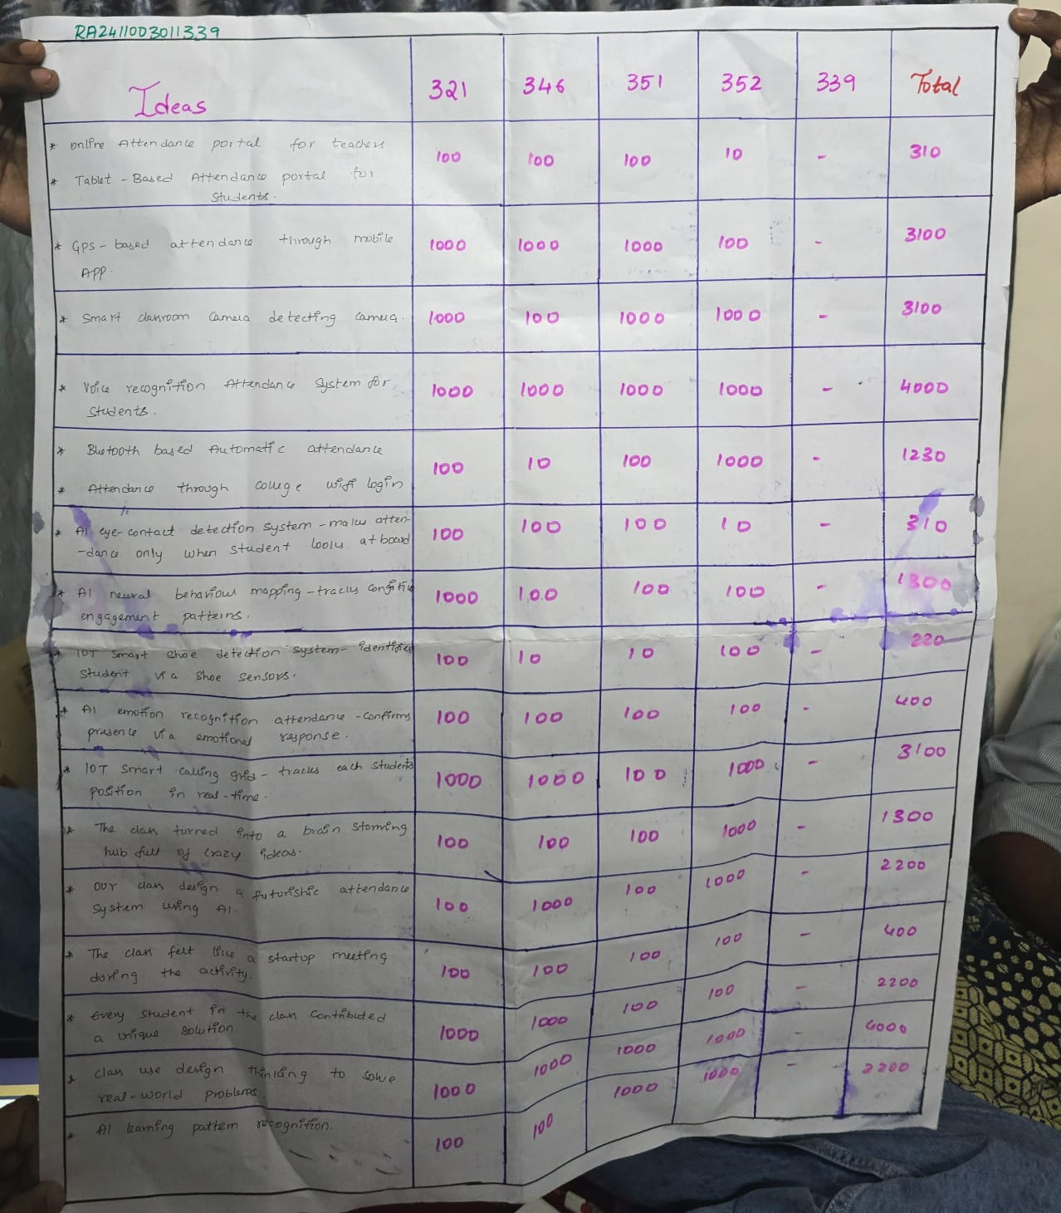

Business Model Canvas

