
DATA STRUCTURES AND ALGORITHMS
23CSE203
LAB MANUAL
SUBMITTED BY
NAME | PRANAY KINTALI
ROLL NO | AV.SC.U4CSE25209
YEAR/SEM/SECTION | 2ND YEAR/SEM-3/CSE-C
CREDITS | 05

SUBMITTED TO | Dr Gayathri Parasa
DESIGNATION | Asst. Professor (Sr. Gr)
DEPARTMENT | SCHOOL OF COMPUTING

INDEX
S.NO | TITLE | PAGE NO
1. | WEEK 1:  1(A). A rocket launch system displays a countdown before launch. Instead of using a loop, implement the countdown using recursion. Write a recursive python program to display a countdown from n to 1, followed by “Launch!”.  1(B). Banks calculate the growth of an investment using compound interest. The formula requires calculating powers, which can be implemented recursively. Write a recursive program to calculate P^{n}(power) where: P= principal growth factor, n= number of years.  1(C). A HR department stores employee ID’s in a list. Develop a recursive program to search for a given employee ID. Write a recursive function to search for an employee ID in a list.  1(D). In a logistics company, the number of possible ways to arrange n different parcels are calculated using the factorial formula (n!). Develop a recursive program to calculate the factorial of a given number.  1(E). Write a recursive python program to print the first n terms of the Fibonacci series. | 5-9
2. | WEEK 2:  2(A). Write a python program to implement linear search.  2(B). Write a python program to implement binary search with and without sorted array as an input. | 10-12
3. | WEEK-3:  3(A). Write a python program to implement bubble sort.  3(B). Write a python program to implement insertion sort.  3(C). Write a python program to implement selection sort. | 13-15
4. | WEEK-4:  4(A). Write a python program to implement quick sort.  4(B). Write a python program to implement merge sort. | 16-19
5. | WEEK-5:  5(A). Write a python program to implement a Singly Linked List with the below operations.  - Create Linked List  - Insert Beginning  - Insert End  - Insert at Index  - Delete by Value  - Delete First Node  - Delete Last Node  - Count number of nodes  - Sort the data of SLL  - Search data in SLL  - Display or Traverse  - Exit | 20-25
6. | WEEK-6:  Write a python program to implement a Double Linked List with the below operations.  - Create Linked List  - Insert Beginning  - Insert End  - Insert at Index  - Delete by Value  - Delete First Node  - Delete Last Node  - Count number of nodes  - Display or Traverse  - Exit | 26-31
7. | WEEK-7:  7(A). Write a python program to implement stack operations such as push, pop, peek, display using an array.  7(B). Write a python program to implement stack operations such as push, pop, peek, display using a linked list. | 32-37
8. | WEEK-8:  8(A). Write a python program to implement Queue and its operations such as enqueue, dequeue, peek, display with a menu driven approach. Implement using array, and linked list data structures.  8(B). Write a python program to implement Circular Queue and its operations such as enqueue, dequeue, peek, display with a menu driven approach. Implement using array, and linked list data structures. | 38-47
9. | WEEK-9:  Write a python program to implement a Binary Search Tree (BST) and perform the following operations.  1. Insertion  2. Deletion  3. Tree Traversals – in-order, pre-order and post-order  4. Count Leaf Nodes  5. Count Internal Nodes  6. Height of the Tree | 48-52
10. | WEEK-10:  Write a menu driven python program to implement an AVL Tree and perform the following operations.  1. Insertion  2. Deletion  3. Tree Traversals  4. Count Leaf Nodes  5. Count Internal Nodes  6. Height of the Tree | 53-57
11. | WEEK-11:  Write a menu-driven Python program to implement a Binary Heap (Max Heap and Min Heap) and perform the following operations:  - Insertion of an element into the Heap.  - Deletion of the root element from the Heap.  - Display the array representation of the Heap.  - Exit the program. | 58-61
12. | WEEK-12:  Write a program to implement the following three collision resolution techniques in a Hash Table:  - Separate Chaining  - Linear Probing  - Quadratic Probing | 62-67
WEEK – 1
PROGRAM-1(A):
AIM: To write a recursive Python program to display a countdown from n to 1, followed by “Launch!”.
CODE:
def countdown(n):
if n == 0:
print("Launch!")
else:
print(n)
countdown(n - 1)

n = int(input("Enter countdown number: "))

countdown(n)

OUTPUT:
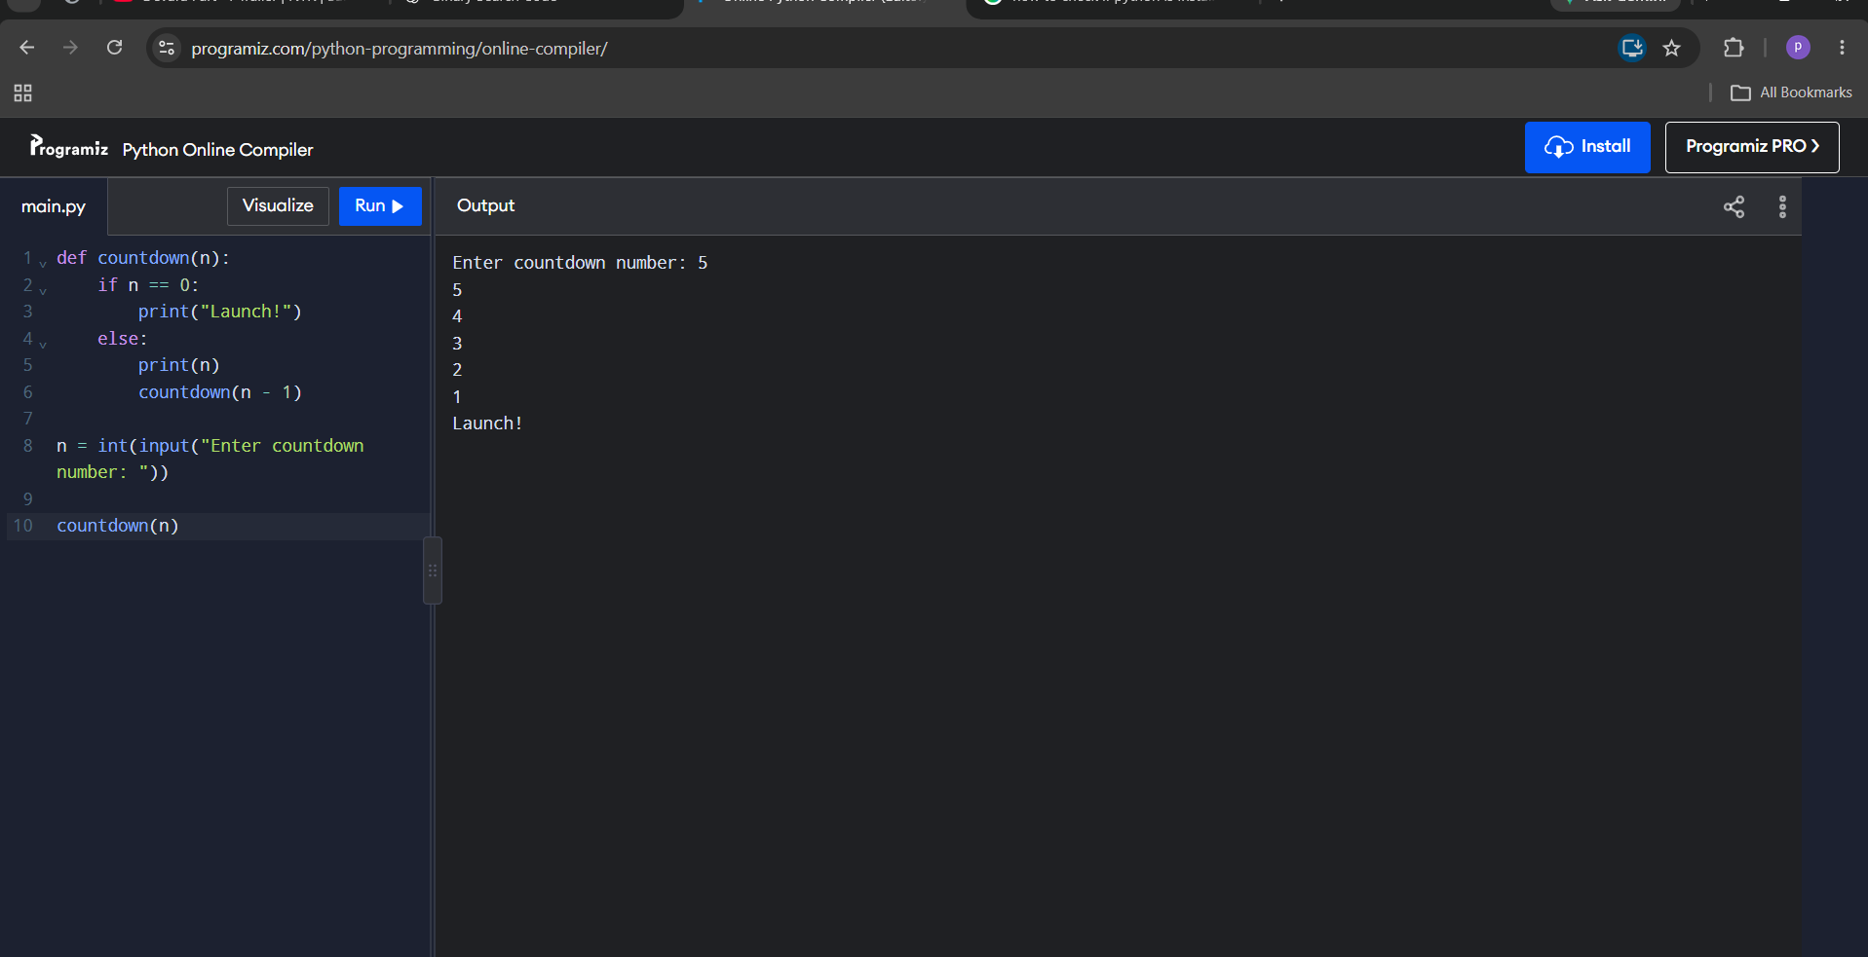

PROGRAM-1(B):
AIM: To write a recursive Python program to calculate Pⁿ (P = principal growth factor, n = number of years) for compound growth of an investment.
CODE:
def power(p, n):
if n == 0:
return 1
else:
return p * power(p, n - 1)

p = int(input("Enter principal growth factor: "))
n = int(input("Enter number of years: "))

result = power(p, n)

print("Power =", result)

OUTPUT:
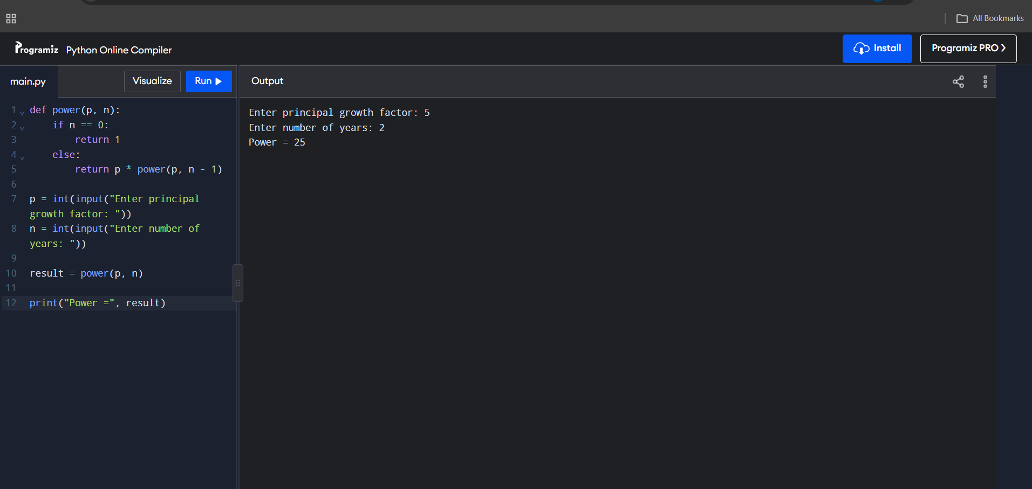
PROGRAM-1(C):
AIM: To write a recursive Python function to search for a given employee ID in a list.
CODE:
def search(arr, key, i):
if i == len(arr):
return -1

if arr[i] == key:
return i

return search(arr, key, i + 1)

arr = list(map(int, input("Enter employee IDs separated by comma: ").split(',')))

key = int(input("Enter employee ID to search: "))

result = search(arr, key, 0)

if result != -1:
print("Employee ID found at index:", result)
else:
print("Employee ID not found")

OUTPUT:
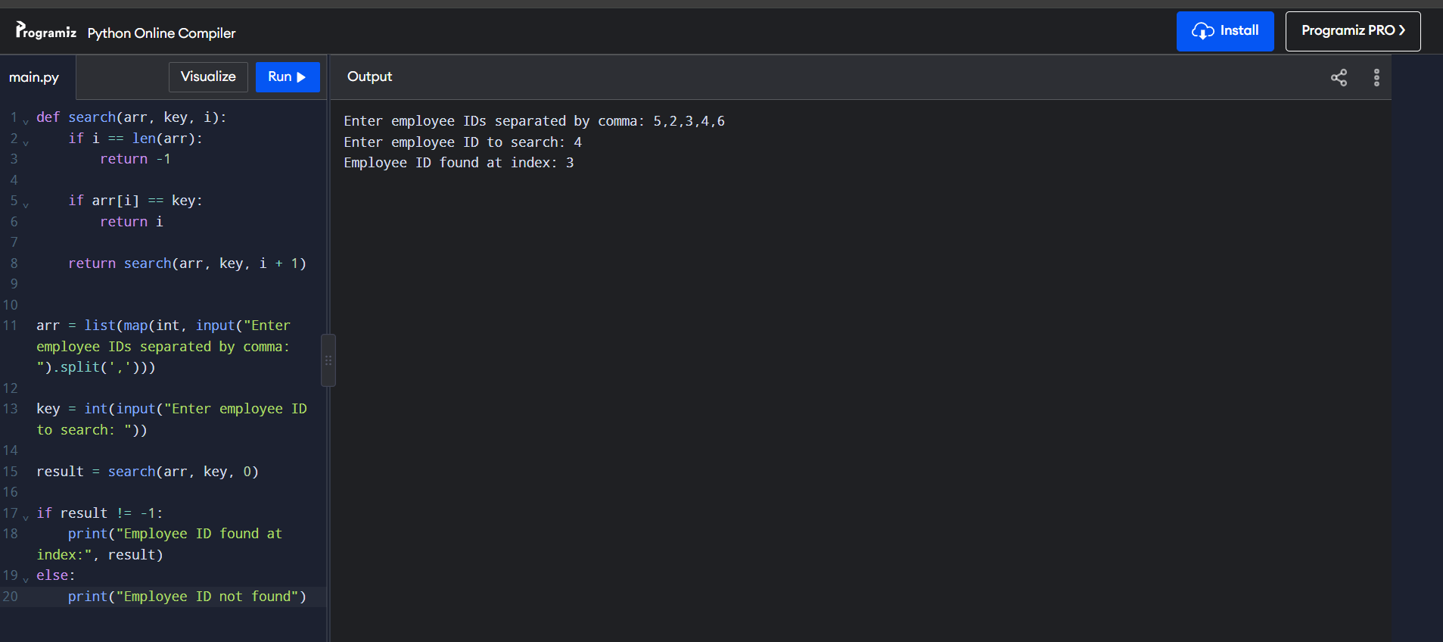

PROGRAM-1(D):
AIM: To write a recursive Python program to calculate the factorial of a given number.
CODE:
def factorial(n):
if n == 0 or n == 1:
return 1
else:
return n * factorial(n - 1)

n = int(input("Enter a number: "))

result = factorial(n)

print("Factorial =", result)

OUTPUT:
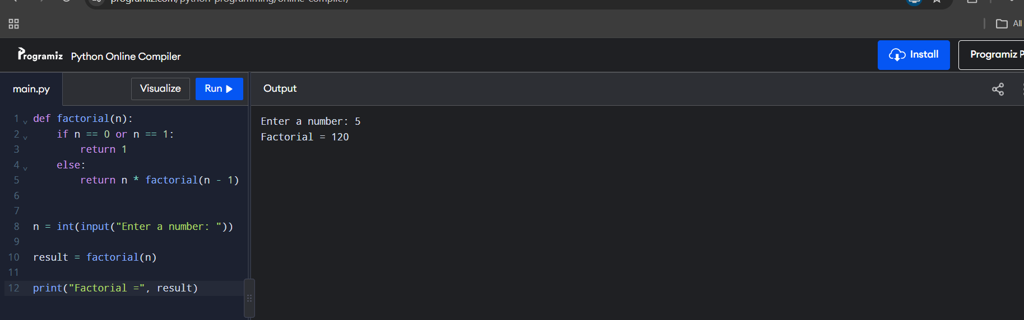

PROGRAM-1(E):
AIM: To write a recursive Python program to print the first n terms of the Fibonacci series.
CODE:
def fibonacci(n):
if n == 0:
return 0
elif n == 1:
return 1
else:
return fibonacci(n - 1) + fibonacci(n - 2)

n = int(input("Enter number of terms: "))

for i in range(n):
print(fibonacci(i), end=" ")

OUTPUT:
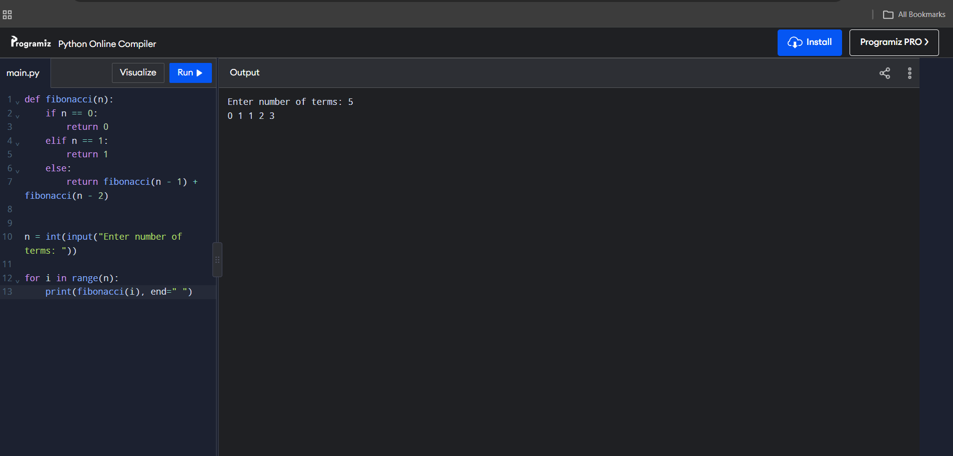
WEEK – 2
PROGRAM-2(A):
AIM: To write a Python program to implement linear search.
CODE:
def linear_search(arr,k):
for i in range(len(arr)):
if arr[i]==k:
return i
return -1
arr=list(map(int,input("Enter the array with separating by ',': ").split(',')))
k=int(input("Enter the key to be found: "))
re=linear_search(arr,k)
if re!=-1:
print(k," is found at: ", re)
else:
print("Not Found")

OUTPUT:
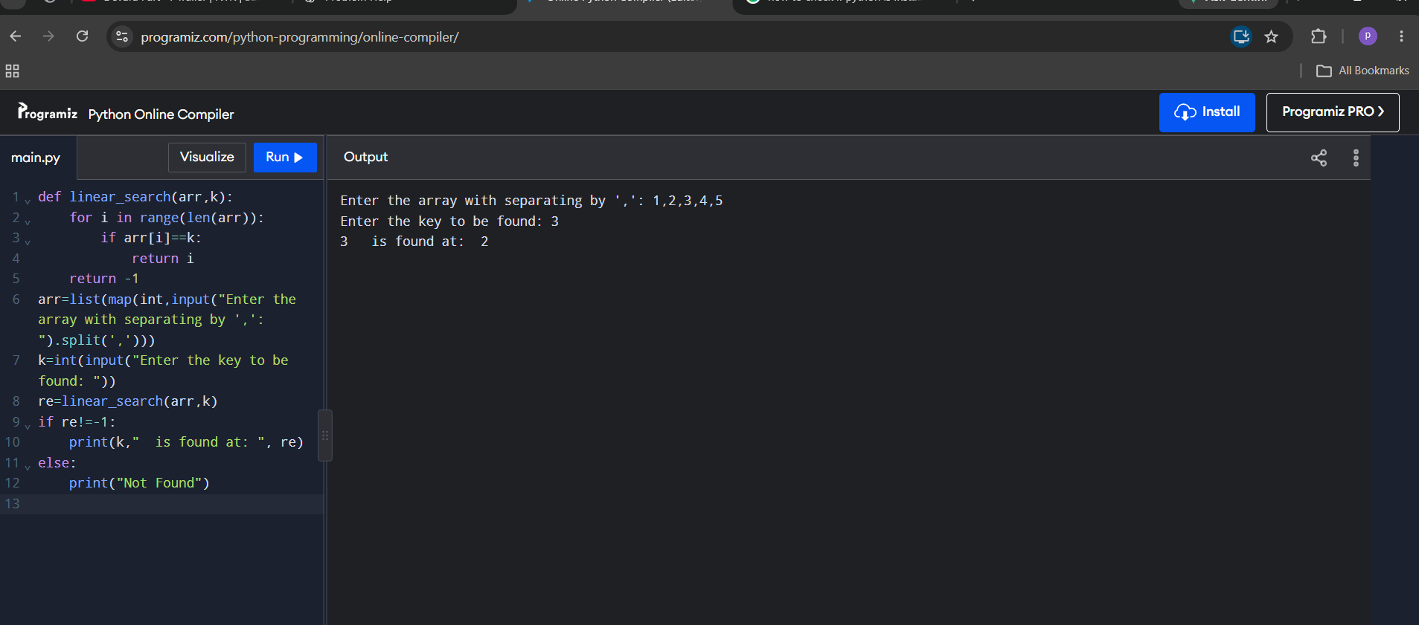
PROGRAM-2(B):
AIM: To write a Python program to implement binary search with and without a sorted array as an input.
CODE:
Binary Search (Iterative) – sorted array
def binary_search(arr,k):
lo=0
high=len(arr)-1
while lo<=high:
mid=(lo+high)//2
if arr[mid]==k:
return mid
elif arr[mid]>k:
high=mid-1
else:
lo=mid+1
return -1
arr=list(map(int,input("Enter the array with separating by ',': ").split(',')))
k=int(input("Enter the key to be found: "))
re=binary_search(arr,k)
if re!=-1:
print(k," is found at: ", re)
else:
print("Not Found")

Binary Search (Recursive) – sorted array
def binary_search(lo,high,arr,k):
if lo<=high:
mid=(lo+high)//2
if arr[mid]==k:
return mid
elif arr[mid]>k:
return binary_search(lo,mid-1,arr,k)
else:
return binary_search(mid+1,high,arr,k)
else:
return -1
arr=list(map(int,input("Enter the array with separating by ',': ").split(',')))
k=int(input("Enter the key to be found: "))
re=binary_search(0,len(arr)-1,arr,k)
if re!=-1:
print(k," is found at: ", re)
else:
print("Not Found")

Binary Search with unsorted array as input
def binary_search(arr, k):

arr.sort()

lo = 0
high = len(arr) - 1

while lo <= high:

mid = (lo + high) // 2

if arr[mid] == k:
return mid

elif arr[mid] > k:
high = mid - 1

else:
lo = mid + 1

return -1

arr = list(map(int, input("Enter array separated by comma: ").split(',')))

k = int(input("Enter the key to be found: "))

re = binary_search(arr, k)

if re != -1:
print(k, "is found at index:", re)
else:
print("Not Found")

OUTPUT:
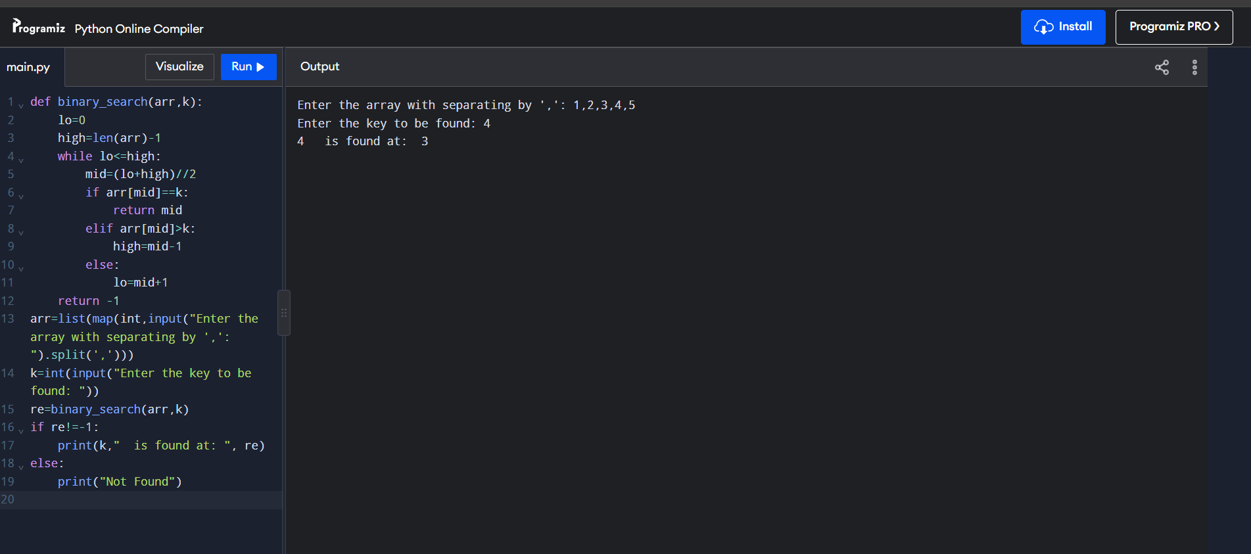
WEEK – 3
PROGRAM-3(A):
AIM: To write a Python program to implement bubble sort.
CODE:
def BubbleSort(arr):
for i in range(len(arr)-1):
for j in range(len(arr)-i-1):
if arr[j]>arr[j+1]:
arr[j],arr[j+1]=arr[j+1],arr[j]

arr=list(map(int,input("Enter Numbers split(,): ").split(',')))
BubbleSort(arr)
for i in arr:
print(i,end=" ")

OUTPUT:
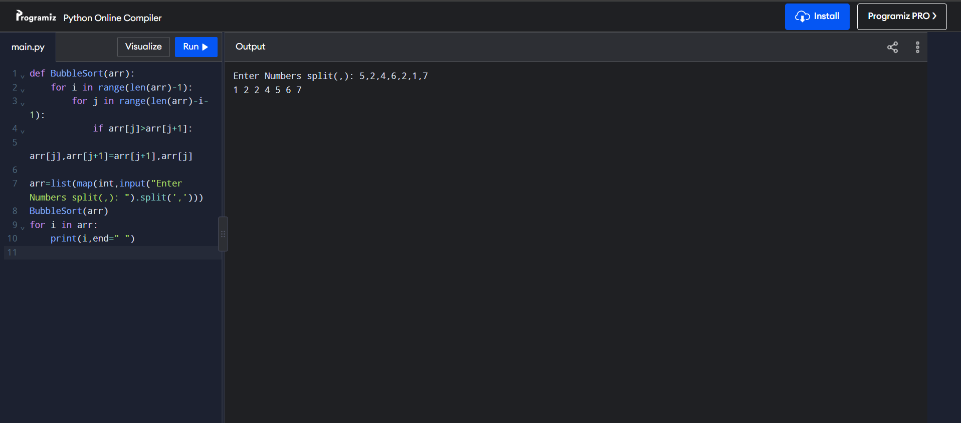
PROGRAM-3(B):
AIM: To write a Python program to implement insertion sort.
CODE:
def Insertion_Sort(arr):
for i in range(1,len(arr)):
key=arr[i]
j=i-1
while j>=0 and arr[j]>key:
arr[j+1]=arr[j]
j=j-1
arr[j+1]=key
arr=list(map(int,input("Enter Numbers split(,): ").split(',')))
Insertion_Sort(arr)
for i in arr:
print(i,end=" ")

OUTPUT:
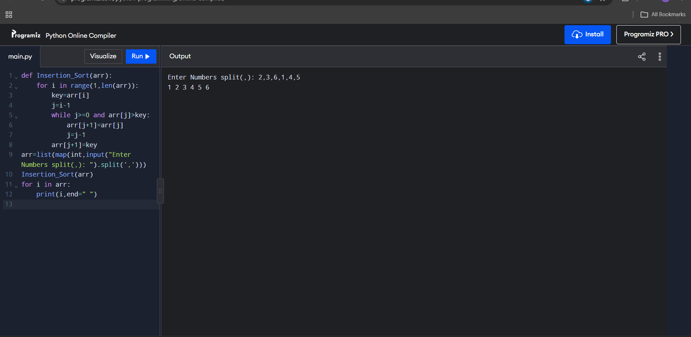
PROGRAM-3(C):
AIM: To write a Python program to implement selection sort.
CODE:
def Selection_Sort(arr):
for i in range(len(arr)-1):
min=i
for j in range(i+1,len(arr)):
if arr[j]<arr[min]:
min=j
arr[i],arr[min]=arr[min],arr[i]
arr=list(map(int,input("Enter Numbers split(,): ").split(',')))
Selection_Sort(arr)
for i in arr:
print(i,end=" ")

OUTPUT:
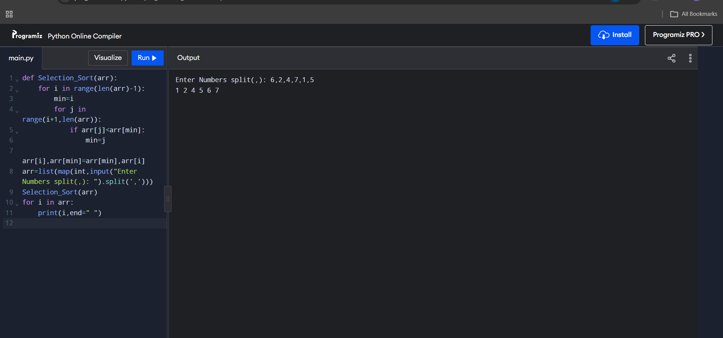
WEEK – 4
PROGRAM-4(A):
AIM: To write a Python program to implement quick sort.
CODE:
def quicksort(a, low, high):
if low < high:
i = low
j = high
pivot = low

while i < j:

while i < len(a) and a[i] <= a[pivot]:
i += 1

while a[j] > a[pivot]:
j -= 1

if i < j:
a[i], a[j] = a[j], a[i]

a[j], a[pivot] = a[pivot], a[j]

quicksort(a, low, j - 1)
quicksort(a, j + 1, high)

a = list(map(int, input("Enter numbers to sort: ").split()))

n = len(a)

quicksort(a, 0, n - 1)

print("Sorted array:")
print(a)

OUTPUT:
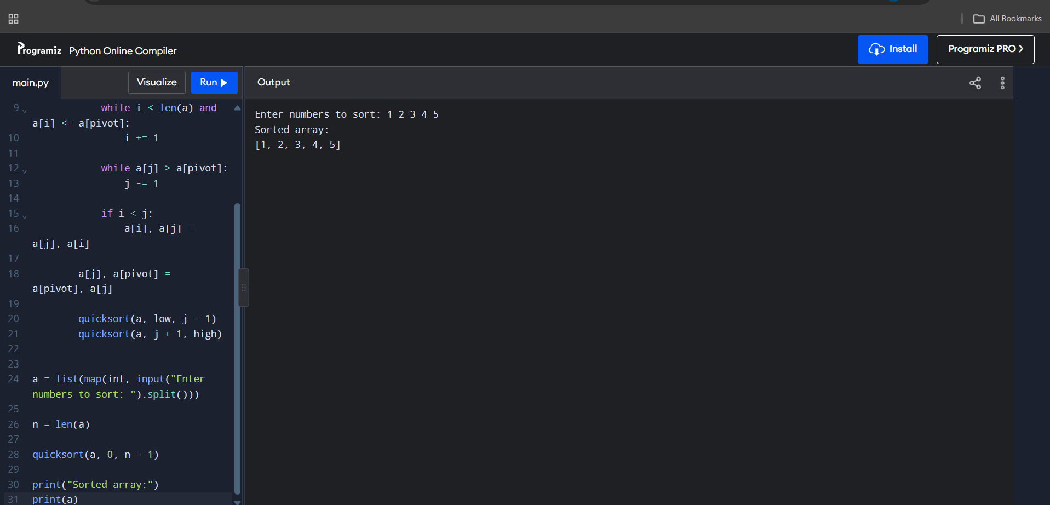
PROGRAM-4(B):
AIM: To write a Python program to implement merge sort.
CODE:
def merging(arr, low, mid, high):
result = []

i = low
j = mid + 1

while i <= mid and j <= high:
if arr[i] < arr[j]:
result.append(arr[i])
i += 1
else:
result.append(arr[j])
j += 1

while i <= mid:
result.append(arr[i])
i += 1

while j <= high:
result.append(arr[j])
j += 1

i = low
j = 0

while i <= high:
arr[i] = result[j]
i += 1
j += 1

def merge_sort(arr, low, high):
if low < high:
mid = (low + high) // 2

merge_sort(arr, low, mid)
merge_sort(arr, mid + 1, high)

merging(arr, low, mid, high)

arr = list(map(int, input("Enter numbers to sort: ").split()))

n = len(arr)

merge_sort(arr, 0, n - 1)

print("Sorted array:", arr)

OUTPUT:
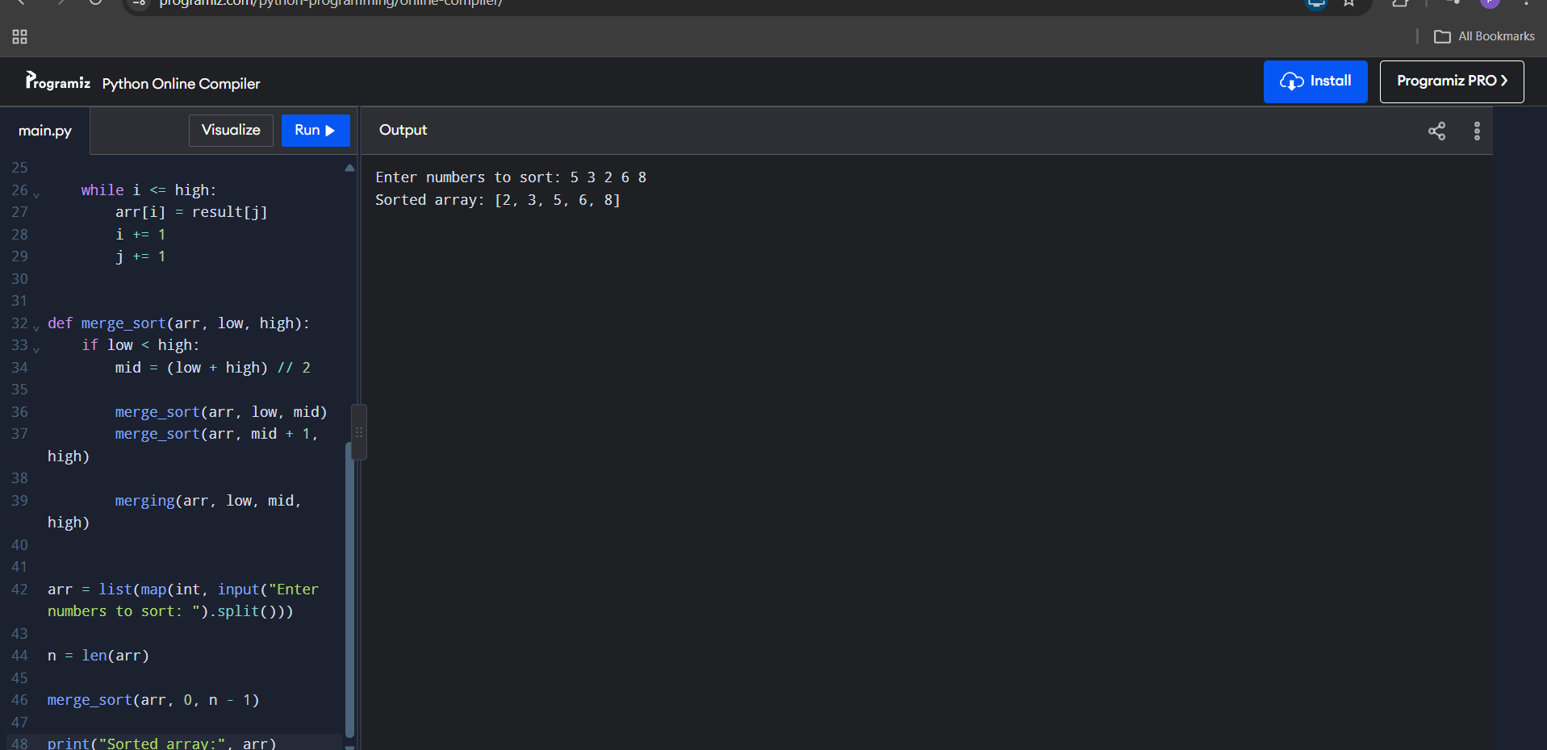

WEEK – 5
PROGRAM-5(A):
AIM: To write a Python program to implement a Singly Linked List with the operations: Create, Insert at Beginning, Insert at End, Insert at Index, Delete by Value, Delete First Node, Delete Last Node, Count number of nodes, Sort, Search, Display/Traverse and Exit.
CODE:
Part 1: Create, Insert, Delete, Count, Display
class Node:
def __init__(self, data):
self.data = data
self.next = None
class SinglyLinkedList:
def __init__(self):
self.head = None

def Create(self):
n=int(input("Enter the number of Elements: "))
for i in range(n):
x=int(input("Enter a value: "))
new=Node(x)
if self.head is None:
self.head=new
else:
temp=self.head
while temp.next:
temp=temp.next
temp.next=new

def display(self):
if self.head is None:
print("List is empty")
else:
temp=self.head
while temp:
print(temp.data,end="--> ")
temp=temp.next
print(None)

def insert_at_beg(self,data):
new=Node(data)
new.next=self.head
self.head=new

def insert_at_end(self,data):
new=Node(data)
if self.head is None:
self.head=new
else:
temp=self.head
while temp.next:
temp=temp.next
temp.next=new

def insert_index(self, index, data):
if index==0:
self.insert_at_beg(data)
return
new=Node(data)
temp=self.head
for i in range(index-1):
if temp.next is None:
print("Invalid Index")
return
temp=temp.next
new.next=temp.next
temp.next=new

def deleteAtBeg(self):
if self.head is None:
print("List is empty")
else:
temp=self.head
self.head=temp.next
print("Deleted Value is :",temp.data)

def deleteAtEnd(self):
if self.head is None:
print("List is empty")
elif self.head.next is None:
self.head=None
else:
temp=self.head
temp1=temp
while temp.next:
temp1=temp
temp=temp.next
temp1.next=None
# Delete specific value from the list
def delete(self,value):
if self.head is None:
print("List is empty")
else:
temp=self.head
if temp and temp.data==value:
self.head=temp.next
print("Value Deleted")
return
while temp and temp.data!=value:
temp=temp.next
if temp is None:
print("Value not found")
else:
temp.next=temp.next.next
print("Value Deleted")

def count(self):
count=0
temp=self.head
while temp:
count+=1
temp=temp.next
print("Number of nodes in the list:",count)

S1= SinglyLinkedList()
while True:
#Menu using match case
print("1. Create a Singly Linked List")
print("2. Display the List")
print("3. Insert at Beginning")
print("4. Insert at End")
print("5. Insert at Specific Index")
print("6. Delete from Beginning")
print("7. Delete from End")
print("8. Delete Specific Value")
print("9. Count Nodes")
print("10. Exit")
choice=int(input("Enter your choice: "))
match choice:
case 1:
S1.Create()
case 2:
S1.display()
case 3:
data=int(input("Enter a value to insert at beginning: "))
S1.insert_at_beg(data)
case 4:
data=int(input("Enter a value to insert at end: "))
S1.insert_at_end(data)
case 5:
index=int(input("Enter the index to insert: "))
data=int(input("Enter a value to insert: "))
S1.insert_index(index,data)
case 6:
S1.deleteAtBeg()
case 7:
S1.deleteAtEnd()
case 8:
value=int(input("Enter the value to delete: "))
S1.delete(value)
case 9:
S1.count()
case 10:
break
case _:
print("Invalid Choice")

Part 2: Search and Sort
class Node:
def __init__(self,data):
self.data=data
self.next=None

class SinglyLinkedList:
def __init__(self):
self.head=None

def Create(self):
n=int(input("Enter number of elements: "))
for i in range(n):
x=int(input("Enter a value"))
new=Node(x)
if self.head is None:
self.head=new
else:
temp=self.head
while temp.next:
temp=temp.next
temp.next=new
#k=target
def search(self,k):
if self.head is None:
print("Cannot perform search")
return
temp=self.head
while temp:
if temp.data==k:
print(f"{k} is found ")
return
temp=temp.next
print(f"{k} not found")

def display(self):
if self.head is None:
print("No data")
return
temp=self.head
while temp:
print(temp.data,end='-->')
temp=temp.next
print("None")

def sort(self):
if self.head is None:
print("Cannot perform sorting")
return
i=self.head
while i:
j=i.next
while j:
if i.data>j.data:
i.data,j.data=j.data,i.data
j=j.next
i=i.next
print("Sorting Completed")

s11=SinglyLinkedList()

while True:
print('1.Create a Linkedlist')
print('2.Display')
print('3.Search ')
print('4.Sort')
print('5.exit')
n=int(input("Enter your choice: "))
match(n):
case 1:
s11.Create()
case 2:
s11.display()
case 3:
n=int(input("Enter your target: "))
s11.search(n)
case 4:
s11.sort()
case 5:
break;
case _:
print("Invalid Choice")
OUTPUT: 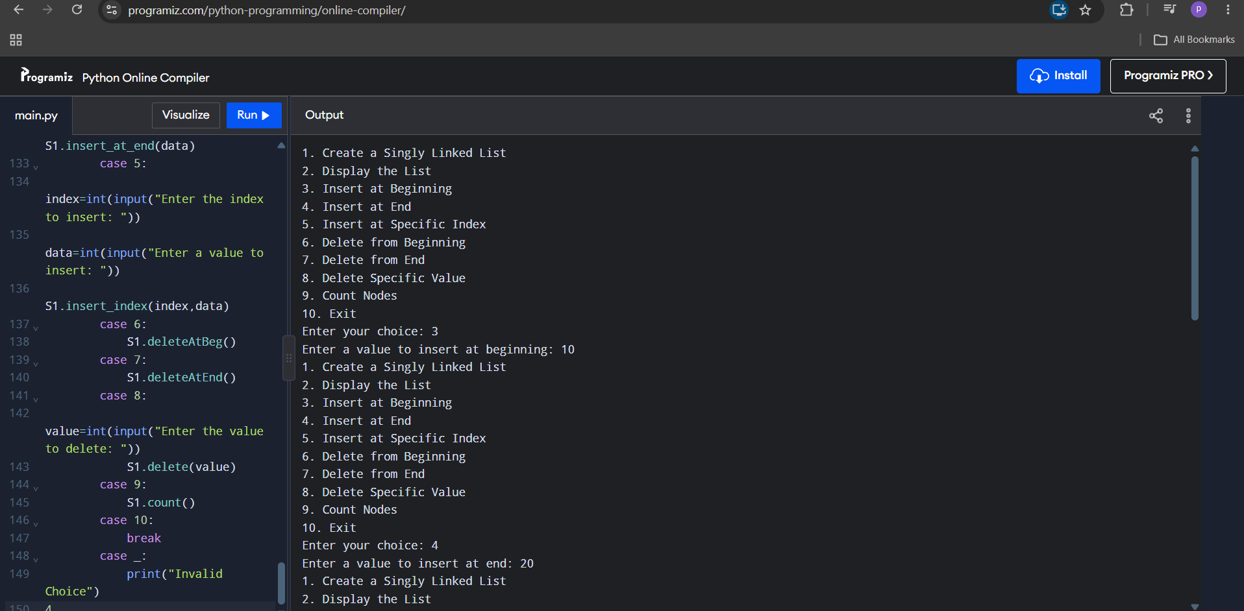
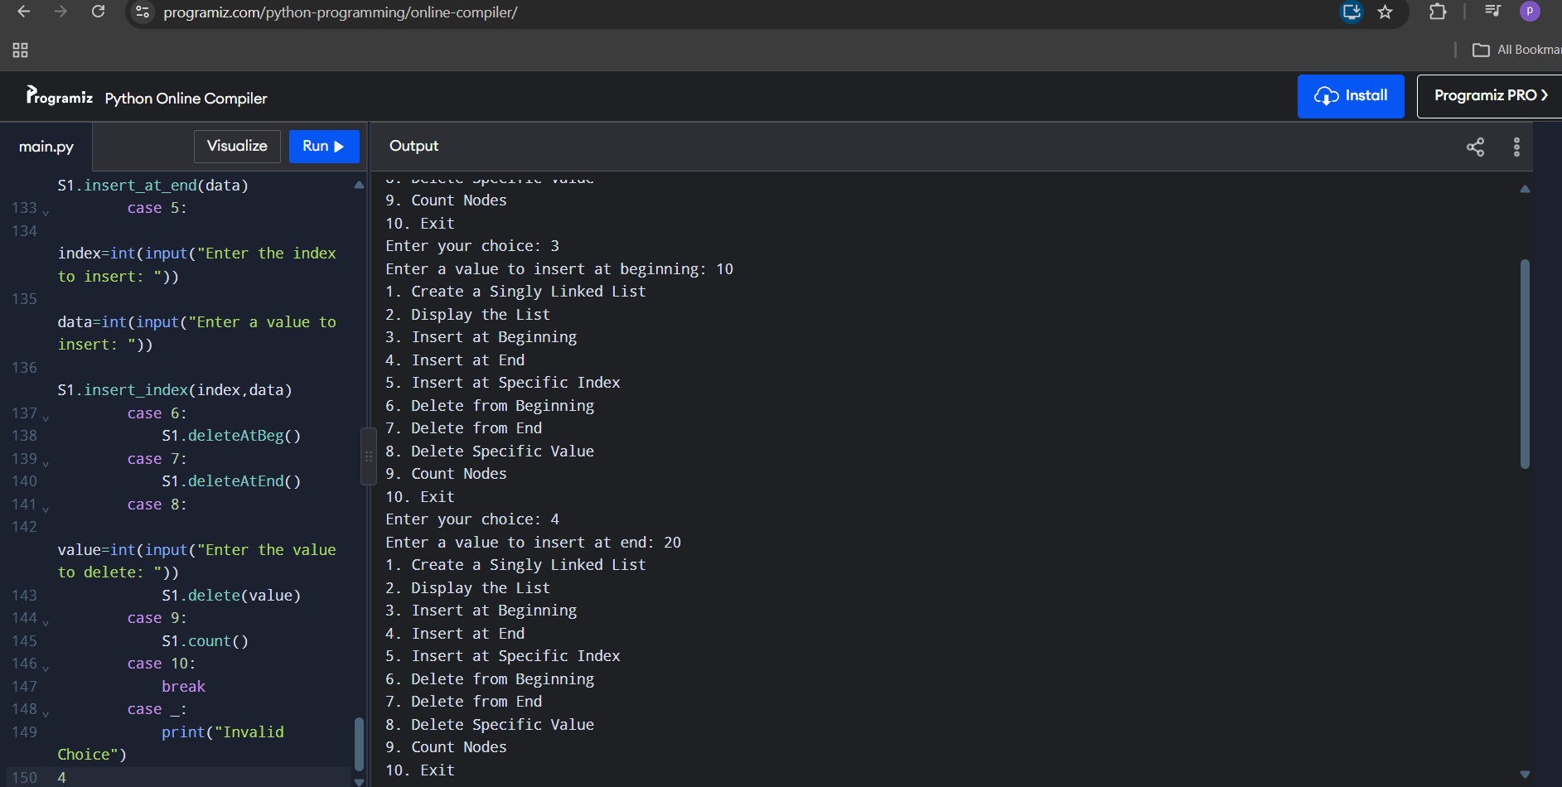

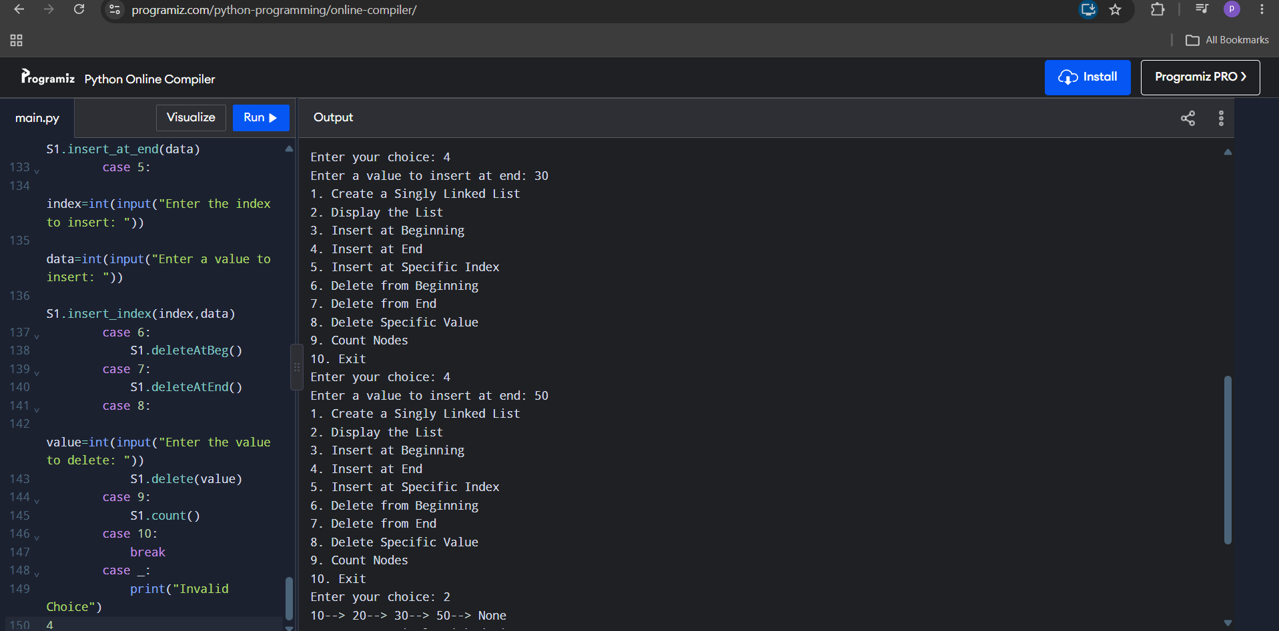
WEEK – 6
PROGRAM-6:
AIM: To write a Python program to implement a Doubly Linked List with the operations: Create, Insert at Beginning, Insert at End, Insert at Index, Delete by Value, Delete First Node, Delete Last Node, Count number of nodes, Display/Traverse and Exit.
CODE:

class Node:
def __init__(self, data):
self.prev = None
self.data = data
self.next = None

class DoublyLinkedList:
def __init__(self):
self.head = None

# 1. Insert at Beginning
def insert_begin(self, data):
new = Node(data)

if self.head is None:
self.head = new
else:
new.next = self.head
self.head.prev = new
self.head = new

print("Insertion Completed")

# 2. Insert at End
def insert_end(self, data):
new = Node(data)

if self.head is None:
self.head = new
else:
temp = self.head

while temp.next:
temp = temp.next

temp.next = new
new.prev = temp

print("Insertion Completed")

# 3. Insert at Specific Position (Index)
def insert_index(self, index, data):
if index < 0:
print("Invalid Index")

elif index == 0:
self.insert_begin(data)
return

else:
new = Node(data)
temp = self.head

for i in range(index - 1):
if temp is None:
print("Invalid Index")
return
temp = temp.next

if temp is None:
print("Invalid Index")
return

new.next = temp.next
new.prev = temp

if temp.next:
temp.next.prev = new

temp.next = new

print("Insertion Completed")

# 4. Delete at Beginning
def delete_begin(self):
if self.head is None:
print("Can't perform delete operation")

elif self.head.next is None:
self.head = None
print("Value Deleted")

else:
self.head.next.prev = None
self.head = self.head.next
print("Value Deleted")

# 5. Delete at End
def delete_end(self):
if self.head is None:
print("Can't perform delete operation")

elif self.head.next is None:
self.head = None
print("Value Deleted")

else:
temp = self.head

while temp.next:
temp = temp.next

temp.prev.next = None
temp.prev = None

print("Value Deleted")

# 6. Delete at Specific Position (Index)
def delete_index(self, index):
if self.head is None:
print("Can't perform delete operation")

elif index < 0:
print("Invalid Index")

elif index == 0:
self.delete_begin()

else:
temp = self.head

for i in range(index):
if temp is None:
print("Invalid Index")
return
temp = temp.next

if temp is None:
print("Invalid Index")

elif temp.next:
temp.next.prev = temp.prev
temp.prev.next = temp.next
print("Value Deleted")

else:
temp.prev.next = None
temp.prev = None
print("Value Deleted")

# 7. Forward Display
def display_fwd(self):
temp = self.head

if temp is None:
print("List is Empty")
return

while temp:
print(temp.data, end=" <-> ")
temp = temp.next

print("None")

# 8. Backward Display
def display_bwd(self):
if self.head is None:
print("List is Empty")
return

temp = self.head

while temp.next:
temp = temp.next

while temp:
print(temp.data, end=" <-> ")
temp = temp.prev

print("None")

# Main Menu
dll = DoublyLinkedList()

while True:
print("\n----- DOUBLY LINKED LIST MENU -----")
print("1. Insert at Beginning")
print("2. Insert at End")
print("3. Insert at Specific Position")
print("4. Delete at Beginning")
print("5. Delete at End")
print("6. Delete at Specific Position")
print("7. Display Forward")
print("8. Display Backward")
print("9. Exit")

choice = int(input("Enter your choice: "))

if choice == 1:
data = int(input("Enter data: "))
dll.insert_begin(data)

elif choice == 2:
data = int(input("Enter data: "))
dll.insert_end(data)

elif choice == 3:
pos = int(input("Enter index: "))
data = int(input("Enter data: "))
dll.insert_index(pos, data)

elif choice == 4:
dll.delete_begin()

elif choice == 5:
dll.delete_end()

elif choice == 6:
pos = int(input("Enter index: "))
dll.delete_index(pos)

elif choice == 7:
dll.display_fwd()

elif choice == 8:
dll.display_bwd()

elif choice == 9:
print("Exiting Program")
break

else:
print("Invalid Choice")

OUTPUT:
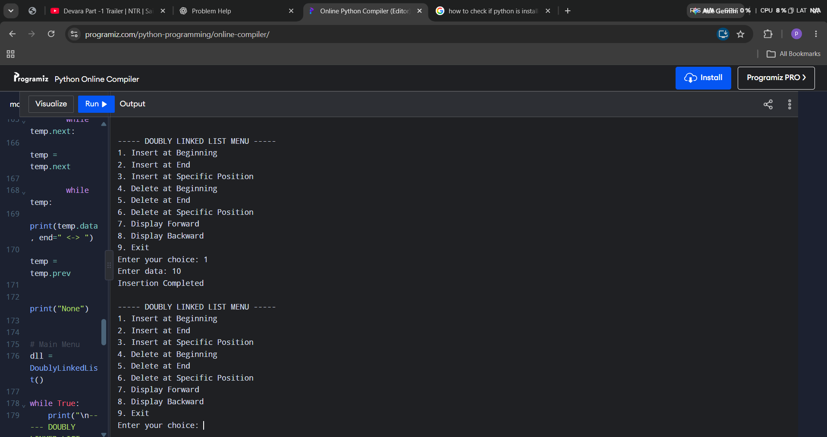

WEEK – 7
PROGRAM-7(A):
AIM: To write a Python program to implement stack operations such as push, pop, peek and display using an array.
CODE:

class Stack:
def __init__(self, size):
self.size = size
self.stack = [None] * size
self.top = -1

# PUSH
def push(self, item):
if self.top == self.size - 1:
print("Stack Overflow")
else:
self.top += 1
self.stack[self.top] = item
print(item, "inserted")

# POP
def pop(self):
if self.top == -1:
print("Stack Underflow")
else:
item = self.stack[self.top]
self.top -= 1
print("Deleted value =", item)

# PEEK
def peek(self):
if self.top == -1:
print("Stack is Empty")
else:
print("Top element =", self.stack[self.top])

# DISPLAY
def display(self):
if self.top == -1:
print("Stack is Empty")
else:
print("Stack elements:")
for i in range(self.top, -1, -1):
print(self.stack[i])

# Main Program
size = int(input("Enter stack size: "))
s = Stack(size)

while True:
print("\n1. Push")
print("2. Pop")
print("3. Peek")
print("4. Display")
print("5. Exit")

choice = int(input("Enter choice: "))

if choice == 1:
item = int(input("Enter element: "))
s.push(item)

elif choice == 2:
s.pop()

elif choice == 3:
s.peek()

elif choice == 4:
s.display()

elif choice == 5:
print("Exiting...")
break

else:
print("Invalid Choice")

OUTPUT: 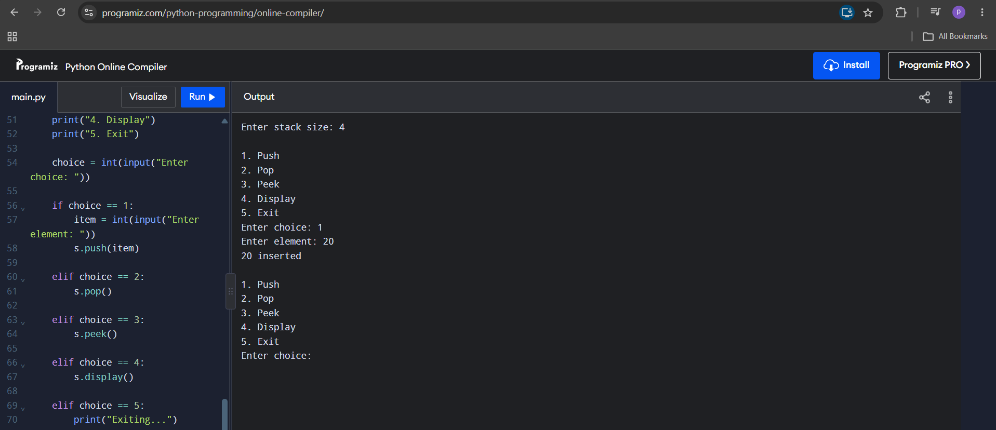

PROGRAM-7(B):
AIM: To write a Python program to implement stack operations such as push, pop, peek and display using a linked list.
CODE:

class Node:
def __init__(self, data):
self.data = data
self.next = None

class Stack:
def __init__(self):
self.top = None

# PUSH
def push(self, data):
new = Node(data)
new.next = self.top
self.top = new
print(data, "inserted")

# POP
def pop(self):
if self.top is None:
print("Stack Underflow")
else:
temp = self.top
print(temp.data, "popped from stack")
self.top = self.top.next

# PEEK
def peek(self):
if self.top is None:
print("Stack is Empty")
else:
print("Top element =", self.top.data)

# DISPLAY
def display(self):
if self.top is None:
print("Stack is Empty")
else:
temp = self.top
print("Stack elements:")

while temp:
print(temp.data)
temp = temp.next

# Main Program
s = Stack()

while True:
print("\n1. Push")
print("2. Pop")
print("3. Peek")
print("4. Display")
print("5. Exit")

choice = int(input("Enter choice: "))

if choice == 1:
data = int(input("Enter element: "))
s.push(data)

elif choice == 2:
s.pop()

elif choice == 3:
s.peek()

elif choice == 4:
s.display()

elif choice == 5:
print("Exiting...")
break

else:
print("Invalid Choice")

OUTPUT:
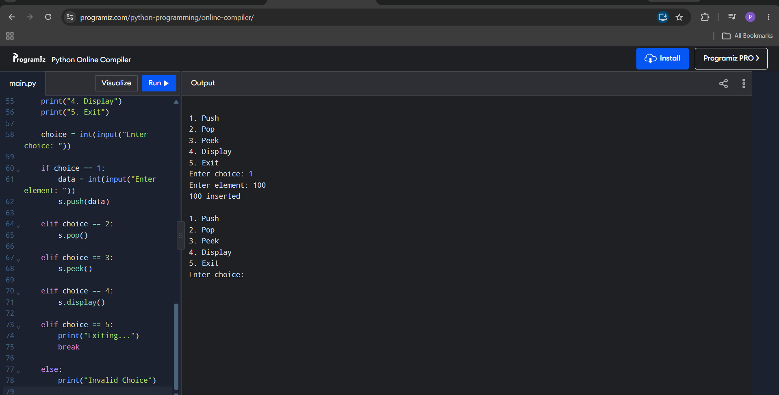
WEEK – 8
PROGRAM-8(A):
AIM: To write a Python program to implement a Queue and its operations such as enqueue, dequeue, peek and display with a menu driven approach, using array and linked list data structures.
CODE:
Queue using array
class Queue:
def __init__(self, size):
self.size = size
self.queue = [None] * size
self.front = -1
self.rear = -1

# ENQUEUE
def enqueue(self, data):
if self.rear == self.size - 1:
print("Queue Overflow")

elif self.front == -1 and self.rear == -1:
self.front = 0
self.rear = 0
self.queue[self.rear] = data
print(data, "inserted")

else:
self.rear += 1
self.queue[self.rear] = data
print(data, "inserted")

# DEQUEUE
def dequeue(self):
if self.front == -1 or self.front > self.rear:
print("Queue Underflow")

else:
item = self.queue[self.front]
print("Deleted element =", item)
self.front += 1

if self.front > self.rear:
self.front = -1
self.rear = -1

# PEEK
def peek(self):
if self.front == -1:
print("Queue is Empty")
else:
print("Front element =", self.queue[self.front])

# DISPLAY
def display(self):
if self.front == -1:
print("Queue is Empty")
else:
print("Queue elements:")
for i in range(self.front, self.rear + 1):
print(self.queue[i], end=" ")
print()

# Main Program
size = int(input("Enter queue size: "))
q = Queue(size)

while True:
print("\n----- QUEUE USING ARRAY -----")
print("1. Enqueue")
print("2. Dequeue")
print("3. Peek")
print("4. Display")
print("5. Exit")

choice = int(input("Enter choice: "))

if choice == 1:
data = int(input("Enter element: "))
q.enqueue(data)

elif choice == 2:
q.dequeue()

elif choice == 3:
q.peek()

elif choice == 4:
q.display()

elif choice == 5:
print("Exiting...")
break

else:
print("Invalid Choice")

Queue using linked list

class Node:
def __init__(self, data):
self.data = data
self.next = None

class Queue:
def __init__(self):
self.front = None
self.rear = None

# ENQUEUE
def enqueue(self, data):
new = Node(data)

if self.front is None:
self.front = new
self.rear = new

else:
self.rear.next = new
self.rear = new

print(data, "inserted")

# DEQUEUE
def dequeue(self):
if self.front is None:
print("Queue Underflow")

else:
temp = self.front
print("Deleted element =", temp.data)

self.front = self.front.next

if self.front is None:
self.rear = None

# PEEK
def peek(self):
if self.front is None:
print("Queue is Empty")
else:
print("Front element =", self.front.data)

# DISPLAY
def display(self):
if self.front is None:
print("Queue is Empty")

else:
temp = self.front

print("Queue elements:")

while temp:
print(temp.data, end=" -> ")
temp = temp.next

print("None")

# Main Program
q = Queue()

while True:
print("\n----- QUEUE USING LINKED LIST -----")
print("1. Enqueue")
print("2. Dequeue")
print("3. Peek")
print("4. Display")
print("5. Exit")

choice = int(input("Enter choice: "))

if choice == 1:
data = int(input("Enter element: "))
q.enqueue(data)

elif choice == 2:
q.dequeue()

elif choice == 3:
q.peek()

elif choice == 4:
q.display()

elif choice == 5:
print("Exiting...")
break

else:
print("Invalid Choice")

OUTPUT:
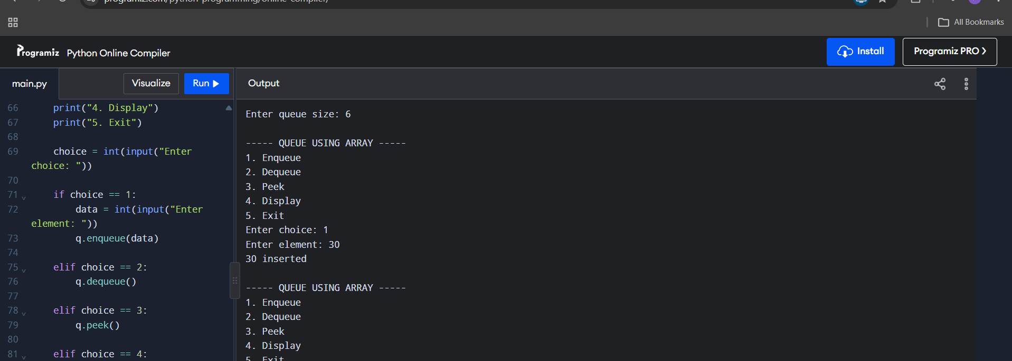
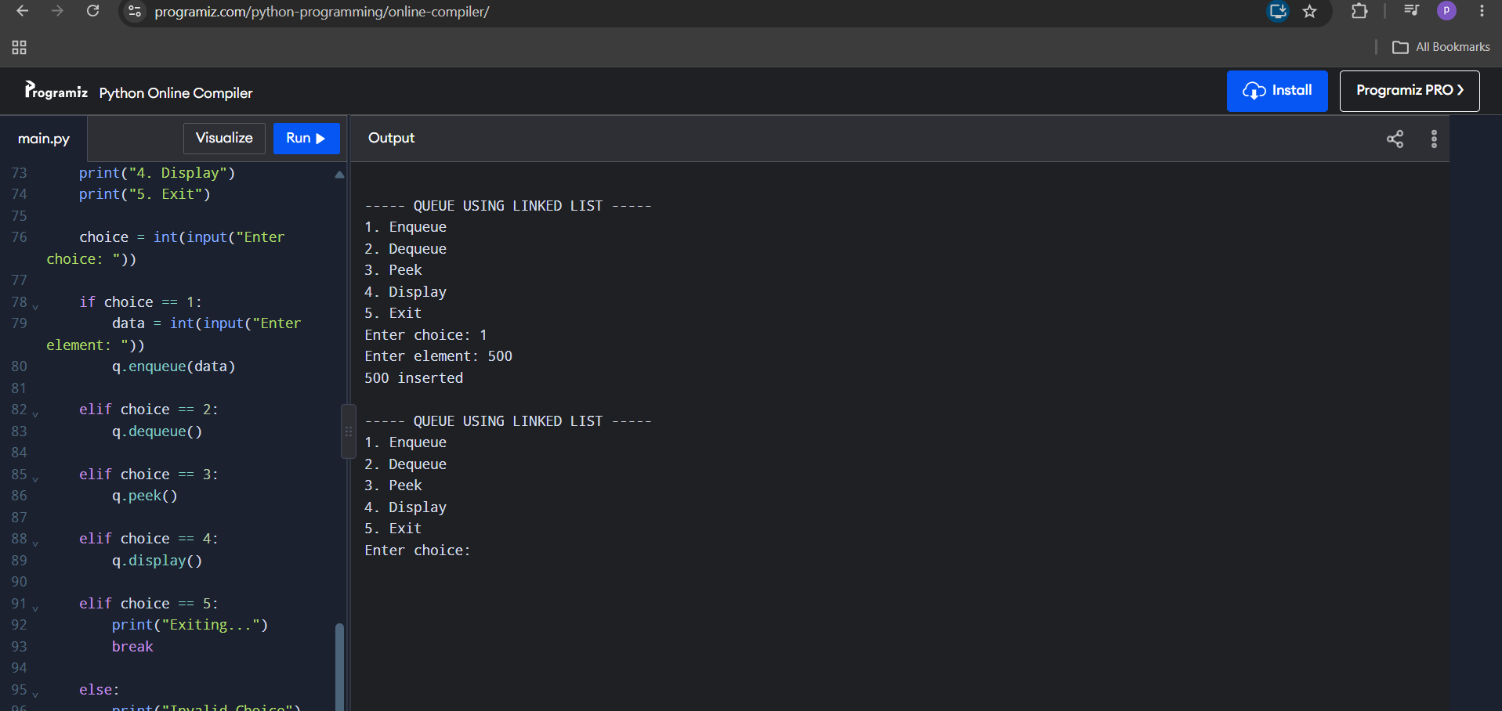
PROGRAM-8(B):
AIM: To write a Python program to implement a Circular Queue and its operations such as enqueue, dequeue, peek and display with a menu driven approach, using array and linked list data structures.
CODE:
Circular Queue using array
class CircularQueue:
def __init__(self, size):
self.size = size
self.queue = [None] * size
self.front = -1
self.rear = -1

def enqueue(self, item):
if (self.rear + 1) % self.size == self.front:
print("Queue Overflow")
elif self.front == -1:
self.front = 0
self.rear = 0
self.queue[self.rear] = item
print(item, "inserted into the queue")
else:
self.rear = (self.rear + 1) % self.size
self.queue[self.rear] = item
print(item, "inserted into the queue")

def dequeue(self):
if self.front == -1:
print("Queue Underflow")
# Only one element is present
elif self.front == self.rear:
item = self.queue[self.front]
self.queue[self.front] = None
self.front = -1
self.rear = -1
print(item, "deleted from the queue")
# More than one element
else:
item = self.queue[self.front]
self.queue[self.front] = None
self.front = (self.front + 1) % self.size
print(item, "deleted from the queue")

# Display operation
def display(self):
if self.front == -1:
print("Queue is empty")
else:
print("The elements of the queue are:")
i = self.front
while True:
print(self.queue[i])
if i == self.rear:
break
i = (i + 1) % self.size

# Create Circular Queue
size = int(input("Enter the size of the queue: "))
q = CircularQueue(size)
while True:
print("\n----- CIRCULAR QUEUE MENU -----")
print("1. Enqueue")
print("2. Dequeue")
print("3. Display")
print("4. Exit")
choice = int(input("Enter your choice: "))
if choice == 1:
item = int(input("Enter the element to enqueue: "))
q.enqueue(item)
elif choice == 2:
q.dequeue()
elif choice == 3:
q.display()
elif choice == 4:
print("Program terminated.")
break
else:
print("Invalid choice")

Circular Queue using linked list

class Node:
def __init__(self, data):
self.data = data
self.next = None

class CircularQueue:
def __init__(self):
self.front = None
self.rear = None

# ENQUEUE
def enqueue(self, data):
new = Node(data)

if self.front is None:
self.front = new
self.rear = new
new.next = self.front

else:
self.rear.next = new
self.rear = new
self.rear.next = self.front

print(data, "inserted")

# DEQUEUE
def dequeue(self):
if self.front is None:
print("Queue Underflow")

elif self.front == self.rear:
print("Deleted element =", self.front.data)
self.front = None
self.rear = None

else:
temp = self.front
print("Deleted element =", temp.data)

self.front = self.front.next
self.rear.next = self.front

# PEEK
def peek(self):
if self.front is None:
print("Queue is Empty")
else:
print("Front element =", self.front.data)

# DISPLAY
def display(self):
if self.front is None:
print("Queue is Empty")

else:
temp = self.front

print("Queue elements:")

while True:
print(temp.data, end=" -> ")
temp = temp.next

if temp == self.front:
break

print("(Back to Front)")

# Main Program
q = CircularQueue()

while True:
print("\n----- CIRCULAR QUEUE USING LL -----")
print("1. Enqueue")
print("2. Dequeue")
print("3. Peek")
print("4. Display")
print("5. Exit")

choice = int(input("Enter choice: "))

if choice == 1:
data = int(input("Enter element: "))
q.enqueue(data)

elif choice == 2:
q.dequeue()

elif choice == 3:
q.peek()

elif choice == 4:
q.display()

elif choice == 5:
print("Exiting...")
break

else:
print("Invalid Choice")

OUTPUT:
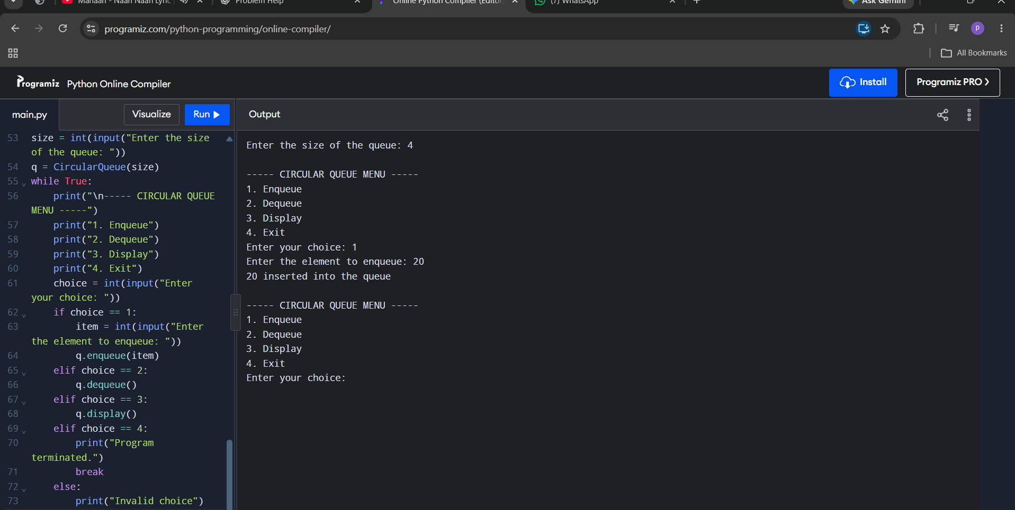
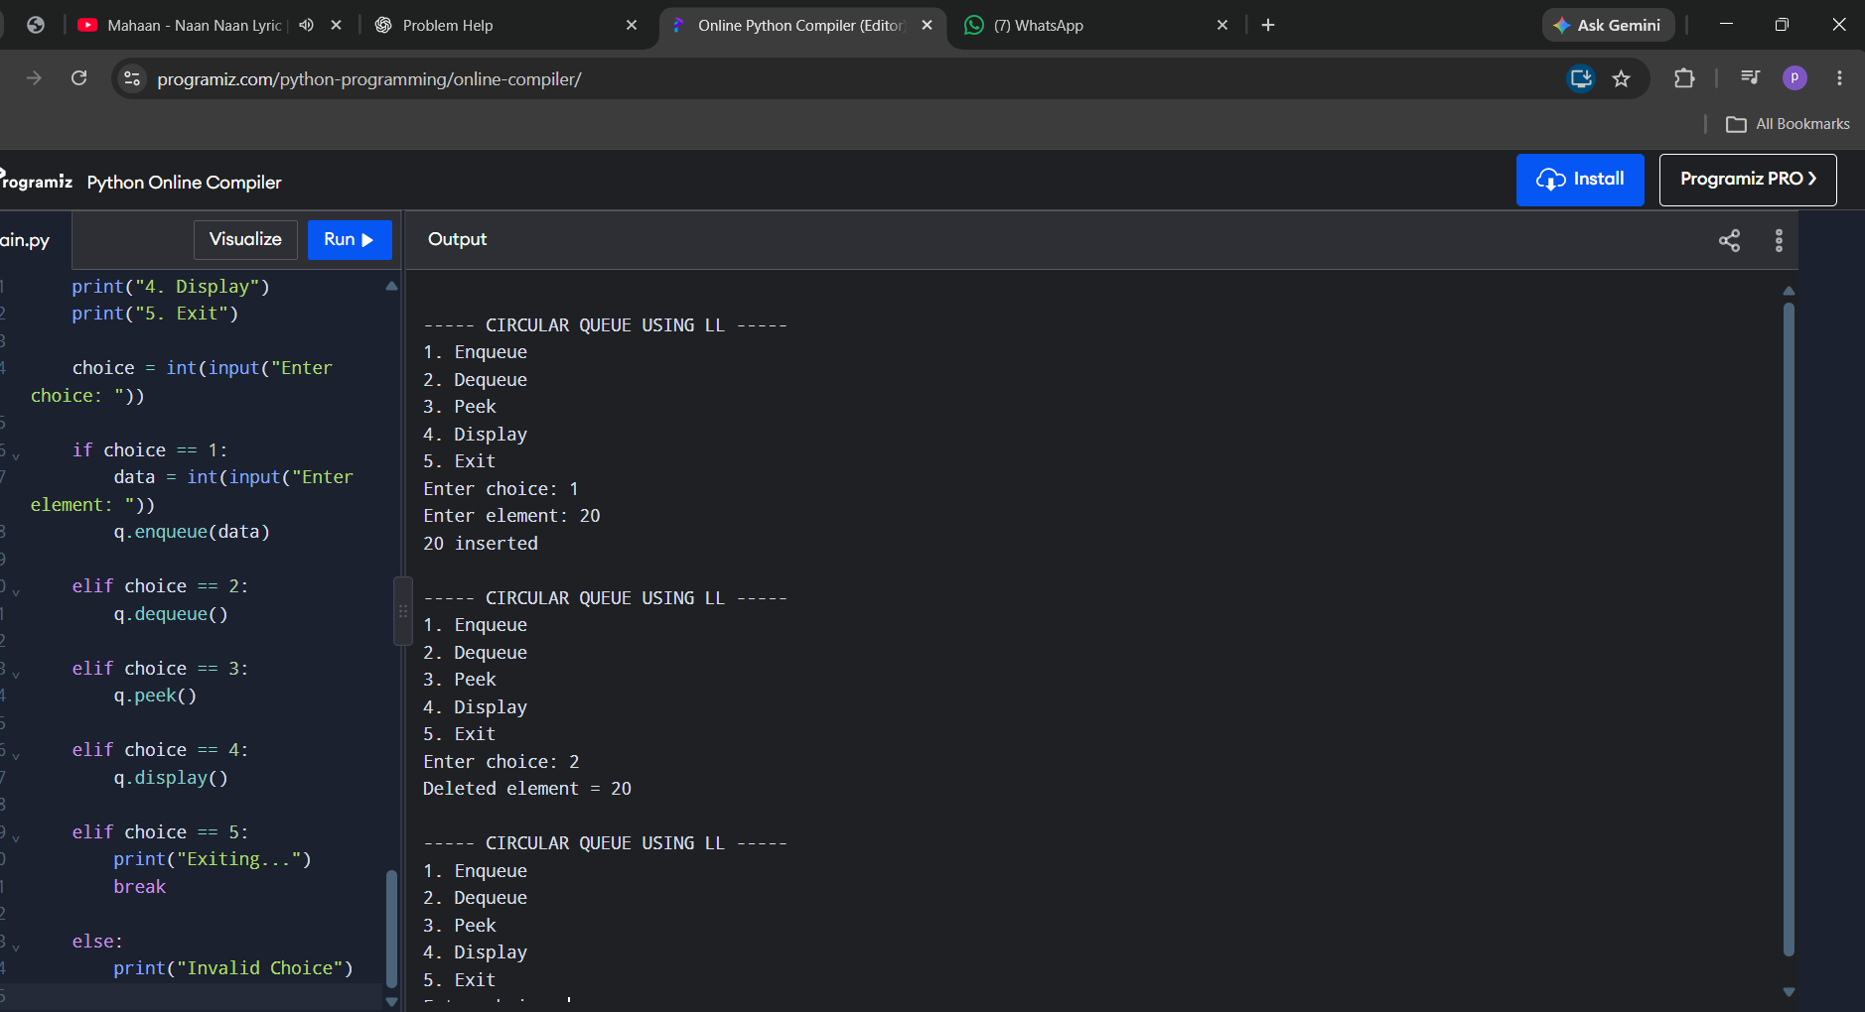
WEEK – 9
PROGRAM-9:
AIM: To write a Python program to implement a Binary Search Tree (BST) and perform Insertion, Deletion, Tree Traversals (in-order, pre-order, post-order), Count Leaf Nodes, Count Internal Nodes and find the Height of the tree.
CODE:
class Node:
def __init__(self, data):
self.data = data
self.left = None
self.right = None

def insert(root, x):
if root is None:
return Node(x)
if x < root.data:
root.left = insert(root.left, x)
elif x > root.data:
root.right = insert(root.right, x)
else:
print("Duplicate value is not allowed.")
return root

def inorder(root):
if root is None:
return
inorder(root.left)
print(root.data, end=" ")
inorder(root.right)

def preorder(root):
if root is None:
return
print(root.data, end=" ")
preorder(root.left)
preorder(root.right)

def postorder(root):
if root is None:
return
postorder(root.left)
postorder(root.right)
print(root.data, end=" ")

def find_min(root):
if root is None:
return None
while root.left is not None:
root = root.left
return root

def find_max(root):
if root is None:
return None
while root.right is not None:
root = root.right
return root

def search(root, data):
if root is None:
return None
if data < root.data:
return search(root.left, data)
elif data > root.data:
return search(root.right, data)
else:
return root

def count_nodes(root):
if root is None:
return 0
return count_nodes(root.left) + count_nodes(root.right) + 1

def count_leaves(root):
if root is None:
return 0
if root.left is None and root.right is None:
return 1
return count_leaves(root.left) + count_leaves(root.right)

def count_internal(root):
if root is None:
return 0
if root.left is None and root.right is None:
return 0
return count_internal(root.left) + count_internal(root.right) + 1

def height(root):
if root is None:
return -1
left_height = height(root.left)
right_height = height(root.right)
return max(left_height, right_height) + 1

def delete(root, x):
if root is None:
print("Element not found.")
return None
if x < root.data:
root.left = delete(root.left, x)
elif x > root.data:
root.right = delete(root.right, x)
else:
# Case 1: Node has no children
if root.left is None and root.right is None:
root = None
# Case 2: Node has only right child
elif root.left is None:
root = root.right
# Case 3: Node has only left child
elif root.right is None:
root = root.left
# Case 4: Node has two children
else:
successor = find_min(root.right)
root.data = successor.data
root.right = delete(root.right, successor.data)
return root

def print_level(root, level):
if root is None:
return
if level == 0:
print(root.data, end=" ")
else:
print_level(root.left, level - 1)
print_level(root.right, level - 1)

def level_order(root):
h = height(root)
for level in range(h):
print_level(root, level)

# =====================================================
# MAIN PROGRAM
# =====================================================

root = None
while True:
print("\n\n******** BINARY SEARCH TREE ********")
print("1. INSERT")
print("2. PREORDER TRAVERSAL")
print("3. INORDER TRAVERSAL")
print("4. POSTORDER TRAVERSAL")
print("5. FIND MINIMUM")
print("6. FIND MAXIMUM")
print("7. SEARCH")
print("8. DELETE")
print("9. COUNT NODES")
print("10. COUNT LEAVES")
print("11. COUNT INTERNAL NODES")
print("12. HEIGHT")
print("13. LEVEL ORDER TRAVERSAL")
print("14. EXIT")

choice = int(input("Enter your choice: "))
if choice == 1:
data = int(input("Enter the data to be inserted: "))
root = insert(root, data)
print("Element inserted successfully.")
elif choice == 2:
print("Preorder Traversal:", end=" ")
if root is None:
print("Tree is empty.")
else:
preorder(root)
print()
elif choice == 3:
print("Inorder Traversal:", end=" ")
if root is None:
print("Tree is empty.")
else:
inorder(root)
print()
elif choice == 4:
print("Postorder Traversal:", end=" ")
if root is None:
print("Tree is empty.")
else:
postorder(root)
print()
elif choice == 5:
node = find_min(root)
if node is None:
print("Tree is empty.")
else:
print("Minimum element:", node.data)
elif choice == 6:
node = find_max(root)
if node is None:
print("Tree is empty.")
else:
print("Maximum element:", node.data)
elif choice == 7:
data = int(input("Enter the data to be searched: "))
node = search(root, data)
if node is None:
print("Element", data, "is not found.")
else:
print("Element", data, "is found.")
elif choice == 8:
data = int(input("Enter the data to be deleted: "))
root = delete(root, data)
elif choice == 9:
print("Number of nodes:", count_nodes(root))
elif choice == 10:
print("Number of leaf nodes:", count_leaves(root))
elif choice == 11:
print("Number of internal nodes:", count_internal(root))
elif choice == 12:
print("Height of BST:", height(root))
elif choice == 13:
print("Level Order Traversal:", end=" ")
if root is None:
print("Tree is empty.")
else:
level_order(root)
print()
elif choice == 14:
print("Program terminated.")
break
else:
print("Invalid choice. Please try again.")

OUTPUT:
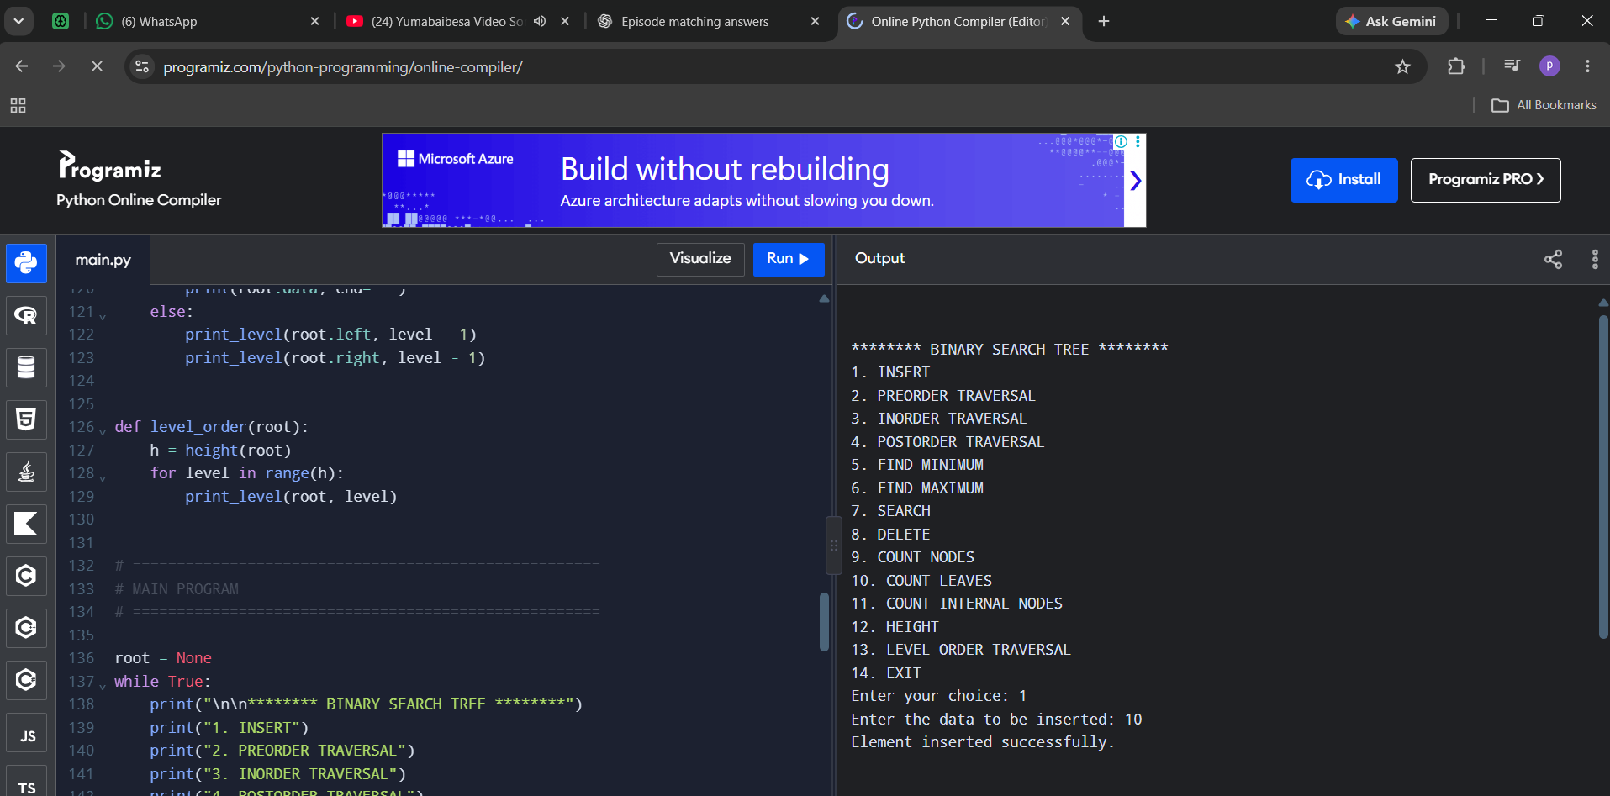
WEEK – 10
PROGRAM-10:
AIM: To write a menu driven Python program to implement an AVL Tree and perform Insertion, Deletion, Tree Traversals, Count Leaf Nodes, Count Internal Nodes and find the Height of the tree.
CODE:
class Node:
def __init__(self, x):
self.left = None
self.data = x
self.right = None
self.h = 0

#AVL TREE Program
def height(root):
if root is None:
return -1
else:
return root.h

# LL Rotation
def LL(x):
y = x.left
x.left = y.right
y.right = x
x.h = max(height(x.left), height(x.right)) + 1
y.h = max(height(y.left), height(y.right)) + 1
return y

# RR Rotation
def RR(x):
y = x.right
x.right = y.left
y.left = x
x.h = max(height(x.left), height(x.right)) + 1
y.h = max(height(y.left), height(y.right)) + 1
return y

# LR Rotation
def LR(k3):
k3.left = RR(k3.left)
return LL(k3)

# RL Rotation
def RL(k3):
k3.right = LL(k3.right)
return RR(k3)

# Inorder Traversal
def inorder(root):
if root is not None:
inorder(root.left)
print(root.data, end=" ")
inorder(root.right)

# Preorder Traversal
def preorder(root):
if root is not None:
print(root.data, end=" ")
preorder(root.left)
preorder(root.right)

# Postorder Traversal
def postorder(root):
if root is not None:
postorder(root.left)
postorder(root.right)
print(root.data, end=" ")

# Insert a node into AVL Tree
def insert(root, x):
if root is None:
return Node(x)

if x < root.data:
root.left = insert(root.left, x)
if height(root.left) - height(root.right) == 2:
if x < root.left.data:
root = LL(root)
else:
root = LR(root)

elif x > root.data:
root.right = insert(root.right, x)
if height(root.right) - height(root.left) == 2:
if x > root.right.data:
root = RR(root)
else:
root = RL(root)
else:
print("Duplicates not allowed")
root.h = max(height(root.left),height(root.right)) + 1
return root

# Delete a node from AVL Tree
def delete(root, x):
# Element not found
if root is None:
return None

# Search in left subtree
if x < root.data:
root.left = delete(root.left, x)
if height(root.left) - height(root.right) == 2:
if x < root.left.data:
root = LL(root)
else:
root = LR(root)

# Search in right subtree
elif x > root.data:
root.right = delete(root.right, x)
if height(root.right) - height(root.left) == 2:
if x > root.right.data:
root = RR(root)
else:
root = RL(root)

# When target found
else:
if root.left is None and root.right is None:
root = None
elif root.right is None:
root = root.left
elif root.left is None:
root = root.right
else:
successor = root.right # Find inorder successor
while successor.left is not None:
successor = successor.left
root.data = successor.data #Copy successor data
root.right = delete(root.right, successor.data) # Delete the inorder successor

root.h = max(height(root.left), height(root.right)) + 1
return root

# -------------------------------
# Main Program
# -------------------------------

root = None

while True:

print("\n***** AVL TREE MENU *****")
print("1. INSERT")
print("2. PREORDER TRAVERSAL")
print("3. INORDER TRAVERSAL")
print("4. POSTORDER TRAVERSAL")
print("5. DELETE")
print("6. EXIT")

choice = int(input("Enter your choice: "))
if choice == 1:
data = int(input("Enter the data to be inserted: "))
root = insert(root, data)
elif choice == 2:
print("Preorder Traversal:")
preorder(root)
print()
elif choice == 3:
print("Inorder Traversal:")
inorder(root)
print()
elif choice == 4:
print("Postorder Traversal:")
postorder(root)
print()
elif choice == 5:
data = int(input("Enter the data to be deleted: "))
root = delete(root, data)
elif choice == 6:
print("Program terminated.")
break
else:
print("Invalid choice!")

OUTPUT:
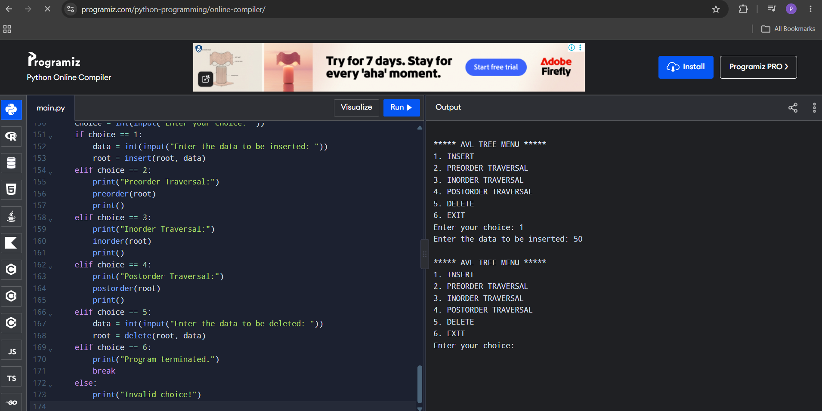

WEEK – 11
PROGRAM-11:
AIM: To write a menu-driven Python program to implement a Binary Heap (Max Heap and Min Heap) and perform Insertion, Deletion of the root element and Display of the array representation of the heap.
CODE:
Max Heap
def insert(heap, value):
heap.append(value)
i = len(heap) - 1
while i > 0:
parent = (i - 1) // 2
if heap[i] > heap[parent]:
heap[i], heap[parent] = heap[parent], heap[i]
i = parent
else:
break

def delete(heap):
if len(heap) == 0:
print("Heap is empty")
return
print("Deleted element:", heap[0])
heap[0] = heap[-1]
heap.pop()

n = len(heap)
i = 0
# Move the root downward
while True:
largest = i
left = 2 * i + 1
right = 2 * i + 2
if left < n and heap[left] > heap[largest]:
largest = left
if right < n and heap[right] > heap[largest]:
largest = right
if largest != i:
heap[i], heap[largest] = heap[largest], heap[i]
i = largest
else:
break

def display(heap):
if len(heap) == 0:
print("Heap is empty")
else:
print("Heap elements:", heap)

#Main Program
heap = []
while True:
print("\n--- MAX HEAP MENU ---")
print("1. Insert")
print("2. Delete")
print("3. Display")
print("4. Exit")
choice = int(input("Enter your choice: "))
if choice == 1:
value = int(input("Enter value to insert: "))
insert(heap, value)
elif choice == 2:
delete(heap)
elif choice == 3:
display(heap)
elif choice == 4:
print("Exiting program")
break
else:
print("Invalid choice")

Min Heap

def insert(heap, value):
heap.append(value)
i = len(heap) - 1

while i > 0:
parent = (i - 1) // 2

if heap[i] < heap[parent]:
heap[i], heap[parent] = heap[parent], heap[i]
i = parent
else:
break

def delete(heap):
if len(heap) == 0:
print("Heap is empty")
return

print("Deleted element:", heap[0])

heap[0] = heap[-1]
heap.pop()

n = len(heap)
i = 0

# Move the root downward
while True:
smallest = i
left = 2 * i + 1
right = 2 * i + 2

if left < n and heap[left] < heap[smallest]:
smallest = left

if right < n and heap[right] < heap[smallest]:
smallest = right

if smallest != i:
heap[i], heap[smallest] = heap[smallest], heap[i]
i = smallest
else:
break

def display(heap):
if len(heap) == 0:
print("Heap is empty")
else:
print("Heap elements:", heap)

# Main Program
heap = []

while True:
print("\n--- MIN HEAP MENU ---")
print("1. Insert")
print("2. Delete")
print("3. Display")
print("4. Exit")

choice = int(input("Enter your choice: "))

if choice == 1:
value = int(input("Enter value to insert: "))
insert(heap, value)

elif choice == 2:
delete(heap)

elif choice == 3:
display(heap)

elif choice == 4:
print("Exiting program")
break

else:
print("Invalid choice")

OUTPUT:
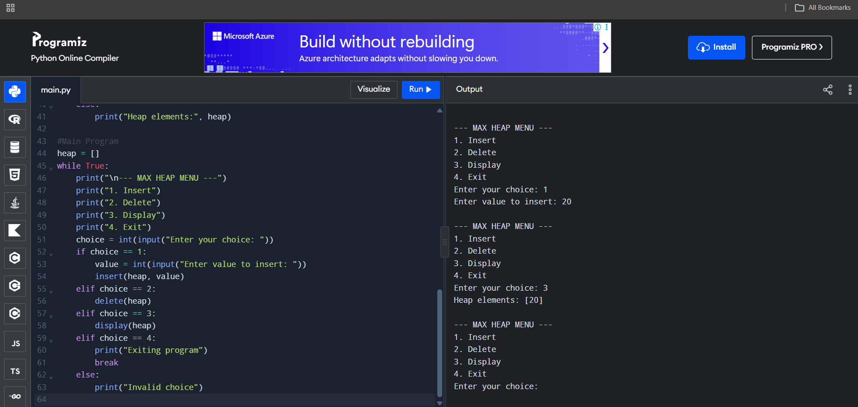
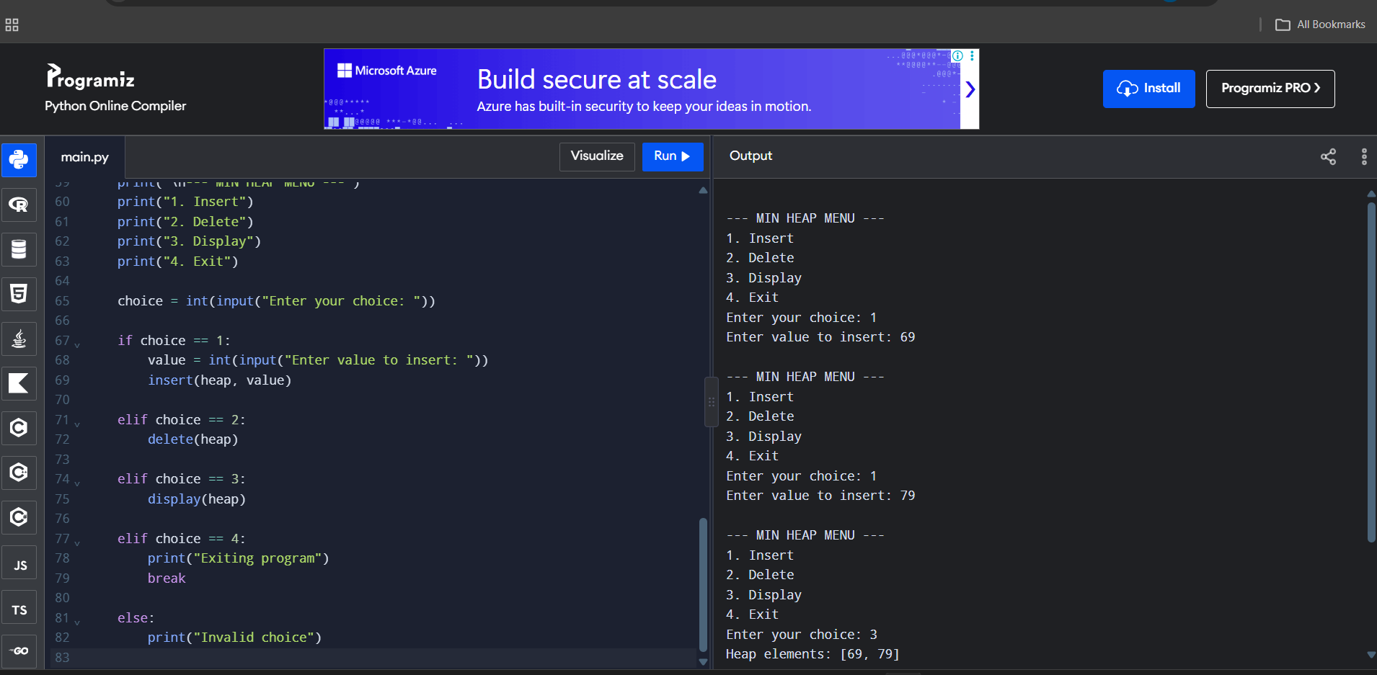
WEEK – 12
PROGRAM-12(A):
AIM: To write a Python program to implement a Hash Table using Separate Chaining for collision resolution.
CODE:
class Node:
def __init__(self, data):
self.data = data
self.next = None

SIZE = 10
ht = [None] * SIZE

def insertValue(value):
index = value % SIZE
newnode = Node(value)
if ht[index] is None:
ht[index] = newnode
else:
temp = ht[index]
while temp.next is not None:
temp = temp.next
temp.next = newnode

def displayValue():
for i in range(SIZE):
print(i, end=": ")
temp = ht[i]
if temp is None:
print("None")
else:
while temp is not None:
print(temp.data, end=" -> ")
temp = temp.next
print("None")

repeat = True
while repeat:
print("\n1. Insert")
print("2. Display")
print("3. Exit")
ch = int(input("Enter your choice: "))
if ch == 1:
value = int(input("Enter value: "))
insertValue(value)
elif ch == 2:
print("\nHash table values:")
displayValue()
elif ch == 3:
repeat = False
else:
print("Invalid choice")

OUTPUT:
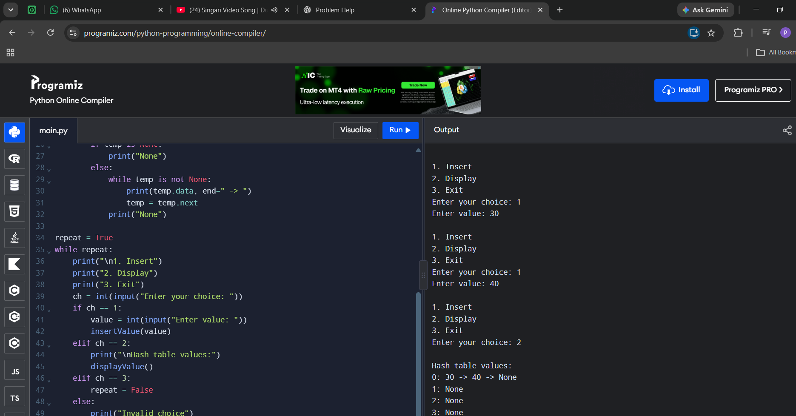
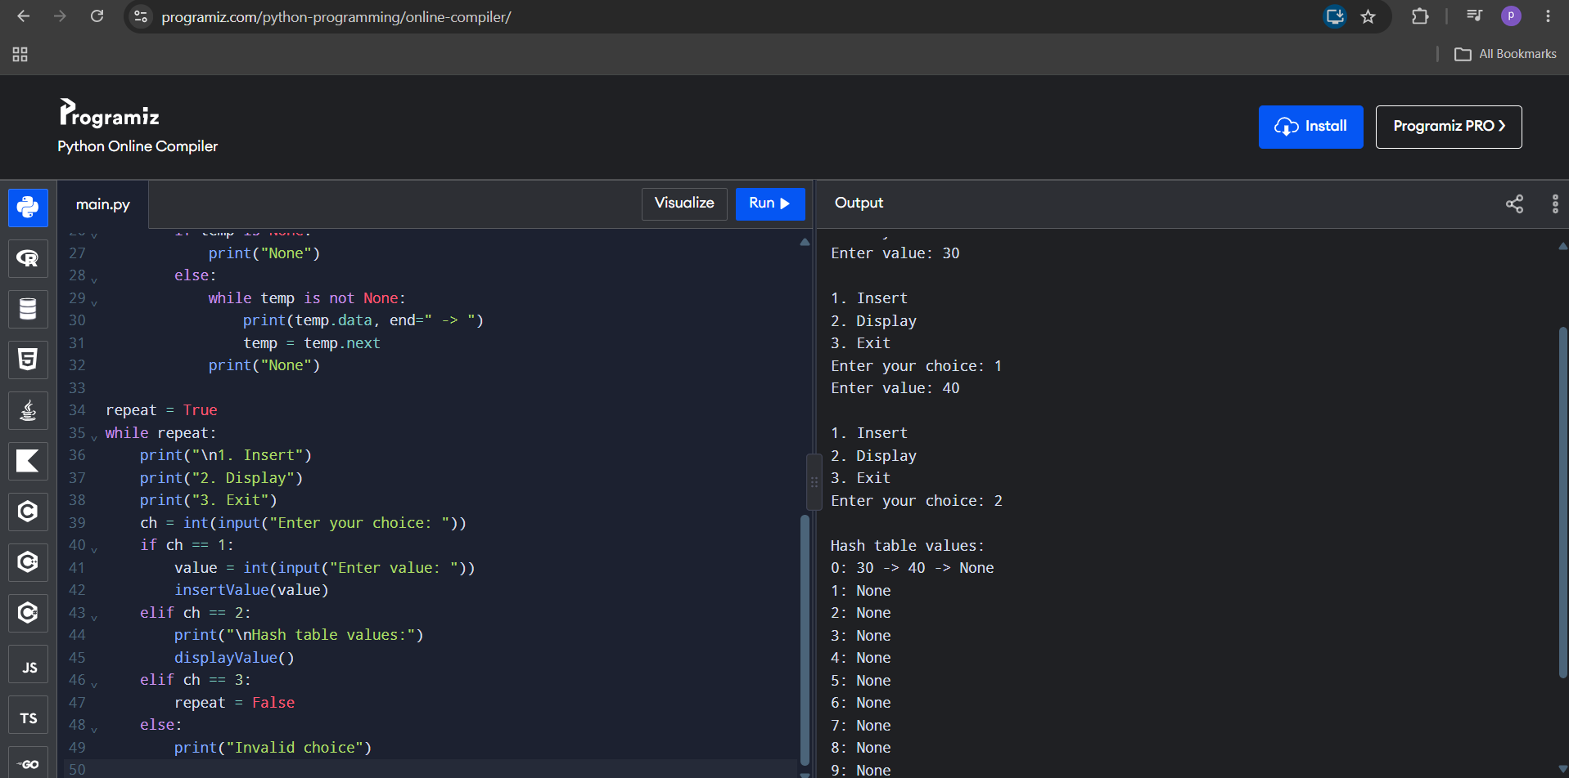
PROGRAM-12(B):
AIM: To write a Python program to implement a Hash Table using Linear Probing for collision resolution.
CODE:
SIZE = 10
a = [-1] * SIZE
def insertValue(x):
for i in range(SIZE):
index = ((x % SIZE) + i) % SIZE
if a[index] == -1:
a[index] = x
print("Element inserted")
return
print("Hash table is full")

def deleteValue(x):
for i in range(SIZE):
index = ((x % SIZE) + i) % SIZE
if a[index] == x:
a[index] = -1
print("Element deleted")
return
print("Element not found")

def search(x):
for i in range(SIZE):
index = ((x % SIZE) + i) % SIZE
if a[index] == x:
print("Element found at index", index)
return
if a[index] == -1:
break
print("Element not found")

def displayValue():
print("Index\tValue")
for i in range(SIZE):
print(i, "\t", a[i])

# Menu-driven program
repeat = True
while repeat:
print("\n1. Insert")
print("2. Display")
print("3. Delete")
print("4. Search")
print("5. Exit")
ch = int(input("Enter your choice: "))
if ch == 1:
value = int(input("Enter value: "))
insertValue(value)
elif ch == 2:
print("Values are:")
displayValue()
elif ch == 3:
value = int(input("Enter value to delete: "))
deleteValue(value)
elif ch == 4:
value = int(input("Enter value to search: "))
search(value)
elif ch == 5:
repeat = False
else:
print("Invalid choice")

OUTPUT:
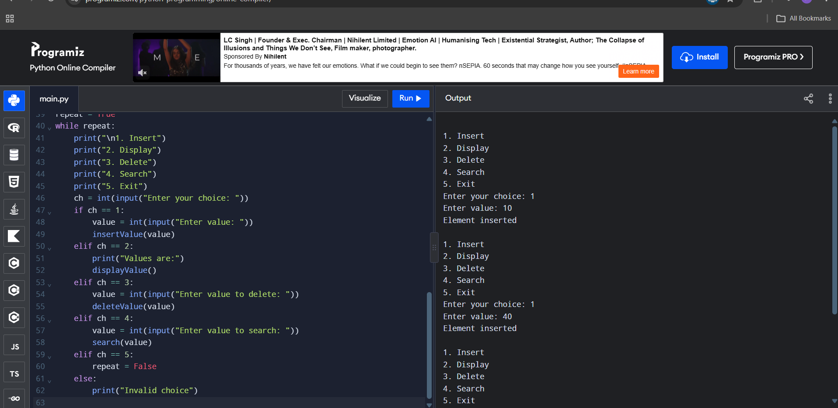
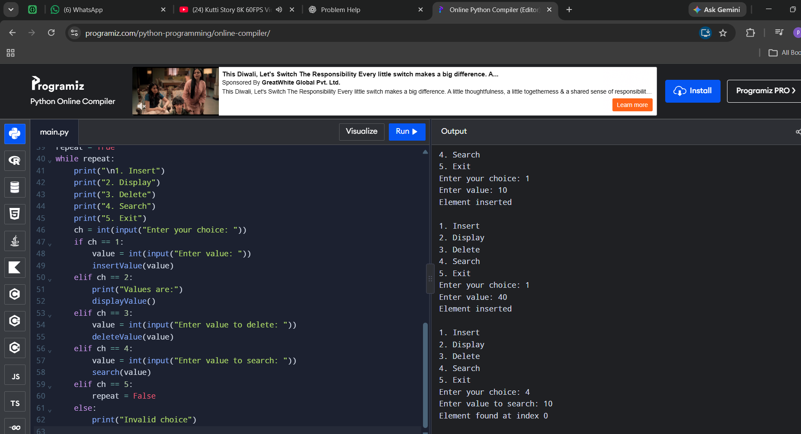
PROGRAM-12(C):
AIM: To write a Python program to implement a Hash Table using Quadratic Probing for collision resolution.
CODE:
SIZE = 10
a = [-1] * SIZE

def insertValue(value):
for i in range(SIZE):
index = ((value % SIZE) + i * i) % SIZE
if a[index] == -1:
a[index] = value
print("Element inserted at index", index)
return
print("No empty slot found in the probe sequence")

def displayValue():
print("Values are:")
for i in range(SIZE):
print(a[i])

# Menu-driven program
repeat = True
while repeat:
print("\n1. Insert")
print("2. Display")
print("3. Exit")
ch = int(input("Enter your choice: "))
if ch == 1:
value = int(input("Enter value: "))
insertValue(value)
elif ch == 2:
displayValue()
elif ch == 3:
repeat = False
else:
print("Invalid choice")

OUTPUT:


