REDSHIFT
Agenda
- Introduction
- Key Features
- Use Cases
- Redshift vs Traditional Databases
- Architecture of Redshift
- Setup of Redshift
- Loading Data in Query Editor v2
- Databases and Schemas
- Tables and Views
- Distribution Styles
- Column Encoding
Introduction:
Amazon Redshift is a fully managed cloud data warehouse service offered by AWS, designed specifically for analyzing large-scale datasets using SQL-based queries. Built on PostgreSQL, it supports most of its features, making it familiar and easy to use for those with SQL experience. Redshift is optimized for Online Analytical Processing (OLAP), enabling users to run complex analytical queries efficiently on petabytes of structured and semi-structured data.
One of Redshift’s key strengths is its high performance, achieved through columnar storage, data compression, and massively parallel processing (MPP) architecture. These features significantly speed up query execution and reduce the amount of I/O required. Redshift also supports seamless data loading from various sources, including Amazon S3, Amazon RDS, Amazon DynamoDB, and on-premises databases using AWS Data Migration Service (DMS).
Key Features of Amazon Redshift:
- Fully Managed: AWS handles provisioning, configuration, maintenance, backups, and patching.
- High Performance: Optimized with techniques like query caching, columnar storage, and parallel query execution.
- Columnar Storage: Stores data by columns rather than rows, reducing disk I/O and improving performance for analytical queries.
- Massively Parallel Processing (MPP): Distributes data and query loads across multiple nodes to enable parallel execution.
- Scalable: Can scale from hundreds of gigabytes to petabytes of data by adding nodes or using RA3 node types with managed storage.
- Data Compression: Redshift automatically compresses data using the most efficient encoding scheme for each column.
- Security: Offers encryption at rest and in transit, VPC integration, and fine-grained access control using AWS IAM and KMS.
- Integration with AWS: Natively integrates with S3, AWS Glue, Athena, Kinesis, Data Pipeline, and more.
- Concurrency Scaling: Automatically adds transient clusters to handle bursts in query load, ensuring consistent performance.
- Spectrum: Allows you to query data directly from S3 without loading it into Redshift.
Use Cases of Amazon Redshift:
- Business Intelligence and Reporting: Run complex analytics with BI tools.
- Data Warehousing: Centralize data from different sources for analytics.
- ETL Processing: Transform and load large datasets efficiently.
- Log Analytics: Analyze application, server, and user logs at scale.
- Clickstream Analysis: Analyze website traffic and customer behavior.
- Real-time Dashboards: Power dashboards with near real-time query performance.
Redshift vs Traditional Databases:
Aspect | Traditional Databases | Amazon Redshift
Purpose | Designed for OLTP (Online Transaction Processing) – handling day-to-day transactions. | Designed for OLAP (Online Analytical Processing) – handling complex analytics.
Storage Format | Row-based storage – good for transactional operations. | Columnar storage – optimized for reading large volumes of data.
Scalability | Scales vertically (limited by hardware capacity). | Scales horizontally using MPP (Massively Parallel Processing) architecture.
Performance | Slower for analytical queries on large datasets. | High performance for complex queries on massive datasets.
Management | Requires manual configuration, tuning, and maintenance. | Fully managed by AWS with automated backups, scaling, and patching.
Data Volume | Handles smaller to moderate-sized datasets. | Optimized for petabyte-scale data warehousing.
Cost Efficiency | Can become expensive as resource demand grows. | Pay-as-you-go pricing with features like Redshift Spectrum to query S3 data.
Integration | Limited cloud ecosystem integration. | Deep integration with AWS services (S3, Glue, QuickSight, SageMaker, etc.).
Concurrency | Limited concurrent query support. | Supports high concurrency with features like Concurrency Scaling.
Backup & Restore | Manual backup and recovery setup required. | Automated backups and snapshot restore capabilities included.
Security | On-prem setups require dedicated security efforts. | Built-in encryption, IAM, VPC, and compliance features.
ETL Support | Needs third-party tools or custom scripts. | Seamless ETL with AWS Glue, DMS, and COPY commands from various sources.
Architecture of Redshift:
Amazon Redshift’s architecture is built for high-performance, scalable, and cost-efficient data warehousing in the cloud. It follows a Massively Parallel Processing (MPP) model and uses columnar storage to speed up analytical queries on large datasets.
Main Components of Redshift Architecture:
1. Leader Node
- Acts as the brain of the cluster.
- Responsible for:
  - Receiving SQL queries from clients.
  - Parsing and optimizing the queries.
  - Generating query execution plans.
  - Distributing tasks to compute nodes and aggregating results.
- There is only one leader node in a Redshift cluster.
2. Compute Nodes
- Handle actual query execution and data storage.
- Store user data and execute operations as instructed by the leader node.
- Multiple compute nodes work in parallel (MPP).
- Each node has its own dedicated CPU, memory, and disk.
Types of Compute Nodes:
Type | Use Case | Storage Type
RA3 | For large, scalable workloads | Managed storage
DC2 (Dense Compute) | High-performance, smaller data | SSD
DS2 (Dense Storage) | High storage, low cost | HDD
3. Node Slices
- Each compute node is divided into slices.
- Each slice:
  - Handles a portion of the data.
  - Processes part of the workload independently.
  - The number of slices depends on the node type.
Storage & Processing Model:
Columnar Storage
- Stores data in columns instead of rows.
- Speeds up analytical queries by reading only necessary columns.
- Enhances compression and reduces I/O.
Massively Parallel Processing (MPP)
- Distributes workload among multiple compute nodes.
- Each node works in parallel on its data slice.
- Ensures faster processing and scalability.
Data Distribution & Sorting:
Distribution Styles
Used to determine how data is distributed across compute nodes:
Style | Description
KEY | Distributes rows based on a column’s hash value.
ALL | Replicates the table on all nodes (used for small tables).
EVEN | Distributes rows evenly without regard to column values.
Sort Keys
- Define how data is physically stored and ordered.
- Speeds up query performance through efficient data scanning.
- Types:
  - Compound Sort Key: Best for range queries with multiple columns.
  - Interleaved Sort Key: Good for multiple columns queried independently.
Data Ingestion & Query Execution:
Data Ingestion Methods
- Using the COPY command (bulk load from S3, DynamoDB, etc.)
- AWS Glue or DMS for ETL.
- Direct INSERT statements for small data.
- Integration with third-party tools.
Query Execution Flow
- The user submits a query to the leader node.
- Leader node parses and creates an execution plan.
- Tasks are distributed to compute nodes.
- Each compute node processes its slice of data.
- Results are sent back to the leader node.
- Leader node compiles and sends the final result to the user.
Redshift Spectrum (Extension of Architecture):
- Enables running SQL queries directly on data stored in Amazon S3.
- Uses external tables defined in AWS Glue Data Catalog.
- Supports querying structured and semi-structured data (e.g., Parquet, JSON).
- Reduces the need to load data into Redshift for occasional queries.
Security in Architecture:
- Encryption at Rest: Using KMS or HSM.
- Encryption in Transit: SSL encryption.
- VPC: Redshift clusters run inside Virtual Private Clouds.
- IAM: Fine-grained access control with Identity and Access Management.
Backup, Recovery, and Maintenance:
- Automated snapshots and backups.
- Restore clusters from snapshots.
- Resize operations: Change number/type of nodes as needed.
- Maintenance windows for patching and updates.
Monitoring & Optimization:
- Tools: AWS CloudWatch, Redshift Console, Performance Insights.
- Query optimization using EXPLAIN plans.
- Workload management (WLM) to manage concurrent queries.
Setup of Redshift:
Step 1: Go to the console and login with your AWS credentials.
Step 2: In the search bar, type Redshift and click on Amazon Redshift service.
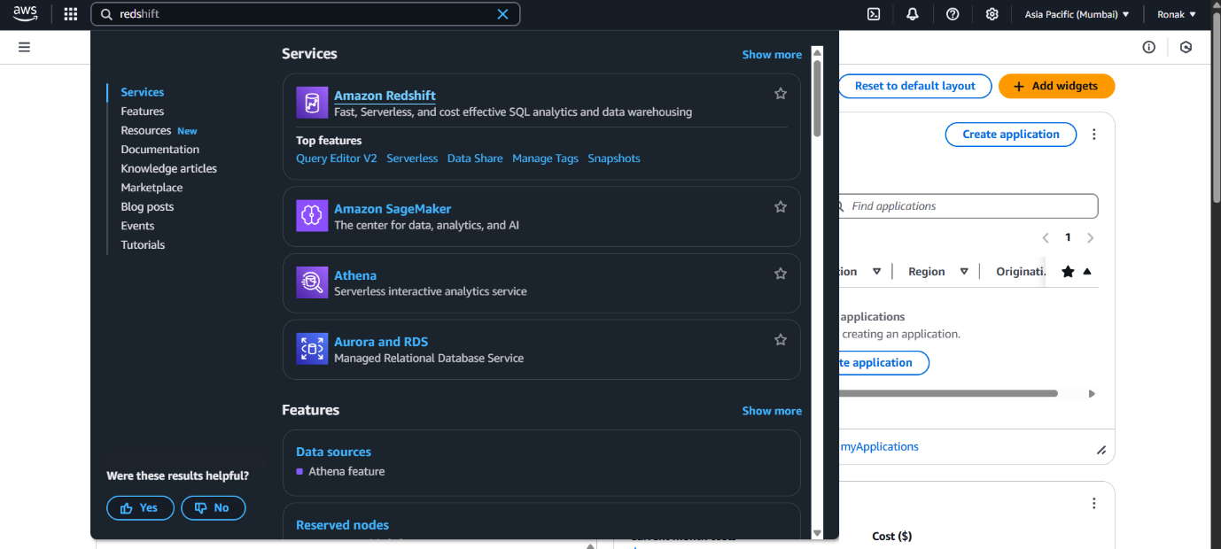
Step 3: Click on Create Cluster.
Cluster Configuration:
- Cluster identifier: redshift-cluster-1
- Node type: dc2.large (or any Free Tier eligible if available)
- Number of nodes: 1 (for learning/demo)
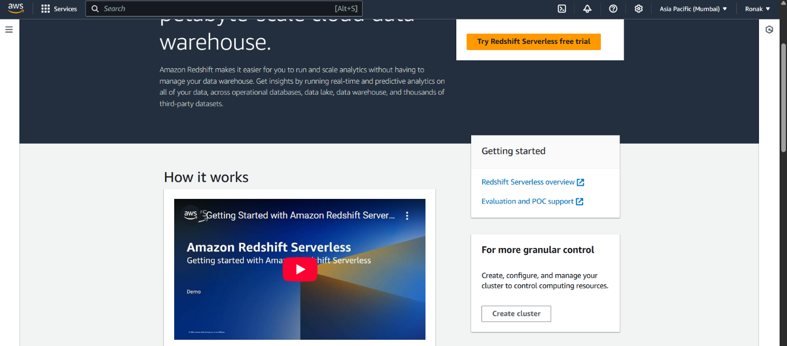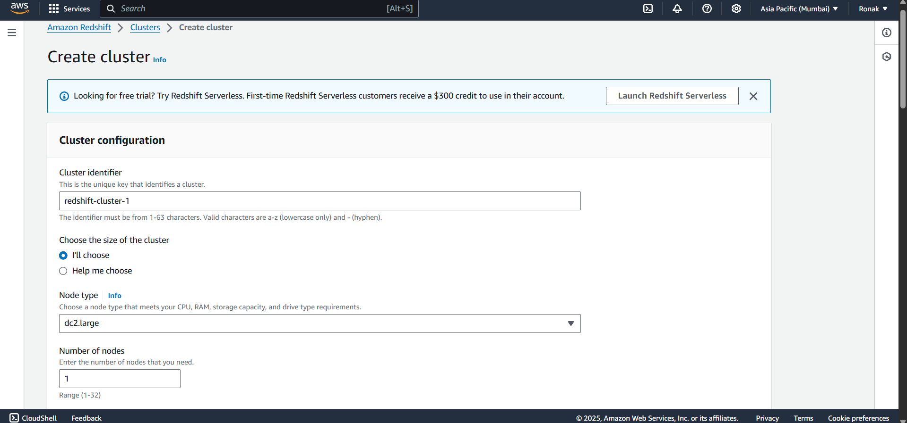
Step 4: Database Configuration
- Database name: dev (keep default)
- Master username: awsuser
- You can select a Master password also (Save it securely – it’s required for login.)
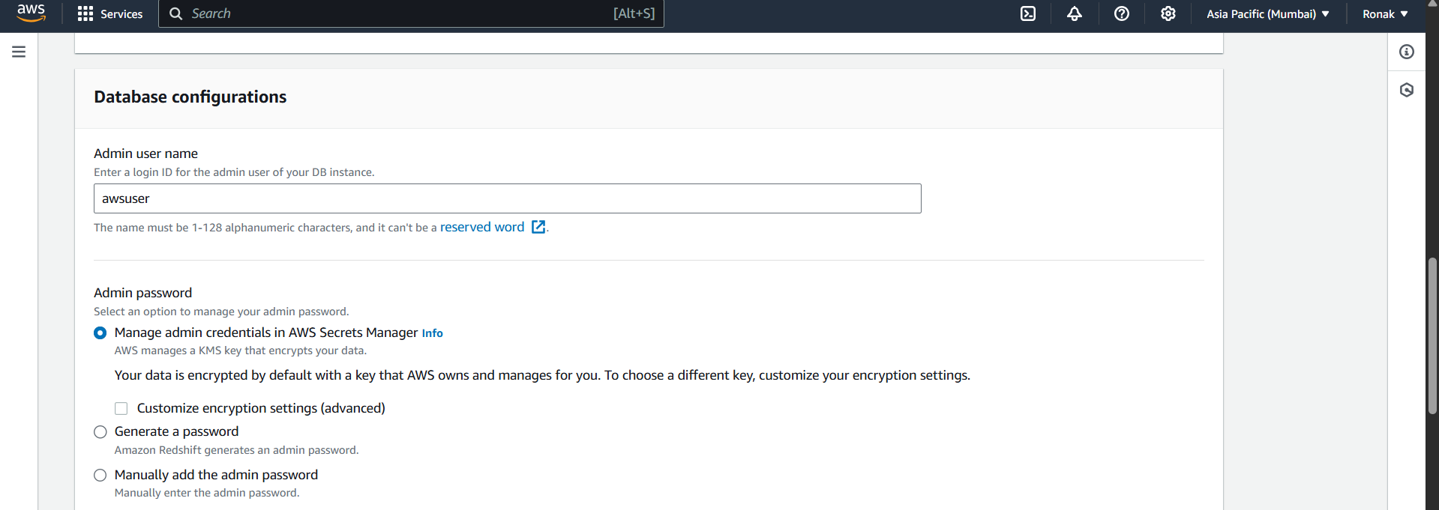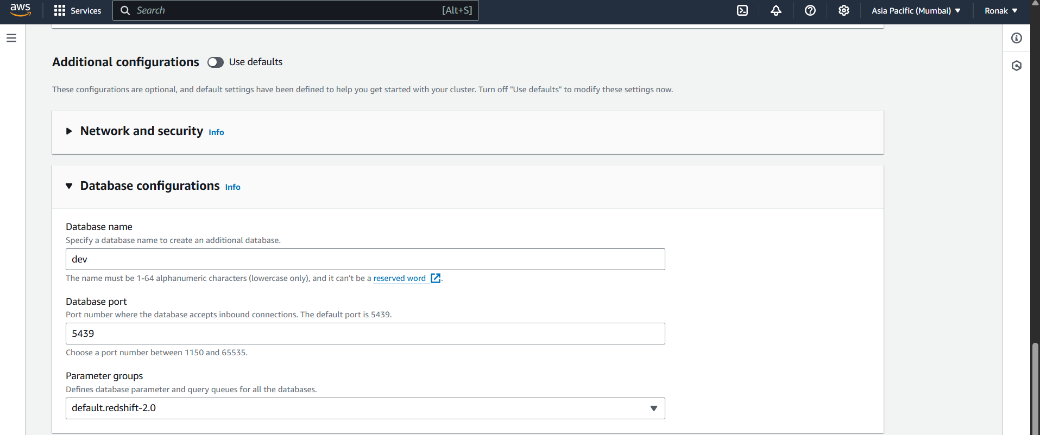
Step 5: Now, you can customise configurations or use defaults.
Network and Security Settings
In “Network and security” section:
- VPC: Select default VPC or create a new one.
- Publicly accessible: Select YES (to access from your laptop).
Click on “Create Cluster”.
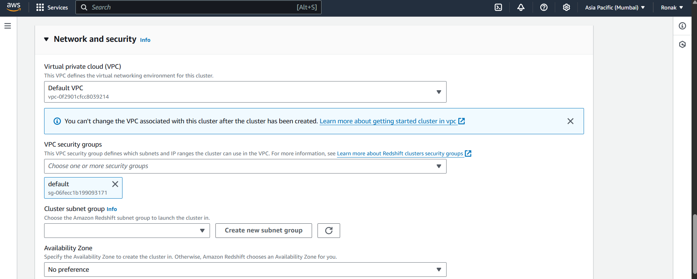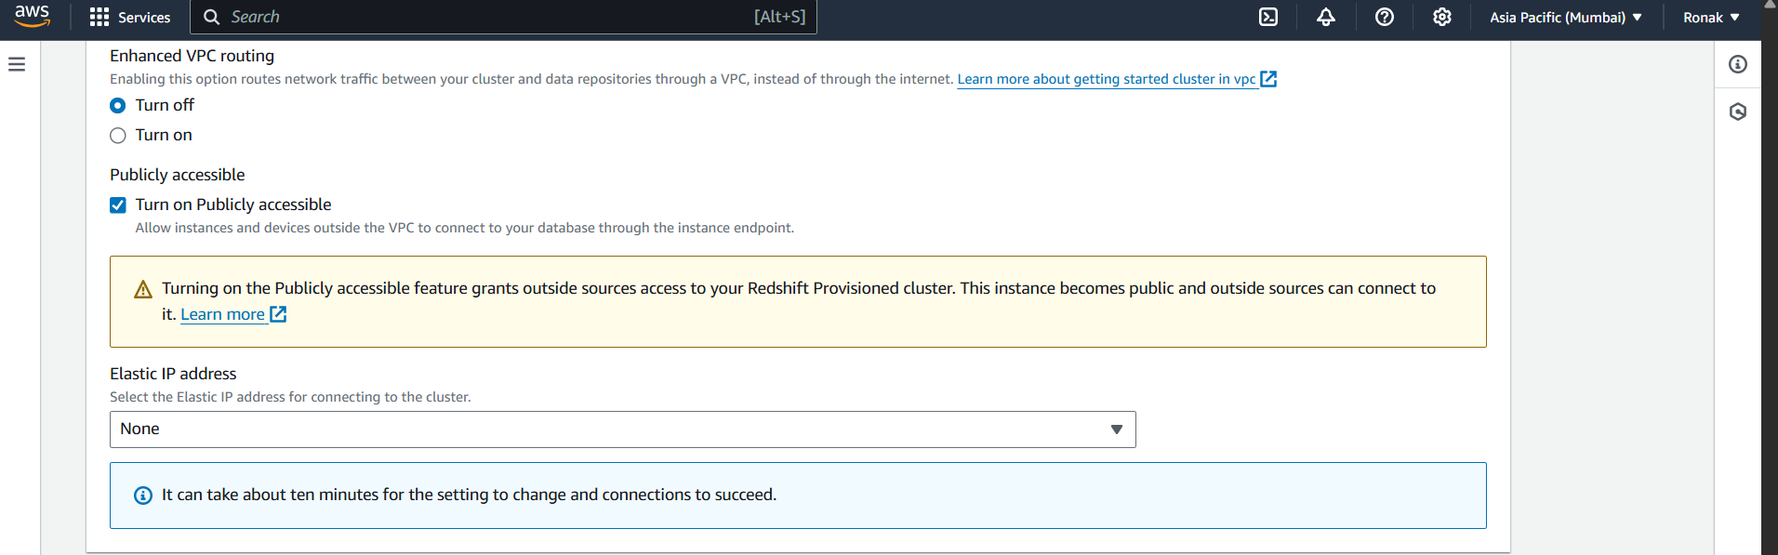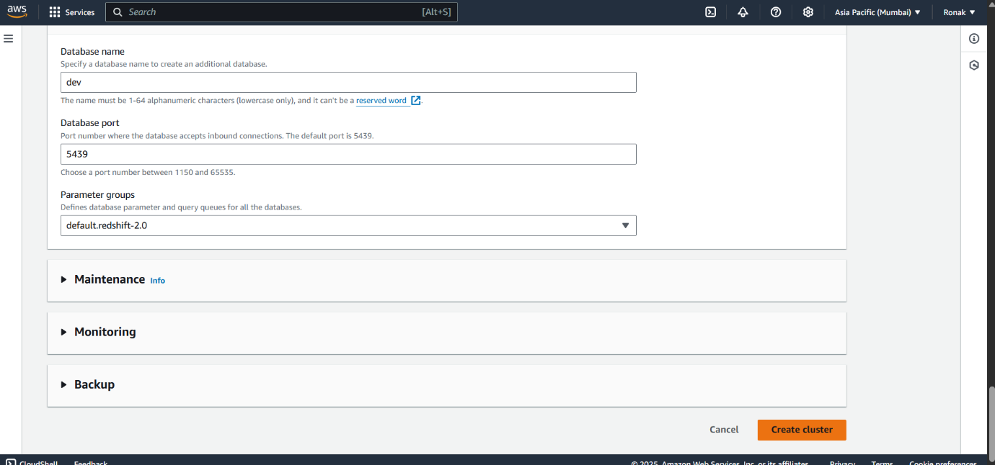
Step 6: Wait 3–5 minutes for status to become “Available” and then it will appear in the clusters list below.
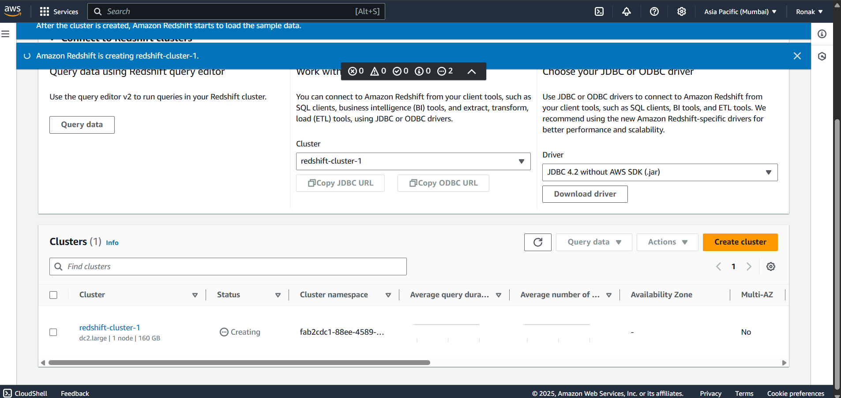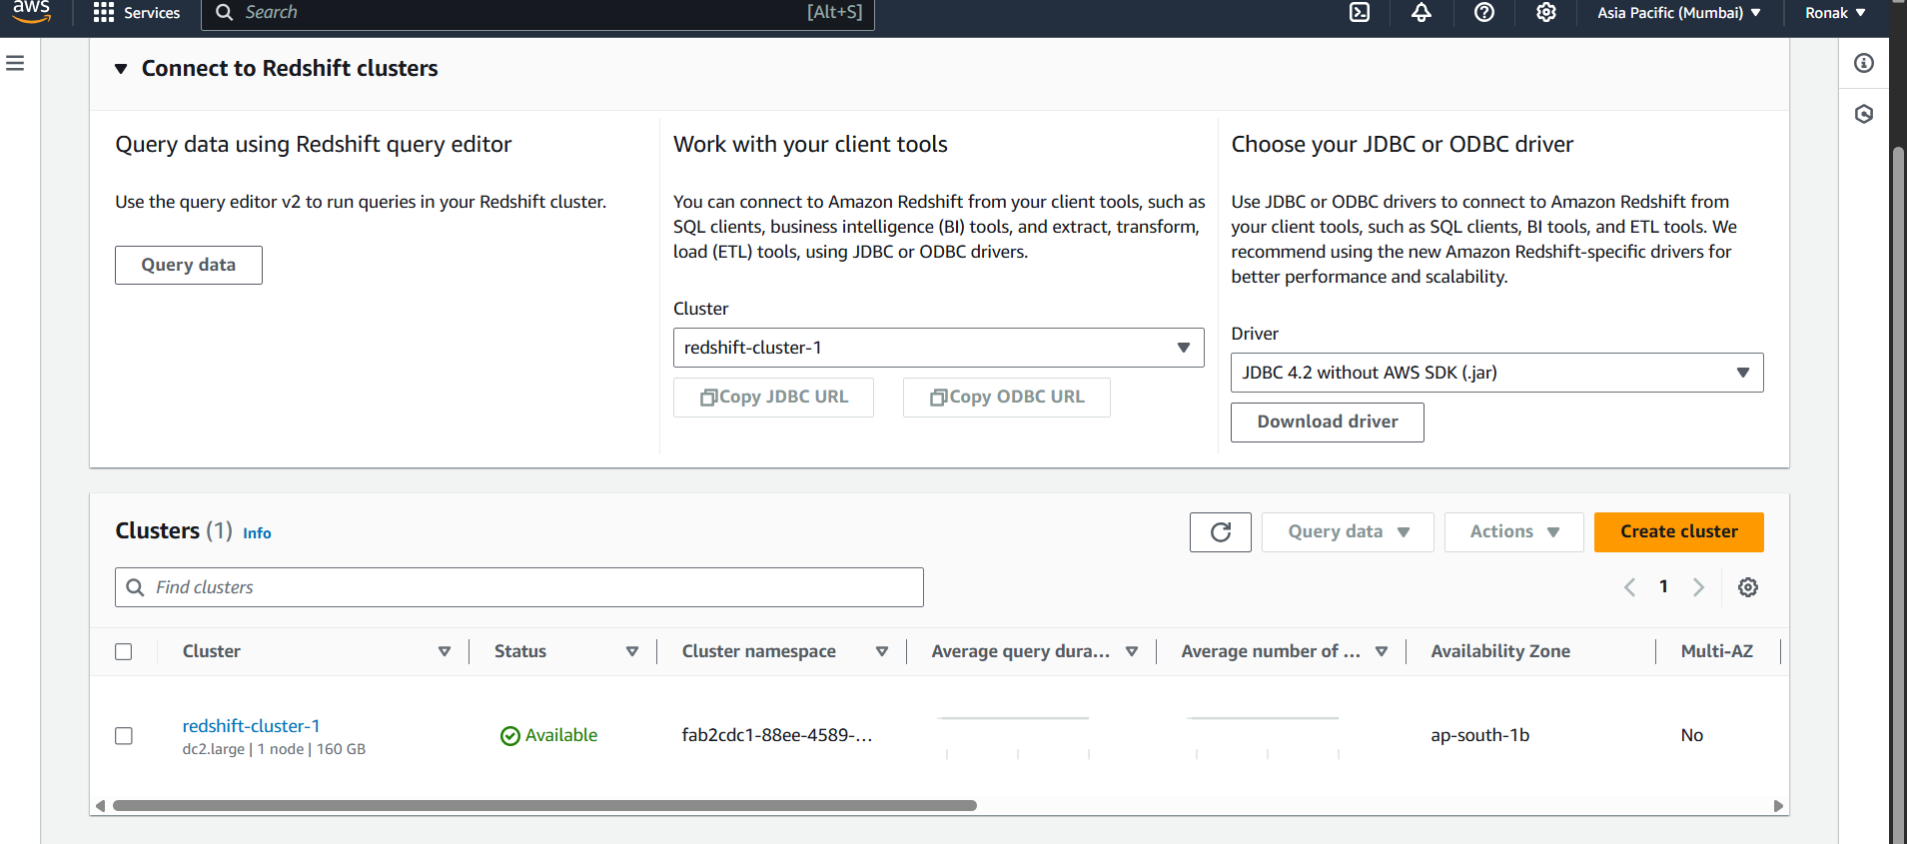
Step 7: Connect to the Cluster using Query Editor v2
- Go back to the Redshift Dashboard.
- In the left panel, click “Query Editor v2”.
- Click “Connect to Database”.
NOTE: If the dropdown of cluster or Database doesn't show any option, it means that there is no connection yet, so click on the three dots on the side of cluster name and create connection.
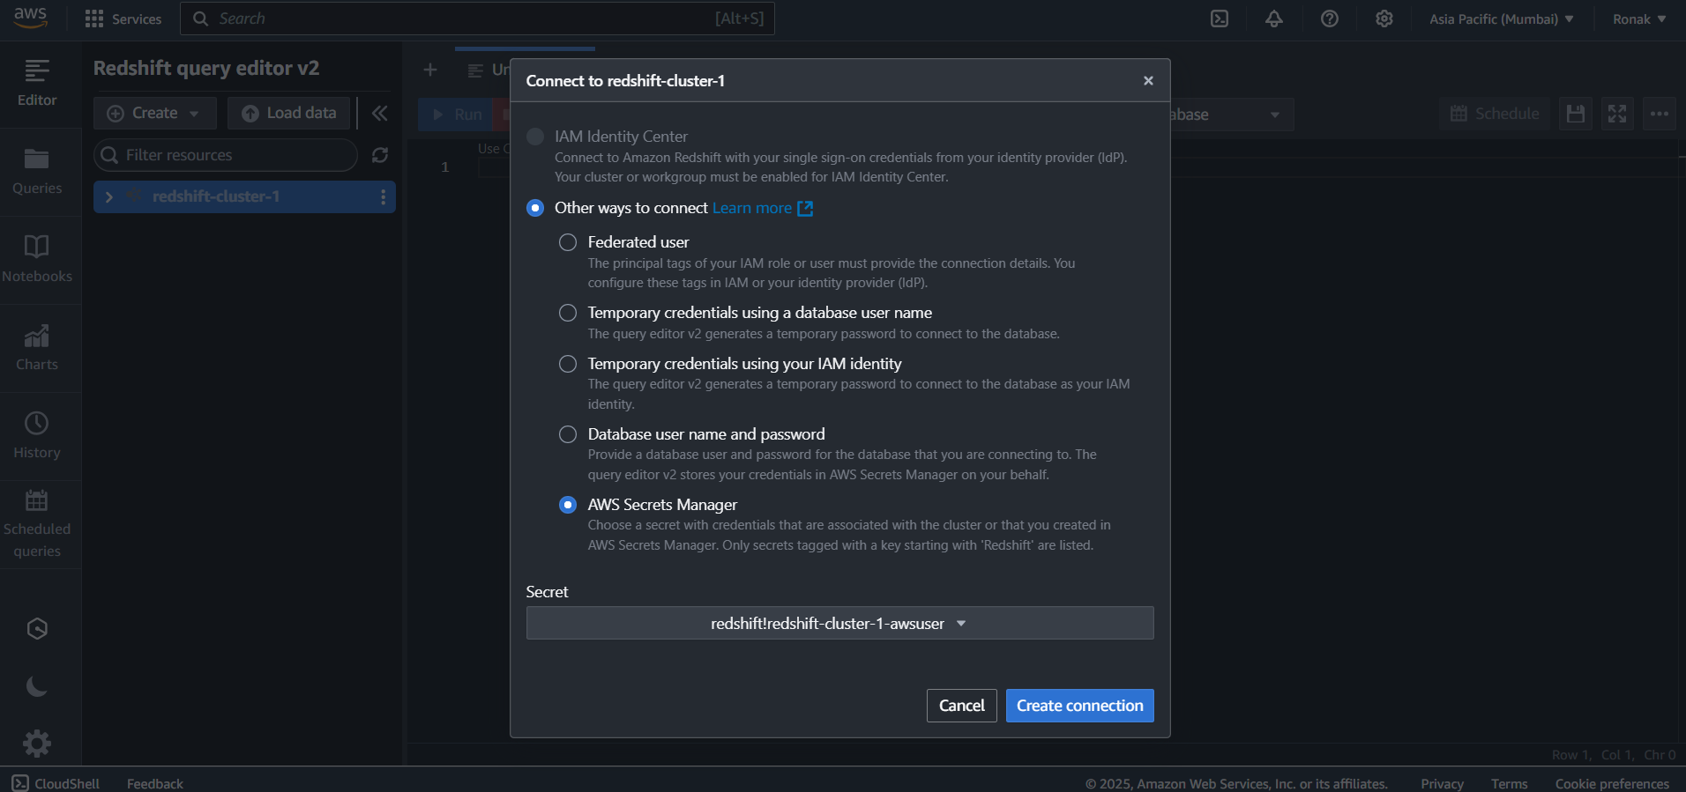
After that, your query editor v2 is ready for use with both clusters and databases selected.
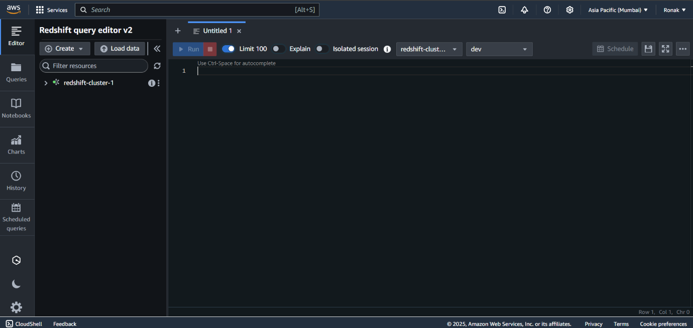
Loading Data in Query Editor V2:
In Amazon Redshift Query Editor v2, the "Load data" feature is used to upload datasets (such as CSV or TSV files) into Redshift after creating a cluster and connecting to a database. This function allows users to easily import data without needing external ETL tools. By selecting the file, specifying the target table name, and choosing the appropriate schema (e.g., public), Redshift automatically detects column names and data types, creates the table, and loads the data into it. This is especially useful for analysts and data engineers who want to begin querying and analyzing data immediately within the Query Editor environment, making it ideal for quick data exploration, prototyping, or small-to-medium-sized analytics projects.
Steps:
STEP 1: Upload Your CSV File
- Click on “Load data” at the top left (next to the “Create” button).
- Choose “Upload file”.
- Select your CSV file from your local system.
- Give your target table a name.
- Choose the correct schema (usually public, unless you created a different one).
- Redshift will infer column names and datatypes from your file — review them.
- Click “Next” and then “Load”.
NOTE: You can use Data Source to be either S3 or Local file.
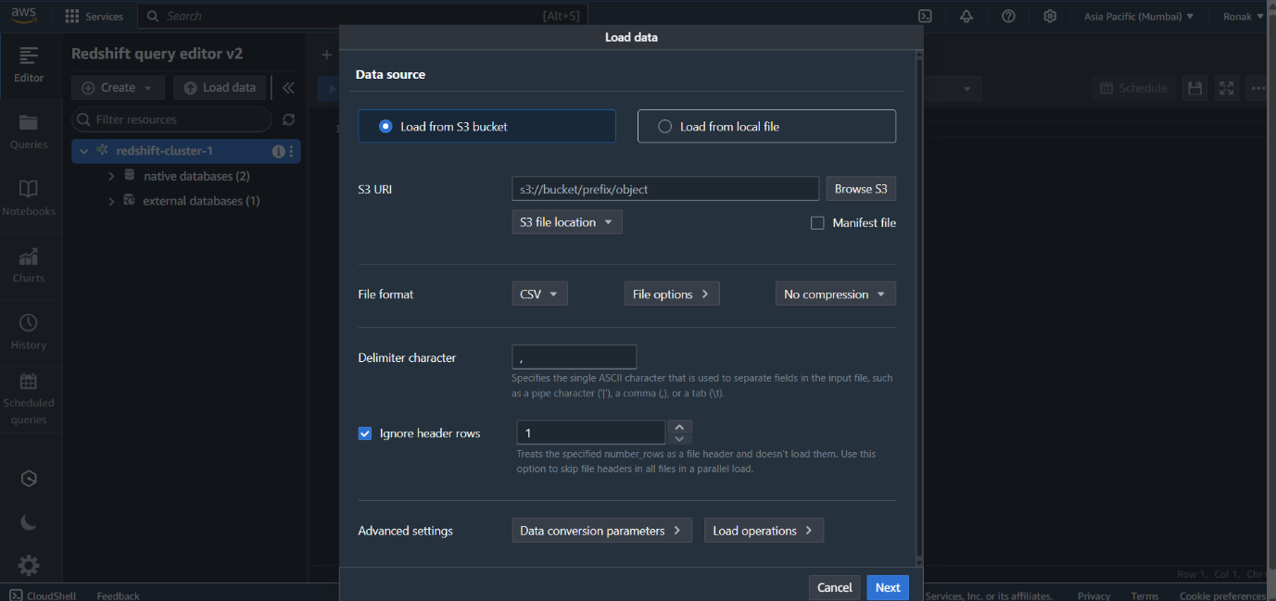
Redshift will now create a table and load your file’s data into it.
STEP 2: Check Your Table
Once data is loaded:
-- List all tables in your current schema
SELECT * FROM information_schema.tables WHERE table_schema = 'public';
STEP 3: View Your Data
Run a simple query to preview the data:
SELECT * FROM your_table_name LIMIT 10;
Replace your_table_name with the name you gave during upload.
STEP 4: Start Analyzing:
Now you can run any queries for analysis. Some example queries.
Databases and Schemas in Redshift:
Databases:
- In Redshift, a database is a container that holds schemas, tables, and other objects.
- When you create a Redshift cluster, a default database named dev is created.
Schema:
- A schema is like a folder inside a database that organizes tables, views, and other related objects.
- Helps with data isolation, management, and access control.
Syntax:
-- Create a schema
CREATE SCHEMA myschema;
-- Use a schema
SET search_path TO myschema;
Tables and Views:
Table:
- Stores actual data in rows and columns.
Create Table:
CREATE TABLE employees (
emp_id INT,
name VARCHAR(50),
salary DECIMAL(10,2)
);
View:
- A virtual table based on a SQL query.
- Does not store data physically.
Create View:
CREATE VIEW high_salary_employees AS
SELECT * FROM employees
WHERE salary > 50000;
Redshift Data Types:
Category | Data Types
Numeric | SMALLINT, INTEGER, BIGINT, DECIMAL, REAL, DOUBLE PRECISION
Character | CHAR(n), VARCHAR(n), TEXT
Date/Time | DATE, TIMESTAMP
Boolean | BOOLEAN
Example:
CREATE TABLE product (
id INT,
name VARCHAR(100),
price DECIMAL(8,2),
available BOOLEAN
);
Managing Tables:
1. Alter Table:
-- Add column
ALTER TABLE students ADD COLUMN city VARCHAR(50);
-- Drop column
ALTER TABLE students DROP COLUMN grade;
2. Drop Table:
DROP TABLE students;

Temporary vs Permanent Tables:
Feature | Temporary Table | Permanent Table
Scope | Session-based | Stored permanently
Visibility | Only visible to current session | Visible to users with access
Storage | Stored on local disk | Stored on Redshift storage
Create Temporary Table:
CREATE TEMP TABLE temp_students (
id INT,
name VARCHAR(50)
);
Temporary tables are automatically dropped when the session ends.
Primary Keys & Foreign Keys:
Primary Key:
- Uniquely identifies each row in a table.
- Only one per table.
CREATE TABLE department (
dept_id INT PRIMARY KEY,
dept_name VARCHAR(100)
);
Foreign Key:
- Refers to the primary key in another table.
- Used to define relationships between tables.
CREATE TABLE employees (
emp_id INT,
emp_name VARCHAR(100),
dept_id INT REFERENCES department(dept_id)
);
Note: In Redshift, Primary Keys and Foreign Keys are not enforced – they are informational only. They help the optimizer but do not block duplicate/inconsistent data.
Constraints in Redshift:
Supported (Informational Only):
- PRIMARY KEY
- FOREIGN KEY
- UNIQUE
These constraints do not enforce data integrity. They're used only for query planning and optimization.
Not Supported (Ignored):
- CHECK
- NOT NULL (only enforced for DISTKEY or SORTKEY columns)
Example:
CREATE TABLE products (
product_id INT PRIMARY KEY,
name VARCHAR(100),
price DECIMAL(8,2),
category VARCHAR(50),
UNIQUE (name)
);
Table Design & Performance Keys in Redshift:
Redshift is columnar and distributed, so table design (sort keys, distribution styles, encoding) directly affects query speed and cost. Let’s explore all performance-related features.
1. Sort Keys:
- Determines the order in which rows are stored on disk.
- Helps Redshift skip reading unnecessary blocks during queries → faster performance.
2. Compound Sort Key:
- A single sort key with multiple columns (ordered).
- Redshift uses the first column most to filter data.
Syntax:
CREATE TABLE sales (
sale_id INT,
sale_date DATE,
region VARCHAR(50)
)
COMPOUND SORTKEY (sale_date, region);
3. Interleaved Sort Key:
- Distributes sort priority evenly across all columns in the sort key.
Syntax:
CREATE TABLE sales (
sale_id INT,
sale_date DATE,
region VARCHAR(50)
)
INTERLEAVED SORTKEY (sale_date, region);
Distribution Styles:
- Controls how Redshift stores table data across nodes.
A. EVEN Distribution
- evenly spread rows across all nodes.
- Best for: small dimension tables or when no clear join column.
CREATE TABLE products (
id INT,
name VARCHAR(100)
)
DISTSTYLE EVEN;
B. KEY Distribution
- Rows are distributed based on the values of one column.
- Best for: large fact tables joined on that column.
CREATE TABLE orders (
order_id INT,
customer_id INT
)
DISTKEY (customer_id);
Ensures rows with the same key go to the same node → improves join performance.
C. ALL Distribution
- Copies the entire table to every node.
- Best for: small dimension tables that are frequently joined.
CREATE TABLE country (
country_id INT,
name VARCHAR(50)
)
DISTSTYLE ALL;
Best Practices for Table Design:
Area | Best Practice
Distribution Style | Use KEY when joining on that column. Use ALL only for small lookup tables.
Sort Keys | Use COMPOUND when filtering on fixed columns. Use INTERLEAVED for varied filters.
Column Types | Use appropriate data types – smaller is better.
Encoding | Use column compression for space and speed.
Avoid Wide Tables | Redshift is columnar – avoid unnecessary columns.
Analyze & Vacuum | Run ANALYZE and VACUUM regularly to maintain stats and sort order.
Column Encoding (Compression):
- Redshift stores columns in compressed format.
- Improves query performance and reduces storage.
Common Types:
Encoding | Use Case
LZO | Generic use, fast compression
BYTEDICT | For low cardinality strings
DELTA | For incrementing integers (like IDs)
RUNLENGTH | For repeating values
Syntax:
Redshift automatically applies optimal encoding, but you can manually set it:
CREATE TABLE orders (
order_id INT ENCODE DELTA,
status VARCHAR(20) ENCODE BYTEDICT
);

