DOCKER
Agenda:
- Docker introduction
- Docker components
- Docker architecture
- Containers in Docker
- Docker image
- Docker image vs Docker containers
- Docker vs Virtual Machines
- Steps to install docker
- Debugging a Docker container
- Creating a Server in Docker
Docker
Docker is an open-source platform designed to enable developers to build, deploy, and manage applications using lightweight, portable containers. It is a containerization platform that packages an application and its dependencies into a single, portable unit called a container. Containers ensure that applications run consistently across various computing environments, from development to testing and production.
By using Docker, developers can:
- Automate application deployment.
- Improve resource utilization.
- Ensure portability across environments.
- Simplify development and operations workflows.
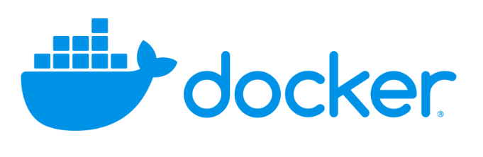
Docker Components
1. Docker Engine
The core of Docker, the engine enables the creation and management of containers. It has three main components:
- Docker Daemon (dockerd):
  - The Docker Daemon runs in the background and manages Docker containers, images, networks, and volumes.
  - It listens for commands from the Docker Client through a REST API and executes them.
- Docker Client (CLI):
  - The Docker Client is the command-line interface used to interact with Docker.
  - Users execute commands like docker run, docker build, and docker ps to manage containers, images, and other resources.
- REST API:
  - Docker uses a REST API as a communication bridge between the Docker Client and the Docker Daemon.
2. Docker Image
- A Docker image is a lightweight, standalone, and immutable file that contains everything needed to run an application.
- Images include:
  - Application code.
  - Runtime (e.g., Node.js, Python, Java).
  - Libraries and dependencies.
  - Configuration files.
- Images are versioned, meaning each change creates a new image layer. This makes Docker images efficient by reusing unchanged layers.
3. Docker Container
- A Docker container is a runtime instance of a Docker image.
- Containers are:
  - Isolated: Each container has its own file system, memory, and network namespace.
  - Lightweight: Containers share the host OS kernel, reducing overhead compared to VMs.
  - Ephemeral: Containers can be stopped, started, and deleted without affecting the Docker image.
4. Docker Registry
- The Docker registry is where Docker images are stored, managed, and shared.
- Common registries include:
  - Docker Hub: A public repository where developers can access and share images.
  - Private Registries: Secure, private repositories for organizational use.
- Docker registries support push (uploading images) and pull (downloading images) operations.
5. Docker Compose
- Docker Compose is a tool that allows you to define and manage multi-container Docker applications using a YAML file (docker-compose.yml).
- With Docker Compose, you can:
  - Define services, networks, and volumes.
  - Start multiple containers with a single command (docker-compose up).
6. Docker Swarm
- Docker Swarm is Docker's native orchestration tool for managing clusters of Docker containers.
- It enables features like:
  - Scaling containers up or down.
  - Load balancing across nodes.
  - High availability of services.
Docker Architecture
Docker follows a client-server architecture with the following components:
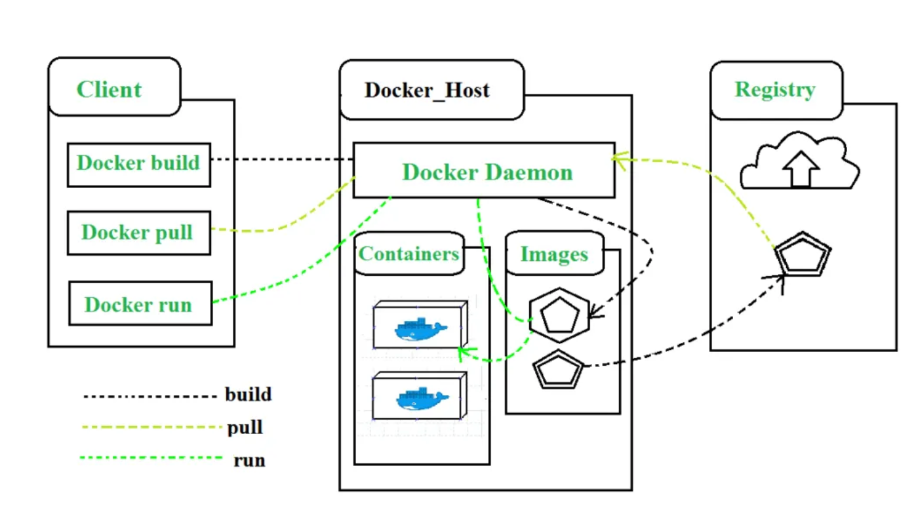
1. Docker Client (CLI):
- A user-facing interface for interacting with Docker.
- Sends commands to the Docker Daemon via the REST API.
- Common commands:
  - docker build: Create a Docker image.
  - docker run: Run a container from an image.
  - docker ps: List running containers.
  - docker stop: Stop a running container.
2. Docker Daemon:
- The core component responsible for managing Docker objects (e.g., containers, images, networks).
- Executes commands sent by the Docker Client.
3. Docker Images:
- Stored locally or in a Docker Registry.
- Images are used to create containers.
4. Docker Containers:
- Created from Docker images.
- Share the host OS kernel but have isolated file systems.
5. Docker Registry:
- Stores Docker images for sharing and deployment.
Benefits of Docker
- Portability:
  - Write once, run anywhere. Applications run the same regardless of the underlying infrastructure.
- Consistency:
  - Docker eliminates "it works on my machine" issues by ensuring identical environments across development, staging, and production.
- Resource Efficiency:
  - Containers use less memory and disk space compared to VMs.
- Speed:
  - Containers can start in seconds, enabling faster development and deployment cycles.
- Scalability:
  - Easily scale applications up or down by deploying multiple containers.
- Simplified Deployment:
  - Docker images encapsulate the application and its dependencies, simplifying deployment.
Docker Use Cases
- Development and Testing:
  - Standardized environments reduce inconsistencies between development and production.
- Microservices Architecture:
  - Run each service in its own container for better isolation and scalability.
- CI/CD Pipelines:
  - Automate testing, building, and deployment processes.
- Cloud and Hybrid Deployments:
  - Docker's portability makes it suitable for cloud-based environments.
- Legacy Applications:
  - Run legacy applications in isolated containers without modifying the host system.
Containers in Docker
Imagine you live in House A. This house is your current development environment where you have all the furniture (libraries, configurations, and tools) needed to work on your project. Everything is arranged, but as you work on it, you realize that this setup is specific to your house, and it's not easy to move.
Now, another developer joins your team who lives in House B (their Linux environment), but they need to set up the same environment. They will need to manually bring over all the furniture (install all the libraries and dependencies), but even if everything goes right, there's always a chance they might miss a piece.
This is where containers come into play.
What Is a Container?
A container is like a storage box that allows you to package everything you need from your house (development environment) into one box. All your furniture (libraries, tools, dependencies, configurations) are neatly packed inside this box, making it portable. Once you’ve packed everything into the box, it doesn’t matter whether you're moving it to House B (Linux), House C (Mac), or House D (QA server), because the box already contains everything needed for the house to function properly.
So, now, instead of worrying about whether your colleague will forget to bring the sofa (a crucial library), they can simply take your pre-packed container and everything will be ready to go.
A Docker container is a runtime instance of a Docker image. When you run an image, Docker creates a container to execute your application, using the image as the blueprint.
Think of a container as a live, running application created from the image, whereas the image is the inactive template.
Breaking Down the Docker Container:
- Dynamic and Ephemeral:
  - Unlike images, containers are dynamic—they are created when you run an image and are alive only as long as the application inside the container is running.
  - Containers are ephemeral: once the container stops running (i.e., the application finishes or is stopped), the container is terminated. However, the image remains intact and reusable.
- Isolation:
  - Containers provide an isolated environment where your application runs, separate from the underlying system. It uses the OS kernel, but it is isolated enough to avoid conflicts between dependencies or libraries installed on the host system.
- Execution Environment:
  - A container is like a virtualized environment running the application from the image. It will have the exact libraries and settings needed, based on the Docker image, but once it runs, it becomes an active process.
- Lifecycle:
  - Containers have a lifecycle: they are created (from an image), run (execute the application), and then terminated (when the application finishes or is stopped).
Docker Image
A Docker image is essentially a template or blueprint that contains all the necessary instructions to set up an environment for your application. Think of it like a snapshot of everything that needs to run your application: libraries, dependencies, application code, environment variables, and configuration files.
Breaking Down the Docker Image:
- Layers:
  - Docker images are built in layers. Each layer represents a specific set of instructions or changes, such as installing a Python library or setting an environment variable.
  - These layers are stacked on top of each other in a way that makes Docker images both efficient and portable.
- Example:
  - Layer 1: Base operating system (e.g., Ubuntu)
  - Layer 2: Install Python
  - Layer 3: Install project dependencies (e.g., numpy, pandas)
  - Layer 4: Add application code
  - Each layer is cached and can be reused across different Docker images, making the process efficient.
- Image as a Static Artifact:
  - A Docker image is static—once you build the image, it does not change unless you explicitly rebuild it. It is an artifact that can be shared across different systems or environments.
  - Portability: The image can be shared between developers, QA, staging, or production environments. It guarantees that the application will run the same way across all environments, with all dependencies intact.
- Dockerfile:
  - A Dockerfile is a set of instructions to create a Docker image. It defines how the image is built, specifying what base image to use, which dependencies to install, and how the application should run inside the container.
Example of a simple Dockerfile:
# Step 1: Base image
FROM python:3.8-slim
# Step 2: Install dependencies
RUN pip install numpy pandas
# Step 3: Copy application code into image
COPY app.py /app/
# Step 4: Set working directory
WORKDIR /app
# Step 5: Command to run application
CMD ["python", "app.py"]
Comparison between Docker Images and Docker Containers:
Aspect | Docker Image | Docker Container
Definition | A static package or template containing everything needed to run an application. | A dynamic, running instance of a Docker image.
Nature | Read-only and immutable. | Read-write during runtime.
Lifecycle | Exists as a blueprint or template, can be stored and shared. | Exists only while the application is running. Discards when stopped.
Portability | Portable across systems, can be shared and moved between environments. | Not portable; it's specific to the environment where it’s running.
Persistence | Persistent and immutable unless rebuilt. | Ephemeral; data inside the container is lost once stopped unless volumes are used.
Usage | Used to build and store application environments. | Used to execute the application in an isolated environment.
Creation | Built from a Dockerfile (a set of instructions). | Created by running a Docker image using docker run.
Storage | Stored as an artifact in a Docker registry (e.g., Docker Hub). | Runs as a process on the system.
Changes | Changes require rebuilding the image. | Changes occur during runtime (e.g., new files, logs).
Size | Generally smaller in size, since it’s just a template with layers. | Can be larger due to runtime changes, logs, or temporary data.
Example | A Docker image is like a recipe or a blueprint of what the application needs. | A Docker container is like the cooked meal that comes from the recipe, ready to eat.
Purpose | Provides the environment needed for the application to run. | Runs the application with the environment provided by the image.
Layer Virtualization: Docker vs Virtual Machines
- Docker:
  - Docker virtualizes only the application layer of the operating system.
  - This means that Docker images use the host system's OS kernel to interact with the hardware. Docker does not have its own OS kernel.
- VM (Virtual Machine):
  - A VM virtualizes both the application layer and the OS kernel layer.
  - It functions as a complete, independent subsystem installed within the host OS. Each VM has its own OS kernel, which interacts with the hardware independently of the host system's kernel.
Advantages and Disadvantages
Aspect | Docker | Virtual Machine (VM)
Virtualization | Only the application layer is virtualized. | Both application and OS kernel layers are virtualized.
Image Size | Smaller, typically in megabytes (MB). | Larger, typically in gigabytes (GB).
Startup Time | Faster, as only the application layer is started. | Slower, as the OS kernel and application layer both need to start.
Compatibility | May face issues if the OS kernel of the host does not support the image. | No compatibility issues; VMs are independent of the host OS.
Resource Allocation | Shares the host system’s kernel and resources dynamically. | Requires dedicated resources like CPU, RAM, and disk space.
Isolation | Uses host OS kernel; less isolated compared to VMs. | Fully isolated with its own OS kernel and environment.
Steps for Installation of Docker
Step 1: Determine Your Operating System
Docker can be installed on Windows, macOS, or Linux. Choose the relevant steps for your operating system:
- Windows: Windows 10/11 (Home or Pro, 64-bit) versions are required.
- macOS: Docker supports both Intel and Apple chips.
- Linux: Various distributions are supported (e.g., Ubuntu, Fedora, Debian).
Step 2: Check System Requirements
Windows Requirements:
- OS: Windows 10 (64-bit, Home or Pro) version 21H1 or higher, or Windows 11 (64-bit).
- Hardware:
  - 64-bit processor with virtualization support.
  - Minimum 4GB of system RAM.
- Virtualization Support: Ensure virtualization is enabled in your system's BIOS settings.
macOS Requirements:
- OS: macOS with Intel or Apple chip.
- Minimum 4GB of RAM.
Linux Requirements:
- A 64-bit kernel and CPU with virtualization support.
- At least 4GB of system RAM.
- The desktop environment may require GNOME or KDE.
- Supported distributions: Ubuntu (Jammy or later), Fedora, Debian, etc.
Step 3: Enable Virtualization (Windows-Specific)
- Open Task Manager.
- Navigate to the Performance tab and click on CPU.
- Look for "Virtualization." If it shows as "Disabled":
  - Restart your system and enter the BIOS/UEFI settings by pressing the designated key (e.g., F11, Del, Esc) during boot.
  - Find and enable the Virtualization or VT-x/AMD-V option in the BIOS settings.
  - Save changes and restart.
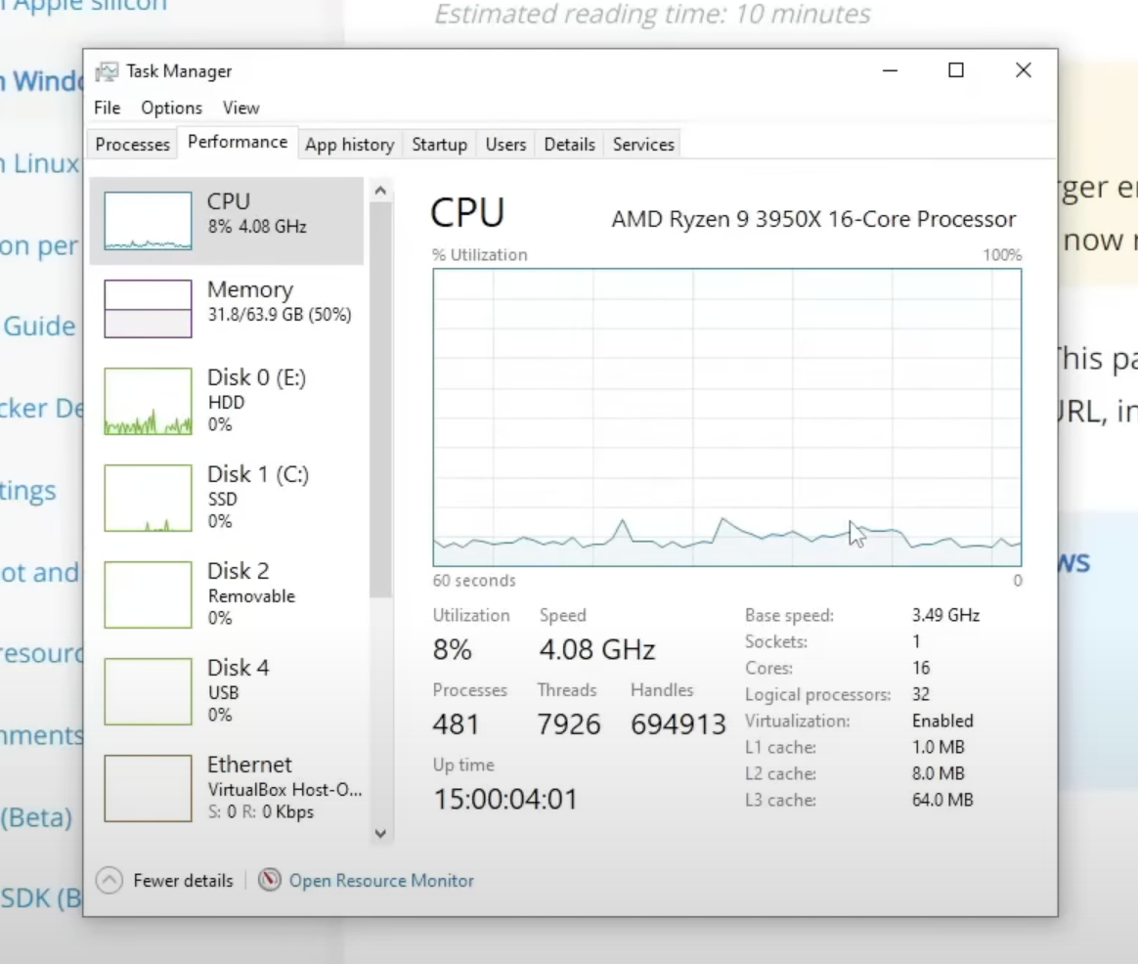
Step 4: Download Docker
Windows:
- Go to Docker's official website.
- Click on Get Started.
- Select Docker Desktop for Windows.
- Download the .exe installer.
macOS:
- On the Docker website, select the appropriate version for your chip:
  - Intel chip: Click on “Mac Intel chip.”
  - Apple chip: Click on “Mac Apple chip.”
- Download the .dmg installer.
Linux:
- On the Docker website, choose the appropriate distribution (e.g., Ubuntu, Fedora, Debian).
- Follow the provided documentation for your specific Linux distribution.
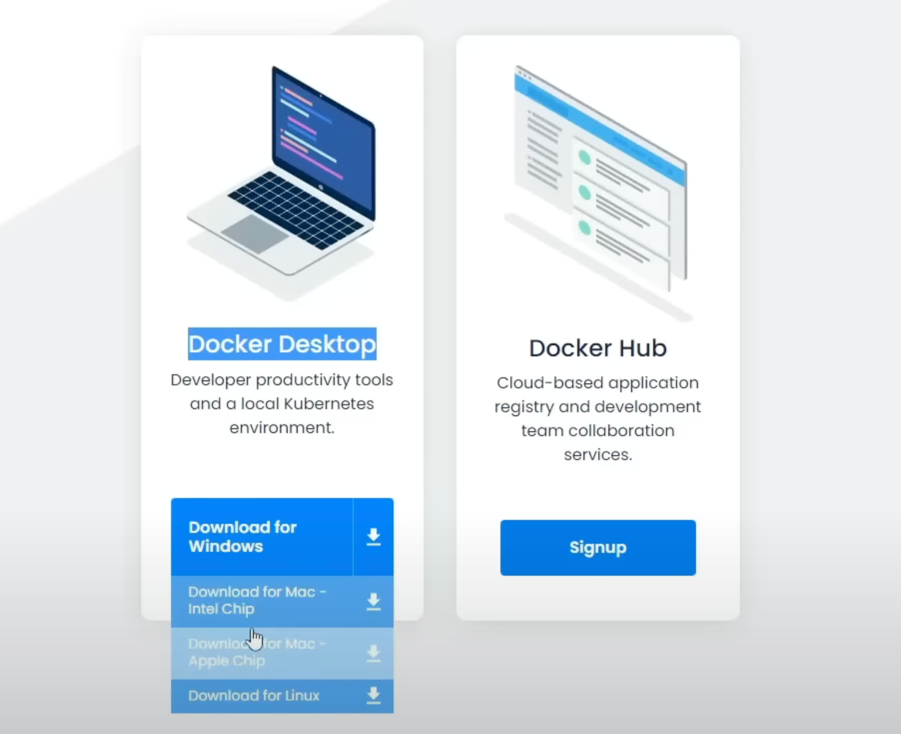
Step 5: Install Docker
Windows:
- Run the downloaded .exe installer.
- Click through the installation wizard by selecting Next for each step.
- Ensure the following options are enabled:
  - Use WSL 2 backend (Windows Subsystem for Linux).
  - Enable Windows containers and Hyper-V.
- Once installed, open Docker Desktop and verify that it is running by checking the system tray icon.
macOS:
- Open the downloaded .dmg file.
- Drag the Docker application to the Applications folder.
- Launch Docker from Applications.
- Follow any additional prompts for permissions or system adjustments.
Linux:
- Open a terminal.
- Use the package manager for your distribution to install Docker:
Ubuntu example:
sudo apt-get update
sudo apt-get install docker.io
- Follow the Docker documentation for distribution-specific commands.
Add your user to the Docker group (optional but recommended):
sudo usermod -aG docker $USER
- Restart your system for the changes to take effect.
Step 6: Verify Docker Installation
- Open a terminal (or Command Prompt for Windows).
Check if Docker is installed correctly:
docker --version
- This command will display the Docker version installed.
Test Docker functionality:
docker run hello-world
- This will pull and run a sample Docker container.
Step 7: Optional Setup for Windows Users
- Enable Windows Features:
  - Search for Turn Windows features on or off in the Start menu.
  - Enable Hyper-V and Containers.
  - Restart your system.
- If using an older Windows version, note:
  - Docker Toolbox was an alternative but is now deprecated.
  - You may need to use a virtual machine to run Docker.
Step 8: Explore Docker Desktop
- Open Docker Desktop.
- Familiarize yourself with the interface:
  - Containers/Apps: Displays running containers.
  - Images: Lists downloaded Docker images.
  - Volumes: Manages data storage for containers.
- Create or run sample containers to test functionality.
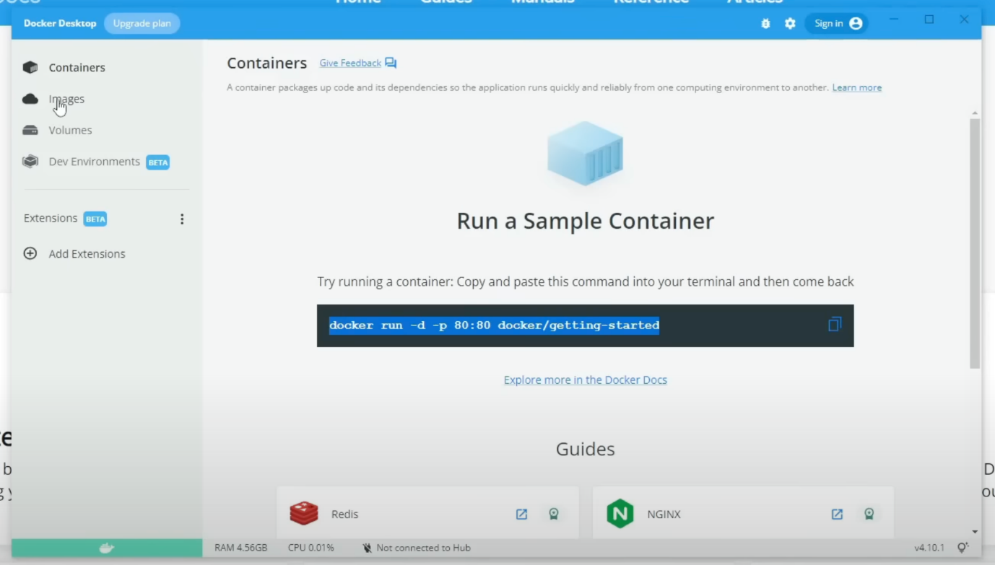
Step 9: Keep Docker Updated
- Regularly check for updates to Docker Desktop or the Docker CLI.
- Updates often fix compatibility issues and add new features.
Docker commands
1. Working with Images
- docker pull <image>
  - Downloads an image from Docker Hub or another registry to your local machine.
  - Example: docker pull redis
- docker images
  - Lists all locally available Docker images.
- docker rmi <image>
  - Deletes an image from your local machine.
  - Example: docker rmi redis
2. Working with Containers
- docker run <image>
  - Creates and starts a new container from an image.
  - Example: docker run redis
- docker run -d <image>
  - Runs the container in detached mode (in the background).
  - Example: docker run -d redis
- docker run -p <host_port>:<container_port> <image>
  - Runs a container and binds a port from the host to the container.
  - Example: docker run -p 6379:6379 redis
- docker ps
  - Lists running containers.
- docker ps -a
  - Lists all containers, including stopped ones.
- docker stop <container_id>
  - Stops a running container.
  - Example: docker stop abc123
- docker start <container_id>
  - Starts a stopped container.
  - Example: docker start abc123
- docker restart <container_id>
  - Restarts a running or stopped container.
- docker rm <container_id>
  - Deletes a stopped container.
3. Debugging and Logs
- docker logs <container_id>
  - Shows logs from a container.
- docker exec -it <container_id> /bin/sh
  - Opens a shell inside a running container (for debugging).
  - Example: docker exec -it abc123 /bin/sh
- docker inspect <container_id>
  - Displays detailed information about a container.
4. Managing Volumes
- docker volume ls
  - Lists all Docker volumes.
- docker volume rm <volume_name>
  - Deletes a Docker volume.
5. Cleanup Commands
- docker system prune
  - Removes all stopped containers, unused networks, and dangling images.
- docker container prune
  - Removes all stopped containers.
- docker image prune
  - Removes unused images.
Debugging a Docker container
1. Viewing Container Logs
If an application inside a container is not working correctly, checking its logs is the first step.
To view logs of a running container:
docker logs <container_id>
If you prefer using the container’s name instead of its ID:
docker logs <container_name>
To continuously stream logs (useful for real-time debugging):
docker logs -f <container_id>
2. Accessing the Running Container (Interactive Shell)
If you need to explore inside the container and execute commands, use the exec command:
Open an interactive terminal session inside the container:
docker exec -it <container_id> /bin/sh
or (for containers using Ubuntu/Debian-based images):
docker exec -it <container_id> /bin/bash
Once inside, you can navigate directories, inspect files, check environment variables, etc.
ls -la # List files in the current directory
printenv # View environment variables
3. Checking Running Containers
If you’re unsure whether the container is running, list active containers:
docker ps
To see all containers, including stopped ones:
docker ps -a
4. Restarting or Stopping Containers
If a container is misbehaving, restarting it might resolve the issue:
docker restart <container_id>
To stop a running container:
docker stop <container_id>
To remove a stopped container:
docker rm <container_id>
5. Inspecting Container Details
To view detailed information about a container (including environment variables, mounts, and network settings):
docker inspect <container_id>
6. Viewing Live Resource Usage
To monitor CPU, memory, and network usage of running containers:
docker stats
7. Testing Network Connectivity
If your container is not connecting to other services, you can check network settings:
List networks:
docker network ls
Inspect a specific network:
docker network inspect <network_name>
Test connectivity from inside the container using curl or ping:
docker exec -it <container_id> ping google.com
By using these debugging techniques, you can troubleshoot common container issues such as connectivity problems, configuration errors, or application crashes.
Creating a Server in Docker:
Docker makes it easy to package, distribute, and run applications in isolated environments called containers. To create a server in Docker, we need to:
- Write a Dockerfile (which defines how our image is built).
- Build an image from the Dockerfile.
- Create and run a container from the image.
Writing a Dockerfile
A Dockerfile is a script that tells Docker how to build an image. Below is an example of a simple Nginx web server running in a Docker container.
Step 1: Create a Dockerfile
Create a new file named Dockerfile (without any extension) and add the following:
# Use the official nginx image as the base image
FROM nginx:alpine
# Copy our local HTML files into the nginx web directory
COPY ./src/html /usr/share/nginx/html
# Expose port 80 so that the server is accessible
EXPOSE 80
# Start nginx
CMD ["nginx", "-g", "daemon off;"]
Step 2: Create the Web Page
Inside your project folder, create a src/html directory, then create an index.html file inside:
<!DOCTYPE html>
<html lang="en">
<head>
<meta charset="UTF-8">
<meta name="viewport" content="width=device-width, initial-scale=1.0">
<title>My Docker Web Server</title>
</head>
<body>
<h1>Hello, Docker!</h1>
<p>This is a simple web server running inside a Docker container.</p>
</body>
</html>
Building a Docker Image
Once the Dockerfile and website files are ready, we need to build the Docker image.
Run this command inside the project directory:
docker build -t my-web-server .
Explanation of the Command:
- docker build: Tells Docker to create an image.
- -t my-web-server: Tags the image with a name (my-web-server).
- . (dot): Specifies that the Dockerfile is in the current directory.
After the build completes, run:
docker images
You should see an image named my-web-server in the list.
Creating and Running a Container
Now that we have an image, we can create a container from it.
Step 1: Run the Container
docker run -d -p 8080:80 --name web-container my-web-server
Explanation of the Command:
- docker run: Runs a new container.
- -d: Runs the container in detached mode (background).
- -p 8080:80: Maps port 80 inside the container to port 8080 on the host machine.
- --name web-container: Assigns a name to the container (web-container).
- my-web-server: Uses the my-web-server image we built.
Step 2: Verify the Container is Running
Check running containers:
docker ps
It should show our web-container running.
Accessing the Web Server
Now, open a web browser and visit:
http://localhost:8080
You should see your simple web page.
Stopping and Removing Containers & Images
Stop the Container
docker stop web-container
Remove the Container
docker rm web-container
Remove the Image
docker rmi my-web-server
Docker Ignore File (.dockerignore)
Similar to .gitignore, we can create a .dockerignore file to prevent unwanted files from being added to the image.
Example .dockerignore
*.log
*.tmp
node_modules/
passwords.txt
This ensures files like passwords.txt and logs are not included in the container.
Automating with a docker-compose.yml File
Instead of manually running multiple docker commands, we can use Docker Compose.
Example docker-compose.yml
version: '3'
services:
web:
image: my-web-server
build: .
ports:
- "8080:80"
volumes:
- ./src/html:/usr/share/nginx/html
To build and run using Docker Compose:
docker-compose up -d
To stop and remove the container:
docker-compose down

