BIGQUERY
Agenda
- Datasets and Tables
- Creating Tables
- Data Types in BigQuery
- Loading Data into BigQuery
- Querying in BigQuery
- Connecting BigQuery to Looker Studio
Datasets and Tables:
In BigQuery, a dataset serves as the top-level container that holds various data resources, including tables, views, and their associated metadata. It acts as an essential organizational unit within a project, allowing users to logically group related data assets. This structure not only enhances data management and clarity but also plays a vital role in access control. By assigning IAM (Identity and Access Management) roles at the dataset level, organizations can manage who has permission to read, write, or administer the resources contained within. This fine-grained control helps ensure that data is both secure and accessible to the right users, supporting better governance and collaboration across teams.
Creating a Dataset:
Step 1: Go to the BigQuery console.
Step 2: In the Explorer pane, click on your project name.
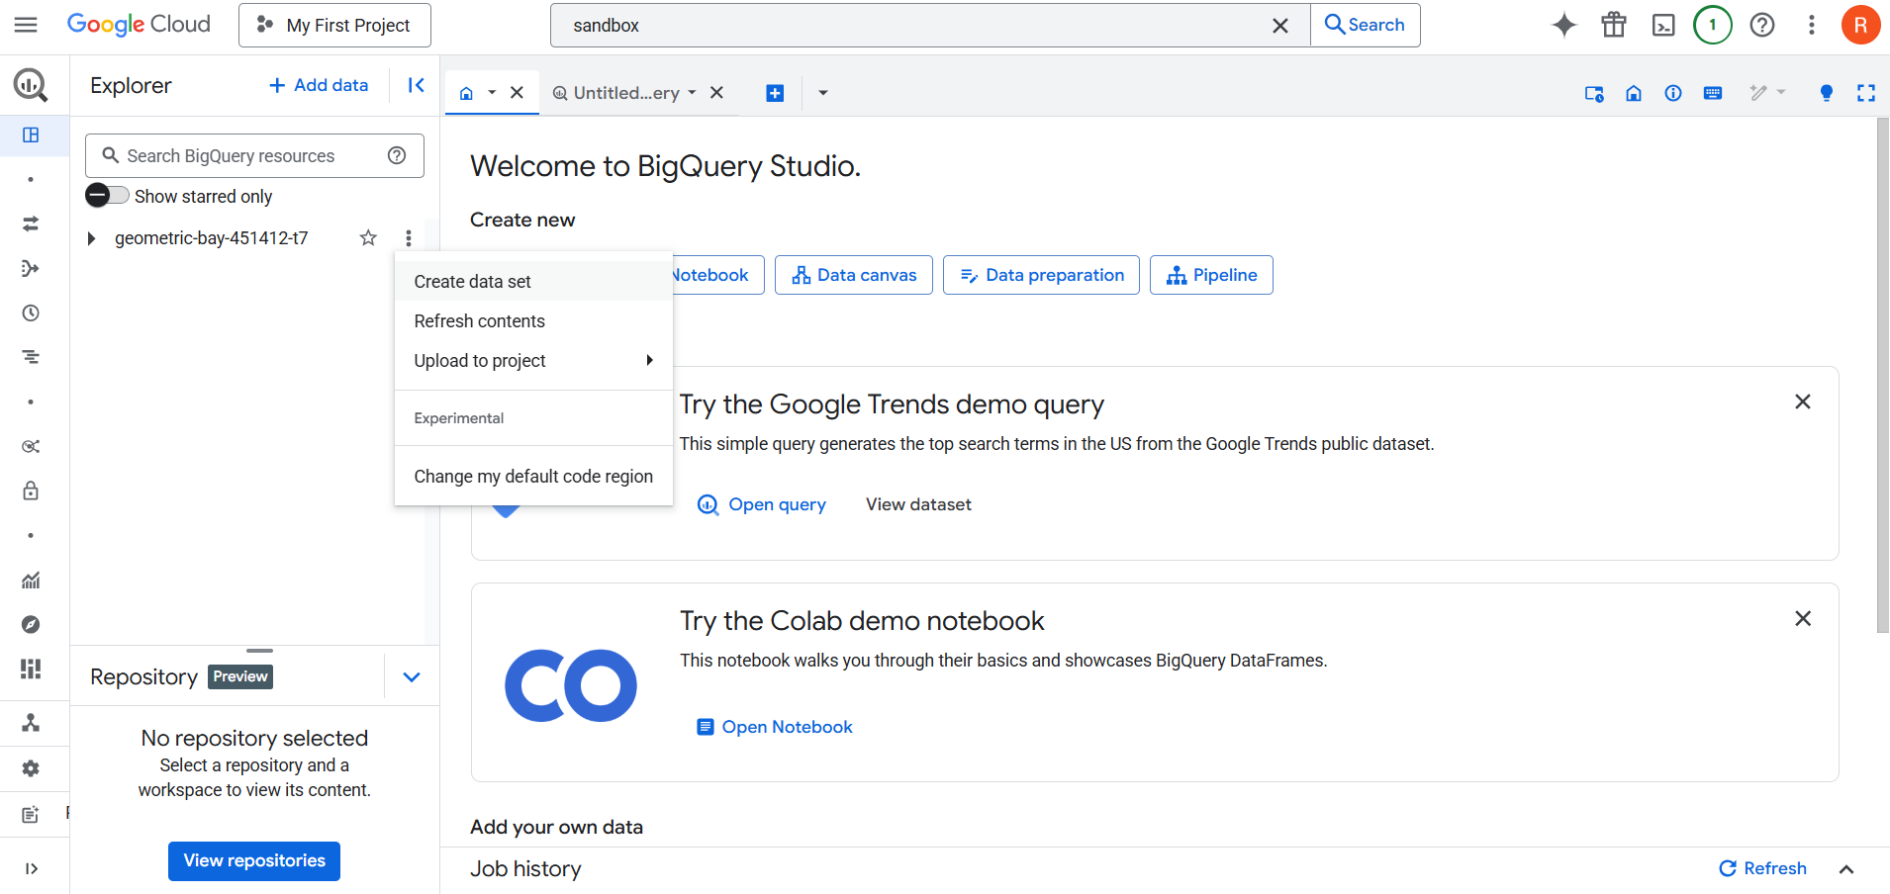
Step 3: Fill in the details:
- Dataset ID: Unique name within the project.
- Data location: Region (e.g., us, europe-west2).
- Default table expiration: Optional; auto-deletes tables after a set period.
- Encryption: Choose Google-managed or Customer-managed.
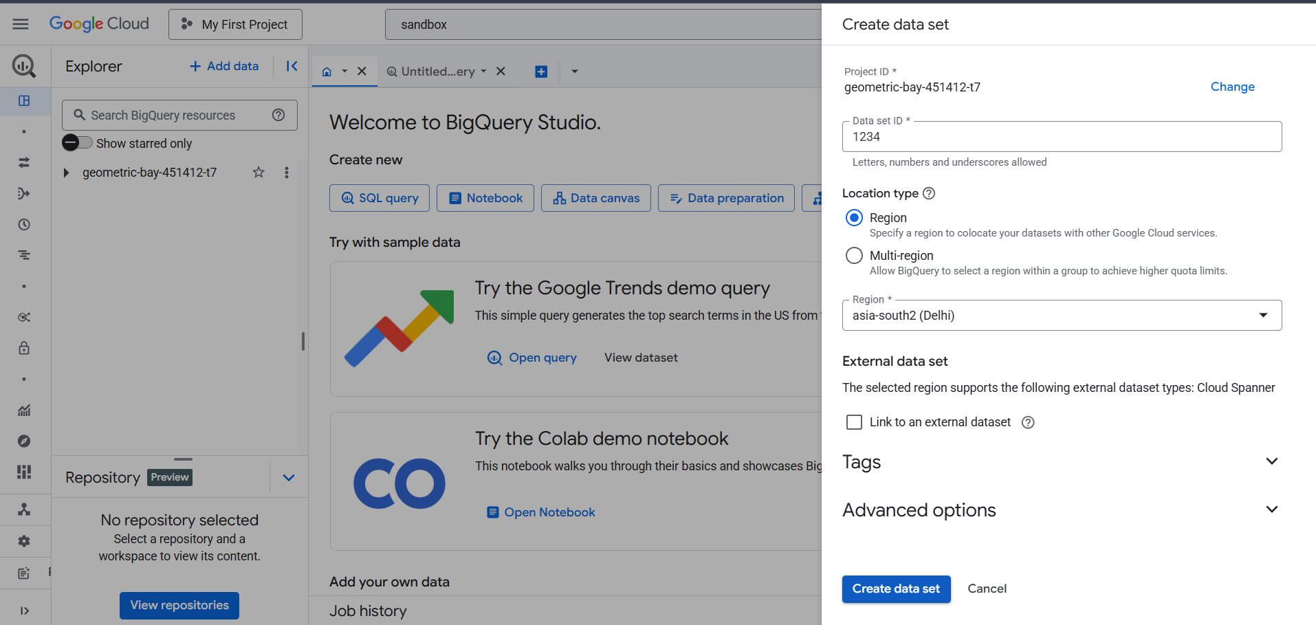
Step 4: Click Create Dataset.
Creating Tables: Native vs External:
A. Native Table:
- A native table stores data inside BigQuery.
- You load data from files like CSV, JSON, AVRO, PARQUET, or ORC.
- Data is managed and optimized by BigQuery.
Creating Native Tables (UI):
Step 1: Click on a dataset → Click Create Table.
Step 2: Source: Upload file, Cloud Storage, or blank table.
Step 3: Table type: Leave as "Native table".
Step 4: Define Schema (manually or auto-detect).
Step 5: Click Create Table.
B. External Table:
- An external table references data outside of BigQuery, usually in Cloud Storage, Google Drive, or BigLake.
- Useful for large raw datasets or data lakes where importing is not preferred.
Creating External Tables (UI):
Step 1: Click on a dataset → Click Create Table.
Step 2: Source: Provide Cloud Storage URI (e.g., gs://bucket_name/folder/file.csv).
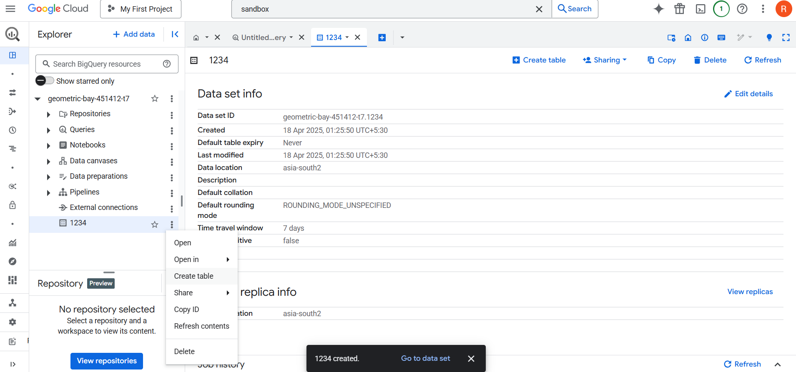
Step 3: Table type: Choose External table.
Step 4: File format: CSV, JSON, etc.
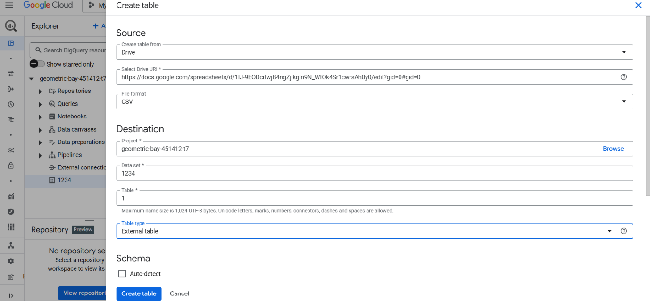
Step 5: Define Schema.
Step 6: Click Create Table.
Native vs External:
Feature | Native Table | External Table
Storage | In BigQuery | Outside BigQuery (e.g., GCS)
Performance | High (optimized) | May be slower
Cost | Storage + Query cost | Only Query cost
Use case | Frequently used data | Ad-hoc / infrequent queries
Table Types: Permanent, Temporary, External
1. Permanent Table:
- Default type when creating a table.
- Exists until manually deleted or expiration set.
- Stored in datasets.
2. Temporary Table:
- Created during query execution.
- Not stored in a dataset.
- Automatically deleted after the session ends.
Example: Common Table Expressions (CTEs), subqueries, or:
CREATE TEMP TABLE temp_table AS
SELECT * FROM dataset.table
3. External Table:
- Stored outside BigQuery.
- Data is accessed in-place.
- Used in federated querying.
Table Schemas and Modes:
- A schema defines the structure of a table: field names, data types, and modes.
- Every column/field must have:
  - Name
  - Type (STRING, INT64, FLOAT, BOOL, TIMESTAMP, etc.)
  - Mode (NULLABLE, REQUIRED, REPEATED)
Schema Modes:
Mode | Description
NULLABLE | Column can contain NULL values (Default)
REQUIRED | Must always contain a value; NULL not allowed
REPEATED | Represents an array of values (nested or flat)
Data Types in BigQuery:
BigQuery supports various data types to handle different kinds of information. Understanding these is key for writing accurate queries and storing data effectively.
A. STRING
- Represents text or character sequences.
- Enclosed in quotes (single or double).
- Example: 'Hello World', "Email@example.com"
- Use functions like LENGTH(), UPPER(), LOWER(), CONCAT() for string manipulation.
B. INT64 (Integer)
- Represents whole numbers (no decimal points).
- 64-bit signed integer: Range is from -9,223,372,036,854,775,808 to +9,223,372,036,854,775,807.
- Examples: 42, -1000, 0
- Useful for counting, indexing, IDs, etc.
C. FLOAT64 (Floating Point)
- Represents approximate numeric values with decimals.
- 64-bit IEEE floating point.
- Examples: 3.14159, -0.001, 1.0e3
- Use for percentages, measurements, or any data requiring precision and scale.
D. BOOL (Boolean)
- Represents true/false values.
- Only two possible values: TRUE or FALSE
- Useful for flags, conditions, and logic-based columns.
NOTE: Now, in order to Query Data, you need to open the table and open the Query Editor and start coding on that particular table of a particular Dataset.
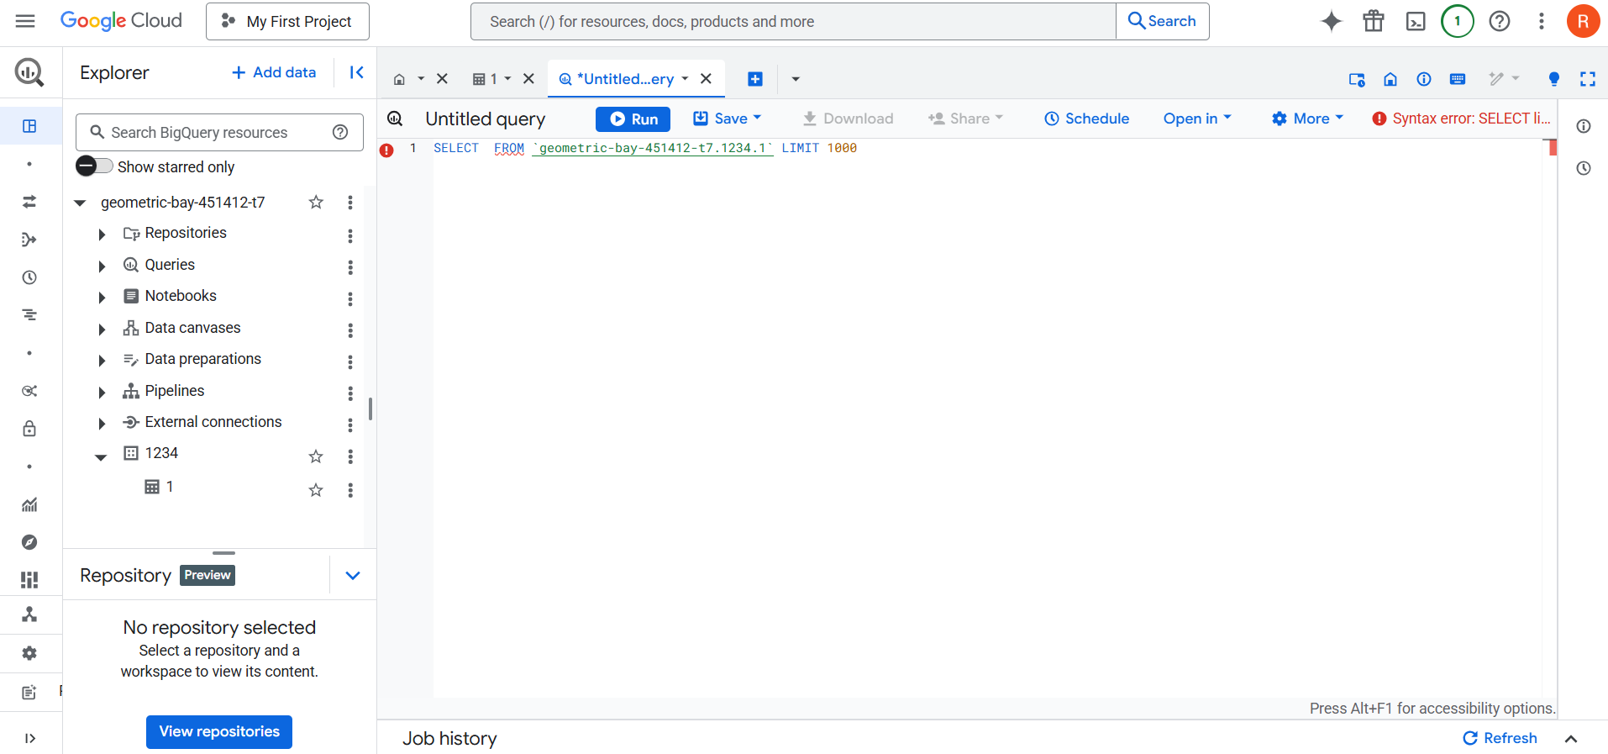
Loading Data into BigQuery:
1. Uploading CSV/JSON Files
- You can upload data directly into BigQuery from your local machine.
- File types supported: CSV, JSON, Avro, Parquet, ORC.
- UI path: Create Table > Source: Upload > Select File.
- Specify file format and delimiter (for CSV).
- Choose a dataset and table name.
2. Load from Google Cloud Storage (GCS)
- Use GCS for large or recurring loads.
- Path format: gs://bucket_name/folder/file.csv
- Allows automation and bulk loads.
- Ensure service account permissions (BigQuery needs access to GCS).
3. Load from Google Drive
- Select Google Drive as the source.
- Provide the shareable link (must be public or shared with your account).
- File types: CSV, Sheets, JSON.
- Used for ad-hoc and small-scale loads.
4. Auto-detect Schema
- BigQuery can auto-detect schema based on file content.
- Enable “Auto-detect” option during load.
- Good for quick start, but manual schema definition is preferred for production loads.
Scheduling and Saved Queries:
Scheduled Query:
A scheduled query in BigQuery allows you to automatically run a SQL query on a recurring basis (e.g., hourly, daily, weekly) and optionally save the output to a destination table.
This is very useful for:
- ETL (Extract, Transform, Load) workflows
- Automating data refresh for dashboards
- Periodic reporting
How to Create a Scheduled Query:
Step 1: Write Your Query
- Open the BigQuery SQL Editor.
- Write the SQL you want to run on a schedule.
Step 2: Schedule the Query
- Click on the clock icon or “Schedule” > “Create new scheduled query”.
Step 3: Configure the Schedule.
Field | Description
Name | A unique name for your scheduled query job
Schedule | Choose frequency: Hourly, Daily, Weekly, Monthly, or Custom (cron)
Start time | When the first query execution should happen
Timezone | Important if your scheduling logic is time-sensitive
Destination:
- Save results to a table:
  - You must choose a project, dataset, and table.
  - You can choose:
    - Append to table
    - Overwrite table
    - Create table if needed
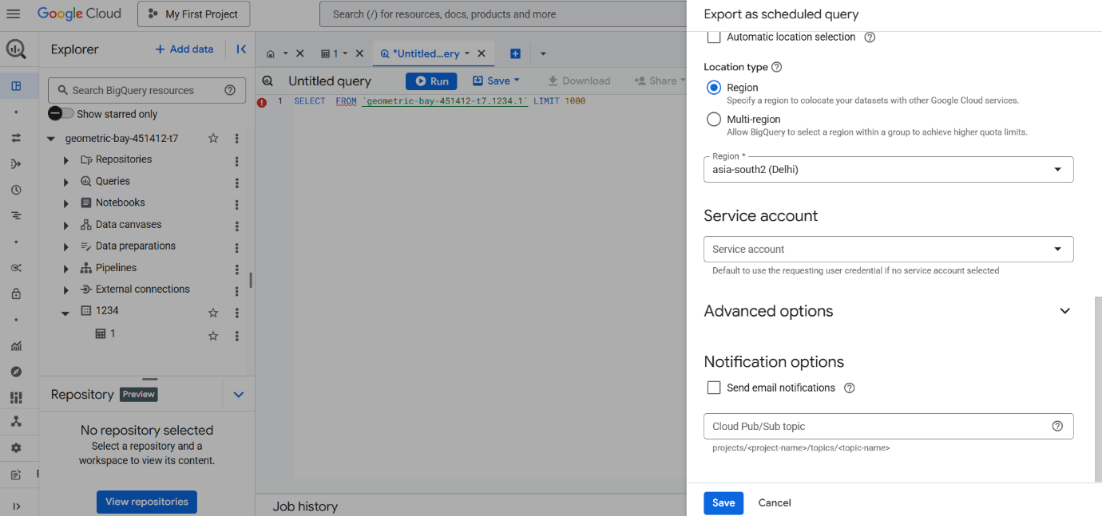
Saved Queries in BigQuery:
Saved queries allow you to store frequently used SQL scripts in your BigQuery project, making it easy to reuse or collaborate.
They are not executed automatically like scheduled queries, but they:
- Improve productivity
- Help with version control and review
- Are great for documentation or templates
How to Save a Query:
Step 1: Write Your Query
- Open the BigQuery SQL Editor and write your SQL.
Step 2: Save the Query
- Click the “Save” button above the editor.
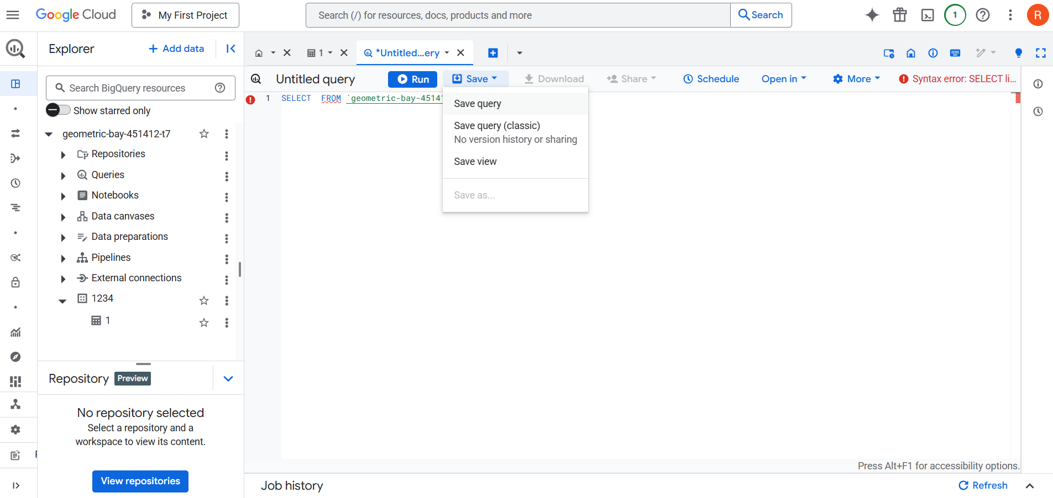
Step 3: Choose Save Options.
Option | Description
Save as new | Creates a new saved query
Overwrite existing | Updates a previously saved query
Add a description | Helps you remember the purpose of the query
Saved queries are stored per user, not shared across the entire project unless you explicitly share them (e.g., via code or documentation).
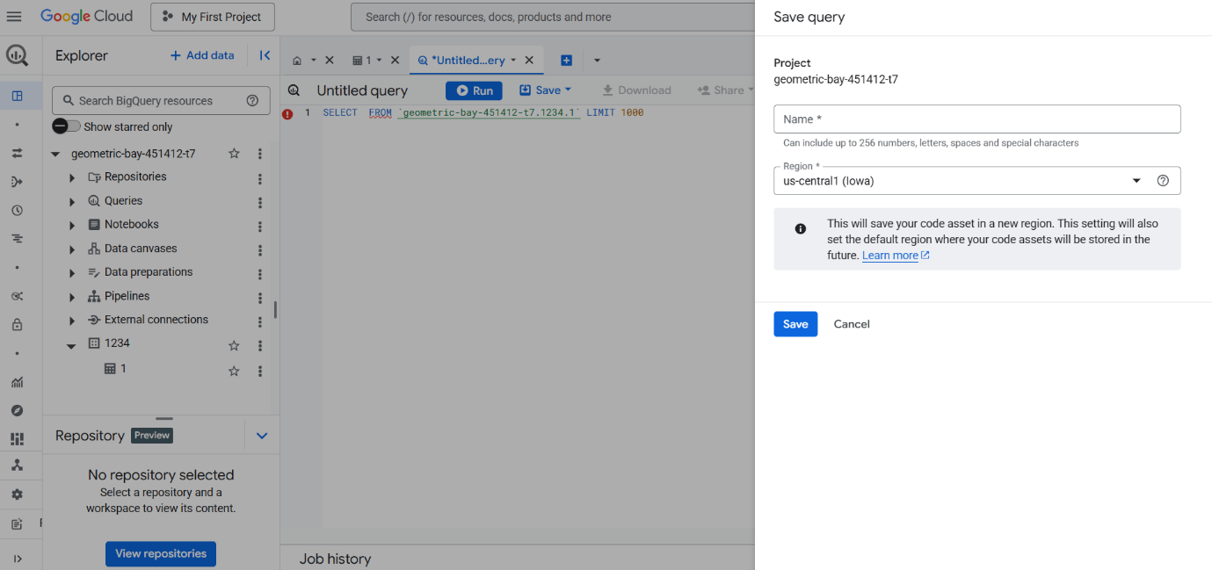
Accessing Saved Queries:
Step 1: Navigate to the “Saved Queries” tab in BigQuery (on the left panel).
Step 2: Click on a saved query to open and run it.
Step 3: You can search, edit, delete, or rename them.
Querying in BigQuery:
Creating a table in a new project created for Querying in BigQuery.
Dataset:
https://docs.google.com/spreadsheets/d/1GO5b8D_7VPc7qaYWv6khoo8JxomRSKeUYbp66aDFQq0/edit?gid=0#gid=0
Creating a Table in a new project:
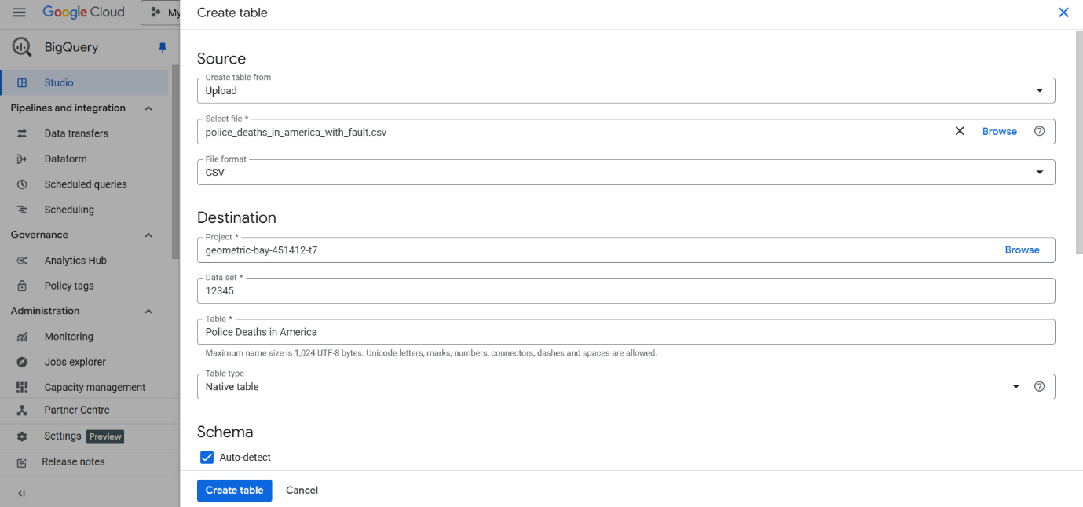
After uploading, the Dataset looks like this, you can apply any filter to get any customised view.
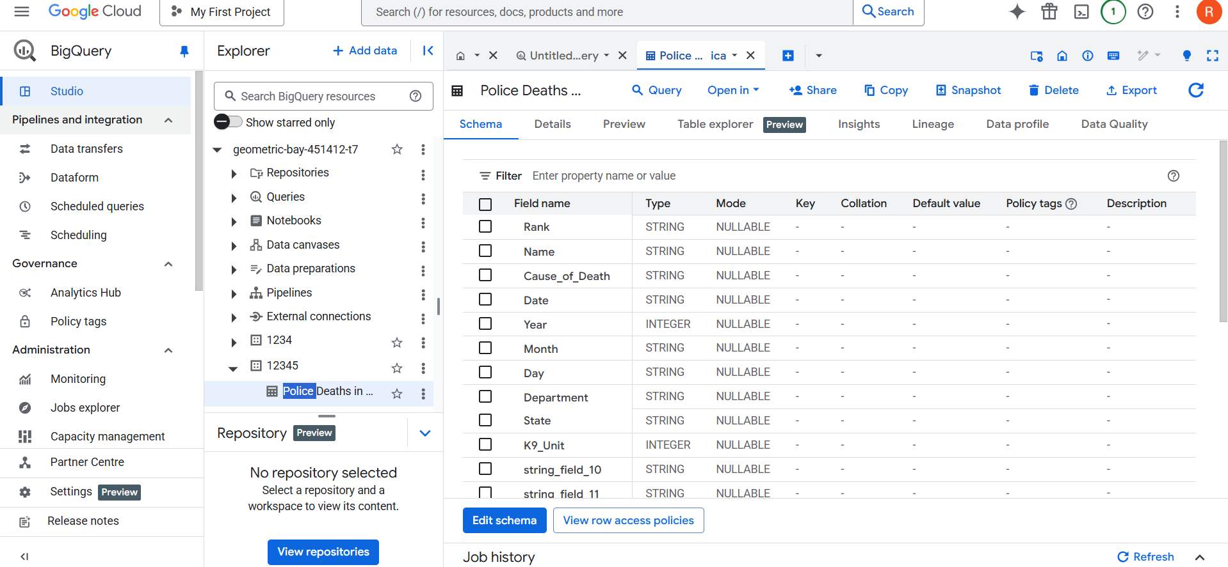
Running of a basic Query:
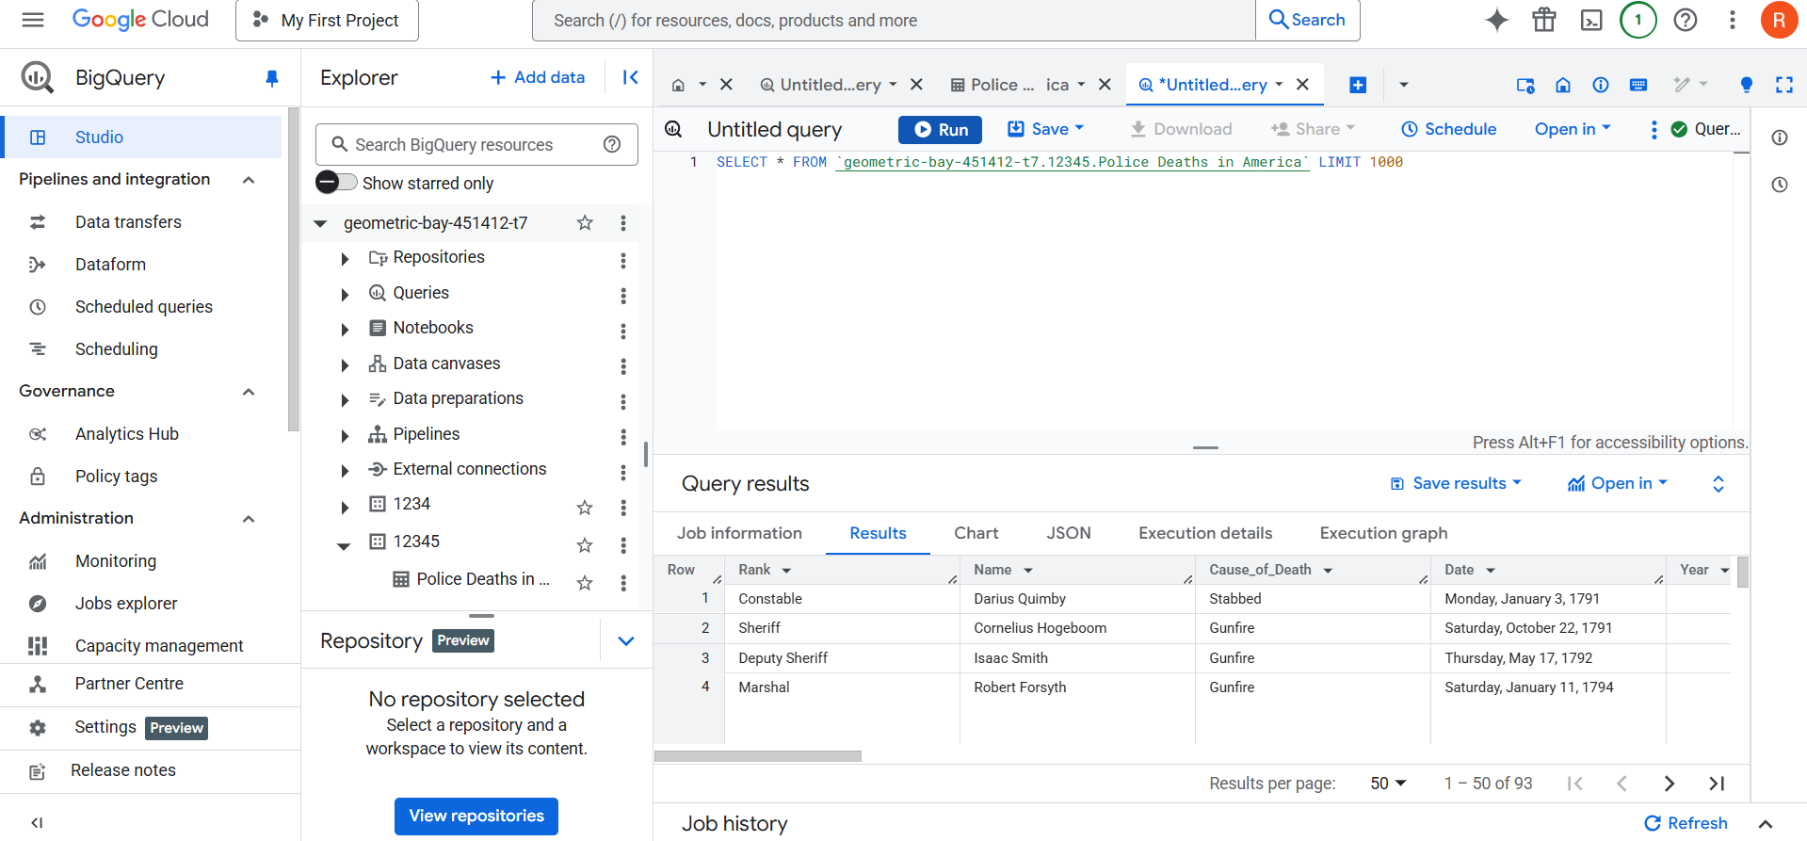
1. SELECT statements:
The SELECT statement is used to fetch data from a table. You can select specific columns or use * to select all.
Example:
SELECT Name, Rank, Cause_of_Death
FROM your_dataset.line_of_duty;
2. Filtering with WHERE:
WHERE is used to filter rows based on conditions.
Example:
SELECT *
FROM your_dataset.line_of_duty
WHERE State = 'TX' AND Year = 2021;
3. LIMIT and ORDER BY
- ORDER BY sorts results (ASC by default or DESC).
- LIMIT restricts the number of rows returned.
Example:
SELECT Name, Date, Cause_of_Death
FROM your_dataset.line_of_duty
ORDER BY Date DESC
LIMIT 5;
4. DISTINCT
DISTINCT removes duplicate values from the result set.
Example:
SELECT DISTINCT Cause_of_Death
FROM your_dataset.line_of_duty;
SELECT DISTINCT Cause_of_Death
FROM your_dataset.line_of_duty;
5. Aggregations & JOINS
A. COUNT, SUM, AVG, GROUP BY
Aggregate functions summarize data:
- COUNT() – total number of rows
- AVG() – average value
- GROUP BY – groups rows for aggregation
Example:
SELECT State, COUNT(*) AS deaths
FROM your_dataset.line_of_duty
GROUP BY State
ORDER BY deaths DESC;
B. JOINs (INNER, LEFT, RIGHT)
📖 Theory:
- JOIN combines rows from multiple tables based on a related column.
- INNER JOIN shows matches from both tables.
- LEFT JOIN shows all from left + matched from right.
- RIGHT JOIN is the opposite.
Example:
SELECT l.Name, l.State, s.Population
FROM your_dataset.line_of_duty l
JOIN your_dataset.state_info s
ON l.State = s.State;
6. Subqueries, Aliases, CASE
A. Subquery within FROM
A subquery is a nested query used as a temporary table.
Example:
SELECT *
FROM (
SELECT State, COUNT(*) AS total_deaths
FROM your_dataset.line_of_duty
GROUP BY State
)
WHERE total_deaths > 10;
B. Aliases
AS gives temporary names to columns or tables to simplify reference.
Example:
SELECT Name AS OfficerName, Department AS Dept
FROM your_dataset.line_of_duty;
C. CASE (Conditional Logic)
CASE is SQL's version of if/else.
Example:
SELECT Name,
CASE
WHEN Cause_of_Death LIKE '%gun%' THEN 'Violent'
WHEN Cause_of_Death LIKE '%heart%' THEN 'Medical'
ELSE 'Other'
END AS Death_Type
FROM your_dataset.line_of_duty;
7. Partitioning and Clustering
A. Partitioning
Splits a table into segments (partitions) based on a column, typically a date.
Example:
CREATE TABLE your_dataset.partitioned_data
PARTITION BY Date
AS SELECT * FROM your_dataset.line_of_duty;
Now queries with WHERE Date = '2022-01-01' scan only that partition.
B. Clustering
Organizes data inside a partition by one or more columns.
Example:
CREATE TABLE your_dataset.clustered_data
PARTITION BY Date
CLUSTER BY State, Cause_of_Death
AS SELECT * FROM your_dataset.line_of_duty;
8. Views and Materialized Views
A. Views A saved SQL query that runs fresh every time.
Example:
CREATE VIEW your_dataset.k9_deaths AS
SELECT * FROM your_dataset.line_of_duty
WHERE K9_Unit = 'Yes';
B. Materialized Views
A precomputed view that stores results for faster querying.
Example:
CREATE MATERIALIZED VIEW your_dataset.mv_deaths_by_state AS
SELECT State, COUNT(*) AS total
FROM your_dataset.line_of_duty
GROUP BY State;
9. Common Table Expressions (CTEs)
WITH clause lets you define temporary named subqueries.
Break down complex logic, reuse chunks of SQL.
Example:
WITH violent_deaths AS (
SELECT * FROM your_dataset.line_of_duty
WHERE Cause_of_Death LIKE '%gun%'
),
summary AS (
SELECT State, COUNT(*) AS gun_deaths
FROM violent_deaths
GROUP BY State
)
SELECT * FROM summary WHERE gun_deaths > 5;
10. BigQuery Functions
A. STRING Functions
SELECT UPPER(Name), LENGTH(Name)
FROM your_dataset.line_of_duty;
B. DATE Functions
SELECT Date, EXTRACT(YEAR FROM Date) AS year_extracted
FROM your_dataset.line_of_duty;
C. MATH Functions
SELECT ROUND(RAND() * 100, 2) AS random_score;
D. User Defined Functions (UDFs)
Custom functions written in SQL or JavaScript for reuse.
Example:
CREATE TEMP FUNCTION isK9(name STRING)
RETURNS BOOL
AS (CONTAINS_SUBSTR(LOWER(name), 'k9'));
SELECT Name, isK9(Name) AS Is_K9
FROM your_dataset.line_of_duty;
NOTE: You can use Sandbox as it is a free and easy way to start using Google BigQuery without needing to provide a credit card or set up billing. It's ideal for experimentation, learning, and small-scale development.
Connecting BigQuery to Visualization Tools:
Looker Studio (formerly Google Data Studio)
Looker Studio is a free Google tool for creating interactive reports and dashboards. It supports direct connection to BigQuery for real-time data visualizations.
Steps to Connect BigQuery to Looker Studio:
Step 1: Search for Looker Studio in GCP console.
Step 2: Click on Create > Report
- This opens a new blank report canvas.
- You will be prompted to add a data source.
Step 3: Choose BigQuery as the Data Source
- In the connector list, click BigQuery.
- You may be asked to grant permissions.
Step 4: Select Your Project, Dataset, and Table/View
- Navigate through the folder tree:
  - Choose your Google Cloud project
  - Select the dataset (like sales_data)
  - Pick a table (or view) to visualize (e.g., monthly_sales)
Step 5: Click "Add" → Then "Add to Report"
- This connects your BigQuery table as a data source to the report.
Step 6: Create Charts
- Use the toolbar to insert:
  - Bar charts
  - Pie charts
  - Line charts
  - Geo maps
  - Scorecards
  - And more
- Drag and drop fields to configure dimensions (e.g., category) and metrics (e.g., total_sales).
Step 7: Customize & Share
- Apply filters, date ranges, themes, calculated fields.
- Share dashboards with your team or export to PDF.

