SpEx+-Based Target Speaker Extraction for Reliable In-Car Voice Assistance

Abstract:
Voice assistants in vehicles must recognize the intended occupant even when passengers are speaking and the cabin is affected by road noise, ventilation, and audio playback. This paper proposes a target speaker extraction system for in-car voice interaction based on SpEx+. A short enrollment utterance identifies the occupant whose speech should be retained. Cabin microphone signals are first processed to reduce playback echo and obtain spatial cues. The cabin mixture and enrollment utterance then pass through time-domain speech encoders with shared weights. A speaker-conditioned extractor uses the enrollment representation to isolate the target voice, which is reconstructed by a speech decoder. Before the recovered speech reaches the assistant, a target-presence decision checks whether the enrolled occupant is speaking, reducing the risk of activation by a passenger. Accepted speech is passed to wake-word detection, automatic speech recognition, and command interpretation. The study will compare recognition from unprocessed cabin audio, a single-channel SpEx+ baseline, and the proposed multichannel system. Performance will be assessed using extraction quality, transcription and command accuracy, false activations, and processing latency across different driving and overlap conditions. The evaluation is intended to determine whether combining speaker identity with cabin spatial information improves the reliability of in-car voice interaction.

Introduction
Speech-based interaction has become an increasingly useful interface for vehicle navigation, communication, and cabin control. A voice assistant allows an occupant to issue a command without navigating a visual menu, but its usefulness depends on recognizing the correct speaker and the correct words. Inside a moving vehicle, microphone recordings are affected by road and engine noise, ventilation, open windows, and audio played through the car speakers. The problem becomes more difficult when two or more occupants speak at the same time. In that situation, improving the overall quality of the recording is insufficient: the system must determine which occupant is addressing the assistant and preserve that person’s speech while suppressing competing voices.
Recent in-car speech research has begun to address these conditions using multichannel recordings and dedicated recognition pipelines. AISHELL-5, for example, provides speech from multiple occupants recorded inside cars, together with far-field microphone signals and environmental noise [1]. Such data show the importance of evaluating speech systems under realistic cabin conditions. Nevertheless, a recognition system that receives the combined microphone signal may still produce errors when a passenger speaks over the intended user. General speech separation offers one possible solution, but its output streams do not inherently identify the speaker who issued the command. For a voice assistant, extracting the intended occupant is therefore a more specific problem than separating every audible voice.
Target speaker extraction uses a reference utterance to specify the voice that should be recovered from a mixture. SpeakerBeam established this approach for overlapping speech [2]. SpEx+ subsequently introduced a fully time-domain architecture in which the mixture and reference utterance are processed through speech encoders with shared weights [3]. The reference representation guides the extractor toward the target voice. These properties make SpEx+ a relevant starting point for an assistant serving an enrolled driver or passenger. However, a model developed for general speech mixtures must still be examined under the changing noise, reverberation, speaker positions, and playback conditions of a vehicle cabin.
A narrower challenge arises when the target occupant speaks during passenger conversation. The assistant must retain short commands without incorporating words spoken by another occupant. It must also remain inactive when only a passenger speaks. These requirements are distinct from obtaining a high signal-to-noise ratio: an extracted signal can sound clearer while still containing the wrong speaker or losing a word that is essential to the command. Consequently, target speaker extraction should be assessed together with speech recognition and assistant activation, rather than solely through signal-level measures. Processing time is also relevant because a delayed response can make an otherwise accurate assistant impractical.
This paper proposes a SpEx+-based target speaker extraction framework for in-car voice assistance. A short enrollment utterance provides the identity of the intended occupant, while cabin microphones capture the speech mixture during use. The proposed system uses SpEx+ to estimate the target voice and investigates whether information from multiple microphone positions can further distinguish occupants seated in different parts of the car. The extracted speech is passed to wake-word detection, automatic speech recognition, and command interpretation. The study compares recognition from the unprocessed cabin signal with standard SpEx+ and the proposed cabin-adapted system. Evaluation considers extraction quality, transcription and command accuracy, false activations when the target is absent, and processing latency. This combined evaluation is intended to establish whether improvements in target voice extraction translate into more reliable voice assistant operation under realistic cabin interference.

Proposed System
Figure 1 shows the proposed SpEx+ based voice assistant system. The architecture has two input paths. The first processes speech recorded by the car cabin microphones; the second processes an enrollment utterance from the occupant whose voice the system is required to extract. The paths meet at the speaker-conditioned extractor, after which the recovered speech passes through the assistant pipeline.
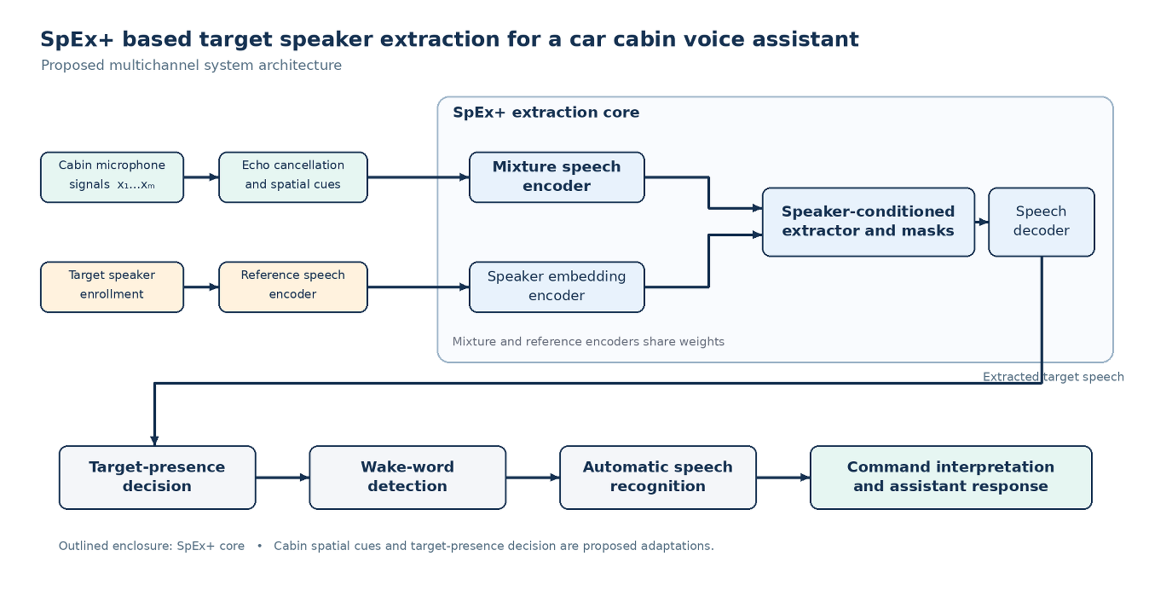
Figure 1. Block diagram of the proposed SpEx+ based target speaker extraction and car cabin voice assistant system.
The cabin microphones record the target occupant together with passenger speech, vehicle noise, and sound from the car audio system. Their signals first enter the echo cancellation and spatial processing block. Echo cancellation uses the audio playback signal as a reference to reduce sound reproduced by the vehicle speakers and recaptured by the microphones. For multichannel recordings, this block also derives cues from differences between the microphone signals. These cues can help distinguish occupants at different seating positions when their voices overlap. The processed cabin signal is then passed to the mixture speech encoder.
In the second path, the target occupant provides a short enrollment utterance recorded separately from the command being processed. The reference speech encoder processes this utterance, and the speaker embedding encoder produces a representation of the target voice. As indicated in Figure 1, the mixture and reference speech encoders share weights. This is a defining feature of SpEx+: both signals are represented through the same time-domain encoding process before the target speaker information is used for extraction.
The speaker-conditioned extractor receives the encoded cabin mixture and the target speaker representation. It estimates masks that retain speech associated with the enrolled occupant while attenuating competing voices and other interference. The speech decoder uses the masked representation to reconstruct a waveform containing the estimated target speech. The proposed cabin adaptation introduces spatial cues at the microphone front end; its contribution will be assessed against a single-channel SpEx+ baseline.
The extracted waveform next reaches the target-presence decision block. This block addresses cases in which a passenger speaks while the enrolled occupant is silent. Rather than forwarding every extracted signal, the system determines whether there is sufficient evidence that the target occupant is speaking. Accepted speech passes to wake-word detection and then to automatic speech recognition. The resulting transcript is interpreted as a vehicle command or information request, and the assistant generates the appropriate response. Audio produced by the assistant is also available as a playback reference for echo cancellation during subsequent interactions.
The system will be evaluated as a complete path from cabin recording to assistant response. Comparisons will include the unprocessed microphone signal, conventional single-channel SpEx+, and the proposed multichannel configuration. Extraction quality will indicate how well the target waveform is recovered, while target-presence errors, wake-word activations, transcription accuracy, command recognition, and latency will measure the effect on voice interaction.

Experimental Setup and Training Procedure
The experimental study is organized in three stages: dataset preparation, model training and validation, and testing in a real vehicle environment. The first two stages establish whether SpEx+ can extract the voice of an enrolled occupant under cabin noise and overlapping speech. The final stage examines whether this improvement carries through to wake-word detection and command recognition on edge hardware. All comparisons will use the same test recordings and enrollment utterances wherever possible.
Dataset Preparation
The dataset will be prepared as paired examples containing a cabin microphone recording, a separate enrollment utterance from the target occupant, and a time-aligned reference of that occupant’s speech. Training mixtures will combine target speech with passenger speech and recorded cabin noise under varied overlap and interference levels. For multichannel examples, the same sources will be represented at each microphone position while preserving differences in arrival time and level. Target-absent examples, including passenger-only commands, will be included to train the system to reject speech from the wrong occupant. Existing in-car recordings and noise from AISHELL-5 will support model development, while a separate command corpus will be collected in the intended language of the assistant. Each example will retain speaker identity, seat position, driving condition, transcript, and command label where applicable. Speakers and original recording sessions will be assigned to training, validation, and test sets before mixture generation. Enrollment utterances will remain separate from the target commands, and no source recording or noise excerpt will be reused across the data partitions.
Model Training
The model will be initialized from a pretrained SpEx+ checkpoint and trained using four-second cabin mixtures paired with a separate enrollment utterance and a time-aligned target waveform. All recordings will be converted to the sample rate required by the selected checkpoint. As an initial training configuration, we will use the AdamW optimizer, a batch size of eight, gradient clipping at 5, and a maximum of 60 epochs. During the first five epochs, the shared speech encoder will be frozen while the extractor and decoder adapt to cabin recordings at a learning rate of (10^{-4}). From epochs 6 to 40, the full single-channel model will be fine-tuned, using (10^{-5}) for pretrained encoder weights and (10^{-4}) for the extractor and decoder. The multichannel spatial module will then be introduced and trained over the remaining 20 epochs, initially with the SpEx+ weights fixed and subsequently through joint fine-tuning. For target-present examples, the principal loss will be negative SI-SDR between the extracted and reference speech, combined with a speaker-classification loss where speaker labels are available. A target-presence head will be trained with binary cross-entropy on both present and absent examples; absent examples will also receive a penalty for nonzero output speech, without applying SI-SDR to a silent reference. The loss weights and duration of each training stage will be refined on the validation set. Checkpoints will be selected using extraction performance together with the passenger false-activation rate, and the test set will remain untouched until the final evaluation.

References
[1] Y. Dai et al., “AISHELL-5: The First Open-Source In-Car Multi-Channel Multi-Speaker Speech Dataset for Automatic Speech Diarization and Recognition,” Interspeech, 2025.
[2] K. Žmolíková et al., “SpeakerBeam: Speaker Aware Neural Network for Target Speaker Extraction in Speech Mixtures,” IEEE Journal of Selected Topics in Signal Processing, 2019.
[3] M. Ge et al., “SpEx+: A Complete Time Domain Speaker Extraction Network,” Interspeech, 2020.

Command corpus- set of speech to actions dataset, main goal of this model is to achieve maximum performance on this

