Game Design Document

Fill up the following document

1. Write the title of your project.

Pirates

1. What is the goal of the game?

The goal of the game is that using a navy ship you have to survive the carribean ocean and there will be pirates who shoot cannons this game is a infinite runner.

1. Write a brief story of your game.

The navy ship has to sail through the carribean to reach to a certain

Destination but on the way there are pirate ships who will try to rob

Them so they have to survive and reach the destination.

1. Which are the playing characters of this game?

* Playing characters are the ones who respond to the user based on the input from the user.
* Cars, monkeys, dinos, wizards, etc., are the playing characters in the game.

|  |  |  |
| --- | --- | --- |
| Number | Character Name | What can this character do? |
| 1 | Navy ship | Sail and dodge |
| 2 |  |  |
| 3 |  |  |
| 4 |  |  |
| 5 |  |  |
| 6 |  |  |
| 7 |  |  |
| 8 |  |  |

1. Which are the Non-Playing Characters of this game?

* Non-Playing characters are the ones that don't have an action or behavior when the user interacts with the game.
* Hurdles, stones, bananas, coins, etc., are non-playing characters in the game.

|  |  |  |
| --- | --- | --- |
| Number | Character Name | What can this character do? |
| 1 | Pirate ship | Destroy navy ship |
| 2 | ammunition | Score points |
| 3 |  |  |
| 4 |  |  |
| 5 |  |  |
| 6 |  |  |
| 7 |  |  |
| 8 |  |  |

Draw your imagination of this game. What does this game look like?

* Draw the game either on your computer or on paper.
* Add images of the game scenes to show each of the playing and non-playing characters at least once.

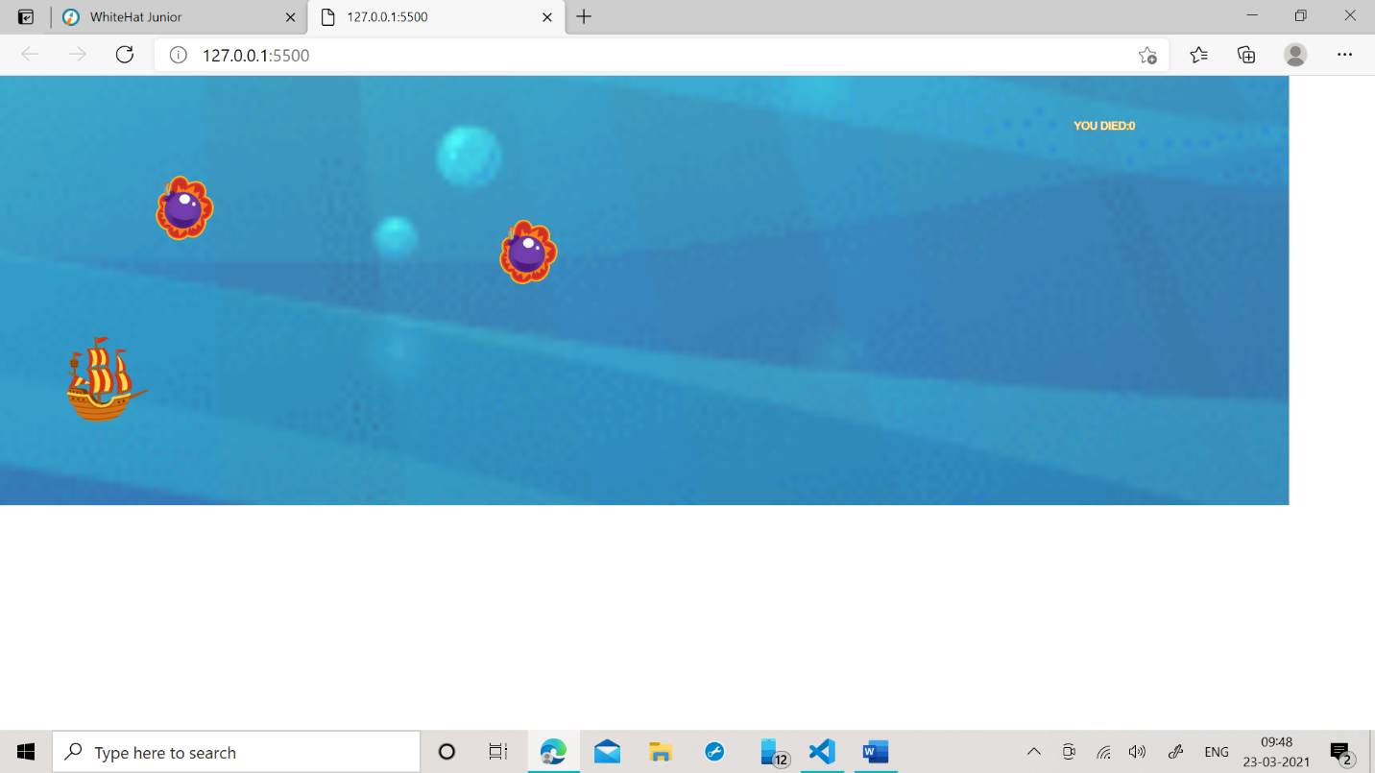

How do you plan to make your game engaging?

Since it is an infinite runner the game will not end so people will stop playing.