Creating a Virtual Machine on VirtualBox

Praneesh Sharma

21052264

**STEP 1:**

Open VirtualBox on your device. Click on the ‘New’ button form the available options on the top bar.

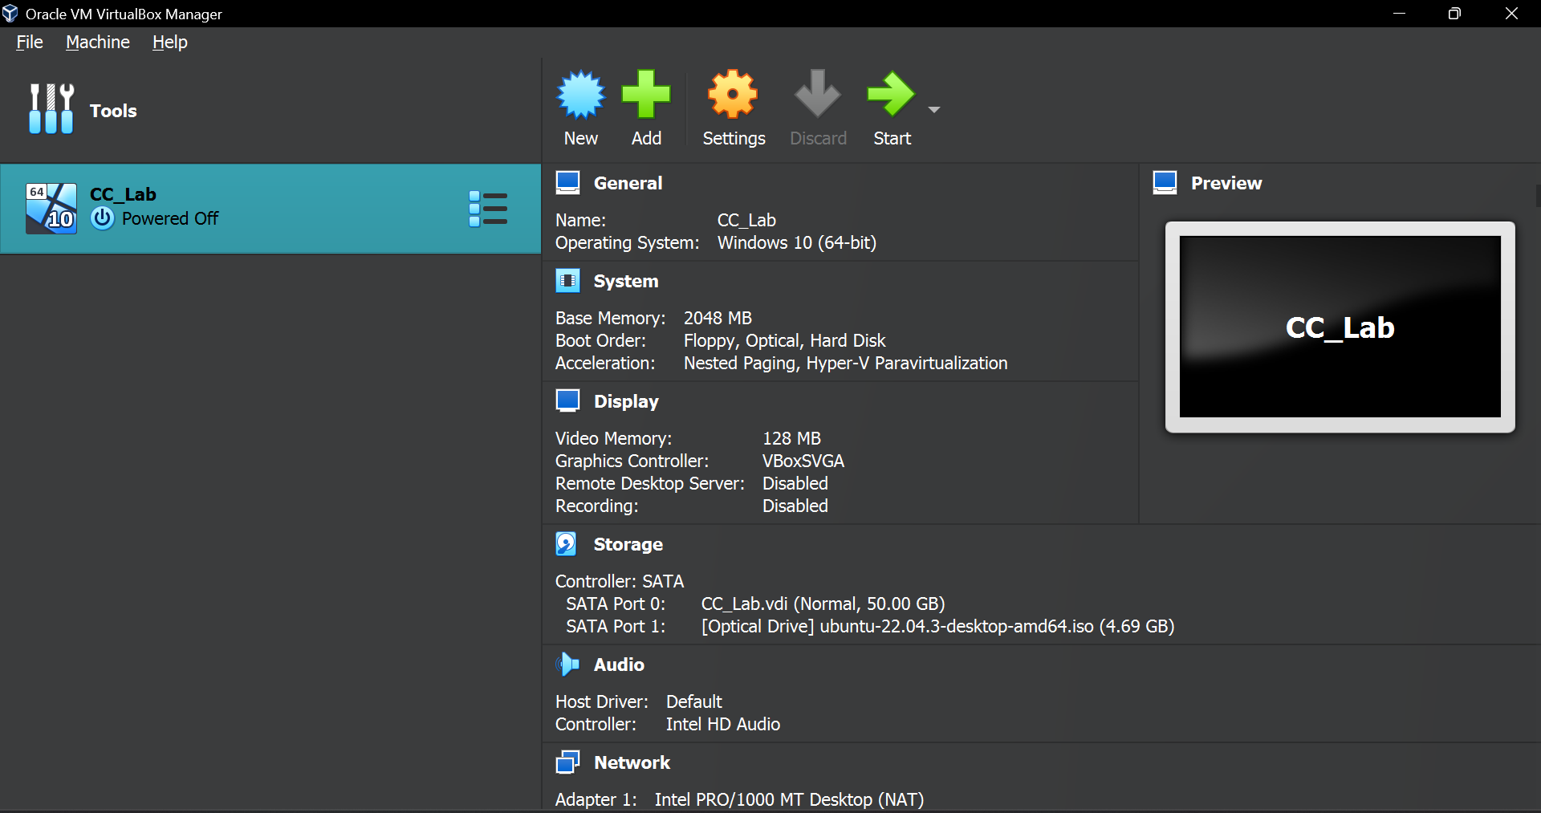

**STEP 2:**

A dialogue box appears. Give a suitable name for your virtual machine. You can set the location of the machine in your device using the Folder option. VirtualBox offers various types of machines like Windows, Linux or Mac OS. We will be creating a Linux machine. Click ‘Next’ after configuring the machine with your wanted settings.

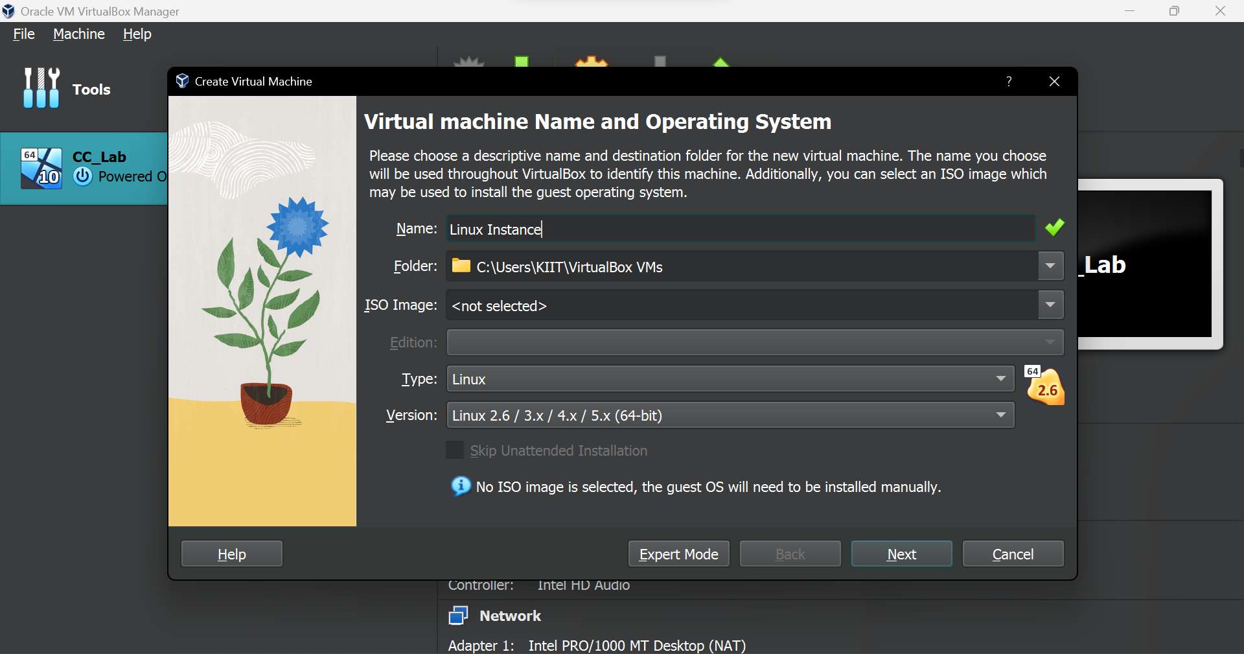

**Step 3:**

A new dialogue box appears. Here, we can configure the hardware settings. You can change the amount of Base Memory as well as the number of Processors you need for your machines. Click ‘Next’ after you have configured the hardware settings.

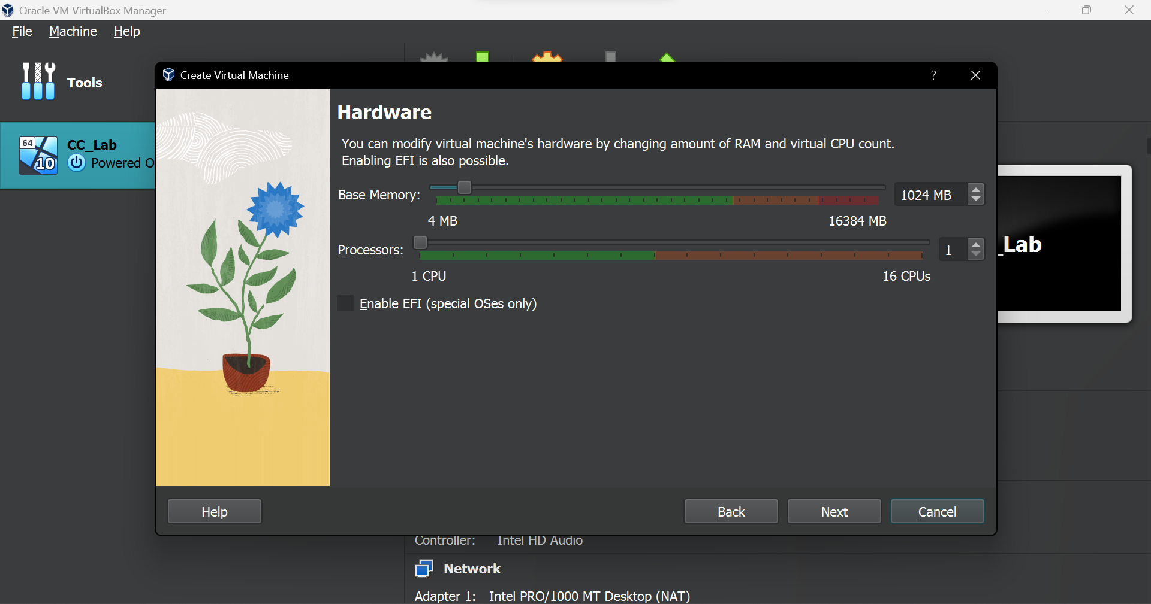

**Step 4:**

The next dialogue box gives options for the Virtual Hard disk. You can choose to add an existing virtual hard disk to the machine, create a new hard disk file or create a machine without a hard disk. Click on ‘Next’ after you have configured the Virtual Hard Disk settings.

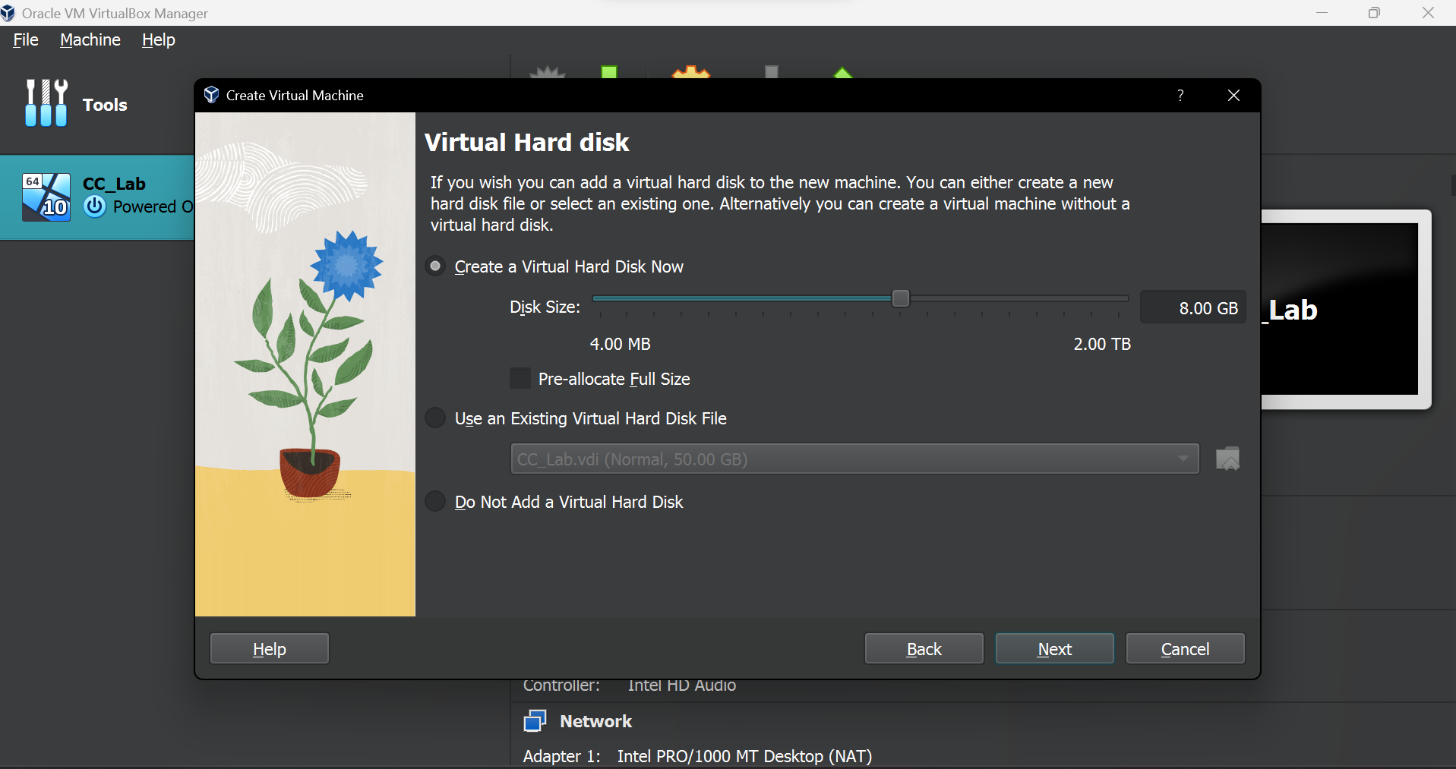

**Step 5:**

The final dialogue box tells us the summary of all the settings and configurations that we have set for our virtual machine. After verifying that everything is accurate, click on the ‘Finish’ button to finish setting up your virtual machine.

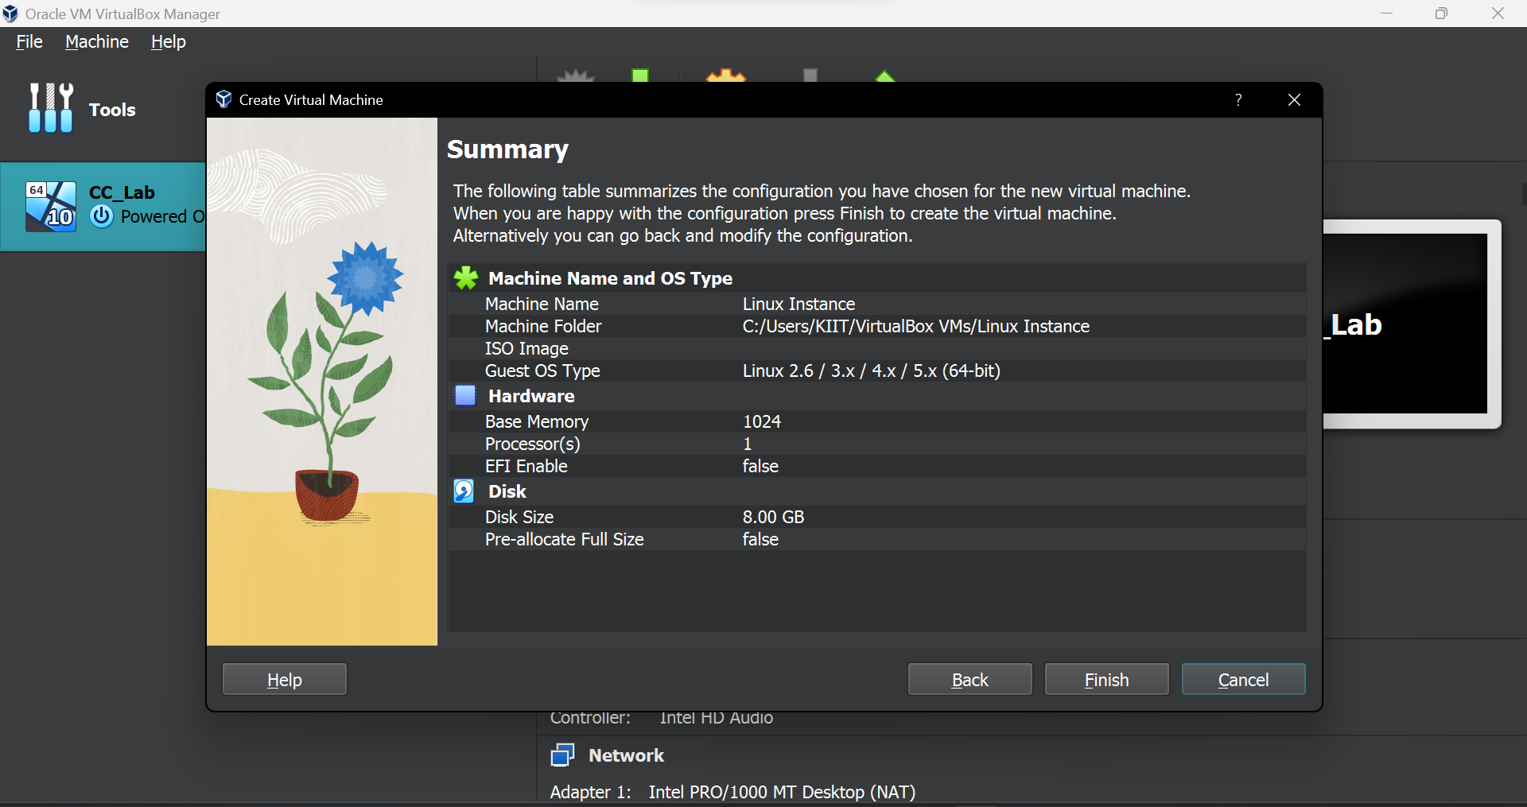

**Step 6:**

You have created your virtual machine. Next, we will be adding a secondary storage device. Click on the ‘Settings’ button from the available options.

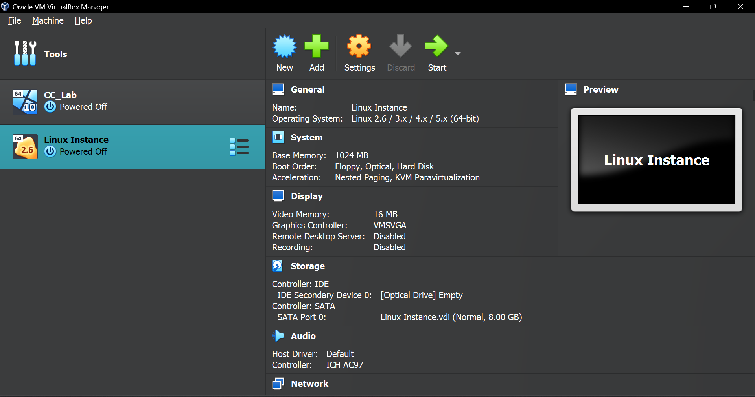

**Step 7:**

The settings dialogue box appears. Click on the Storage option. You will see that the Storage Device controller IDE is Empty. Click on the Empty button. You will see some settings on the right. Click on the small disk icon to the right of the Optical Drive field.

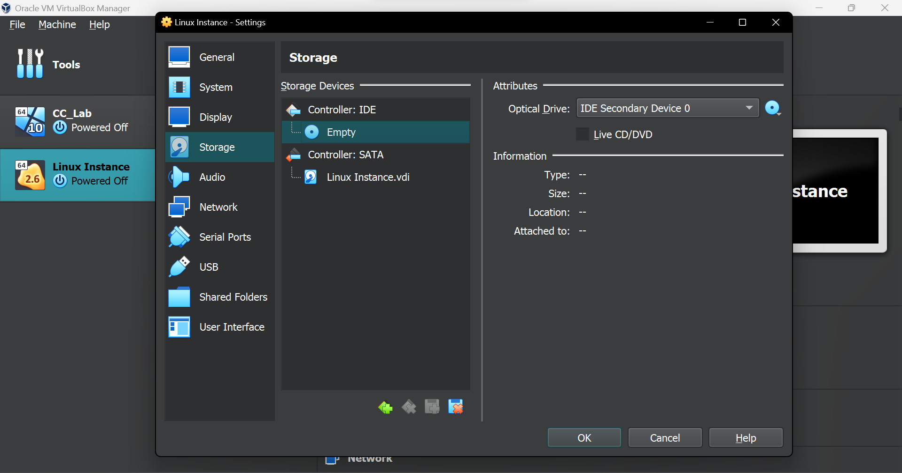

**Step 8:**

Click on the ‘Choose a Disk File’ option and add the given .iso file. Click on OK to finish setting up your virtual machine. Now you are all set to launch your virtual machine and use it according to your needs.

