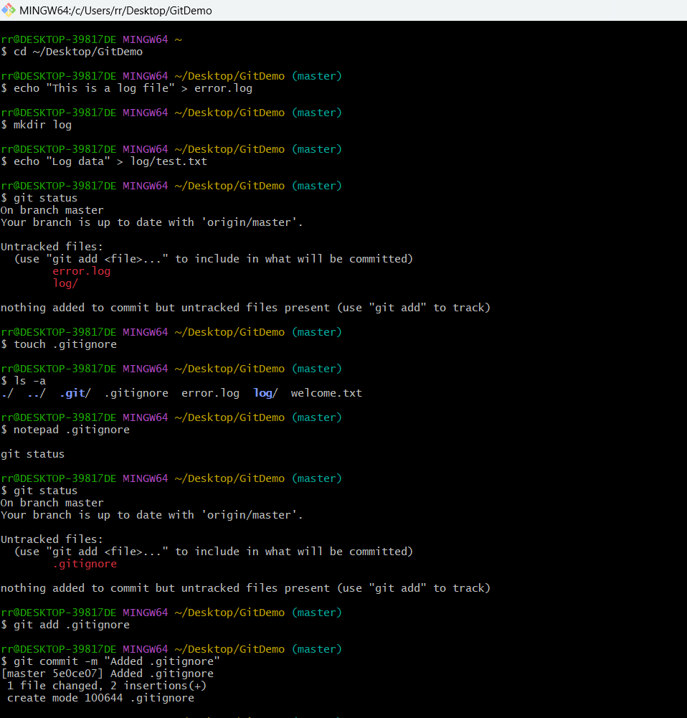
PRANEESH S
SUPERSET ID: 6739011
EXERCISE 2 PRACTICE

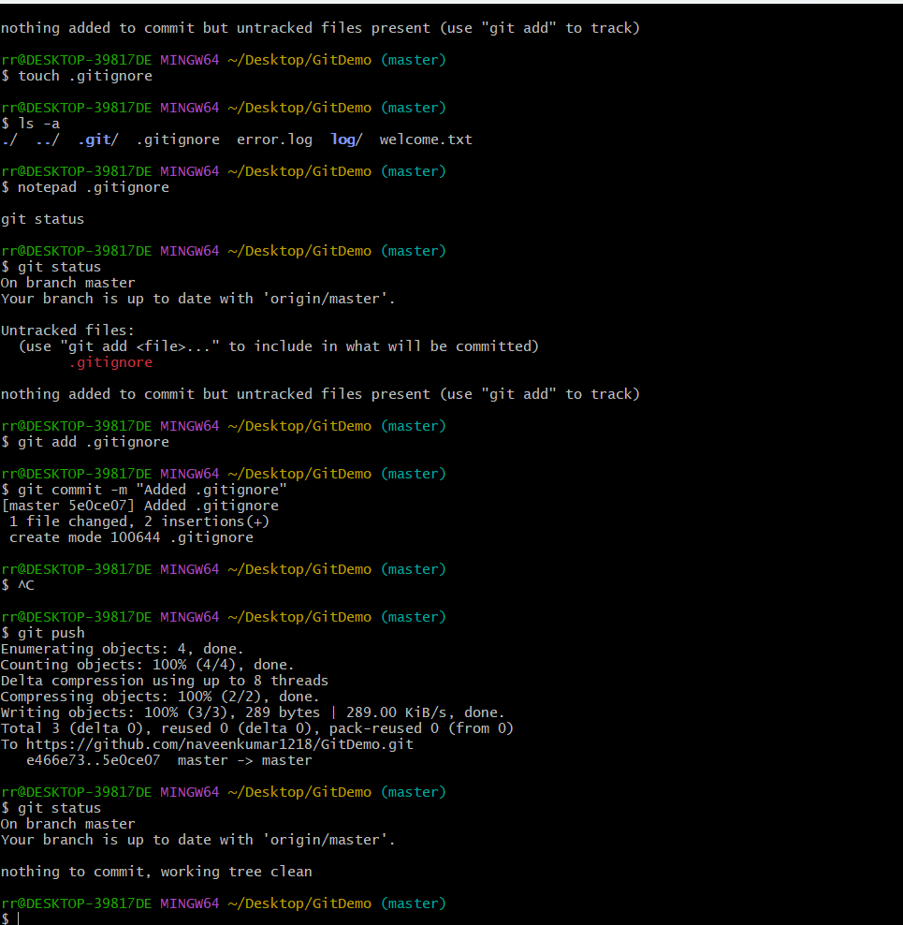

GITHUB OUTPUT (OPENED .GITIGNORE FILE):

