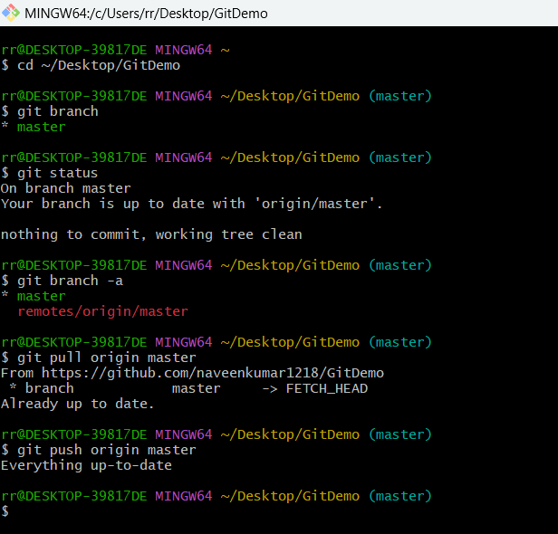
PRANEESH S
SUPERSET ID: 6739011
EXERCISE - 5 PRACTICE

