**Assignment**

1. Write a C program to add two integers

**IPO**

* The program takes two integer values from the user, for example, a = 5 and b = 7.
* The program adds the two input numbers using the addition operator (+) and stores the result in a variable named sum.The program displays the sum of the two numbers on the screen. For example, if a = 5 and b = 7, the output will be:  
  **sum = 12**

**Code:**

#include<stdio.h>

void main()

{

int a,b,sum;

scanf("%d%d",&a,&b);

sum=a+b;

printf("sum=%d",sum);

}

**Output:**

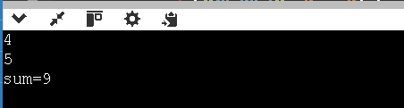

1. Write a program to swap two numbers using a temporary variable.

**IPO**

* The program takes two integers from the user. For example, a = 3 and b = 7.
* It uses a temporary variable c to store the value of a, then assigns b to a, and finally assigns the original a (stored in c) to b, thus swapping their values.
* The program prints the swapped values of a and b. If the input was a = 3, b = 7, the output will be:

**Code:**

#include<stdio.h>

void main()

{

int a,b,c;

scanf("%d%d",&a,&b);

c=a;

a=b;

b=c;

printf("swap a=%d\nswap b=%d\n",a,b);

}

**Output:**

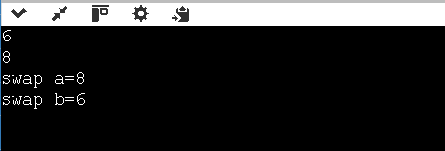

1. Write a program to swap two numbers without using a temporary variable.

**IPO**

* The program takes two integers as input from the user, for example, a = 10 and b = 20.  
  It performs the following steps to swap the numbers without using a third variable:
* Add both numbers and store in a → a = a + b
* Subtract new b from new a → b = a - b (now b has original a)
* Subtract new b from new a again → a = a - b (now a has original b)

**CODE:**

#include<stdio.h>

void main()

{

int a,b;

scanf("%d%d",&a,&b);

a=a+b;

b=a-b;

a=a-b;

printf("swap a=%d\nswap b=%d\n",a,b);

}

**Output:**

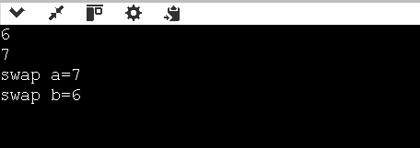

1. Write a program to find the ASCII value of a character.

**IPO**

* The user enters a single character (e.g., A).
* The program reads the character and determines its corresponding ASCII value using the internal integer representation of characters in C.
* The program prints the ASCII value of the entered character. For example:  
  "The ASCII value of 'A' is 65"

**Code:**

#include <stdio.h>

void main()

{

char ch;

printf("Enter a character: ");

scanf("%c", &ch);

printf("The ASCII value of '%c' is %d\n", ch, ch);

}

**OUTPUT:**

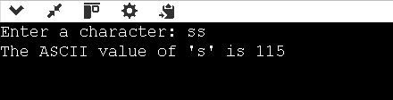

1. Write a program to calculate the area and perimeter of a rectangle.

**IPO**

* The user enters two integer values representing the length and breadth of a rectangle. Example: length = 5, breadth = 3.
* The program calculates the area using the formula Area = length × breadth, and the perimeter using Perimeter = 2 × (length + breadth).
* It prints the area and perimeter of the rectangle. Example:  
  Area=15 Perimeter=16

**CODE:**

#include <stdio.h>

void main()

{

int length,breadth,Area,Perimeter;

scanf("%d%d",&length,&breadth);

Area=length*breadth;

Perimeter=2*(length+breadth);

printf("Area=%d Perimeter=%d",Area,Perimeter);

}

**OUTPUT:**

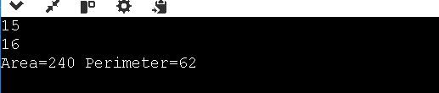

1. Write a program to compute the simple interest.

**IPO**

* The user enters the principal amount, rate of interest, and time in years.  
  Example: Principal = 1000, Rate = 5, Time = 2.
* The program calculates simple interest using the formula:

Simple Interest=Principal×Rate×Time100\text{Simple Interest} = \frac{\text{Principal} \times \text{Rate} \times \text{Time}}{100}Simple Interest=100Principal×Rate×Time​   
It displays the calculated simple interest.  
Example: Simple Interest = 100

**CODE:**

#include <stdio.h>

void main()

{

int principle,rate,tim,intrest;

scanf("%d%d%d",&principle,&rate,&tim);

intrest=principle*rate*tim/100;

printf("Intrest=%d",intrest);

}

**OUTPUT:**

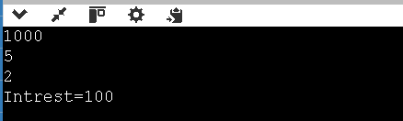

1. Write a program to convert temperature from Celsius to Fahrenheit.

**IPO**

* The user enters temperature in Celsius. Example: 37.0
* The program converts it using the formula:

Fahrenheit=(Celsius×95)+32\text{Fahrenheit} = \left( \text{Celsius} \times \frac{9}{5} \right) + 32Fahrenheit=(Celsius×59​)+32

* It prints the temperature in Fahrenheit.  
  For input 37.0, output: Fahrenheit = 98.60

**CODE:**

#include <stdio.h>

void main()

{

float celcius;

float farenheit;

scanf("%f",&celcius);

farenheit=celcius*(9.0/5.0)+32;

printf("%f",farenheit);

}

**OUTPUT:**

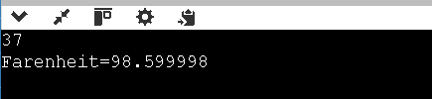

1. Write a program to find the quotient and remainder of two integers.

**IPO**

* The user enters two integers: the dividend and the divisor.
* The program divides the dividend by the divisor to find the quotient using /, and the remainder using %.
* It prints the quotient and the remainder.

**CODE**

#include <stdio.h>

void main()

{

int quotient,remaind,divider,divisior;

scanf("%d%d",&divider,&divisior);

quotient=divider/divisior;

remaind=divider%divisior;

printf("Quotient=%d\nRemind=%d\n",quotient,remaind);

}

**OUTPUT**

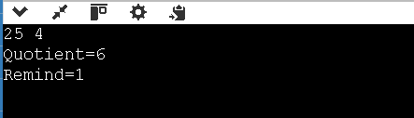

1. Write a program to check whether a number is even or odd.

**IPO**

* The user enters a single integer value (e.g., 7).
* The program checks if the number is divisible by 2 using the modulus operator %.
* If a % 2 != 0, it's odd.
* Otherwise, it's even.

**CODE**#include <stdio.h>

void main()

{

int a;

scanf("%d",&a);

if(a%2!=0)

{

printf("its a odd number");

}

else

{

printf("its a even number");

}

}

**OUTPUT**

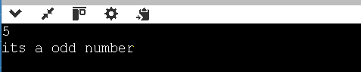

10**.**Write a program to calculate the square and cube of a number.

**IPO**

* The user enters one integer (e.g., 5).
* The program calculates square using a * a.
* The cube is calculated using a * a * a.
* It prints the square and cube.

**CODE**

#include <stdio.h>

void main()

{

int a,square,cube;

scanf("%d",&a);

square=a*a;

cube=a*a*a;

printf("square=%d\ncube=%d\n",square,cube);

}

**OUTPUT**

