**Get AWS Certified for Free!**

Students, follow the steps provided to become eligible for **100% discount vouchers** and write your certified AWS exam at no cost. Don't miss this chance to validate your skills!

**Step-by-Step Guide:**

**Step 1:**(i)Go to AWS Academy -> Choose the ACF/ any other course that was assigned.  
(ii)Scroll to the bottom of the course.  
(iii)Under “**AWS T&C Resources**” -> Go to “**Activate Your AWS Skill Builder Offer**”.

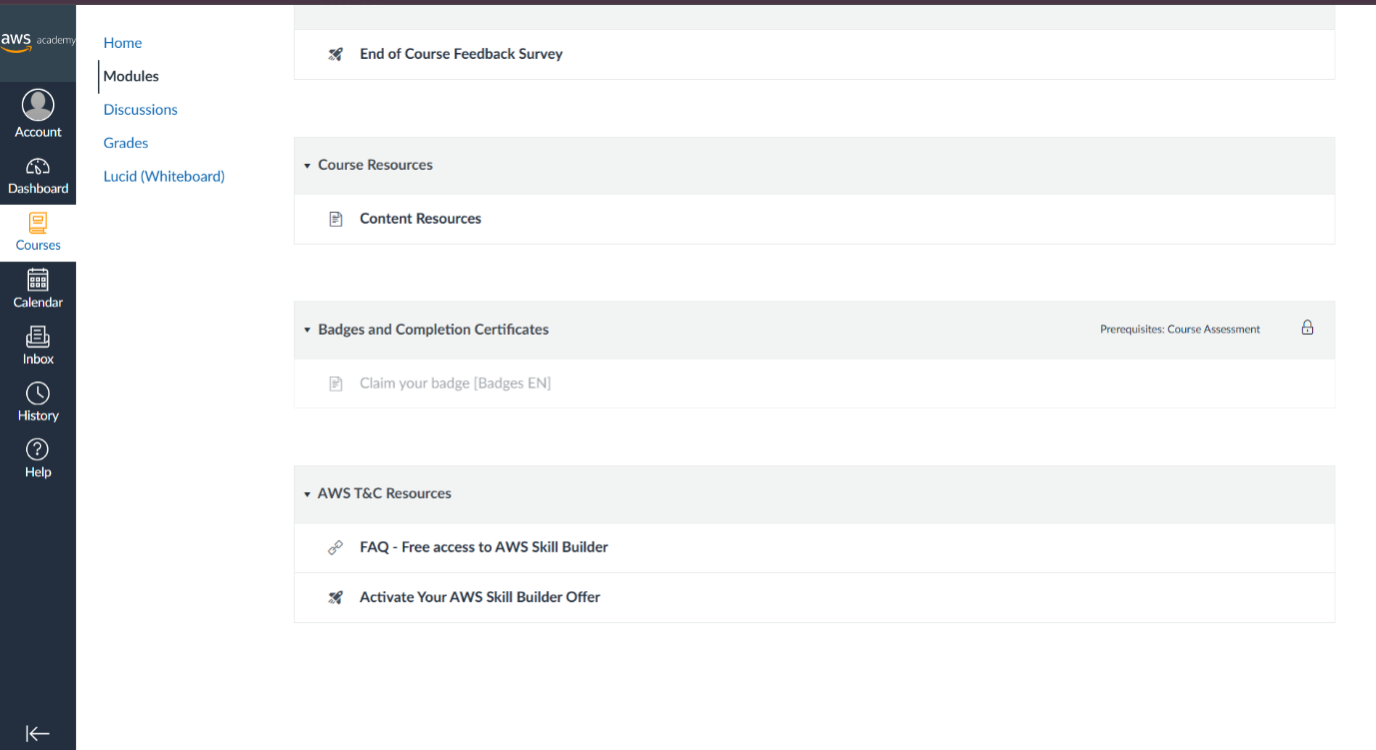

(iv)Then, take up the survey. You will receive a outlook mail from AWS training within few hours with a link attached to it.  
(v)Click the link and create an **AWS Skill Builder** account using **college mail**.

**Step 2:**

(i) After creating, Click “**Learning Plans**” -> “**Explore Plans**”

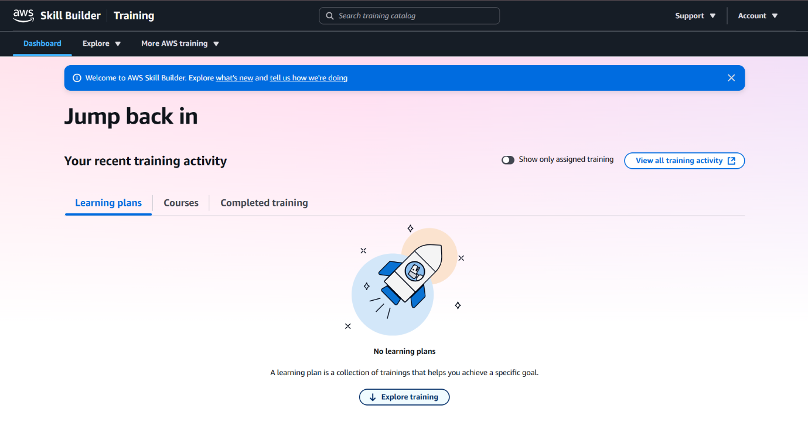

(ii)Scroll down to “**From Start to Certified**” section -> Choose “**Cloud Practitioner**”  
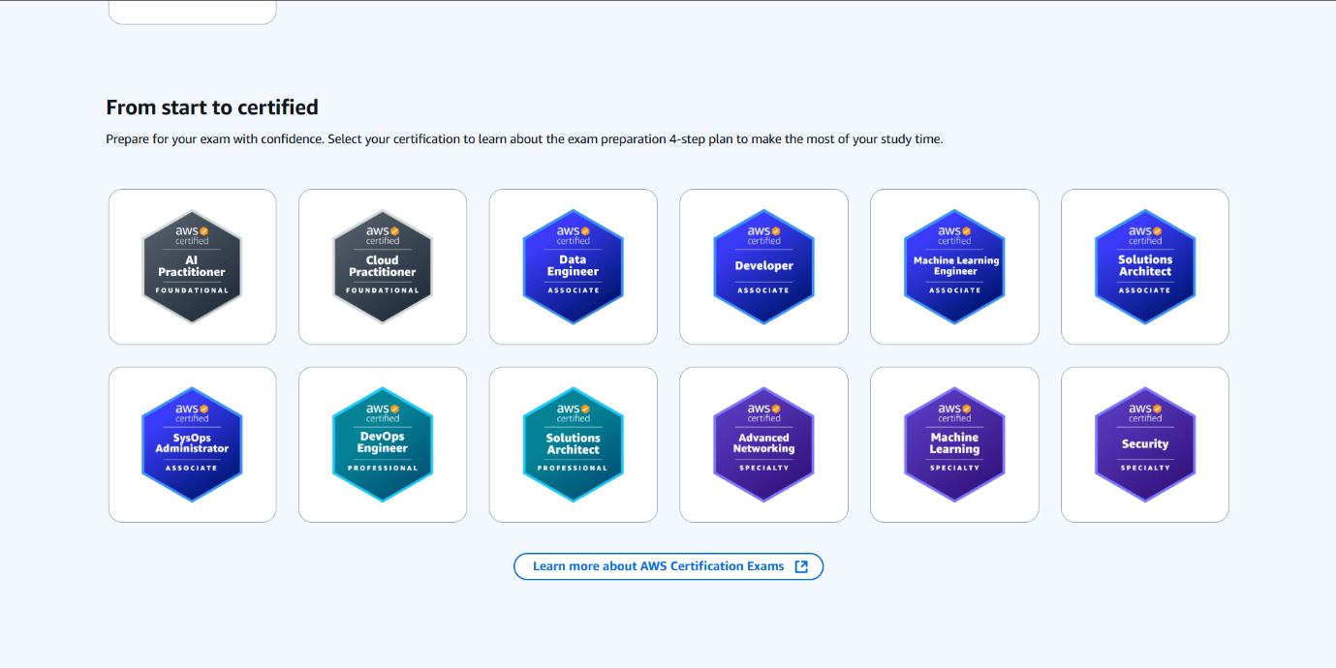

**Step 3 :**(i) In the below image, “**Official Practice Exam: AWS Certified Cloud Practitioner (CLF-C02)**” is highlighted and marked as “Complete”.

**For you guys, it will marked as “Assigned”.**

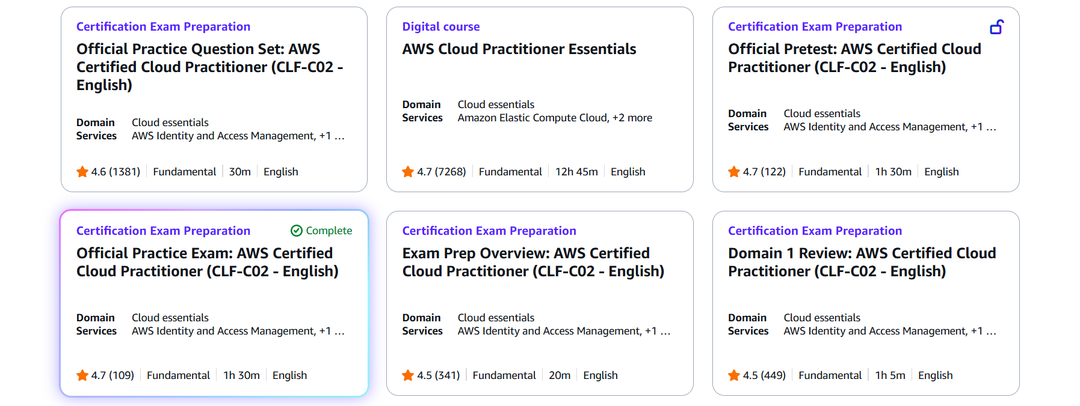

Kindly complete it to become eligible for 100% discount voucher. After taking up the Practice Exam, you will receive mail like this:

