ML Lab-3

Praneesh R V

CB.SC.U4CYS23036

Installing Creditcardfraud.csv

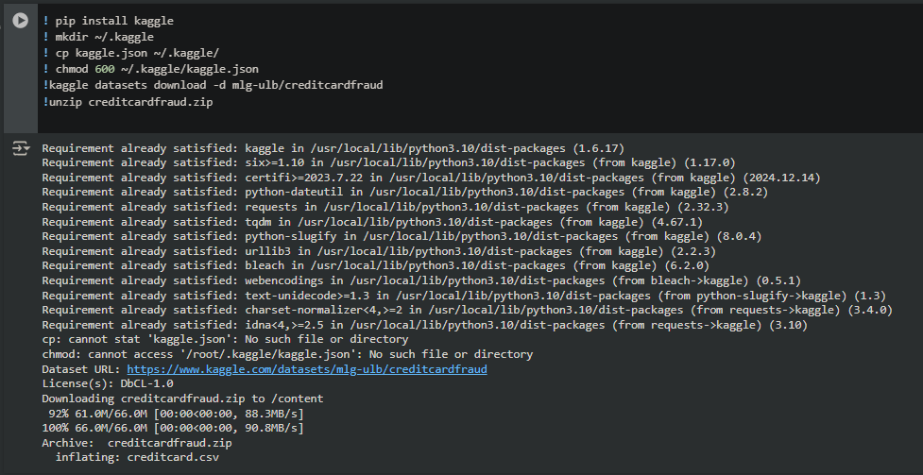

splitting the data into training data and testing data

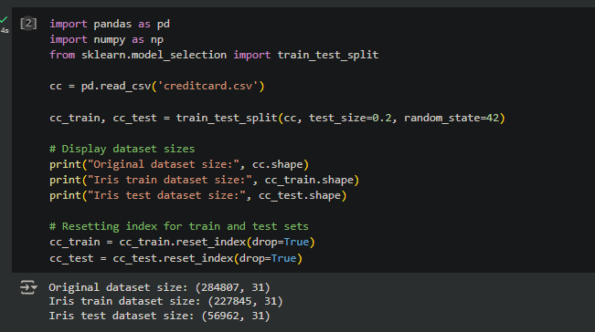

The code applies a Decision Tree Classifier to detect anomalies, such as fraudulent transactions, in a dataset. It prepares the data by splitting it into training and testing subsets, separating the features from the target column (Class). The classifier is initialized, trained on the training data, and used to make predictions on the test data.

The model's performance is evaluated using metrics like accuracy, precision, recall, and F1-score, presented in a classification report. Additionally, the decision tree is visualized to illustrate how features are used for classification, with node colors and labels providing insights into the model's decision-making process. This approach effectively combines training, evaluation, and interpretability for anomaly detection.

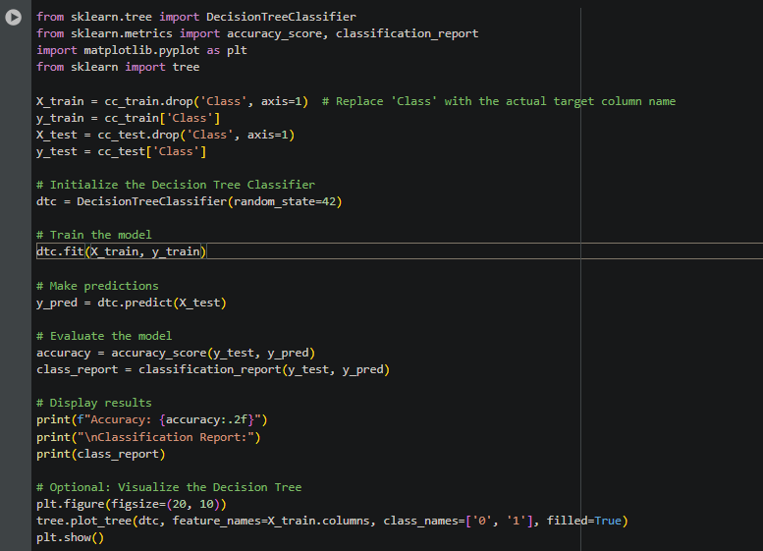

Output:

**Accuracy**: Displays the overall percentage of correct predictions.

**Classification Report**: Lists precision, recall, and F1-score for fraud (Class 1) and non-fraud (Class 0) transactions.

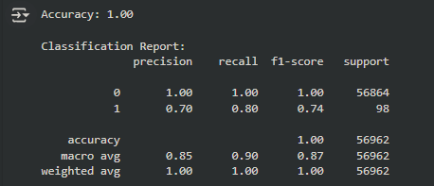

**Tree Visualization**: Shows the structure of the decision tree, illustrating how features are used to classify transactions.

