ML Lab-4

Praneesh R V

CB.SC.U4CYS23036

1. Use StandardScaler to standardize the features of a Credit card fraud dataset. Include code, description and screenshots of outputs.

! pip install Kaggle

! mkdir ~/.kaggle

! cp kaggle.json ~/.kaggle/

! chmod 600 ~/.kaggle/kaggle.json

!kaggle datasets download -d mlg-ulb/creditcardfraud

!unzip creditcardfraud.zip

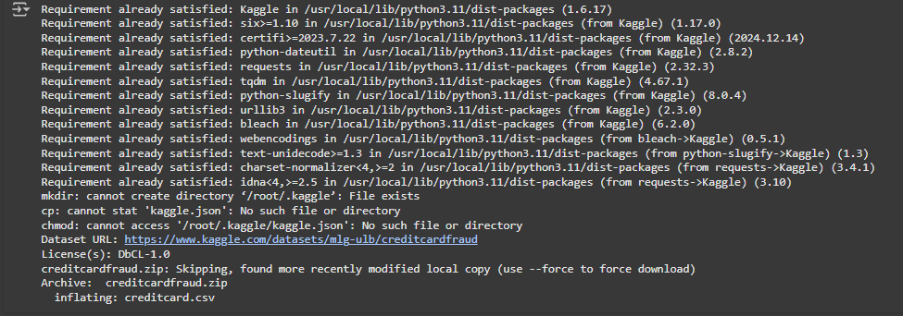

Uploading the file first.

import pandas as pd

from sklearn.preprocessing import StandardScaler

data = pd.read_csv('creditcard.csv')

X = data.drop('Class', axis=1)

y = data['Class']

scaler = StandardScaler()

X_scale = scaler.fit_transform(X)

X_scale_df = pd.DataFrame(X_scale, columns=X.columns)

print(X_scale_df.head())

reading the dataset and scaling it. Displaying the head values.

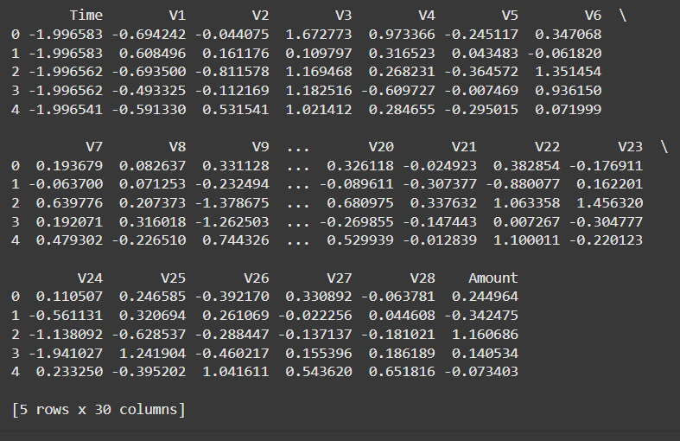

from imblearn.over_sampling import SMOTE

from sklearn.model_selection import train_test_split

X_train, X_test, y_train, y_test = train_test_split(X_scaled, y, test_size=0.2, random_state=42)

smote = SMOTE(random_state=42)

X_train_resampled, y_train_resampled = smote.fit_resample(X_train, y_train)

print("Class distribution before SMOTE:")

print(y_train.value_counts())

print("\nClass distribution after SMOTE:")

print(pd.Series(y_train_resampled).value_counts())

using SMOTE to equalize the number of class(0) and class(1) samples.

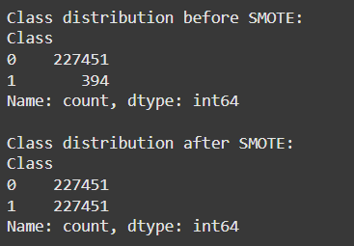

from sklearn.tree import DecisionTreeClassifier

from sklearn.metrics import confusion_matrix, accuracy_score, precision_score, recall_score, f1_score

model = DecisionTreeClassifier(random_state=42)

model.fit(X_train_resampled, y_train_resampled)

y_pred = model.predict(X_test)

conf_matrix = confusion_matrix(y_test, y_pred)

accuracy = accuracy_score(y_test, y_pred)

precision = precision_score(y_test, y_pred)

recall = recall_score(y_test, y_pred)

f1 = f1_score(y_test, y_pred)

print("Confusion Matrix:")

print(conf_matrix)

print("\nAccuracy:", accuracy)

print("Precision:", precision)

print("Recall:", recall)

print("F1 Score:", f1)

creating a decision tree classifier and other performance measures to show the quality of the model.

