Machine Learning Lab -5

CB.SC.U4CYS23036

Praneesh R V

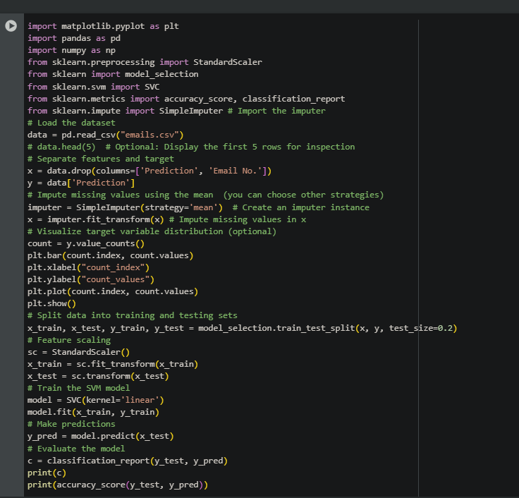

Output:

