Praneesh R V

CB.SC.U4CYS23036

Lab - 3 - Feed Forward Neural Network to classify traffic data

import kagglehub

path = kagglehub.dataset_download("chethuhn/network-intrusion-dataset")

print("Path to dataset files:", path)

from google.colab import drive

drive.mount('/content/drive')

import os

kaggle_path = '/root/.cache/kagglehub/datasets/chethuhn/network-intrusion-dataset/versions/1'

for file in os.listdir(kaggle_path):

print(file)

import os

import shutil

kaggle_folder = '/root/.cache/kagglehub/datasets/chethuhn/network-intrusion-dataset/versions/1'

drive_folder = '/content/drive/MyDrive/CICIDS2017_Parts'

os.makedirs(drive_folder, exist_ok=True)

for file in os.listdir(kaggle_folder):

if file.endswith('.csv'):

shutil.copy(os.path.join(kaggle_folder, file), os.path.join(drive_folder, file))

import pandas as pd

import glob

csv_files = glob.glob('/content/drive/MyDrive/CICIDS2017_Parts/*.csv')

df = pd.concat((pd.read_csv(f) for f in csv_files), ignore_index=True)

df.head()

from sklearn.preprocessing import LabelEncoder, StandardScaler

from sklearn.model_selection import train_test_split

data = df.dropna()

import numpy as np

from sklearn.preprocessing import StandardScaler

X = df.drop(' Label', axis=1)

y = df[' Label']

X = X[(X >= 0).all(axis=1)]

threshold = 1e8

X = X[(X < threshold).all(axis=1)]

y = y.loc[X.index]

scaler = StandardScaler()

X_scaled = scaler.fit_transform(X)

from sklearn.model_selection import train_test_split

X_train, X_test, y_train, y_test = train_test_split(

X_scaled, y, test_size=0.2, random_state=42

)

import tensorflow as tf

from tensorflow.keras.models import Sequential

from tensorflow.keras.layers import Dense, Dropout

model = Sequential()

model.add(Dense(128, input_dim=X_train.shape[1], activation='relu'))

model.add(Dense(64, activation='relu'))

model.add(Dropout(0.2)) model.add(Dense(32, activation='relu'))

from sklearn.preprocessing import LabelEncoder

from tensorflow.keras.utils import to_categorical

import numpy as np

import pandas as pd

label_encoder = LabelEncoder()

label_encoder.fit(pd.concat([y_train, y_test]).unique())

y_train_encoded = label_encoder.transform(y_train)

y_test_encoded = label_encoder.transform(y_test)

num_classes = len(label_encoder.classes_)

y_train_categorical = to_categorical(y_train_encoded, num_classes=num_classes)

y_test_categorical = to_categorical(y_test_encoded, num_classes=num_classes)

model.pop() model.add(Dense(num_classes, activation='softmax'))

model.compile(optimizer='adam', loss='categorical_crossentropy', metrics=['accuracy'])

model.summary()

history = model.fit(X_train, y_train_categorical, epochs=10, batch_size=64, validation_split=0.2)

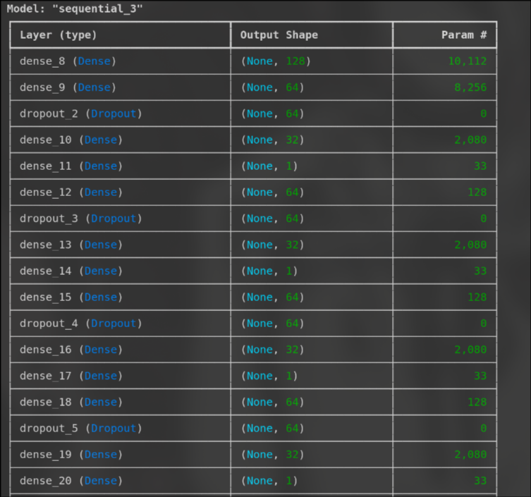

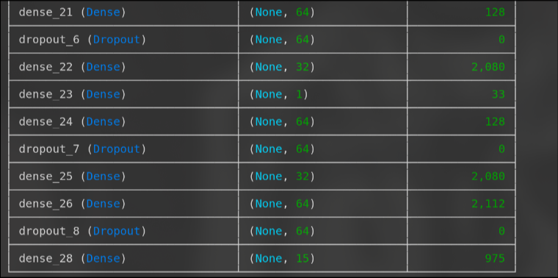

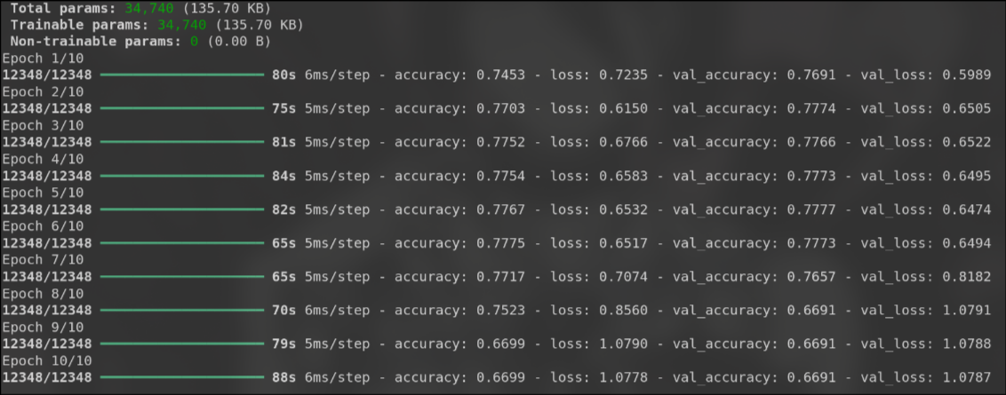

# Plot training history

import matplotlib.pyplot as plt

plt.plot(history.history['accuracy'], label='Training Accuracy')

plt.plot(history.history['val_accuracy'], label='Validation Accuracy')

plt.xlabel('Epoch')

plt.ylabel('Accuracy')

plt.legend()

plt.show()

