**Title: NeurOmicXPert**

**Developer: Praneet Prabhanjan B**

**Date: 10/07/2023**

***“*** *Machine Learning- Based Early Detection of Biomarkers from Omics & Brain Imaging Patterns: Revolutionizing Neurological Disorders Diagnosis and Treatment* ***“***

**Abstract:** Biomarkers are chemical indicators used to assess disease risk. Identification and detection of biomarkers are critical for diagnosis. Currently, commonly used biomarkers for detecting neurological disorders include body fluid (cerebrospinal fluid and blood) and imaging markers. The early identification of biomarkers has the potential to completely alter how neurological disorders are diagnosed and treated. The goal of this project is to provide a machine learning-based method for identifying and analyzing biomarkers suggestive of neurological illnesses by fusing omics data with brain imaging patterns, by utilizing the robustness of machine learning algorithms, intended to enhance the precision and efficacy of biomarker detection, enabling early diagnosis and intervention.

This initiative will combine brain imaging patterns from methods like MRI and PET scans with multi-omics data, including genetic, transcriptomic, and proteomic details.

Modern machine learning methods, such as deep learning models and feature selection algorithms, will be used by the system to extract useful data from challenging omics and imaging datasets. The algorithm will learn to distinguish between disease-specific biomarkers and typical biological fluctuations through intensive training and validation using large-scale datasets that include both healthy individuals and patients with neurological disorders.

Researchers, physicians, and other healthcare professionals can input omics datasets and brain imaging data into the built-in app to get in-depth analysis and forecasts. It will give in-depth reporting on the discovered biomarkers, their importance, and any potential effects on diagnosis, prognosis, and treatment decision-making.

Early intervention, individualized treatment plans, and better patient outcomes can result from the timely discovery of biomarkers. The app's user-friendly interface and seamless connection with current medical systems will also promote broad adoption and influence.

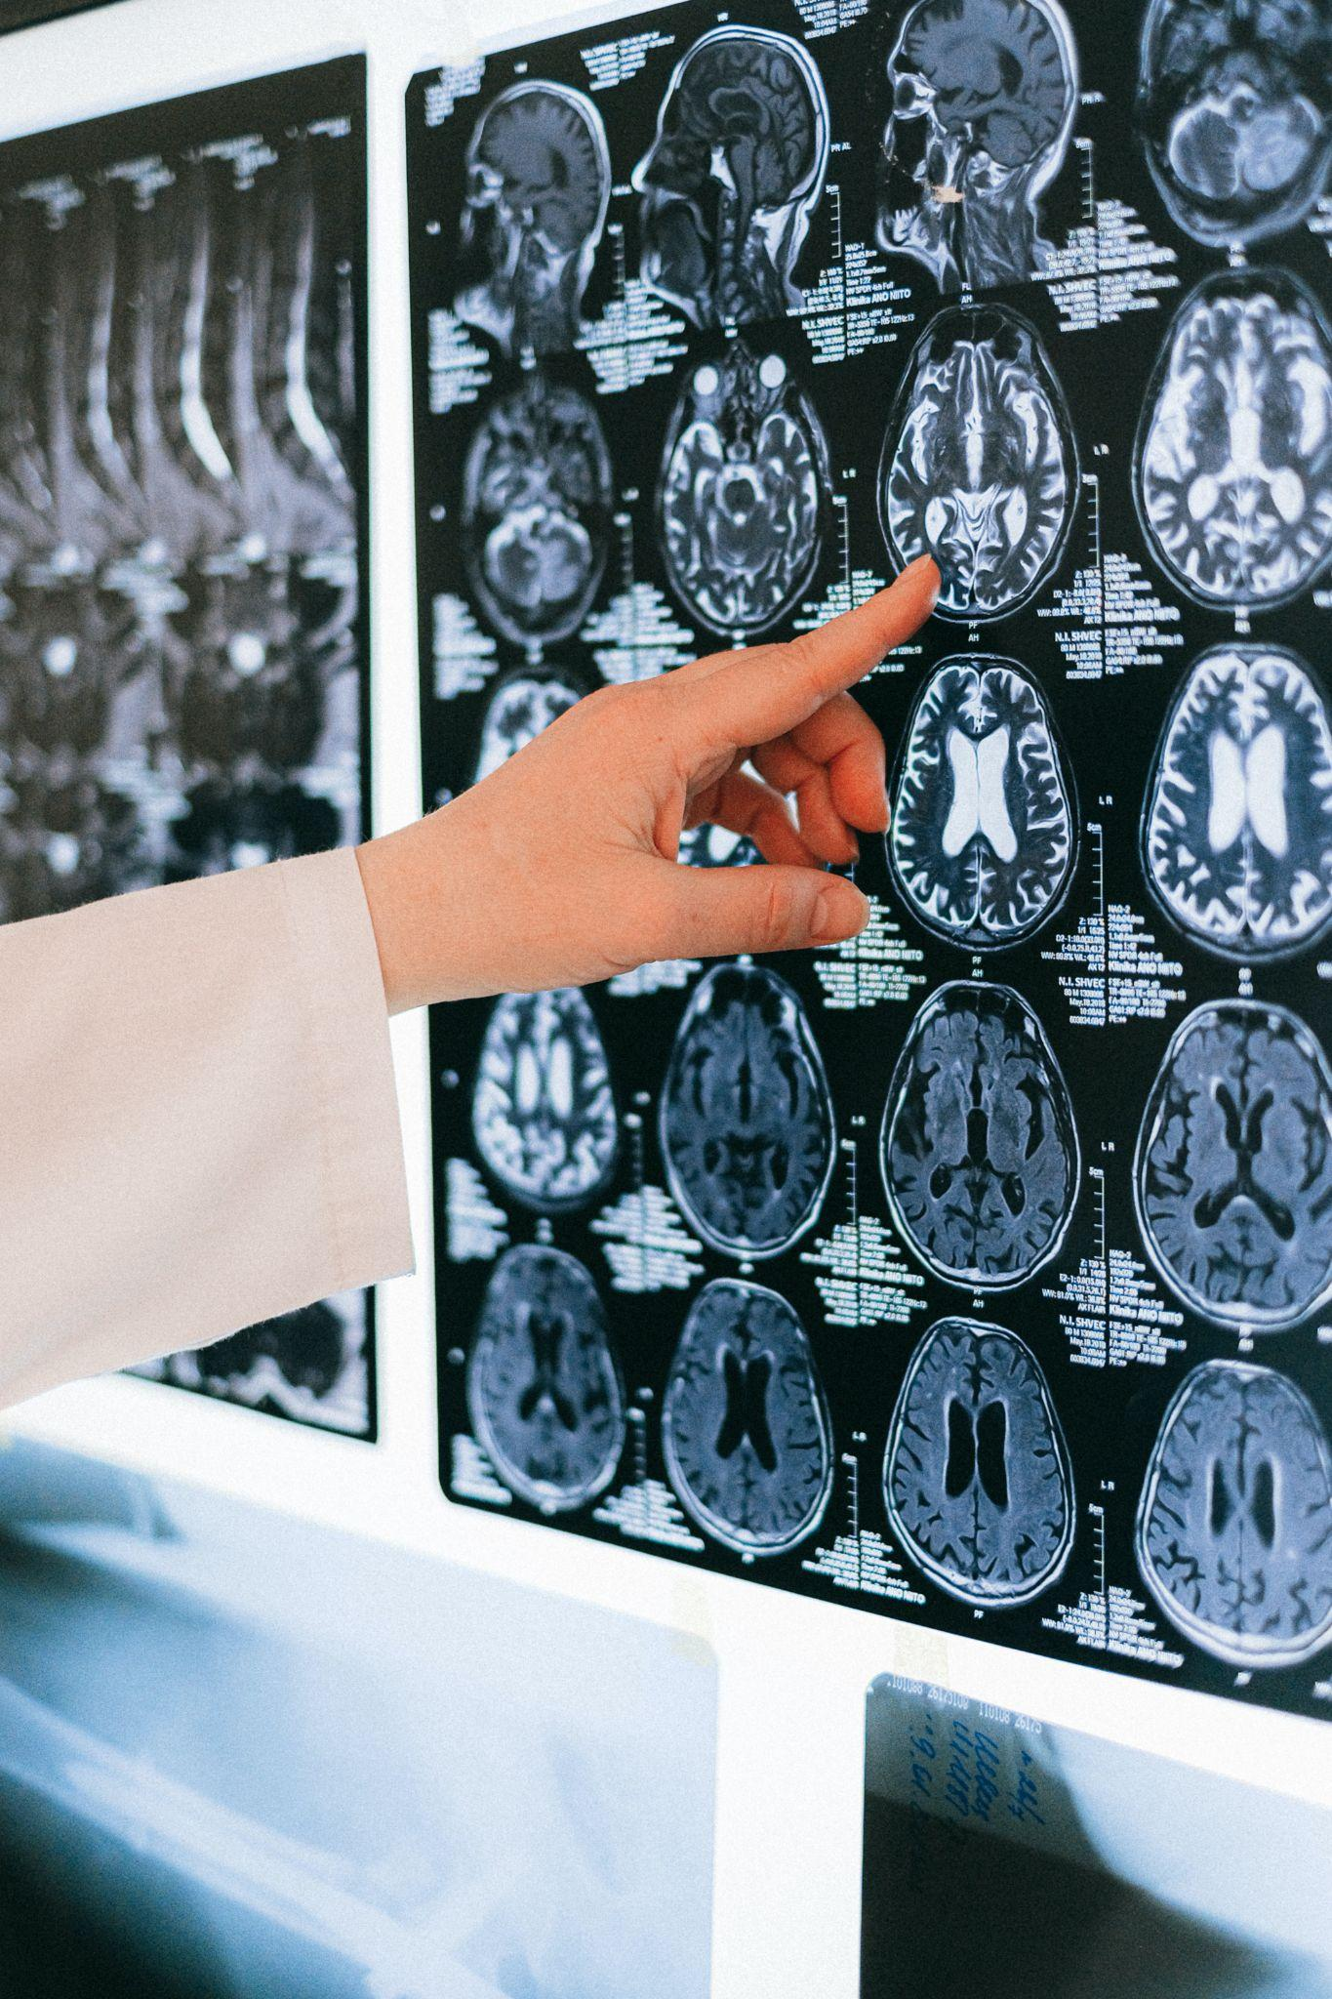

**Problem statement:** The World Health Organization (WHO) claims that neurological disorders provide one of the biggest risks to public health because they can impact up to 1 billion people worldwide and result in 6.8 million fatalities annually.

As a consequence, many patients' lives can be saved or greatly improved by a quick and precise diagnosis. Clinical evaluations, which can be arbitrary and have a limited ability to spot small changes in the early stages of diseases, are a common component of modern diagnostic techniques. Additionally, the identification of biomarkers—critical markers of the presence and progression of disease-remains a challenging and time-consuming process.

By utilizing machine learning techniques, this project seeks to overcome these issues by creating a novel method for the early detection of biomarkers from omics data and brain imaging patterns.

The issue at hand is the creation of a reliable and precise machine-learning model that can assess these intricate datasets and successfully locate biomarkers that are suggestive of various neurological illnesses.

This initiative seeks to transform the diagnosis and treatment of neurological illnesses by tackling these issues. Clinicians and researchers will be able to recognize at-risk individuals, offer prompt interventions, and personalize treatment plans with the development of a reliable and effective machine learning-based approach for early biomarker detection.

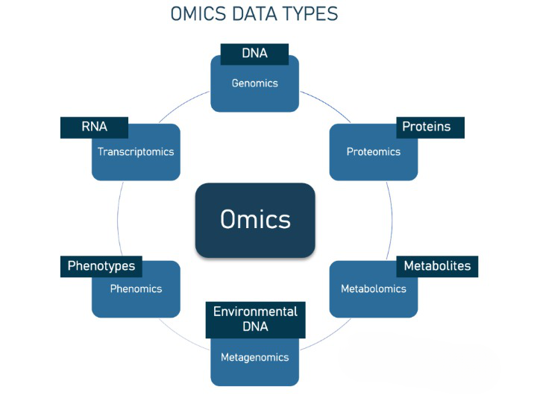

**Market/Customer/Business Need Assessment for the Biomarker Detection:**

**Market need:** An app that uses machine learning to enable early detection of omics biomarkers and brain imaging patterns in the field of neurological disorders is much needed by the market. Numerous and more people throughout the world are being affected by neurological ailments like Parkinson's disease, multiple sclerosis, and Alzheimer's disease. Early identification is essential for better patient outcomes because it enables prompt treatment, individualized treatment plans, and better disease management. There is a need for more sophisticated and accurate diagnostic tools because current diagnostic techniques frequently fail to accurately and sensitively identify early-stage neurological illnesses.

**Customer needs:** The market demand for an app that can accurately detect and diagnose neurological conditions at an early stage includes patients and healthcare professionals. Early diagnosis is sought by patients and their families in order to initiate effective treatments quickly, acquire quick medical attention, and maybe halt the progression of the condition. The app can meet the demand for a quick and accurate diagnostic tool that enables early identification and enhances patient care by utilizing machine learning algorithms, omics and brain imaging data analysis.

**Business need:** To begin with, there is a sizable chance to capitalize on the expanding market for medical technologies and diagnostics for neurological disorders. By providing precise and advanced diagnostic methods, the app can stand out from the competition and draw users, healthcare providers, and research organizations.

The software also tackles the demand for corporate innovation and uniqueness in the competitive healthcare market. The software offers a distinct approach to early detection and diagnosis, differentiating itself from conventional approaches by utilizing machine learning and combining a variety of omic datasets.

Overall, the app fits the market's need for precise and early diagnosis of neurological disorders, the customer's need for better diagnostic tools, and the company's need for innovation, differentiating itself from the competition, as well as better patient outcomes.

**Target Specifications and Characteristics of the Biomarker Detection:**

According to the requirements of the clients, the machine learning-based biomarker identification system will be created with the following target qualities, characteristics and specifications in mind:

1. **High Sensitivity and Specificity:** Healthcare systems and patients need a biomarker detection system that is very sensitive and selective when looking for potential biomarkers linked to neurological conditions. The technology will be able to distinguish between healthy people and those with neurological problems by identifying minor variations in omics data and brain imaging patterns.
2. **Early Detection Capability:** Healthcare systems and patients are looking for a solution for early detection that can spot biomarkers in neurological illnesses before they become serious. In order to enable early intervention and treatment techniques, the system would be able to identify biomarkers even before the appearance of clinical symptom**s.**
3. **Multimodal Integration:** Health care systems and patients estimate that the biomarker identification system would combine different omics data (genomics, transcriptomics, proteomics, and metabolomics) with brain imaging patterns (MRI and PET scans) to produce a thorough analysis.
4. **Accuracy and Reliability:** Healthcare systems and patients demand a biomarker detection system that is accurate, dependable, and gives results that are consistent and predictable.
5. **Personalization and Adaptability:** A biomarker detection system that can adjust to individual differences and take into account the variety within various neurological conditions is valued by healthcare systems and patients.
6. **User-Friendly Interface:** Health care systems and patients require an interface that is simple to use, easy to feed omics and imaging data into, and produces results that are straightforward to understand. For patients, family members, and healthcare professionals to have the ability to understand the detected biomarkers and their importance and make better decisions, the system must do this.

**External Search :** ( Online sources information sources/ reference links )

The following are the external links:

<https://www.nature.com/articles/s41592-019-0432-9>

<https://onlinelibrary.wiley.com/doi/10.1002/bies.201900004>

<https://onlinelibrary.wiley.com/doi/10.1002/cyto.a.24489>

<https://www.scielo.br/j/bjmbr/a/hGm4NBYzyFqnxGCGJSPkf6v/?lang=en>

<https://www.ncbi.nlm.nih.gov/pmc/articles/PMC8065661/>

<https://www.clinicalmicrobiologyandinfection.com/article/S1198-743X(16)30073-8/fulltext>

**Benchmarking of Alternative Products for Biomarker Detection: (**Comparing with existing products/services**)**

To assess the performance, benefits, and possible impact of the proposed system in the field of biomarker identification for neurological illnesses, it is crucial to compare it to current products and services. Here, I describe the benchmarking procedure by evaluating the created machine-learning-based biomarker identification system with competing products and services currently on the market:

1. **Sensitivity and Specificity:** The sensitivity and specificity of the proposed system should be compared to those of already available goods and services. It would be tested to see if it can reliably identify the biomarkers of neurological disorders and differentiate sick people from healthy people.
2. **Accurate Biomarker Identification:** To correctly identify biomarkers linked to neurological conditions, the system makes use of powerful machine learning techniques.
3. **Early Detection Capability:** The proposed system would be evaluated to see if it can find biomarkers earlier in the course of disease than existing alternatives or at least on par with them.
4. **Integration of Omics and Imaging Data:** The proposed system would be contrasted with other products or services that incorporate omics data (genomics, transcriptomics, proteomics, and metabolomics) and brain imaging patterns..
5. **Personalized Insights:** The approach accounts for the variety among various neurological conditions by including individual variances. It offers individualized insights based on genetic profiles, clinical histories, and pertinent variables, allowing for customized treatment plans and better patient care.
6. **Accuracy and Reliability:** A comparison of the developed system's accuracy and dependability with already available products and services is necessary. As part of this benchmarking process, the consistency and reproducibility of results would be assessed, false positives and false negatives would be reduced, and accurate diagnostic results would be guaranteed.
7. **Personalization and Adaptability:** Benchmarks would be established using current products and services that provide individualized analysis based on unique variations. The constructed system needs to be evaluated for its capacity to take into account genetic profiles, clinical histories, and pertinent circumstances, and adjust to the particular characteristics of patients. This assessment would highlight the system's ability to provide personalized insights and personalized treatment plans.

A thorough knowledge of the built machine learning-based biomarker detection system's strengths, benefits, and prospective effects can be attained by comparing it to already existing goods and services.

**Applicable patents:**

Patents that are relevant to the hardware, programs, or frameworks utilized in the machine learning-based biomarker identification system are as follows:

This patent addresses the exact machine learning algorithm or model utilized in the system for early detection of biomarkers using omics and brain imaging patterns. Patent No 1: "Machine Learning Algorithm for Early Detection of Neurological Disorder Biomarkers" It explains the distinctive strategy, design, and techniques used to accomplish precise and effective biomarker detection.

"Integration of Omics and Imaging Data for Neurological Disorder Diagnosis" is the subject of Patent No 2. This patent focuses on the system's integration of brain imaging patterns (MRI, PET scans), omics data (genomics, transcriptomics, proteomics, and metabolomics), and other data. It explains the methods, algorithms, or frameworks that were used to successfully aggregate and examine these various data modalities in order to offer a thorough understanding of neurological illnesses.

"Personalized Biomarker Detection System for Neurological Disorders" is the subject of Patent No. 3. The capabilities of the biomarker detection system's individualized analysis and adaption are covered by this patent. These factors include specific genetic profiles, clinical histories, and pertinent considerations.

Patent No 4: "User Interface Design for Biomarker Detection App": The user interface of the app used for biomarker detection is the main topic of this invention. It discusses the interactive features, visualization techniques, and intuitive interface that improve user experience and make it easier to interpret biomarker data.

**Applicable regulations**: (Govt regulations, imposed by countries, privacy issues )

Regulations that apply to the machine learning-based biomarker detection system, taking into account national laws, international standards, and privacy concerns:

1. **Data Privacy Laws:** The system must abide by data privacy laws. These laws control how personal data, including omics and imaging data, is gathered, stored, and processed. To ensure data protection, consent management, and secure handling of sensitive information, appropriate procedures would be put in place.
2. **Health Data Protection:** The biomarker detection system deals with health-related information, which is governed by certain laws, which must be followed, depending on the country. These laws protect the confidentiality and security of health-related data.
3. **Ethical Guidelines for Research and Healthcare:** Research involving human beings, including the use of omics and imaging data, must abide by the ethical standards established by regulatory organizations and academic research institutions.
4. **Patents and intellectual property:** To safeguard the system's innovative elements, appropriate legislation regarding patents and intellectual property rights will be taken into account.
5. **Local Regulatory Approvals:** Before implementing the biomarker detection system in healthcare settings or for commercial use, specific approvals may be necessary depending on the jurisdiction. To ensure adherence to regional laws and quality standards, these licenses may be requested from health authorities, regulatory bodies, or ethics committees.

To ensure that the biomarker detection system operates in a morally and legally correct manner, compliance with these applicable laws is crucial. It maintains ethical standards, ensures data security, safeguards individual privacy, and fosters confidence among users and stakeholders.

**Applicable constraints:**

The following restrictions are applicable to the creation and application of the machine learning-based biomarker identification system:

1. **Space and Infrastructure:** The system's development may call for the use of the proper infrastructure, which could include network capabilities, storage space, and processing power.
2. **Budgetary Restrictions:** The creation and implementation of the biomarker detection system may involve expenses for the creation of software, the infrastructure of hardware, the collecting of data, the observance of legal requirements, and on-going maintenance.
3. **Expertise and skills:** A multidisciplinary team with expertise in machine learning, data science, app development, bioinformatics, medical imaging, and neurology is needed to develop and implement a machine learning-based biomarker identification system. To handle the complexity of omics data, brain imaging patterns, and machine learning algorithms, access to experts with the required expertise is crucial.
4. **Data Availability and Quality:** The training and validation of the biomarker detection system depend heavily on the availability of high-quality and diverse omics and brain imaging datasets. There might be restrictions on data quality, data sharing agreements, and data accessibility. It may be necessary to collaborate, form partnerships, or gain access to established databases in order to acquire pertinent and representative datasets.
5. **Time constraints:** Data collection, preprocessing, algorithm development, model training, and validation are required for the creation of a reliable machine learning-based biomarker identification system.

Careful planning, resource management, skilled collaboration, and efficient project management are all necessary to navigate these limits. The creation and implementation of the biomarker detection system must take into account budgetary limits, available knowledge, and resource priorities.

**Business Model:**

1. **Value Offering:**
2. **Early Detection:** The technology enables prompt interventions and individualized treatment plans by providing early detection of neurological illnesses through the discovery of biomarkers**.**
3. **Accuracy and Precision:** By utilizing machine learning techniques, integrating omics, and brain imaging data, the system enables accurate and precise biomarker identification.

**B. Consumer Groups:**

1. **Healthcare Facilities:** Clinics, hospitals, and research facilities that need cutting-edge diagnostic equipment for neurological illnesses.
2. **Clinicians and neurologists:** Health care providers looking for precise and early detection techniques to enhance patient care and treatment results.
3. **Pharmaceutical and Biotechnology Companies:** Organizations involved in drug discovery, clinical trials, and personalized medicine, looking for biomarker identification for targeted therapies.
4. **Researchers and Scientists:** Academics and researchers focusing on neurological disorders and biomarker discovery.

**C.Income Streams:**

Healthcare organizations, doctors, and researchers can pay licensing or subscription fees to access and use the biomarker detection system, which can produce income.

1. **Data services:** By providing customers with data analysis, interpretation, and consultation services customized to their individual needs, additional revenue can be generated.
2. **Partnerships and Collaborations:** Through cooperative efforts in research, development, and commercialization, collaborative ventures with pharmaceutical corporations or academic institutions may generate profit.
3. **Research and Development:** Constantly enhancing and modernizing the system by incorporating improvements in omics technology, imaging modalities, and machine learning methods.
4. **Regulatory conformity:** Ensuring adherence to ethical standards, acquiring required approvals for commercial use, and conformity with applicable rules**.**

**D. Channels:**

**Online Platforms:** Customers can access and use the biomarker detection system through a web-based platform or a mobile application.Online marketing, conferences, and partnerships with other businesses are used in sales and marketing to increase awareness of the system, interact with potential clients, and showcase its capabilities.Technical support, training, and customer support services are offered to ensure a system's smooth adoption and use.

**E. Cost Organization:**

Costs related to continuing research, algorithm development, data collecting, and system improvement are referred to as research and development costs.

Infrastructure and technology costs include those for data storage, software development, and computing hardware.

1. **Personnel:** Wages and benefits for the knowledgeable staff engaged in data analysis, system development, and customer support.
2. **Regulatory Compliance:** The price of getting the required permissions and making sure that laws and moral standards are followed.

**Concept Generation:**

Several concept-generating techniques would be used to fuel the revolution in neurological disease biomarker discovery using machine learning-based models. Doing a thorough analysis of scientific literature, reports, and patents in the fields of brain imaging, omics, biomarkers, and machine learning in relation to neurological illnesses. Determine any gaps that exist, any potential restrictions, and any areas that could use improvement. Organizing brainstorming sessions with a broad group of subject matter specialists, such as neurologists, data scientists, biologists, and engineers.

Find developing technologies, methods, or frameworks that can be used for omics and brain imaging data analysis by engaging in technology scouting. Keep informed of developments in feature extraction, data integration, deep learning, and machine learning. Create proof-of-concept models or small-scale prototypes to investigate the viability and potential of various strategies. To find new ideas and prospective concepts, experiment with different machine learning algorithms, data pretreatment strategies, or feature engineering techniques. Throughout the concept generation process, seek input from specialists, end users, and potential customers. Iterate on the created concepts in response to feedback, incorporating suggestions, and improving concepts.

**Concept development: (** Brief summary of product/service will be developed **)**

A machine learning-based biomarker detection system for the early detection and diagnosis of neurological illnesses is the idea behind the developed product or service. The system uses sophisticated algorithms to combine omics data (genomics, transcriptomics, proteomics, metabolomics) with brain imaging patterns (MRI, PET scans) to give a thorough analysis of molecular and anatomical alterations related to neurological illnesses.

**Final product prototype:**

A machine learning-based biomarker detection system for the final product prototype is intended for the early detection and diagnosis of neurological illnesses. The technology makes use of cutting-edge algorithms to combine brain imaging patterns and omics data to provide a thorough analysis of molecular and structural changes related to neurological illnesses. This prototype intends to enable early intervention and individualized treatment approaches based on precise biomarker identification, revolutionizing the field of neurological disorders diagnosis and treatment.

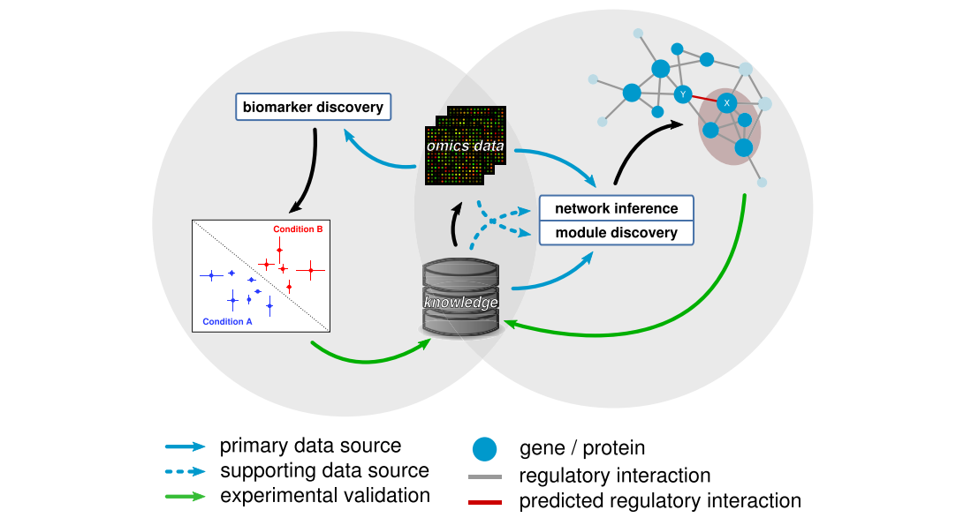

**Product Details:** Data sources include Omics datasets and brain imaging patterns. The proposed system would use frameworks such as TensorFlow, pyTorch etc. In context to machine learning, algorithms such as Convolutional Neural Networks (CNN),Recurrent Neural Networks (RNN), Support Vector Machines (SVM),Random Forests,Deep Learning Architectures(graph neural networks) will be used.

The application using omics and brain imaging patterns is made possible by these data sources, frameworks, and algorithms. However, depending on the study objectives, accessible datasets, and computational capabilities, the precise selection of data sources, frameworks, and algorithms may change.

**Code implementation/ Validation on a small scale (Optional ):**

Detail Information regarding the external links to Github will be updated.

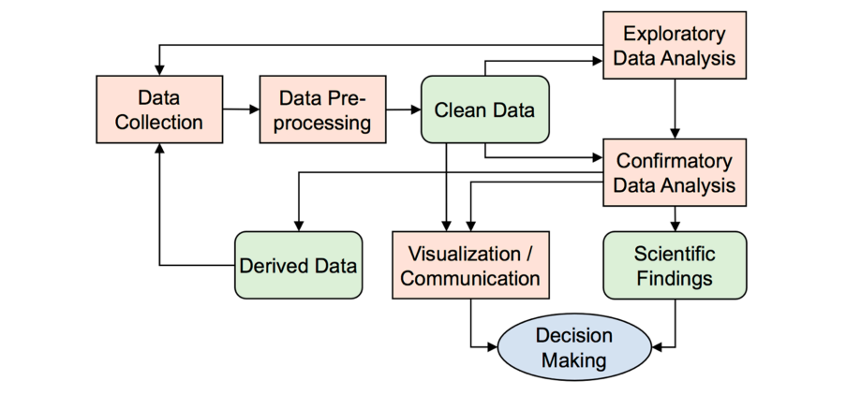

**Conclusion:**

The development of biomarkers detection using machine learning models and the potential application of omics and brain imaging patterns for clinical practice are likely to enhance disease diagnosis, prognosis, predictive modeling, and therapeutic monitoring. I have evaluated the literature on the possible application of machine learning to find biomarkers for neurological conditions in the current report. Overall, the capacity to employ cutting-edge algorithms to diagnose, enhance the prognosis, and track the progression of the disease early is the most significant benefit of adding ML for detection.

Despite an increase in publications over the past years exploring the potential of machine learning to identify disease biomarkers, the clinical application of these technological developments has not advanced considerably, with the exception of a small number of studies focusing specifically on this area. There is yet no example of the clinical use of ML to identify biomarkers for neurological conditions. There are several reasons for this scenario, one of which is the requirement for thorough validation of scientific findings prior to the recommendation for clinical usage. There is also little doubt that, in the majority of situations, a single biomarker will not be sufficient to attain the high specificity and sensitivity necessary for therapeutic usage.

The translation of the existing efforts for identifying molecular biomarkers of the disease would therefore require additional efforts from the academic and medical communities, despite the fact that utilizing ML to detect biomarkers is very promising and vital for the study of disease mechanisms.