A Reliable & Fast Automatic combination of Deep Features and Species Categorization using Unified Ensemble Layer
*A Neural Network Approach
PRANEET PATNAIK [1], SARTHAK SARANGI [2], Dr. A. C. SANTHA SHEELA[3]
[1][2] UG Student,Dept.of CSE,Sathyabama Institute of Science and Techonology ,Chennai,India
[3] Associate Professor,Dept.of CSE,Sathyabama Institute of Science and Techonology ,Chennai,India

ABSTARCT—A Deep Learning based Plant Species Detection performs extensively on plant species electronic system and systematic botany, which is the foundation for investigation and enhancement of new plant species. This semantic research introduces a new approach for plant species detection using plant species leaf dataset images. It concentrates on the established characteristics mining of leaf, such as the geometricqualities of structure and the roughness characteristics. In this paper, a progressive perform various tasks primary learning calculation is created to help huge scope species identification, where visual tree is developed for getting sorted out huge quantities of plant species in the coarse-to-fine design and deciding the between related learning undertakings naturally.
Keywords—Plant Specifies Detection, Neural Network, Artificial Intelligence , Ensemble Learning, Deep Learning,

Introduction to Plant Species
It is of fundamental significance just as an incredible test to perceive plant species on the earth planet, from which people can profit a lot. Subsequently it is valuable to plan a helpful and powerful picture characterization strategy to consequently order various species.
In the proposed system, we will identify the below Plants Species
Fig.1- Black-Grass
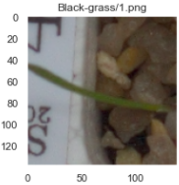
Fig.2- Charlocks
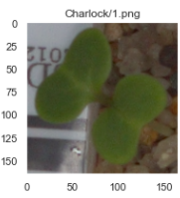

Fig.3- Cleaver
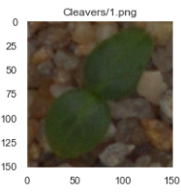
- CommonChickweed
- Commonwheat
- FatHen
- Loose Silky -Bent
- Maizes
- ScentlessMayweed
- ShepherdPurse
- Small-floweredCranesbill
- Sugarbeet
Since leaf of one sort of plant has remarkable shape, size and association, individuals can recognize the plant species by its leaf. Deep Learning based Plant Species Identification innovation attempts to perceive the known plant species by notable features of the leaf. The focal point of framework is to separate the steady features of plants, which could be utilized to segregate with others.
Proposes an approach to evaluating the condition of plant species in metropolitan climate based on fluffy data from a gathering of specialists. Various species with potential qualities are going to annihilation since the climate crumbles seriously in late many years. The principal measure takend for insurance ought to be precisely and successfully grouping them.

Existing Operations-ResNet

Neural Network
ResNet is at present the cutting edge engineering for huge scope picture acknowledgment. One of the topics just the same as past models is that the more profound the network is, the better the exhibition. Notwithstanding, with expanding profundity of the network, the issue of disappearing slopes is additionally intensified since each layer progressively figures its angle as for the inclination from the past layer. The bigger the quantity of layers, the more modest the slopes become, in the long run disappearing to 0.
Fig.4- Layers of ResNet

Output Performance

The output error is essentially a mistake count that is performed to decide how unique a neural network's output is from the ideal output. This worth is once in a while utilized for any reason other than as a steppingstone in the estimation of the root mean square mistake for the whole preparing set. When the entirety of the components of a preparation set have been gone through the network, the RMS blunder can be determined. This mistake goes about as the worldwide pace of blunder for the whole neural network.
The ordinary objective of a profound network is to become familiar with a bunch of features. The principal layer of a profound network figures out how to recreate the first dataset. The ensuing layers figure out how to remake the likelihood conveyances of the enactments of the past layer. The output layer of a neural network is attached to the general goal. This is regularly strategic regression, with the quantity of features equivalent to the quantity of inputs of the last layer, and the quantity of outputs equivalent to the quantity of classes.

Proposed Operations
The mean deduction step is regularly trailed by a standardization step, which has the impact of scaling each element measurement along a similar scale. This is finished by isolating each component segment by its standard deviation. For the network to learn interpretation just as pivot invariances, it is frequently recommended to enlarge a preparation dataset of pictures with the alternate point of view change of pictures. For example, you can take an input picture and flip it evenly and add it to the preparation dataset. Alongside level flips, you can decipher them by a couple of pixels among other potential changes.
A pooling or subsampling layer regularly promptly follow the convolution layer in the CNN. Its job is to downsample the output of the convolution layer along with both the spatial elements of tallness and width.

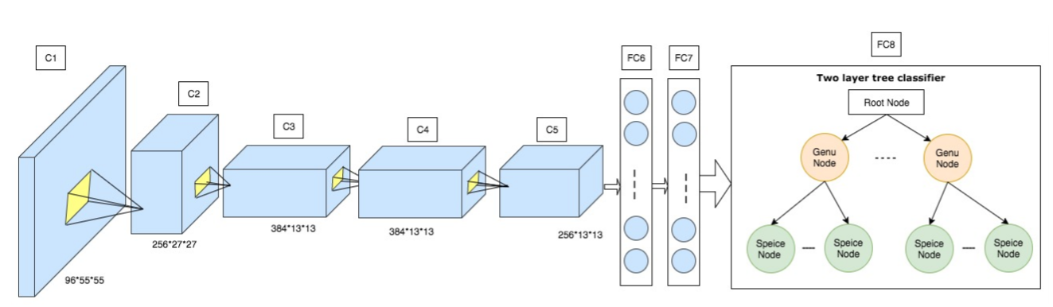
Fig.5- Architecture Diagram

Input Layer
The input layer is frequently characterized as your crude input information. For text information, this can be words or characters. For a picture, this can be crude pixel esteems from various shading channels. Additionally, with shifting components of input information, it structures various constructions, like an onedimensional vector or a tensor-like design.

Output Layer
The output layer is essentially the output estimation of the network and is shaped relying upon the issue setting. In solo learning, like encoding or unravelling, the output can be equivalent to the input. For characterization issues, the output layer can have n neurons for n-way grouping and use a SoftMax capacity to output the likelihood of being each class.

Hidden Layer
Hidden layers will be layers between the input and output layers. Neurons on hidden layers can take different structures, for example, a maximum pooling layer, convolutional layer, etc, all be performing distinctive numerical functionalities. On the off chance that you consider the whole network a line of numerical changes, the hidden layers are each changed and afterward created together to plan your input information to the output space.

Experiment Results
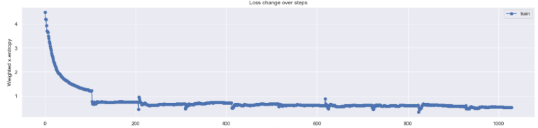
Fig.6- Loss change
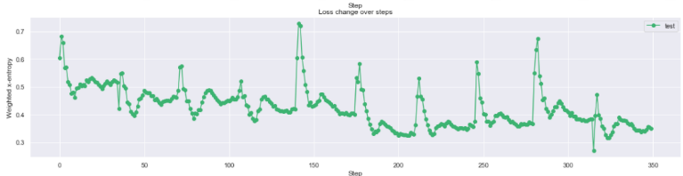
Fig.7- Step Loss change over steps
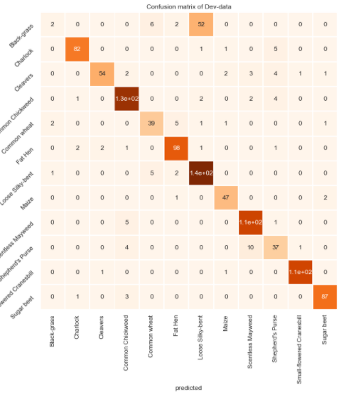Fig.8- Confusion Matrix

conclusion
In this exploration, computerized pictures of leaves are changed over into a grayscale design. In the element extraction stage, the morphological features, to be specific, significant pivot, minor hub, centroid, strength, border, and direction are removed. Trials on our new datasets give that our way based profound network can accomplish serious outcomes on both the precision rates and the computational proficiency for largescale plant species detection proof.

references
- Ali Beikmohammadi and Karim Faez. Leaf classification for plant recognition with deep transfer learning. In 2018 4th Iranian Conference on Signal Processing and Intelligent Systems (ICSPIS), pages 21–26. IEEE, 2018.
- Vinit Bodhwani, DP Acharjya, and Umesh Bodhwani. Deep residual networks for plant identification. Procedia Computer Science, 152:186– 194, 2019.
- Muhammad, A.F.A.; Lee, S.C.; Fakhrul, R.R.; Farah, I.A.; Sharifah, R.W.A. Review on techniques for plant leaf classification and recognition. Computers 2019.
- Choi, S.: Plant identiﬁcation with deep convolutional neural network: SNUMedinfoat LifeCLEF plant identiﬁcation task 2015.
- M. Young, The Technical Writer’s Handbook. Mill Valley, CA: University Science, 1989.
- Scheirer, W.J., Jain, L.P., Boult, T.E.: Probability models for open set recognition.IEEE Transactions on Pattern Analysis and Machine Intelligence 36(11) (2014).
- Guillermo L Grinblat, Lucas C Uzal, Monica G Larese, and Pablo M ´ Granitto. Deep learning for plant identification using vein morphological patterns. Computers and Electronics in Agriculture, 127:418–424, 2016.

