a
MINI PROJECT REPORT ON

“EmPLOYEE MANAGEMENT SYSTEM USING JAVA”

By

Sr. No. | NAME | ROLL NO.
1. | Jay Jadhav | 32233
2. | Yash Jain | 32234
3. | Vedant Karale | 32238
4. | Praneet Patare | 32250

GUIDE
Mr. Ajinkya Rasal Sir

Department Of
Electronics and TELECommunication ENGINEERING
PUNE INSTITUTE OF COMPUTER TECHNOLOGY
PUNE – 43

A.Y. 2021-22

K

INDEX

Sr. No. | Contents | Page No.
1 | Problem Statement | 3
2 | Objectives | 3
3 | Introduction | 3
4 | Source code | 5
5 | Source code Description | 9
6 | Result | 15
7 | Conclusion | 21
8 | Applications | 21
9 | Future scope | 21
10 | Copy Right Affirmation | 21

1. PROBLEM STATEMENT:
Create an Employee Management System Project using Java

2. OBJECTIVE:
- Create a System that stores Employee details such as his/her ID, Name, Salary, Contact No. and e-mail address.
- The System should allow user to add, search, edit, delete, display and save all the above details in a file.

3. INTRODUCTION:
Employee information system is easy to use application which is created to manage the employee data. It is created to record the details of the employees. This system can easily help in tracking employee records such as Employee Id, Employee Name, Employee Salary, Employee Contact No.. There is a search feature which allows getting records of a specific employee. The user can add, edit, delete, display & save records in a file.

  - Project Details
- JAVA
- Classes, Methods & Switch Statements
- File Handling:
In Java, a File is an abstract data type. A named location used to store related information is known as a File. There are several File Operations like creating a new File, getting information about File, writing into a File, reading from a File and Deleting a File.
Before understanding the File operations, it is required that we should have knowledge of Stream and File methods. If you have knowledge about both of them, you can skip it.

Stream
A series of data is referred to as a stream. In Java, Stream is classified into two types, i.e., Byte Stream and Character Stream.
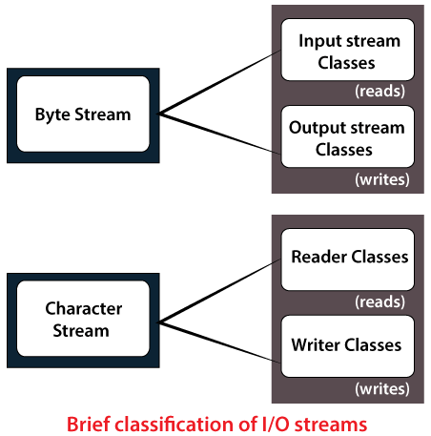
- ArrayList<>: Java ArrayList class uses a dynamic array for storing the elements. It is like an array, but there is no size limit. We can add or remove elements anytime. So, it is much more flexible than the traditional array. It is found in the java.util package. It is like the Vector in C++.

- API(Serializable): Object serialization is the process of saving an object's state to a sequence of bytes, as well as the process of rebuilding those bytes into a live object at some future time. The Java Serialization API provides a standard mechanism for developers to handle object serialization. The API is small and easy to use, provided the classes and methods are understood.

  - Purpose
To Create a System that stores Employee details such as his/her ID, Name, Salary, Contact No. and e-mail address. The System should allow user to add, search, edit, delete, display and save all the above details in a file.

3.3 Scope:
Project Goal:
To Create a System that stores Employee details such as his/her ID, Name, Salary, Contact No. and e-mail address. The System should allow user to add, search, edit, delete, display and save all the above details in a file.

Deliverables:
The project is about, to deliver a data storable Management System for Employee data, able to
- Adding Employee details
- Search for Employee details
- Editing Employee Details
- Deleting Employee Details
- Displaying all Employees working in the company
- Saving data to database

Deadline:

Starting date | Last date of submission
09/11/2021 | 13/12/2021

SOURCE CODE:

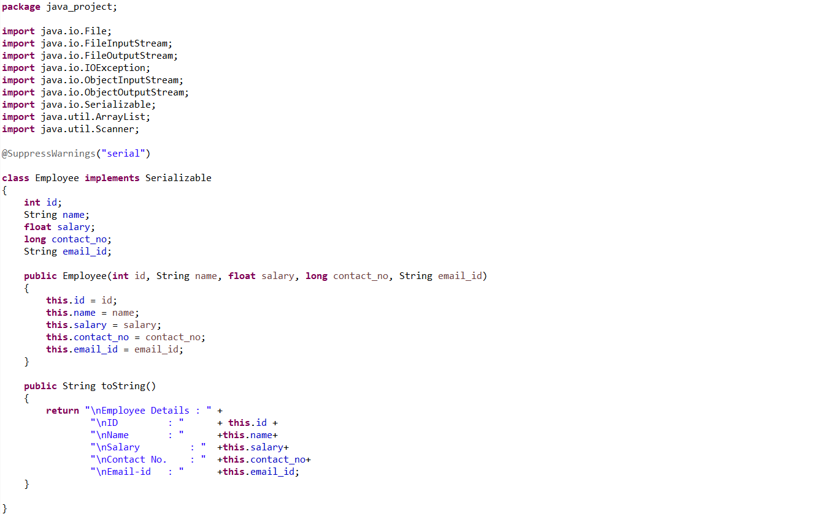
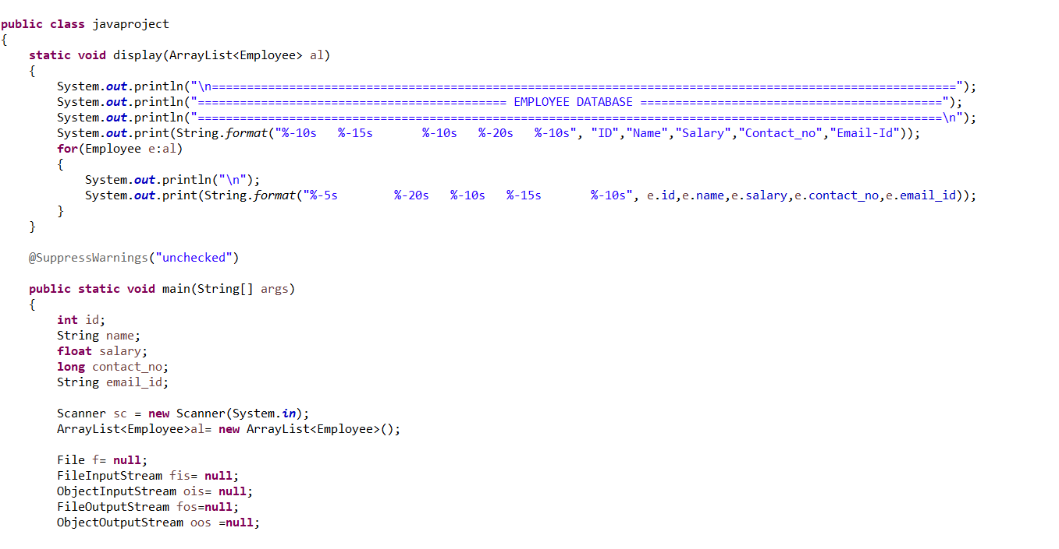
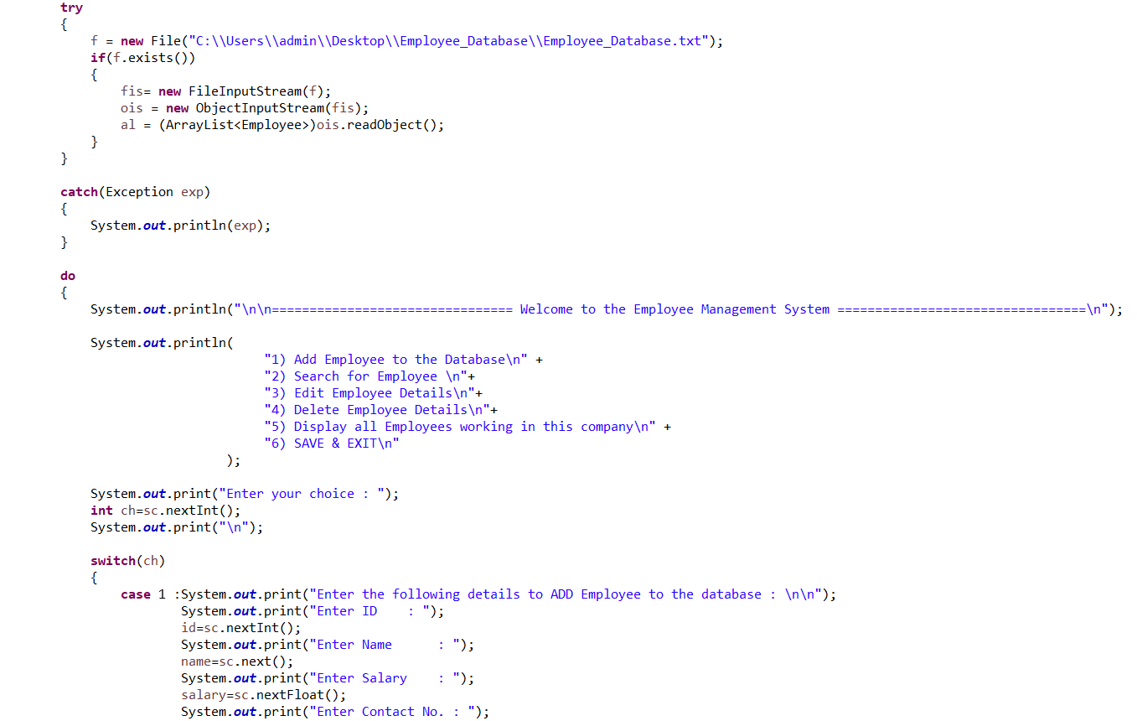
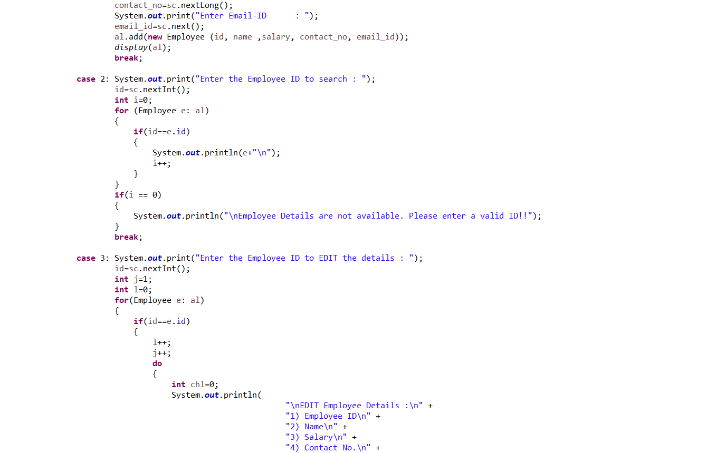
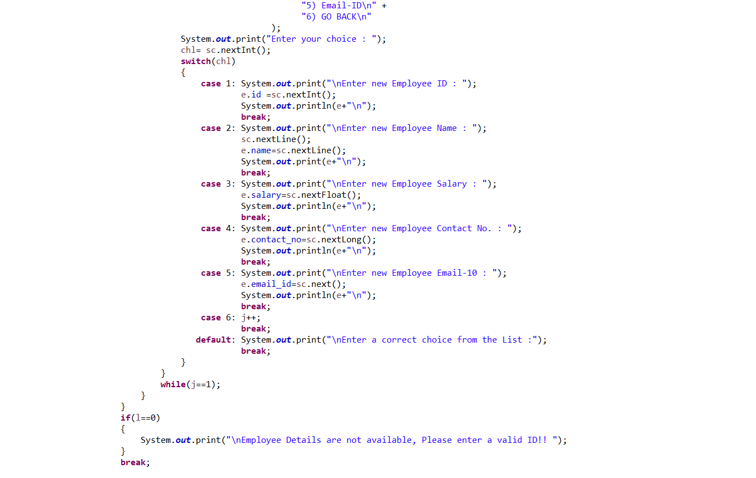
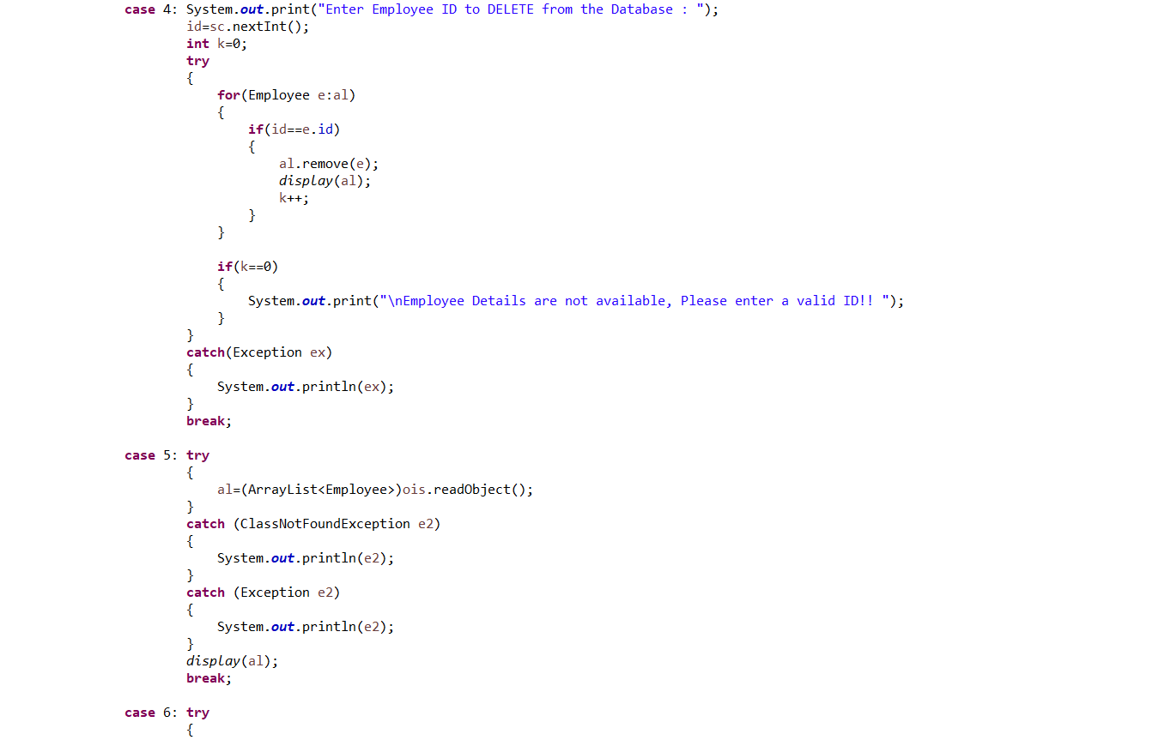

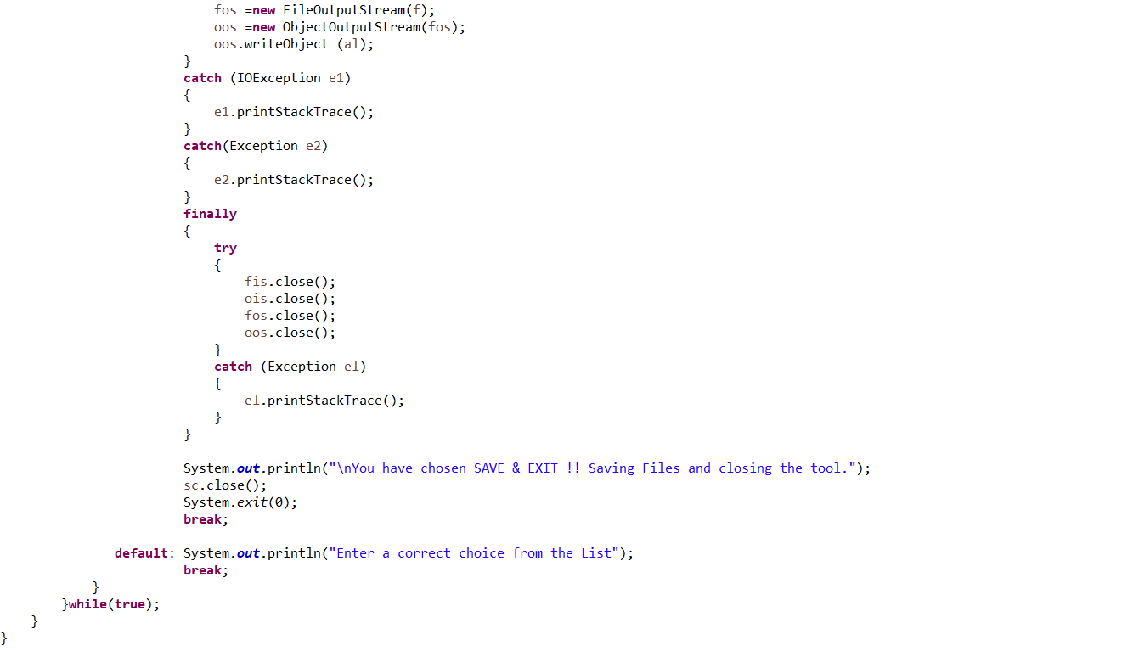

5. SOURCE CODE DESCRIPTION:

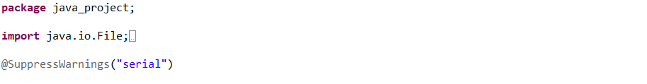

- Class Employee

Serialization and Deserialization in JAVA:

Serialization is a mechanism of converting the state of an object into a byte stream. Deserialization is the reverse process where the byte stream is used to recreate the actual Java object in memory. This mechanism is used to persist the object.

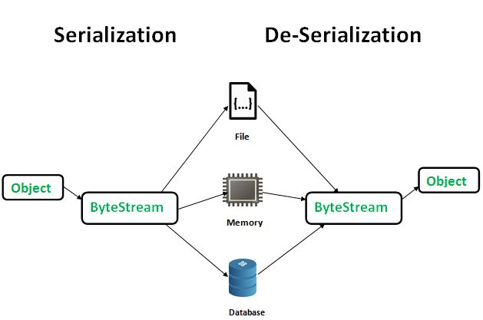

The byte stream created is platform independent. So, the object serialized on one platform can be deserialized on a different platform.
To make a Java object serializable we implement the java.io.Serializable interface.

- The ObjectOutputStream class contains writeObject() method for serializing an Object.

public final void writeObject(Object obj)
throws IOException

- The ObjectInputStream class contains readObject() method for deserializing an object.

public final Object readObject()
throws IOException,
ClassNotFoundException

Java code for serialization and deserialization of a Java object
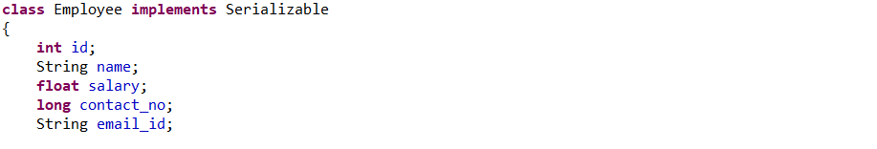

• Default constructor
Like C++, Java automatically creates default constructor if there is no default or parameterized constructor written by user, and (like C++) the default constructor automatically calls parent default constructor. But unlike C++, default constructor in Java initializes member data variable to default values (numeric values are initialized as 0, Booleans are initialized as false and references are initialized as null).
0
null
false
0
0.0

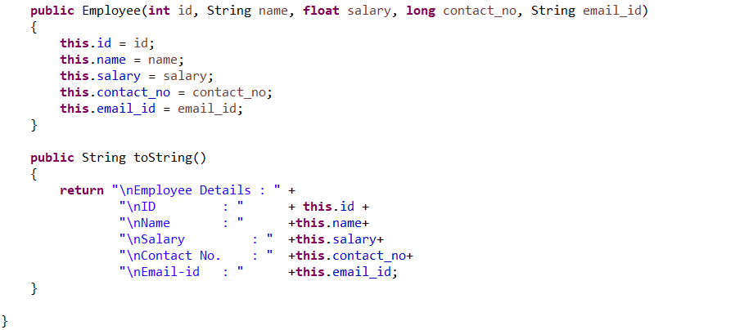

- Main Class Java project:
Main class is the class which contains main method.

• Display Method
A method is a collection of statements that perform some specific task and return the result to the caller. A method can perform some specific task without returning anything. Methods allow us to reuse the code without retyping the code. In Java, every method must be part of some class which is different from languages like C, C++, and Python.
Methods are time savers and help us to reuse the code without retyping the code.

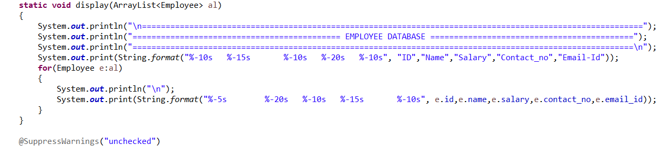

• Main Method
The main () is the starting point for JVM to start execution of a Java program. Without the main () method, JVM will not execute the program. The syntax of the main () method is:
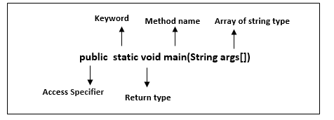
public: It is an access specifier. We should use a public keyword before the main() method so that JVM can identify the execution point of the program. If we use private, protected, and default before the main() method, it will not be visible to JVM.

static: You can make a method static by using the keyword static. We should call the main() method without creating an object. Static methods are the method which invokes without creating the objects, so we do not need any object to call the main() method.

void: In Java, every method has the return type. Void keyword acknowledges the compiler that main() method does not return any value.Stay

main(): It is a default signature which is predefined in the JVM. It is called by JVM to execute a program line by line and end the execution after completion of this method. We can also overload the main() method.

String args[]: The main() method also accepts some data from the user. It accepts a group of strings, which is called a string array. It is used to hold the command line arguments in the form of string values.

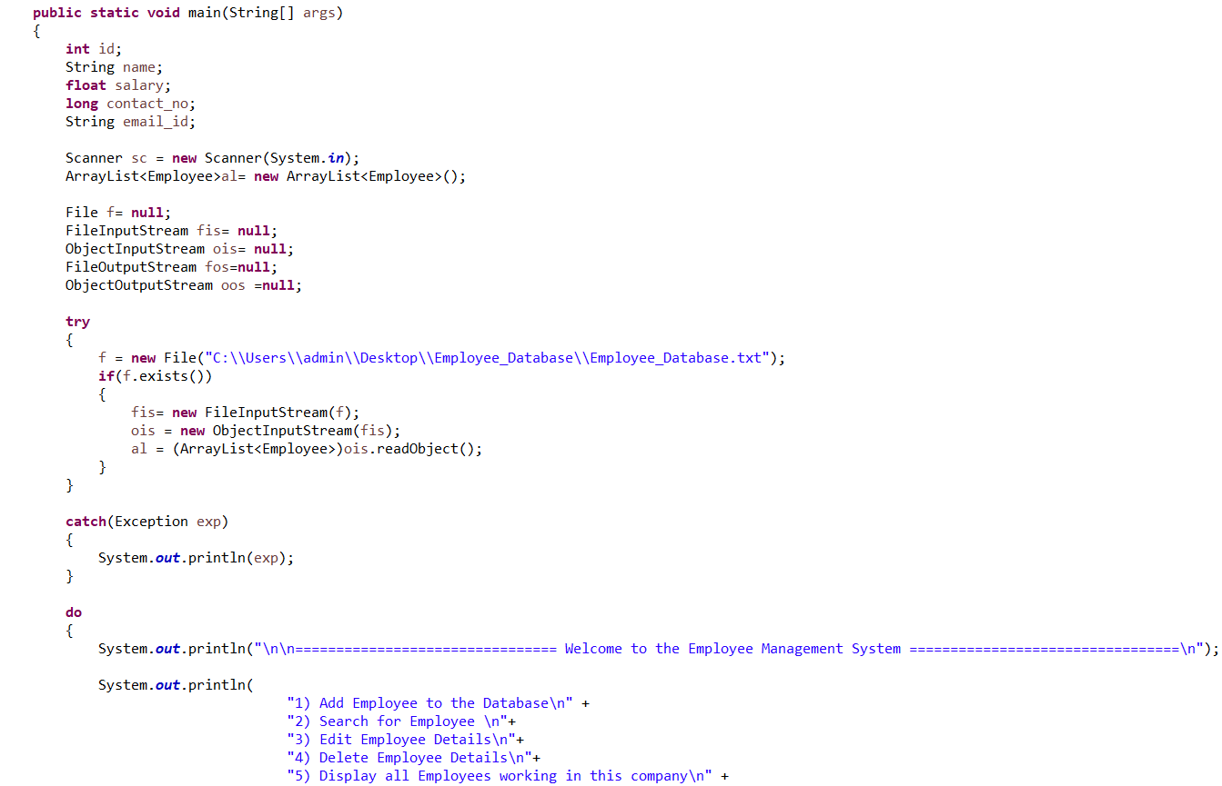
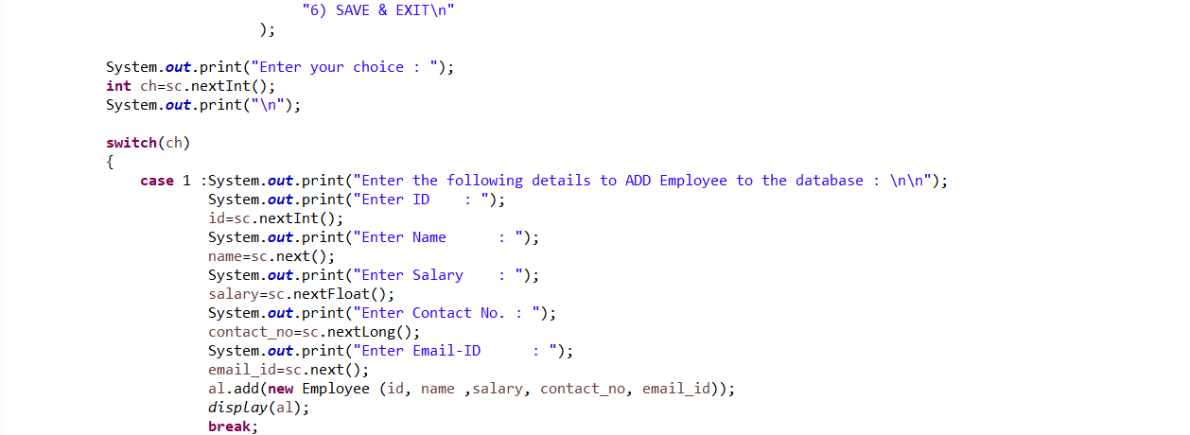
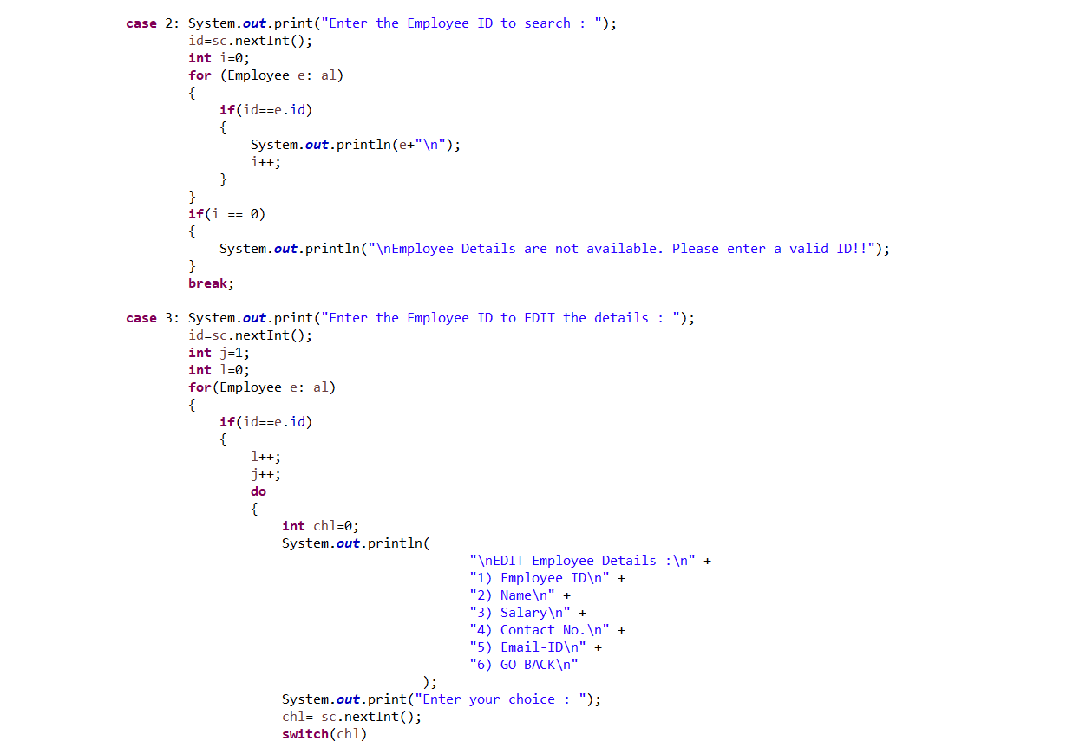
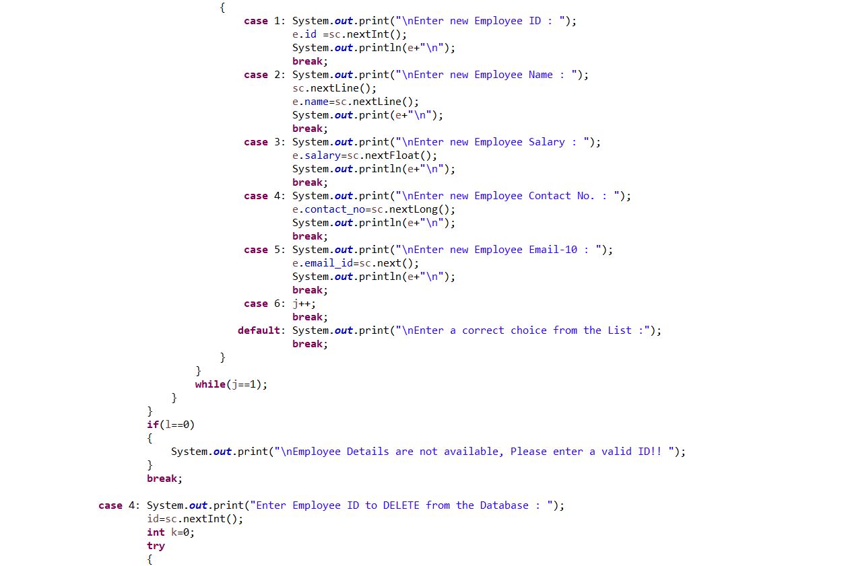
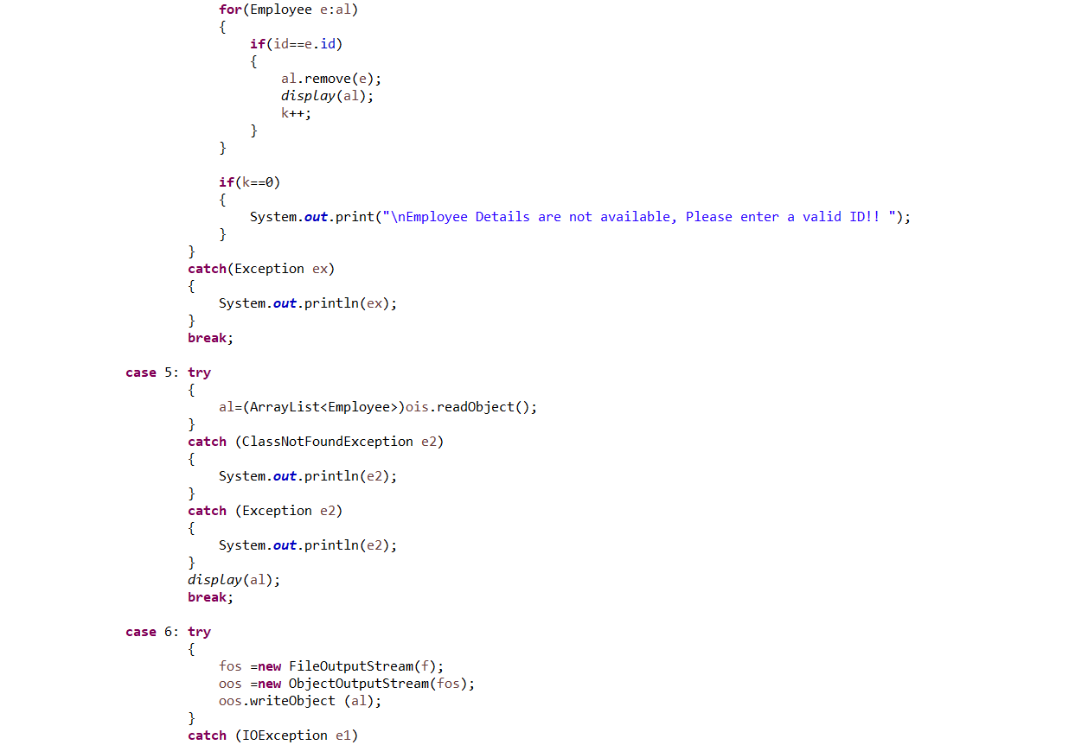
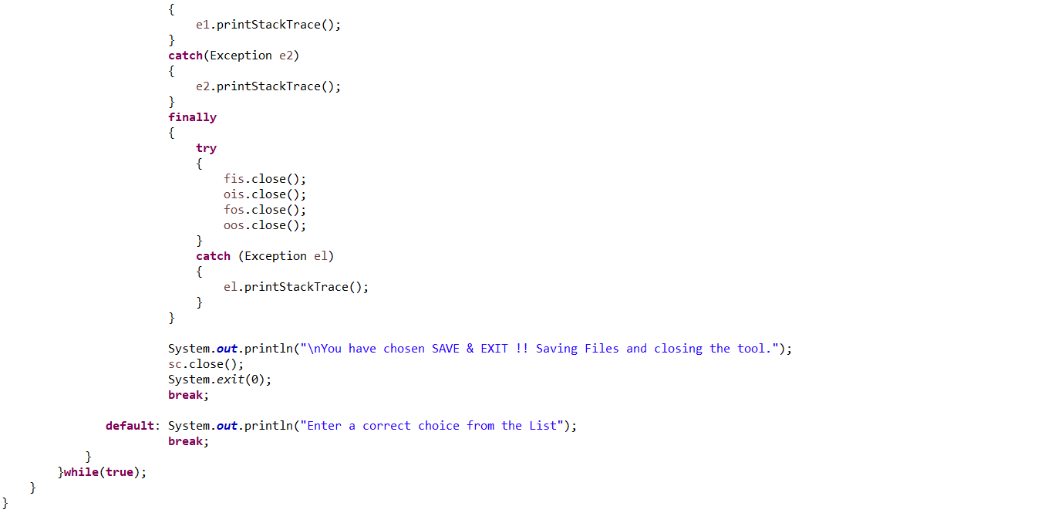

6.RESULT:

- Fetching stored Employee data from database :
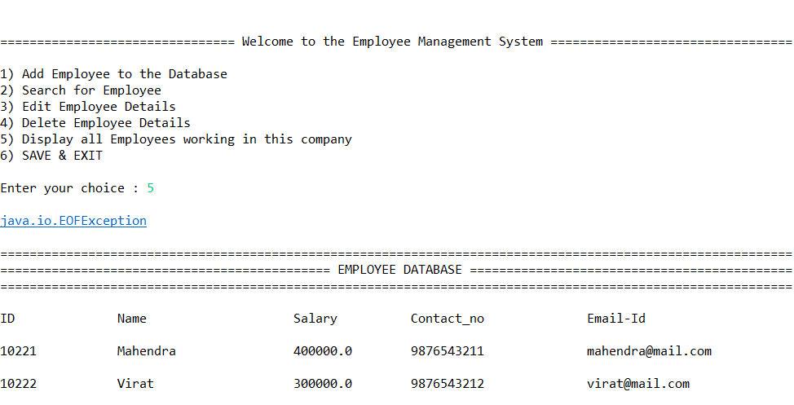

- Adding Employee data to the database :
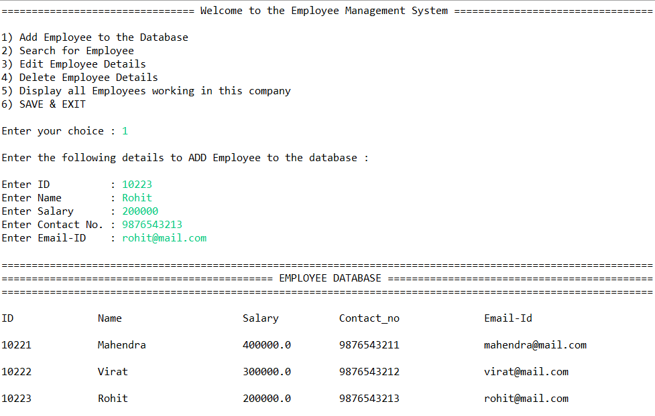

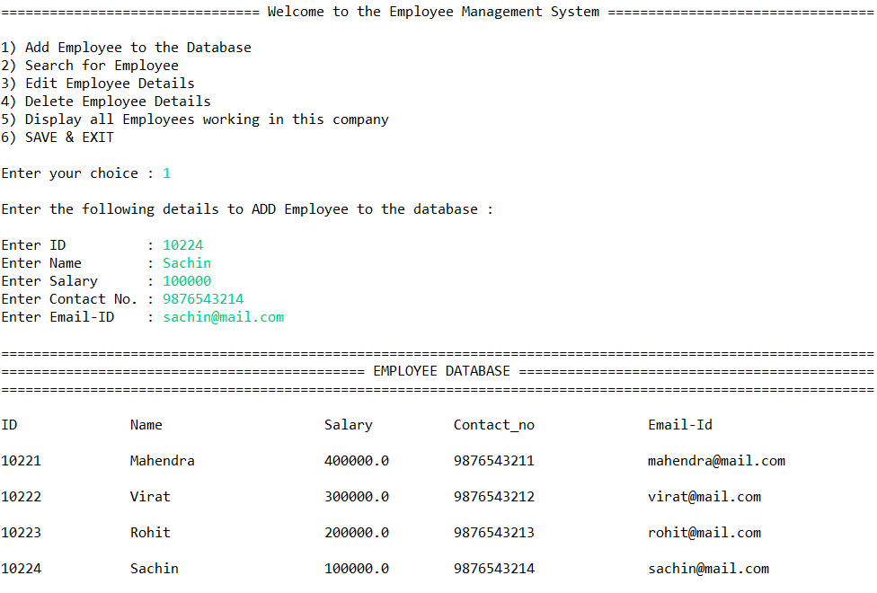

- Searching data for particular Employee from Employee ID :
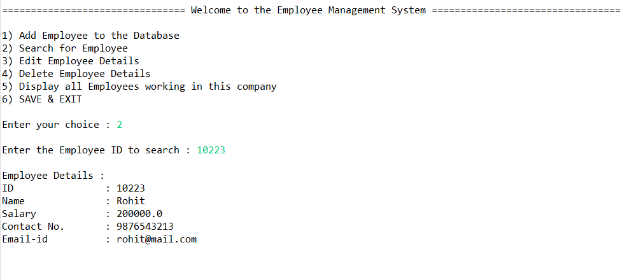

- Result After entering wrong Employee ID for searching Employee:
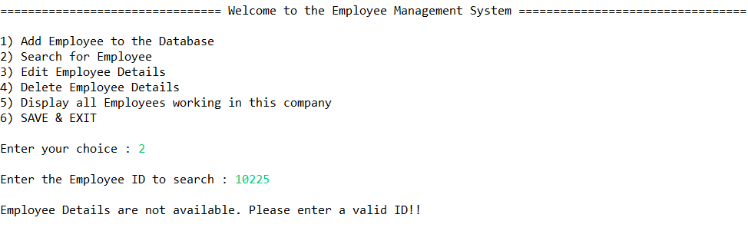

- Editing details of existing Employee from database:
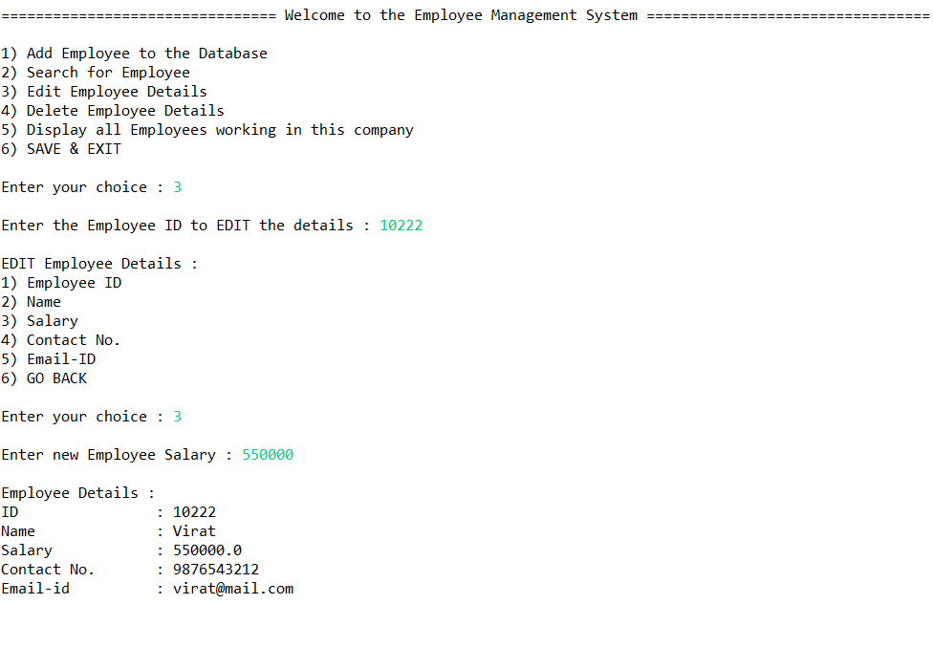

- Displaying edited details of Employee:
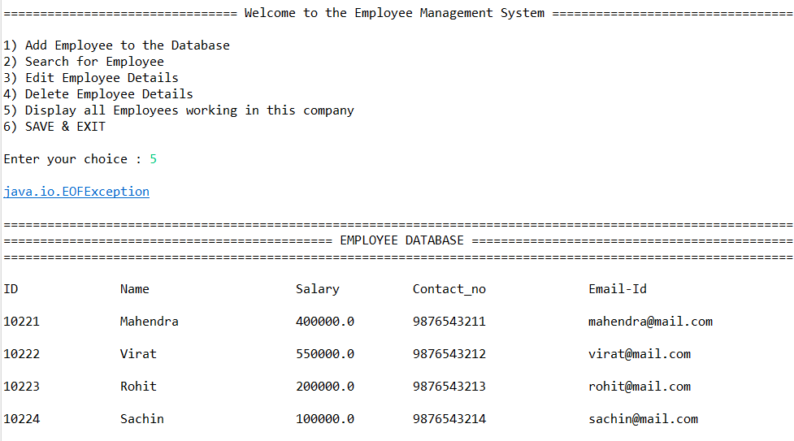

- Result after entering wrong Employee ID for editing Employee details:
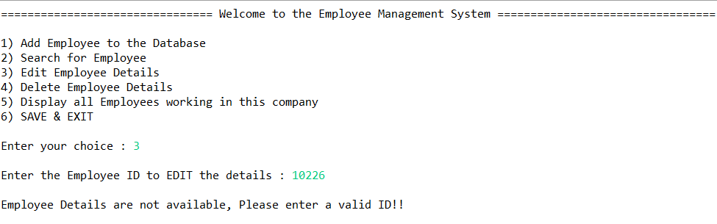

- Deleting Employee details from the database from Employee ID:
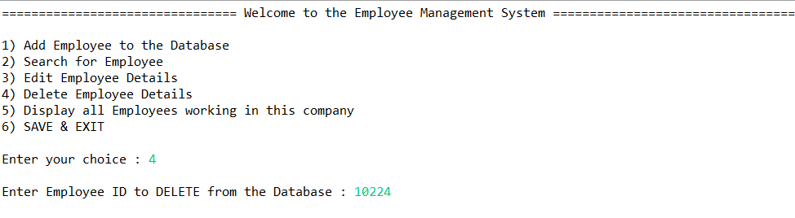
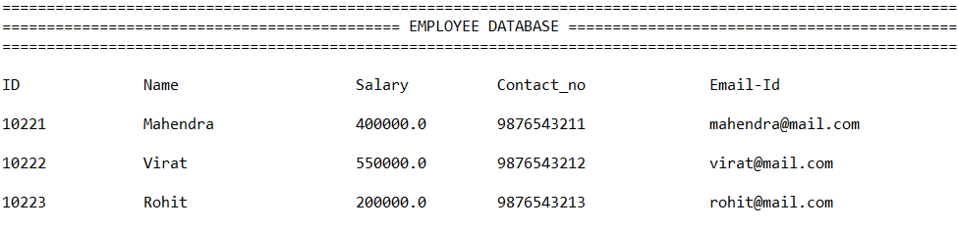

- Result after entering wrong Employee ID for deleting Employee details:
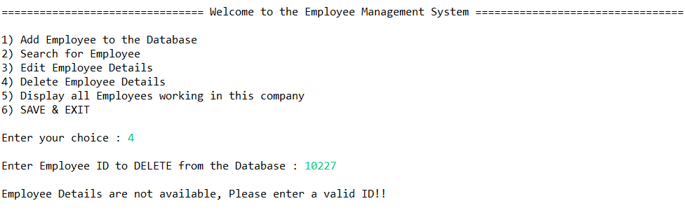

- Displaying Employee details after deleting particular employee details from the database:
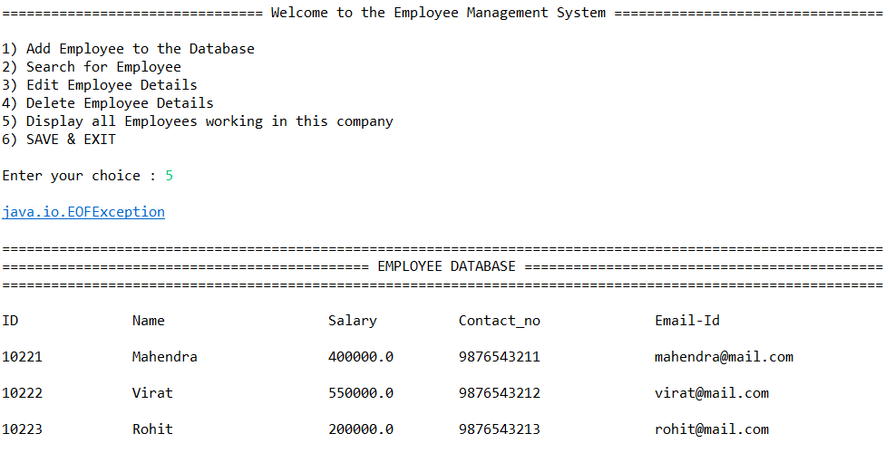

- Displaying final Employee details from database:

- SAVING & EXITING from the program:
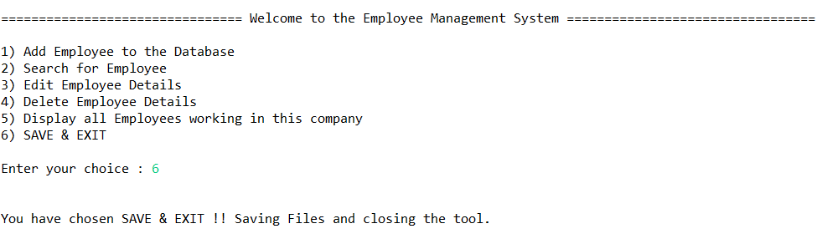

- Result after selecting wrong choice from given choices:
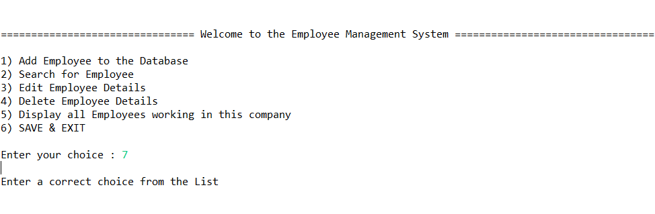

7. CONCLUSION:
- In this project we implemented almost all the fundamental concepts of Java such as file handling, interfaces, arrays, strings, switch cases etc. and built the Employee Management System.
- Thus, we have completed our Mini-Project and created a System that stores Employee details (such as his/her ID, Name, Salary, Contact No. and e-mail address) and allows user to add, search, edit, delete, display and save all the above details in a file.

8.APPLICATIONS:
- This System can be used in offices to store and fetch basic data of employees.
- Also, whenever some of the data needs to be updated one can just search for it and simply edit the data.
- This system is basic as well as easy to understand and hence can be used in schools, colleges, offices, banks, etc. by simply changing the entities to the desired values.

9 FUTURE SCOPE:
.
- By using advanced java concepts, we can create application for this system consisting of front end and backend.

10. COPY RIGHT AFFIRMATION:

We undersigned pledge and represent that the source code printed in this mini project report does not violate any proprietary or personal rights of others (including, without limitation, any copyrights or privacy rights); that the Work is factually accurate and contains no matter libelous or otherwise unlawful; that we have substantially participated in the creation of the Work and that it represents our original work sufficient for us to claim authorship.

Name of students Sign
1. Jay Jadhav
2. Yash Jain
3. Vedant Karale
4. Praneet Patare

Continuous Assessment
Novelty and Explanation of project (5) | Source code readability, GUI Design  (5) | Timely Submission(5) | Viva  (5) | Total (20) | Sign.:
 |  |  |  |  | Date:

